

University of Wales Trinity Saint David
School of Engineering

Vehicle to Grid Technology
Automotive Materials and Sustainability (ACHA6012)

Taylor Winter
Automotive Engineering
1901843

15/10/2022

Table of Contents
1 Introduction iii
2 Background Research iv
2.1 Bi-Directional Charging iv
2.2 Vehicle to Grid v
2.3 Climate vii
3 Analysis viii
3.1 Current Charging Technologies for Domestic Use viii
3.2 Issues with Peak Energy Demands xi
3.3 Cost of Implementation xiii
3.4 Increased Battery Degeneration xv
3.5 Ethical Issues xvi
4 Conclusion xviii
5 Bibliography xx
5.1 Figures xxi

Figure 1: Bi-Directional Charging. iv
Figure 2: Vehicle to Grid. v
Figure 3: EV vs Bi-directional EV. vi
Figure 4:CHAdeMO. viii
Figure 5: Nissan Leaf. ix
Figure 6: Mitsubishi Outlander EV. ix
Figure 7: Kia Soul EV. ix
Figure 8: National Grid Live Average Data. xi
Figure 9: Flexible Demands. xii
Figure 10: Running Cost of EV vs Petrol vs Diesel. xiii
Figure 11: Running Costs Over a Lifetime. xiv
Figure 12: Income, Poverty and Mobility in the UK. xvi
Figure 13: Vehicle to Home Examples. xviii

1 Introduction

Vehicle to grid is an up-and-coming eco-friendly way of travelling, completely eradicating petrol and diesel cars, and solely using battery power. Before this can be implemented it needs to be decided whether or not this is a feasible way to meet peak energy demands across the UK via domestic use. To do this, multiple factors need to be considered, such as long-term and short-term costs, ethical issues that could come into play further down the line, other more feasible options and current technologies that are able to support bi-directional charging.

2 Background Research

2.1 Bi-Directional Charging

Bi-directional charging is the technology that makes vehicle to gird, vehicle to home and other types of battery discharging a possibility. “Bi-directional charging allows us to not only charge the batteries of electric vehicles but to also take energy from car batteries and push it back to the power grid to help balance momentary spikes in electricity demand.” (Virta, 2019).

“Bi-directional charging is a great way to locally manage momentary spikes in electricity consumption” (Virta, 2019). Figure one below shows how bi-directional charging can be used.

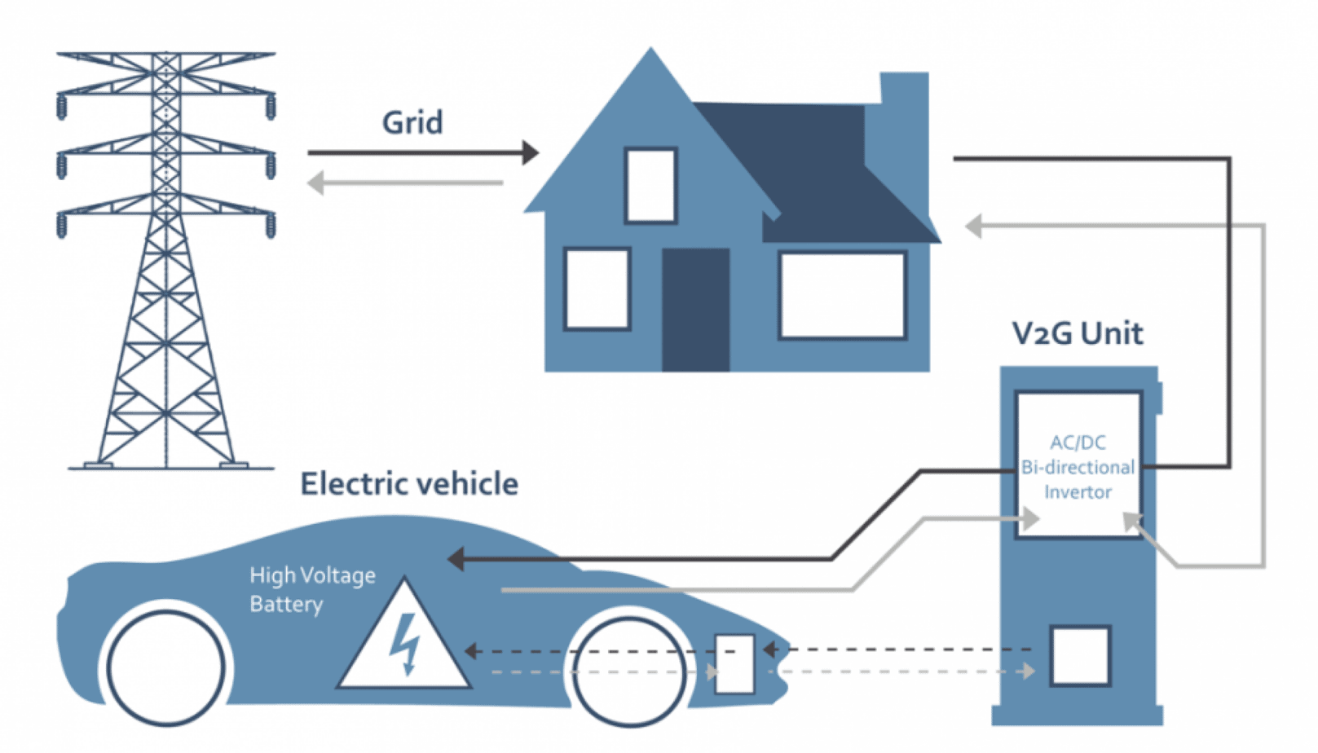
Figure 1: Bi-Directional Charging.

2.2 Vehicle to Grid

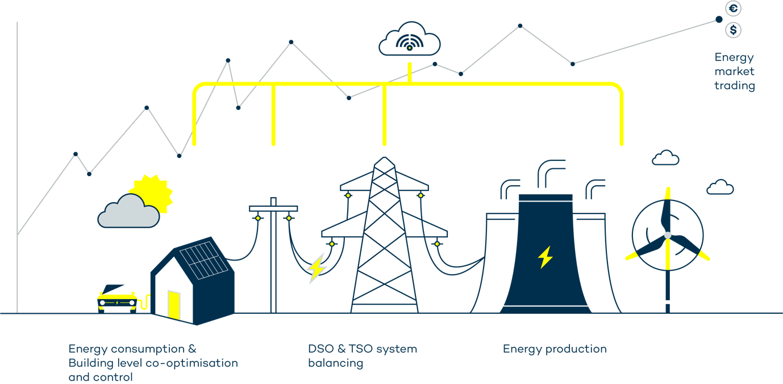
Figure 2: Vehicle to Grid.
Vehicle to Grid is a process where energy that is stored in electric vehicles is discharged back into the national grid, it enables sharing and re-purposing energy. It works similarly to smart charging where the grid is balanced by managing the charging of electric vehicles to match with peak and off-peak demands. Therefore, at peak demand times the charging power of electric vehicles will be decreased and then increased again at off-peak demand times. However, unlike smart charging, vehicle to grid is also able to temporarily move power back to the grid from vehicle batteries in order to balance the grid.

This is an important concept as the idea is to diminish climate change by balancing the energy system as well as using renewable energy. Balancing the grid means guaranteeing that there is enough energy for peak times, much like rush hour, there are peak times of energy use when the most energy is required throughout the day. This Reduces the chances of a power outage or black out, “it also stops power surges, which could damage domestic appliances, or cause electrical fires.” (Topping, 2021).

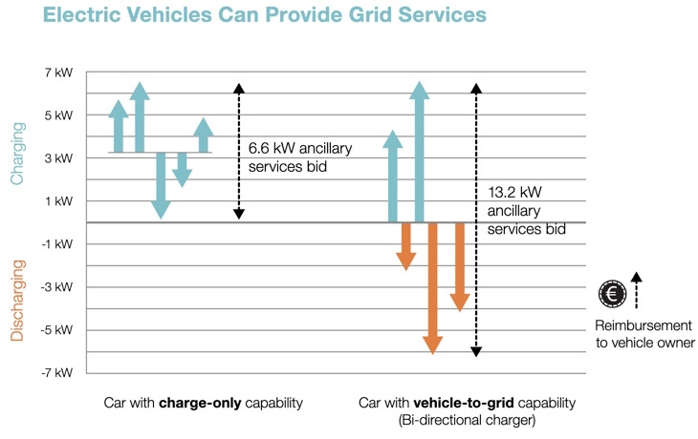
Figure 3: EV vs Bi-directional EV.
Figure three above shows the difference between a regular electric vehicle compared to a bi-directional electric vehicle being charged and discharged.

2.3 Climate

The climate crisis that we are currently in is very well known, however not much is being done about it. Which is why the vehicle to grid trials that have been going on are giving inspiration and hope to many people and companies for a better future. “An innovative technology known as Vehicle to Grid could help further incentivize the adoption of electric vehicles and help Europe see its way out of its ongoing energy crisis by reducing short-term price volatility and allowing for more efficient and decentralized energy production, storage, and distribution.” (Zimmermann, 2021).

Vehicle to grid is hopefully a way to reduce the amount of fossil fuels used for energy, making huge steps on helping to improve and protect the climate. “By tapping on available energy in all existing electric cars, the use of V2G can offer grid balance services when there are high demands for energy. This function improves the sustainability and resilience of the energy systems, can reduce dependence from fossil fuels and emissions, primarily if electricity come from renewable sources.” (Climate-Adoption-Platform, 2020).

There have already been very promising movements in the right direction and the hopes of vehicle to grid are becoming a reality thanks to many studies across the world. “A study on EV2 looks at the storage capacity of plug-in hybrid electric vehicles and their potential to distribute or ‘sell’ this stored energy peak demands. Result of their study shows that V2G presents a promising solution for future energy problems. Many automotive and governments around the world have seen this possibility and are taking steps to make V2G viable for future use.” (Climate-Adoption-Platform, 2020).

This has already been put into motion by the UK government, “by 2030, you will no longer be able to buy a new car that is powered solely by petrol or diesel. Hybrids can still be sold, but they will have to be capable of travelling a substantial distance on electric power alone. By 2035 even those PHEVs will be outlawed.” (Knight, 2021).

3 Analysis

3.1 Current Charging Technologies for Domestic Use

During the V2G trial held in the UK it is clear that there are already issues that have been raised. “It saw between 300 and 400 vehicle-to-grid chargers installed, a number which was lowered from 1,000 due to limits of the number of consumers with compatible EVs.” (Grundy, 2021). This is due to the fact that currently, vehicle to grid is not supported by many charging technologies, in fact CHAdeMO is the only one; however, it can only deliver up to 62.5kW. This can be seen below in figure four compared to the different types of EV charging connections which are commonly seen.

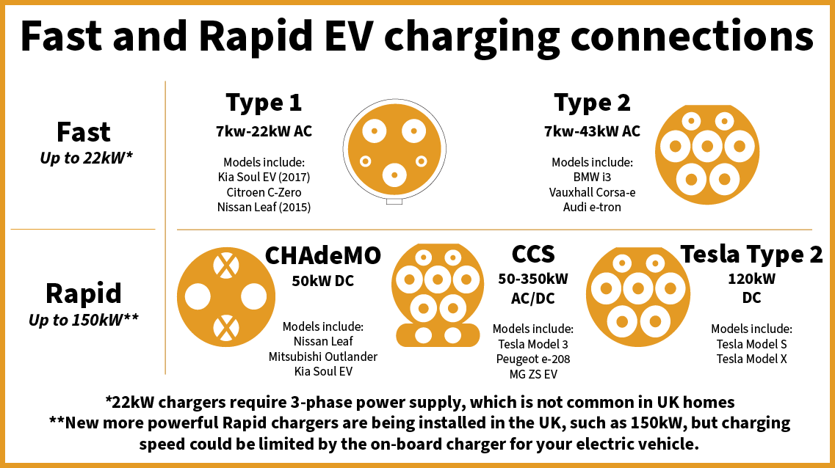
Figure 4:CHAdeMO.
The only current cars that are capable of vehicle to grid due to having the CHAdeMO charger is the Nissan leaf, Mitsubishi Outlander and Kia Soul. “The Nissan Leaf is currently the only mass production EV on the market to support bi-directional charging today. Hyundai, Kia and Lucid all have future vehicles that the companies say will include this capability.” (Mckerracher, 2021). However, this does pose the issue of standardisation across the world, “Currently only the “CHAdeMO” DC connector is capable of V2G, it’s not currently used in homes, and it is not by any means a universal connector. If V2G technology becomes viable in the mainstream, there would need to be agreed standards between various OEMs. This consensus will be challenging to establish.” (McKemey, 2018).

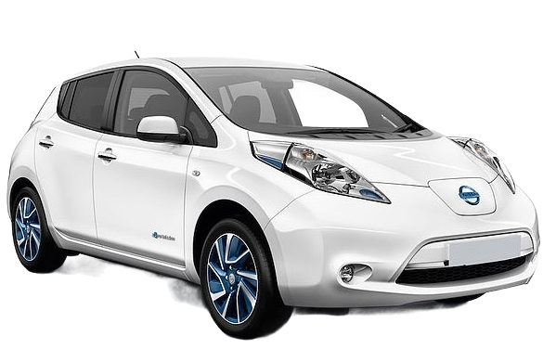
Figure 5: Nissan Leaf.
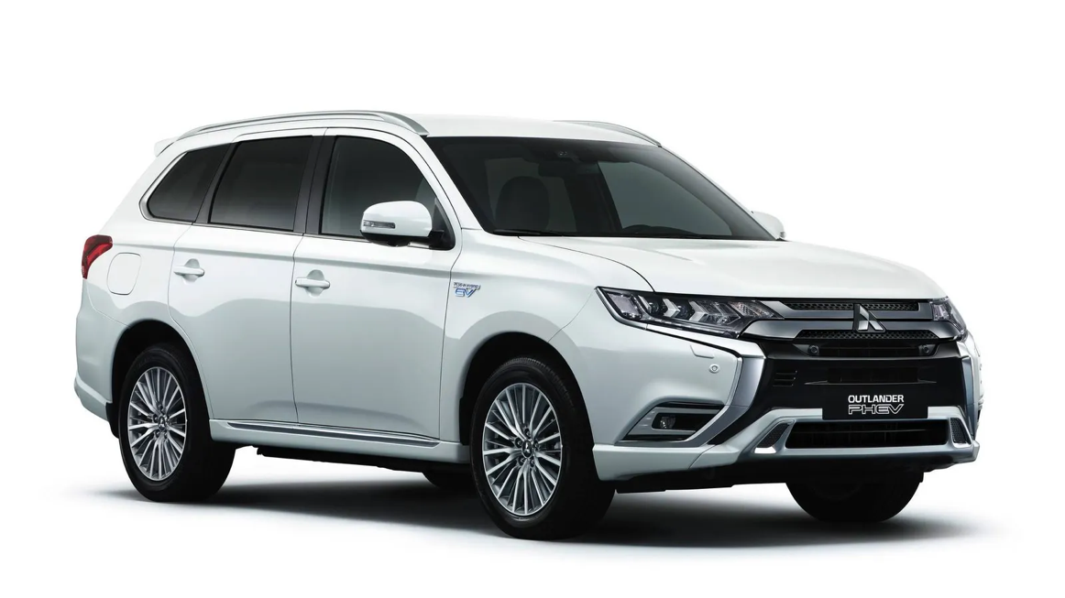
Figure 6: Mitsubishi Outlander EV.
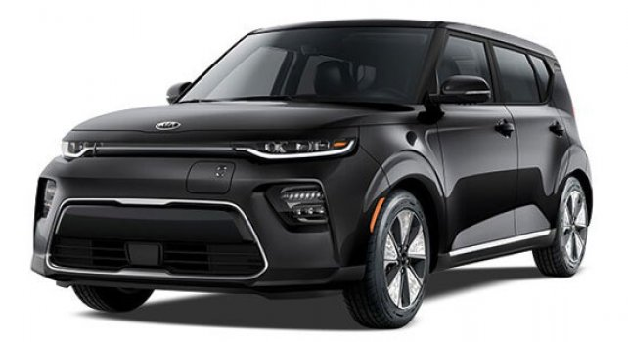
Figure 7: Kia Soul EV.

Figures five, six and seven above shows the Nissan Leaf, Mitsubishi Outlander and Kia Soul. For domestic use these vehicles will be feasible, however it does lead to a lack of options for those who do want to eventually support vehicle to grid when or if it becomes readily available.

There are also a few promising announcements from companies that are soon planning on making vehicle to grid a possibility in the future, such as Volkswagen. “From 2022 onwards, new electric vehicle models from VW will support something called bi-directional charging.” (Mckerracher, 2021) as well as “Hyundai recently announced that its new stylish EV, the Ioniq, would support something called vehicle-to-load technology.” (Mckerracher, 2021).

The Hyundai Ioniq will be capable of running home appliances, or practically anything electric. This also highlights the fact that the capacity of these vehicle could be huge, which could completely eradicate the metrics used in todays’ marketing. “Zero to 60 mph is no longer an adequate differentiator for high-end vehicles because all carmakers can easily add this capability.” (Mckerracher, 2021). This can and will completely change the way that we look at vehicles. There is a promising movement in the right direction however, this doesn’t solidly mean that vehicle to grid will be the final or only option for our future.

3.2 Issues with Peak Energy Demands

“If all of us suddenly swap into electric cars, it seems obvious that demand for electricity will skyrocket. Surely the existing infrastructure will just go into meltdown and we’ll have blackouts?” (Knight, 2021). This seems to be a common thought throughout this topic. If all vehicles become electric will the grid even have the power to charge all of these EVs without failure?

According to Graeme Cooper, Transport Decarbonisation Director for the National Grid, “There is definitely enough energy, and the grid can cope easily. The growth in renewable energy and smart metering will make it more efficient.” (Knight, 2021). He also says that “most people will be charging their cars over night, when there is a lower energy demand.” (Knight, 2021). However, when every household has an electric vehicle and begins to charge them at night when they have been prompted to do so, the energy demand will not decrease it will just shift to a different time of day.

“Peaks in electricity demand cause significant negative environmental and economic impacts. In many countries, peak demand periods require carbon intensive and costly dispatchable generation and cause difficulties for constrained capacity local low voltage (LV) distribution networks.” (Anderson & Torriti, 2018). Figure eight below shows the average Energy used throughout the UK compared to the sources of the energy. As shown, the majority of energy used still comes from fossil fuels even in 2021, although renewable energy is being used there is not enough of it being created to sustain the UK’s energy demand.

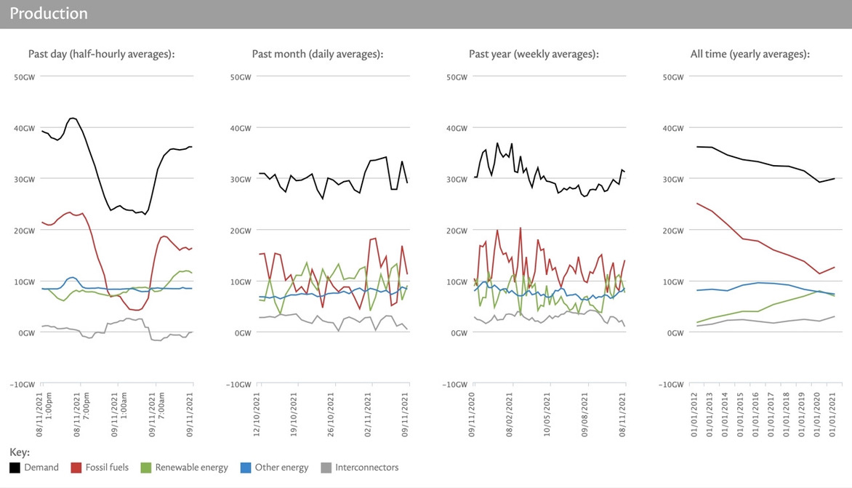
Figure 8: National Grid Live Average Data.
There is a potential to fix this issue with flexible demands created by Cenex, Ovo Energy, Indra, Kaluza and Nissan. “Flexibility is the ability to change a planned electricity consumption (in the case of demand) or production (in the case of generation) pattern at short notice. Additionally, flexibility can be used to move consumption to periods where cheaper or renewable generation is available.” (Cenex, 2021) Figure nine below shows that the total demand and total generation can constantly be matched by using this system. However, this does not solve the issue of the huge amount of fossil fuels being used.

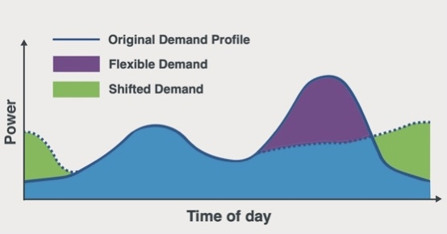
Figure 9: Flexible Demands.

3.3 Cost of Implementation

The initial cost of an EV is one of the main things to consider when analysing the cost of vehicle to grid. The Nissan Leaf starts at £25,995, the Mitsubishi Outlander starts at £33,304 and the Kia Soul starts at £35,570. As a base line for EVs that are compatible with vehicle to grid, the price is very high. Arguably, the money spent on an EV results in lower running cost due to prices of petrol and diesel. Figure ten below shows the comparison of initial costs and running cost of EVs, petrol and diesel.

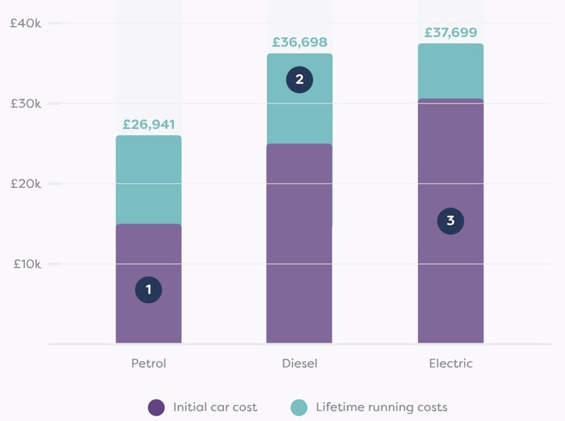
Figure 10: Running Cost of EV vs Petrol vs Diesel.
“The running costs of electric cars are 36% cheaper than petrol and diesel.” (Money-Supermarket, nd) Although the running cost are much lower than that of a petrol car, the initial cost is still double. This price may come down in years to come as they become more popular, however this could also impact the running cost. The price of electricity may skyrocket especially with vehicle to grid technology.

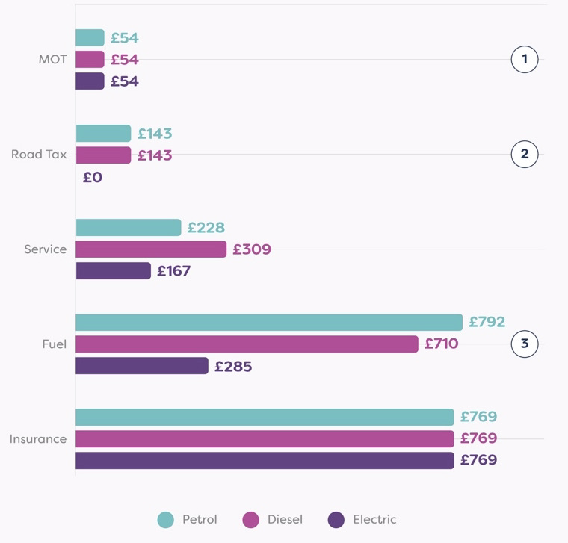
Figure 11: Running Costs Over a Lifetime.
Figure eleven shows a breakdown of the running costs. The biggest cost difference is the fuel but as previously stated, there is no certainty that it will stay that way. The same way that prices in petrol increase with demand, electricity is likely to do the same.

Another concern about EVs is the battery replacement costs. Although it is not something that should be a concern for many years, “Nissan warrants that its electric car batteries will last eight years or 100,000 miles, for example and Tesla offers a similar guarantee.” (eDF-Energy, nd) but what happens when they do eventually die?

“The cost of batteries fell about 80% between 2010 and 2016 according to McKinsey, from $1000 to $227/kWh. Therefore, a new 40kWh battery in 2016 would have cost just shy of £10,000. Some predictions estimate that prices are set to fall below $100/kWh by 2030.” (eDF-Energy, nd)

3.4 Increased Battery Degeneration

A huge concern about vehicle to grid is the risk of increasing battery degeneration in EVs due to the excessive discharging required for V2G. “V2G systems place more use (and stress) on batteries, reducing their lifetime and resulting in early retirement of batteries. One study found that average capacity losses in each frequency regulation event range from 0.0010%–0.0023% with different charger availability at home or work locations, corresponding to a cost of battery degradation as high as $0.20–$0.46 per charge.” (Sovacool, et al., 2018) which is equivalent to £0.15-£0.33 per charge.

This is something that needs to be addressed before people are happy to invest in a car that is capable of any form of bi-directional charging. “Multiple charging cycles which is reducing battery life due to parasite (electrode-electrolyte) reactions during charging and discharging of the battery.” (Mkhize & Dorrell, 2019) with this in mind, “Once the battery capacity falls below 80%, drivers may start to notice a fall in the range and performance of the battery.” (eDF-Energy, nd). Due to the increased battery degeneration, that 80% capacity will come around much sooner than normal. This means that consumers will be feeling the knock-on effect of vehicle to grid.

3.5 Ethical Issues

There are a few ethical issues that may occur that may seem unexpected. Of course, there are the obvious ethical issues with pollution, lithium mining and things of that nature, but there are also concerns in areas such as gender norms and social or energy justice.

Regular petrol/diesel cars have always been prevailed as masculine and this may become an ethical issue for marketing, “manufacturers exploited such prevailing gender norms when they tried to frame cars as masculine.” (Sovacool, et al., 2018). Whereas now EVs are sold as clean, easy, and limited range. “Electric vehicles thus came to be associated with lack of power and femininity.” (Sovacool, et al., 2018).

However, this view may already be in the past as, “a survey of Canadian car buyers finds that early electric vehicle buyers are overwhelmingly male (81%), especially Tesla owners, though among conventional vehicle owners, females express slightly greater interest in being the 'next' electric vehicle buyers” (Sovacool, et al., 2018).

Social justice is also becoming a prevalent issue. “A social justice frame to energy and transport therefore involves burdens, or how the hazards of the energy system are disseminated throughout society; benefits, or how access to energy or mobility services is distributed throughout society; procedures for ensuring that energy decision-making respects due process and representation; and recognition, that the marginalized or vulnerable have special consideration.” (Sovacool, et al., 2018). Figure twelve below outlines the connection between travel and issues with income and class. This suggest that the implementation of vehicle to grid may negatively affect the lower income or lower class by escalating the issue as well as the gap between the income classes.

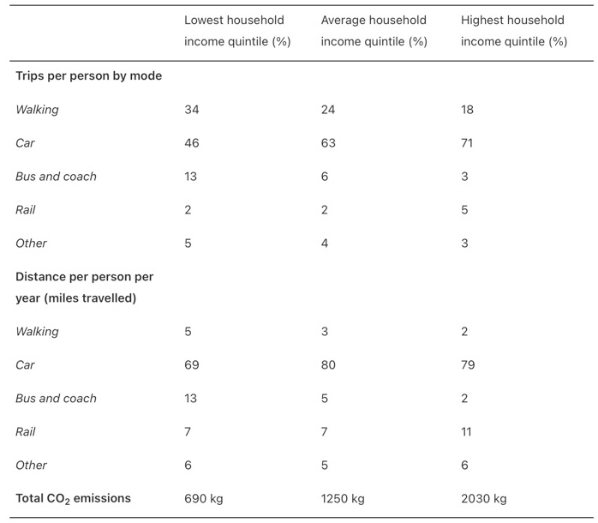
Figure 12: Income, Poverty and Mobility in the UK.
Of course, there are also huge ethical issues with lithium mining, “Extracting the raw materials, mainly lithium and cobalt, requires large quantities of energy and water. Moreover, the work takes place in mines where workers — including children as young as seven — often face unsafe conditions.” (595, 2021). This is clearly a huge issue which needs to be substituted for an alternative process before vehicle to grid can become a reality.

4 Conclusion

Vehicle to grid would not be the perfect solution to peak energy demands in the UK. It would be a good concept to consider however the issues with peak energy demands are only going to be worsened by putting more stress on the grid to supply power to all EV with the ban on new petrol and diesel cars. However, another option to consider would be vehicle to home.

Vehicle to home works with the same principle as vehicle to grid. Electric vehicles are discharged during peak times giving energy back to the house, instead of the grid. However, unlike vehicle to grid, when energy is discharged from the EV the power can be used during power outages. This is something that could be used as an emergency power supply for homes, “during the 2011 Tohoku earthquake and tsunami, Nissan sent 66 numbers of Nissan Leafs to the north-eastern coast of Japan which acted as the primary power supply for many days!” (Paulraj, 2020).

Vehicle to home can help to reduce electricity consumption during peak demands as well as reducing the power demands from the grid. “As the number of electric vehicles constantly increasing, and when all of these EVs are plugged-in simultaneously for charging, they could increase the peak demand on the grid, contributing to grid overload and create the need for upgrades at the distribution level. EVs that support V2H gives the flexibility, to deliver electricity during peak hours and take charge whenever the electricity rates are cheap.” (Paulraj, 2020). This option will therefore also help to reduce consumers’ bills.

The Graph shown in figure thirteen shows the effects of EV batteries discharging during an emergency power supply and discharging during peak demands.

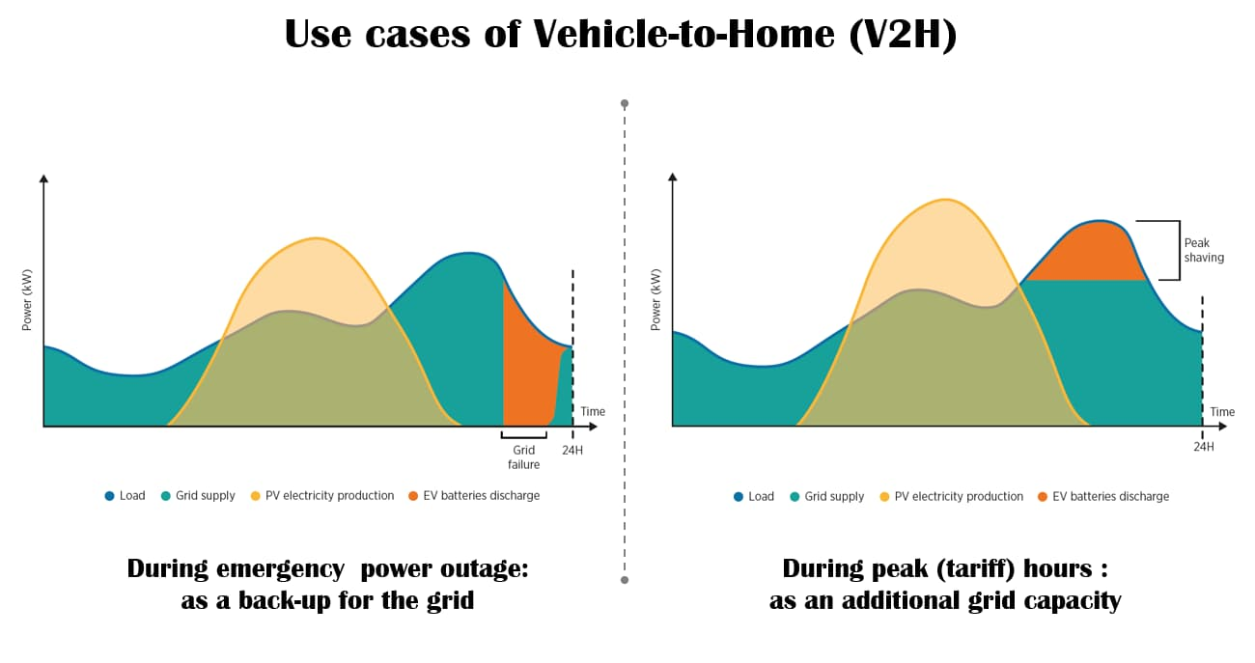
Figure 13: Vehicle to Home Examples.
This could also help to increase capacity to enable large home appliances at the same time such as washing machines and dryers, “electric vehicles with V2H can act as a buffer in these cases to provide the extra capacity, without going for a need to upgrade the grid connection. ” (Paulraj, 2020).

Vehicle to home technology shows the possibility of self-sustainable living which could lead to a much eco-friendlier way of living and is a much more feasible solution to meet peak energy demands in the UK without upgrading the grids capability. It is also a much cheaper option, “at present, most of the smart homeowners install solar panels and storage batteries which enable them to increase self-consumption of solar power. A typical home storage battery (4 - 7 kWh) costs about $5000.” (Paulraj, 2020). Which is about £3720.

5 Bibliography
595, N., 2021. Nature. [Online]
Available at: https://www.nature.com/articles/d41586-021-01735-z
[Accessed 18 November 2021].
Ahmadian , A. et al., 2018. Cost-Benefit Analysis of V2G Implementation in Distribution Networks Considering PEVs Battery Degradation. [Online]
Available at: https://ieeexplore.ieee.org/stamp/stamp.jsp?tp=&arnumber=8093695&tag=1
[Accessed 16 November 2021].
Anderson, B. & Torriti, J., 2018. Journals Elsevier. [Online]
Available at: https://reader.elsevier.com/reader/sd/pii/S030142151830630X?token=F8E961689C65192E49A9D3D412C1E3D9C2D2EA899EEAF60BF79ACF4617E779BFB91E3D99905274FE6E639B50D9DAAE1E&originRegion=eu-west-1&originCreation=20211109130746
[Accessed 1 November 2021].
Cenex, 2021. Cenex. [Online]
Available at: https://www.cenex.co.uk/app/uploads/2021/01/V2G-Commercial-Viability-1.pdf
[Accessed 16 November 2021].
Climate-Adoption-Platform, 2020. Climate Adoption Platform. [Online]
Available at: https://climateadaptationplatform.com/v2g-technology-and-its-role-in-climate-change-adaptation-and-mitigation/
[Accessed 18 November 2021].
eDF-Energy, nd. eDF Energy. [Online]
Available at: https://www.edfenergy.com/electric-cars/batteries
[Accessed 19 November 2021].
Gaton, B., 2020. The Driven. [Online]
Available at: https://thedriven.io/2020/06/12/what-are-the-current-vehicle-to-grid-options/
[Accessed 12 November 2021].
Grundy, A., 2021. Current. [Online]
Available at: https://www.current-news.co.uk/news/worlds-largest-domestic-v2g-trial-finds-hardware-costs-still-too-high-despite-significant-financial-rewards
[Accessed 17 November 2021].
Knight, T., 2021. Auto Express. [Online]
Available at: https://www.autoexpress.co.uk/features/356478/whats-problem-electric-cars-cop26-special
[Accessed 17 November 2021].
McKemey, J., 2018. Pod Point. [Online]
Available at: https://pod-point.com/electric-car-news/v2g-is-it-viable
[Accessed 16 November 2021].
Mckerracher, C., 2021. Bloomberg. [Online]
Available at: https://www.bloomberg.com/news/newsletters/2021-04-27/more-evs-are-being-designed-to-push-power-to-the-electrical-grid
[Accessed 16 November 2021].
Mkhize, S. & Dorrell, D. G., 2019. Practical Limitations of Vehicle to Grid (V2G) Infrastructure. Melbourne, VIC, Australia, IEEE .
Money-Supermarket, nd. Money Supermarket. [Online]
Available at: https://www.moneysupermarket.com/car-insurance/electric-car/the-cost-of-driving-green/?source=GOO-0X000002F7B46FCFBA&gclid=Cj0KCQiA-eeMBhCpARIsAAZfxZBkpCi6RBPvuKzBmZnlafZq_hI4gdqnijttGB_P0dBSpC4ChI8GxvsaAvqeEALw_wcB&gclsrc=aw.ds
[Accessed 19 November 2021].
Paulraj, P., 2020. E-Mobility Simplified. [Online]
Available at: https://www.emobilitysimplified.com/2020/01/electric-car-powers-home-v2h-charger.html
[Accessed 8 November 2021].
Shirazi, Y., Carr, E. & Knapp, L., 2015. Elsevier. [Online]
Available at: https://www-sciencedirect-com.ezproxy.uwtsd.ac.uk/science/article/pii/S030142151530121X
[Accessed 16 November 2021].
Sovacool, B. K., Noel, L., Axsen, J. & Kempton, W., 2018. Iop Science. [Online]
Available at: https://iopscience.iop.org/article/10.1088/1748-9326/aa9c6d#erlaa9c6ds4
[Accessed 17 November 2021].
Sree Lakshmi, D. G., Divya, G. & Sravani, G., 2019. E3S Conferences. [Online]
Available at: https://www.e3s-conferences.org/articles/e3sconf/pdf/2019/13/e3sconf_SeFet2019_01019.pdf
[Accessed 3 November 2021].
Topping, C., 2021. OVO Energy. [Online]
Available at: https://www.ovoenergy.com/guides/electric-cars/vehicle-to-grid-technology
[Accessed 27 October 2021].
Virta.Global, 2019. Virta Global. [Online]
Available at: https://www.virta.global/vehicle-to-grid-v2g
[Accessed 8 November 2021].
Virta, 2019. Virta. [Online]
Available at: https://www.virta.global/blog/bidirectional-charging-as-a-v2g-solution
[Accessed 18 November 2021].
Wallinger, R., 2019. Sino Voltaics. [Online]
Available at: https://sinovoltaics.com/learning-center/electric-vehicles/what-is-vehicle-to-building-charging-v2b/
[Accessed 16 November 2021].
Zimmermann, K., 2021. Fortune. [Online]
Available at: https://fortune.com/2021/10/07/vehicle-to-grid-technology-could-ease-europes-energy-transition-woes/
[Accessed 18 November 2021].

5.1 Figures

Figure 1: Bi-Directional Charging. Available at:
https://myev.online/the-future-of-charging-bidirectional-v2g/ (Accessed 18th November 2021)

Figure 2: Vehicle to Grid. Available at:
https://www.virta.global/vehicle-to-grid-v2g (Accessed 1st November 2021)

Figure 3: EV vs Bi-directional EV. Available at:
https://newmotion.com/en/knowledge-center/news-and-updates/the-future-of-ev-charging-with-v-2-x-technology (Accessed 16th November 2021)

Figure 4: CHAdeMO. Available at:
https://www.smarthomecharge.co.uk/features/ev-basics-electric-car-charging-connections-explained/ (Accessed 16th November 2021)

Figure 5: Nissan Leaf. Available at:
https://www.mister-ev.com/vehicles/nissan-leaf-i-96/ (Accessed 16th November 2021)

Figure 6: Mitsubishi Outlander EV. Available at:
https://www.wired.co.uk/article/mitsubishi-outlander-phev-2019-review (Accessed 16th November 2021)

Figure 7: Kia Soul EV. Available at:
https://www.ccarprice.com/uk/kia-soul-ev-2021-price-in-united-kingdom-4575 (Accessed 16th November 2021)

Figure 8: National Grid Live Average Data. Available at:
https://grid.iamkate.com (Accessed 9th November 2021)

Figure 9: Flexible Demands. Available at:
https://www.cenex.co.uk/app/uploads/2021/01/V2G-Commercial-Viability-1.pdf (Accessed 16th November 2021)

Figure 10: Running Cost of EV vs Petrol vs Diesel. Available at:
https://www.moneysupermarket.com/car-insurance/electric-car/the-cost-of-driving-green/?source=GOO-0X000002F7B46FCFBA&gclid=Cj0KCQiA-eeMBhCpARIsAAZfxZBkpCi6RBPvuKzBmZnlafZq_hI4gdqnijttGB_P0dBSpC4ChI8GxvsaAvqeEALw_wcB&gclsrc=aw.ds (Accessed 20th November 2021)

Figure 11: Running Cost Over a Lifetime. Available at:
https://www.moneysupermarket.com/car-insurance/electric-car/the-cost-of-driving-green/?source=GOO-0X000002F7B46FCFBA&gclid=Cj0KCQiA-eeMBhCpARIsAAZfxZBkpCi6RBPvuKzBmZnlafZq_hI4gdqnijttGB_P0dBSpC4ChI8GxvsaAvqeEALw_wcB&gclsrc=aw.ds (Accessed 20th November 2021)

Figure 12: Income, Poverty and Mobility in the UK. Available at:
https://iopscience.iop.org/article/10.1088/1748-9326/aa9c6d#fnref-erlaa9c6dbib141 (Accessed 17th November 2021)

Figure 13: Vehicle to Home Examples. Available at:
https://www.emobilitysimplified.com/2020/01/electric-car-powers-home-v2h-charger.html (Accessed 8th November 2021)

