12/14/2025
Assessment
Portfolio Report on Contemporary Software Applications for Business


Student Name: Mohamed Alaamri
Student ID: 2516572

Module NaMe: Software solutions for business
Module Code: ACCA 4026
Lecturer: amitave banik
Trinity saint david University of Wales (London Campus)

Table of Contents
Introduction 2
Main Body 2
Task 1 2
e-Commerce Website builders/software solutions 2
Task 2 2
Mind-map of Contemporary Software Applications 2
Task 3 3
Office Applications for Creating, Storing, Presenting, and Analysing Data 3
a. 3
b. 3
Task 4 3
Communication and Collaboration applications 3
a. 3
b. 4
Conclusion 4
References 4
Appendices 4

Introduction

Main Body

Task 1
(10 marks)

e-Commerce Website builders/software solutions
(Approx. 500 words)

Name several e-Commerce website builders/software solutions most popularly used and give a description of 2 contemporary e-Commerce website builders/software solutions based on their major features, benefits and limitations (approx. 2/3 sources).

Many modern businesses rely on e-commerce platforms to easily establish and manage their online stores, without needing complex technical skills. These platforms combine page design, product organization, payment processing, and various marketing tools into a single system. This section presents two of the most popular platforms currently used in e-commerce: Shopify and Wix eCommerce, highlighting their key advantages and disadvantages.
1. Shopify – A Complete Overview
Shopify is one of the world's leading platforms for building online stores. It has earned its reputation by being a fully hosted platform operating on a Software as a Service (SaaS) model. This means that Shopify handles the core technical aspects, such as hosting, security, and regular maintenance. According to the Webiprog Report (2024), Shopify is known for being a stable and reliable platform, suitable for businesses of all sizes. One of Shopify's key advantages is its intuitive interface, which simplifies store management. Users can easily add new products, track orders, analyze customer data, and customize the store's appearance. Shopify offers a wide range of professional templates that empower businesses to create an attractive storefront without requiring advanced design skills. The platform also boasts a rich app store, allowing users to integrate additional features such as SEO tools, loyalty programs, and advanced shipping and marketing solutions, making it flexible and scalable[1].

Furthermore, Shopify supports multiple payment methods, in addition to its own Shopify Payments system, which provides a seamless checkout experience for users. WebsiteBuilderExpert (2024) noted the platform's high scalability, enabling it to manage large inventory or handle high traffic without impacting performance.Despite its numerous advantages, Shopify is not without its drawbacks. Monthly fees can increase with increased reliance on paid apps, and advanced website customization often requires programming expertise, leading some businesses to hire professional developers (Webiprog, 2024). Nevertheless, Shopify remains a strong option for organizations anticipating significant growth and needing a professional platform to support their expansion.
2. Wix for E-commerce
Wix began as a general website design platform but later expanded to offer e-commerce solutions through its Wix Stores feature. Wix is ​​known for its drag-and-drop editor, which allows users to visually and easily arrange elements and customize website pages without any technical complexities. SimiCart (2024) notes that Wix offers a large number of modern and diverse templates suitable for various types of projects[2].
Wix's e-commerce feature includes a set of essential tools that cater to the needs of small shops, such as product display, discount application, abandoned cart recovery, simple shipping management, and social media integration. Wix is ​​often seen as a cost-effective solution for entrepreneurs or small businesses looking to enter the e-commerce world with a limited budget. Futuremerce (2024) states that Wix is ​​a suitable option for small, visually oriented shops, such as craft stores or small brands.
However, Wix does have some limitations. The platform isn't designed for large stores or extensive operations, and its performance may suffer when managing a large number of products or with increased visitor traffic. Wix also doesn't offer the same level of advanced tools as specialized platforms like Shopify (Maktagg, 2024). Another limitation is that changing the template after launch requires a complete redesign, which can be time-consuming.

Task 2
(15 marks)

Mind-map of Contemporary Software Applications
(Approx. 500 words)

a. Describe mind mapping and explain the benefits of using mind mapping in business operations (approx. 2/3 sources). 5 marks
Mind maps are a visual technique used to organize information and ideas in a clear and flexible way. Unlike traditional linear note-taking, a mind map begins with a central idea placed in the middle of the page, from which main axes branch out, representing key themes. Each axis can then be expanded into smaller branches containing additional details. This method mirrors how the human brain connects ideas and concepts, making it easier to absorb and remember new information and generate innovative ideas. Tony Buzan (2018) noted that mind maps are an effective way to enhance creativity, organize thinking, and simplify complex information. Mind maps rely on keywords, colors, symbols, and simple images to visually represent ideas. This visual format helps users quickly and easily notice connections between concepts, rather than reading long lists or texts. MindTools (2024) indicates that the visual approach in mind maps enhances individuals' ability to process and retain information better, making them an ideal tool for brainstorming, planning, and problem-solving. In a professional context, mind maps offer numerous practical benefits, most notably supporting creativity and idea generation. During brainstorming sessions, the team can record all ideas on the map simultaneously, allowing them to observe the relationships between ideas and connect them in new ways, thus leading to innovative solutions. This method also ensures that no suggestion is lost, as all contributions are compiled into a single, clear diagram. Mind maps also provide significant support for planning and decision-making. They help visually represent all elements related to a topic—such as objectives, risks, options, and resources—making it easier to analyze information and evaluate alternatives. For example, a company can use a mind map to study market opportunities, potential challenges, and different operating strategies. A study published in the International Journal of Management Studies (2022) showed that using visual planning tools like mind maps reduces cognitive strain and helps managers process complex information more quickly. Another benefit is improved communication and collaboration within the team. Mind maps serve as a shared visual reference that all team members can access and contribute to, especially when using digital tools like MindMeister, Miro, and XMind. This enhances coordination, reduces misunderstandings, and provides a clear framework for discussion.Mind maps also contribute to increased productivity and organization. They allow large projects to be broken down into smaller, manageable tasks, with clearly defined responsibilities and deadlines for each part. This makes it easier for employees to prioritize and reduces time wasted on replanning. Furthermore, mind maps are an effective tool for training and knowledge transfer because they present procedures and workflows in an easy-to-understand and remember way.In short, mind maps are a versatile tool for businesses, fostering creativity, supporting decision-making, strengthening team collaboration, simplifying complex information, and increasing productivity. By providing a clear and structured visual representation of ideas, mind maps help organizations operate more efficiently and make more informed decisions.

b. Create a mind map of contemporary software applications that are used to support day-today business/Organisation operations. 10 marks
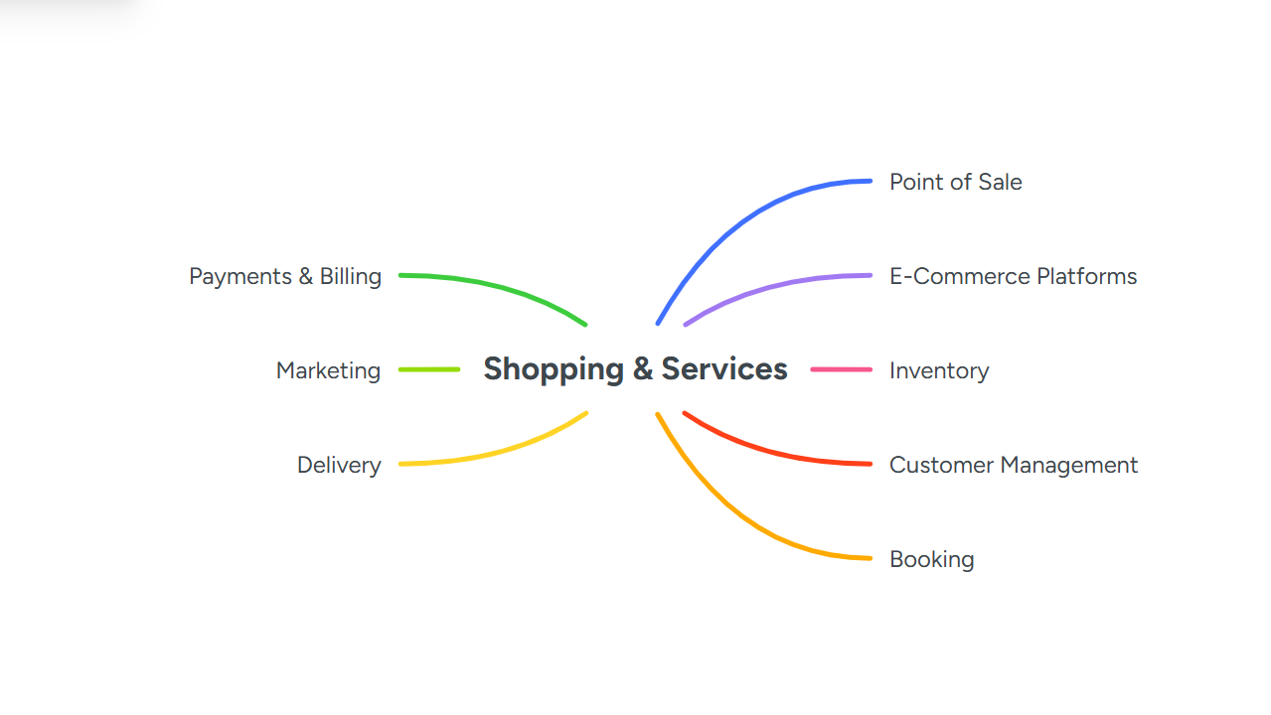
Shopping and services software helps businesses efficiently manage their daily operations. The software includes tools for selling products or services, tracking inventory, processing payments, and managing customer data. It also covers e-commerce, appointment booking, marketing campaigns, and delivery operations. Using such software contributes to faster workflows, reduced errors, and an improved customer experience.

Task 3
(50 marks)

Office Applications for Creating, Storing, Presenting, and Analysing Data
(Approx. 2000 words)

a.
30 marks
Explain four office software solutions for business operations (MS Word, MS PowerPoint, MS Excel, and MS Access), highlighting their major features, benefits, and limitations (if there are any). You can use some images in addition to text (approx. 4/5 sources).
Mind maps are a visual method for organizing information and ideas in a flexible and easily understandable way. Instead of taking notes in a traditional, sequential manner, a mind map begins with a central idea in the middle of the page, from which main branches extend, representing key themes. Each branch can be expanded with smaller sub-branches containing related details or examples. This approach mirrors the brain's natural way of thinking, helping users see the big picture while simultaneously grasping the details. Tony Buzan, the founder of the modern mind mapping concept, has asserted that its use enhances creativity, organizes thinking, and facilitates the understanding of complex information. Mind maps rely on visual elements such as keywords, colors, symbols, and images to clearly represent ideas[3]. Compared to long lists or paragraphs, these elements help quickly identify relationships between ideas. Studies, such as those cited by MindTools (2024), indicate that visual representation improves memory and comprehension, and facilitates planning, problem-solving, and decision-making. Mind maps are particularly useful in environments that require quick and creative thinking, such as strategy meetings, marketing planning, project development, and workflow organization. Mind maps also help generate ideas and foster creativity. In brainstorming sessions, each idea can be recorded on a map and linked to the central idea or to other branches, allowing for the observation of patterns and connections between ideas. This promotes lateral thinking, as an idea in one branch can inspire solutions in another. For example, a product development team can use a mind map to connect customer needs, design ideas, marketing strategies, and supply chain considerations, helping them discover new opportunities to improve products and services. Research has shown that using mind maps increases both the quantity and quality of ideas, thus boosting innovation at work.Mind maps provide a visual representation of all elements of projects and plans, enabling managers to evaluate options, understand the relationships between factors, and allocate resources efficiently. For example, a company planning to expand into a new market can use a mind map to organize data related to consumer behavior, regulations, logistics, and competitive strategies. By visually linking these factors, decision-makers can quickly identify potential problems, prioritize them, and develop actionable strategies[4]. A study published in the International Journal of Management Studies (2022) demonstrated that visual planning tools, such as mind maps, reduce mental effort and facilitate the processing of complex information, leading to better and more efficient decision-making. Mind maps also promote communication and collaboration within teams. They serve as a shared visual reference, minimizing misunderstandings and ensuring that all team members have a unified understanding of goals and responsibilities. Digital mind mapping tools such as MindMeister, Miro, XMind, and Coggle allow participants to work together in real time, even if they are in different locations. In project management, tasks, phases, responsibilities, and deadlines can be visually displayed, facilitating coordination and reducing duplication of effort. This collaborative approach is particularly beneficial for remote or geographically dispersed teams, where traditional meetings or emails may not be sufficient to clearly convey complex information. Creating an interactive visual map fosters greater team cohesion and enables teams to adapt quickly to changes. Mind maps also help boost productivity and organization. Large projects or complex tasks can be broken down into smaller, more manageable parts, with each branch representing a task, phase, or responsibility. This approach allows for prioritization, progress tracking, and avoiding bottlenecks. For example, a software development team can use a mind map to define project requirements, programming tasks, testing phases, and deployment schedules, providing a clear view of dependencies and deadlines. Mind maps are also used in training and knowledge transfer, visually and intuitively presenting processes and procedures. This helps new employees quickly grasp the organizational structure and interdepartmental interactions, ensuring business continuity when key roles change. Another advantage of mind maps is their ability to simplify the communication of complex information. By visually summarizing ideas and plans, executives, clients, and team members can quickly understand key points without having to read lengthy reports. For example, during strategic meetings, a mind map can be presented that illustrates business objectives, available resources, risk factors, and performance indicators, helping stakeholders focus on the most important aspects. Furthermore, mind maps are a powerful tool for planning and decision-making. Businesses often face complex challenges involving multiple factors such as objectives, risks, resources, and timelines, and mind maps help organize these elements clearly and systematically. Mind maps integrate multimedia elements, such as diagrams, images, hyperlinks, and annotations, providing deeper context and supporting data-driven decision-making. This visual representation ensures clarity of key ideas and enhances the quality of group discussions. Various types of mind maps can be used depending on an organization's needs[5]. Concept maps focus on highlighting the connections between ideas and are ideal for analysis and problem-solving. Flowcharts visualize processes and workflows, making them suitable for operational planning, quality assurance, and procedures training. Ray maps start from a single central idea, enhancing brainstorming sessions and strategic planning. Tree maps organize information hierarchically and are useful for illustrating organizational structures or classifying products. Choosing the most appropriate type enhances information clarity and ease of use, ensuring that the visual representation effectively conveys the intended meaning. Digital tools have significantly expanded the capabilities of mind maps. Platforms like MindMeister, Miro, XMind, and Coggle enable real-time collaboration, file and image attachment, and linking of ideas to actionable tasks within project management tools such as Asana, Trello, and Monday.com. This integration transforms creative ideas into actionable workflows, making mind maps an invaluable tool in business environments. For example, a marketing team can develop a mind map that outlines a campaign plan, links tasks to responsible individuals and deadlines, and integrates performance dashboards to ensure the effective execution of ideas. Mind maps are widely employed across various business functions, including marketing, human resources, operations, project management, and strategic planning. They enable marketing teams to map target audiences, campaign strategies, content plans, and budgets. They help human resources departments organize recruitment processes, training programs, and onboarding pathways. They empower project managers to define tasks, schedules, responsibilities, and dependencies, while operations teams help organize production, supply chain logistics, and quality control processes. For strategic planners, mind maps enable the assessment of market opportunities, competitive threats, and the efficient allocation of resources. In short, mind maps provide the ability to identify relationships between different elements, prioritize resources, and make more informed and accurate decisions, making them a powerful strategic tool in modern business environments. The use of mind maps supports scientific research by enhancing perception, learning, and productivity. Studies indicate that visual representations boost memory, comprehension, and problem-solving abilities. For example, a study published in the Journal of Educational Technology (2020) showed that students who used mind maps outperformed those who used traditional linear note-taking methods in comprehension and information retrieval tasks. In work environments, mind maps facilitate the processing of complex information, reduce mental strain, and foster creativity and collaboration in problem-solving. Making mind maps effectively requires adhering to certain best practices. Starting with a clear central idea ensures focus, and using concise keywords instead of long sentences maintains map clarity. Integrating colors, symbols, and images enhances visual memory and facilitates the rapid identification of related concepts. It is also advisable to limit the number of branches at each node to avoid confusion and to use hierarchical structures to clarify relationships and prioritize objectives. Regularly updating mind maps allows for keeping pace with changes in strategy, processes, or operational priorities. By following these guidelines, mind maps become an effective tool for organizing information, sharing knowledge, and managing tasks. Despite their numerous advantages, mind maps do have some limitations. Complex maps with many branches can confuse and overwhelm users. Some individuals accustomed to taking linear notes may find it difficult to adapt to the non-linear structure of mind maps. Furthermore, creating effective mind maps requires practice and training, especially when using advanced digital tools. Mind maps also rely heavily on visual representation and may not provide precise textual or numerical details unless further documentation is provided. In conclusion, mind maps are a powerful tool for organizing and visualizing information. They foster creativity, improve decision-making, enhance communication and collaboration, increase productivity, and simplify complex information. By using keywords, colors, symbols, and images, mind maps align with the brain's natural thinking patterns, enabling individuals and teams to develop innovative solutions, plan strategically, and communicate effectively[6]. With the integration of digital tools and collaboration platforms, mind maps have become more practical in modern work environments, as organizations that adopt them contribute to improving knowledge transfer, operational efficiency, and the quality of decision-making, making them an essential tool for success in a rapidly changing and information-rich business environment.

b.
20 marks
Test some (Two different functions/tools from two different software applications. Show the process step by step through screenshots) business-related features of Office Applications (e.g., Mail merge, IF Function, VLOOKUP, Pivot Table, Goal Seek, Database concept using MS Access) and document several screenshots with accompanying description to provide evidence of practical use.

1. IF Function
Objective:
Use the IF function to classify data based on conditions. In this example, student scores are classified as "Pass" or "Fail".
Procedure:
- Create a table with columns: Student Name, Score, Result.
- Enter the formula in the first cell of the Result column:
=IF(C4>=60,"Pass","Fail")
• Press Enter and copy the formula down for all rows.
• Observe that the Result column automatically updates based on the condition.

The IF function was used to automatically classify students’ scores as "Pass" or "Fail". Scores equal to or above 60 are considered Pass, and below 60 as Fail. This demonstrates how Excel can be used for conditional data processing efficiently.
2. VLOOKUP Function
Objective:
Use the VLOOKUP function to retrieve related data from another table. In this example, employee departments are retrieved based on Employee ID.
Procedure:
- Create Table 1 (Employee Data) with columns: Employee ID, Name, Department.
- Create Table 2 (Department Lookup) with Employee IDs and their corresponding departments.
- In the Department column of Table 1, enter:
=VLOOKUP(B4, $G$4:$h$7, 2, FALSE)
- B4 = the Employee ID you want to look up.
- $G$4:$H$7 = the range of the lookup table (Table 2).
- 2 = column number in the lookup range that contains the data to retrieve (Department).
- FALSE = ensures an exact match.
- Press Enter and drag the formula down for all rows. The Department column will automatically populate with the correct department for each employee
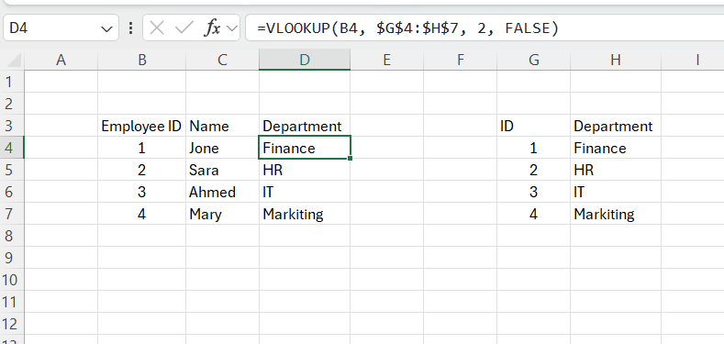

Explanation:
The VLOOKUP function searches for the Employee ID in the lookup table and returns the corresponding Department. This eliminates the need to manually enter data and ensures consistency when handling large datasets.

Task 4
(25 marks)

Communication and Collaboration applications
(Approx. 1000 words)

a. 13 marks
Analyse one contemporary Communication (Email, MS Teams etc.) and one Collaboration (SharePoint, One Drive etc.) applications/tools used frequently in modern business world and document a summary of their key features, benefits and limitations using written text with some images and relevant citations. (approx. 2/3 sources) In today's business environment, communication and collaboration applications are essential tools for organizational efficiency, especially in remote and hybrid work environments. Digital tools have significantly transformed how teams interact, share information, and manage projects. Among the most widely used applications are Microsoft Teams for communication and Miro for team collaboration. Each has a specific role: Teams focuses on structured messaging and meetings, while Miro provides a visual workspace to support interactive teamwork. Microsoft Teams is a comprehensive communication platform integrated with the Microsoft 365 suite of applications. The platform allows teams to collaborate through channels, direct messages, audio and video calls, and file sharing. Conversations are organized into teams and channels that can be public or private, helping to maintain focus and context. The chat feature supports instant messaging with attachments, formatting, and emojis, enabling effective one-on-one and group communication. Teams' integration with Microsoft applications such as Word, Excel, and PowerPoint enables real-time collaboration on documents, including co-authoring in real time[7]. Users can also schedule meetings or host live events using built-in video and audio features. The search history allows for easy retrieval of past messages, files, and discussions, fostering knowledge sharing within the team. Teams also supports integration with external applications, streamlining workflows and improving productivity. Available on desktop, web, and mobile, it ensures continuous communication regardless of location. While Teams improves efficiency and reduces reliance on email, the sheer volume of messages can be overwhelming, and advanced features may require training to use effectively.
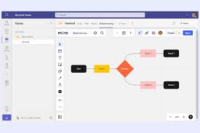

Mero, on the other hand, is an online collaboration tool designed to support visual teamwork. It provides an infinite digital whiteboard where teams can brainstorm, plan projects, and co-create content simultaneously. Mero's real-time collaboration allows multiple participants to see edits and comments instantly, promoting interaction and creativity. It also includes a wide range of templates, such as mind maps, Kanban boards, flowcharts, and evaluation sessions, accelerating planning and idea generation. Sticky notes, comments, polls, and tags help provide feedback and make decisions in an organized manner. Integration with applications like Microsoft Teams, Slack, and project management software enables seamless workflows across different tools. Miro also supports asynchronous collaboration, allowing team members in different time zones to contribute at their own pace. This visual and interactive approach makes understanding complex projects easier and fosters team cohesion and creativity. However, new users may need some time to adapt to its interface, and very large panels with multiple elements can sometimes impact performance.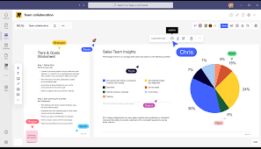

Microsoft Teams and Miro complement each other in the modern workplace. Teams enhances clarity and speed of communication, providing a structured platform for messaging, meetings, and document collaboration. Miro, on the other hand, supports collaboration and creativity by visualizing ideas and workflows effectively. Using these tools together helps organizations streamline communication, improve project management, and foster a collaborative work culture that supports both synchronous and asynchronous collaboration. By leveraging Teams and Miro, companies can break down barriers, increase transparency, and maintain productivity in increasingly digital and distributed work environments[8].
b. 12 marks
Test some features of a freely available Communication (1) and Collaboration (1) application and document several screenshots with brief accompanying description to provide evidence of practical use.
With the increasing reliance on digital technologies, companies are using modern tools to support communication and collaboration among employees, especially in remote and hybrid work environments. This report reviews the features of two free applications: Microsoft Teams as a communication tool and Miro as a collaboration tool, illustrating how to use each in a business setting through practical, step-by-step examples supported by illustrative images.
Using Microsoft Teams in a Business Environment User Case: Organizing online team meetings and facilitating daily communication among company employees. Step Description: A detailed overview of the usage process, supported by illustrative screenshots.
Step 1: Creating or Joining a Team
Employees are added to a team or channel created for a specific department or project.

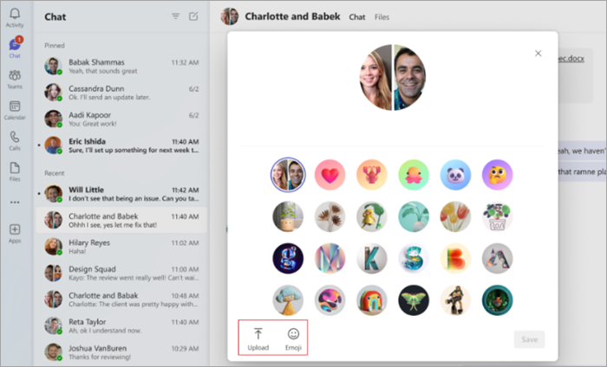
Step 2: Chat and Messaging
Team members send instant messages, announcements, and updates in the channel chat. Ensures fast and clear communication without emails.

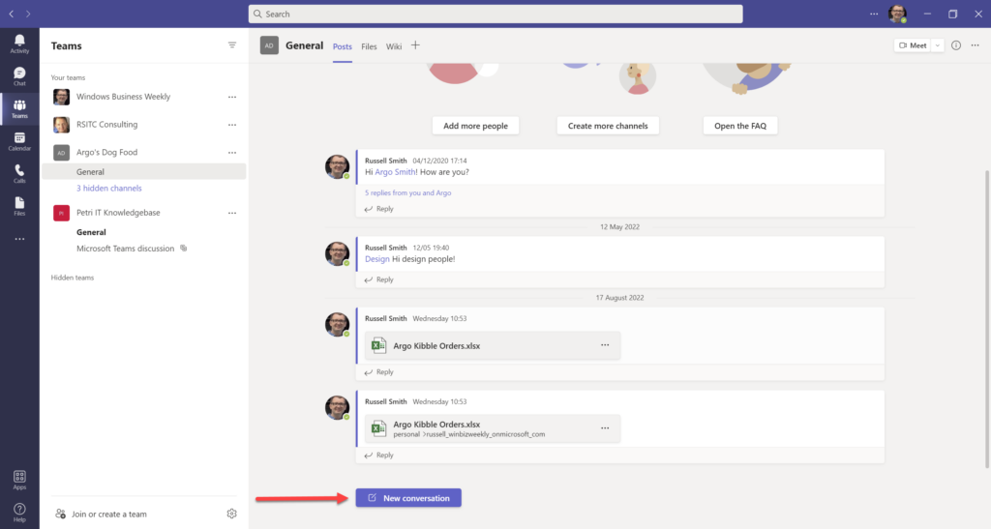Step 3: Video Meeting
A meeting is scheduled or started instantly for discussions and presentations.
Business value: Supports remote meetings and reduces travel costs.

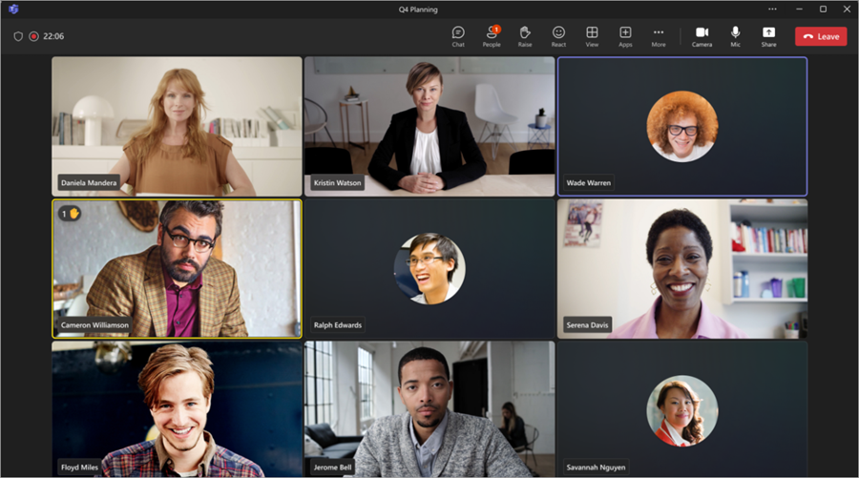
Advantages of Microsoft Teams in a Business Environment Provides instant and easy communication between employees Supports remote and hybrid work models Integrates seamlessly with Microsoft applications such as Word, Excel, and PowerPoint
2. Collaboration App
App Name: Miro
Reasons for Choice:
Miro is a free online platform that enables teams to share ideas, organize and plan projects, and visually represent ideas interactively and in real time.Using Miro in Business Use Case: Supporting brainstorming sessions and project planning during team group workshops[9].
Step 1: Create a New Board
The user opens a new board on the Miro platform to use for organizing ideas or planning tasks.

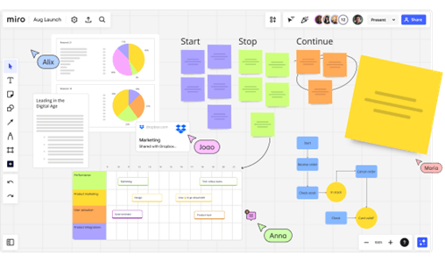
Added Value:
Provides a shared visual work environment for all team members.
Step 2: Add Content Team members add sticky notes, charts, and various shapes to present and share their ideas.

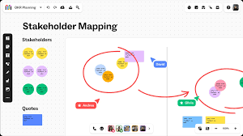

Added Value:
Helps stimulate creative thinking and generate new ideas.

Step 3: Collaborate in Real Time
Multiple users can work on the same board simultaneously and see changes as they happen.
Added Value:
Enhances teamwork and increases interaction among team members.

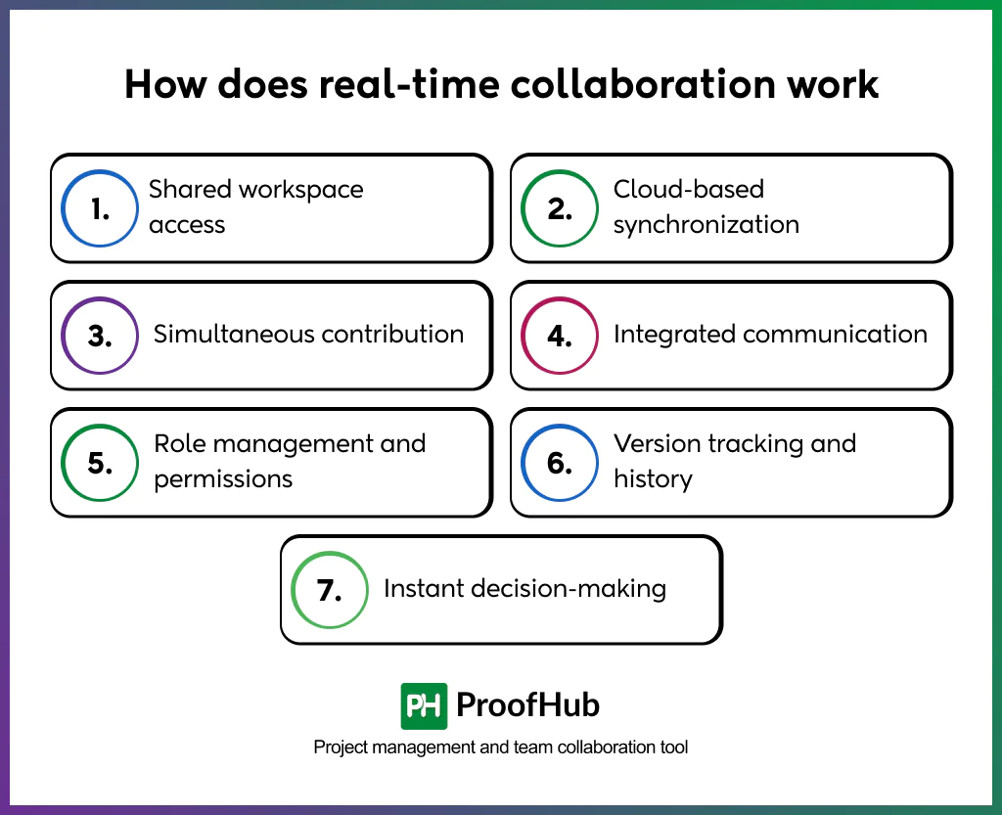

Step 4: Share the Board
A link to the board is sent to team members to enable them to access and participate. Added Value:Allows effective collaboration without needing to be physically present.

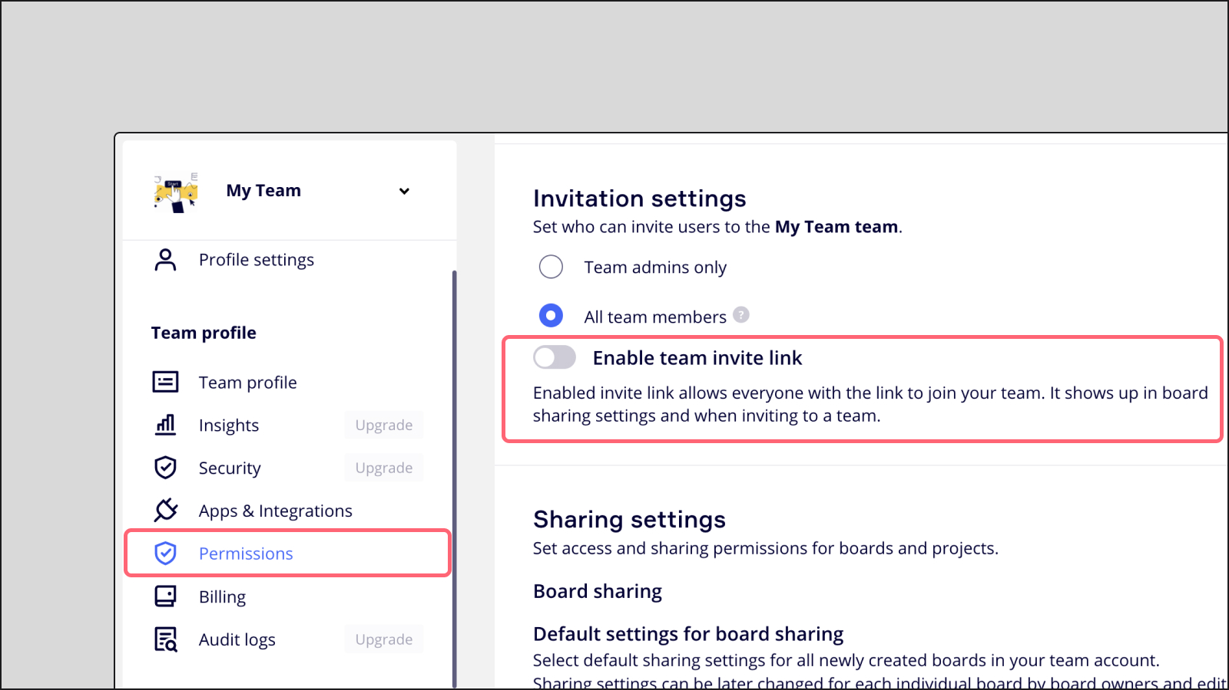
Benefits of Miro in a Business Environment Supports visual collaboration methods Suitable for brainstorming sessions and project planning Promotes creativity and effective team participation

Conclusion

References
References
[1] A. A. Sozinova and N. K. Saveleva, "MARKETING QUALITY MANAGEMENT IN INDUSTRY 4.0 IN TRANSBORDER MARKETS." vol. 16, no. 3, 2022,
[2] Z. Fan, "No title," 2007,
References
[3] B. Kolluri, M. J. Panik and R. N. Singamsetti,Introduction to quantitative methods in business: with applications using Microsoft Office Excel, John Wiley & Sons, 2016.
[4] F. O. SAM-ELEYI and P. Harcourt, "PROFICIENCY IN MICROSOFT OFFICE PROGRAMS AND THE ABILITY TO CREATE REPORTS AND DO STATISTICAL ANALYSIS AMONG OFFICE AND INFORMATION MANAGEMENT GRADUATES OF BUSINESS EDUCATION IN RIVERS STATE."
[5] F. A. Dakhil, W. M. Ali and A. A. A. Reda, "Prioritizing software capabilities and focal points of MS Access and Excel in perspective of data management," vol. 14, no. 3, pp.15–30, 2018,
[6] L. Foulkes, Learn Microsoft Office 2019: A Comprehensive Guide to Getting Started with Word, PowerPoint, Excel, Access, and Outlook, Packt Publishing Ltd, 2020.
References
[7] C. Maican, A. Cazan, R. Lixandroiu, L. Dovleac and M. A. Maican, "Exploring the factors influencing the use of communication and collaboration applications," vol. 33, no. 4, pp.94–124, 2021,
[8] I. Guarino, et al., "Classification of communication and collaboration apps via advanced deep-learning approaches", 2021 IEEE 26th International Workshop on Computer Aided Modeling and Design of Communication Links and Networks (CAMAD), pp. 1–6.
[9] C. I. Maican, A. Cazan, R. C. Lixandroiu and L. Dovleac, "A study on academic staff personality and technology acceptance: The case of communication and collaboration applications," Comput.Educ. vol. 128, pp.113–131, 2019,

