

Module name: Business Intelligence
Assignment 2 –Written Assesment
Word count : 3000 +/-
Module code: LCBB5000
Lecturer name : Gasso Wilson Mwaluseke
Student name: Mariana Mihaela Cicu
Student ID number : 2028271

Executive Summary
The entire paper has described different types of statistical test in the case of identifying the number of students according to the gender as well as the flavour of ice-cream. Along with this, advantages and disadvantages of MS Excel and SPSS has been describe that helps to understand the way of maintain all effective information in an adequate manner. As well as the data mining and text mining process also has described how to maintain their business activities by monitoring relevant information of customer.

Table of Contents
Part 1 4
1. Introduction 4
Main Body 4
Use of excel for visualizing, pre-processing & analysing the data 5
The sale of commodities concerning the category 5
Concerning the units is the sales margin of the product 6
Pre-profit from the sale of profit 8
Pre-processing data 10
Pre-processing data 10
Performance concerning the commodity 11
Conclusion 11
Part 2 12
Introduction 12
2.1 Recognizing the number of students who like the vanilla flavour of ice cream 12
2.2 Identify the number of students is male and female 13
2.3 Explanation of Mean and Median of participants 15
2.4 Clustering with the use of K-means 16
2.5 Explanation of data mining and text mining methods 16
2.6 Advantages & disadvantages of SPSS & Excel 17
Conclusion 18
Reference List 19

Part 1

1. Introduction
The sale from any firm is a necessary factor as it provides help in improving the profitability of the firm in a very significant way. The prime aim of this study is to identify whether there is any decrease in the sales as well as the profit of the firm. Concerning this, certain excel functions had been considered in this paper to understand the decrease in sales as well as the profit. “Pivot Table" is one of the key functions that have been provided to take assistance in recognizing if there is any increase or decrease in the profit or sales. Moreover, with reliable information extraction, it is even necessary to appoint an employee who is very skilful so that the data can be handled effectively and efficiently and productivity can even get enhanced easily. Therefore, data handling is very much authentic as well as a reliable source to make sure the integrity of the firm.

Main Body
In this study, it is further said that the fundamental part of this paper will primarily create an emphasis on various elements as well as factors that generate an impact on the margin revenue of the firm. As discussed by Kirkby, Zhang, et al. (2019, P. 13), The main cause behind the negative impact of the firm’s decreasing revenue is the execution of the firm’s activity over a large scale. In addition to this, taking into consideration the given scenario it can even be identified that the sale, as well as the profit margin of the firm, has decreased over time. The categorization of the commodities into various categories of commodities further determined the cause behind the reduced profit margin.
Moreover, the given data is applied to understand the interest of the consumers concerning the various commodities sales. The understanding of the interest of the customer as well as their taste and preference had even been recognized by an implication of an information visualization technique whereas, with the implication of information visualization techniques firms were able to identify the various categories of products. As opined by Bittner, Nedelchev, et al. (2019, P. 11), it is however perceived that the implication of various Excel functions had formed a huge impact on the estimation as well as the evaluation of the products.

Use of excel for visualizing, pre-processing & analysing the data
The revenue and the profitability is a crucial indicator of financial sustainability of a firm. It can play a crucial role in determining commercial success of a product. Based on the analysis, it has been detected that the financial management of the firm has to consider profit and revenue for monetary success. In the present scenario, the value of sales in the month of August is £261.54. It is also determined that there is a financial loss of £213.25 detected in that month. It can be said that the firm can generate profit whether the revenue is increased. It can play a significant role in ensuring sustainability of the firm. As discussed by Huppmann, Gidden, et al. (2021, P.34), The firm has prioritized its order that contains “medium priority”, “critical priority”, “high priority”, “not a specified priority”., and “low priority”.

The sale of commodities concerning the category
From this study, it can be seen that the various goods, as well as the commodities of the firm, are recognized by the assumption of the various categories of the product. As discussed by Nunes, Anckaert, et al. (2022, P. 20), from the further assumption it can be said that the firm has sold nearly 14,920 products in the previous year. Whereas, the total evaluation of the sales margin further includes various products like furniture, office4 supplies, and various other products.
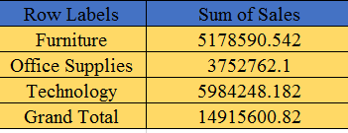
Figure 1: calculation of sales margin concerning the different categories of the product
(Source: Self-developed)
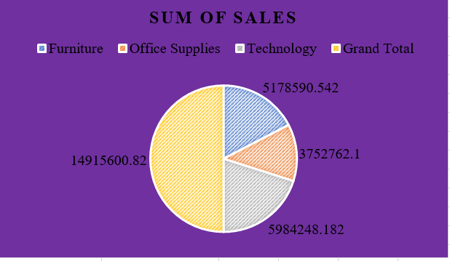
Figure 2: Graph of the category of the product
(Source: Self-developed)
Figures 1 & 2 depict the calculation of sales margin concerning the different categories of the product and the graph of the category of the product. From the above figure, it can be seen and said, that the technological factor is the prime reason for the hike in the operational cost as well as the operational cost. With reliable information extraction, it is even necessary to appoint an employee who is very skilful so that the data can be handled effectively and efficiently and productivity can even get enhanced easily.

Concerning the units is the sales margin of the product

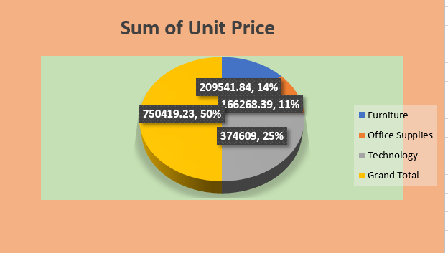

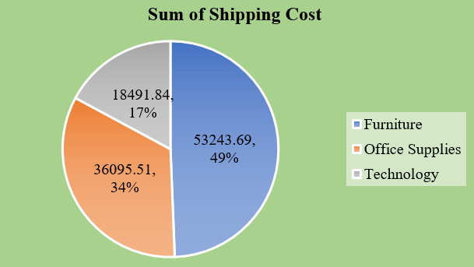
Figure 3: Calculation of the unit price of the product
(Source: Self-made)
Figure 3 depicts the graphical representation of the product by implementing the technique of data visualization. However, by using the technique of price evaluation, the enhanced cost of the product is recognized to be 750419. Hence, it is depicted that the excessive cost of the product is further recognized by comparing the price as well as the range of the two various products. As discussed by Hackl et al. (2021, P. 30), based on the given result & the total evaluation, it can be said that the authenticated data output can be easily carried out by applying smart technologies.

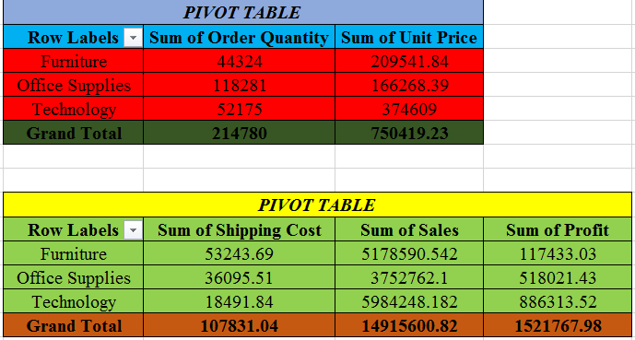
Figure 4: Assumption of the PIVOT table
(Source: Self-developed)

From the previous illustration and given set of data it can be analyzed that the tool the PIVOT table of excel is used to see the data as well as to bring out reliable & authentic information. As discussed by Tournier, Smith, et al. (2019, P. 12), it can further be said that the tools can even be used, to sum up, a bigger set of data. However, with the help of the tool PIVOT tables, it becomes really easy to answer the unanticipated question. According to figure 4, the office supplies information or data are very big in comparison to the other data. Hence the function of the PIVOT table shows the total revenue margin, shipping cost, and product’s profit margin.

Pre-profit from the sale of profit
The prime goal of every firm is to maximize the margin of profit because with the help of it only the business can make essential as well as decisions through data manipulation. Moreover, it said that applying the IF function and various techniques of big data will help in concerning the profit and various products will even get evaluated.

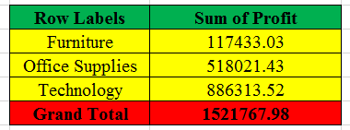
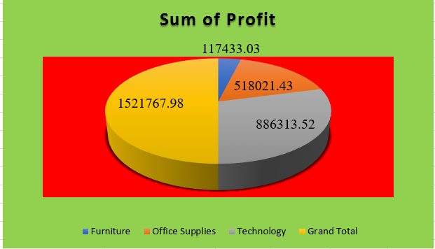
Figure 5: Sales of product based on the profit margin
(Source: Self-developed)
Figure 5 depicts the graphical representation of product sales based on the profit margin. As discussed by NEEDHAM, NAEMI, et al. (2021, P.13), the above figure shows the data that are concerned about the products and are providing help to the firm in increasing the profit margin. The graph however shows that the profit margin had been depicted as £ 1,521,767. However, it can be further seen that the firm after building the strategy of profit enhancement can easily increase its sale margin. Moreover, it can be seen that 60% of the sales margin depicts the growth of income as very low.
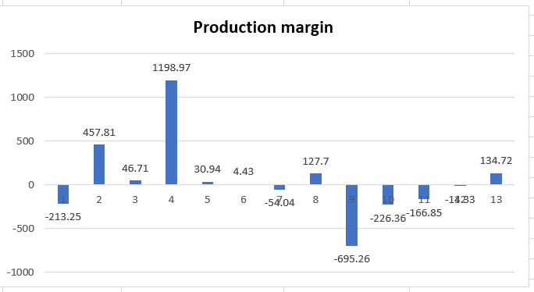
Figure 6: Sales margin concerning the production
(Source: Self-developed)
From the figure 6 graphical image, it can be stated that the data is shown to understand the production margin as well as the range of the various products. As discussed by Nunes, Anckaert, et al. (2021, P. 12), it is observed that the business focuses on the strategy of profit maximization as well as product categorization. However, the implementation of IF requires the supplier to assess the demand & supply as well as the profit margin of the product.

Pre-processing data
In this study, it is defined as a necessary tool that obliges the firm to enhance its manufacturing activity of the firm. As discussed by Golodoniuc, Davis, et al.(2019, p. 2), Not only this, it even provides firm assistance in appropriate usage as well as the transformation of the data set. With the help of the given description by appropriate usage of excel functions, the working of the stock in the market can get evaluated very easily.

Pre-processing data
In this study, it is defined as a necessary tool that obliges the firm to enhance its manufacturing activity of the firm. As discussed by Miltiades, Grant, et al. (2019, P. 23), not only this, it even provides firm assistance in appropriate usage as well as the transformation of the data set. With the help of the given description by appropriate usage of excel functions, the working of the stock in the market can be evaluated very easily.

Performance concerning the commodity
From this study, it can be analysed that the data procession assists in maintaining the total business information to evaluate the performances of the market of the firm whereas it is said that the PIVOT table is used to understand the categories of the products. As discussed by Kent, Gospel, et al. (2022, P. 74), the IF function is applied to analyse the working of the firm. The working of the production depicts that the profit had been reduced by 8361.

Conclusion
Taking into consideration the data set of the superstore, it can be determined that the firm deals with the sales activity of various products. The various activities in which the firm deals are office supplies, furniture, technology, and various other products. Therefore, the pivot table utilization assists in evaluating the various types of commodities. Whereas, in the case IF function, it has been articulated that the tool is implemented to determine as well as implement the diminishing profit as well as the sales margin. It can further be said that the relevant tools can even be used, to sum up, a bigger set of data. However, with the help of the tool PIVOT tables, it becomes really easy to answer the unanticipated question. According to figure 4, the office supplies information or data are very big in comparison to the other data. In the conclusion, it can further be stated that the sale of 38 products has reflected that the profit margin of the firm has declined by 8361 commodities. Hence, it is stated that with the help of various techniques of data visualization evaluation of various shipping costs as well as the cost of the commodities becomes easy.

Part 2

Introduction
The second part will describe the sort functions that are going to be used for calculating the number of male and female candidates that will be sorted in ascending order from smallest to largest number. Along with this, the information regarding the ice cream also will be sorted in the same way from largest to smallest number. Furthermore, the calculation of mean, median and more also can be found in this part with the help of different types of statistical tests. Moreover, the present study paper will represent the value of the median of the student in which the number of students who liked strawberry and chocolate flavoured ice cream will be known.

2.1 Recognizing the number of students who like the vanilla flavour of ice cream
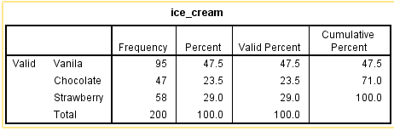
Figure 7: Frequency test of ice cream flavour
(Source: Developed by the learner)
After gathering all effective information regarding the students it has been found that 91 male students mostly liked the vanilla flavour of ice cream.
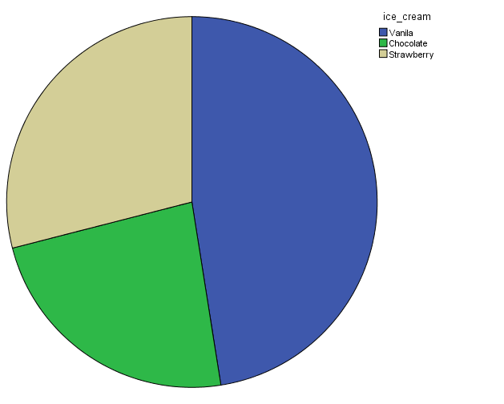
Figure 8: Pie-chart for different types of ice cream flavour
(Source: Developed by the learner)
The above graph is representing the percentages of each flavour that is most liked by the students individually. In this case, it can be recognized that vanilla flavour is liked mostly

2.2 Identify the number of students is male and female
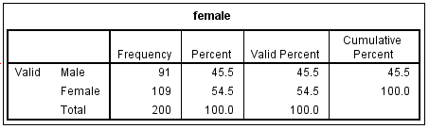
Figure 9: Frequency test of gender
(Source: Developed by the learner)
Concerning the information regarding the total number of students, it has been recognized that the total number of male students is 91 and the total number of female students is 109. In this case it has been figured out that all the effective information or data has been ascended from smallest to largest number by using the sort functions of MS excel.
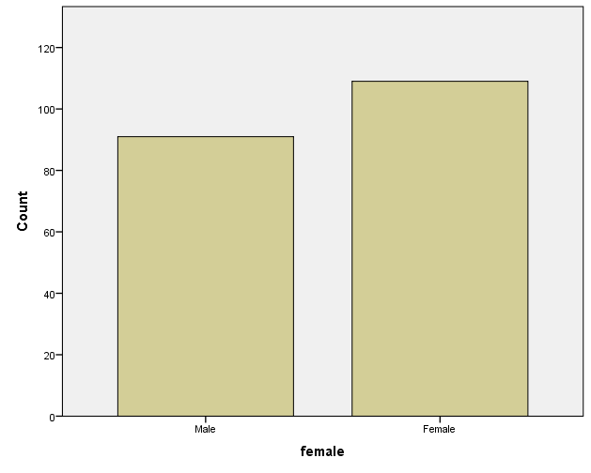
Figure 10: Graph of gender
(Source: Developed by the learner)
The above graph represents the highest number of female students for 109 female students who like chocolate-flavoured ice cream among 200 students. Based on the “visual representation”, it is also determined the comparison of male and female.

2.3 Explanation of Mean and Median of participants
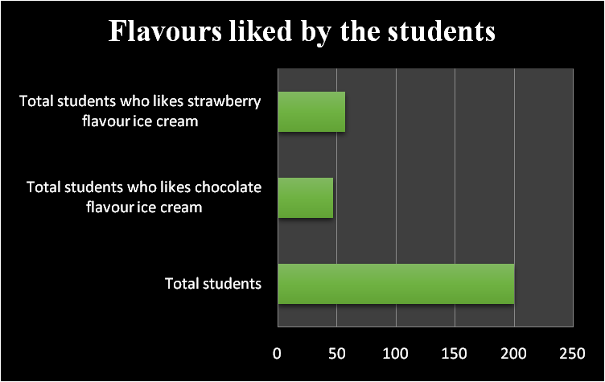
Figure 11: Different flavours liked by the students
(Source: Self-developed)
The above graph represents the number of students who like chocolate flavour ice cream and strawberry flavour ice cream. In this case, it has been recognized that 47 students mostly like ice cream with chocolate flavour and 57 students like to have strawberry-flavoured ice cream among 200 students. Based on the number identification the value of the mean for the students that mostly liked the ice cream with the flavour of chocolate has been figured at 23.5. Along with this, the value of the median for the students that mostly like to have ice cream of strawberry flavour has been determined at 28.5. However, the value of the median of the entire dataset has been determined which helps to know the middle value of the entire dataset. Furthermore, the median value for the students who like chocolate flavour has been determined for 2 as well as, and the student who likes strawberry flavour has been calculated for 3.

2.4 Clustering with the use of K-means
According to the words of Yang and Sinaga, (2019, p.114472) K-means clustering is the most effective statistical test that is used for finding the groups that have not been explicitly labelled in all the information or data. In this case, based on the data regarding male and female students and different kinds of flavours of ice cream, K-means clusters have been figured out.
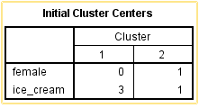
Figure 12: K-means
(Source: Self-developed)
The figure is reflecting two different variables such as female and ice cream in terms of conducting the K-means cluster test. In this case, it can be found that the evaluation of K-means clustering for the variable as female has been determined for 0 in cluster 1 and 1 in cluster 2. In the same way, k-means have been determined for ice cream as 3 in cluster 1 and 1 in cluster 2. Concerning the outcome, it explains that there are a larger number of students than the total number of ice creams that maintain the equilibrium among the students.

2.5 Explanation of data mining and text mining methods
Data mining is the most effective procedure in the case of data analysis that helps to manage the bank's work with the credit rates as well as the anti-fraud systems. Along with this, in terms of analyzing the financial data of each customer in a business, recognizing the transactions of purchasing and the card transaction, the data mining prices bring many opportunities to get effective outcomes within a very short period (Ribeiro et al. 2019, p.684). Furthermore, the data mining method also helps to understand the habits and preferences of the customer which is effective to increase total revenue over the period. Eventually, the marketing manager of the company will be able to identify new marketing designs effectively and efficiently.
On the other hand, the text mining procedure enables the researchers to identify and recognize the amount of mass of all effective pieces of information within a very short period (Júnior et al. 2018, p.8). In this case the outcome of the text mining can be considered as the surface of the significant links between several kinds of entities that may not have been found.

2.6 Advantages & disadvantages of SPSS & Excel
SPSS & Excel both are effective techniques as well as a tool that provides assistance to analyze, interpret, and store data in a very effective way. As discussed by Lee, Cordell, et al. (2020, P. 11), both tools had advantages as well as disadvantages which are depicted below.
Tools & Techniques | Advantages | Disadvantages
Excel | i. Any individual can perform the calculation with the help of this tool.  ii. It is a simple method to visualize the charts along with the data.  iii. It is one of the best ways of data storage.  iv. It provides help in transferring as well as clearing the data effectively. | i. Excel included various functional tools which required various steps to calculate increased represent time consumption.  ii. Since Excel contains various tools which require a price, hence it is stated that Excel is a very cost-effective method.  iii. It might lead to an error in the calculation.
SPSS | i. It is an effective data management system.  ii. It gives a reliable outcome to the users.  iii. This type of software can be used for both qualitative as well as quantitative data. | i. It is very much similar to excel.  ii. It is very expensive software and students might not be able to use it.  iii. It only contains very limited functions to perform.

Table 1: Advantages & disadvantages of excel & SPSS
(Source: Self-developed)

Conclusion
After all of these, it can be concluded that using frequency tests the number of flavours of ice cream and the number of male and female students has been identified effectively. In this case the K-means statistical test has described the value of k-means in two different clusters in which it has been found that the number of students is highest. the information regarding the ice cream also will be sorted in the same way from largest to smallest number. Furthermore, the calculation of mean, median and more also can be found in this part with the help of different types of statistical tests. Furthermore, the study paper also has described the advantages and disadvantages of MS Excel and SPSS which have helped to know how to maintain the dataset with the help of MS-Excel and SPSS in an adequate manner. Along with this, once a business organization focuses on adopting data mining and text mining system in their business they will be able to maintain all effective information as well as the customer need and preferences effectively and efficiently by mitigating all problems.

Reference List
Bittner, A., Falcón-Barroso, J., Nedelchev, B., Dorta, A., Gadotti, D.A., Sarzi, M., Molaeinezhad, A., Iodice, E.N.R.I.C.H.E.T.T.A., Rosado-Belza, D., de Lorenzo-Cáceres, A. and Fragkoudi, F., 2019. The GIST pipeline: A multi-purpose tool for the analysis and visualisation of (integral-field) spectroscopic data. Astronomy & Astrophysics, 628, p.A117.
Golodoniuc, P., Davis, A., Bradley, S. and Mulè, S., 2019. GPT: Scalable geophysical survey data analysis and visualisation. ASEG Extended Abstracts, 2019(1), pp.1-5.
Hackl, J., Scholtes, I., Petrović, L.V., Perri, V., Verginer, L. and Gote, C., 2021, April. Analysis and visualisation of time series data on networks with pathpy. In Companion Proceedings of the Web Conference 2021 (pp. 530-532).
Huppmann, D., Gidden, M.J., Nicholls, Z., Hörsch, J., Lamboll, R., Kishimoto, P.N., Burandt, T., Fricko, O., Byers, E., Kikstra, J. and Brinkerink, M., 2021. pyam: Analysis and visualisation of integrated assessment and macro-energy scenarios [version 2; peer review: 3 approved]. Open Research Europe, 1.
Júnior, J.B., Cappelli, C., Revoredo, K. and Nunes, V., 2018, May. Text mining as a transparency enabler to support decision making in a people management process. In Proceedings of the 19th Annual International Conference on Digital Government Research: Governance in the Data Age (pp. 1-8).
Kent, L., Gopsill, J., Giunta, L., Goudswaard, M., Snider, C. and Hicks, B., 2022. Prototyping through the Lens of Network Analysis and Visualisation. Proceedings of the Design Society, 2, pp.743-752.
Kirkby, A.L., Zhang, F., Peacock, J., Hassan, R. and Duan, J., 2019. The MTPy software package for magnetotelluric data analysis and visualisation. Journal of Open Source Software, 4(37), p.1358.
Lee, B., Hu, X., Cordeil, M., Prouzeau, A., Jenny, B. and Dwyer, T., 2020. Shared surfaces and spaces: Collaborative data visualisation in a co-located immersive environment. IEEE Transactions on Visualization and Computer Graphics, 27(2), pp.1171-1181.
Miltiadou, M., Grant, M.G., Campbell, N.D., Warren, M., Clewley, D. and Hadjimitsis, D.G., 2019, June. Open source software DASOS: Efficient accumulation, analysis, and visualisation of full-waveform lidar. In Seventh International Conference on Remote Sensing and Geoinformation of the Environment (RSCy2019) (Vol. 11174, pp. 524-540). SPIE.
NEEDHAM, R., NAEMI, R. and CHOCKALINGAM, N., 2021. Advancements in data analysis and visualisation techniques to support multiple single-subject analyses: an assessment of movement coordination and coordination variability. Studies in health technology and informatics, 280, pp.146-149.
Nunes, C., Anckaert, J., De Vloed, F., De Wyn, J., Durinck, K., Vandesompele, J., Speleman, F. and Vermeirssen, V., 2021. HTSplotter: an end-to-end data processing, analysis and visualisation tool for chemical and genetic in vitro perturbation screening.
Nunes, C., Anckaert, J., De Vloed, F., De Wyn, J., Durinck, K., Vandesompele, J., Speleman, F. and Vermeirssen, V., 2022. HTSplotter: an end-to-end data processing, analysis and visualisation tool for chemical and genetic in vitro perturbation screening. bioRxiv, pp.2021-09.
Ribeiro, J., Duarte, J., Portela, F. and Santos, M.F., 2019. Automatically detect diagnostic patterns based on clinical notes through Text Mining. Procedia Computer Science, 160, pp.684-689.
Tournier, J.D., Smith, R., Raffelt, D., Tabbara, R., Dhollander, T., Pietsch, M., Christiaens, D., Jeurissen, B., Yeh, C.H. and Connelly, A., 2019. MRtrix3: A fast, flexible and open software framework for medical image processing and visualisation. Neuroimage, 202, p.116137.
Yang, M.S. and Sinaga, K.P., 2019. A feature-reduction multi-view k-means clustering algorithm. IEEE Access, 7, pp.114472-114486.

