George Parker (1704367)

Personal learning environments

Learning and collaboration for global citizenship (BMSP4003)

Dr Alex Bell

3rd of April 2018

Personal learning environments

An introduction to personal learning environments

Personal learning environments are one of the best forms of information transfer to a person no matter the age or technological capability. Personal learning environments are systems that strive to help the learner to take control of their own learning by finding what methods and forms of information transfer are most compatible with the intended user. Personal learning environments are inclusive of teachers by allowing for the provision of support and guidance towards set goals allowing for the teacher to manage the information learned both in terms of content and process (Gilbert, n.d.).
Personal learning environments are a massively all-encompassing spectrum and to assist in the understanding of what the spectrum contains within a personal learning environments there is at one end there is the “personalisation for the learner” which is tailored by the provider of information or teacher and at the other end of the spectrum defined by Dan Buckley there is the “personalisation by the learner” allowing for the learner to use forms of learning that they know works for them and use this knowledge to adapt future tasks to themselves creating a much more efficient personal learning environment.
The origin of personal learning environments
Personal learning has been in existence for over fifty years when it was a process considered to only be created by the few highly trained individuals that through the use of technology and the process of teaching allowing limitless students to become active in the role of highly personalising their own learning (Epstein, Sam and Beryl., 1961). Although at this time there is no set definition or requirements for a personal learning environment which perhaps is a positive as it allows for the topic of personal learning environments to be open ended and open to the interpretation of the individual whether that to be the teacher that is to create a personal learning environments for students or the student that is looking to adapt their learning in an advantageous way to one’s self (Fiedler and Väljataga, 2011). In two thousand and six Microsoft adopted the spectrum of personal learning environments through the practical guide to envisioning and transforming information, this was a very good step forward for personal learning environments as they are much more adaptable when used in conjunction with digital technology allowing for higher levels of individualisation for the intended user by a teacher or by the users themselves (Richards, 2006).
Digital media uses in personal learning environments
Digital media allowed for personal learning environments to become much more unique and adaptable to the user as the capabilities of technology are endless. They most integral aspect to technology is the ability to access it and in recent year’s technology has almost taken over where every individual owns either a computer, phone or tablet although it is much more common for an individual to own two or three of these devices. This level of access to technology means learning can take place in both formal learning environments such as class rooms with high levels of organisation that can be a widely assisted by the use of technology for the purposes of learning and also in non-formal learning environments such as discussion forums and study groups which can have a strong dependency upon technology for their function whilst also having much lower levels of organisation than formal learning environments. Finally there are informal learning environments, these have the goal of providing knowledge although they can have little to no formal structure and are much more integrated into everyday life such as using social media to view an informative video or reading a magazine that contains information on obscure knowledge that was not previously known (EPALE - European Commission, 2018).
Attitudes and understanding of media
There are a lot of concerns and issues that people have with media and the internet in general and people are right to be concerned as there are issues that people feel they need to protect themselves from online such as fraud and identity theft. Luckily there are many precautions that can be takes to protect yourself such as making personal information inaccurate by changing your shown birth data to one that is wrong and removing photos of yourself and avoiding filling in online surveys so that your personal information cannot be harvested and used for purposes that you have not agreed to (Company, 2018). There are many regulations in place on the internet that are designed for the users protection meaning that information cannot be stolen and when the user knows this confidence online can increase meaning that users feel much more confident doing things online, through the feeling of confidence the user can become better at navigation the internet to find information such as trusting search engines such as google and Bing to lead you the information that you seek without having to look in depth through many other pieces information to find what you were originally looking for. Online privacy is the most common way of obtaining internet confidence, internet privacy allows for the user to have the right towards privacy when concerning the use of user information by the host site and disallowing for the sales of information on users to third party groups that may wish to refine target markets and focused efforts for the ultimate goal of higher profits (Company, 2018). There are two forms of privacy the first from is personally identifying information and this refers to information such as a person’s personal address and phone number and the second is non-personally identifying information which refers to the number of visitors that a sight has as well as a user’s behaviour on a website, this is monitored so that website administrators can act appropriately for the good of the website. It is important to consider the other side of this opinion that people can use the internet to broadcasts themselves and their lives because it may follow a trend or be an expressive form of someone’s personality, and this can be supported by privacy investigation specialists such as Steve Rambam who says “privacy is dead get over it” (https://www.youtube.com/watch?v=DaYn_PkrfvQ, 2018). (Anon, 2018).
A part of the google generation
The google generation is most likely the most connected generation in history, the google generation are those born after nineteen ninety three and are brought up in a highly immersive atmosphere accompanied by a lively culture full of media activity and access to almost any form of knowledge and information only a fingers click away. The google generation have adopted the core need to feel connected to the internet perhaps as the internet provides the generation with assurance where it be on the way they look, to support their opinions or even to ensure that they do not feel alone. The google generation can also be known as the cut and past generation this may be because the generation has become such highly reliant on technology that they have become incapable of thinking for themselves and rely upon others for their knowledge and way of thinking rather that forming their own opinions and solving their own issues. There are positive parts to being a part of the google generation such as being able to pick up technological skills through trial and error meaning that the google generation feel comfortable making mistakes with technology in the pursuit of ultimately being able to adequately use technology in question. The google generation are also quite advanced at searching the internet for knowledge and being able to find it quickly with ease, this may be because search engines are an ideal fit for collage life as it requires no library either online or physical and in fact eighty nine percent of students will use search engines at the start of an information search with the rest choosing from a library or an online library. This may also be as obtaining physical copies and even online copies of books are very expensive and as student life does not leave room to spear money on expensive books (De Rosa, 2006).
Web 2.0 and its impact
Web 2.0 is a different type of web, it is focused around user generated content and interconnectivity allowing users and creators to connect their ideas together without issue open up a dialog allowing others to get involved and learn from one another profiting from shared experiences. There are further characteristics that are identified by O’Reilly as “harnessing collective intelligence” meaning that there is not a problem that cannot be solved when people come together in pursuit of their collective goal (O'Reilly, 2018). It is important to state that web 2.0 is not at all an update on what is called web 1.0, they are two separate areas of the internet even though they are connected as a bridge separated two land masses. A large aspect of web 2.0 is its connection to social media and indirectly using social media as a personal learning environment as the user generated data acts as a perfect incubator for a virtual community enveloping all that wish it to become involved within it. Sites such as Wikipedia, Facebook and 4chan are the best given examples resulting from their range of discussions and ideas.
My personal learning environments
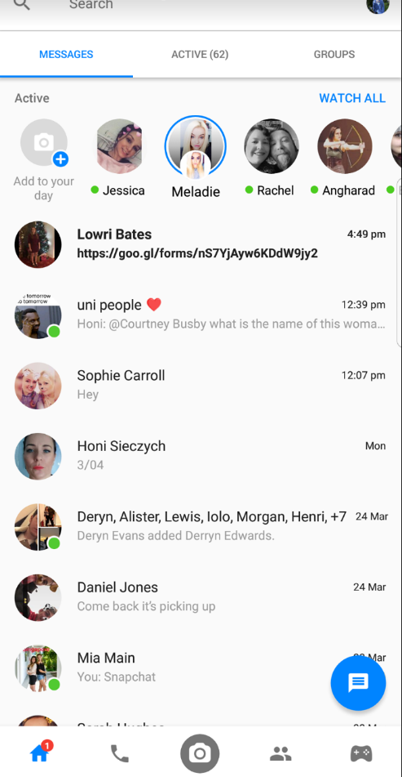
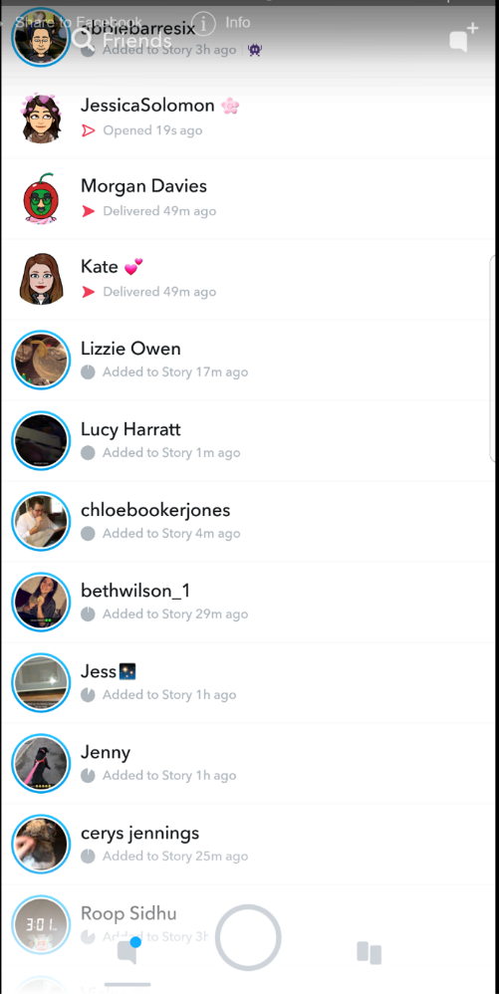
Personally I use many different types of personal learning environments each day in order to do my work and assist me in a lot of other areas of my life, these include audio and video focused personal learning environments skype and WhatsApp as they allow me to communicate with my fellow students for discussions when it is not possible to meet in person. Similarly to this I also use online audio and visual personal learning environments such as Spotify to listen to informative pod casts as well as viewing YouTube videos to help visually explain difficult topics and share these with others to help. Also I use games as a form of personal learning environment as they keep me interested and focused longer than I usually would with other types of personal learning environments, I often use words with to increase my knowledge as well as using kahoot in a classroom to create competition as a fun form of learning. Another helpful personal learning environment that I use is blogs and news sources as these are often highly informative and as up to date as it is possible to be although the most common personal learning environment that I use is most definitely social media for me personally these mainly include Facebook as its used for me as the location for group chats and pages to help with our learning. Then there is snapchat which is a good way to share images amongst friends of helpful pages and extracts of information very similar there is Instagram, tumbler and Pinterest allowing for each user to tag each other in relative imagery that can help in learning. Twitter is also useful as it provides a platform for conversational issues to find the opinions of others and gauge the general opinions of others on issues.

These personal learning environments are my most commonly used informal methods of information transfer as hey suit my way of learning with is focused much more towards interaction and visual learning rather that learning that is focused around using books and journals.

Bibliography

Anon, (2018). [online] Available at: https://www.emeraldinsight.com/doi/full/10.1108/00012530810887953 [Accessed 28 Mar. 2018].
Company, T. (2018). Opinion | How the Republicans Sold Your Privacy to Internet Providers. [online] Nytimes.com. Available at: https://www.nytimes.com/2017/03/29/opinion/how-the-republicans-sold-your-privacy-to-internet-providers.html [Accessed 28 Mar. 2018].
Company, T. (2018). Opinion | Republicans Attack Internet Privacy. [online] Nytimes.com. Available at: https://www.nytimes.com/2017/03/29/opinion/republicans-attack-internet-privacy.html [Accessed 28 Mar. 2018].
De Rosa, C. (2006). College students' perceptions of libraries and information resources. Dublin, Ohio: OCLC Online Computer Library Center.
EPALE - European Commission. (2018). The downsides of digital learning environments - EPALE - European Commission. [online] Available at: https://ec.europa.eu/epale/en/blog/downsides-digital-learning-environments-0 [Accessed 28 Mar. 2018].
Epstein, Sam and Beryl. (1961). Science Education, 39(1), pp.73-73.
Fiedler, S. and Väljataga, T. (2011). Personal Learning Environments. International Journal of Virtual and Personal Learning Environments, 2(4), pp.1-11.
Gilbert, A. (n.d.). Research and development in higher education.
https://www.youtube.com/watch?v=DaYn_PkrfvQ (2018). [image].
O'Reilly, T. (2018). Open Source Paradigm Shift - O'Reilly Media. [online] Archive.oreilly.com. Available at: http://archive.oreilly.com/pub/a/oreilly/tim/articles/paradigmshift_0504.html [Accessed 28 Mar. 2018].
Richards, C. (2006). Towards an integrated framework. Technology, Pedagogy and Education, 15(2), pp.239-255.

