Student Name:Alexandra Dobridoreanu
Id Student:1817744
Module Name:Professional Career Development
Lector:Mary March

Professional Career Development

Table of Contents
Introduction 1
1. Analysis of Reflection Model 2
2. My Career Plans 4
3. Employers Requirements for the Job Market 5
4. Self-motivation 7
4.1 Refection on What Motivates Me 7
5. Reflection on My Learning Style 9
6. Personal Development Tools 11
6.1 The Johari Window 11
6.2 Force Field Analysis 12
6.3 Personal SWOT Analysis 13
7. Employment Goals 14
Conclusion 15
References 18

List of Figures
Figure 1: Gibbs Reflective Cycle 2
Figure 2: Employers expected employee qualities 5
Figure 3: VAK Learning Style 9
Figure 4: The Johari Window 11
Figure 5: Force Field Analysis 12
List of Tables
Table 1: A sample of demonstrating employees expected qualities 6
Table 2: Personal SWOT analysis 13
Table 3: Personal Action Plan 16

Introduction
Professional career development is a process of the different task which helps to gain expertise in the expected field of an individual. It helps to prepare a set of objectives and goals which will build the path for a career. A career development plan helps to identify areas of improvement and identifies lacking which needed to improve before someone goes into action in professional life (Zepeda, 2019). This plan is a personalised strategy to develop expertise and incorporate aspirations into reality. This report will be a reflective model of myself where I will write a professional development plan in a reflective perspective where I will demonstrate my career paths, learning methods, and a future career development plan. I will be able to understand and demonstrate the needs and requirements of the skills, their appropriateness for my goals, and my understanding of my strengths, weaknesses, opportunities, and threats which will help me to administer my goals.

1. Analysis of Reflection Model
Gibbs's reflective cycle is one of the famous reflection models which was developed by Graham Gibbs in 1988 to learn through experiences. It offers a framework for examining experiences, and given its cyclic nature lends itself particularly well to repeated experiences, allowing you to learn and plan from things that either went well or didn’t go well. There are six stages to this reflective cycle which are described below:
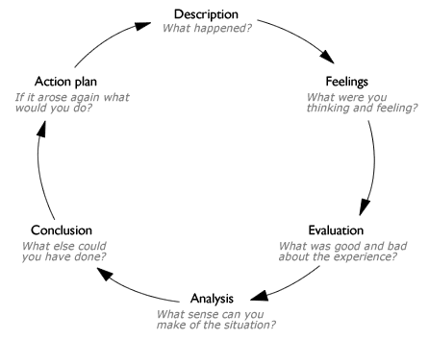
Figure 1: Gibbs Reflective Cycle
Source: (Bassot, 2015)
Description: Description is the explanation of what happened earlier for any task. Here individuals generally decide what happened, when, and how happened, what was the outcome of the situation (Bassot, 2015). To prepare this essay I have gathered many experiences that help me to understand the outcome. I have found students to struggles for a proper career plan and ended up choosing contradictory plans which didn’t work well. In my case, I have gained experience by choosing the wrong set of training and development program which was contradictory to my future career plan.
Feelings: Feelings are the sentiment of becoming a failure at that time. It motivates people often positively and negatively. When I ended up choosing the wrong programs for myself I felt frustrated and vague about my decisions. I was feeling not prepared to compete in the market. But before choosing those programs I was cheerful that I am doing something good to boost my capability.
Evaluation: Evaluation helps to find out good and bad things about these decisions such as what went well and what didn’t and what contributes to this situation (Hayes et al., 2017). I was choosing those programs by becoming motivated to hear some influencer’s advertisement and also I left those decisions by hearing some motivators who gives knowledge on how to pursue career goals. It didn’t go well because my career goal was contradictory and not applicable to attain those goals.
Analysis: Analysis helps to make sense of what happened as until the individual just knew what happened and this stage helps to understand why that happened. Now individuals are focused on the matters and target the mistakes (Zepeda, 2019). In my case, I found that these training programs are not for myself and I should look at others to enhance my expertise. It gives knowledge of deciding and analysing things before going for a specific program that will be appropriate to my goals.
Conclusion: The conclusion sums up the learning outcomes of the situation and highlights the actions to take. I have learned that before gaining a professional course I should select my priority and then I should make a plan and process to achieve those career goals. I could have asked my mentors what extra-curriculum I can take for my objective which might save my time and money I spend on those training programs.
Action Plan: Action plan is the plan of activities which I will take if I ever go to this situation again (Hayes et al., 2017). I will never do this mistake without understanding the needs and requirements of this training. I will always adjust the pros and cons and before going to that situation. If I ever fall into this situation again, I will leave this training and will work on amending it.

2. My Career Plans
In the field of work employers and employees have a different set of expectations which should be matched and awareness of the sector, locality, and individual should be identifiable by the employers and employees. Employees need to know about the actual vacancies and should be knowledgeable about their appropriate career plan. In this segment, I will discuss my future career plans.
Education and Training: Education and training are the most important option for planning future growth. This helps to gain experience and knowledge about the employment base and helps to gain skilled expertise about specific requirements. Education and training are given through different institution and sometimes education doesn’t need any academic curriculum. People can gain knowledge from different sources (Field, 2013). I am planning to extend the boundary of my educational qualification for my future growth. I will get admission for gaining a professional qualification in the London business school. I will get admission to their MBA program in management by the end of this year 2020. There I will be able to gain knowledge about professionalism in business, leadership knowledge, problem-solving knowledge, etc. training gives a man perfectionism about the specific task. I will accumulate some technical knowledge from different training program organised by the different professional institution in the UK. Technical knowledge is the best achievable from training hence I will take part in a soft skill development training program.
Management consultant: Management consultants are the employees of the organisation who conduct research, analyses the information to find the weakness of the companies, and prepare management and policies to fix them so that they can achieve corporate goals. Management consultants are the people who solve issues, create values for the companies, maximise growth and profit, and improve the overall performance of the business (Markham, 2014). I want to become a management consultant as I have aspirations for these jobs and I am trying to accumulate specific job knowledge and expertise for this job. This is an option I have chosen for my future career as this career has employment growth and lots of opportunities in the market.
Business analyst: A business analyst interacts with the stakeholders of the companies so that they can understand the problem needs and wants. They help in guiding businesses to improve the process, products, services, software through data analysis. Their task is to gather information, documents, solve requirements through data analysis. This is an unconventional job and has ample opportunities in the future. Most companies in today’s world are data-driven. Organisation needs experts who can analyse customer data for product and market development (COOK, 2018). I am choosing this option because this job offers significant financial support and the macro-environment of the markets offers lots of vacancies in different organisation.

3. Employers Requirements for the Job Market
Learning styles are a particular way of individual learns to acquire knowledge and expertise. Different people have a different mode of learning styles. In the job market employers have different requirement about the employee's qualities which employers want in their team which is discussed below:
What employers want: Employers have a different set of expectations from the employees which can help them to collaborate with different department jobs and corporate goals. Employers set priorities of qualities for different department roles but there are some qualities employers want as basic requirements in their team.

Figure 2: Employers expected employee qualities
Source: (Levine and Toffel, 2010)
Employers want to see honesty and integrity, trustworthiness among the employees from day one of their job. Employees will be able to listen to others, integrate works, present ideas, and creativity, work safely, time management skills, give attention to details, and should balance their professional and personal hours. When an employer gives jobs to people they look forward to people who already have these qualities so that preparing them for the job becomes easier for the training authority and has expert knowledge before starting their job.
Whether I can demonstrate these qualities: To demonstrate these qualities, every employee should have self-motivation which will push them to achieve, produce, develop, and moving forward. Employees can only demonstrate when they have inner motivation to gain these qualities and apply these qualities (Levine and Toffel, 2010). I am an enthusiastic and motivated person which can force me to demonstrate these qualities at the workplace. I want to be a management consultant in the companies where I will need these requirements to fulfill my job. That’s why before entering my professional life I have prepared a list of preferences of these qualities which I needed most at the workplace and need to develop more.
Qualities of Employees | How I can demonstrate
Honesty and Integrity | I will not pamper internal crucial information to other companies
Trustworthiness | I will be liable to keep secret of company strategies
Ability to listen | I will allow sharing ideas of their employees and will listen to them
Ability to integrate | I will integrate managerial goal and my suggested tactics and strategies
Ability to present to ideas | I will suggest different tactics which will compete with a business situation
Work safely | I will use protected software so that my work doesn’t get pirated
Good time management | I will set deadlines work according to this
Demonstrate attention to details | I will emphasise each requirement
Personal time management | I will keep separate hours for my personal and professional life
Table 1: A sample of demonstrating employees expected qualities
Source: Self
For example: as a management consultant I need integration of work skills and time management skills more than others as this job needs collaboration of the performance and timely work for higher managerial decisions. I have already gained these qualities by attending group work and different competitions. I also assisted my teachers in prepare research work which helps me to grow these qualities. In the management consultant position, I will be able to demonstrate these qualities by perming timely work and providing consultation by analysing organisation performance. Suppose I can suggest to them how to enhance 5% sales in 5 months inflation periods by preparing reports and strategies before inflation begins.

4. Self-motivation
Self-motivation is the encouragement people found form themselves without the influence of other people or situations. This motivation doesn’t influence anything irrespective of a person’s situation. It’s an internal drive that pushes people to produce, achieve, develop, and moving forward. When people are in a dilemma in doing something self-motivation is the only thing that pushes people whether to take it or quit it. It satisfies desire, serves expectations, and changes behaviour (Snow and Narváez, 2017). Different types of self-motivation push people. Some people are influenced by their autonomy characteristic which enables them to work according to their own choice. Some people think their work is crucial and make a difference in the world. Some want to have recognition by others, some want stability in the future, others may want social standing among the crowd (Snow and Narváez, 2017). Self-motivation is of four kinds; Intrinsic motivation which comes from internal reasons, an extrinsic motivation which comes from outside, the introjected motivation which comes from a person’s feeling of guilt and identified motivation which comes from person planning.

4.1 Refection on What Motivates Me
Many motivating factors push people to perform a specific task. Some people are motivated by achieving success, some motivate by deadlines, target and goals, mentoring, coaching, learning new things, creative ideas, analysing complex data, etc. I have many sets of reflecting factors that motivate me. Here I am disclosing my motivating factors.
- Meeting deadlines: Deadlines are the date of completing tasks within which all the activities should be performed related to this task (Urban and Wood, 2015). Deadlines help me to define my task, divide them, set priorities to complete the task, and help me to create strategies to complete them.
- Learn new things: I like to learn new things and their application in real life. When I try to learn new things I focus on how to intricate that knowledge in gaining success. I prefer learning in a different scope of areas which gives me real-life knowledge and morals of building etiquette and respect people.
- Success: I want success in my life for which I do what needs to achieve this success. I synchronise my decisions, set goals for those, and practice those. This is one of my prime motivators which push me to go forward. Credibility and social recognition are the major reasons here.
- Achievements: Achievements are the result of performance. Achievement is a very crucial factor that motivates (Urban and Wood, 2015). Last year I got the best student award which motivates me to work harder to gain this award this year also. When I will become an employee I would love to get awards of the best employee in the organisation because I know this is something I work for throughout the year

5. Reflection on My Learning Style
Learning style is the preferred mode of learning through which the individual learns, acquire knowledge and skills. There are many learning styles; such as Kobbs learning style, Honey and Mumford, and VAK learning style. Here is an overview of the VAK learning style is given below:
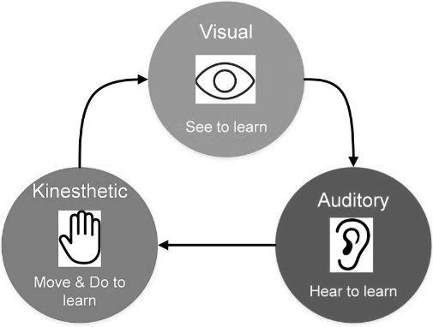
Figure 3: VAK Learning Style
Source: (Walsh, 2011)
Visual, auditory, kinaesthetic also known as VAK learning style is invented by Fernald, Keller, Orton, Gillingham, Stillman, and Montessori, starting in the 1920s who were psychologists and teaching specialists. According to this model, people first learn by seeing, hearing, and doing it by themselves. VAK learning style suggests three particular styles of learning. First, Visual learning style by which people learn just by seeing and the rate is 65% of the population and they are best learned by written materials, diagrams, pictures, etc. secondly, auditory learning styles by which people learn by hearing music, video clips, conversations (Walsh, 2011). Lastly, Kinaesthetic learning style is a style of learning which takes place by the students by carrying objects by themselves, by doing physical activities. The VAK learning style is the most convenient way of learning individual takes up to learn something over the years.
My learning Style (Kinaesthetic learning style) I have learned things by not using any specific learning model rather I use different learning models for different things. I generally prefer learning using a visual learning style but I often use the kinaesthetic model of learning as it helps me to find my weakness and helps me to overcome it. I found kinaesthetic learning style best for self as it learns best by doing things physically. It needs the active participation of people which is not possible in visual and auditory learning styles. People often lack attention in both of them but in kinaesthetic learning style individual needs to present both physically and mentally (Paterson and Robottorn, 2011). Kinaesthetic learning style is best for myself because I can’t remember exactly what I hear and see and also I tend to do mistakes in performing. Kinaesthetic learning style helps me to learn from mistakes that give me perfection at work. For example; when I write on exam paper I used to forget my materials which I have learned by reading and hearing but when I have started to learn by physically, my tendency of becoming forgetfulness has been lessened. Another example is; when I used to go to computer classes I learned basics by using a computer at class hours but when I didn’t practice those at that time and I came home and opened my laptop, I couldn’t able to do that properly.

6. Personal Development Tools

6.1 The Johari Window
The Johari window is a technique of building trust and relationships with people. Psychologists Joseph Luft and Harrington developed this model in 1955 which is used in self-help groups and corporate settings as a heuristics exercise (METAPEOPLE | Great Work at Work | Lifting Workforce Capability, 2020). This model is based on two concepts. One is; build trust by revealing information about ownself and second is; learn from others' feedback.
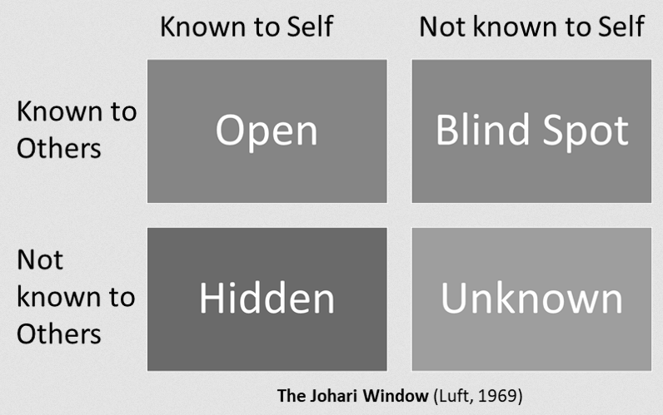
Figure 4: The Johari Window
Source: (METAPEOPLE | Great Work at Work | Lifting Workforce Capability, 2020)
Johari window has four quadrants and each block is used to determine a person’s behavior. The open quadrant describes a person who has knowledge about themself and knows others. The blind spot refers the people know peoples but don’t have self-knowledge. The hidden people are not likely to know others but know themselves. The unknown people are irrespective self and others.

6.2 Force Field Analysis
Force Field analysis is a development in social science that provides a framework to influence a situation. Psychologist Kurt Lewin established force field analysis. This tool used to drive forces and restrain forces to achieve specific changes.
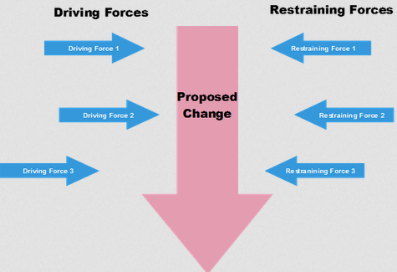
Figure 5: Force Field Analysis
Source: (Dewar and Rigney, 2015)
Three steps used in this tool to work. Step 1 works by describing the proposed change which defines goal or vision for proposed change stays in the middle of the driving force and restraining force. Step 2 identifies forces that are needed for developing the changes. These driving forces are positively related to the change (Dewar and Rigney, 2015). Step 3 identifies the restraining forces which reduce the effectivity of the correlation of driving force and proposed change.

6.3 Personal SWOT Analysis
For personal development, SWOT analysis is an effective way of identifying weaknesses and areas of improvement. It helps to find the strengths and opportunities of an individual as well as helps to find threats (Personal SWOT Analysis: – Making the Most of Your Talents and Opportunities, 2020). It is an effective way of linking goals with strengths and minimise threats. Here I have done my SWOT analysis.
Strengths  - I have educational qualifications  - I am very creative  - I have soft computer skills  - I can communicate with people very well | Weaknesses  - I do mistakes in my tasks due to my forgetfulness  - I lack expertise for my career goal  - I do lack of analytical ability  - I get nervous in presenting ideas
Opportunities  - I have greater exposure as I am a presenter in different programs  - The business analytics jobs have bigger employment market  - I have a link with different companies that know about my expertise.  - I am going to attend a business conference next month | Threats  - My competitors are more expert in this field  - Competitors have better communication skill  - There is a threat of not disclosing my ideas.  - The economy is getting down due to COVID-19

Table 2: Personal SWOT analysis
Source: Self
This SWOT analysis helps me to find my weaknesses and threats for which I will be able to minimise those threats and able to work to overcome weaknesses. These are the strengths and opportunities here which I will need to pursue the career of the business analyst.

7. Employment Goals
Employment goals need a SMART objective to carry out and before that, I have to identify the needs and requirements of my career paths. I have chosen the career of business analyst and management consultant. Both of them require the same educational backgrounds and also need some skills and abilities to proceed. Here I will prepare a SMART employment plan for a business analyst.
The skills I will become a business analyst: A business analyst must be a good communicator for which a person needs good communication skills. The other skills are problem-solving, critical thinking skills, key analysis techniques, business analysis tools, relationship building skills, self-managing skills, Presentation skills, time management skills, stakeholder management, documentation skills (Reed, 2017).
The requirements I will need: The requirements I will need are bachelors’ degree, 5 years’ experience, exceptional analytical thinking, and leadership quality to influence stakeholders.
My plans For Future: As I want to become a business analyst I need to develop these skills and have to prepare myself for the future job market. Here I plan to accumulate the selected skills and requirements. In the previous sections, I have developed a set of weaknesses and in this section, I have demonstrated the expected skills that a business analyst should have, I will work for these skills to achieve my career goal. As a plan, I will prepare a personal action plan for removing weaknesses and gain expertise and will proceed for further studies.

Conclusion
Professional career development needs a proper formulation of the different tasks which should be quantifiable and qualitative in terms of needs and requirements of the career paths. Professional development is only possible when someone pays attention to their lacks and needs so that they can gain career goals. Here I will develop a personal action plan which will help me to overcome my weaknesses and will help me to gain my chosen career path.
Development Needs | What I will do to achieve this? | What resources I will need? | What will my success criteria be? | Target date of completion
Communication Skill | - Engaged with people  - Achieved acceptable body language  - Use catchy words | Reading materials, exercise, peers and friends, emails, and phones. | I will become a good communicator. | 2 months (From June 2020- July 2020)
Problem-solving Skill | - Work out with brain  - Keep updated with journal  - Exercise knowledge | Creative intelligence, training | I will be able to analyse different organisation problem and give solutions. | 2 months (From 2020- August September 2020)
Critical thinking skill | - Listed basic questions to self  - Always be aware  - Adjust the perspective  - Administered positive and negative side  - Develop future sight | Reading materials, training | I will be able to decisions in critical situations. | 3 months (From 2020- October -December 2020)
Business analysis tools | - Microsoft Office Knowledge  - Google docs file expertise  - Marketing analytics | Computer, software | My technical soft skill will be developed. | 1 month (February 2021)
Relationships building skill | - Identify basic relationships needs  - Try to be positive and compassionate with others  - Manage gossiping | Peers and colleagues, emails and social events | My organisation will have good stakeholder relationships. | 2 months (From March 2021- April 2021)
Stakeholders management | - Know the stakeholders status  - Decide what I want from them  - Identify the way of communication method  - Implements plan | Stakeholders, events, dividends, CSR | I will be able to keep stakeholders interest. | 2 months (From August 2021- September 2021)
Table 3: Personal Action Plan
Source: Self
In this assignment, I have become able to identify my core interest and able to prepare a list of goals to achieve my selected career goals. In this essay, I have prepared a Personal development plan which I am going to use to gain expertise for my chosen career. I will be able to become a good employee in the organisation and will be able to make a difference in the world.

References
Bassot, B., 2015. The Reflective Practice Guide. Florence: Taylor and Francis.
COOK, J., 2018. The Power Of The Agile Business Analyst. [Place of publication not identified]: IT GOVERNANCE LTD.
Dewar, D., and Rigney, C., 2015. Force Field Analysis. Red Bluff, Calif., USA: QCI International.
Field, K., 2013. Education, education, education: reforming England’s schools. Professional Development in Education, 39(5), pp.865-866.
Hayes, C., Daly, J., Duncan, M., Gill, R., and Whitehouse, A., 2017. Developing As A Reflective Early Years Professional. St Albans: Critical Publishing.
Levine, D., and Toffel, M., 2010. Quality Management and Job Quality: How the ISO 9001 Standard for Quality Management Systems Affects Employees and Employers. SSRN Electronic Journal.
Markham, C., 2014. How To Be Your Management Consultant. London: Kogan Page.
Metapeople.com.au. 2020. METAPEOPLE | Great Work At Work | Lifting Workforce Capability. [online] Available at: <https://www.metapeople.com.au/> [Accessed 3 May 2020].
Mindtools.com. 2020. Personal SWOT Analysis: – Making The Most Of Your Talents And Opportunities. [online] Available at: <https://www.mindtools.com/pages/article/newTMC_05_1.htm> [Accessed 3 May 2020].
Paterson, P., and Robottorn, J., 2011. Learning style and learning strategies. Research in Learning Technology, 3(1).
Reed, A., 2017. Business Analyst.
Snow, N., and Narváez, D., 2017. Self, Motivation, And Virtue.
Urban, B., and Wood, E., 2015. THE IMPORTANCE OF OPPORTUNITY RECOGNITION BEHAVIOUR AND MOTIVATORS OF EMPLOYEES WHEN ENGAGED IN CORPORATE ENTREPRENEURSHIP. Journal of Business Economics and Management, 16(5), pp.980-994.
Walsh, B., 2011. VAK Self-Audit. Victoria, BC: Walsh Seminars Pub. House.
Zepeda, S., 2019. Professional Development. Milton: Routledge.

