Student Name: Lourie John
Student Number: 2113730
Module Code: HPHE5013/HPHE6013
Module: Difficult Heritage/Dark Tourism
Due Date: 19th March 2023
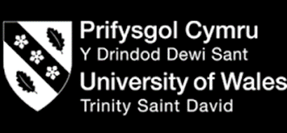

INTRODUCTION
In the twenty-first century today, when most people who do not call the islands of the Caribbean home think about it, they think of Carnival, rum, food, sand, sun, and sea. However, the islands represent much more than that and carry with them all a very dark history, one filled with blood, death, tears and strength. So, in the eyes of Caribbean natives, Carnival is a symbol of freedom, they are a region of people who are stronger than any rum, with a shared cuisine that is reflective of their multi-heritage, and whose ancestors had their identities ripped away as they slaved in the sun farming sugarcane. The dark heritage of the Caribbean is not lost or forgotten simply because the outside world turns a blind eye towards it. It is as alive as ever in the language (dialect/creole) spoken, the music, food, and the physical remnants left behind of a darker time. These remnants are a site to see and attract both tourist and locals alike. They hold great beauty as they do history and all Caribbean islands alike use them to their advantage to boost tourism. Though some might argue that this also promotes heritage, it also masks and trivializes the real history and heritage behind it. One such example of a physical place (remnant) in the Caribbean that stands as a symbol of dark heritage and history is The Black Point Tunnel also known as the Jasper Rock Tunnel in St. Vincent and the Grenadines.

The Dark Origins of The Black Point Tunnel SVG
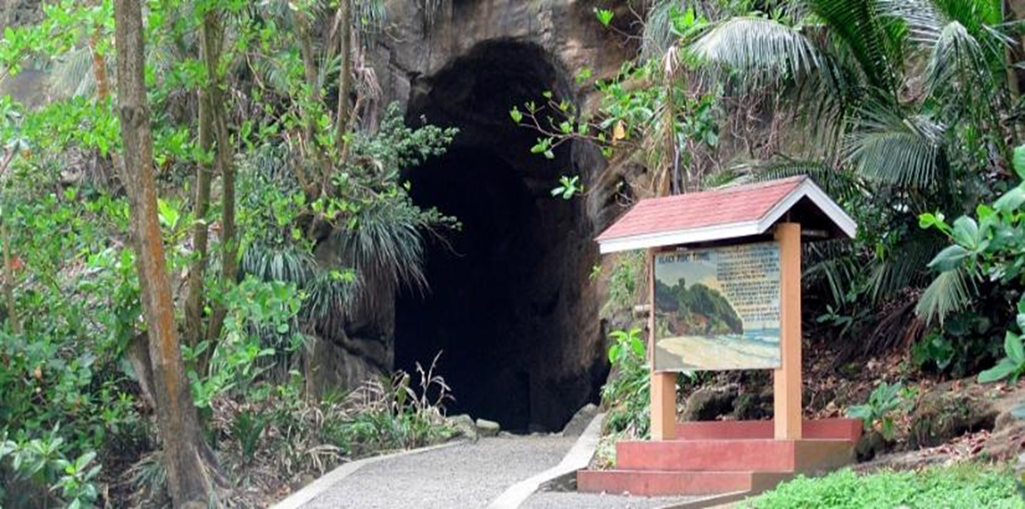Image showing the entrance of The Black Point Tunnel by Gooding (2014).
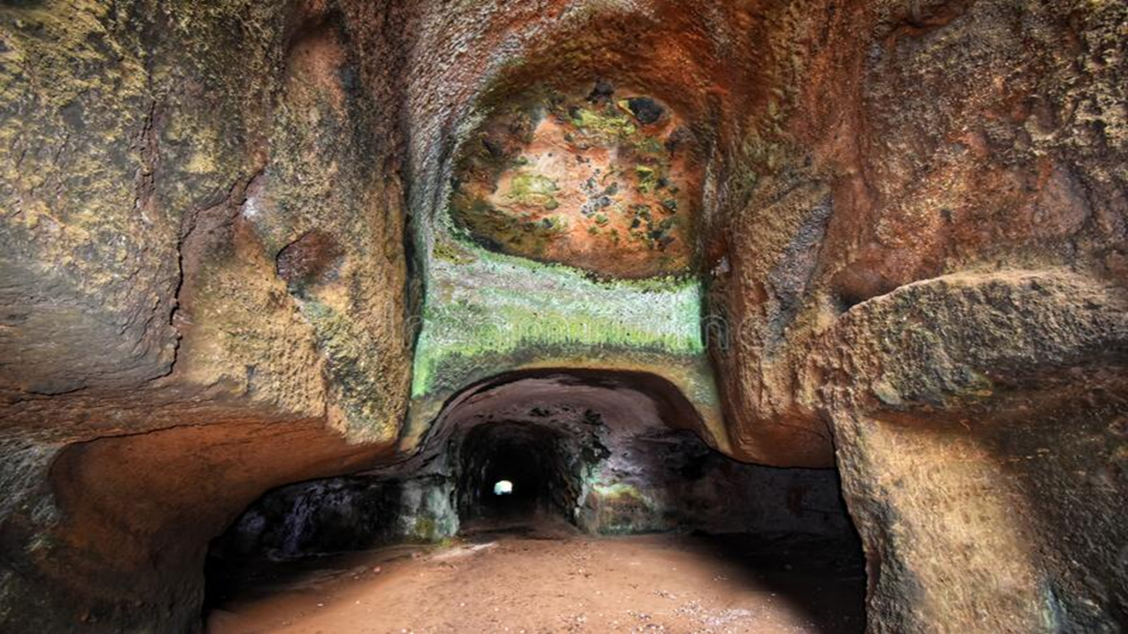Image showing the inside of The Black Point Tunnel by Bridlal (2020).

The Black Point Tunnel is home to the Caribbean Island of St. Vincent and the Grenadines. St. Vincent is a small island about 133 square miles located in the southeast Windward Islands of the Lesser Antilles. It has a population of roughly 110,400 people. St. Vincent is the mother island and is followed by the Grenadines, The Grenadines are a lovely series of smaller sister islands. St. Vincent and the Grenadines is made up of 32 islands and cays. The island is best known for the Grenadines, its beautiful underwater and marine life, being the breadfruit capital of the Caribbean and most importantly being one of the few islands in the Caribbean that were home to the indigenous group of natives known as Carib, Garifuna and Kalinago which are all different variations of the Carib.
The island is said to have been discovered and named by the ‘great’ explorer Christopher Columbus even though it had been home to the native Caribs for over 200 years prior. According to Trillo (2022) Saint Vincent, was once known as the island of ‘Youloumainby’ and ‘Hairouna’ by the native Caribs in honour of the rainbow spirit and the blessings of the island. Christopher Columbus and the Spanish conquistadors named the island after Saint Vincent of Saragossa when they landed in 1498. According to British teacher historian Luscombe (2020) and studies conducted by Vincentian historian Dr. Adrian Fraser, despite this discovery the natives remained undisturbed for many years until the invasion of the French then the British in the 1600’s and their attempts to colonize the island and its inhabitants. The Earl of Carlisle by Charles I claimed ownership of the island in 1627, and it was re-granted to Lord Willoughby in 1672. The Caribs and the French lived in somewhat of a neutral system as the French understood their rebellious spirit and unwillingness to be colonised and enslaved. Despite this, British General Monckton seized the island in 1762, and colonisation continued despite the Caribs' resistance to recognise British dominion. After endless fighting against the natives, the British labelled the Caribs as cannibals, aggressive, uneducated and war like, these are sadly characteristics that were taught in schools, printed in CARIBBEAN history books, and are still associated to the people today. A deal was signed with the French and allegedly the Caribs in 1773, and the island was given to the French in 1779. The British invaded once again, as the slave trade was in motion and the island was returned to the British by the Treaty of Versailles (1783). The Caribs rebelled in 1795, aided by the French, and were finally defeated on March 14th 1796 after much warfare by Sir Ralph Abercromby. Lots of lives were lost and March 14th is a public holiday in St. Vincent and the Grenadines. Celebrated as the country’s ‘National Hero’s Day’ on this day the war is remembered and paramount (Carib) Garifuna chief ‘Joseph Chatoyer’ SVG’s national hero is celebrated is for his sacrifice and fight for his people. St. Vincent and the Grenadines gained independence from the British on October 27th 1979, however, today the King is still head of state.
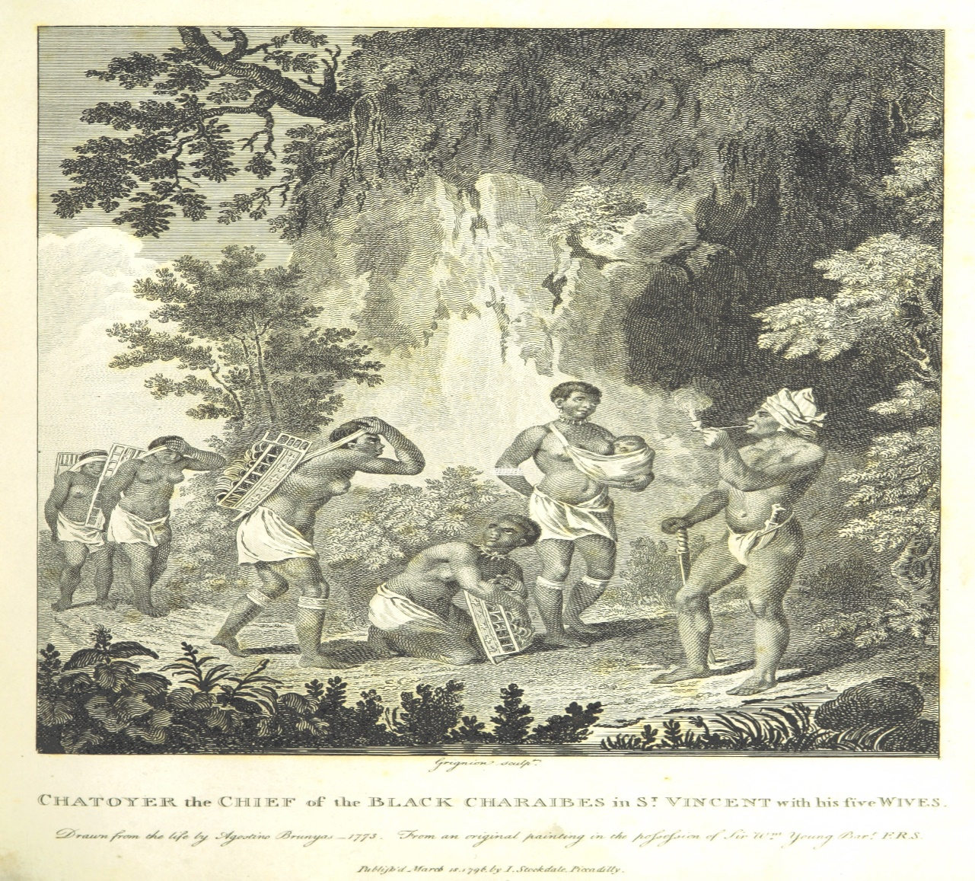Drawing of the Caribs sourced by British Library/Mechanical Curator collection (2023)
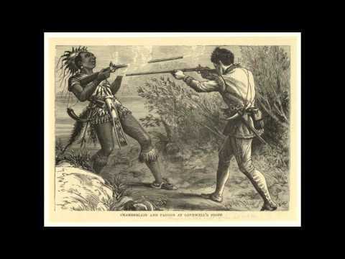
YouTube video by Hininio (2014) detailing Carib (Garifuna) history.

YouTube video of an interview with local historian Dr. Adrian Fraser on Vincentian lost history, by Sayers TV (2022).

HOW DOES ALL THIS HISTORY (HERITAGE) RELATE TO THE BLACK POINT TUNNEL?
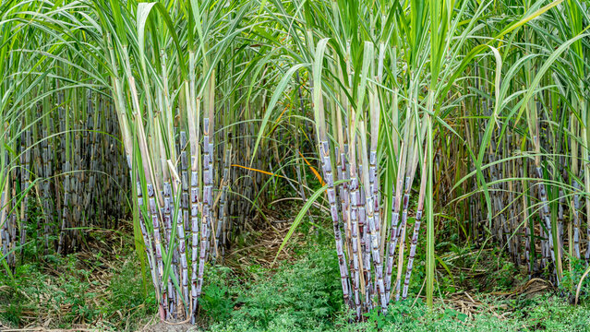
Sugar was in high demand during the eighteenth century and according to BBC History (2022), this prompted the conquest of Caribbean islands and the Atlantic slave trade. Due to the Caribbean’s tropical climate and fertile soil, it was the perfect place to grow sugar cane. Almost every Caribbean Island was covered with sugar fields and mills for refining the cane for its delicious sweet sugar. The dark twist is that those who cultivated and milled the sugar cane reaped none of the financial gain nor were they allowed to savour its sweetness. They instead were forced into hard labour, stolen from their homelands, had their land stolen and were treated like cattle. These persons were of Caribbean native and African origin. Sugar commerce rose considerably between 1700 and 1709 as sugar became more popular for sweetening beverages like tea and coffee. It was a very profitable market and considered a luxury.

St. Vincent was no exception to the western worlds wicked greed and suffered the same fate. The cultivation of sugar was very labour-intensive work and historians at the BBC (2023) further explain that, there was a period where the natives would die off, by suicide, refusal to eat, being over worked and were considered very rebellious. As a result, African slaves were considered harder and more stronger workers who were less rebellious and easy to ‘breed’ and multiply in ‘stock.’ African slaves were brought to the Caribbean to work, they became one with the Caribbean natives, their cultures merged into one and it is a reflection of the Caribbean people seen today. British economist, writer and publicist Malachi Postlethwaite stated in 1746 boldly that without the enslaved, "We can't have sugar, tobacco, rum, or anything else. As a result, the British government money generated by the importation of plantation produce will be lost. Hundreds of thousands of British working in the triangle trade will lose their employment and go hungry ". Many other economists and politicians agreed with this paradigm that the slave-based plantation system was critical to British prosperity, industry, and jobs. One of the biggest plantations on St. Vincent was the Grand Sable Estate on the windward side of the island in a village called Byrea, this estate was connected to The Black Point Tunnel in an effort to transport the sugar cane to the factory then finally, the finished product ready for shipment.
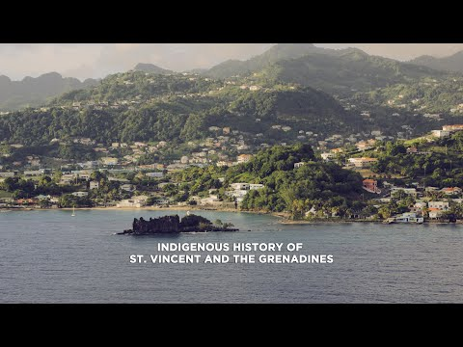
Video by Vincentian filmmaker Akley Olton (2020) on the ‘Indigenous History of SVG’
In an article by The Vincentian (2012) newspaper, local historian Dr. Adrian Fraser addresses the dark history of The Grand Sable Estate and The Black Point Tunnel. After most of the Caribs were expelled in 1797 for their ‘rebellious ways’, it took time to sell the lands they occupied, especially given the ongoing disputes over the 6,000 acres of land allotted to Colonel Thomas Brown, who was the ‘owner’. A law passed by the British in1804 declared that the natives had renounced all rights to previously occupied territories, and in 1805 an act of amnesty was issued for those who remained in St. Vincent. It took considerable time for potential plantation owners to establish various estates from Carib lands. About the time that The Black Point Tunnel, which was intended to increase connection between the Carib country estates and the rest of the country, was eventually constructed in 1813, an area of the Grand Sable estate was set aside for the town of Georgetown. The Carib country estates were already established and producing sugar at the time, according to the Slave Register, which was made feasible by an Act of 1817. Long thought to be excellent for sugar production, these territories were the major source of contention with the Caribs. Grand Sable, one of St. Vincent's largest estates, had 587 slaves by 1817. Further research and documentation of past slave records by The Cambridge University Press (2018) proves that numerous slaves did in fact pass through this estate and would have been apart of sugar cultivation and export linking them all again, directly to The Black Point Tunnel. Procedures stipulated by the legislation for the abolition of slavery eventually became implemented. The revelation that there remained inter-island slave trafficking and that slaves from foreign boats still involved in the trade were arriving in the colonies drove the drafting of a Slave Registration statute, which encountered considerable opposition in St. Vincent. With the abolition of the slave trade, more slaves arrived in the Americas between 1815 and 1830 than in the previous years of the 18th century.
British manufacturers sold items to slave dealers, while British traders purchased produce raised with slave labour. At a Legislative Council meeting on October 12, 1815, a committee formed to evaluate the Slave Register law issued a warning against "unwarranted meddling" by the Imperial Parliament in the internal affairs of the colonies. The Committee advocated its resistance, stating it should be done "by whatever legal or constitutional means possible," because it contradicted the initial rights that British settlers were encouraged to assert. The Assemblies were in danger of fading "into absolute insignificance" if they were allowed to continue. They urged for the establishment of communications in order to bolster their protest. Under the Slave Laws in St. Vincent, slaves were deemed property, but planters had to cope with the fact that they were also people all the time. As word of the 1816 rebellion in Barbados reached St. Vincent, martial rule was declared and the militia was summoned out. The slaves had previously seen what was possible thanks to Toussaint LâOuverture's insurrection and events in Haiti. According to Mrs. Carmichael, a Scottish planter's wife who arrived in St. Vincent in 1820 and lived a few years there, the slaves thought "that there is to be no massas at all and Massa King George is to buy up all the estate land and give them to dwell on."
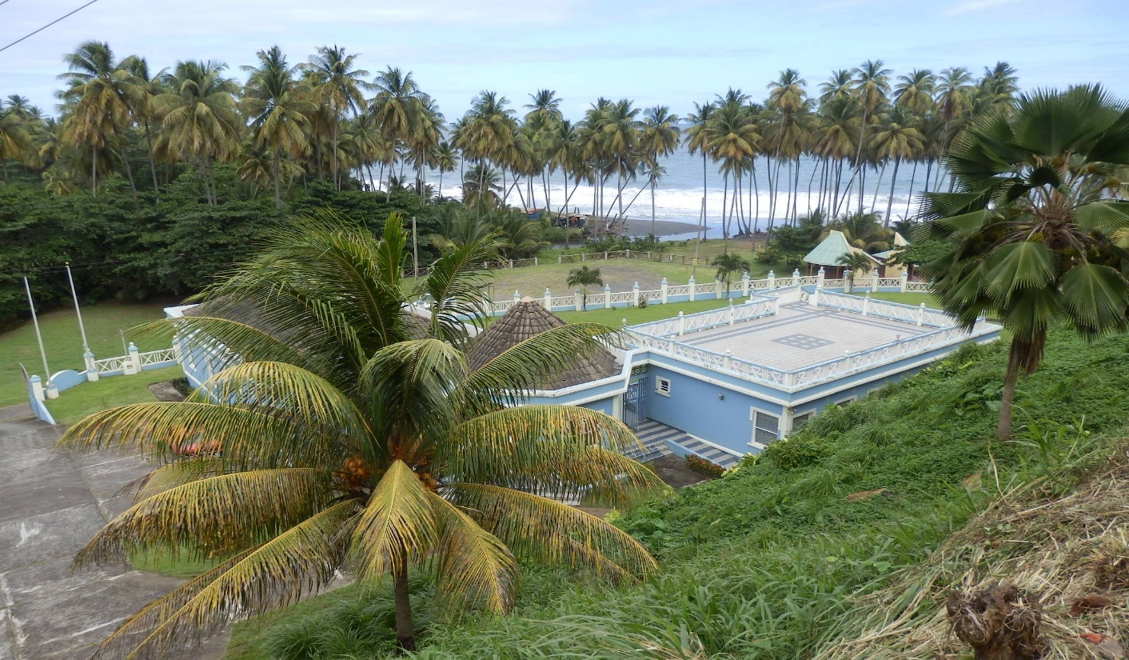
Image by Gooding (2014) of the modern-day Grand Sable Estate
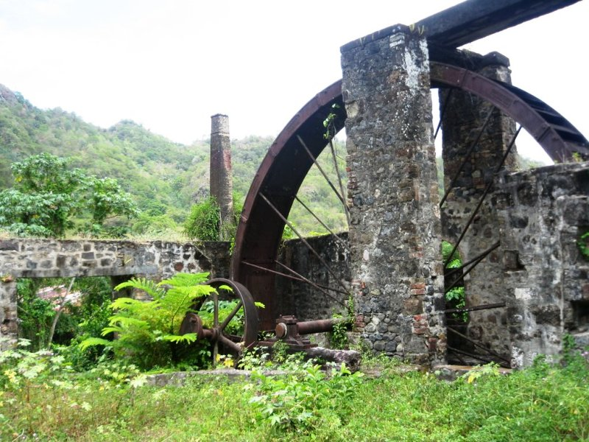
Image by Gooding (2014) showing parts of the old mill at Grand Sable.

As mentioned, The Grand Sable Estate housed many slaves of different sex and ages. In a dark twist of irony the slaves on this estate which is connected to The Black Point Tunnel, are on record being given ‘humane treatment’ and are described as being ‘privileged slaves’ in some records. These statements trivialize what slavery actually was and what it truly meant to be enslaved, having your home, identity, freedom and hope ripped away from you. While the land that was once The Grand Sable Estate by itself is still there, it is not in the same condition it once was. There is a new building on the land and few people remember it for was what it truly was. The Black Point Tunnel on the other hand stands strong as solid proof of all that transpired and is a historic relic of remembrance to be cherished. This tunnel was constructed to transfer the then-valuable sugar cane (sugar) from the fields to the sugar refinery and finally to the ships. The slaves laboured diligently, without the benefit of modern technology or equipment, to not only finish the tunnel, but also to cultivate sugar cane, harvest it, manufacture it, and prepare it for shipping. It was and still is considered an engineering masterpiece for its time and upon entry of the tunnel, the first thought that comes to mind is “how ever did they do this?” Slaves were forced to drill through 360 feet of volcanic rock to create this tunnel. While it was engineered by the British who got most of the praise and reaped the financial gains it provided, the slaves did all of the intensive labour surrounding its construction. In an interview with Sayers TV (2020) Vincentian historian Dr. Adrian Fraser explains, the tides and currents on the windward side of the island where the tunnel is located are very strong. As a result, the ships that came to The Black Point Tunnel were afraid to come into contact with these waters and would stay a distance away where they thought they were safe. There was and still is a stereotype attached to Caribs where they were thought to be one with the water and unable to drown, because of this the natives would be the ones forced to travel out to sea on canoes with sacks of sugar and barrels of rum to these ships. These waters are considered unsafe and swimming and recreational activities are prohibited to this day. It is without a doubt that many Caribs lost their lives during this process. Today, The Black Point Tunnel has been redesigned into what is described by SVG’s tourism authority as a ‘Family Friendly’ historical site and recreational park. Little is relayed about the site’s dark history to visitors whether local or international. As a result, the cultural significance behind The Black point Tunnel is lost, it is blocked by the greed for tourism revenue that advertises the site mostly for its uniqueness and beauty more than its historical importance.
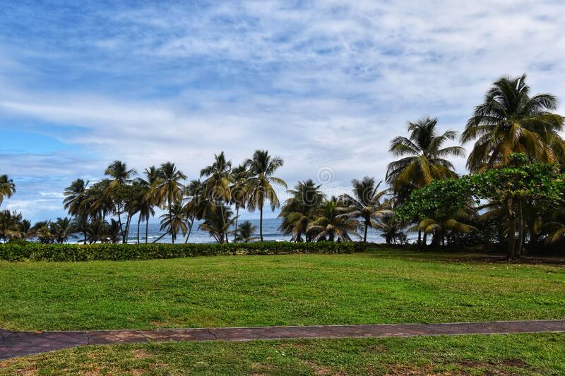
Image of the recreational park at The Black Point Tunnel by Bridglal(2020)

Ideas of re-negotiation

As it relates to the physical site of The Black Point Tunnel (Jasper Rock Tunnel) SVG, there is nothing I would recommend. The Tourism board of St. Vincent and the Grenadines as well as the Eco Tourism Development Organization in charge of the site does a remarkable job of making sure the site is protected, maintained and attractive. They have certainly rejuvenated the site and transformed it from a bat festered ‘cave’ into an area that can be truly admired for its inimitability and beauty. Coupled with the recreational park, The Black Point Tunnel is the perfect family outing, but, that’s just it, through these lenses the site and its importance is trivialized, The Black Point Tunnel has the potential and deserves to be so much more. As explored the tunnel has a very rich and dark history; it stand as a physical monument and is the epitome of what not only Vincentians, but people of the Caribbean went through all in the name of greed and power.

HOW CAN THE HISTORY OF THE SITE BE ENRICHED?
- Historical information boots. More detailed information boots should be placed in and around the site outlining its history and dark heritage. These booths will help to keep locals and visitors alike informed and educated about the sites history and all connected to it, this will help them to view the site as more than a beauty and marvel and appreciate its history.
- Tour guides and workers at The Black Point Tunnel and Recreational Park should all be educated about the sites history so that when they interact with visitors, they could effectively relay all that transpired, keeping visitors interested and captivated. Derrick (2023) of Select school tours explains that by their local expertise and educational assistance, a professional guide can help one make the most of their tour experience by delivering information in a way that will inspire, educate, and stimulate visitors. If one is new to taking a tour, a guide can help them bring crucial historical eras and situations to life while also making the most of their time on tour.
- Locals are not educated enough about Vincentian history and one way to preserve our heritage and culture can be through historical field trips and on-site lectures. Schools should be encouraged to visit this site as they would a museum. There are no big museums in SVG, so, The Black Point Tunnel is the perfect place to see true Vincentian history. It shows what the ancestors went through and why freedom should be cherished and their fight should be remembered. In a case study on the importance of field trips by Kennedy (2014) a teacher explains that she absolutely thinks it has enhanced her enthusiasm for field excursions at her school. She explained that she knows that she would want her kids to go on field excursions and have that ability, not just for material, but also for social components, such as learning how to act in public and how to get along with one another in different situations and appreciate raw history and heritage.

THE END

Reference list
Ali, J. (2009) Breadfruit: superfood of St Vincent, Caribbean Beat Magazine. Available at: https://www.caribbean-beat.com/issue-96/superfood-st-vincent#axzz7vI6psQVY (Accessed: 7 March 2023).
BBC History (2022) British colonies - Britain and the Caribbean - National 5 History Revision, BBC Bitesize. Available at: https://www.bbc.co.uk/bitesize/guides/zjyqtfr/revision/2#:~:text=Between%201700%20and%201709%20the%20trade%20in%20sugar (Accessed: 15 March 2023).
British Library (2023) Peeking behind the curtain of the Mechanical Curator, blogs.bl.uk. Available at: https://blogs.bl.uk/digital-scholarship/2013/10/peeking-behind-the-curtain-of-the-mechanical-curator.html (Accessed: 15 March 2023).
Das Gupta, K. (2015) Sweet cruelty, www.downtoearth.org.in. Available at: https://www.downtoearth.org.in/coverage/sweet-cruelty-48588.
Derrick, J. (2023) Educational Tour Guides, selectschooltours.com. Available at: https://selectschooltours.com/resources/educational-tour-guides.
Gooding (2014) Black Point, www.georgetownsvgrevisited.co.uk. Available at: https://www.georgetownsvgrevisited.co.uk/black-point.php (Accessed: 1 March 2023).
Hininio, S. (2014) The Garinagu (Garifuna) History & TimeLine (Part 1), www.youtube.com. Available at: https://youtu.be/lCG8EKV6LCQ (Accessed: 15 March 2023).
Kennedy, M. (2014) The Benefit of Field Trips Recommended Citation.
Luscombe, S. (2020) Saint Vincent and the Grenadines Colony, www.britishempire.co.uk. Available at: https://www.britishempire.co.uk/maproom/stvincent.htm (Accessed: 15 March 2023).
National Sites of SVG (2011) tourism.gov.vc. Available at: http://tourism.gov.vc/tourism/index.php/national-sites-of-svg (Accessed: 8 March 2023).
Olton, A. (2020) Indigenous history of Saint Vincent and the Grenadines, www.youtube.com. Available at: https://youtu.be/9r7rZ6fQsik (Accessed: 16 March 2023).
Saint Vincent and the Grenadines - History | Britannica (2012) www.britannica.com. Available at: https://www.britannica.com/place/Saint-Vincent-and-the-Grenadines/History.
Sayers TV (2022) Dr Adrian Fraser Historian| Garifuna| slavery| St Vincent and the Grenadines Independence, www.youtube.com. Available at: https://www.youtube.com/watch?v=HE6TO3oTKsQ (Accessed: 15 March 2023).
SMITH, S.D. (2018) ‘“Not that of mere accident, but of humane treatment”: natural increase and “amelioration” on Grand Sable Estate, St Vincent’, Continuity and Change, 33(1), pp. 117–144. Available at: https://doi.org/10.1017/s0268416018000073.
St Vincent and the Grenadines Maps & Facts (no date) WorldAtlas. Available at: https://www.worldatlas.com/maps/st-vincent-and-the-grenadines.
The flags of SVG (2014) thevincentian.com. Available at: https://thevincentian.com/the-flags-of-svg-p1434-155.htm (Accessed: 8 March 2023).
the_muskox (2021) Pleistocene a’a flow on top of volcaniclastics, Black Point Tunnel, St. Vincent (geologists for scale). Available at: https://www.reddit.com/r/geology/comments/l2s5j4/pleistocene_aa_flow_on_top_of_volcaniclastics/ (Accessed: 6 March 2023).
Trillo, M. (2022) Hairuna or The Land of The Blessed | Oikologica, oikologica.com. Available at: https://oikologica.com/hairuna-or-the-land-of-the-blessed/ (Accessed: 13 March 2023).
Zarem, J. (2016) Black Point Tunnel, AFAR Media. Available at: https://www.afar.com/places/black-point-heritage-and-recreational-park-byera (Accessed: 9 March 2023).

