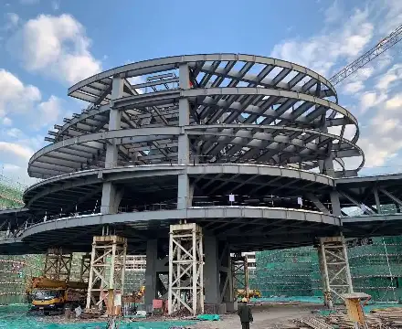  Structural Analysis (ACBA5027)  1/05/2026 | task 1: Multi-Storey Buildings structural Systems  Francis Barcelo 2401983@student.uwtsd.ac.uk

Table of Contents
1 Introduction 2
2 Survey of different types of structural Systems 3
2.1 Braced Frame System 4
2.2 Core and Outrigger System 5
2.3 Framed Structural System 6
2.4 Shear Wall System 7
2.5 Tube Structural System 8
2.6 Flat Plate and Flat Slab System 10
2.7 Hybrid Structural System 11
3 Conclusion 12
4 References 13
5 Task 2: Analysis of Structures 15
5.1 Question 1 15
5.1.1 Hand Calculations 15
5.1.2 Robot Structural Analysis 20
5.1.3 Comparison 21
5.2 Question 2 22
5.2.1 Hand Calculations 22
5.2.2 Robot Structural Analysis 22
5.2.3 Comparison 23
5.3 Question 3 24
5.3.1 Hand Calculations 24
5.3.2 Robot Structural Analysis 28
5.3.3 Comparison 28
5.4 Question 4 29
5.4.1 Hand Calculation 29
5.4.2 Robot Structural Analysis 33
5.4.3 Comparison 33
5.5 Question 5 34
5.5.1 Hand Calculations 34
5.5.2 Robot Structural Analysis 35
5.5.3 Comparison 35

Introduction
With the rapid growth of urban population, multi-storey buildings have become a key feature in most modern cities. This has led to an increase in demand for such structures to be built. Structural systems play a vital role in ensuring the safety and stability of this type of structure. As land becomes scarcer the need for a safe, efficient, and economical solution has become essential. Multi-storey structural systems are designed to support vertical loads such as dead and live loads and resist lateral loads like wind and seismic activities using specialised frameworks. There are various types of structural systems making the selection important depending on the purpose and design of the building. The type of system selected can have a direct impact on the building’s strength, safety, and functionality. As taller buildings become more common, more advanced systems are required to maintain stability. This report evaluates the importance of structural systems in multi-storey buildings and how each system varies from each other, focusing on the materials used and the how they are constructed.

Survey of different types of structural Systems

Braced Frame System
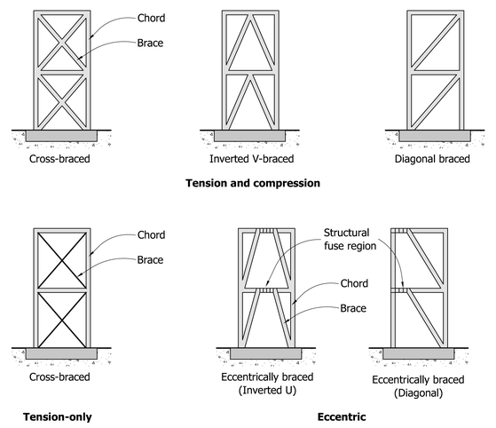
Figure 1: Examples of various types of braced frames, (Charleson. A, 2008)
A Braced Frame System is a type of method used to enhance stability, particularly in steel structures. This technique employs steel construction and is efficient in improving the lateral stiffness and resistance of rigid frame systems. Functioning as a vital load bearing element, it helps stiffens the framework to resist dynamic loads such as wind and earthquakes by transferring loads through axial stresses. (Patil. S, 2021). Primarily utilized in streel construction, these systems are built by forming a vertical truss diagonal members that act as the “web” and columns serves as “chords” as seen on Figure 1. This process helps minimise the bending of beams and columns. Construction methods include concentrically braced frames such as X-bracing or V-bracing (See Figure 1). Famous case studies include the Empire State Building and Chicago’s John Hancock Center (875 North Michigan Avenue), where both utilises a specialised braced tube system to withstand massive loads (See Figure 2).
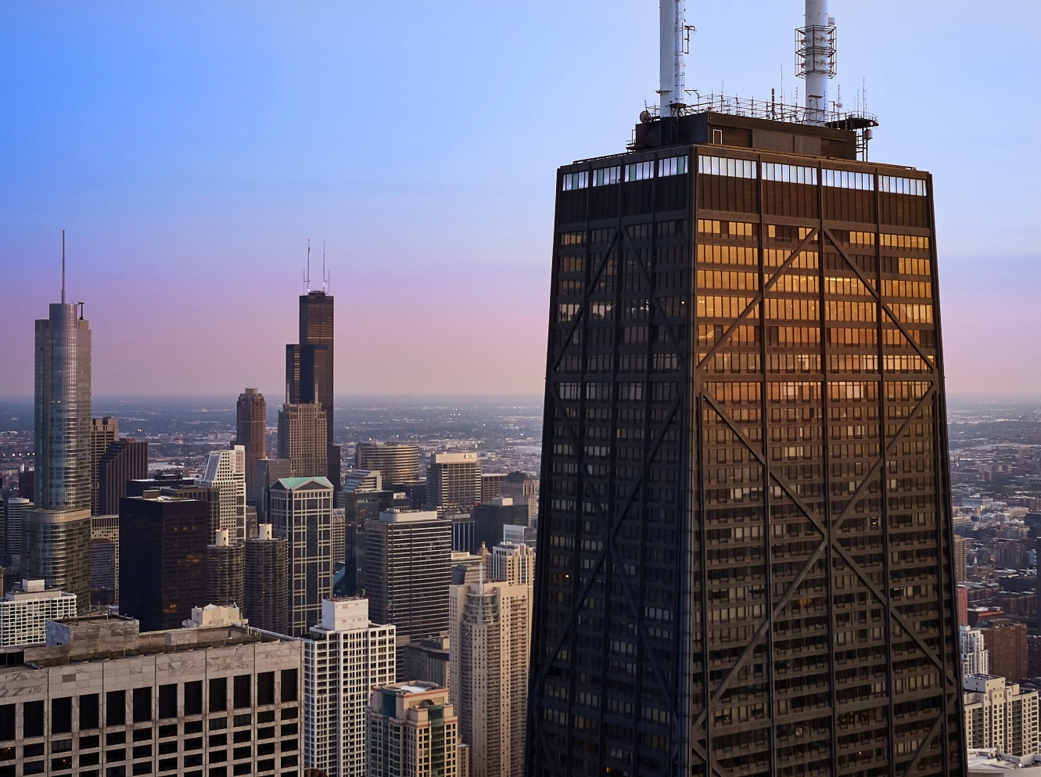
Figure 2: 875 North Michigan Avenue, (SOM, 2026 A)

Core and Outrigger System
Core and outrigger System is commonly used in high rise buildings to enhance stability and resistance to wind and seismic activity. These consists of a central reinforced core that is connected to perimeter columns via horizontal structural members called outriggers. The core usually made of reinforced concrete or steel contains the building’s vertical elements such as stairs and utilities. The outriggers extent from the core and effectively ties up the entire structure together and distribute loads efficiently (Chicago Architecture Center, n.d.). With the connection of the central core to the perimeter columns, the system increases the buildings lateral and torsional stiffness (Patil. S, 2021). This allows for the construction of taller and thinner buildings without the need for thick walls or large structural elements. (Chicago Architecture Center, n.d.) Materials typically include high strength reinforced concrete for the core walls and steel for the outrigger trusses. A prominent example of this is the Burj Khalifa where it utilises a “buttressed core” system, a central hexagonal concrete core that is supported by three wings in a “Y” shape. The outrigger walls connect the outer perimeter columns to the central core allowing vertical columns to contribute to the building’s lateral stiffness as seen on Figure 3.
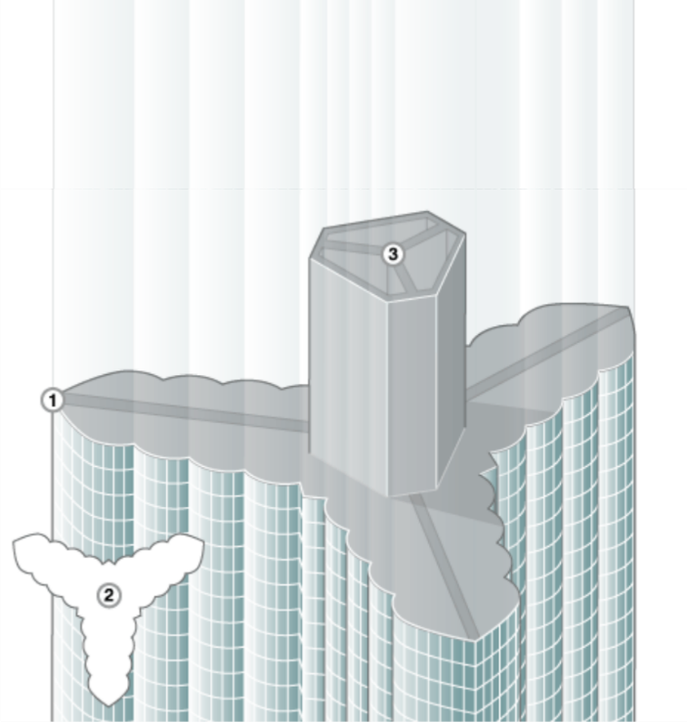
Figure 3: Structural System of the Burj Khalifa, (EMAAR, 2026).

Framed Structural System
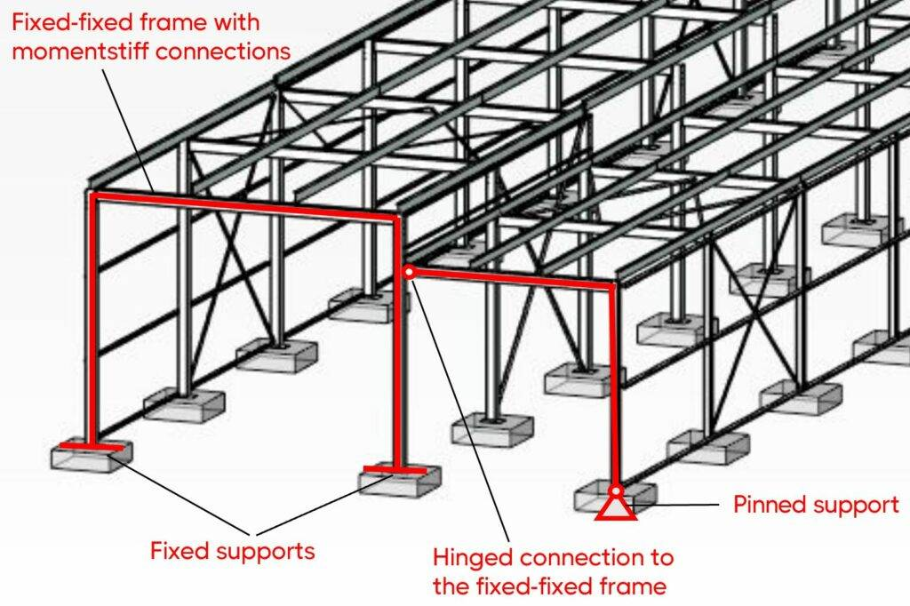
Figure 4: Steel warehouse as example of a frame structure, (Ernst. L, 2026)
The Framed Structural System is structural assembly that resists both vertical and lateral loads through the bending of beams and columns (Patil. S 2021). This type of system represents major advancement in building design and is now the most widely used system in multi-storey construction. The regular frameworks can be created by using timber, reinforced concrete or steel that compromises the beams and columns. The beams in this system transfer loads from the roof, floors, and walls to the columns. The columns then transfer it down to the foundation (Designing Buildings, 2020 A). This type of system offers significant advantages including design flexibility, the ability to create large open spaces, and the capacity to accommodate taller buildings. Common case studies include a typical office building where open floor plans are essential for flexible workspace arrangements.

Shear Wall System
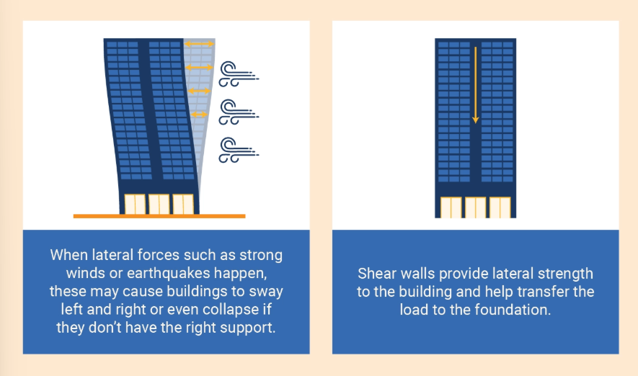
Figure 5: Image showing how shear walls work, (BigRentz, 2023).
To address the increasing demand for resistance to lateral forces in taller buildings, shear wall systems are commonly incorporated. A shear wall is a structural support element that resists shear forces such as wind and earthquakes. Shear walls help keep buildings stable by transferring lateral load to the founding which prevents the structure from leaning and collapsing as seen on Figure 5. There are various factors that need to be considered when selecting the materials for this type of design. Like Framed Structures they can be made from concrete, steel or timber, and factors like thickness and length all contribute to determine the design of a structure (BigRentz, 2023). The most common type used in high-rise buildings are made from reinforced concrete where they are constructed either by casting concrete in-situ using formwork or by assembling precast panels. Most residential buildings are observed to have shear wall systems implicated to ensure stability and safety. These systems are effective in regions prone to earthquakes, as they help to minimise lateral displacement and structural damage (Designing Buildings, 2020 B).

Tube Structural System
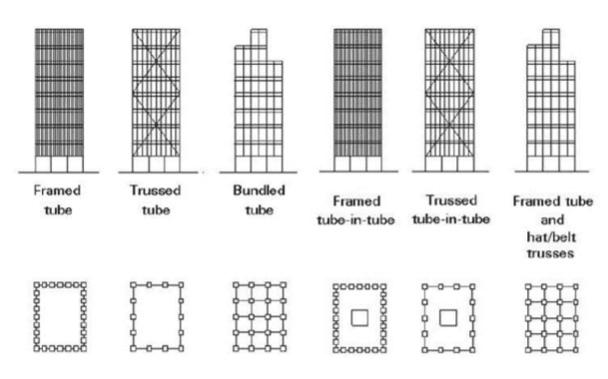
Figure 6: Image showing different types of structural tube systems, (Arab Architecture, 2021)
A Tube structural system is used in high-rise buildings due to its efficiency in resisting lateral loads such as wind. It functions as an equivalent hollow tube to resist the lateral loads through a rigid exterior frame of columns and beams (Patil. S, 2021). There are several variations of this system, including the framed tube, braced tube, and bundled tube as seen on figure 6. Each offers different levels of stiffness and structural efficiency depending on the building height and design requirements. Developed by Fazlur R. Khan the system is highly economical, requiring approximately half the material of ordinary framed buildings (Patil. S, 2021). This type of system is typically constructed using steel or reinforced concrete and the system reduced the need for internal columns therefore helping maximise useable floor space.
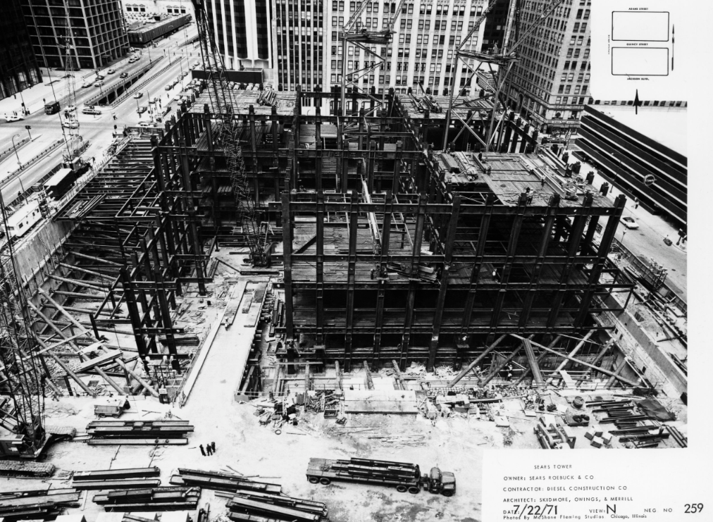
Figure 7: Willis Tower during construction, (SOM, 2026 B)
An example of a tube system in the Willis Tower in Chicago where the building consists of “nine 75-foot-by75-foot column-free square tubes at the base, forming a cellular-tube frame” (SOM, 2026 B) (See Figure 7). Another example is the John Hancock Center, which uses a braced tube system as seen on Figure 2. Overall, tube systems provide an effective and adaptable solution for modern high-rise buildings.

Flat Plate and Flat Slab System
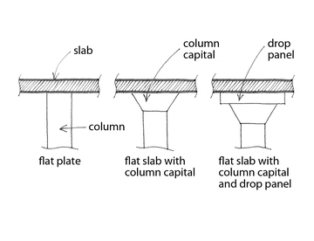
Figure 8: Image showing examples of flat plate and flat slabs, (OpenQuake, n.d)
This type of system consists of slabs either flat or plate which are connected to columns without the use of beams. They are widely used in multi-storey buildings due to their simplicity, efficiency, and suitability for repetitive floor layouts. There are two key differences between their structural enhancement. Flat slab systems incorporate additional elements such as drop panels or column capitals to improve load distribution and permit longer spans. A flat plate is the simplest structural shape where it utilises a slab of uniform thickness (Patil. S, 2021). Examples can be seen in figure 8. These systems are constructed using in-situ reinforced concrete. The process involves erecting formwork, placing steel reinforcement, and pouring concrete to form the slab and column connections. The construction method is straightforward which allows for faster building times and reduced labour cost compared to more complex systems.
Flat plate and flat slab systems are commonly used in residential buildings and office spaces where flexibility in interior layout is important. Overall, they provide an economical and practical structural solution.

Hybrid Structural System
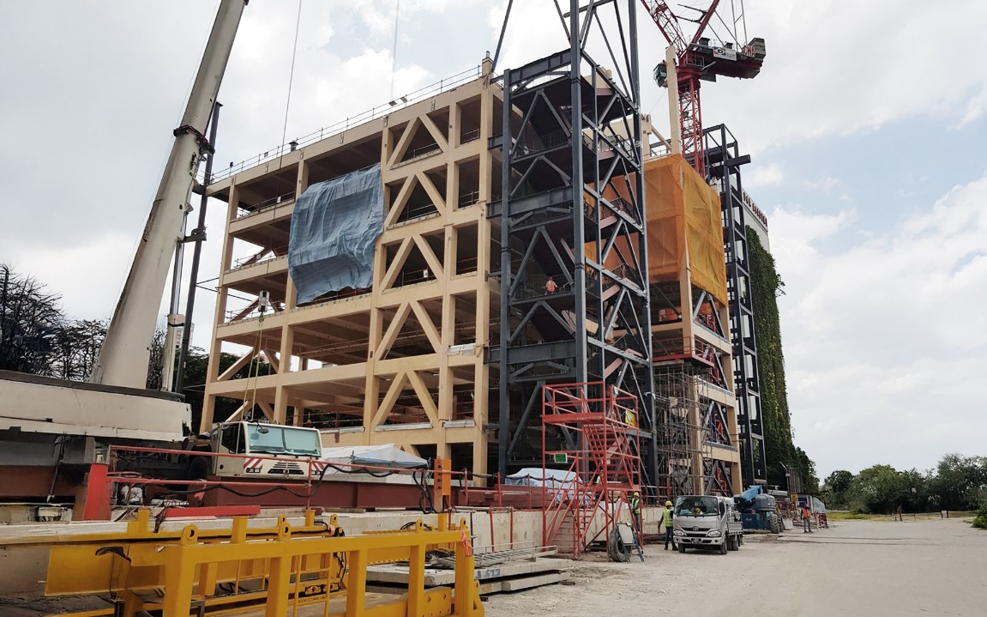
Figure 9: Picture of a building using hybrid system, (Rothoblaas, n.d)
Hybrid structural systems are widely used in modern multi-storey buildings as they combine two or more structural systems to maximise efficiency, strength, and overall performance (Patil. S, 2021). The main principle behind hybrid construction is the combination of materials to utilise their individual strengths. Concrete is valued for its availability and stiffness, timber for its sustainability and lightness, and steel for its strength. With the combination of these materials it helps determine viable solutions with the resources given. This balances functionality with regulatory performance standards (Rothoblaas, n.d).
As buildings increase in height and complexity, relying on a single structural system is often insufficient to meet both structural and architectural demands. Hybrid systems address this by integrating elements such as reinforced concrete cores, steel frames, and shear walls to work together as a unified structure. The construction process involves co-ordinating multiple methods which includes in-situ concrete castings for cores and slab, alongside with the erection of prefabricated steel components. This approach allows for faster construction while maintaining structural integrity (Rothoblaas, n.d). Overall, they offer a balanced solution by combining the strengths of different systems to achieve improved safety, reduced material usage, and enhanced design adaptability.

Conclusion
In conclusion, the selection of the type of structural system is a fundamental aspect of multi-storey building design. Each system presents distinct advantages and limitations in terms of cost, structural performance, method of construction, and suitability for building’s fitness of purpose. As urbanisation continues to increase, the demand for taller and more complex structures has driven the development of more advanced and efficient structural systems. The evolution of structural design reflects the growing need for innovation in construction. By having a comprehensive understanding of these systems, including their materials and methods of construction, can help engineers make informed decisions in the design phase. Ultimately, the correct choice of structural system ensures not only the safety and stability of a building but also its economic efficiency, functionality, and long-term sustainability.

References
SAFS (2022) Four structural systems of multi-storey steel structure building engineering. [online] Available at: https://www.safsteelstructure.com/news/four-structural-systems-of-multi-storey-steel-structure-building-engineering/?srsltid=AfmBOorlukCXsswHrhGw_85-IK5n6BH5KKoCDqbRaQHl8muOHkQayLyq (Accessed on 19 January 2026)
Charleson. A (2008) Seismic Design for Architects, Architectural Press. [online] Available at: https://taxonomy.openquake.org/terms/braced-frame-lfbr (Accessed on 22 April 2026).
Patil. S (2021) Evaluation of different structural systems for High Rise Construction. [online] Available at: https://ijaem.net/issue_dcp/Evaluation%20of%20different%20structural%20systems%20for%20High%20Rise%20Construction.pdf (Accessed on 22 April 2026)
SOM (2026 A) 875 North Michigan Avenue. [online] Available at: https://www.som.com/projects/875-north-michigan-avenue-formerly-john-hancock-center/ (Accessed on 22 April 2026).
EMAAR (2026) Structures: Burj Khalifa’s unbeatable structural design. [online] Available at: https://www.burjkhalifa.ae/the-tower/structures/ (Accessed on 22 April 2026).
Ernst. L (2026) Structural Frame Types and How They Work {2026 Guide}. [online] Available at: https://www.structuralbasics.com/structural-frame/ (Accessed 23 April 2026).
Designing Buildings (2020 A) Structural Systems. [online] Available at: https://www.designingbuildings.co.uk/wiki/Structural_systems#Framed_structures (Accessed on 23 April 2026).
Designing Buildings (2020 B) Shear Walls. [online] Available at: https://www.designingbuildings.co.uk/wiki/Shear_wall#:~:text=Shear%20walls%20are%20typically%20constructed%20from%20materials,also%20be%20resisted%20by%20steel%20braced%20frames. (Accessed on 23 April 2026).
BigRentz (2023) What is a Shear Wall and Why Is It Important. [online] Available at: https://www.bigrentz.com/blog/shear-wall#:~:text=Shear%20walls%20help%20keep%20buildings%20stable%20by:,Big%20houses%20*%20High%2Drise%20buildings%20*%20Skyscrapers (Accessed on 23 April 2026).
Arab Architecture (2021) Types of structural tube system and its advantages. [online] Available at: https://archup.net/types-of-structural-tube-system-and-its-advantages/ (Accessed on 24 April 2026)
SOM (2026 B) Willis Tower formerly Sears Tower. [online] Available at: https://www.som.com/projects/willis-tower-formerly-sears-tower/ (Accessed on 24 April 2026).
OpenQuake (n.d) Flat slab/plate or waffle slab. [online] Available at: https://taxonomy.openquake.org/terms/flat-slab-plate-or-waffle-slab-lfls#:~:text=Slabs%20and%20columns%20are%20constructed,Brzev) (Accessed on 24 April 2026).
Rothoblaas (n.d) Hybrid buildings: what they are and why they’re gaining ground in the construction industry. [online] Available at: https://www.rothoblaas.com/blog/hybrid-buildings-efficiency-in-modern-construction (Accessed on 24 April 2026).

