

Assessment 1
Title: Assessment component: Financial performance and management

Name: Shaunakkumar Patel
Student ID: 2504923
Module Name: Financial Management
Module Code: LCMB7002_LON
Lecturer’s Name: Dr. Shengfeng Mei
Word Count: 5031

Term 1
Table of contents

1. Introduction 3
2. Financial health analysis 3
2.1. Introduction to financial analysis 3
2.2. Ratio analysis 4
2.3. Trend analysis 6
2.4. Corporate failure prediction 7
3. Working capital management analysis 7
3.1. Assess the cash operating cycle. 7
3.2. Recommend strategies to improve liquidity through working capital reforms 7
3.3. Compare short-term vs. long-term financing options. 8
4. Strategic financial restructuring plans 10
4.1. Financial restructuring options 10
4.2. Impact on shareholder value, debt structure, and operational flexibility 12
4.3. International and ethical considerations 13
5. Investment appraisal and capital budgeting 14
5.1. Payback period 14
5.2. Average Rate of Return 15
5.3. Net Present Value 15
5.4. Profitability Index 16
5.5. Internal rate of return 17
5.6. Recommendation 17
Conclusion 17
Reference 19
Appendix 23

Introduction
The main focus of this report, as the new Chief Financial Officer of General Electronics, is to assess the declining performance of the company in terms of financial and ethical performance over the last five years and the development of a financially and ethically sound turnaround plan. General Electronics operates in a very competitive global consumer electronics business in which falling sales, pressure on margins, and high-speed change in technology have had a drastic impact on profitability and liquidity. The analysis is conducted based on the data obtained in the consolidated income statement, balance sheet, cash flow statement, and ratio calculations of the firm, according to the requirements of the course. The report will start with an in-depth financial health check with ratio analysis and corporate failure prediction models to establish the core weaknesses, trends, and default risk. It then looks at the working capital management to gauge the liquidity constraints and efficiency of short-term asset management. A financial restructuring plan is offered to achieve financial stability, protect shareholder value, and adjust operations in an international environment. Lastly, some investment projects are seriously appraised using conventional methods of capital budgeting as guides to making informed decisions upon capital rationing requirements.

Financial health analysis

Introduction to financial analysis
Financial analysis is a methodical procedure of assessing the financial performance, stability, and risk of a firm (Financial professionals, 2025). The information is contained in its income statement, balance sheet, and cash flow statement. It allows the management and stakeholders to evaluate profitability, liquidity, efficiency, and solvency over a period and to determine financial strengths and weaknesses emerging. In the case of a struggling company like General Electronics, financial analysis plays a major role in the diagnosis of the factors that are leading to the deteriorating performance and mounting financial pressure. Ratio analysis, trend analysis, and cash flow analysis are objective financial data to facilitate strategic decisions and turnaround planning, as well as analysis of the capacity of the firm to continue operation and fulfill its debts.

Ratio analysis

Profitability
The profitability ratios show that the earning power of General Electronics has considerably declined during the five years. The net profit margin decreased drastically to major losses of -23.36% and -6.09% in 2023 and 2024, respectively, as compared to the positive 6.28% of 2020. This trend indicates declining sales, surging operating expenses, and low-quality control of costs. Equally, the operating profit margin became negative in the past few years, with 6.06% in 2020, -20.29% in 2023, and -3.87% in 2024. This brings to light structural inefficiencies in core operations as opposed to short-term problems. 2022 recorded a slight recovery, although this was not sustained. The continued loss in operations minimizes the capacity of the firm in terms of reinvesting, servicing debt, and rewarding shareholders (Rafid et al., 2024). All in all, the profitability analysis demonstrates that the loss of revenue, excessive operating costs, and the lack of pricing power are fundamental factors that lead to a financial crisis and have to be solved immediately on the operational level.

Liquidity
The liquidity ratios indicate that General Electronics has a moderate short-term solvency, although the liquidity strength has declined. The current ratio decreased between 2020 (1.82) and 2024 (1.53), which shows the decreased presence of a buffer of current assets relative to current liabilities. Although the ratio is above 1, the decreasing trend is an indicator of increasing pressure on working capital. The quick ratio is more conservative, and it dropped to 1.03 in 2024 compared to 1.15 in 2020. This indicates that liquid assets can hardly meet short-term liabilities after the exclusion of inventory. A decline in the quick ratio indicates that the company is more dependent on inventory to finance liquidity, and this can be a risky situation in a fluctuating consumer electronics market. On the whole, although the company is not at risk of a liquidity failure in the short run, deteriorating ratios indicate constrained cash flows and a necessity to better manage receivables, inventory, and short-term cash planning (Corporate Finance Institute, 2024).

Efficiency
The efficiency ratios indicate poor working capital management effectiveness. Inventory turnover decreased to 2.79 times in 2022, which was then slightly improved to 3.54 times in 2024 compared to 3.64 times in 2020. This means that longer holding periods are experienced, which increases holding costs and chances of obsolescence. The receivables turnover ratio was also negative, as it decreased to 3.46 in 2024 compared to 4.75 in 2020. This would mean that customer payments are collected at a slower rate and credit is not well controlled. Lower efficiency is a cash waste in both inventory and receivables, which adds to the reliance on borrowed funds (Alarussi, 2021). Despite certain improvements that are observable over the recent years, efficiency is still at a lower level of performance as compared to previous years. All in all, the efficiency analysis has revealed the shortcomings of inventory planning.

Gearing
Gearing ratios demonstrate the increasing reliance on debt financing and the rising level of financial risk (IG, 2025). The debt-to-equity ratio has been increasing constantly from 0.63 in 2020 to 1.11 in 2024, which means that the total liabilities are higher than the equity of the shareholders today. This change is indicative of deteriorating equity because of accumulated losses and not necessarily aggressive borrowing. Financial distress is also indicated by the interest coverage ratio. It dropped drastically, as it was high at 26.21 in 2020 and negative in 2023 and 2024. Negative interest coverage involves the operating profits being low enough to cover interest payments, and the firm is compelled to finance its expenses using cash or by taking up more debt. This greatly enhances the risk of default.

Investment
Shareholder returns have been eroded severely, as shown in investment ratios. The Return on Equity (ROE) fell below a good value of 12% in 2020 and had a negative value of -55% and -16% in 2023 and 2024, respectively. This implies that the shareholder capital is being killed instead of being improved. Losses have been persistent, which has decreased retained earnings and undermined equity. Earnings per share indicate one of the same trends as they decrease in the same period in 2020; in 2023, they are -7.64, and in 2024, they are -1.85. Negative EPS creates a lack of confidence among investors and restricts the ability of the firm to raise equity at favorable terms. In general, the investment ratios indicate a decreasing market appeal and a deteriorated shareholder value (Nukala and Prasada Rao, 2021).

Cash flow
Cash flow ratios indicate that cash generation is declining, and the operating cash flows are positive in most years. The operating cash flow margin has decreased over 11.94 in 2020 and reported 3.75 in 2024, which means that the company has a lower ability to convert sales into cash. This is an indication of decreased profitability and inefficiencies in working capital management. The free cash flow ratio also declined significantly and became negative in 2022 and low in the following years. Negative or poor free cash flow brings down the ability of the firm to finance capital expenditure, debt reduction, or value giving back to the shareholders without any outside financing. Whereas the operating cash flows are positive, their downward movement indicates lower quality of earnings (Indeed, 2025).

Trend analysis
The trend analysis of General Electronics over five years shows that there is a steady decline in the financial performance. The net sales experienced a significant drop in 2020 compared to 2024 due to the market demand becoming weak and market competition being strong. This changed strong positive margins in 2020 to considerable operating and net losses in 2023 and 2024. There is a slight decrease in liquidity ratios, which reflects the restraint of short-term financial flexibility. The efficiency ratios indicate the lower speed of inventory movement and slower receivables collection, which have added pressure to the working capital. The gearing has been increasing continuously with the depreciation of equity caused by losses.

Corporate failure prediction
Z = 1.2X₁ + 1.4X₂ + 3.3X₃ + 0.6X₄ + 1.0X₅.
Working income/Total assets = 0.26.
Retained earnings/total assets = -0.07.
EBIT/Total Assets = −0.05
Market Value of Equity/Total Liabilities = 0.90
Sales/Total Assets = 1.22
Hence, Z = (1.2×0.26) + (1.4×−0.07) + (3.3×−0.05) + (0.6×0.90) + (1.0×1.22) = 1.44.

Working capital management analysis

Assess the cash operating cycle.
The cash operating cycle is used to determine the time taken to collect cash in inventory and receivables and convert this into sales (Asman et al., 2022). In the case of General Electronics, the efficiency ratios show that the cash operating cycle is extended over the five years. The decreasing inventory turnover indicates that inventory is carried longer, therefore raising holding costs and chances of obsolescence. The decrease in the receivables turnover also indicates slower collections from customers, hence, postponing cash. These delays are not fully compensated for by the payables, although they are significant. This makes cash become more tied up in the working capital, and this strains liquidity and puts a strain on short-term financing.

Recommend strategies to improve liquidity through working capital reforms
Liquidity improvement in the case of General Electronics involves vigorous working capital improvements in terms of inventory, receivables, and payables. Demand-based forecasting and stricter production planning should be used to reduce inventory levels. This will reduce the holding costs and the possibility of product obsolescence. Slow and excess inventory must be pointed out and eliminated either by means of discounting or product rationalization. Efforts should be made to strengthen the management of receivables through the imposition of stringent credit approval procedures and precise payment conditions (Oktavia and Indrati, 2021). Monitoring of outstanding accounts should be done regularly to avoid cash being tied up in overdue invoices. Promotions can be given in terms of early payment. Cash inflows will also be enhanced by automated billing and collection systems. Payables management must be based on the renegotiation of the lengthening of payment terms with large suppliers without damaging relationships with suppliers.

Compare short-term vs. long-term financing options.

Criteria | Short-Term Financing | Long-Term Financing
Purpose and Usage | Short-term financing is employed to finance specific operational requirements that are daily in nature, e.g., purchase of inventory, bills payable, and short-term working capital requirements. It provides the regular business operations, and it assists in the administration of the interim cash flow. In the case of General Electronics, operating cash flows have been decreasing with an intensive utilization of short-term credit facilities (Forbes, 2025). | Strategic goals like capital investment, business restructuring, as well as long-term asset acquisition are long-term financed. It is applicable in financing investments whose benefits are realized over a number of years. In the case of General Electronics, long-term funding would help in financing restructuring efforts, as well as eliminate dependence on unstable short-term borrowing.
Cost of Financing | Short-term financing is normally at lower nominal interest rates than long-term financing. Nonetheless, frequent renewals make the firm susceptible to interest rate changes and unexpected cost changes. During financial crises, obligations when financiers are tightening their belts, they might charge higher rates or lower credit limits, which adds to the overall cost of financing. | Long-term financing is usually associated with increased interest payments because the repayment period is increased, and the risk to the lenders is also increased. Borrowing has the certainty of cost in a fixed rate. Long-term financing is more stable, and it insulates the firm against the short-term fluctuations in the market, even though it is more costly in the short term (World Bank Group, 2017).
Risk and Refinancing Exposure | The financial risk involved with short-term financing is high since facilities have to be renewed regularly. Provided that the credit situation becomes more restrictive, the company can experience a liquidity crunch. Since General Electronics is experiencing decreasing profitability and negative interest coverage, high dependency on short-term financing poses high risks of default (Viscione, 2025). | Long-term financing minimizes the refinancing risk by fixing the long-term funding. Regular repayment plans enhance budget preparation. This consistency is essential to a firm in a turnaround situation since it would lessen the strain during low earnings and cash flow fluctuations.
Impact on Liquidity and Cash Flow | Short-term financing enhances liquidity in the short term but exerts a strain on the short-term cash flows because of the frequent repayments. It may result in a vicious circle of constant borrowing in case operating cash flows are strong. Through repeated use of credit lines by General Electronics, it has been apparent. | Long-term funding reduces short-term liquidity pressure, as it distributes the repayments over a longer period. This will enable the firm to stabilize the cash flows and concentrate on the operational performance, other than the need to ensure that they are able to meet immediate repayment schedules (Corporate Finance Institute, 2024).
Effect on Financial Structure and Flexibility | The intensive application of short-term debt undermines the liquidity position of the firm and makes it more financially vulnerable. It could also be an indication of financial desperation among investors and creditors. Nonetheless, long-term financing offers operational flexibility, as there are fewer long-term obligations (Yanti et al., 2022). | Long-run funds enhance capital structure through a correlation between capital and asset life. The debt covenants have the effect of constraining certain operational decisions but generally increase financial stability. Equity funding empowers the balance sheet and increases the ability to borrow.
Suitability for General Electronics | Only seasonal working capital should be financed in the short term. Further intensive use adds to the liquidity risk and financial instability. Reduction of short-term borrowing should be done under strict control and limited. | The turnaround strategy of General Electronics should be financed in the long term. It endorses restructuring, liquidity stabilization, and minimization of refinancing risk. To recover sustainably, a healthy combination of long-term funds and equity is needed (Challoumis and Eriotis, 2024).

From this table, short-term financing supports daily operations while increasing liquidity and refinancing risks, especially for General Electronics Corporation. Although long-term financing is more expensive, it offers predictability through loan repayments and is better suited for restructuring. As a result, reliance on risky short-term funding decreases.

Strategic financial restructuring plans

Financial restructuring options

Divestiture
Divestiture is the selling of non-core or poor-performing business units to generate cash and enhance strategic focus. In the case of General Electronics, liquidity can be created within the company by selling low-margin product lines or non-strategic international operations. The cash proceeds can be applied in the settlement of debts and in the fortification of the balance sheet. This minimizes the cost of interest and financial risk. It is also through divestiture that the management can focus on the viable core segments and enhance operational efficiency. It can streamline the structure of the organization and decrease overheads (Divestiture, 2024). Nonetheless, there is a short-term loss of revenue and market share due to divestiture. There can also be the restructuring and exit costs. When assets are sold in a poor market performance, they will be undervalued. Timing and choice of assets should hence be taken very carefully.

Merger
Merger has a chance of realizing scale and cost synergies, as well as market expansion. In the case of General Electric, the merger with a complementary company will enable the company to lower the cost of operation by having similar technology platforms, procurement systems, and distribution channels. The synergies can increase operating margins and also rejuvenate competitiveness in the world electronic marketplace. Bargaining power with suppliers and customers can also be increased by a merger. Recovery may be sped up by access to new markets and technologies. Nonetheless, mergers are associated with major risks. The integration issues, cultural diversity, and compatibility of systems may interfere with the functioning. Lack of integration can lead to increased costs and a lack of strategic focus. Initial capital investment and reorganization costs can take a toll on the cash flow. Effective due diligence and apparent post-integration planning of the merger are vital (Riju, 2022).

Equity injection
Equity injection entails raising capital by issuing new shares to the investors. The advantage of this alternative is that it enhances liquidity due to the availability of instant cash without the need to raise debt. In the case of General Electronics, equity financing enhances the capital base and raises the solvency ratios (Wallstreetprep, 2024). It minimizes the risk of finances and increases creditor and investor confidence. The funding restructuring and strategic investment are also made through equity injection. It does not impose any interest. Nonetheless, a new share issue dilutes the ownership of existing shareholders and decreases short-term earnings per share. The success of equity issuance is largely dependent on market perception and confidence of the investors. In case they are issued at low valuation, shares can be issued at times when the company is performing poorly.

Impact on shareholder value, debt structure, and operational flexibility

Shareholder value
Financial restructuring has both short- and long-run impacts on the shareholder value. Divestiture and equity injection are among the acts that can lower earnings reports and earnings per share in the short term. This may undermine the market mood in the short term (Zumente and Bistrova, 2021). The divestiture can also help cut revenue because non-core units would be sold. Nonetheless, it enhances concentration on lucrative segments and enhances cash generation. The success of integration can result in the success of mergers in creating shareholder value by providing cost synergies, market expansion, and a better competitive position. The injection of equity increases financial stability and insolvency risk. Greater liquidity and reduced financial risk ought to enhance the ability to grow in the future. This results in better profitability, less leverage, and consistent cash flows over time, which help in increasing returns to shareholders. It requires transparent communication and ethical governance in order to keep the investors positive in the restructuring process.

Debt structure
In direct relation to the debt structure and financial risk profile of the firm, restructuring of the finances directly affects them. The cash that is generated through divestiture may be used to pay high-cost debt or short-term debt. This limits leverage and interests. The better the interest coverage, the better the creditworthiness and the less risk of default. A merger can enhance the capacity of the firm to refinance the current debt using more favorable conditions since the company has a stronger balance sheet. Equity injection decreases the use of debt as a source of financing and enhances solvency ratios. Nonetheless, restructuring and integration liabilities can be a short-term liability. Inadequately planned restructuring can lead to concealed financial liabilities as well. In general, the rebalanced debt structure will have lower leverage (Deginvest, 2025).

Operational flexibility
Restructuring of the financial facet will increase flexibility in the operations of operations and efficiency in resource allocation. Diversification enables the management to drop out of non-core businesses and focus on the profitable businesses. This enhances decision-making rate and efficiency. An effective merger will be able to increase its operational capacity in terms of technology, experience, and distribution networks (Alolayyan and Alyahya, 2023). It can also enhance economies of scale and eliminate redundancy of resources. This is with the equity injection, which avoids a repayment requirement. This enables the management to make investments in innovation and restructuring efforts. Reduced debt levels will decrease restrictive debt covenants and enhance the freedom of the manager.

International and ethical considerations

Taxation
Tax is a very important factor in financial restructuring and international activity. Capital gains taxes that are brought about by divestiture and mergers cut down the net proceeds when they are not well planned. Tax credits and loss carryforward can be used to allow the effective tax planning of the location of profits and the overall tax burden. Equity injections can be favorably taxed as compared to debt financing because there are no limitations on the deductibility of interest on debt (Kumar, 2024). It is necessary to adhere to international tax laws to prevent fines and losses of reputation.

Currency risk
General Electronics is highly vulnerable to currency risk since the company operates internationally. The fluctuation of exchange rates may have an impact on revenues, costs, and cash flows as foreign earnings are converted into the reporting currency. The reported revenues and profitability can be lowered by a declining foreign currency. The cost of the imported components is also subject to currency volatility (Accaglobal, 2025). To control such a risk, the company ought to employ natural hedging techniques, which include balancing foreign revenues and local expenses.

Inflation
Cost and consumer demand in the electronics industry are affected by inflation. Increasing input prices augment the production and operating costs, which strain the profit margins. In case the company does not have the power to set its price, it might fail to transfer additional costs onto customers. Inflation is also degrading the real value of cash flows and shareholders' returns (Tacanho, 2025). Elevated interest rates, which are commonly linked to inflation, raise the cost of borrowing and financial risk.

CSR
CSR is imperative to the creation of long-term and ethical business practices. The responsible sourcing, decent labour practices, and environmental sustainability enhance brand image and consumer confidence. In the case of General Electronics, CSR can be included in restructuring decisions to improve the support of the stakeholders of those decisions and decrease the reputational risk. It is important to ethically treat employees in case of divestiture or mergers. Open financial reporting and regulation make investors more confident (Interesjournals, 2025).

Investment appraisal and capital budgeting

Payback period
Payback period is the period of time that it takes a project to break even with the beginning of the project in terms of net cash inflows. It is more about liquidity and risk as opposed to profitability. Project B will have the fastest payback period in terms of the projected cash flows since it produces stable and equal annual flows of £6 million. Project A takes more time to recoup its original cost because of lumpy cash flows. Project C is the one with the longest payback period since the majority of cash inflows are later on in years. Such a back-loaded structure carries an additional risk, particularly to a firm that is under liquidity strain, such as General Electronics. The payback approach is applicable in this regard since the company is experiencing deteriorating liquidity and increasing financial pressures. Faster payback projects expose the enterprise to less risk of uncertainty and enhance the short-term cash flows (Dai et al., 2022). The method does not take into account the cash flows beyond the payback point and does not take into account the time value of money. Thus, although Project B seems to be appealing in terms of liquidity and risk, the payback period should be complemented by the use of discounted cash flow techniques instead of making the final decision on the basis of the payback period.

Average Rate of Return
The average rate of return is a measure of the average accounting profit obtained by an investment with reference to the average investment cost. It depreciates straight-line, and it is determined with accounting profits and not cash flows, as the depreciation is assumed in this analysis. The average profits generated by project C throughout its life are the greatest because of the good cash inflows in subsequent years. It is therefore the highest ARR as compared to the other two projects. Project A is bringing in moderate profits and a fair ARR, and Project B is bringing in stable and low profits, which would lead to low ARR. ARR is simple to comprehend and consistent with reported financial performance, which can be handy in internal reporting. It does not, however, take into consideration the timing of returns and the time value of money. It is also based on accounting profits that are not necessarily equal to the cash generation (Accounting rate of return, 2025). In the case of General Electronics, which is under pressure in its cash flow, dependence on the ARR may be inaccurate. Project C is the highest rated under ARR, but it carries the risk of slow returns. Thus, ARR is the method that should be applied as the support technique with cash-based approaches to valuation.

Net Present Value
Net Present Value is the most theoretically valid investment appraisal technique since it accounts for the time value of money and quantitatively measures creation of absolute values. Applying a 10% discount rate, the future cash inflows of each of the projects are discounted to their current value and contrasted with the initial outlay. Project C has the biggest NPV because of the good and rising cash inflows in the later years (Shou, 2022). This means that it generates the highest total value at the current time frame. Project A also indicates a positive NPV, as there is a balance in cash inflows in the project's life. Project B is generating lower but uniform NPV as a result of the fixed yearly inflows. In the case of General Electronics, it is necessary to revive shareholder value in the long run by good NPV projects. The high NPV of Project C is, however, riskier, as the cash flows of the project are risky and back-loaded. With the poor liquidity condition and increasing leverage in the firm, the timing and the probability of the cash flows are very important. Thus, in spite of the fact that NPV supports Project C, financial limitations and risk exposure should be taken into consideration as well before making a final decision.

Profitability Index
Profitability Index (PI) is a measure of value generated on the capital of money invested and is very critical at the time of scarce investment funds. It is calculated by dividing the value of future cash inflow that occurs by the initial investment. A PI exceeding one implies a project is a value-creating project instead of a cost-creating project. In the General Electronics case, the amount of capital that is allowed to be invested is limited to 60 million, which is why PI is an important decision-making tool. Project B exhibits a rather good PI since it has a lower starting capital of £30 million, and it has predictable and constant cash flows during the next five years. This enhances the efficiency of capital and financial pressure (Corporate Finance Institute, 2024). Project A also reports a positive PI, as both cash inflows are equal when compared to its cost of 40 million pounds. Project C has the highest total value when we consider absolute terms, but since the initial outlay of the project is very high (50 million), the PI is reduced. This implies that it is producing less value per pound invested as compared to Projects A and B. Since the firm has low liquidity and high financial risk, the focus on the prioritization of the projects on the basis of their PI values contributes to efficient capital flow.

Internal rate of return
Internal rate of return (IRR) is the rate at which the net present value of a project takes the value of zero. It is a speculative percentage gain on an investment. It is usually equated with the cost of capital of a firm. Each of the three projects has an IRR that exceeds the postulated discount of 10%. It makes them individually acceptable. Project C is the most profitable project due to its high cash inflows in the future, which implies a high level of returns. Project A will yield a satisfactory IRR as well, with the relative balance between the cash inflows of the project's life. Project B provides a smaller, yet stable IRR, which represents high yearly returns and reduced risk. In spite of its popularity, IRR has significant drawbacks (Wangchuk, 2022). It presupposes that interim cash flows can be reinvested at the IRR itself, which, in the case of a financially limited firm, can be unrealistic. Neither does it give cognizance to project size or timing of the cash flow. In the case of General Electronics, liquidity pressure and cash flow volatility are the most important issues.

Recommendation
Project A is also investable, as it will result in a positive Net Present Value, a satisfactory Internal Return above the cost of capital, and equal cash inflows during its existence. Combined, Projects A (£40m) and B (£30m) marginally exceed the capital limit of 60m. Project B needs to be given priority, followed by Project A, if there is flexibility in funding or gradual investment. Project C has the highest NPV and IRR, but it has a huge initial investment and back-loaded cash flows, which pose liquidity risk. Considering the financial limitations of the firm, a capital allocation strategy that entails value efficiency and cash flow stability is the most suitable one.

Conclusion
This report has assessed the financial status of General Electronics in the last five years and has also found the major reasons behind its financial issues. Based on the analysis, the profitability was decreasing sharply, the liquidity became weak, the leverage increased, and the shareholder returns were weak. The working capital was not well managed, as indicated by efficiency ratios, something that has exerted more pressure on the cash flows. The fact that corporate failure indicators increased the risk of default was also a sign that corrective action was needed. In resolving these problems, a report suggested working capital reforms aimed at decreasing the inventory, accelerating the collection of receivables, and enhancing the payment of payables. Several financial restructuring alternatives, such as divestiture, selective merger, and infusion of equity, were considered to reestablish financial stability and flexibility of operations. Other international and ethical considerations that included taxation, currency risk, inflation, and corporate social responsibility also came in to guarantee sustainable recovery. The outcome of the investment appraisal revealed that the capital allocation is to be conservative because of liquidity problems. The high-risk alternatives were not considered, and instead, high-risk projects with a stable cash flow and high capital efficiency were favored.

Reference
- Accaglobal. (2025). Foreign currency risk and its management, Home. Available at: https://www.accaglobal.com/in/en/student/exam-support-resources/fundamentals-exams-study-resources/f9/technical-articles/forex.html
- Accounting rate of return (2025), Corporate Finance Institute. Available at: https://corporatefinanceinstitute.com/resources/accounting/arr-accounting-rate-of-return/
- Alarussi, A.S.A. (2021). Financial ratios and efficiency in Malaysian listed companies. Asian Journal of Economics and Banking, 5(2), pp. pp.116-135.https://www.emerald.com/insight/content/doi/10.1108/AJEB-06-2020-0014/full/htm
- Alolayyan, M.N. and Alyahya, M.S. (2023). Operational flexibility impact on hospital performance through the roles of employee engagement and management capability, BMC Health Services Research. Available at: https://pmc.ncbi.nlm.nih.gov/articles/PMC9827007/
- Asman, F.N., Fernandez, D., Jamaludin, N.A., Omar Zaki, H., and Ghazali, A.W. (2022). Cash conversion cycle and the firm’s performance. International Journal of Academic Research in Business and Social Sciences, 12(11), pp. pp.2682-2692.https://www.academia.edu/download/106769993/cash-conversion-cycle-and-firms-performance.pdf.
- Challoumis, C. and Eriotis, N. (2024). A historical analysis of the banking system and its impact on the Greek economy. Edelweiss Applied Science and Technology, 8(6), pp. 1598-1617. https://www.academia.edu/download/120645815/ssrn_4986469.pdf.
- Corporate Finance Institute. (2024) Corporate Finance Institute. Available at: https://corporatefinanceinstitute.com/resources/accounting/cash-flow-from-financing-activities/
- Corporate Finance Institute. (2024). Corporate Finance Institute. Available at: https://corporatefinanceinstitute.com/resources/accounting/profitability-index/
- Corporate Finance Institute. (2024). Corporate Finance Institute. Available at: https://corporatefinanceinstitute.com/resources/accounting/liquidity/
- Dai, H., Li, N., Wang, Y., and Zhao, X. (2022), March. The analysis of three main investment criteria: NPV, IRR, and payback period. In 2022 7th International Conference on Financial Innovation and Economic Development (ICFIED 2022) (pp. 185-189). Atlantis Press. Press.https://www.atlantis-press.com/proceedings/icfied-22/125971510.
- Deginvest (2025) study on the development effects of debt funds. Available at: https://www.deginvest.de/DEG-Documents-in-English/About-us/What-is-our-impact/Study-DEG-OeEB-Debt-Fund.pdf
- Divestiture (2024). Corporate Finance Institute. Available at: https://corporatefinanceinstitute.com/resources/valuation/divestiture-overview/
- Financial professionals. (2025) Financial analysis | definition, key techniques, tools, and resources. Available at: https://www.financialprofessionals.org/glossary/financial-analysis
- Forbes. (2025). Council post: 6 types of short-term financing. Available at: https://www.forbes.com/councils/forbesfinancecouncil/2022/12/14/6-types-of-short-term-financing/
- IG. (2025) IG. Available at: https://www.ig.com/en/glossary-trading-terms/gearing-ratio-definition
- Indeed. (2025). 6 types of cash flow ratios and how to use them | indeed.com. Available at: https://www.indeed.com/career-advice/career-development/cash-flow-ratios
- Interesjournals. (2025). Corporate Social Responsibility in International Business: Impact. Available at: https://www.interesjournals.org/articles/corporate-social-responsibility-in-international-business-impact-and-implementation-102522.html
- Kumar, T.A. (2024). Ethical Dilemmas in State and Local Tax Planning: Balancing Profit Maximization and Social Responsibility. Educational Administration: Theory and Practice, 30(4),pp.667-678.https://www.researchgate.net/profile/Tarab-Kumar/publication/379671640_Ethical_Dilemmas_In_State_And_Local_Tax_Planning_Balancing_Profit_Maximization_And_Social_Responsibility_Educational_Administration_Theory_And_Practice/links/66152c9af7d3fc28743f23d4/Ethical-Dilemmas-In-State-And-Local-Tax-Planning-Balancing-Profit-Maximization-And-Social-Responsibility-Educational-Administration-Theory-And-Practice.pdf.
- Nukala, V.B. and Prasada Rao, S.S. (2021). Role of debt-to-equity ratio in project investment valuation, assessing risk and return in capital markets. Future Business Journal, 7(1), p. 13. https://link.springer.com/article/10.1186/s43093-021-00058-9.
- Oktavia, D., and Indrati, M. (2021). Effect of receivables, inventories, and payables on working capital. Journal of Research of Social Science, Economics, and Management, 1(2), pp. 101-115. https://digilib.esaunggul.ac.id/public/UEU-Journal-23643-11_2386.pdf.
- Rafid, M., Soukotta, A., Cakranegara, P.A., Sutiyan, O.S.J., and Nurriqli, A. (2024). Analysis of Liquidity Ratios, Profitability Ratios, and Capital Structures on Financial Distress Conditions in Service Companies during the Covid-19 Period. Jurnal Darma Agung, 30(3), pp. pp.614-622.https://jurnal.universitasdarmaagung.ac.id/jurnaluda/article/view/2280.
- Riju, M. (2022). Corporate Restructuring: Analysis and Approach. Part 1 Indian J. Integrated Rsch. L., 2, p.1. https://heinonline.org/hol-cgi-bin/get_pdf.cgi?handle=hein.journals/injloitd2&section=167.
- Shou, T., 2022, July. A literature review on the net present value (NPV) valuation method. In 2022 2nd International Conference on Enterprise Management and Economic Development (ICEMED 2022) (pp. 826-830). Atlantis Press.https://www.atlantis-press.com/proceedings/icemed-22/125975449
- Tacanho, M. (2025). The Redefinition of Inflation: Economic, Ethical, and Civilizational Consequences of a Semantic Fraud. Ethical and Civilizational Consequences of a Semantic Fraud (May 27, 2025). https://papers.ssrn.com/sol3/papers.cfm?abstract_id=5270224.
- Viscione, J.A. (2025). How long should you borrow short-term? Harvard Business Review. Available at: https://hbr.org/1986/03/how-long-should-you-borrow-short-term
- Wallstreetprep. (2024) Wall Street Prep. Available at: https://www.wallstreetprep.com/knowledge/restructuring/
- Wangchuk, P. (2022). Application of depreciation, net present value, and internal rate of return in engineering projects: a brief literature review. Journal of Applied Engineering, Technology and Management, 2(1), pp. 25-30. http://103.133.217.142/index.php/jaetm/article/view/55.
- World Bank Group (2017). Long-term finance, World Bank. Available at: https://www.worldbank.org/en/publication/gfdr/gfdr-2016/background/long-term-finance
- Yanti, Y., Sastra, E., and Kurniawan, T.B. (2022), May. The Impact of Financial Flexibility and Business Risk on Capital Structure with Firm Size as a Moderating Variable. In Tenth International Conference on Entrepreneurship and Business Management 2021 (ICEBM 2021) (pp. 314-322). Atlantis Press. Press.https://www.atlantis-press.com/proceedings/icebm-21/125974136.
- Zumente, I., and Bistrova, J. (2021). ESG importance for long-term shareholder value creation: Literature vs. practice. Journal of Open Innovation: Technology, Market, and Complexity, 7(2), p.127. https://www.mdpi.com/2199-8531/7/2/127.

Appendix
Ratio analysis:
Table:
Profitability ratio
Net profit margin
Profitability ratio
Net profit margin
Particulars | 2024 (Million) | 2023 (Million) | 2022 (Million) | 2021 (Million) | 2020 (Million)
Net income | -24029 | -98238 | 407 | 5301 | 38578
Net sales | 394879 | 420457 | 542751 | 601602 | 614680
Net profit margin = (Net income / Net sales) * 100 | -6.09 | -23.36 | 0.07 | 0.88 | 6.28
Table 1: Net profit margin
(Source: self-report, 2025)

Operating profit margin
Profitability ratio
Operating profit margin
Particulars | 2024 (Million) | 2023 (Million) | 2022 (Million) | 2021 (Million) | 2020 (Million)
Operating profit | -15297 | -85301 | 14548 | 23253 | 37267
Net sales | 394879 | 420457 | 542751 | 601602 | 614680
Operating profit margin = (Operating profit / Net sales) * 100 | -3.87 | -20.29 | 2.68 | 3.87 | 6.06
Table 2: Operating profit margin
(Source: self-report, 2025)

Liquidity ratio
Current ratio
Liquidity ratio
Current ratio
Particulars | 2024 (Million) | 2023 (Million) | 2022 (Million) | 2021 (Million) | 2020 (Million)
Current asset | 242,494 | 258,851 | 338,040 | 337,146 | 326,843
Current liability | 158,291 | 161,148 | 216,473 | 216,787 | 179,510
Current ratio = (Current assets / Current liabilities) | 1.53 | 1.61 | 1.56 | 1.56 | 1.82
Table 3: Current ratio
(Source: self-report, 2025)

Quick ratio
Liquidity ratio
Quick ratio
Particulars | 2024 (Million) | 2023 (Million) | 2022 (Million) | 2021 (Million) | 2020 (Million)
Current asset | 242,494 | 258,851 | 338,040 | 337,146 | 326,843
Current liability | 158,291 | 161,148 | 216,473 | 216,787 | 179,510
Inventory | 79355 | 88273 | 140181 | 134469 | 120430
Quick ratio = (Current assets - Inventory) / Current Liabilities | 1.03 | 1.06 | 0.91 | 0.93 | 1.15
Table 4: Quick ratio
(Source: self-report, 2025)

Efficiency ratio
Inventory turnover ratio
Efficiency ratio
Inventory turnover ratio
Particulars | 2024 (Million) | 2023 (Million) | 2022 (Million) | 2021 (Million) | 2020 (Million)
Cost of sales | 280,885 | 322,897 | 390,459 | 428,586 | 438,424
Inventory | 79355 | 88273 | 140181 | 134469 | 120430
Inventory turnover ratio = Cost of sales / Inventory | 3.54 | 3.66 | 2.79 | 3.19 | 3.64
Table 5: Inventory turnover ratio
(Source: self-report, 2025)

Receivable turnover ratio
Efficiency ratio
Receivable turnover ratio
Particulars | 2024 (Million) | 2023 (Million) | 2022 (Million) | 2021 (Million) | 2020 (Million)
Net sales | 394,879 | 420,457 | 542,751 | 601,602 | 614,680
Account receivable | 114182 | 112596 | 112346 | 129215 | 129433
Receivable turnover ratio = Net sales / Accounts receivable | 3.46 | 3.73 | 4.83 | 4.66 | 4.75
Table 6: Receivable turnover ratio
(Source: self-report, 2025)

Gear ratio
Debt-to-equity ratio
Gear ratio
Debt-to-equity ratio
Particulars | 2024 (Million) | 2023 (Million) | 2022 (Million) | 2021 (Million) | 2020 (Million)
Total Liabilities | 170,249 | 176,952 | 235,757 | 234,399 | 196,989
Shareholders' Equity | 153105 | 178920 | 268406 | 275949 | 313301
Debt-to-equity ratio = Total Liabilities / Shareholders' Equity | 1.11 | 0.99 | 0.88 | 0.85 | 0.63
Table 7: Debt-to-equity ratio
(Source: self-report, 2025)

Interest coverage ratio
Gear ratio
Interest coverage ratio
Particulars | 2024 (Million) | 2023 (Million) | 2022 (Million) | 2021 (Million) | 2020 (Million)
Operating income | -15,297 | -85,301 | 14,548 | 23,253 | 37,267
Interest expense | 3361 | 4332 | 2200 | 566 | 1422
Interest coverage ratio = Operating income / Interest expense | -4.55 | -19.69 | 6.61 | 41.08 | 26.21
Table 8: Interest coverage ratio
(Source: self-report, 2025)

Investment ratio
Return on Equity
Investment ratio
Return on Equity
Particulars | 2024 (Million) | 2023 (Million) | 2022 (Million) | 2021 (Million) | 2020 (Million)
Net Income | -24,029 | -98,238 | 407 | 5,301 | 38,572
Shareholders’ Equity | 153105 | 178920 | 268406 | 275949 | 313301
Return on Equity = Net Income / Shareholders’ Equity | -0.16 | -0.55 | 0.00 | 0.02 | 0.12
Table 9: Return on Equity
(Source: self-report, 2025)

Earnings per share
Investment ratio
Earnings per share
Particulars | 2024 (Million) | 2023 (Million) | 2022 (Million) | 2021 (Million) | 2020 (Million)
Earnings per share | -1.85 | -7.64 | 0.03 | 0.39 | 2.78
Table 10: Earnings per share
(Source: self-report, 2025)

Cash flow ratio
Operating Cash Flow Margin
Cash flow ratio
Operating Cash Flow Margin
Particulars | 2024 (Million) | 2023 (Million) | 2022 (Million) | 2021 (Million) | 2020 (Million)
Operating Cash Flow | 14,822 | 25,190 | 10,926 | 40,283 | 73,392
Net sales | 394879 | 420457 | 542751 | 601602 | 614680
Operating Cash Flow Margin = (Operating Cash Flow / Net Sales) * 100 | 3.75 | 5.99 | 2.01 | 6.70 | 11.94
Table 11: Operating Cash Flow Margin
(Source: self-report, 2025)

Free Cash Flow Margin
Cash flow ratio
Free Cash Flow Margin
Particulars | 2024 (Million) | 2023 (Million) | 2022 (Million) | 2021 (Million) | 2020 (Million)
Operating Cash Flow | 14,822 | 25,190 | 10,926 | 40,283 | 73,392
Capital expenditure | 4572 | 8116 | 14006 | 12586 | 16862
Net sales | 394879 | 420457 | 14006 | 601602 | 614680
Free Cash Flow Margin = ((Operating Cash Flow - Capital Expenditure) / Net Sales) * 100 | 2.60 | 4.06 | -21.99 | 4.60 | 9.20
Table 12: Free Cash Flow Margin
(Source: self-report, 2025)

Graph
Profitability ratio
Net profit margin
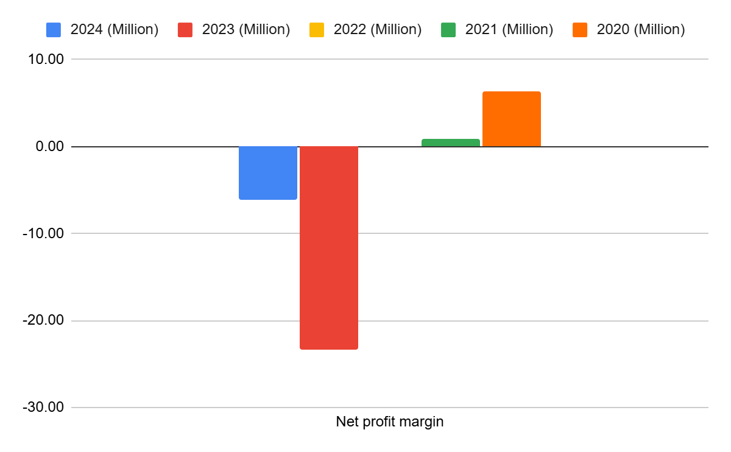
Figure 1: Net profit margin
(Source: self-report, 2025)
Operating profit margin
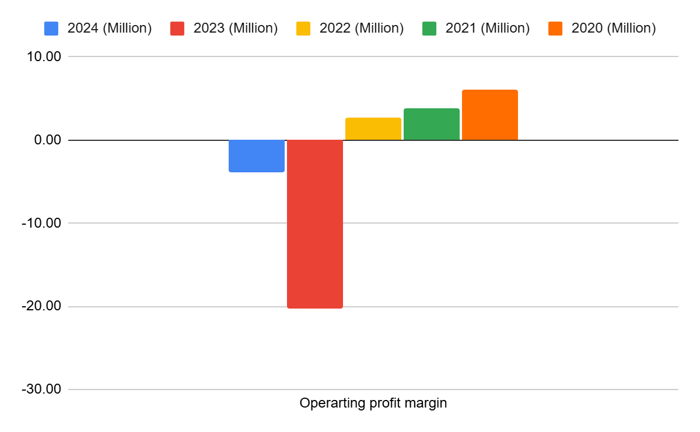
Figure 2: Operating profit margin
(Source: self-report, 2025)
Liquidity ratio
Current ratio
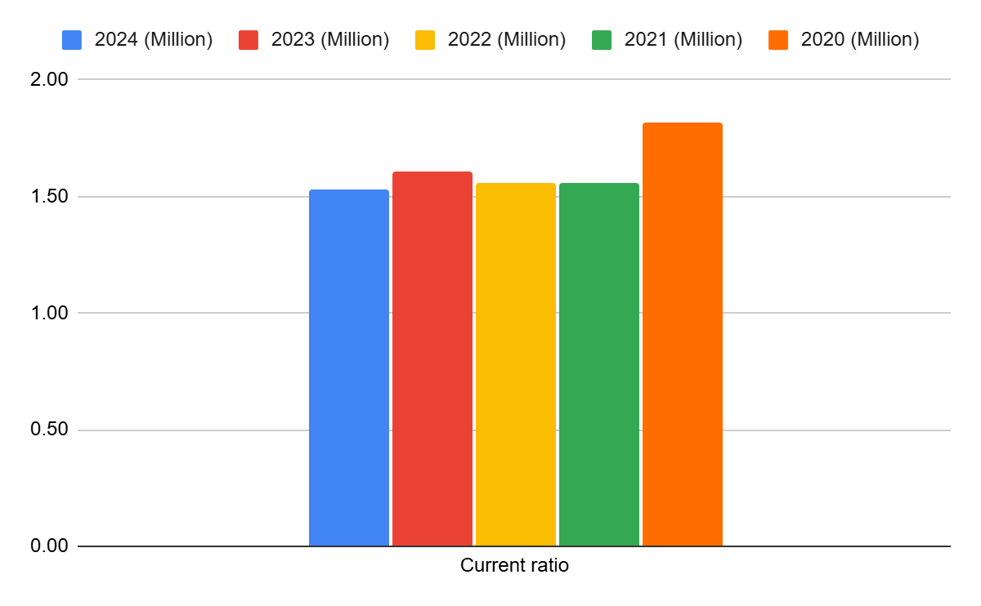
Figure 3: Current ratio
(Source: self-report, 2025)
Quick ratio
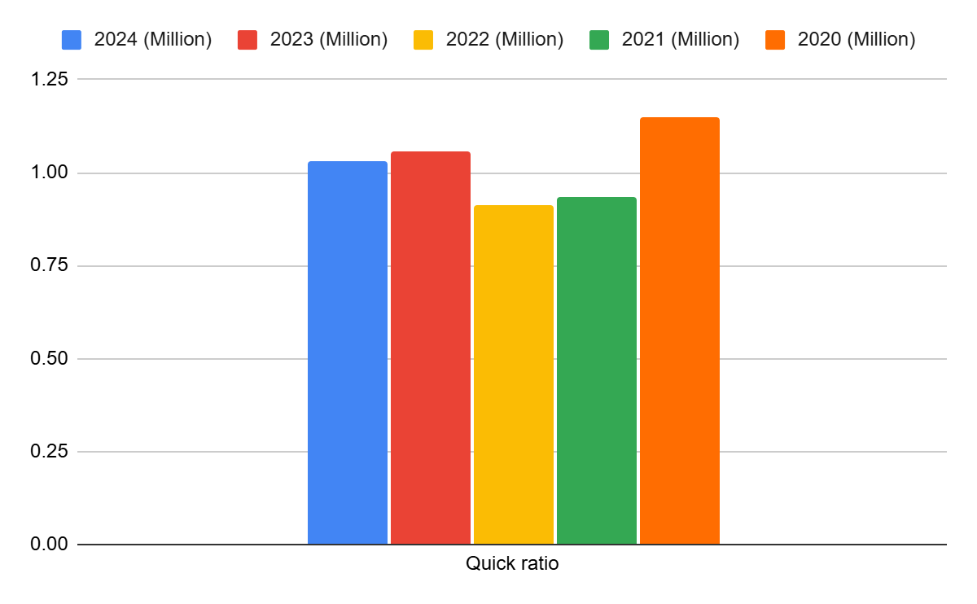
Figure 4: Quick ratio
(Source: self-report, 2025)
Efficiency ratio
Inventory turnover ratio
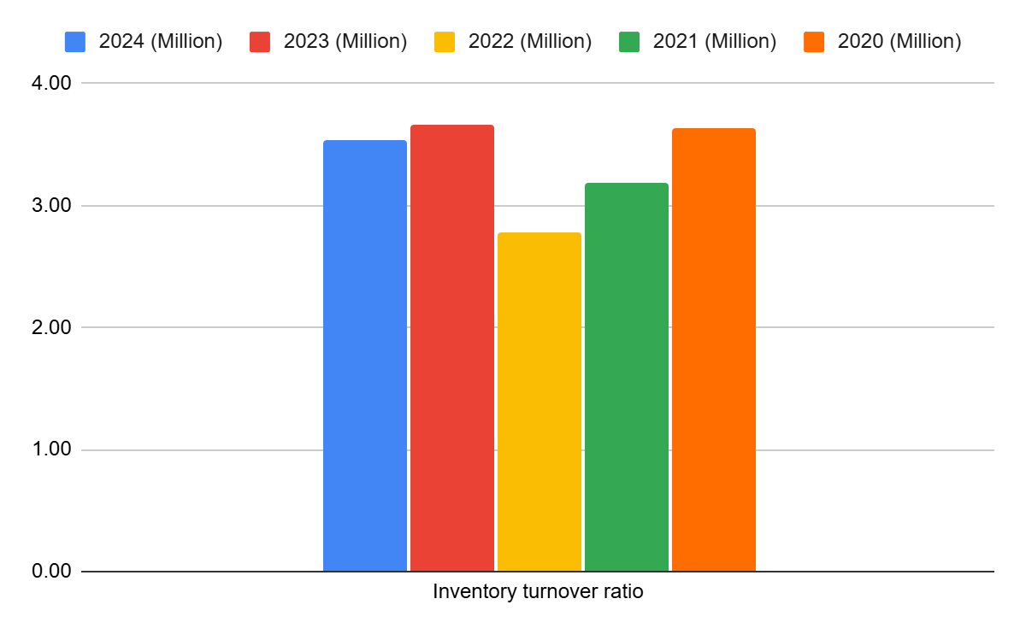
Figure 5: Inventory turnover ratio
(Source: self-report, 2025)
Receivable turnover ratio
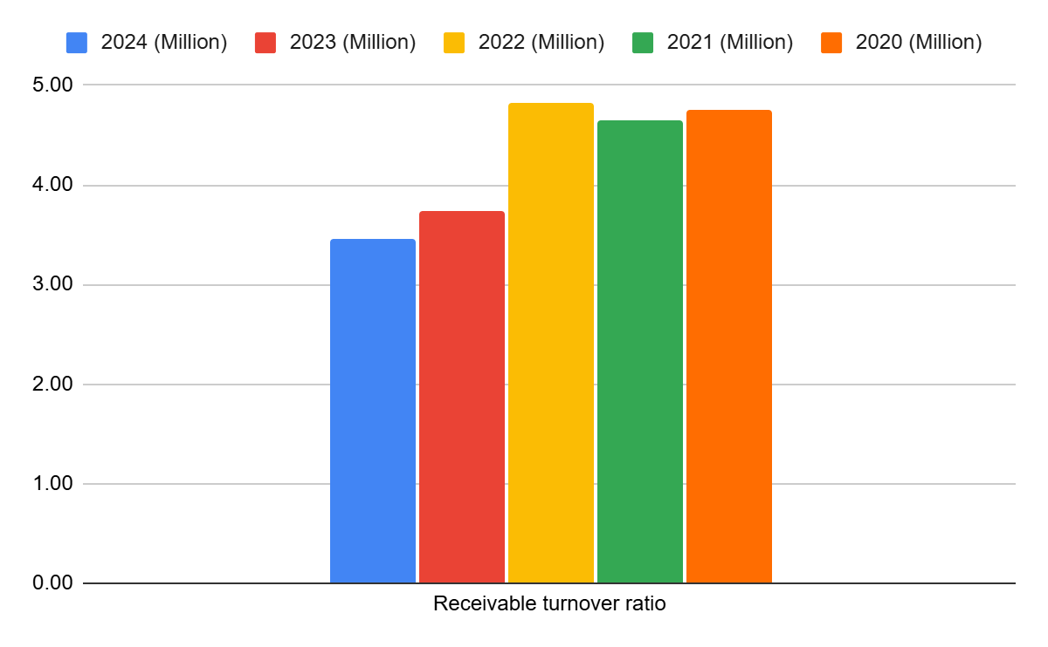
Figure 6: Receivable turnover ratio
(Source: self-report, 2025)
Gear ratio
Debt-to-equity ratio
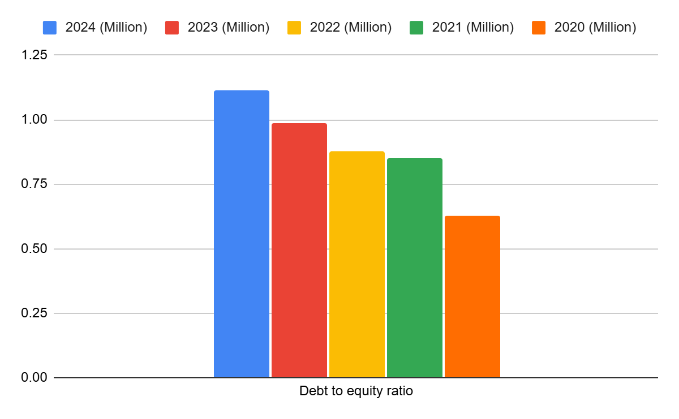
Figure 7: Debt-to-equity ratio
(Source: self-report, 2025)
Interest coverage ratio
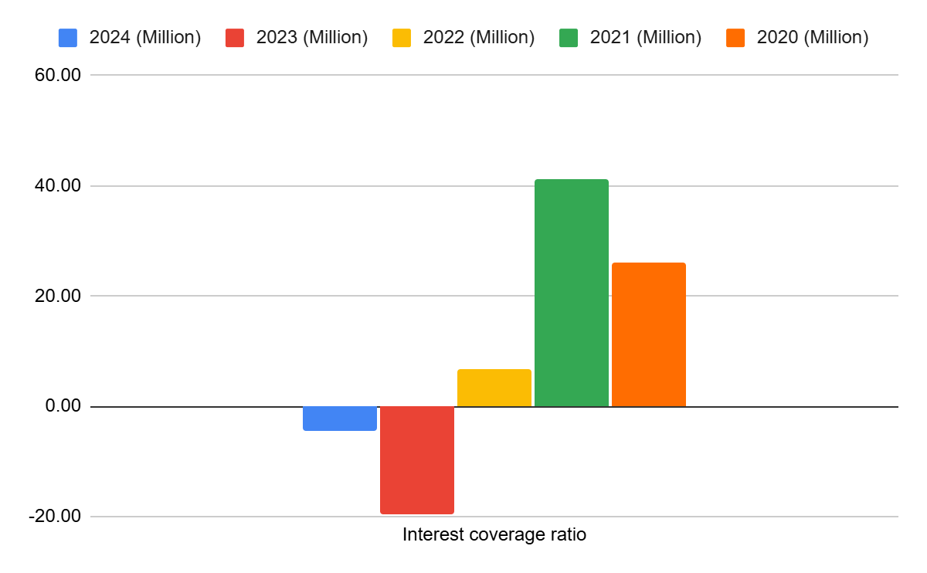
Figure 8: Interest coverage ratio
(Source: self-report, 2025)
Investment ratio
Return on Equity
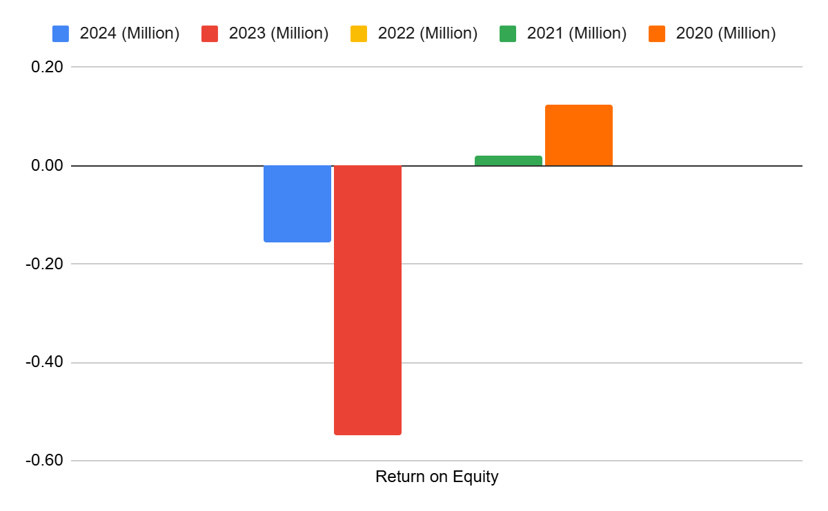
Figure 9: Return on Equity
(Source: self-report, 2025)
Earnings per share
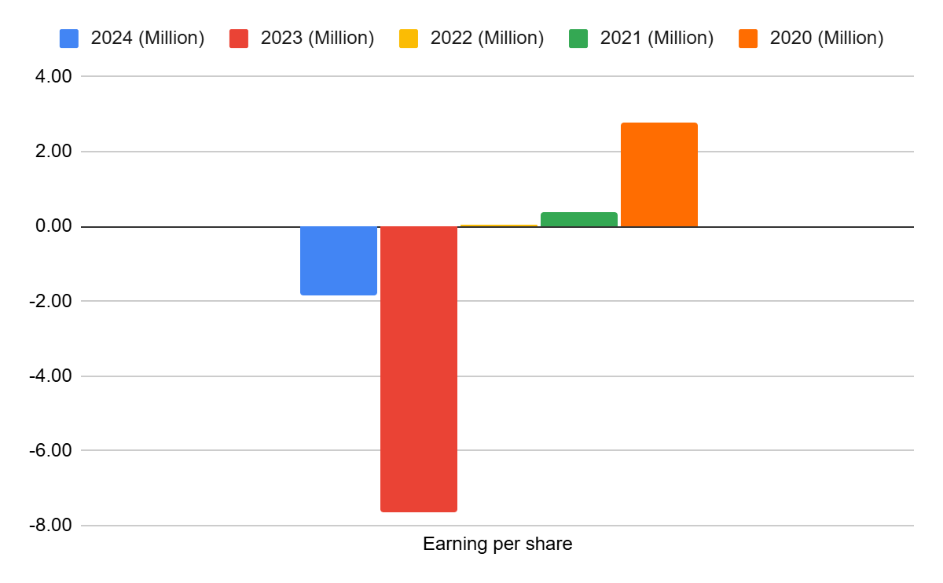
Figure 10: Earnings per share
(Source: self-report, 2025)
Cash flow ratio
Operating Cash Flow Margin
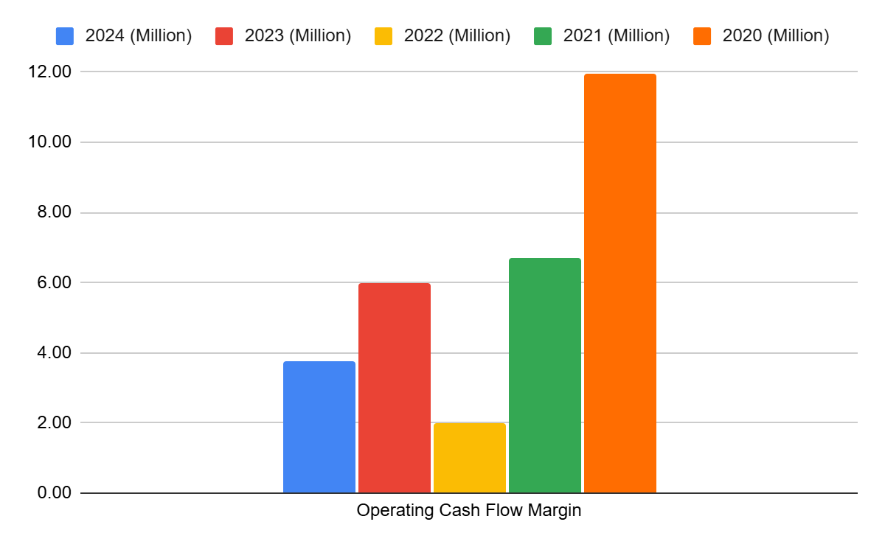
Figure 11: Operating Cash Flow Margin
(Source: self-report, 2025)
Free Cash Flow Margin
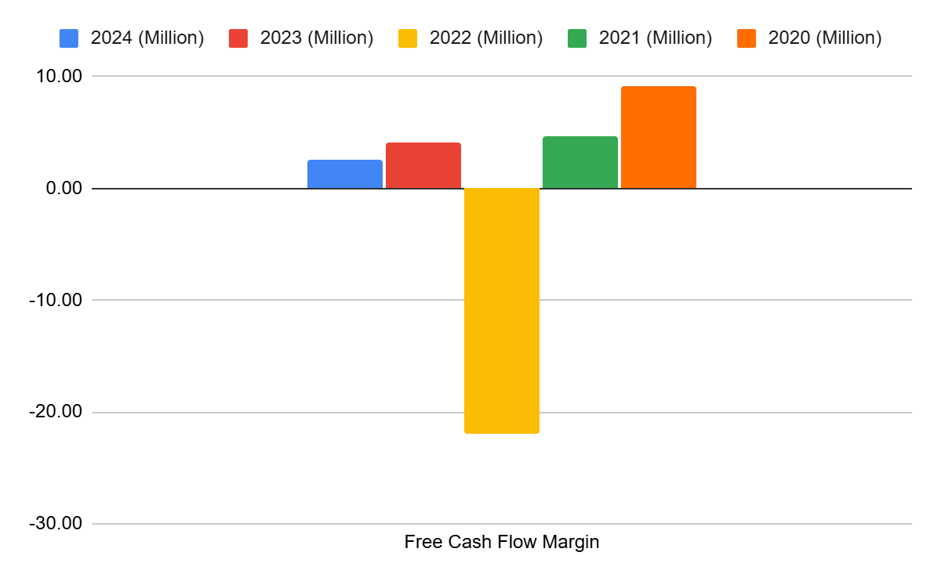
Figure 12: Free Cash Flow Margin
(Source: self-report, 2025)
Trend analysis
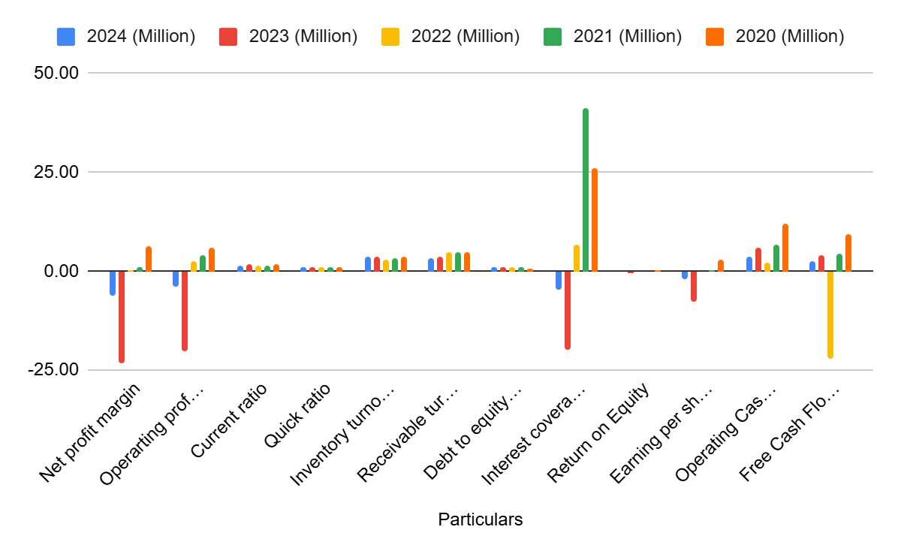
Figure 13: Trend analysis
(Source: self-report, 2025)
Investment analysis
Net Present Value
Project A
Project A
Year | Net cash flow | 10% discount rate | Present Value
1 | £10,000,000 | 0.909 | £9,090,000
2 | £12,000,000 | 0.826 | £9,912,000
3 | £14,000,000 | 0.751 | £10,514,000
4 | £10,000,000 | 0.683 | £6,830,000
5 | £8,000,000 | 0.620 | £4,960,000
Owner's Capital | £40,000,000
Total PV | £41,306,000
Net Present Value | £1,306,000
Table 13: NPV for Project A
(Source: self-report, 2025)
Project B
Project B
Year | Net cash flow | 10% discount rate | Present Value
1 | £6,000,000 | 0.909 | £5,454,000
2 | £6,000,000 | 0.826 | £4,956,000
3 | £6,000,000 | 0.751 | £4,506,000
4 | £6,000,000 | 0.683 | £4,098,000
5 | £6,000,000 | 0.620 | £3,720,000
Owner's Capital (d) | £30,000,000
Total PV | £22,734,000
Net Present Value (c-d) | -£7,266,000
Table 14: NPV for Project B
(Source: self-report, 2025)
Project C
Project C
Year | Net cash flow | 10% discount rate | Present Value
1 | £5,000,000 | 0.909 | £4,545,000
2 | £10,000,000 | 0.826 | £8,260,000
3 | £20,000,000 | 0.751 | £15,020,000
4 | £25,000,000 | 0.683 | £17,075,000
5 | £15,000,000 | 0.620 | £9,300,000
Owner's Capital (d) | £50,000,000
Total PV | £54,200,000
Net Present Value (c-d) | £4,200,000
Table 15: NPV for Project C
(Source: self-report, 2025)
Internal Rate of Return
Project A
Project A
Year | Net cash flow
Owner's Capital | -£40,000,000
1 | £10,000,000
2 | £12,000,000
3 | £14,000,000
4 | £10,000,000
5 | £8,000,000
IRR | 6%
Table 16: IRR for Project A
(Source: self-report, 2025)
Project B
Project B
Year | Net cash flow
Owner's Capital | -£30,000,000
1 | £6,000,000
2 | £6,000,000
3 | £6,000,000
4 | £6,000,000
5 | £6,000,000
IRR | -8%
Table 17: IRR for Project B
(Source: self-report, 2025)
Project C
Project C
Year | Net cash flow
Owner's Capital | -£50,000,000
1 | £5,000,000
2 | £10,000,000
3 | £20,000,000
4 | £25,000,000
5 | £15,000,000
IRR | 6%
Table 18: IRR for Project C
(Source: self-report, 2025)
Profitability Index
Project A
Project A
Year | Net cash flow | 10% discount rate | Present Value
1 | £10,000,000 | 0.909 | £9,090,000
2 | £12,000,000 | 0.826 | £9,912,000
3 | £14,000,000 | 0.751 | £10,514,000
4 | £10,000,000 | 0.683 | £6,830,000
5 | £8,000,000 | 0.620 | £4,960,000
Owner's Capital | £40,000,000
Initial Investment | £41,306,000
Profitability Index | £1
Table 19: Profitability Index for Project A
(Source: self-report, 2025)
Project B
Project B
Year | Net cash flow | 10% discount rate | Present Value
1 | £6,000,000 | 0.909 | £5,454,000
2 | £6,000,000 | 0.826 | £4,956,000
3 | £6,000,000 | 0.751 | £4,506,000
4 | £6,000,000 | 0.683 | £4,098,000
5 | £6,000,000 | 0.620 | £3,720,000
Owner's Capital | £30,000,000
Initial Investment | £22,734,000
Profitability Index | £1
Table 20: Profitability Index for Project B
(Source: self-report, 2025)
Project C
Project C
Year | Net cash flow | 10% discount rate | Present Value
1 | £5,000,000 | 0.909 | £4,545,000
2 | £10,000,000 | 0.826 | £8,260,000
3 | £20,000,000 | 0.751 | £15,020,000
4 | £25,000,000 | 0.683 | £17,075,000
5 | £15,000,000 | 0.620 | £9,300,000
Owner's Capital | £50,000,000
Initial Investment | £54,200,000
Profitability Index | £1
Table 21: Profitability Index for Project C
(Source: self-report, 2025)
Payback period
Project A
Payback period - Project A
Particulars | Amount
Initial Capital | 40
1 | £10
2 | £12
3 | £14
4 | 10
5 | 8
PBP in the year | 3
Unrecovered cash | £4
Recovery period cash flow | £10
PBP (in months) | 4.80
PBP | 3 years and 4.80 months
Table 22: Payback period for Project C
(Source: self-report, 2025)
Project B
Payback period - Project B
Particulars | Amount
Initial Capital | 30
1 | £6
2 | £6
3 | £6
4 | £6
5 | £6
PBP in the year | 5
Unrecovered cash | £0
Recovery period cash flow | £0
PBP (in months) | £0
PBP | 5 years
Table 23: Payback period for Project C
(Source: self-report, 2025)
Project C
Payback period - Project C
Particulars | Amount
Initial Capital | 50
1 | £5
2 | £10
3 | £20
4 | 25
5 | 15
PBP in the year | 3
Unrecovered cash | £15
Recovery period cash flow | £25
PBP (in months) | 7.20
PBP (in years) | 3 years and 7.20 months
Table 24: Payback period for Project C
(Source: self-report, 2025)
ARR
Project A
ARR - Project A
Year | Net cash flow
Owner's Capital | £40
1 | £10
2 | £12
3 | £14
4 | £10
5 | £8
Total inflows over five years | 54
Average annual inflow | 10.8
ARR | 27%
Table 25: ARR for Project A
(Source: self-report, 2025)
Project B
ARR - Project B
Year | Net cash flow
Owner's Capital | £30
1 | £6
2 | £6
3 | £6
4 | £6
5 | £6
Total inflows over five years | 30
Average annual inflow | 6
ARR | 20.00%
Table 26: ARR for Project B
(Source: self-report, 2025)
Project C
ARR - Project C
Year | Net cash flow
Owner's Capital | £50
1 | £5
2 | £10
3 | £20
4 | £25
5 | £15
Total inflows over five years | 75.00
Average annual inflow | 15.00
ARR | 30%
Table 27: ARR for Project C
(Source: self-report, 2025)

