

Calculations on Piston, Rod and Crankshaft Assemblies
Advanced Competition Engine Design (M6X00410)
Student: Alex Oke (P151012)
Lecturer: Malcolm Mcdonald
Due Date: 10/02/2020
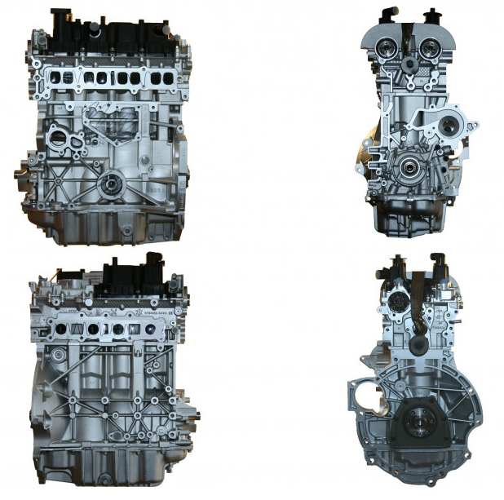
Table of Contents
Table of Figures 3
Table of Equations 3
Table of Tables 5
Table of Graphs 6
1 Introduction 7
1.1 Aims of Assignment 7
2 Research 8
2.1 Component Materials 8
3 Gudgeon Pin 9
3.2 Methodology 10
3.2.1 Pin Tensile Stress (Firing) 10
3.2.2 Pin Compressive Stress (Exhaust TDC) 11
3.3 Gudgeon Pin Results 12
4 Connecting Rod 13
4.2 Methodology of Connecting Rod Point A and B 14
4.2.1 Point A Tensile Stress Scenario (Exhaust TDC) 15
4.2.2 Point A Compressive Stress Scenario (Firing) 15
4.2.3 Point B Tensile Stress Scenario (Exhaust TDC) 16
4.2.4 Point B Compressive Stress Scenario (Firing) 16
4.2.5 Point A and B Stress Concentration Factor 17
4.2.6 Point A Results 18
4.2.7 Point B Results 19
4.3 Methodology Point Connecting Rod Point C 20
4.3.1 Point C Tensile Stress (Exhaust TDC) 21
4.3.2 Point C Stress Concentration Factor 21
4.3.3 Point C Results 22
5 Connecting Rod Bolts 23
5.2 Methodology of Standard Ford Bolt 24
5.2.1 Standard Bolt and Cap Stiffness Ratio 24
5.2.2 Standard Bolt Stiffness 25
5.2.3 Maximum Alternating Load @ 6000rpm 25
5.2.4 Bolt Torque for 90% Yield 26
5.2.5 Original Bolt Stress Concentration Factor 28
5.2.6 Standard Bolt Goodman Diagram @ 6000 rpm 30
5.2.7 Standard Bolt @ 9000rpm 31
5.3 Uprated Bolt Design 32
5.3.1 Uprated Bolt Results 34
5.4 Standard and Uprated Bolt Design Comparison 35
5.4.1 Comparison of the critical design features 35
6 Crankshaft 36
6.1 Methodology of Crankshaft Stress 37
6.1.1 Point B in Tensile (Firing) 38
6.1.2 Point B in Compression (Exhaust TDC) 39
6.2 Crankshaft Stress Concentration Factor 40
6.3 Crankshaft Results 41
7 Conclusion 42
8 References 43
9 Abstract for Further Work 44

Table of Figures
Figure 1 Gudgeon Pin Split Diagram 9
Figure 2 Connecting Rod Sections Diagram 13
Figure 3 Point A Cross Sectional Area 14
Figure 4 Point B Cross Sectional Area 14
Figure 5 Stress Concentration of a stepped tension bar of circular cross section with shoulder fillet 17
Figure 6 Point C Cross Sectional Area 20
Figure 7 Point C Stress Concentration Fillet 20
Figure 8 Connecting Rod Cap Force Split 20
Figure 9 Original Ford Bolt Length of Engagement 23
Figure 10 Original Ford Bolt 23
Figure 11 Stress Concentration of a circular bar in tension with V notch corresponding with a round shaped base 28
Figure 12 Bosch Handbook ISO Metric Threads Dimension Diagram 28
Figure 13 Uprated Bolt Design 33
Figure 14 Standard Bolt Design 35
Figure 15 Uprated Bolt Design 35
Figure 16 Crank Loading Scenario 36
Figure 17 Crankshaft Neutral Axis 37
Figure 18 Stress Concentration Factor for Crankshaft, Grooved round bar in torsion. 40

Table of Equations
Equation 1 How the Stress Concentration Factor is Applied 8
Equation 2 Pin Acceleration 10
Equation 3 Pin Inertia Force 10
Equation 4 Total Tensile Bending Moment 10
Equation 5 Second Moment of Area 10
Equation 6 Tensile Bending Stress 10
Equation 7 Tensile Shear Stress 10
Equation 8 Von Mises Stress 10
Equation 9 Total Compressive Bending Moment 11
Equation 10 Compressive Bending Moment 11
Equation 11 Compressive Shear Stress 11
Equation 12 Von Mises Stress 11
Equation 13 Mean Stress Gudgeon Pin 11
Equation 14 Actual Range of Stress Gudgeon Pin 11
Equation 15 Endurance Limit Gudgeon Pin 11
Equation 16 Allowable Range of Stress Gudgeon Pin 11
Equation 17 Fatigue Safety Factor Gudgeon Pin 11
Equation 18 Point A Net Tensile Force 15
Equation 19 Point A Tensile Stress 15
Equation 20 Point A Compressive Stress 15
Equation 21 Point B Net Tensile Force 16
Equation 22 Point B Tensile Stress 16
Equation 23 Point B Net Compressive Force 16
Equation 24 Kt Formula for Points A and B 17
Equation 25 Point C Inertia Force 21
Equation 26 Point B Tensile Stress 21
Equation 27 Stiffness ratio and Extra Force Relationship 24
Equation 28 Bolt and Cap Stiffness Ratio 24
Equation 29 Bolt Stiffness up to elastic limit 25
Equation 30 Axial Clamping Force 26
Equation 31 Circumferential Head Friction Force 26
Equation 32 Circumferential Head Friction Force 26
Equation 33 Resisting Torque at Head 27
Equation 34 Resisting Torque at Threads 27
Equation 35 Total Tightening Torque 27
Equation 36 Kta Formula for Bolt threads 29
Equation 37 Fatigue Safety Factor 30
Equation 38 Stiffness formula in series 32
Equation 39 Effective width of critical beam 37
Equation 40 Bending Moment at Point B during firing 38
Equation 41 Bending Stress at Point B during firing 38
Equation 42 Shear Stress at Point B during firing 38
Equation 43 Bending Moment at Point B during exhaust TDC 39
Equation 44 Bending Stress at Point B during exhaust TDC 39
Equation 45 Shear Stress at Point B during exhaust TDC 39
Equation 46 Point B Combined Stress Results 39

Table of Tables
Table 1 Gudgeon Pin Material Properties 8
Table 2 Connecting Rod and Cap Material Properties 8
Table 5 Standard Ford Bolt Material Properties 8
Table 4 Uprated Bolt Material Properties 8
Table 3 Crankshaft Material Properties 8
Table 6 General Engine Dimensions 9
Table 7 Gudgeon Pin Dimensions 9
Table 8 Gudgeon Pin Goodman Diagram Results 12
Table 9 Point B Components and Masses 14
Table 10 Point A Components and Masses 14
Table 11 Point A Dimensions, Tensile Force and Stress 15
Table 12 Point A Dimensions, Compressive Force and Stress 15
Table 13 Point B Dimensions, Tensile Force and Stress 16
Table 14 Point B Dimensions, Compressive Force and Stress 16
Table 15 Point A Stress Concentration Factor 17
Table 16 Point B Stress Concentration Factor 17
Table 17 Point A Goodman Diagram Results 18
Table 18 Point B Stress Goodman Diagram. 19
Table 19 Point C Components and Masses 20
Table 20 Point C Dimensions, Masses, Tensile Force and Stress 21
Table 21 Point C Stress Concentration Factor 21
Table 22 Point C Goodman Diagram Results 22
Table 23 Bolt and Cap Stiffness Ratio Values 24
Table 24 Bolt Head and Thread Fiction Co-efficient 26
Table 25 Bolt Torque for 90% yield values 27
Table 26 Bosch Handbook ISO Metric Fine Thread Dimensions 28
Table 27 Standard Bolt Threads Stress Concentration Factor 29
Table 28 Standard Bolt Stress Results 29
Table 29 Standard Bolt Comparison at Modified RPM 31
Table 30 Uprated bolt dimensions 33
Table 31 Standard to New Bolt Comparison of Extra Force 34
Table 32 Crankshaft Dimensions 37
Table 33 Crankshaft 2nd moment of area 38
Table 34 Crankshaft Stress Concentration Factor 40
Table 35 Crankshaft Stress Goodman Diagram Results 41

Table of Graphs
Graph 1 Gudgeon Pin Alternating Stress 12
Graph 2 Gudgeon Pin Goodman Diagram Error! Bookmark not defined.
Graph 3 Point A Alternating Stress 18
Graph 4 Point A Goodman Diagram 18
Graph 5 Point B Goodman Diagram 19
Graph 6 Point B Alternating Stress 19
Graph 7 Point C Goodman Diagram 22
Graph 8 Point C Alternating Stress 22
Graph 9 Alternating Load from Inertia Force 25
Graph 10 Alternating Load from Extra Force 25
Graph 11 Standard Bolt Goodman Diagram @ 6000rpm 30
Graph 12 Original Ford Bolt Goodman Diagram @ 9000rpm 31
Graph 13 Crankshaft Goodman Diagram 41

Introduction
The design of the critical operating components inside Ford’s 1.6 Eco-boost GTDI engine has been carefully de-constructed and reverse engineered in this report to establish a set of Fatigue Safety Factors and Goodman Diagrams. The components include the Gudgeon Pin, Connecting Rod, Bolts and Crankshaft. Using multiple derived mathematical processes, the forces acting on each component have been found, thus aiding the author to proceed in calculating the estimated fatigue life which enables an engineer to apply a life cycle to the component depending upon its application.
In a summarised statement, it can be stated that the Connecting Rod experiences compressive and tensile forces in a cyclic fashion. These forces have been identified in a previous study carried out by the author Alex Oke. The previous study allowed the author to calculate a FSF for the smallest area of the rod shank, however, this study aims to develop the model to show the forces, stresses and fatigue safety factors in 3 areas of the Connecting Rod including large radius areas which is causing stress concentration.
The process carried out on the Connecting Rod will be the same used for the Gudgeon Pin, Bolts and Crankshaft. Allowing for the FSF for every part to be found, thus if the engine was to be modified to a limit of 9000rpm as opposed to the original 6000rpm, the components can be re-designed to adhere to the same FSF to ensure their operating life prior to failure.

Aims of Assignment
- Establish correct forces acting on specific components of the engine as different masses are involved in each area of the Connecting Rod.
- Provide Safety Factors for infinite fatigue life for the engine’s duty cycle for the Gudgeon Pin, Connecting Rod, Bolts and Crankshaft.
- Apply Safety Factors to a modified engine component for a different purpose but remain with the same estimated fatigue life.
- Find appropriate Stress Concentration Factors and apply these where critical fillets sections are being analysed.
- Re-design an engine component applying Fatigue Safety Factors as a design constraint.

Research
Stress concentrations are formed where a sudden change in geometry occurs, this can cause the lines of force which run in a straight fashion to bunch up, this is why stress concentration factors are applied to the endurance limit to reduce this as it takes into consideration areas which are more susceptible to failure.
The reason for fillets, is to reduce the bunching up of the force therefore creating a more gradual flow for the force and less of a problematic area with high stress occurring.
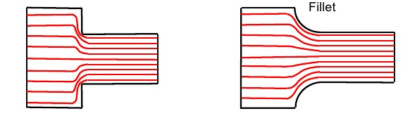

Equation 1 How the Stress Concentration Factor is Applied
$$Final Endurance Limit=\frac{Polished Endurance Limit}{K_{t}}$$

Component Materials
Table 5 Gudgeon Pin Material Properties
Table 5 Connecting Rod and Cap Material Properties
Table 5 Standard Ford Bolt Material Properties
Table 5 Uprated Bolt Material Properties
Table 5 Crankshaft Material Properties

Gudgeon Pin

Notes
- A bending moment has been found for 2 point on the Pin, however, the moment found at Point B is less than that of Point A, therefore the lower FSF will be found at Point A and analysis of Point B can be used in order to establish a taper on the inside of the Gudgeon Pin. This is something which is carried out on turbo engines as they operate at lower engine speeds, thus do not need as much support on the TDC exhaust max scenario.
- A CAD model of the Gudgeon has been constructed by the author to aid in measuring the critical operating parameters as seen in Figure 1, Table 6 and Table 7.
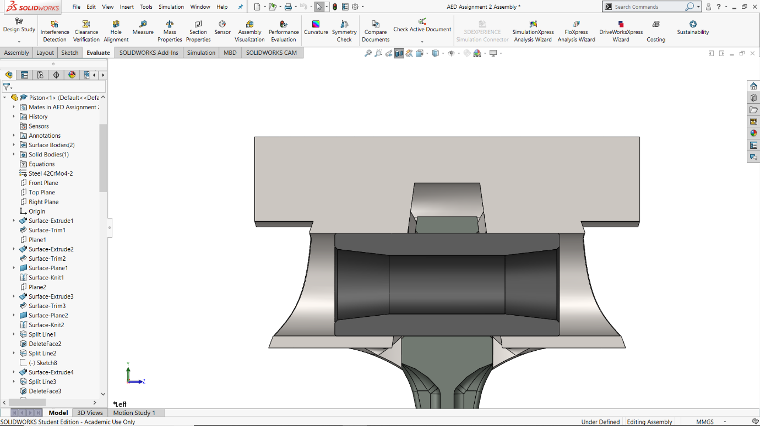
$$\frac{F_{Net}}{2}$$
$$\frac{F_{Net}}{2}$$
Figure 1 Gudgeon Pin Split Diagram
A

L₁
D₁

Y
Neutral Axis
D₂
L₄

L₂

Table 6 General Engine Dimensions
Table 7 Gudgeon Pin Dimensions

Methodology
The Gudgeon Pin has had the stresses acting upon it split into 2 scenarios as these are acting in opposite directions therefore must be calculated individually.

Pin Tensile Stress (Firing)

Equation 2 Pin Acceleration

$$Pin Acceleration=Rω^{2}∙\cos{θ}+\frac{R}{L}Rω^{2}∙\cos{2θ}$$
$$Pin Acceleration=20911.83{m/s}^{2}$$
Equation 3 Pin Inertia Force

$$Pin Interia Force=Pin Acceleration∙Pin Mass Petruding$$
$$Pin Interia Force=542.66 N$$
Equation 4 Total Tensile Bending Moment
$$Total Bending Moment=\left(Net Gas Force∙L_{1}\right)-\left(Pin Inertia Force∙L_{2}\right)$$
$$Total Bending Moment=202175.95 N∙mm$$
Equation 5 Second Moment of Area

$$Pin Second Moment of Area (I)=\frac{π∙\left(D_{1}^{4}-D_{2}^{4}\right)}{64}$$
$$Pin Second Moment of Area \left(I\right)(Taken from solidworks)=7210.99 {mm}^{4}$$
Equation 6 Tensile Bending Stress

$$Tensile Bending Stress (σ_{B})=\frac{M∙Y}{I}$$
$$Tensile Bending Stress \left(σ_{B}\right)=294.39 {N/{mm}}^{2}$$
Equation 7 Tensile Shear Stress

$$Tensile Shear Stress \left(τ\right)=\frac{\left(Net Gas Force-Pin Inertia Force\right)}{\left.\frac{π∙(D_{1}^{2}-D_{2}^{2})}{4}\right.}$$
$$Tensile Shear Stress \left(τ\right)=92.12{N/{mm}}^{2}$$
Equation 8 Von Mises Stress
$$Von Mises Stress=\sqrt{{σ_{B}}^{2}+{(2τ)}^{2}}$$
$$Von Mises Stress {(σ}_{Max})=347.28{N/{mm}}^{2}$$

Pin Compressive Stress (Exhaust TDC)

Equation 9 Total Compressive Bending Moment
$$Total Bending Moment=\left(Net Inertia Force∙L_{1}\right)+\left(Pin Inertia Force∙L_{2}\right)$$
$$Total Bending Moment=-51691.56 N∙mm$$
Equation 10 Compressive Bending Moment

$$Compressive Bending Moment (σ_{B})=\frac{M∙Y}{I}$$
$$Compressive Bending Moment (σ_{B})=-75.27{N/{mm}}^{2}$$
Equation 11 Compressive Shear Stress

$$Compresssive Shear Stress \left(τ\right)=\frac{(Net Inertia Force+Pin Inertia Force)}{\left.\frac{π∙(D_{1}^{2}-D_{2}^{2})}{4}\right.}$$
$$Compresssive Shear Stress \left(τ\right)=-27.70{N/{mm}}^{2}$$
Equation 12 Von Mises Stress
$$Von Mises Stress=\sqrt{{σ_{B}}^{2}+{(2τ)}^{2}}$$
$$Von Mises Stress {(σ}_{Min})=-93.45{N/{mm}}^{2}$$

Goodman Diagram Parameters
Equation 13 Mean Stress Gudgeon Pin

$$σ_{Mean}=\frac{\left(347.28+93.45\right)}{2}=126.92{N/{mm}}^{2}$$
Equation 14 Actual Range of Stress Gudgeon Pin

$$Actual Range of Stress=347.28-\left(-93.45\right)=440.74{N/{mm}}^{2}$$
Equation 15 Endurance Limit Gudgeon Pin

$$Endurance Limit=0.45∙1000=450{N/{mm}}^{2}$$
Equation 16 Allowable Range of Stress Gudgeon Pin

$$Allowable Range of Stress=2∙450∙\left(1-\frac{126.92}{1100}\right)=785.78{N/{mm}}^{2}$$
Equation 17 Fatigue Safety Factor Gudgeon Pin
$$FSF=\frac{785.78}{440.74}=1.78$$

Gudgeon Pin Results
The following results have been yielded from the study carried out in Section 3.2. The forces found are found at Point A highlighted in Figure 1 with the red circle. In a general conclusive manner, the stress which the Gudgeon Pin is experiencing is under the UTS and therefore resulting in a Fatigue Safety Factor of above 1. Table 8 Gudgeon Pin Goodman Diagram Results below displays the results which come from the combined von mises stress calculation which combines both bending and shear stress into a value which can be quantifiably validated with ease as this is what is used as an industry standard.
Table 8 Gudgeon Pin Goodman Diagram Results

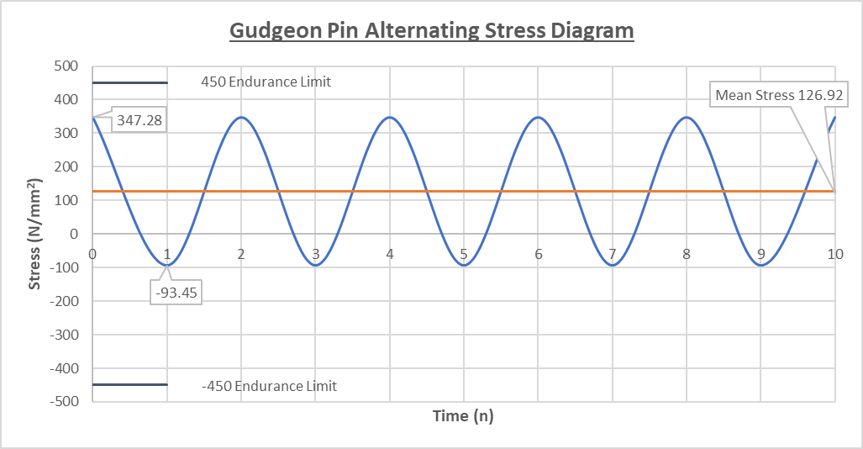
Graph 1 Gudgeon Pin Alternating Stress

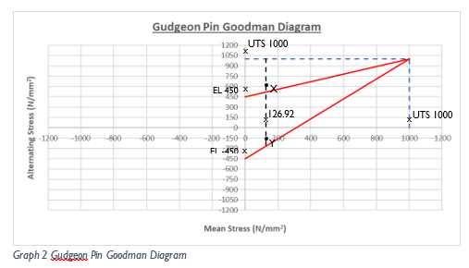

Connecting Rod

Notes
- The connecting rod is a pin jointed scenario as the crank pin is at one end of the joint and the gudgeon pin at the opposite end. Continuing from the previous study by Alex Oke including the net compressive and tensile forces acting on the connecting rod shank found, these forces will be used to find the stress through the cross-sectional area taken at points A and B.
- In this study the author has assumed the connecting rod angle is 0° therefore during firing and exhaust TDC scenarios the force is assumed to be in the vertical Y direction as opposed to a resolved force which the rod would experience in true form.
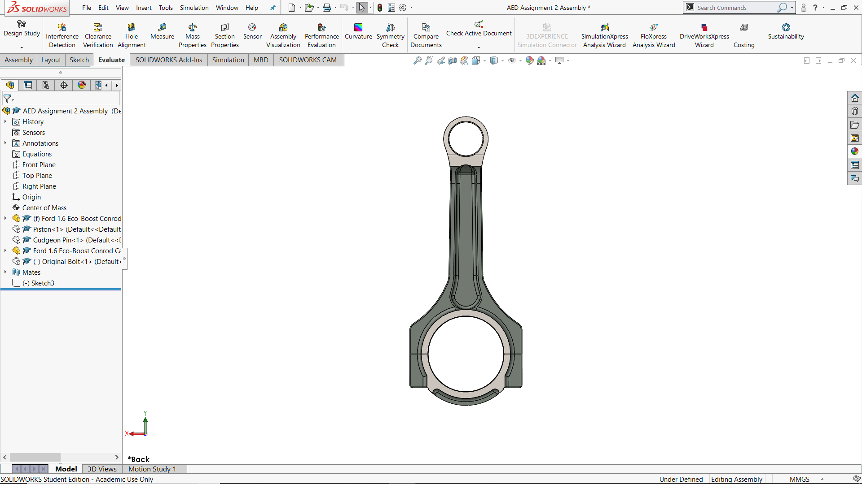
- At point C, due to the geometry of the connecting rod cap and crank pin, the cap only experiences a tensile force when at exhaust TDC. During firing the crank pin is in contact with the top half of the surface which encases the crank pin, this can be seen in Figure 2 and highlighted with the key table below. The red area is in experiencing tensile force during exhaust TDC and the blue area is subject to compressive forces during the firing stage of the 4-stroke cycle.
Point A A
Point B
Point C
Figure 2 Connecting Rod Sections Diagram

Methodology of Connecting Rod Point A and B
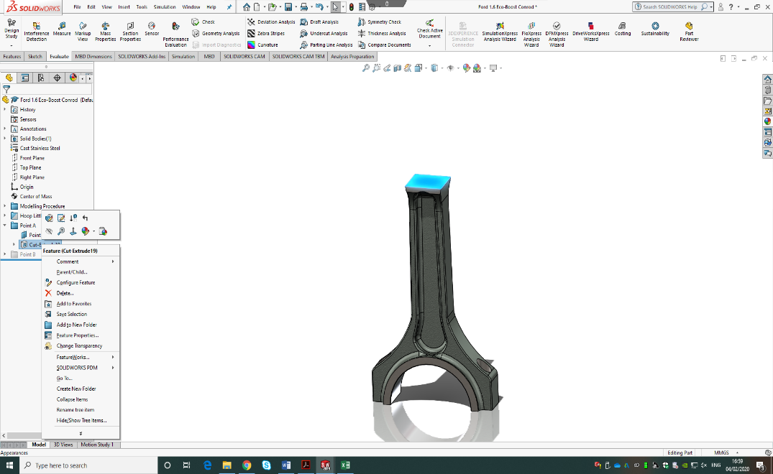
Figure 3 Point A Cross Sectional Area
Area = 302.92mm²

Area = 268.16mm²

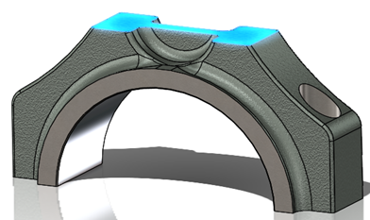

Figure 4 Point B Cross Sectional Area

Due to the radius which is joining the hoop section of the connecting rod with the shank, there will be stress concentrations applied at a later stage of this methodology section. The tensile force is identified by taking the mass of all components and masses which are acting upon this cross sectional area. The highest inertial force was found to be at 6000rpm where the angular velocity of the crank is at it’s peak. The peak compressive force has been defined in the previous study carried out the same way as the inertia however using the largest negative number as this represents the compressive direction. This compressive force was found to be highest at 5700rpm as this is where the gas force hits its peak value, thus making the net compressive force greater at 5700rpm than 6000rpm.
The components and masses included in the inertia force for Point A and B include:
Table 9 Point B Components and Masses
Table 10 Point A Components and Masses

Point A Tensile Stress Scenario (Exhaust TDC)
Table 11 Point A Dimensions, Tensile Force and Stress

Equation 18 Point A Net Tensile Force

$$Point A Net Tensile Force=Gas Force-(Mass acting on Point A Area∙Acceleration)$$
$$Point A Net Tensile Force=11214.65 N$$
Equation 19 Point A Tensile Stress
$$Point A Tensile Stress=\frac{Net Tensile Force}{Point A Area}$$
$$Point A Tensile Stress=37.02 {N/{mm}}^{2}$$

Point A Compressive Stress Scenario (Firing)
Table 12 Point A Dimensions, Compressive Force and Stress

$Point A Net Compressive Force=-41680.26 N$
Equation 20 Point A Compressive Stress
$$Point A Compressive Stress=\frac{Net Compressive Force}{Point A Area}$$
$$Point A Compressive Stress=-137.59 {N/{mm}}^{2}$$

Point B Tensile Stress Scenario (Exhaust TDC)
Table 13 Point B Dimensions, Tensile Force and Stress

Equation 21 Point B Net Tensile Force
$$Point B Net Tensile Force=Gas Force-(Mass acting on Point B Area∙Acceleration)$$
$$Point B Net Tensile Force=8773.67 N$$
Equation 22 Point B Tensile Stress

$$Point B Tensile Stress=\frac{Net Tensile Force}{Point B Area}$$
$$Point B Tensile Stress=32.72 {N/{mm}}^{2}$$

Point B Compressive Stress Scenario (Firing)
Table 14 Point B Dimensions, Compressive Force and Stress

$$Point B Net Compressive Force=-39659.10 N$$
Equation 23 Point B Net Compressive Force
$$Point B Compressive Stress=\frac{Net Compressive Force}{Point B Area}$$
$$Point B Compressive Stress=-147.90 {N/{mm}}^{2}$$

Point A and B Stress Concentration Factor
To define a stress concentration factor, Peterson’s Stress Concentration Factors (Second Edition) has been studied to find the most suitable method. The author has identified the scenario of a stepped tension bar of circular cross section with shoulder fillet as an appropriate way to calculate the value of K_{t}.
Peterson’s method to find K_{t} included finding the several values seen in Figure 5 which are then input to Equation 24.
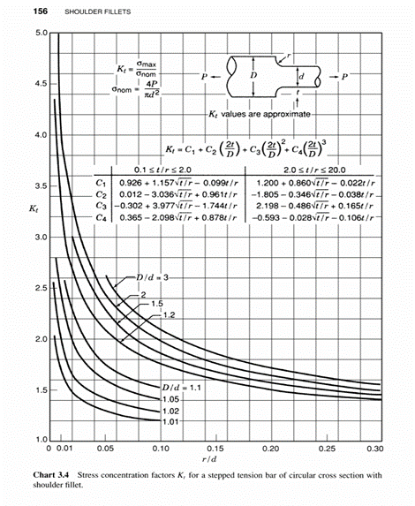
Equation 24 Kt Formula for Points A and B
Figure 5 Stress Concentration of a stepped tension bar of circular cross section with shoulder fillet
$$K_{t}=C_{1}+C_{2}\left(\frac{2t}{D}\right)+C_{3}{\left(\frac{2t}{D}\right)}^{2}+C_{4}{\left(\frac{2t}{D}\right)}^{3}$$

Table 15 Point A Stress Concentration Factor
Table 16 Point B Stress Concentration Factor

Point A Results
The material having a UTS of 750 N/mm² gives a polished endurance limit of 337.5 N/mm², due to the stress concentration value K_{t} being calculated as 1.06 as shown in, the final endurance limit is defined with the use of the following equation:
$$Final Endurance Limit=\frac{337.5}{1.06}=317.28 {N/{mm}}^{2}$$
Table 17 Point A Goodman Diagram Results

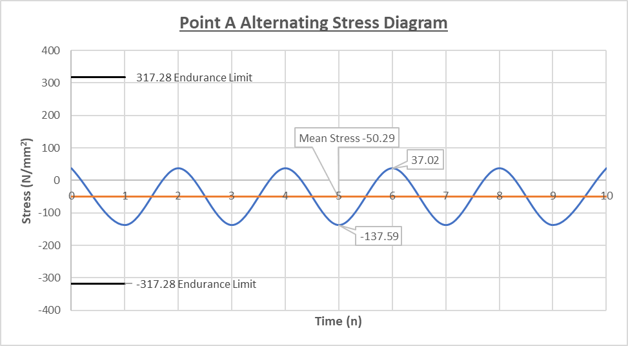
Graph 2 Point A Alternating Stress

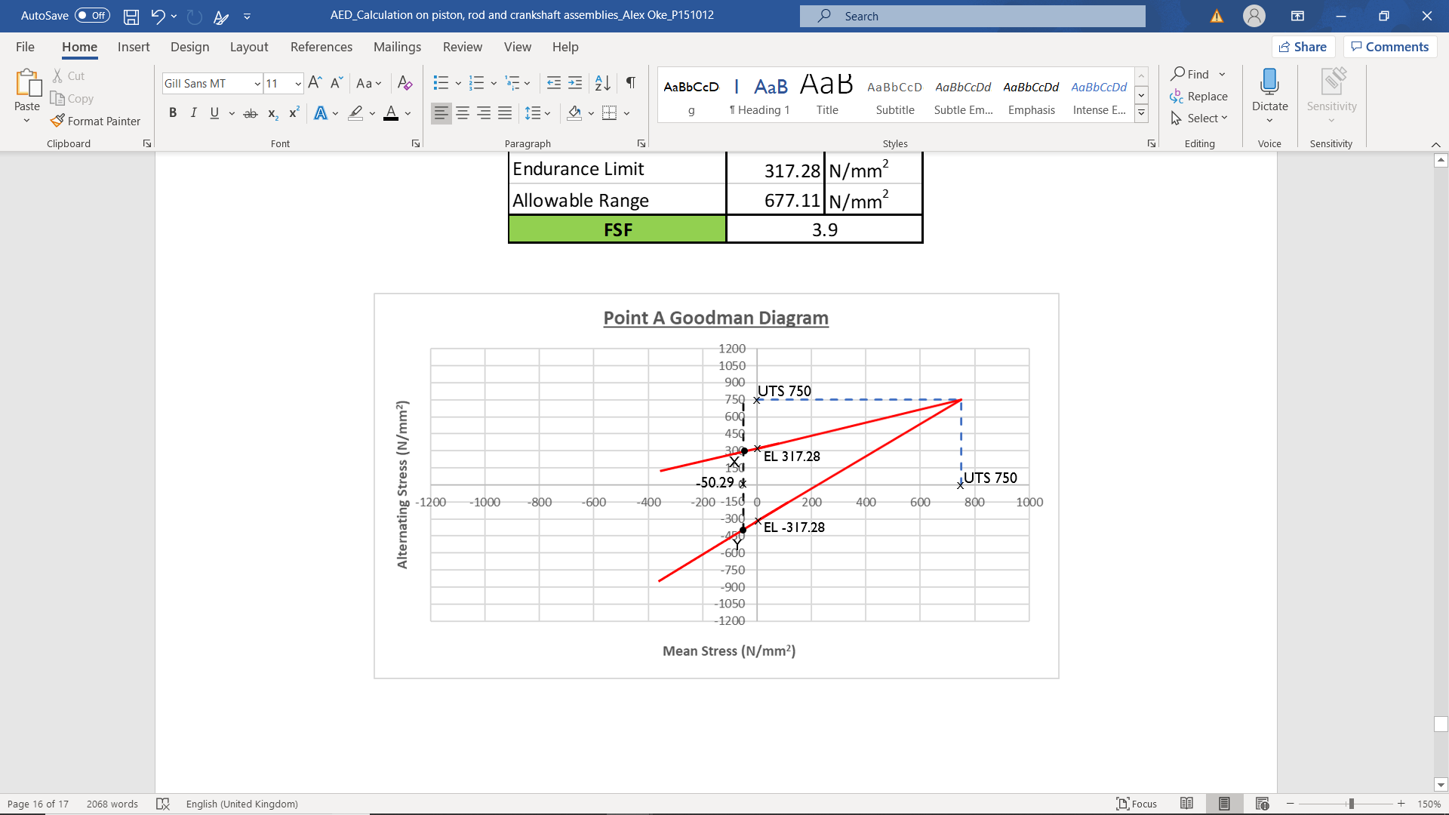
Graph 3 Point A Goodman Diagram

Point B Results
As aforementioned the material used for the connecting rod has a UTS of 750 N/mm² , the polished endurance limit is the same as at Point A, however applying the stress concentration calculated in Table 16, the following equation is used to find the final endurance limit:
$$Final Endurance Limit=\frac{337.5}{1.09}=309.17 {N/{mm}}^{2}$$
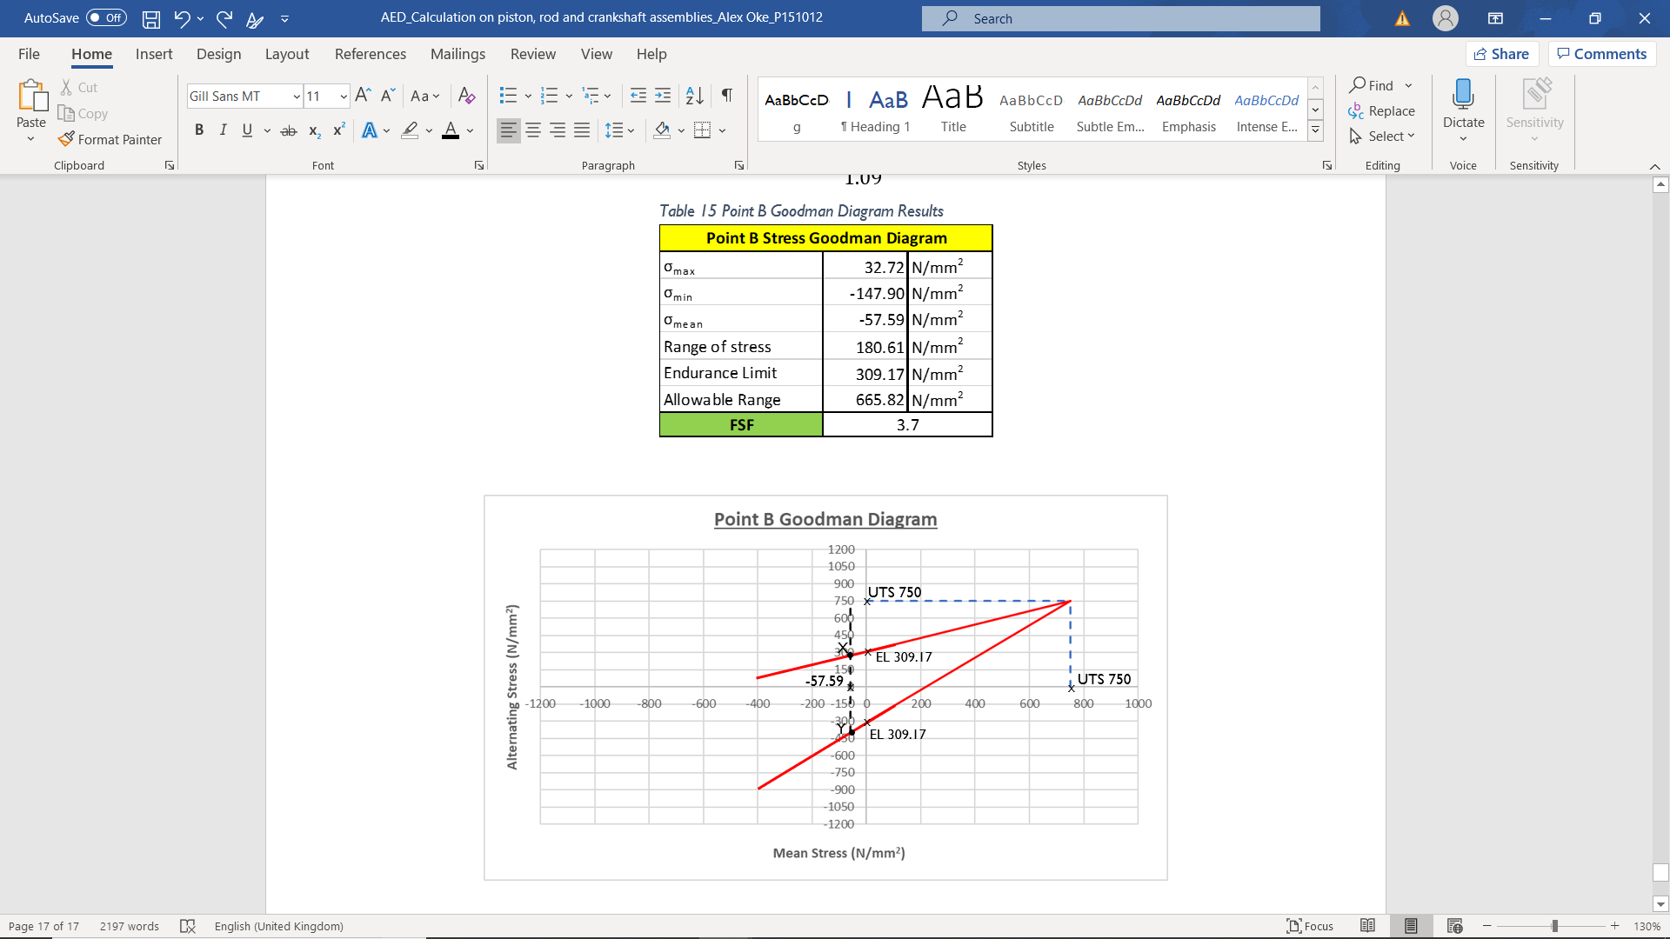
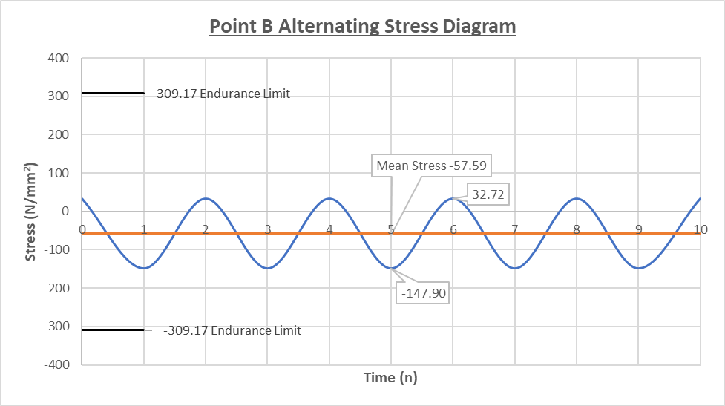
Table 18 Point B Stress Goodman Diagram.
Graph 4 Point B Goodman Diagram
Graph 5 Point B Alternating Stress

Methodology Point Connecting Rod Point C

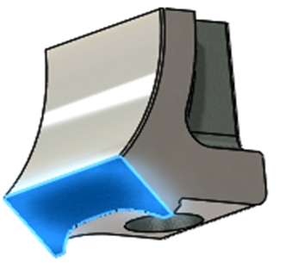
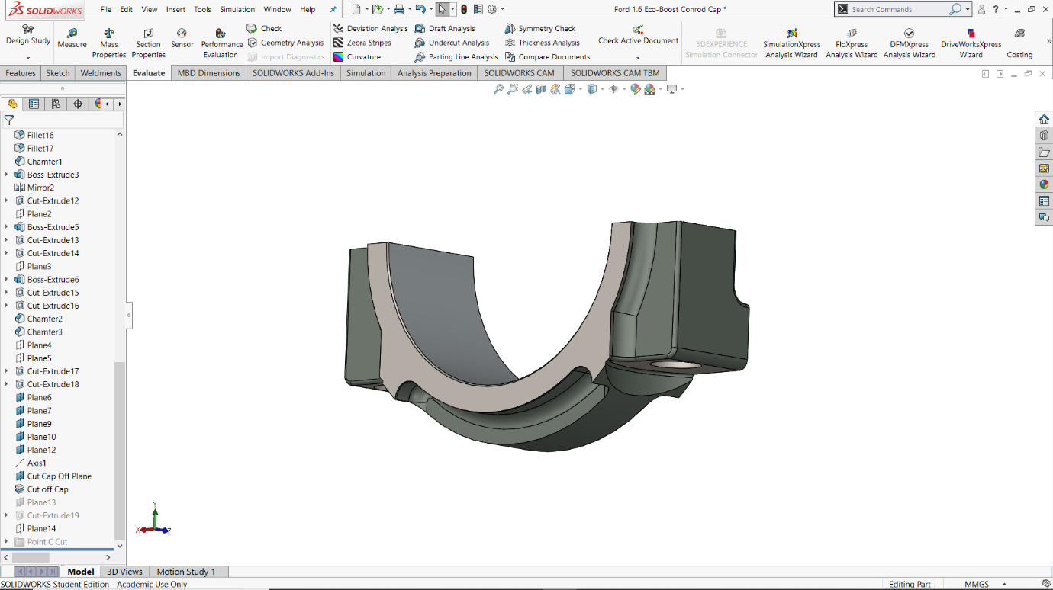
Figure 6 Point C Cross Sectional Area
Area = 131.68mm²
Stress Concentration
Figure 7 Point C Stress Concentration Fillet

Point C which is referring to the Connecting Rod Cap, does not experience a force from the peak gas force due to firing as explained in Section 4.1.1.1. Another difference from Points A and B is that the inertia force which is used is not calculated in the same form.
At point C, the cross section of the component in question being the cap is cut away to reveal the portion of the mating face which meets the bolt head and the fillet which joins this to the curved part of the cap. This radius is very small and is a high stress concentration area, this is the reason for further studies to be carried out. The 2 different types of inertia acting on the connecting rod cap at Point C include:
- The reciprocating masses inertia made up of the gudgeon pin, piston and 1/3rd of the connecting rod mass.
- The rotating mass which is 2/3rd rod mass subtracting the connecting rod caps mass.
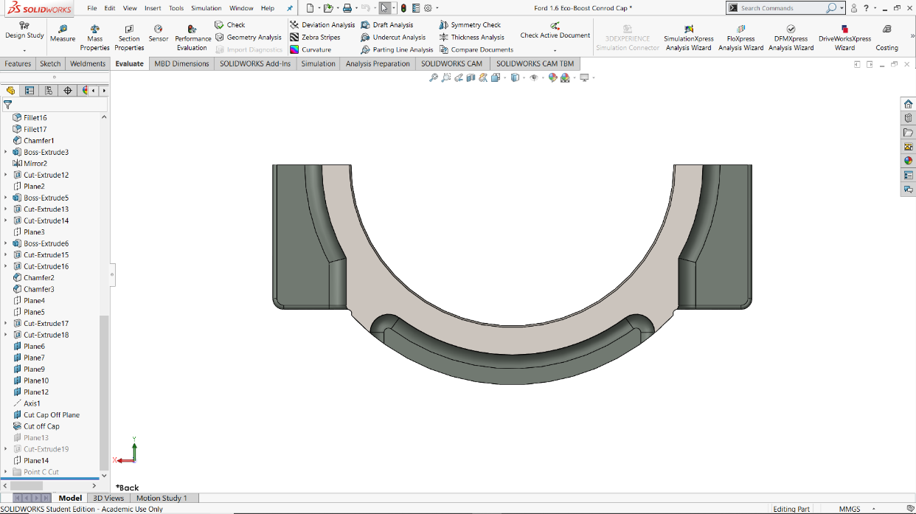
Each of the masses for 1/3 and 2/3 of the connecting rod have been measured using CAD as this has provided with a more accurate value assuming the CAD mo. Since there are technically 2 Point C locations, one on either side of the cap, the force used in this scenario for inertia is halved as this is the same in a hoop stress scenario shown in Figure 8. The masses for the inertia force calculation have been defined on the following page in Table 20.
10126.98 N
5063.49 N
5063.49 N
Figure 8 Connecting Rod Cap Force Split
Table 19 Point C Components and Masses

Point C Tensile Stress (Exhaust TDC)
Table 20 Point C Dimensions, Masses, Tensile Force and Stress

Equation 25 Point C Inertia Force

$$Point C Inertia Force=0.5∙\left(\left(M_{Recip}∙{Rω}^{2}∙1+\frac{R}{L}\right)+\left(M_{Rot}∙{Rω}^{2}\right)\right)$$
$$Point C Inertia Force=5063.49 N$$
Equation 26 Point B Tensile Stress
$$Point C Tensile Stress=\frac{Inertia Force}{Point C Area}$$
$$Point C Tensile Stress=38.45{N/{mm}}^{2}$$

Point C does not experience a compressive stress coming from the gas force during firing as aforementioned in Figure 2. Considering this, the minimum stress is taken as 0 and the maximum is taken from the tensile stress at Point C.
As the force is low through this point of the connecting rod the safety factor is expected to be higher here than at points A and B.

Point C Stress Concentration Factor
As used in Section 4.2.5 for Points A and B, the same method of a stepped tension bar of circular cross section with shoulder fillet has been applied to this section, however with a greater amount of time for a project this can be altered to be a closer fit to the scenario. Table 21 below displays the values found to input into Equation 24 to find the value K_{t}.
Table 21 Point C Stress Concentration Factor

Point C Results
The material having a UTS of 750 N/mm² gives a polished endurance limit of 337.5 N/mm², with a stress concentration of 2.09 the final endurance limit is found using the equation below:
$$Final Endurance Limit=\frac{337.5}{2.09}=160.99 {N/{mm}}^{2}$$
Table 22 Point C Goodman Diagram Results
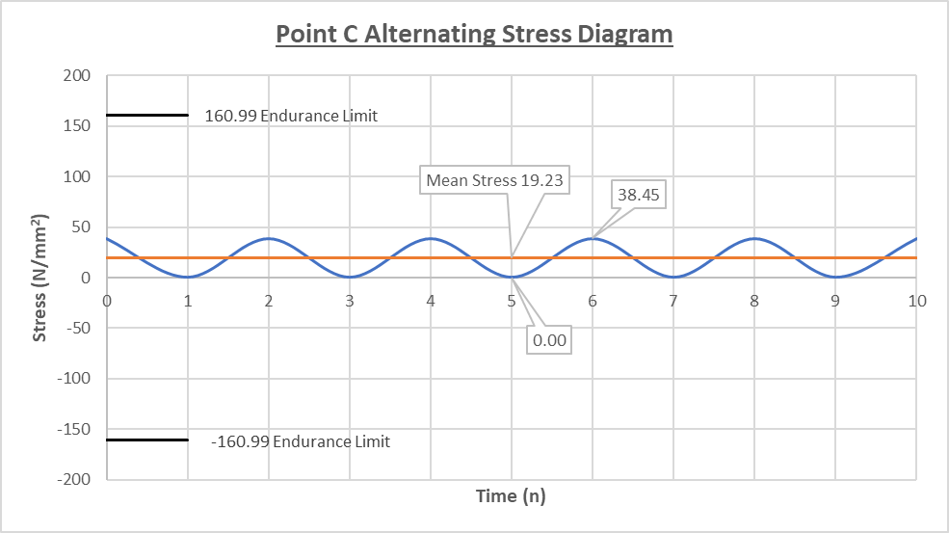
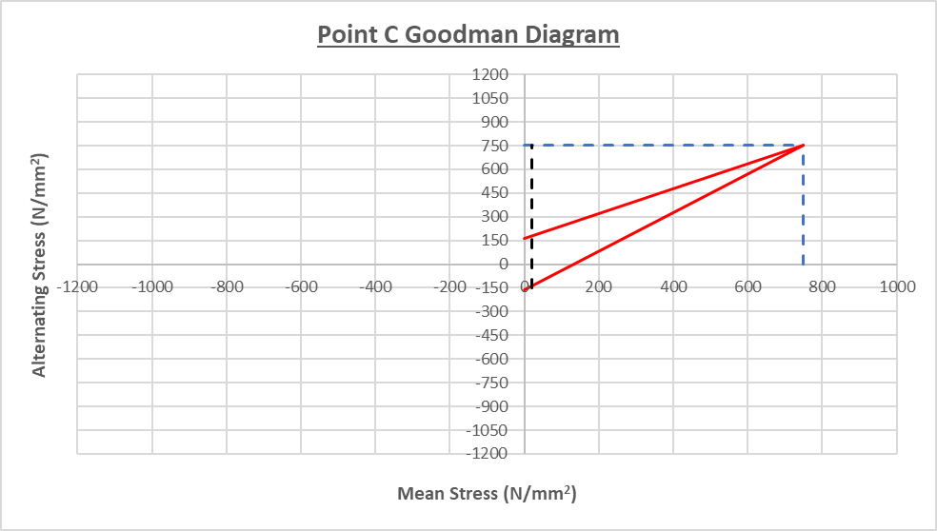
Graph 6 Point C Goodman Diagram
Graph 7 Point C Alternating Stress

Connecting Rod Bolts

Notes
- Connecting rod cap bolts are what hold together the cap and the main body of the connecting rod which is critical in operation from prevents the piston from coming into contact with the valves during its 4-stroke cycle.
- There are 2 forces acting on the bolts, the initial force comes from the static build torque applied to the bolts which causes friction between the bolt head and mating surface and the threads and their respective female threads cut into the connecting rod.
- The extra force comes from the inertia load the connecting rod is subject to during the exhaust stroke at TDC predominantly as found in a previous study by the author.
- A connecting rod cap bolt is tightened to 90% of its yield strength, this torque value is a combination of the friction caused and force needed to overcome this and the desired amount of stretch the bolt will experience. During this process the bolt is stretched, and the cap is compressed.
- The ratio of cap and bolt stiffness is gravely important, in a summarised statement it is known that the cap and bolt stiffness ratio is constant up to the yield point of the material. Once yield and the elastic region has been used, young’s modulus Stress/Strain is no longer applicable therefore the stiffness can decrease in the bolt dramatically causing a larger deformation in the bolt shank, thus having a knock-on effect of lowering the cap compression and clamping force.
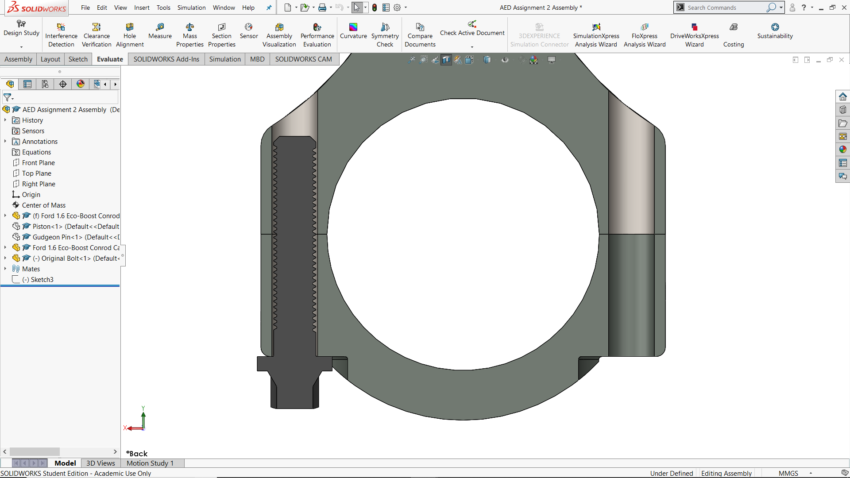
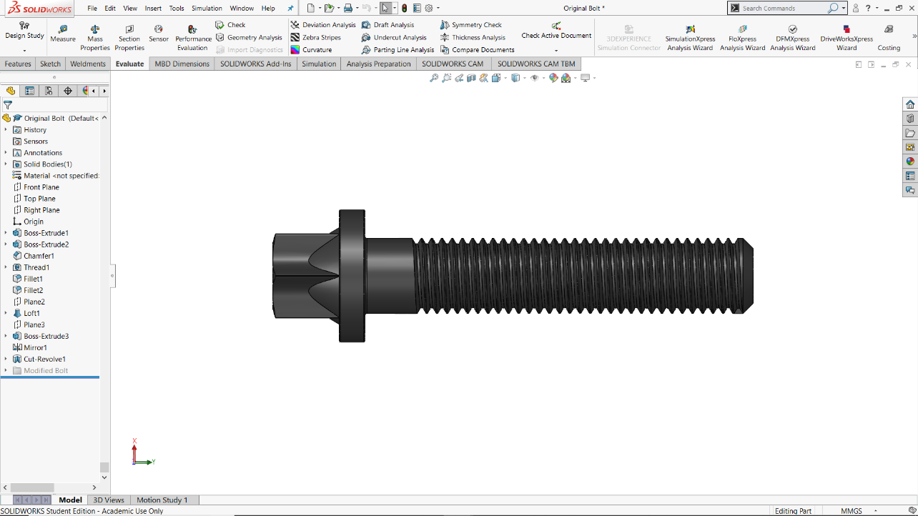
Figure 9 Original Ford Bolt Length of Engagement
Length of Engagement
2nd Engaged Thread
Figure 10 Original Ford Bolt

Methodology of Standard Ford Bolt

Standard Bolt and Cap Stiffness Ratio
To find the stiffness ratio between cap and bolt, 3 values are required to be input into Equation 28. The area for the cap mating face has been measured using CAD and the area used for the bolt has been identified in the Bosch Automotive Handbook 2008 as seen in Table 23.
The higher the stiffness ratio, the higher the extra force the bolt can be subject to and not fail is defined by the following relationship below:
Equation 27 Stiffness ratio and Extra Force Relationship
$$Extra Force in Bolt=\frac{1}{\left(1+\frac{K_{Cap}}{K_{Bolt}}\right)}∙5063.49$$
This relationship between Extra Force in the bolt is influenced by the ratio seen in Equation 27 in the form of recognising that when this ratio is increased, the extra force decreases, therefore allowing for a higher inertial force from higher engine speeds, this will become evidential in the section further in this report discussing a modified bolt design.
Equation 28 Bolt and Cap Stiffness Ratio
Table 23 Bolt and Cap Stiffness Ratio Values
$$\frac{K_{Cap}}{K_{Bolt}}=\frac{E_{Cap}∙A_{Cap}}{E_{Bolt}∙A_{Bolt}}$$

$$Stiffness ratio\left(\frac{K_{Cap}}{K_{Bolt}}\right)=\frac{170000∙126.75}{210000∙39.20}=2.62$$

Standard Bolt Stiffness
As aforementioned in Section 5.1.1.1, the stretch region of the bolt up to the materials elastic limit can be defined using the materials Young’s Modulus of 210 GPa. Once the bolt has passed this linear part of the stress/strain graph shown below, this can no longer be applied, thus the bolt stiffness decreases with no real quantifiable trend other than to say the stiffness can reach 0 and eventually become negative. Therefore, up to the elastic limit of H13 Tool Steel the standard ford bolt stiffness can be defined using Equation 29 Bolt Stiffness up to elastic limit
Equation 29 Bolt Stiffness up to elastic limit
$$K_{Bolt}=\frac{E_{Bolt}∙A_{Bolt}}{L_{Engagement length} }$$
$$K_{Bolt}=\frac{210000∙39.20}{22.52 }$$
$$K_{Bolt}=365541.70 N/{mm}$$

Maximum Alternating Load @ 6000rpm
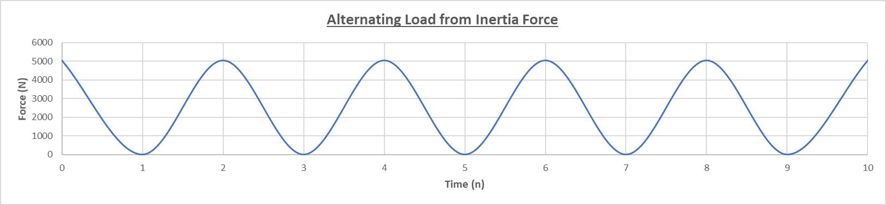
Looking at the maximum inertia force which the connecting rod cap and bolts are subject to uses the same force which has been calculated in Section 4.3.1, however, as the force calculated is across the entire cap, there are 2 bolts therefore the total force of 10126.97 N is halved to give the maximum alternating load each bolt with experience of 5063.49 N. With this alternating load present, the extra force can be found so an alternating load diagram is produced showing the alternating load from inertia and from the extra force due to the cap and bolt stiffness ratio.
Graph 8 Alternating Load from Inertia Force
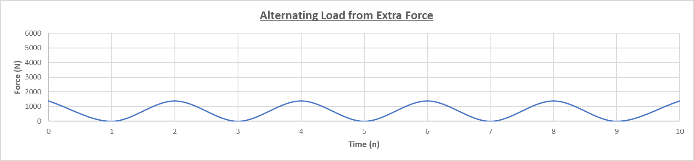
Graph 9 Alternating Load from Extra Force

Bolt Torque for 90% Yield
When building an engine and tightening the connecting rod cap bolts, it is believed that tightening to 90% of the material yield point is required for the bolt to stretch a specific amount in order to reduce the stiffness in the bolt therefore increasing the cap to bolt stiffness ratio thus allowing for a greater extra force to be applied to the bolt from inertia. It can be found from the static bolt force that the torque which must be applied is affected by the torque resisting at the threads and the bolt head in contact with the cap mating face. This is causing a torsional stress from the twisting motion and an axial stress from the stretching of the bolt.
Referring to the material properties in Section 2.1, the original ford bolt has a UTS of 1100 N/mm². So, in light of the yield point is 90% of the UTS, resulting in a yield strength of 990 N/mm². Now, Ford recommend only tightening the bolts to 90% of yield therefore the stress which the bolt will be subject to is 891 N/mm².
The axial clamping force which the bolt is subject to is stated to be 60% of the yield stress. The workings for finding the axial clamping force is defined below:
Equation 30 Axial Clamping Force
$$Axial Clamping Force=\left(0.6∙Yield Strength\right)∙Bolt Working Area$$
$Axial Clamping Force=\left(0.6∙990\right)∙39.2$
$$Axial Clamping Force=23284.80 N$$

A co-efficient of friction depending on the oil viscosity and quantity between threads during engine construction has been assumed from Malcolm Mcdonald provided data for both the bolt threads and bolt head, see Table 24 for values.
Table 24 Bolt Head and Thread Fiction Co-efficient

Equation 31 Circumferential Head Friction Force

$$Circumferential Head Friction Force=Axial Clamping Force∙0.12$$
$$Circumferential Head Friction Force=2794.18 N$$
Equation 32 Circumferential Head Friction Force
$$Circumferential Thread Friction Force=Axial Clamping Force∙0.18$$
$Circumferential Thread Friction Force=4191.26 N$
The resisting torque which is formed from the circumferential friction force produced by the head and threads can be calculated with the following process:
Equation 33 Resisting Torque at Head

$$Resisting Torque @ Head=\left(Average head radius∙Friction Force\right)∙{10}^{3}$$
$$Resisting Torque @ Head=\left(5.25∙2794.18\right)∙{10}^{3}=14.67 N∙m$$
Equation 34 Resisting Torque at Threads
$$Resisting Torque @ Threads=\left(Average thread radius∙Friction Force\right)∙{10}^{3}$$
$$Resisting Torque @ Threads=\left(3.75∙4191.26\right)∙{10}^{3}=15.72 N∙m$$

The total torque value when the engine has been built from the overall friction between the threads and bolt head is simply the sum of the resisting torque values Nm for both head and threads in order to overcome the circumferential friction force. The results from this can be seen in Table 25.

Equation 35 Total Tightening Torque
Table 25 Bolt Torque for 90% yield values
$$Total Tightening Torque=\sum{Resisting Torque for Head and Bolt}$$
$$Total Tightening Torque=14.67+15.72=30.39 N∙m$$

Original Bolt Stress Concentration Factor
To find a suitable scenario for the connecting rod bolts, Peterson’s Stress Concentration Factors (Second Edition) has been used and the scenario chosen is for a V notch with an angular pitch representing the bolt pitch and fine thread angle. It can also be noted that there are stress concentrations in sections other than the threads such as the end of the bolt where there is a 1mm chamfer and also where the bolt shank meets with the head, these areas have been disregarded in this study however can be explored in further reading and dissertation project work.
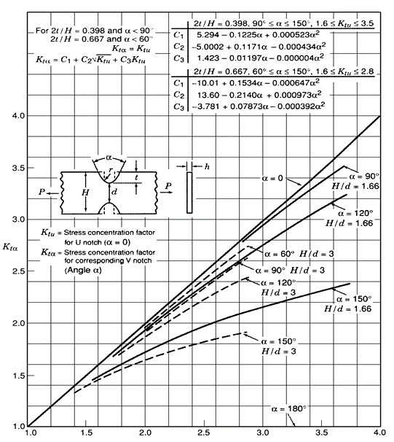
Similar to in Section 4.2.5, the model requires the author to define several values which can be seen in Figure 11.
Figure 11 Stress Concentration of a circular bar in tension with V notch corresponding with a round shaped base

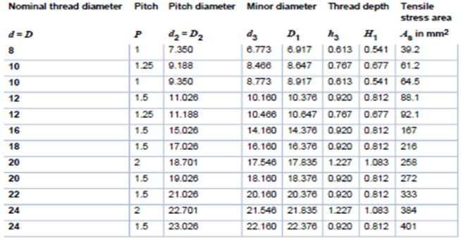
Table 26 Bosch Handbook ISO Metric Fine Thread Dimensions

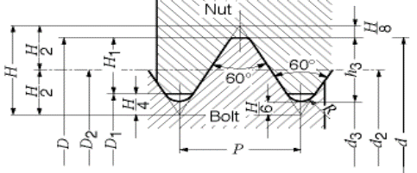
Figure 12 Bosch Handbook ISO Metric Threads Dimension Diagram
Equation 36 Kta Formula for Bolt threads
$$K_{tα}=C_{1}+C_{2}\sqrt{K_{tu}}+C_{3}K_{tu}$$
Equation 36 from the scenario in Figure 11 has an unknown variable called K_{tu} which is not clear to the author and after reading several papers, the author has come to the conclusion to use a constant value of 3 for Ktu. This is a value can be between 2 and 3 quoted by Malcolm Mcdonald as the stress concentration at the bolt threads, however, the stress concentration is not the same all the way down the bolt therefore is only an assumption.
Using the assumed value of 3 for K_{tu}, other values can be input, the results are shown for this in Table 27 Standard Bolt Threads Stress Concentration Factor The final stress concentration factor is defined as K_{tα}.
Table 27 Standard Bolt Threads Stress Concentration Factor

Now that the stress concentration factor has been identified for the standard bolt, the mean stress and range of stress can be calculated using the same method as in Sections including the connecting rod and gudgeon pin. Table 28 shows results of the stress acting on the standard bolt at 6000rpm, with a fatigue safety factor of 1.4 with the use of the XY mean stress line in. The polished endurance limit is 495 N/mm² however with the stress concentration applied, it decreases to 174.11 N/mm². The extra force from the alternating load is 1399.71 N.

Table 28 Standard Bolt Stress Results

Standard Bolt Goodman Diagram @ 6000 rpm
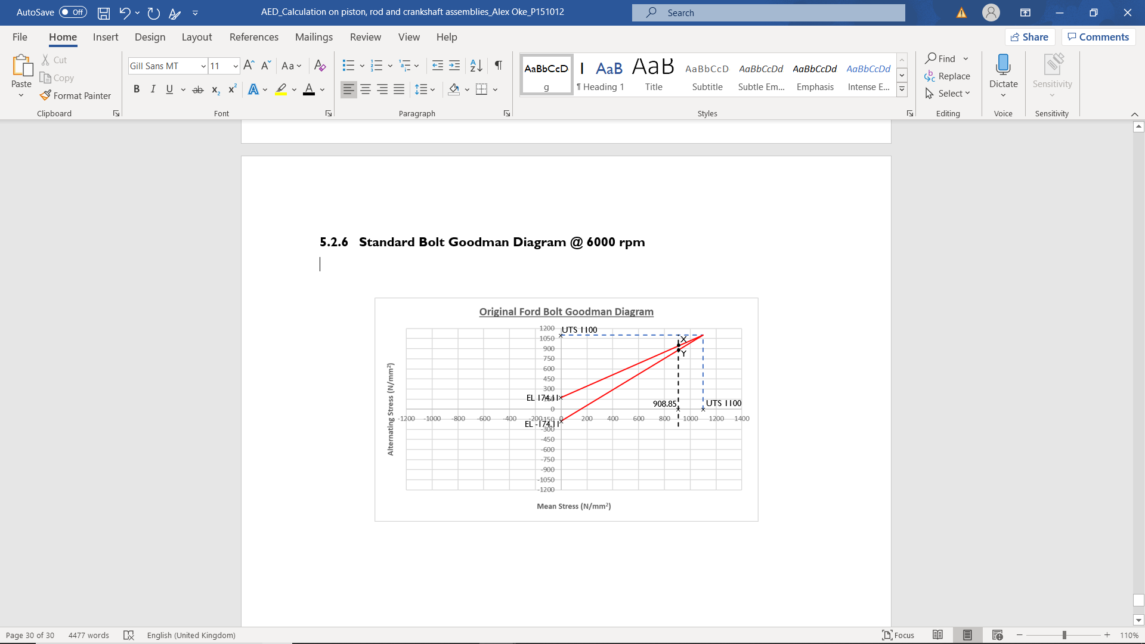
Graph 10 Standard Bolt Goodman Diagram @ 6000rpm

The safety factor for the standard bolt has been stated in Table 28, the Goodman diagram provides the author with an allowable stress range which enables a design engineer to establish a FSF by applying Equation 37.
Equation 37 Fatigue Safety Factor
$$FSF=\frac{Allowable Range}{Actual Range}$$

The next section of this report will suggest a suitable grade and detail design of an uprated bolt for a modified engine capable of engine speeds up to 8500rpm. With the inclusion of 500rpm extra for contingency purposes due to the driver over-revving the engine on downshifts so this peak engine speed is lifted to 9000rpm. Initially to find a baseline the standard bolt has been tested at 9000rpm to see check the resultant FSF. The standard bolt has a FSF of 0.7 when it is run at 9000rpm which to the author indicates the component will fail. This process of designing the uprated bolt and finding the baseline safety factor will continue in the following section.

Standard Bolt @ 9000rpm
Table 29 Standard Bolt Comparison at Modified RPM

The inertia force has increased from 5063.49 N to 11392.85 N as the angular velocity of the engine has increased. This has resulted in an increased extra force which the bolt is subject to, thus increasing the extra stress. Minimum stress remains the same as this is 90% of the yield strength of the material, however, the maximum stress increases due to the increase in extra stress from the engine speed having risen 33%. Mean stress is affected by the increase of maximum stress, thus causing the actual range of stress to be larger than the allowable stress range indicating that the bolt will fail. The fatigue safety factor established for the standard bolt at 9000rpm is 0.7 which is half that of the standard bolt when operated within its design parameters of 6000rpm. It is evident in Graph 11 that the existing standard bolt has a decreased allowable stress of 53.45 N/mm².

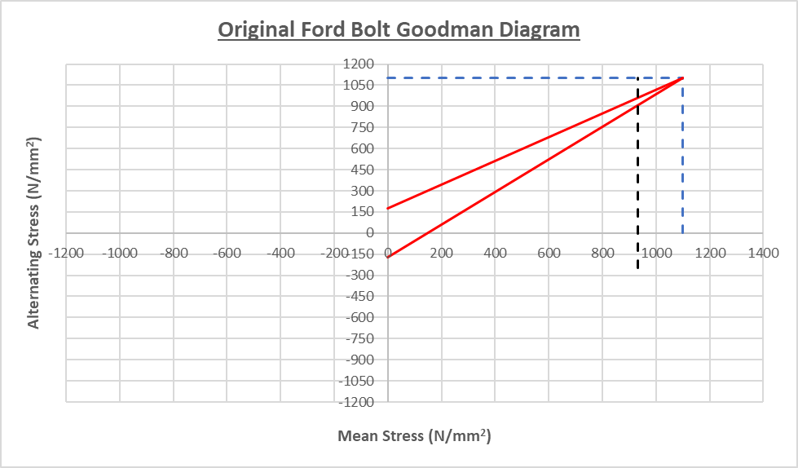
Graph 11 Original Ford Bolt Goodman Diagram @ 9000rpm

Uprated Bolt Design
To ensure the new bolt to cap stiffness is higher than the standard bolt currently conforms to, either the cap itself can be made stiffer from a different material or the bolt can be made to stretch in a specific region to protect the threads from experiencing an increased extra force from the increased alternating load.
In order to design a new connecting rod bolt, the following criteria must be met due to specific design implication it may have:
- Reduce the shank diameter to reduce the bolt stiffness, thus reducing the extra force in the threads.
- Increase $\frac{K_{Cap}}{K_{Bolt}}$ stiffness ratio by decreasing K_{Bolt}.
- Increase UTS of bolt material so the same clamping force can be achieved without exceeding 90% of yield.
The method used to determine the new bolt design is shown below as a process of finding the minimum shank diameter the new bolt can have and then using the spring stiffness equation for a set of springs in series as shown in Equation 38.
Equation 38 Stiffness formula in series
$$K=\frac{1}{\left(\frac{1}{K_{1}}+\frac{1}{K_{2}}+\frac{1}{K_{3}}\right)}$$
To determine the minimum shank diameter the new bolt can be tapered down to, the following derivation has been utilised to suit the application and re-arranged to define the subject as the diameter of the new uprated bolt:
$${7.5}^{2}∙1100={\left(New bolt average diameter\right)}^{2}∙New UTS$$
$${7.5}^{2}∙1100={\left(New bolt average diameter\right)}^{2}∙1600$$
$${\left(New bolt average diameter\right)}^{2}={\frac{1100}{1600}∙7.5}^{2}$$
$$New bolt average diameter=\sqrt{{\frac{1100}{1600}∙7.5}^{2}}$$
$$New bolt average diameter=6.22 mm$$

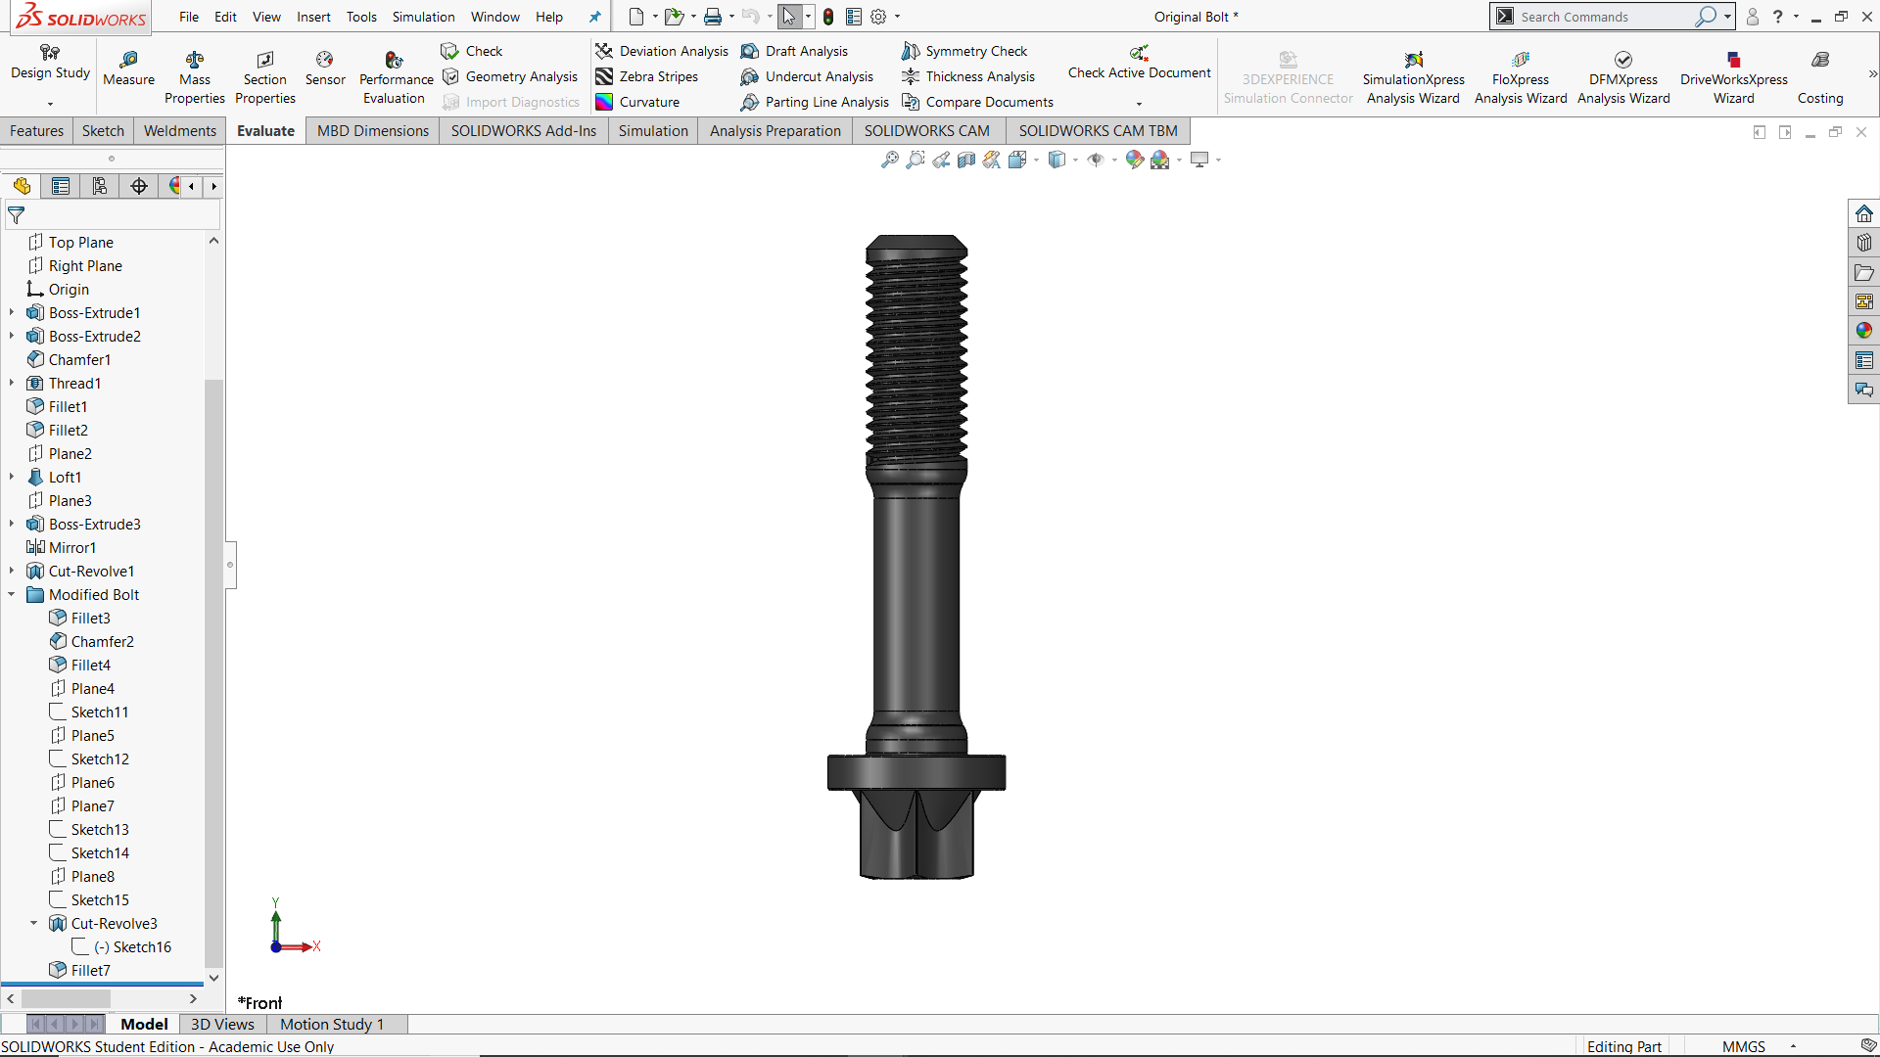
L₁ = 2.70mm
L₂ = 18.64mm
L₃ = 4.4mm
2nd engaged thread
D₁ = 7.4mm
D₃ = 7.4mm
D₂ = 6.2mm

Figure 13 Uprated Bolt Design
To find the new stiffness of the bolt with the reduced minimum shank diameter in the centre of the bolt, Equation 38 is used with the values from Table 30.
Table 30 Uprated bolt dimensions

$$K_{1}=\frac{210000∙43.01}{2.70}=3345098 N/{mm}$$
$$K_{2}=\frac{210000∙30.37}{18.64}=342183 N/{mm}$$
$$K_{3}=\frac{210000∙43.01}{4.40}=2052674 N/{mm}$$
$$New Overall K=\frac{1}{\left(\frac{1}{3345098}+\frac{1}{342183}+\frac{1}{2052674}\right)}$$
$$New K_{Bolt}=269649 N/{mm}$$

By decreasing the longest section of the new bolt, the stiffness formula has revealed that the stiffness in the centre section of the bolt is where the bolt will stretch in order to protect the threads from the increased extra force. Increasing the UTS allows the designer to keep the same clamping force and also keep below the 90% of yield point.
The new uprated bolt must have the extra force re-calculated due to the stiffness ratio increasing by 26% which is a similar increase as the rpm from 6000 to 9000, this is something the author would like to look into further in a dissertation project.

Uprated Bolt Results
Table 31 Standard to New Bolt Comparison of Extra Force
The extra force has been reduced by increasing the stiffness ratio by 26%, thus the threads will experience less tensile force in a cyclic fashion. The extra stress has been reduced as a knock-on effect of reducing the extra force in the bolt. The minimum stress is higher as the UTS is 1600 as opposed to 1100, thus meaning the axial tightening stress is still the same at 81% of the yield strength of each material, this is found by dividing the minimum stress with the UTS of each bolt design.
The same reason is to explain why the maximum stress in the new bolt is higher than the original bolt as the percentage is still the same of the UTS as the original ford bolt. The mean stress is the same percentage again of its UTS as the original bolt is operating at 6000rpm so therefore the Fatigue Safety Factor should be the same, the actual resultant safety factor is slightly lower at 1.3 as opposed to 1.4 of the standard bolt at but still acceptable as the percentage of all stresses against the UTS experienced by the new bolt are the same as the original at 6000rpm.
The same stress concentration factor has been used as the original bolt as the threads have not changed as this means the same rod can be re-used with the uprated bolts. However, the increased engine speed may have a negative effect on the connecting rod, this may not be able to withstand the higher engine speeds as discussed in a previous study carried out by Alex Oke.
Stress concentrations have been introduced where the change in diameter occurs in the uprated bolt design. These have been made ineffective in this study due to the threads holding the highest stress concentration value therefore are insignificant.

Standard and Uprated Bolt Design Comparison

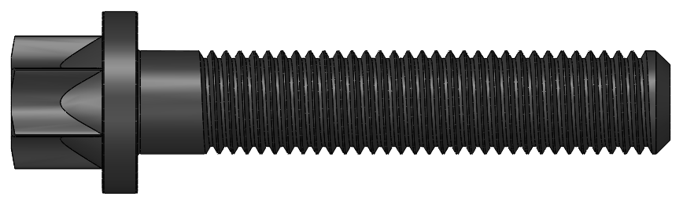
L = 22.52mm

D = 7.4mm
2nd engaged thread
Figure 14 Standard Bolt Design
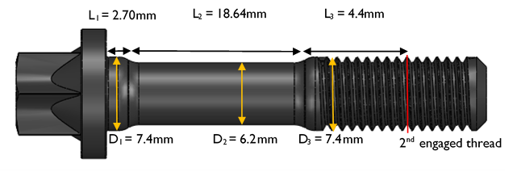

Figure 15 Uprated Bolt Design

Comparison of the critical design features
- The diameter at the start of the uprated rod has been kept the same so the bolt has a locating shoulder when it is inserted into the cap to keep it concentric.
- The step changes on the uprated bolt have been designed with a 2.5mm radius so the stress concentrations created making the change in diameter is not creating problems.
- The head and thread of the bolt are the same so manufacturing is not greatly affected where it can be helped.
- To ensure durability the material has been changed to that of a higher UTS from 1100 to 1600 N/mm².
- Lastly, the working engagement length of the uprated bolt has been kept the same to ensure the stiffness of the bolt is not affected in an adverse way, also allowing for the same connecting rod to be used.

Crankshaft
The type of loading scenario which the crankshaft is subject to is similar to that of the gudgeon pin in the sense that it experiences both bending and shear stress from a moment created due to the force being along a neutral axis plane and certain distance from that plane, thus creating a moment.
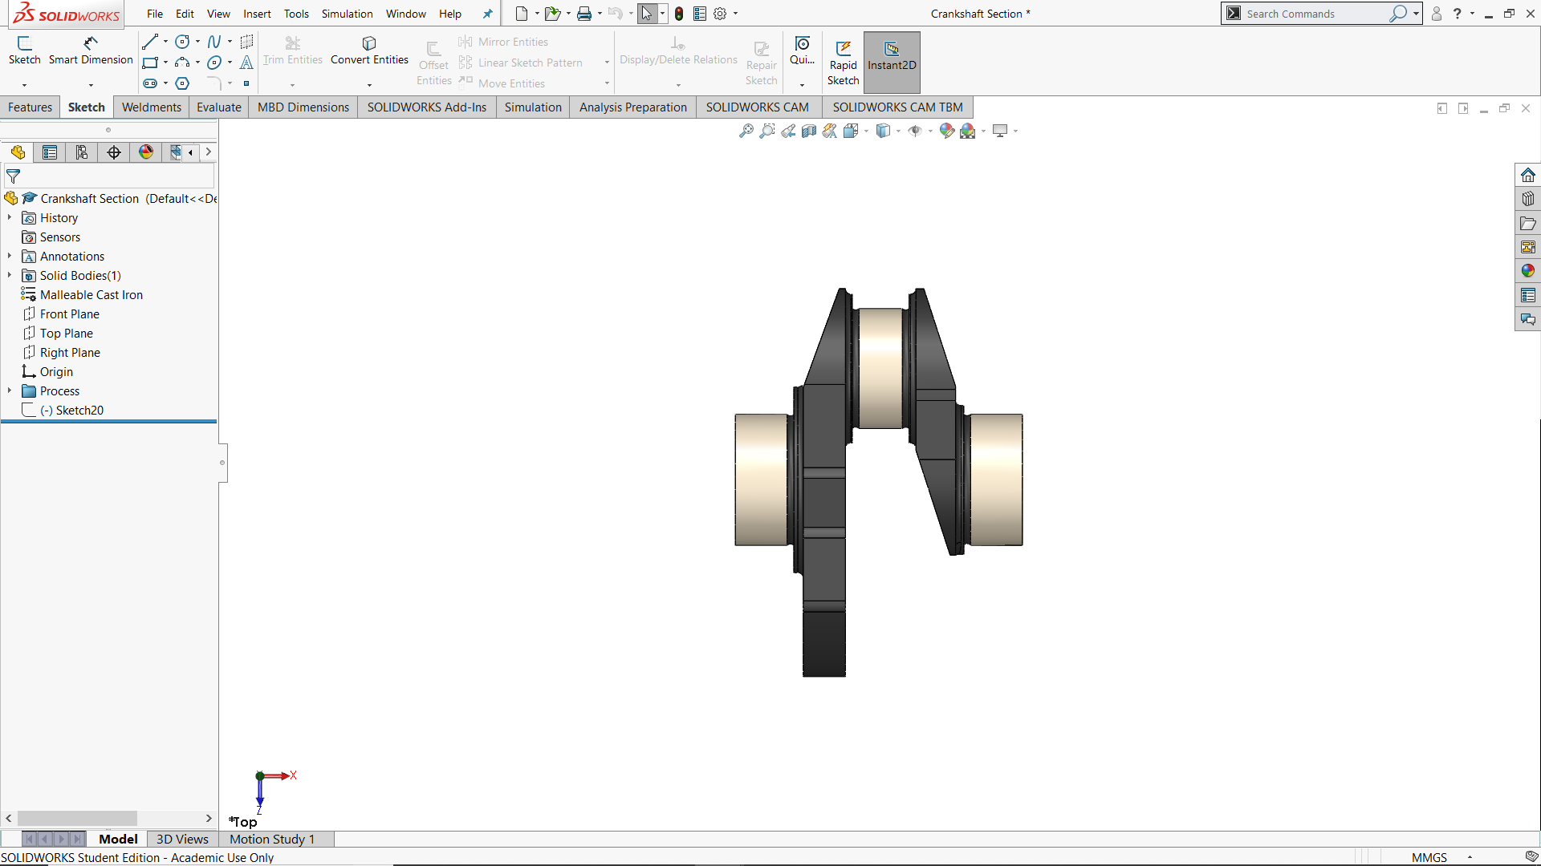
The following section is a single span analysis where the forces which are being exerted through the connecting rod and down onto the crank pin are then reacted upwards by the adjacent main journal shell bearings as shown in Figure 16.
Fnet
Fnet/2
Fnet/2
Figure 16 Crank Loading Scenario

The force used as Fnet is the same as previously identified in a study carried out by the author Alex Oke on the connecting rod assembly.
There has been 2 points noted as the weakest points of the crank assembly due to the fillets in these areas, these fillets are caused by undercutting the crankpin and main journals during manufacturing and then fillet rolled to attempt to create a residual stress to aid with these stress concentrations, these 2 areas known as A and B are highlighted in Figure 17.
The fillets are less than 3mm and this is classed as a problematic area creating a stress concentration so must have a factor applied to it when accessing. The next section of this report will explain the methodology to calculate the stress experienced at either point A or B depending on which is an extreme case to the engine designer.

Methodology of Crankshaft Stress
To begin with a model of the crankshaft section in question has been built by the author using a CAD package to aid with accurate measurements for this study.
The neutral axis between points A and B have been identified, therefore the next item to calculate is the effective width of the critical beam in question as this is a beam scenario as described in Section 3 like the gudgeon pin.
L₁

L₂
Table 32 Crankshaft Dimensions
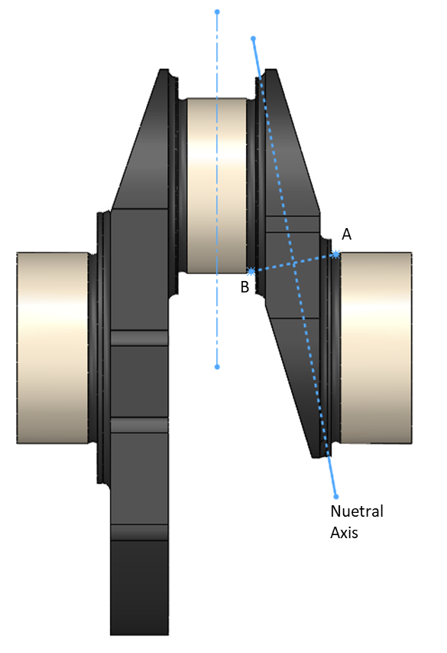
Figure 17 Crankshaft Neutral Axis

Equation 39 Effective width of critical beam
$$Effective Width of Critical Beam \left(b\right)=\frac{\left(crank pin diameter+main journal diameter\right)}{2}$$
$$Effective Width of Critical Beam \left(b\right)=\frac{\left(44+48\right)}{2}=46 mm$$

Equation 39 can only be used in a scenario where the crank pin and the main journal are assumed to be in line as if the engine is at top dead centre as this is where the maximum inertia force will be experience and very close to the firing scenario.
Table 33 Crankshaft 2nd moment of area
$$2nd Moment of Area=\frac{{\left(b∙Distance from A to B\right)}^{3}}{12}$$
$$2nd Moment of Area=28333 {mm}^{4}$$

Due to Point B being further away from the reaction force from the main bearing, this is the moment which is going to be considered as the maximum case for this scenario, the further the point is from the force the greater the moment will be therefore this is due to be where the lowest fatigue safety factor is going to be found.

Point B in Tensile (Firing)

Equation 40 Bending Moment at Point B during firing

$$Bending Moment @ Point B (Firing)=\frac{F_{Net}}{2}∙L_{2}$$
$$Bending Moment @ Point B (Firing)=701405.15 N/{mm}$$
Equation 41 Bending Stress at Point B during firing

$$Bending Stress @ Point B (Firing)=\frac{M∙Y}{I}$$
$$Bending Stress @ Point B (Firing)=174.61{N/{mm}}^{2}$$
Equation 42 Shear Stress at Point B during firing
$$Shear Stress @ Point B (Firing)=\frac{Point B Area}{F_{Net}}$$
$$Shear Stress @ Point B (Firing)=23.36{N/{mm}}^{2}$$
$$Von Mises Stress @ Point B (Firing)=180.76{N/{mm}}^{2}$$

Point B in Compression (Exhaust TDC)
Equation 43 Bending Moment at Point B during exhaust TDC

$$Bending Moment @ Point B (Exhaust TDC)=F_{Inertia}∙L_{2}$$
$$Bending Moment @ Point B (Exhaust TDC)=336013.13 N/{mm}$$
Equation 44 Bending Stress at Point B during exhaust TDC

$$Bending Stress @ Point B \left(Exhaust TDC\right)=\frac{M∙Y}{I}$$
$$Bending Stress @ Point B \left(Exhaust TDC\right)=83.65{ N/{mm}}^{2}$$
Equation 45 Shear Stress at Point B during exhaust TDC

$$Shear Stress @ Point B (Exhaust TDC)=\frac{Point B Area}{F_{Inertia}}$$
$$Shear Stress @ Point B \left(Exhaust TDC\right)=5.60{N/{mm}}^{2}$$

$$Von Mises Stress @ Point B \left(Exhaust TDC\right)=-84.39{N/{mm}}^{2}$$

Equation 46 Point B Combined Stress Results

Crankshaft Stress Concentration Factor
A stress concentration scenario which fits the fillets on the crankshaft has been found in Pilkey’s 2008 Stress Concentration Factors research paper. The scenario is a Grooved round bar in torsion, this is a match for the criteria as the crank has a torque applied every time the crank rotates under its own inertial mass and also from the gas force.
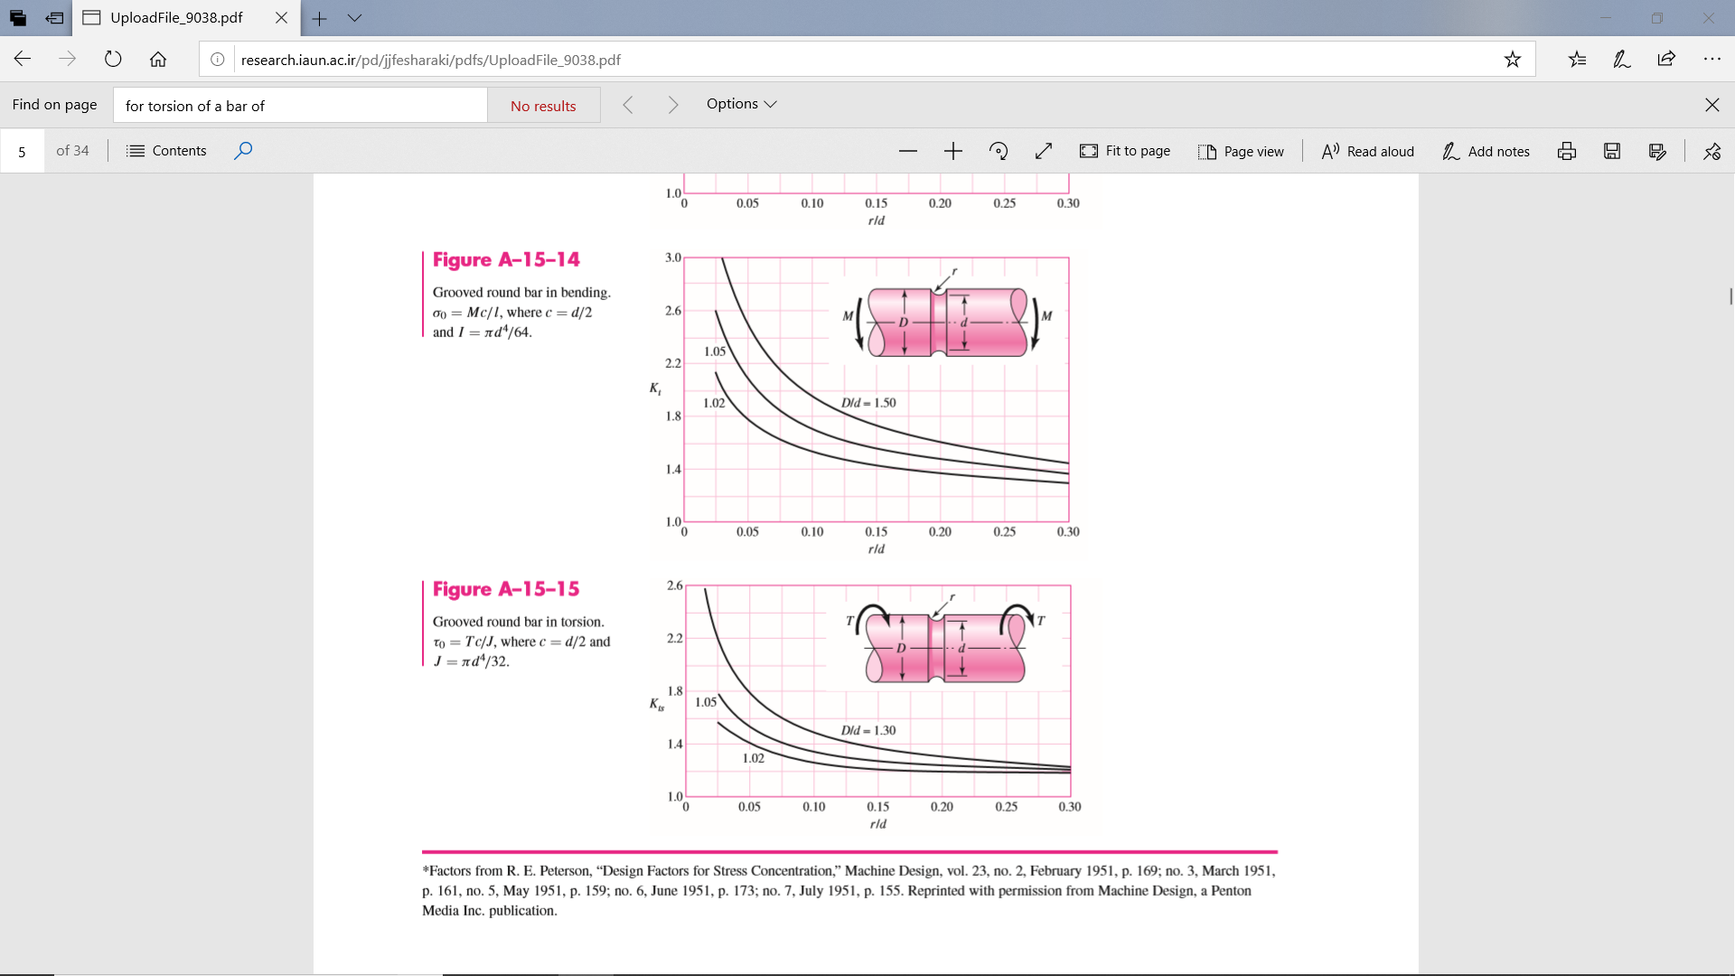
Figure 18 Stress Concentration Factor for Crankshaft, Grooved round bar in torsion.

The radius of the fillets had to be measured along with the diameter of the crankpin and journal in order to find the D value and d is found by subtracting double the radius depth from D.
Table 34 Crankshaft Stress Concentration Factor

The author has had to estimate a value for K_{ts} as there is no equation in place to input values for or calculate therefore, r/d has been calculated and applied with a best fit approach in order to apply an appropriate factor which will increase accuracy of the results over not having used a concentration factor. The final stress concentration factor is defined as K_{ts} and applied to the polished endurance limit in the following section.

Crankshaft Results
Table 35 Crankshaft Stress Goodman Diagram Results

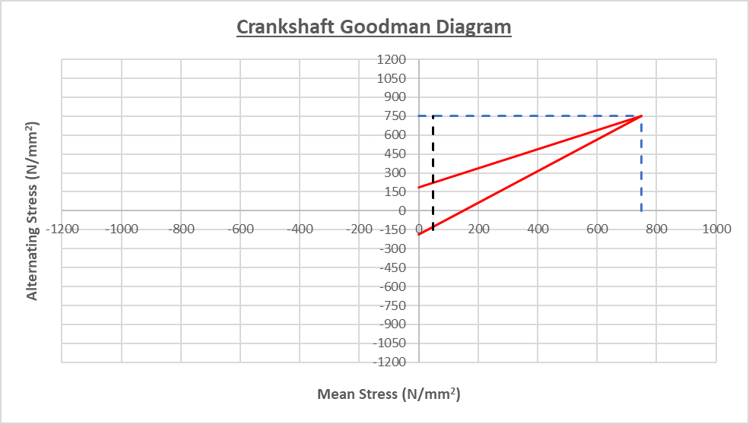
Graph 12 Crankshaft Goodman Diagram

Referring to Section 2 the UTS of the crankshaft is 750 N/mm². This is shown on the Goodman diagram and gives a clear indication that the crank is well within its useable range of stress.
The safety factor of 1.3 is relatively low, this can be due to the fact that no friction is taken into consideration in the model being lost during the entire cycle which reduces the inertial load. Friction can also make the fatigue safety factor decrease even further if it were to be considered for the main journal bearings.
The oil film which protects the bearings and the crankshaft itself from having a metal to metal contact is not accounted for in this study, therefore can be a reason for the low safety factor, this is something which a separate study for dissertation project can be looked into.

Conclusion
The gudgeon pin has a fatigue safety factor of 1.78, this is not usually high for a component under such extreme loads in a cyclic fashion, however this could be slightly too high as there is not any thermal stress or analysis being carried out, also the gudgeon pin rotates ever so slightly when the piston is reciprocating causing at time the oil feed hole to be in the vertical position which will create a stress concentration. Overall, the results yielded have been successful in identifying a useable safety factor for the gudgeon pin and that the part is designed for its purpose. It could be improved with the exact material used in the 1.6 Ford GTDI Eco-Boost engine.
For the connecting rod it can be said that the study has been successful in such as the results are correlating with the authors previous study carried out which is a form of validation. However, there are other forces and stresses which are not taken into consideration allowing for the fatigue safety factor to be high is point C in the form of the extra force taken by the bolts during the exhaust TDC scenario. This would further increase the safety factor. Points A and B are very similar in FSF as they are very similar in scenario, the main difference being their mass of inertia, however the mass being greater taken at point B is counteracted by a smaller cross sectional area and vice versa for the Point A inertia mass taken and larger cross sectional area giving both point a FSF of ≈3.5.
With the standard Ford bolt giving the FSF of 1.4 at 6000rpm, it was deemed that the standard bolt would not hold up at higher rpm’s, this proved correct. However, at 9000rpm the uprated bolt has achieved the same FSF without the need to re-size the cup sizes or tightening torque. Although this is successful, it must be noted that if the new bolt is stretching too much the piston may come into contact with valves and the connecting rod may fail itself at these higher engine speeds.
The Crankshaft has a relatively low safety factor which can be assumed to be caused by the lack of friction considered and the nominal load which the bearings are subject to. To conclude, the study has been beneficial to the author to aid in the designing of an uprated bolt for the connecting rod and to calculate the load at different points of the connecting rod whilst taking into consideration the effect of sudden geometry changes which previously would have been overlooked.
The reduction in endurance limit caused by the application of a stress concentration factor has multiple effects, it then lowers the allowable range and also the therefore the safety factor, thus to finish this study it can be said that the higher the stress concentration factor, the greater affect it will have on lowering the FSF.

References
Afzal, A., 2004. Fatigue Behaviour and Life Predictions of Forged Steel and Powder Metal Connecting Rods, Toledo: s.n.
Anon., n.d. General Mechanical Engineering Design. s.l.:s.n.
BOSCH, n.d. BOSCH Automotive Handbook. s.l.:s.n.
Corp., S., 2010. Understanding Motion Simulation. Concord, Masschusetts: Dassault Systemes.
Heywood, J. B., 1988. Internal COmbustion Engine Fundamentals. USA: Library of Congress Cataloging-in-Publication Data.
MacDonald, M., 2019. Advanced Engine Design Lecture. Swansea: UWTSD.
Pilkey, W. D., 1997. Peterson's Stress Concentration Factors. 2nd Edition ed. Canada: Library of Congress .

Abstract for Further Work

