
z-axis straightness rig
Group Project

26th of may
University of Wales Trinity Saint David

Abstract
The purpose of this reflective report is to analyse a past project and make recommendations on how the project was undertaken from a management and engineering perspective. The report starts with an introduction to the company, Renishaw, and what the company specialises in. There is also a brief background of the project and why it was necessary.
Aims and objectives of both the project and the report were written out, explaining the meaning behind them and why they were necessary. This gave an insight into what was hoped to be achieved by carrying out the project and the report. The aim of the project was to create a rig that would overcome safety concerns and make the overall process more streamlined. The aims of the report were to reflect on the project and offer recommendations where applicable.
The main findings are split into two parts, the project section and the analysis section. The project section comprises of two sub-sections, the first being an in depth explanation of the rig. The second sub-section explains the different steps leading up to the completion of the rig. The second section of the main findings is the analysis. This too is split into two sub-sections, a managerial analysis and an engineering analysis.
The managerial analysis includes applying a 4-D project management model and an 8-point change management model. The results of these tools aid the analysis section of the report as they brought to light some flaws in the project and how it was managed. The project did not have a written design specification and the project was carried out by one person, which resulted in the rig being delayed.
The engineering analysis comprises of an FMEA (failure modes and effects analysis) that was carried out on the rig. This brought to light some flaws in the designing of the rig such as a risk of moving or knocking over the rig when installing the z-axis trolley. The cables that connected the z-axis to the rig could also be easily trapped and damaged.
Recommendations were made to rectify these flaws in the shape of writing up a design specification and allocating more resource to the project from the start. The rig could have also been designed to have larger feet to support the framework or be bolted into the floor to improve stability. A bracket could have also been designed to hold the cables when testing the z-axis.
The last section concludes with recommendations on how the project could be improved. There is also a section that goes through the time management undertaken when writing this report. This includes a screenshot of the Gantt chart used to keep track of the report writing.
Table of Contents
Abstract 1
Introduction 3
1. Aims & Objectives 4
1.1 Aims of the Project 4
1.2 Objectives of the Project 4
1.3 Aims of the Report 4
1.4 Objectives of the Report 4
Main Findings 6
1. The Project 6
1.1 Rig Functions 6
1.2 Project Steps 10
2. Analysis 16
2.1 Change Management Analysis 16
2.2 Engineering Analysis 22
Conclusion 25
Bibliography 27

Introduction

Renishaw are world leaders in additive manufacturing (metal 3D printing). The machine the company produces is called the RenAM500Q (Figure 1). Fine metal powder is dosed along a build plate in the top chamber. Four high powered lasers then fire onto the build plate, melting the metal powder into the chosen shape. The chosen shape is achieved by directing the lasers very quickly and accurately through the use of various optics. For the 3D element to be achieved, the build plate must be moved along the up/down z-axis.
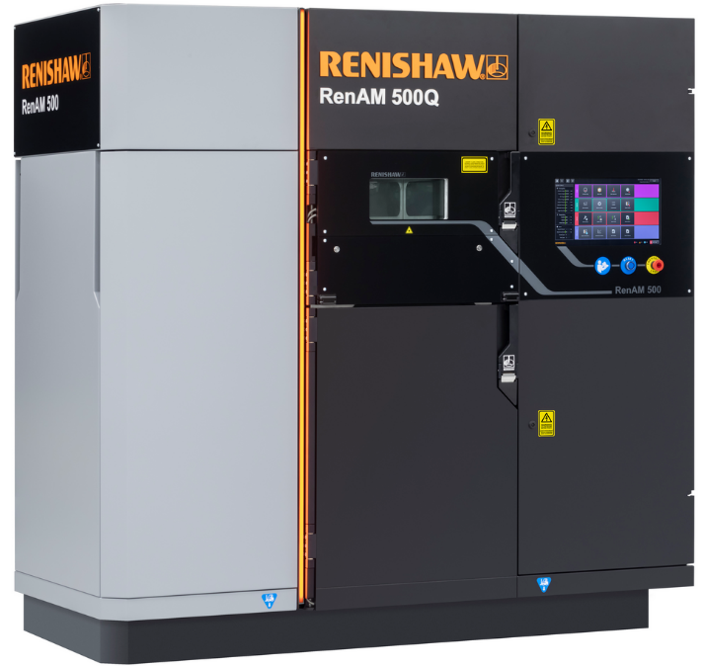

Figure 1 (Renishaw plc, 2019)
The z-axis assembly is a major sub-system in the machine. It allows the up and down movement of the build plate in order for the many layers of powder to be distributed and melted by the lasers. The largest build achievable by the RenAM500Q is 250mm with each layer being less than a millimetre in thickness. This means that the straightness of the z-axis is critical, it can cause deformities and failed builds if it is not straight.
The old method of checking the z-axis straightness was to fit the assembly to the machine, then connect the motor to a drill to manually drive the z-axis up and down. An engineering square and a DTI was then fitted to the elevator to monitor and record the results of the test.

The z-axis was then manually driven down using the drill in 10mm increments, all the way down to 250mm, with readings from the DTI taken every increment. The assembly could not deviate by more than +/- 0.15mm or it would be classed as a fail. This process was very time consuming, so with each z-axis taking around four hours to test at £125 per hour for labour cost. A new way of testing the z-axis was devised which would be more automated, safer to use and a lot more reworkable.

1. Aims & Objectives

1.1 Aims of the Project
The aim of this project is to change and improve the Z-axis building and testing by applying modern technologies and automation to the process, thus, cutting down on labour time and making the process safer, easier and more robust.

1.2 Objectives of the Project
The first objective of this project is to build a rig/test that runs with highly accurate measuring equipment. Secondly, to overcome a safety concern that arose on the health & safety dashboard, Alcumus, within Renishaw. Finally, to align the testing parameters between the AM (Additive Manufacturing) build line and AM commissioning.

1.3 Aims of the Report
The aims of this report are to evaluate how this project was designed, implemented and managed. To write about what went well and what did not, then to recommend improvements and ways that could have made the project easier to manage.

1.4 Objectives of the Report
The objectives of this report are to critically analyse the way the design process was carried out and the way the change was managed. This will be achieved through two different perspectives. There will be an engineering-based analysis, where an FMEA (failure modes & effects analysis) will be used to pinpoint any issues and improvements that can be made.
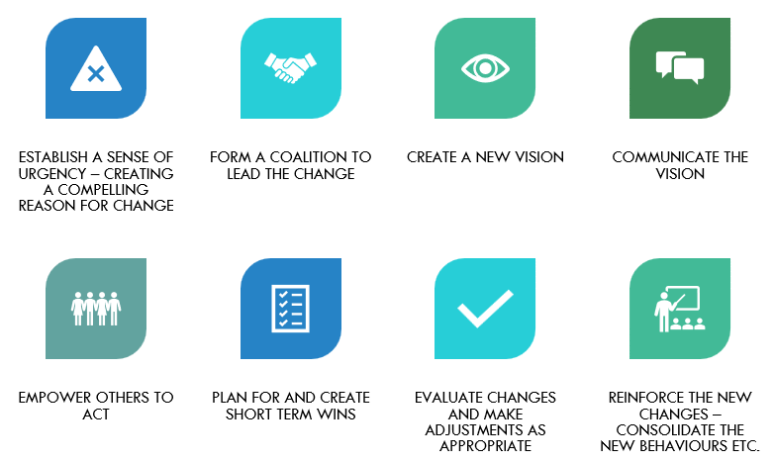
There will also be a management-based analysis where two management tools, Kotter’s model (Figure 2) and the 4-D model will be used to analyse how the change was managed and how it could have been improved.

Figure 2 (Pitson, 2023)

Main Findings

1. The Project

1.1 Rig Functions

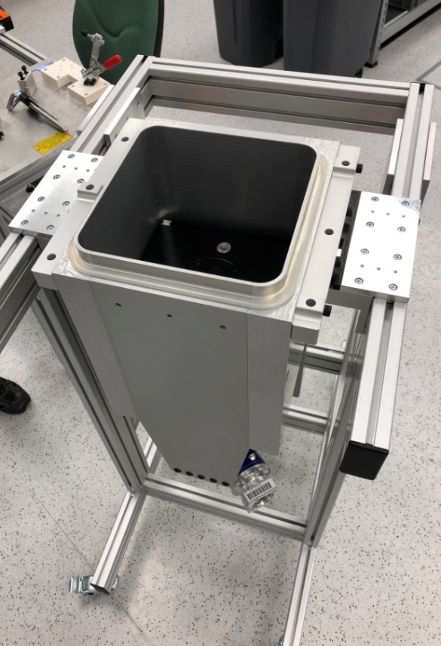
The first step of the process is to load the z-axis assembly onto the z-axis transportation trolley. The trolley is purpose built for the z-axis assembly and is used with the z-axis rig to test the assemblies. Figure 3 shows the assembly and the trolley:

Z-axis Trolley
Z-axis Assembly

Figure 3 (Wade, 2023)
After that, the trolley can be loaded into the z-axis rig by gently pushing the trolley into the rig, using the guide skis and the interlocks to locate the trolley safely. This step is shown in Figure 4:

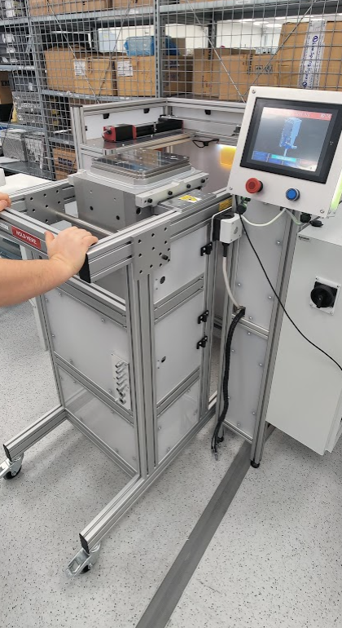

Figure 4 (Wade, 2023)
Now that the z-axis assembly and trolley have been loaded into the rig, the HMI can be used by the operator. The first step is to log in as a technician level user. The engineer level log in is reserved for the engineering team and is used to manually override certain steps and to carry out preventative maintenance on the rig.
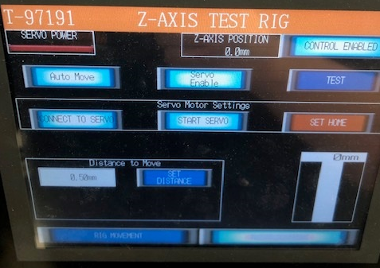
Once the user has logged in, the first step is to home the elevator which will ensure the elevator is flush with the build volume. This is to ensure that the z-axis assembly is in the correct starting point for the proceeding tests. A photo of the homing button displayed on the HMI can be seen in Figure 5:

Figure 5 (Wade, 2023)
Once the elevator is homed, the straightness testing can begin. To do this, the operator must mount two engineering squares to the heater plate, secured by bespoke clamps that screw into the heater plate itself. The two engineering squares are orientated so that the x-axis and y-axis straightness are being tested at the same time. Once the squares have been secured, the operator should then move the x-axis sensor, responsible for taking the straightness readings, so that it is touching the relevant square. The y-axis sensor moves automatically towards its square. Figure 6 gives a visual representation of the two squares being fitted and the sensor engaging with the square:
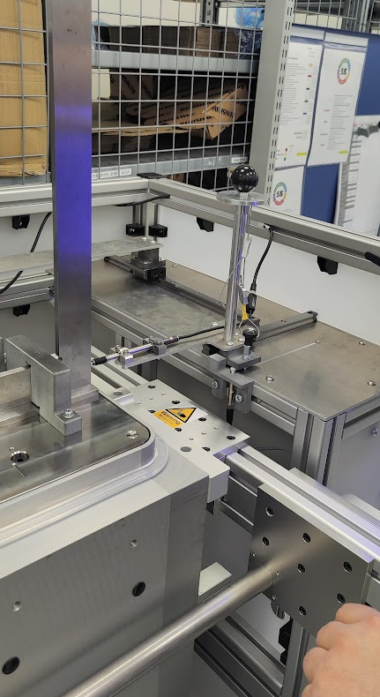
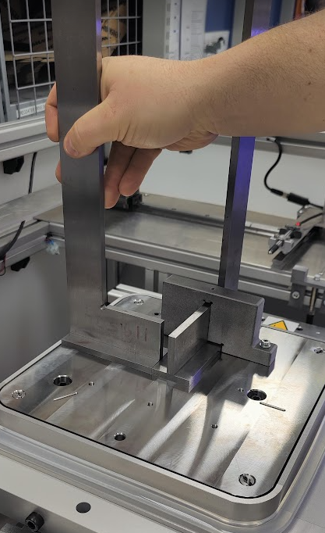

Figure 6 (Wade, 2023)
With the engineering squares fitted and the sensors in the correct positions, the next step is to run the straightness test using the HMI. The operator must navigate to the relevant screen and press the ‘Start’ button, shown in Figure 7:

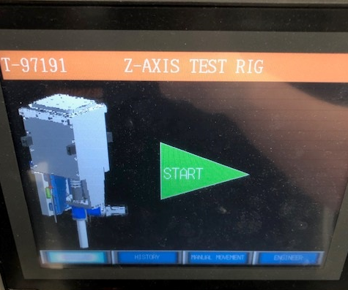

Figure 7 (Wade, 2023)
Once the ‘Start’ button has been pressed, the elevator will be driven down the z-axis by the 3-phase motor in the z-axis assembly. The test program will tell the rig to stop the elevator every 10mm and take a reading from the sensors. Once the elevator has been driven down by 250mm, the test will stop and a pass/fail screen will appear depending on the result of the test. To remove the trolley from the rig, the operator must first remove the cables connecting the trolley to the rig. Only then will the rigs interlock system allow the trolley to be removed.

1.2 Project Steps

The z-axis test rig project was started on the 1st of March 2022 and was finished and handed over by the Design engineering team to the Process engineering team in July 2022. The first step was a design specification, which was documented in the form of a health and safety alert on Renishaw’s Alcumus page. There were also meetings about the requirements but there was no official design specification written by the designer.
The health & safety requirement was to automate the z-axis movement, moving away from an operator using a drill to move the z-axis up and down. This continued drill usage was flagged up as having the potential to cause a repetitive strain injury. As mentioned, this requirement was in the form of an Alcumus entry.
Another requirement was for the rig to align with the way AM commissioning test the z-axis once the machine has been fully built. In AM commissioning, the z-axis is driven using its own 3-phase motor at a speed of 2mm per second. The reason that this method is not carried out on the AM build line is because the machine is built modularly, so the electrical panel and power supplies were not fitted at that point. The commissioning test is more accurate, as the z-axis is run down an encoder which accurately moves the z-axis in 20mm increments. The encoder is accurate down to a few of microns. The old drill method did not move at the same speed, it was slower than the commissioning test. It was also not as accurate, as the old method relied on a steel rule and the human eye to move it in 20mm increments.
A feasibility study was carried out where the proposed z-axis rig plans were scrutinised by production management, process engineering and the design team. They looked at factors like cost, materials, timescales and the needs of the department. Ultimately, the fact that the drill method raised an Alcumus entry was the driving force in approving this project. After a lengthy design period, a final model was drawn up using a 3D CAD software. This model can be seen in Figure 8:

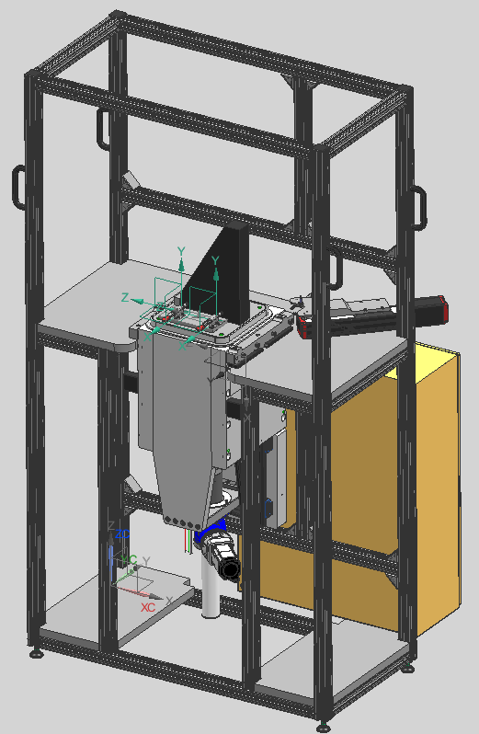

Figure 8 (Cheeseman, 2022)

Once the model had been finalised and peer reviewed, the administration side of the project began. A DL431 was written with this rig, to ensure that it was CE marked and that it meets the strict safety and environmental legislations set by the EU (HSE, 2023). A risk assessment was also carried out by two engineers from the design team. They went through the process using the process flow shown in Figure 9:

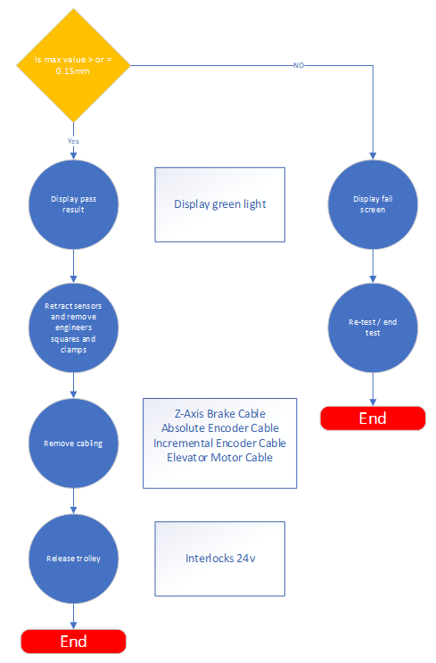
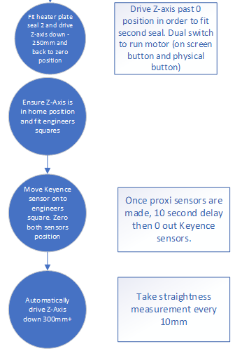
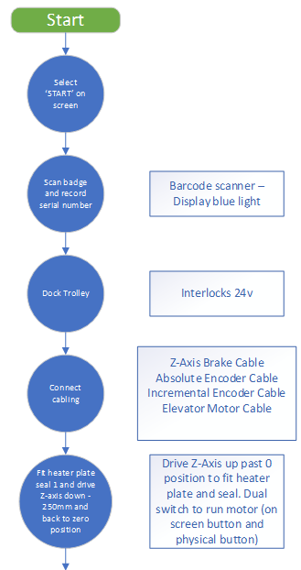

Figure 9 (Harris, 2022)
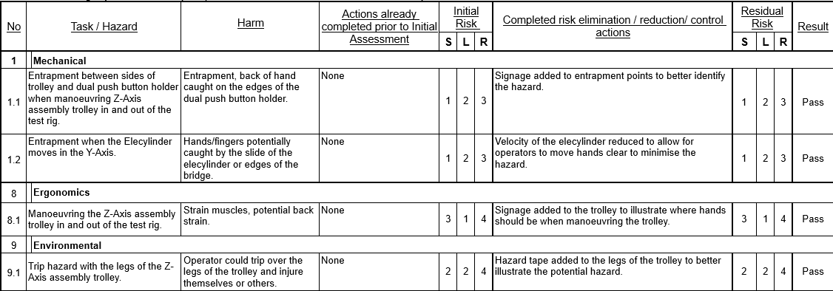
After going through each part of the process, a number of steps were found to be potential hazards. These hazards were given a severity (S) rating and a likelihood (L) rating from 1 to 3. These two values are then multiplied together to give the risk (R) rating. If the risk rating is between 0-5, it is deemed acceptable, if it is 6 it is acceptable only if appropriate guarding and safety features are used. If it scores between 7-10 it is unacceptable and the risk must be reduced prior to anyone using the equipment. Figure 10 shows examples of the risks found:

Figure 10 (Harris, 2022)
As shown, none of the risks identified score above a 5, meaning they are acceptable risks because either the severity is very low or the likelihood is very low. This is a thorough risk assessment that was carried out before any assembling or building of the rig took place.
Further documentation was written for this project in the form of a DL431 Machinery Safety assessment and an AS1541 RoHS assessment. The RoHS (Restriction of Hazardous Substances) assessment (gov.uk, 2014) in particular is important as it is an EU directive explaining that if one of the banned materials, such as mercury were to be disposed of in the wrong manner, it could cause catastrophic damage to the environment. The rig was found to be RoHS compliant, meaning there were no hazardous components that would affect the health of humans or the environment. The DL431 Machinery Safety assessment came with no non-compliances or recommendations.

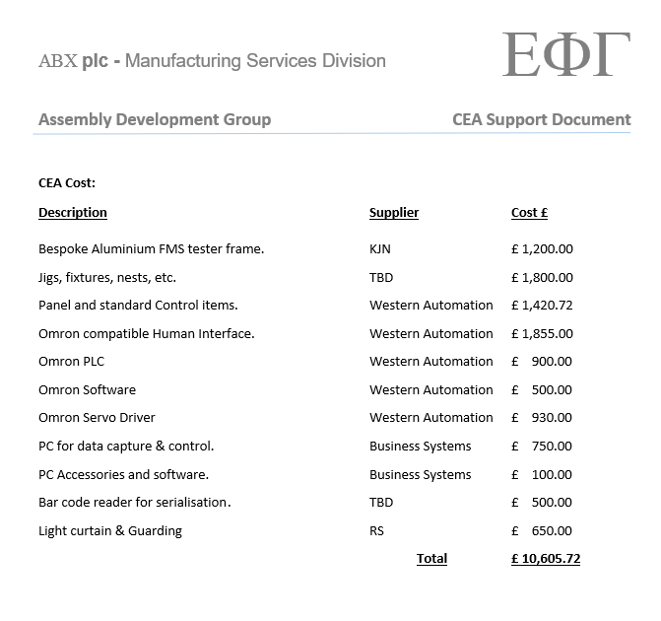
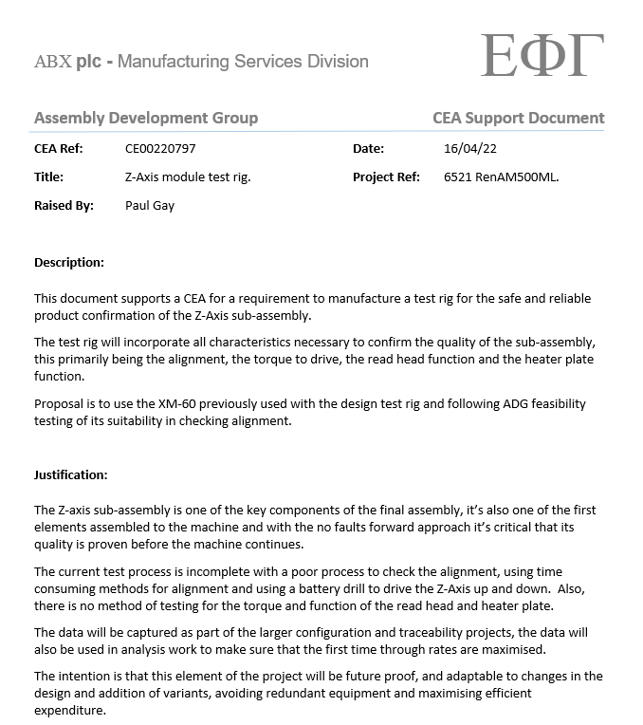
After the designing of the rig and completing all the necessary paperwork needed, the next step of the project was raising a capital expenditure authorisation (CEA). This is where the funding request is written up and approved by management. The first step in this particular process is justifying the project in the form of a top level overview of what the project is and what it is for. It is also to explain why the project is needed and what the money will be spent on. Figure 11 below shows an excerpt of the justification document that was written for this project and an expenditure list:

Figure 11 (Gay, 2022)
The document shows a brief description of the concept of the rig and why it needs to be built, citing that the z-axis is one of the first sub-assemblies built on the production line. It then follows on with the current drill process and parts of the sub-assembly that are not currently tested.
The expenditure list shows a top level breakdown of the components and framework costings, where the parts will be bought from and a total expenditure figure which is £10,605.72. The final cost of the rig came to £9186.16 which means that there was £1419.56 left over from the CEA. This could have occurred due to suppliers changes their prices or offering a discount on certain purchases.

The final stage of the project is the procurement and assembly stage which started with the aluminium extrusion framework that was bolted together, so that all the other components could then be fitted to a solid frame. Next came the nests and skis that are used to guide the z-axis trolley and keep it in place once locked in.
A programmable logic controller (PLC) was used to control all functions and sub-systems within the rig. This needed to have the program written using ladder logic and was connected to the power supply which runs on a 24v supply, as do all of the proximity sensors. A separate box, which contains the main power supply, was bolted to the side of the rig. This is where the PLC and the servo drive are fitted. The servo drive moves the z-axis up and down and it runs on a 415v, 3-phase power supply.
After the power supply box was fitted to the rig, the proximity sensors and the HMI could then be connected. The power supply needed to be fitted first in order for the sensor cables to have a termination point. The HMI needed to have its own script written so it follows the requirements of the process. This script is essential as it will tell the PLC to drive the servo, sensors and motors via operator engagements. For example, a prompt will ask the operator to test the elevator. Upon selecting ‘Test Z-axis’; the servo drive, driven by the PLC, will move the elevator 250mm down.
Once all the electronics had been programmed, fitted and wired, the acrylic cover sheets could be fastened to the frame. This ensures that the production staff have no chance of getting anything trapped in the moving parts within the rig and the z-axis trolley. There was a small amount of testing done on the rig using an old z-axis assembly which confirmed the rigs functionality. The rig was then officially handed over to the process engineering team on the 16th of July 2022.

2. Analysis

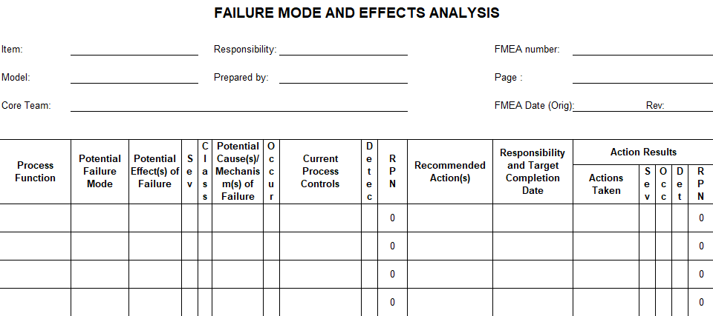
The change management models used within the analysis are the 4-D model (Maylor, 2022) and Kotter’s 8-point change model (Kotter, 1996) which gives a step-by-step guide to change management. The other method of analysis will be a more analytical analysis of the engineering involved in the project. This will be done by carrying out an FMEA (failure modes and effects analysis) on the rig using the template shown in Figure 12:

Figure 12 (UWTSD, 2023)

This will provide a detailed analysis of how the rig could be improved throughout the process. Using the template, the analysis should pinpoint what should have been done from the start of the project and how to improve for the future.

2.1 Change Management Analysis

2.1.1 4D Model
The first change management tool to be used is the 4-D management model (Maylor, 2022). This model usually would be carried out concurrently with a project but as this is an analysis, it will be applied after the project has been completed. The 4-D model consists of four steps that need to be completed in order to have a successful project. These four steps are:
- D1: Define It
- D2: Design It
- D3: Do It
- D4: Develop It
D1 is defining what the consumer needs, this can be in the form of a design specification. This project did not have a written specification, however, the designer had the knowledge and experience to understand that there needed to be a way of driving the z-axis up and down automatically. This could have caused problems later on down the line as a rig could have been designed that still meant a person would have to manually move the z-axis.
There were flaws with the overall design of the rig, these include the stability of the rig and the repeatability of the test results. The length of time taken to finish the rig was more important to the designer than quality or cost. This can be shown visually using the “Iron Triangle” (Maylor, 2022), depicted below in Figure 13:
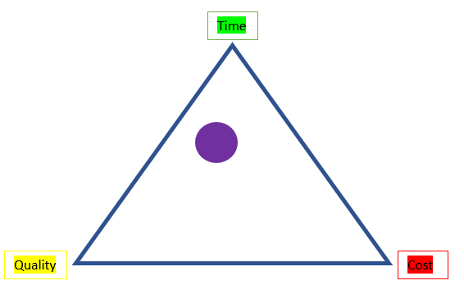

Figure 13 (Rowland-Jones, 2023)

The purple circle in Figure 13 shows where the project lies in terms of time, cost and quality. As the original problem is a health and safety concern, it leans slightly more towards time than quality. As this was a major project the budget was not tightly constricted. The iron triangle used above can be useful in identifying where the trade-offs in a project are likely to be. Pollack (2018) states that this tool is a central concept to project management, research and practice.
Recommendations on how this project could have been managed differently would be to write a design specification. This would remove the risk of designing a product that did not meet what the stakeholders need.

D2 is the designing of the project, which includes time management and speaking to the stakeholders as well as actually designing the solution. There needs to be clear goals and timelines throughout a successful project, otherwise there is no cohesion and you may complete tasks in the wrong order which could result in wasting time and money.
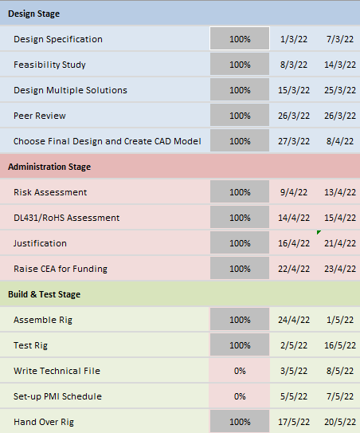
A Gantt chart is a very useful way of clearly displaying tasks and the timelines for those tasks in an easy-to-read format with little time spent on it, Kumar (2005) agrees with this statement. A Gantt chart was drawn up for this project and the task section can be seen below in Figure 14:

Figure 14 (Rowland-Jones, 2023)

As can be seen, there are three different sub-sections to the Gantt chart, a Design stage, an Administration stage and a Build & Test stage. Each sub-section has its own tasks and completion dates assigned to it.
This proved to be very useful throughout the project as, not only did it give achievable targets and dates to the people working on the project, but it also gave the stakeholders a relatively firm completion date. As can be seen, not all of the tasks were achieved.
D3 is buying, building and assembling the project, as well as incorporating time management, by following the Gantt chart. As this project was completed by one person, there was no team management involved. This is an area of the project that could be improved by involving more people to contribute to the design. A study by Schmutz (2019) indicated that teamwork is positively related to the performance of individuals. This would have helped with the timescale element of the project, the rig was handed over in the middle of July, however the rig should have been completed at the end of May, as per the Gantt chart shown in Figure 14.

The procurement of the parts was well thought out by the designer. The aluminium extrusion that makes up the framework (Figure 15) was an in-house purchase as part of Renishaw’s machine shop.
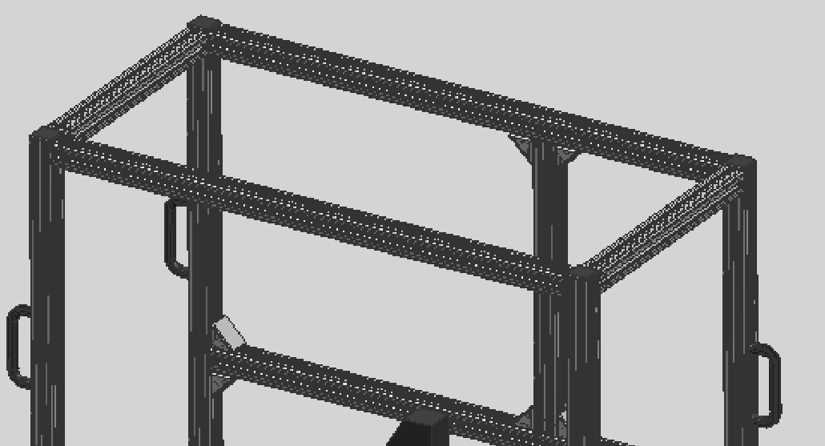

Figure 15 (Cheeseman, 2022)

There were also parts, like the interlocks used to hold the z-axis trolley in the rig, that were also a Renishaw stocked item that did not need to be bought externally. These in-house parts helped towards keeping the overall cost of the rig down as much as possible.
Part of the D3 section of the model is decision-making. At the end of May, when the project was supposed to have been completed, a decision was made to keep the rig in the design area to be worked on when resource was available. At this point, the rig was built physically and could drive the elevator up and down, as per stakeholder needs, but the fully automated test was not quite ready.
The other option would have been to release the rig to the process engineering team for them to work on it, whilst also being used in production. If this option was chosen, it would have meant the production staff would not further incur a health & safety risk and the engineering team, which had more resource at the time, could have finished the automated test concurrently. Therefore, poor decision-making skills meant that the rig was delayed being released to production.
D4 is developing the project which is the only part of the project that was done by the process engineering team. The development took place after the rig had been handed over. As previously mentioned, there were a few things that were picked up as being not up-to-standard on the rig. These actions were now part of a process improvement team. This team was more suitable to develop the rig as they have more time and resource to fix the issues.
Part of D4 is the documentation which should have included a technical file written about the rig by the designer. This would have helped the process engineering team with any queries they may have had when the rig was handed over to the production team but a file was not written. Work instructions were written by the process engineering team, enabling the production staff to use the rig safely.

2.1.2 4D Model Analysis
Maylor’s 4D model is a very useful tool in project management. It allows the user to follow a step-by-step guide that covers all aspects of project management. Each step can be broken down into different sub-sections to be able to complete them in a more manageable way.
This tool could be used on a broad range of different projects. It has worked well on this z-axis rig, it could also be used to drive a larger scale project, such as a company-wide sustainability project. Although it is a step-by-step guide, there are a couple of things that were missing from the model that have been added into this report. In D2, the design stage, there is no mention of actually designing the project itself. This shows that is a broad tool that is not tailored specifically for engineering projects.

2.1.3 Kotter’s Model
The next change management analysis tool comes from John P. Kotter, who wrote the book “Leading Change” (Kotter, 1996). He designed an 8-point change model that could be used throughout a project as a work-to list. His model, shown in Figure 16, will be applied post-project to see if the change could have been managed in a more efficient way:

Figure 16 (Pitson, 2023)

Creating a compelling reason for change was taken out of the designers hands as this project came about in reaction of a health & safety concern raised by the production team. This is also where the sense of urgency came from. There was no coalition or team as previously mentioned, only one person was working on the rig from start to finish. A bigger team would have sped up the project and enable it to be completed in the appropriate time.
A new vision was created through CAD software, giving a very detailed look at what the final product was going to look like. This was not communicated through any medium, however, there was no input from the process engineering team or the production team. This is not best practice as some of the pitfalls in the rig could have been avoided if the design had been discussed and brainstormed with more people.
By creating a Gantt chart, the project had a set of tasks with dates which allowed for short-term wins. Tasks such as the feasibility study and the CEA that was carried out were examples of short-term wins that aided the project. The final two steps were carried out by the process engineering team once the rig had been handed over. The changes, replacing the feet of the rig with bigger ones for example, were as part of a brainstorming session between the engineering team and the production team. The involvement of more people brought about the necessary development of the rig. Reinforcing the changes were done through the physical changes made to the rig and the work instructions written by the engineering team, to be followed meticulously by the production staff.

2.1.4 Kotter’s Model Analysis
Like the 4D model, Kotter’s model provides the user with a guide to follow throughout the project management process. Haas (2021) agrees with this statement and has used the model in that way. Each step can have its own tasks within them for easy wins and a more manageable project.
One limitation is that not every step in the model is applicable to every project, especially an engineering project. The “empower others to act” step doesn’t apply to this project at all. This step is more for wholesale change management projects such as a sustainability project or a business project.

2.2 Engineering Analysis

2.2.1 FMEA

An FMEA (failure modes and effects analysis) is a useful tool that should be used before a design is built. Bongiorno (2001) explains that FMEAs are a risk identification and mitigation strategy used during product development. After completion, the tool remains a live document which can be amended and added to as required. Stamatis (2003) states that there are three components that make up an FMEA, severity, occurrence and detection. Each task has their severity, occurrence and detection scored from 1 to 10.
Once the components have been assigned a number, they are multiplied together to give an RPN (risk priority number). The RPNs are used to decide which of the failures will be addressed first, giving the users a priority list to work to. Figure 17 shows the FMEA that was carried out.
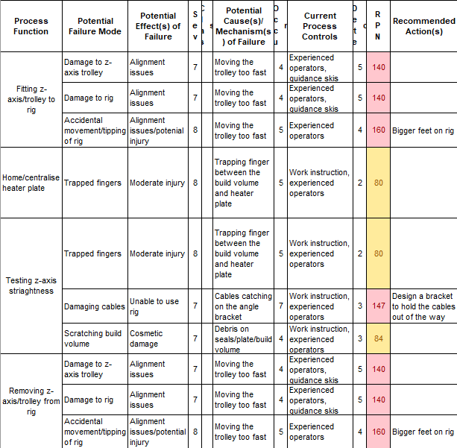

Figure 17 (Wade, 2023)

This FMEA shows that there are a number of different potential failure modes with the rig, creating hazards that range from damaging cables and trolleys to potentially causing physical harm to the people who use the rig.
The two failure modes that scored the highest on the FMEA are moving/tipping the rig when installing the z-axis trolley, and trapping the cables connecting the z-axis to the rig. The design improvements to be recommended on this rig would be to use bigger feet or to bolt the rig to the floor. This would make the rig more stable and reduce the occurrence value, and therefore the RPN of that potential risk.
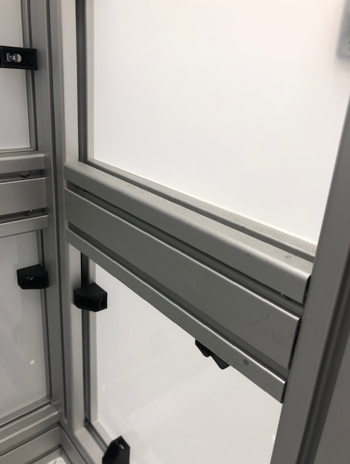
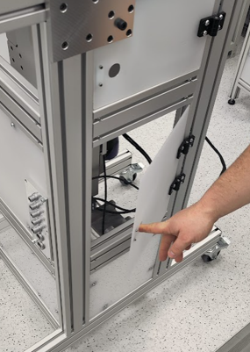
To address the other potential failure mode, a recommendation would be made to design a bracket or sleeving/guarding to house the power and signal cables that are required to be connected. This could be fitted to the inside of the z-axis trolley, as shown in Figures 18 and 19:

Figure 18 (Bennett, 2023) Figure 19 (Bennett, 2023)

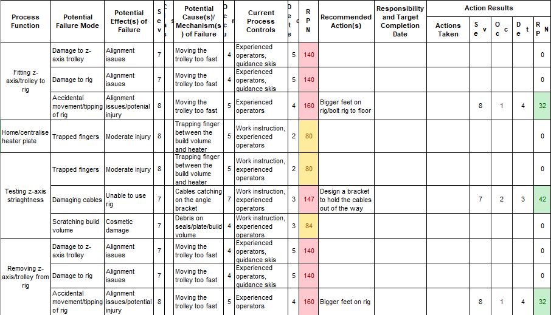
Fitting the guarding as shown would greatly reduce the RPN of that failure mode by decreasing the occurrence. The new occurrence value and RPN number is shown in Figure 20:

Figure 20 (Wade, 2023)

2.2.2 FMEA Analysis
An FMEA is a very useful tool for creating a comprehensive list of tasks within a process and what potential failures can be caused by them. McDermott (2008) states that FMEAs take up a fair amount of time and resource to be completed effectively.
This is the only downside to an FMEA as this tool is meant to be used in groups, so there is more than one thought process going into it. This makes an FMEA thorough, well thought out and gives the user a priority list to work through. Overall, an FMEA is a tool that should have been used on this project from the start to identify the above design flaws and reduce the risks at the design stage, rather than after its been released to the production team.

Conclusion

The goal of this project was to supply the production team with a rig that would allow the user to automatically drive and test the straightness of the z-axis assembly in a safe and efficient manner. The design team has achieved this goal by following a Gantt chart and designing a rig that meets the needs of the production team.
The rig is easy to use, more accurate than the previous process and reduces the time taken to test the z-axis by automating certain parts of the testing. They were successful in keeping a budget, procuring parts in-house where they could, including the framework and some of the sensors used.
Recommendations to be made about this project would include writing a design specification. As there was not one written at the start, the design team relied on their knowledge and memory of the process. This could have easily become a project that was working towards different goals and not what the end user needed.
If the project was undertaken by a team, rather than one person, the project would have been completed on time. Working as a team also opens up different avenues of knowledge and experience that could be used on different projects. Gallie (2012) argues that the benefits of teamwork only occur in self-directed teams and are actually supressed in non-self-directed teams.
In terms of design recommendations, the rig should have been designed with larger feet or with the intention of being bolted to the floor. This would remove the risk of moving or knocking over the rig when installing the z-axis trolley. They also should have designed a bracket to hold the cables when carrying out the testing to avoid trapping and breaking them.
A Gantt chart was created at the start of writing this report outlining the different tasks that needed to be completed. It is split into three sub-sections which are ‘Start Project’, ‘Project Write-up’ and ‘Analysis’. Each sub-section has its own individual tasks which were all achieved on time. Figure 21 shows the Gantt chart:

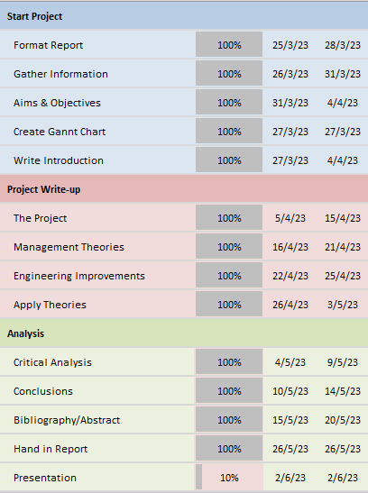

Figure 21 (Rowland-Jones, 2023)
Figure 21 shows that the tasks were achieved on time and, as such, the report was handed in on the 26th of May 2023, achieving the deadline. The time management was successful because each task was given a realistic and achievable timeframe which flowed through the report from start to finish.

Bibliography
Bennett, J., 2023. Z-axis Trolley, Pontyclun: s.n.
Bongiorno, J., 2001. Use FMEAs to improve your product development process. PM Network.
Cheeseman, M., 2022. Z-axis Alignment Rig, Pontyclun: s.n.
Gallie, D., 2012. Teamwork, Skill Development and Employee Welfare. BJIR.
Gay, P., 2022. Z-axis Module Test Rig, Pontyclun: s.n.
gov.uk, 2014. Regulations: restriction of hazardous substances (RoHS). [Online] Date accessed: 05/04/2023
Available at: https://www.gov.uk/guidance/rohs-compliance-and-guidance
Haas, M. R. C., 2021. DidacticsRevolution: Applying Kotter's 8-step Change Management Model to Residency Didactics. West J Emerg Med.
Harris, R., 2022. Z-axis Alignment Rig Risk Assessment, Pontyclun: s.n.
HSE, 2023. CE Marking. [Online] Date accessed: 26/04/2023
Available at: https://www.hse.gov.uk/work-equipment-machinery/ce-mark-summary.htm
Kotter, J. P., 1996. Leading Change. Massachusetts: Harvard Business Review Press.
Kumar, P. P., 2005. Effective Use of Gantt Chart for Managing Large Scale Projects. Cost Engineering, 47(7).
Maylor, H., 2022. Fifth Edition Project Management. London: 2022.
McDermott, R., 2008. The Basics of FMEA (Second Edition). Florida: CRC Press.
Pitson, M., 2023. Introduction to Change Engineers, Swansea: s.n.
Pollack, J., 2018. What is the Iron Triangle, and how has it changed?. International Journal of Managing Projects in Business, 11(2).
Renishaw plc, 2019. A closer look at the RenAM 500Q. [Online] Date Accessed: 29/03/2023
Available at: https://www.renishaw.com/en/a-closer-look-at-the-renam-500q--44937
Rowland-Jones, B., 2023. Iron Triangle, Pontyclun: s.n.
Rowland-Jones, B., 2023. Project Gannt Chart, Pontyclun: s.n.
Rowland-Jones, B., 2023. Report Gannt Chart, Pontyclun: s.n.
Schmutz, J. B., 2019. How effective is teamwork really? The relationship between teamwork and performance in healthcare teams: a systematic review and meta-analysis. BMJ Journals.
Stamatis, D. H., 2003. Failure Mode and Effect Analysis (Second Edition). Milwaukee: Quality Press.
UWTSD, 2023. FMEA Template, Swansea: s.n.
Wade, D., 2023. RenAM Z-axis Assembly, Pontyclun: s.n.
Wade, D., 2023. Z-axis Rig FMEA, Pontyclun: s.n.

