University of Wales Trinity Saint David
Wales Institute of Science and Art


Modelling Industrial Control Systems in MATLAB
Control Technology ACMA6001

Trystan Herdman
2219054
28/07/2025
Contents
1 Introduction 2
1.1 Aims 2
1.2 Objectives 2
2 Background 2
2.1 PID general background 2
2.2 Cruise control standards 3
3 PID tuning 4
3.1 Method 4
3.2 Results and analysis 4
4 Time step impact 5
4.1 Method 5
4.2 Results and analysis 6
5 Number of Bits impact 7
5.1 Method 7
5.2 Results and analysis 8
6 Conclusion 10
7 References 12
8 Code (control function) 12

Figure 1 MATLAB Initialisation Code for PID Parameters and Housekeeping 4
Figure 2: System Response with PID Gains Kp = 3.9, Ki = 1.1, Kd = 0.05 4
Figure 3 System Response with PID Gains (Kp = 1.901, Ki = 1.201, Kd = 1e-05, R = 16) 5
Figure 4 MATLAB Code for Simulation Parameter Setup 6
Figure 5 System Response with Simulation Time Step = 0.05s 6
Figure 6 System Response with Increased Time Step (0.05s) Using PID Gains Kp = 2.2, Ki = 1, Kd = 0.07, R = 16 7
Figure 7 MATLAB Code for Digital Signal Encoding and Sampling Parameters 8
Figure 8 Cruise Control Performance with 16-Bit Signal Resolution 8
Figure 9 Cruise Control Performance with 10-Bit Signal Resolution 9
Figure 10 Cruise Control Performance with 8-Bit Signal Resolution 10

Introduction

Aims
This report aims to analyse the performance of a digital PID controller implemented in MATLAB for a cruise control system. The controller must accurately track a driver’s desired speed while accounting for quantisation, sampling, and communication delays.

Objectives
- Investigate PID tuning and its effect on velocity tracking.
- Evaluate the impact of time step, signal quantisation (bit-depth), and actuator delay.
- Identify trade-offs in controller performance and implementation constraints.

Background

PID general background
Proportional–Integral–Derivative (PID) control is one of the most widely applied feedback control strategies in industrial and engineering systems due to its simplicity, effectiveness, and robustness. The PID controller operates by continuously calculating the error between a system's desired setpoint and its actual output, and then adjusting the control input accordingly through three distinct terms: proportional (P), integral (I), and derivative (D).
The proportional term responds to the present error, scaling the control effort in direct proportion to the error magnitude. This term improves the system's responsiveness but does not eliminate steady-state error. The integral term, which accumulates the error over time, addresses this limitation by applying corrective action to eliminate residual discrepancies. Meanwhile, the derivative term predicts future error trends based on the rate of error change, thereby enhancing system stability and damping (Åström and Hägglund, 2006).
PID controllers are particularly valued in systems requiring precise regulation—such as temperature, pressure, velocity, and flow—because they offer a balance between performance and computational efficiency. Unlike modern optimal or adaptive control methods, PID controllers do not require an accurate mathematical model of the plant, making them highly versatile and suitable for a broad range of applications including manufacturing, chemical processing, and automotive systems (Dorf and Bishop, 2017).
Despite their ubiquity, PID controllers must be carefully tuned to achieve desirable performance metrics such as fast rise time, minimal overshoot, and low steady-state error. Several tuning methodologies, such as the Ziegler–Nichols method or Cohen–Coon method, are used to optimise these parameters depending on system dynamics and design goals (Ogata, 2010). With increasing integration into digital embedded platforms, modern PID implementations must also consider sampling time, quantisation, and communication constraints.

Cruise control standards
In the United Kingdom, cruise control systems—whether conventional or adaptive—must comply with a combination of national legislation and international standards retained in domestic law post-Brexit. These regulatory frameworks are designed to uphold functional safety, ensure driver control, and promote transparent human–machine interaction. Such systems must operate reliably, respond promptly to user inputs, and disengage automatically under predefined conditions.
A principal standard is UNECE Regulation No. 79, which governs steering and driver assistance systems. It stipulates that the driver must retain full authority over the vehicle at all times, requiring cruise control systems to be deactivated through manual intervention such as braking or clutch operation (UNECE, 2019a). This ensures immediate override capability in critical scenarios.
Further safety requirements are set by UNECE Regulation No. 13-H, which addresses the integration of cruise control with braking systems. This regulation demands redundancy in control pathways and compatibility with existing vehicle braking hardware, helping to prevent failures that could compromise safety (UNECE, 2019b).
In the UK context, BS ISO 15622:2018 outlines the operational, safety, and performance criteria for adaptive cruise control (ACC). It details requirements for system behaviour under various road conditions, minimum time gaps between vehicles, reaction times, and fail-safe operation to maintain user safety and comfort (British Standards Institution, 2018).
Moreover, the General Safety Regulation (EU) 2019/2144, retained in UK law, mandates that vehicles registered from 2024 onward include safety technologies such as intelligent speed assistance (ISA), emergency braking, and lane keeping—all of which often function alongside cruise control (European Commission, 2019).
Finally, the Construction and Use Regulations 1986 ensure that automated systems do not interfere with fundamental driving controls, reinforcing the importance of system disengagement and driver priority (UK Government, 1986).
The simulation model developed in this project reflects these principles by implementing velocity constraints, actuator limits, and override logic, aligning the digital control system with UK regulatory standards.

PID tuning

Method
Several PID gain configurations were tested using the simulation model provided. The gains were adjusted to explore how each component (P, I, D) impacts system performance. Gains were evaluated against rise time, overshoot, settling time, and steady-state error.
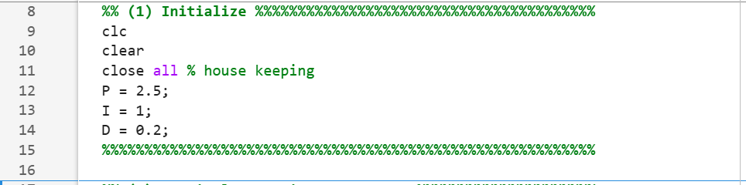
Figure 1 MATLAB Initialisation Code for PID Parameters and Housekeeping

Results and analysis
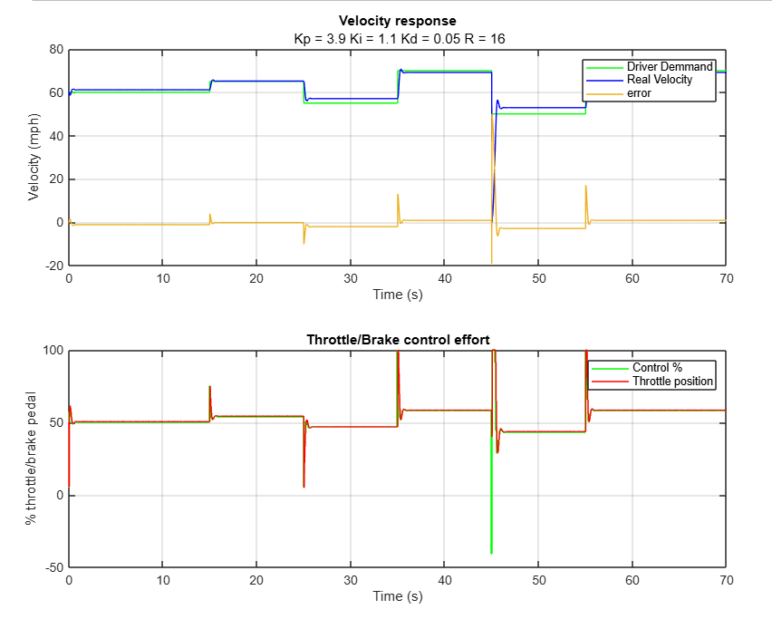
Figure 2: System Response with PID Gains Kp = 3.9, Ki = 1.1, Kd = 0.05
The graph shows how a PID controller responds to changes in the driver’s speed demand in a cruise control system. The top part of the graph shows that the actual vehicle speed (blue line) follows the driver’s requested speed (green line) quite well. When the driver changes the speed, the system reacts quickly and settles at the new speed without much delay or error. The orange line, which shows the difference between the requested and actual speed, stays close to zero, which means the controller is doing a good job. The lower graph shows how the controller changes the throttle and brake settings to match the speed. The green line is the control signal, and the red line shows what is actually sent to the throttle. These lines are very close, which means the system is working smoothly. Overall, the controller reacts well to changes, keeps the vehicle stable, and uses reasonable amounts of throttle and brake to keep the speed under control.
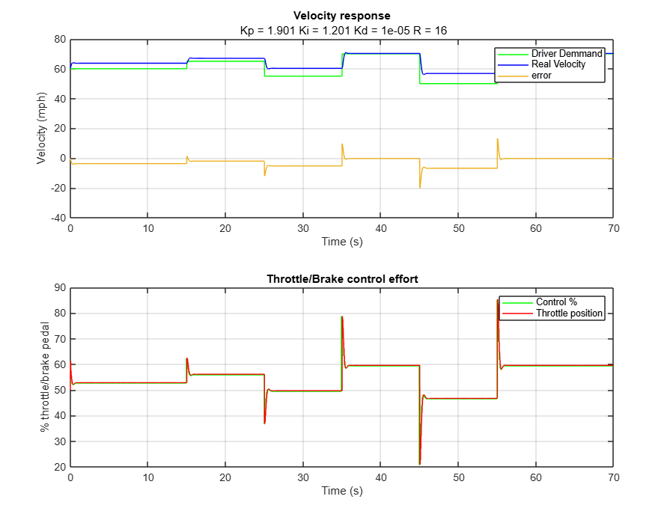
Figure 3 System Response with PID Gains (Kp = 1.901, Ki = 1.201, Kd = 1e-05, R = 16)
This graph shows how the cruise control system responds when using a different set of PID gains: Kp = 1.901, Ki = 1.201, and Kd = 1e-05. The top graph shows the vehicle speed (blue line) compared to the driver’s requested speed (green line). The controller keeps the actual speed close to the demand throughout the test. The system reacts more slowly than other setups but avoids large spikes or overshoots, which means the controller is more stable and conservative. The error (orange line) stays small, showing that the vehicle reaches and holds the target speeds with minimal delay. The bottom graph shows the control signal (green line) and the throttle setting (red line). The control signals are smoother and less aggressive than in previous examples, meaning the system is using less force to make speed changes. This shows that the controller is tuned to prioritise smoothness and stability over quick reactions. Overall, the system is stable, steady, and avoids harsh braking or acceleration.

Time step impact

Method
In the simulation, the controller should run at regular intervals based on the sampling time (Ts). At first, the condition used was mod((j-1)*sim_step, Ts) == 0, but this sometimes failed because of small errors in how MATLAB handles decimal numbers. This meant the controller didn’t run as expected, especially when Ts and sim_step were the same value.
To fix this, the condition was changed to mod(j-1, round(Ts / sim_step)) == 0. This method uses whole numbers instead of decimals, which is more reliable. It checks if the controller should run every few steps, depending on how many times sim_step fits into Ts. This change made the controller work properly again and showed why accurate timing is important in digital control systems.
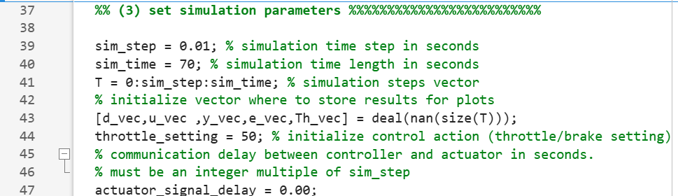
Figure 4 MATLAB Code for Simulation Parameter Setup

Results and analysis
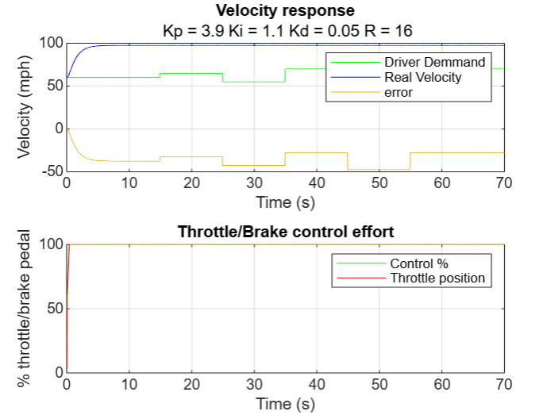
Figure 5 System Response with Simulation Time Step = 0.05s
When the time step (sim_step) was changed to 0.05 seconds, the system stopped responding properly. The vehicle stayed at full throttle and didn’t react to changes in the driver’s speed demand. This happened because the controller wasn’t being updated during the simulation. In the code, the condition used to trigger the controller was based on time: mod((j-1)*sim_step, Ts) == 0. However, when both sim_step and Ts are set to the same value, this condition can sometimes fail due to small rounding errors in how MATLAB handles decimal numbers. As a result, the controller only ran once at the start and then stopped working. To fix this, the condition could be changed to mod(j-1, round(Ts/sim_step)) == 0, which uses the loop index instead of time. This is more reliable because it avoids rounding problems and ensures the controller runs at the correct times.
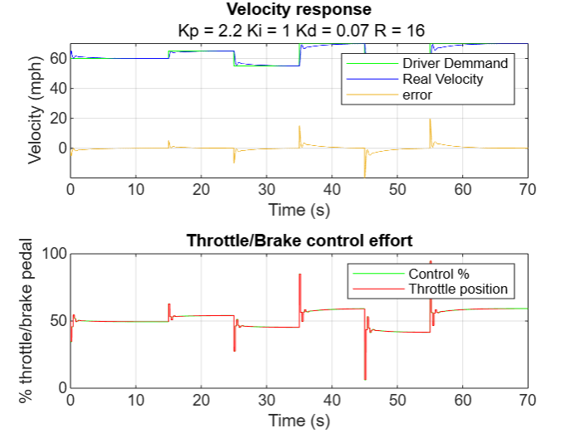
Figure 6 System Response with Increased Time Step (0.05s) Using PID Gains Kp = 2.2, Ki = 1, Kd = 0.07, R = 16
This graph shows the performance of the cruise control system after changing the simulation time step to a larger value, such as 0.05 seconds. The top graph shows how the vehicle speed (blue line) follows the driver’s requested speed (green line). Although the system still tracks the demand fairly well, there is a slight delay in how quickly it reacts to changes, especially around 35 and 50 seconds. The error line (orange) also shows small spikes when the speed demand changes, which means the system takes longer to correct itself. In the bottom graph, the control signal (green) and the throttle position (red) are slightly more jagged compared to smoother results with a smaller time step. This happens because fewer updates are being made per second, so the controller reacts less frequently. As a result, the system becomes slightly less accurate and slower to respond. Overall, the controller still works, but this graph shows that increasing the time step can reduce the performance of the system, especially in terms of response time and control smoothness. It helps to demonstrate why the choice of simulation and sampling rates is important in digital control systems.

Number of Bits impact

Method
To understand how signal resolution affects system performance, three different bit depths were tested: 16 bits, 10 bits, and 8 bits. These values were applied to the sensor signal, driver demand, and control output by changing the corresponding bit parameters in the code. The PID controller settings stayed the same in each test to ensure a fair comparison. The aim was to see how reducing the number of bits changes how accurately the system reads and sends data. With 16 bits, the signals were very precise and the control system responded smoothly. At 10 bits, performance was still acceptable but showed some minor rounding effects. At 8 bits, the system became noticeably less accurate, with slight delays and increased error due to signal quantisation. This method showed how lowering bit depth can affect control quality and why choosing the right resolution is important in digital control systems.
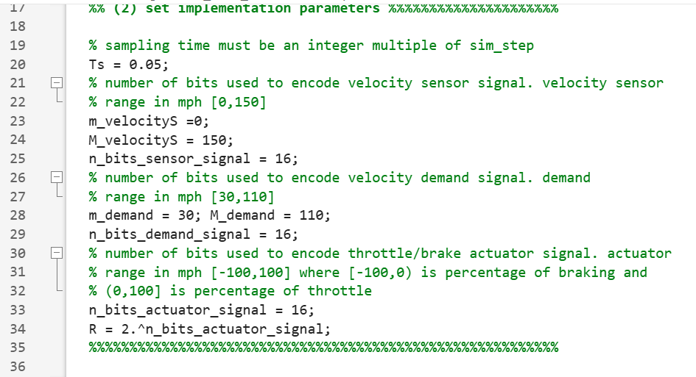
Figure 7 MATLAB Code for Digital Signal Encoding and Sampling Parameters

Results and analysis
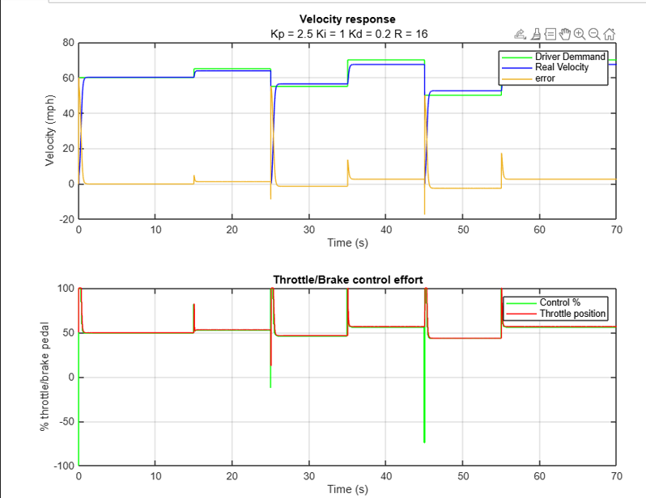
Figure 8 Cruise Control Performance with 16-Bit Signal Resolution
This graph demonstrates the cruise control system's response using a 16-bit signal resolution, which provides a high level of accuracy in representing sensor measurements, control commands, and actuator signals. In the top subplot, the vehicle's actual velocity (blue line) closely follows the driver demand (green line), with minimal deviation. The error signal (orange) remains close to zero throughout, indicating excellent tracking performance and negligible steady-state error.
In the lower plot, the control effort (green) and throttle position (red) exhibit smooth behaviour with only minor fluctuations during transitions. This smoothness is a result of the fine-grained signal encoding—16 bits allow for 65,536 discrete levels, enabling the controller to issue precise adjustments. As such, the controller operates efficiently, with minimal overshoot or aggressive corrections.
This 16-bit simulation represents the ideal performance benchmark for digital implementation. It provides a reliable comparison point for evaluating how reduced bit depths (e.g. 8-bit or 4-bit) impact the system’s control precision and dynamic response.
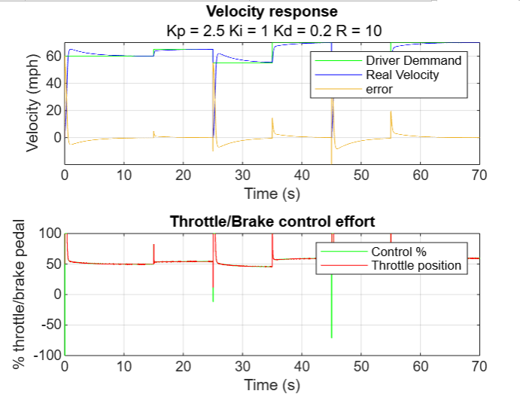
Figure 9 Cruise Control Performance with 10-Bit Signal Resolution
This figure shows the cruise control system’s performance when signal resolution is reduced to 10 bits. In this case, the velocity response (top subplot) still follows the driver demand signal (green) reasonably well, and the real vehicle velocity (blue) maintains a stable trajectory. However, compared to the 16-bit baseline, the error signal (orange) exhibits slightly larger deviations during transitions, indicating some quantisation effects due to the lower resolution.
The control effort (bottom subplot) reflects these limitations more clearly. The control signal (green) shows less smoothness and more abrupt transitions, particularly during speed changes. This is expected with 10-bit encoding, which offers 1024 discrete levels—much fewer than the 65,536 levels in a 16-bit system. These coarser increments lead to less precise actuator control, which in turn causes the throttle position (red) to display minor fluctuations and spikes.
Despite these effects, the system still performs acceptably. The velocity remains within reasonable bounds of the setpoint, and there is no sign of instability or oscillation. Therefore, 10 bits appears to be a workable trade-off, balancing performance with reduced communication load or memory usage.
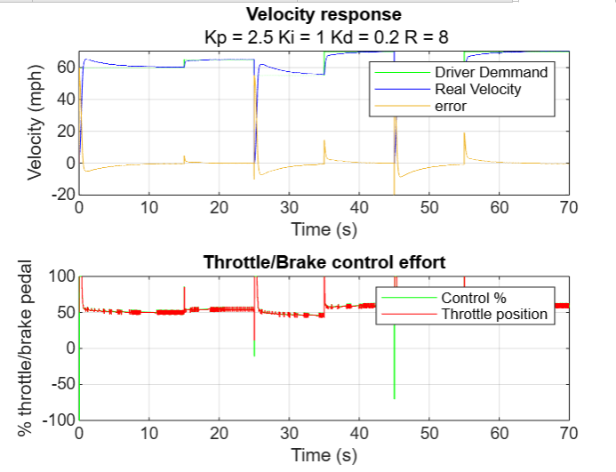
Figure 10 Cruise Control Performance with 8-Bit Signal Resolution
In this simulation, the system uses 8-bit resolution (R = 2⁸ = 256), which significantly reduces the granularity of signal encoding compared to 16-bit resolution. As a result, there is noticeable quantisation in both the velocity and control signals. The top plot shows that although the real velocity tracks the driver demand reasonably well, the system exhibits greater oscillations and error spikes, especially during transitions. This is because fewer bits limit the precision of velocity measurements and actuator commands, making the controller less responsive to small changes.
The bottom plot highlights these effects in the control effort, where the throttle and brake signals appear more erratic and stepped, reflecting coarser control input. The system still functions, but the reduced bit depth compromises smoothness and could lead to wear or discomfort in a real-world application. Overall, 8 bits provide minimal acceptable performance, but the loss in resolution introduces visible degradation in system behaviour.

Conclusion
This project investigated the performance of a digital PID controller applied to a cruise control system using MATLAB simulation. The aim was to test how different factors—such as PID tuning, time step, signal resolution (bit-depth), and delay—affect the system’s ability to follow the driver’s speed demand accurately and smoothly.
The results showed that tuning the PID controller is essential to getting good system performance. Higher proportional gain made the system respond faster but risked overshoot. The integral term helped reduce steady-state error, while the derivative term improved stability and helped reduce sharp changes in control. The best results were found by carefully balancing all three gains.
Changing the time step (sampling time) had a noticeable effect on how well the system worked. When the time step was increased, the system responded more slowly and less accurately. This happened because the controller wasn’t updating often enough, which caused delays in throttle or brake adjustments. Fixing the code to trigger updates using integer steps instead of decimal time helped improve performance and showed how digital controllers depend on correct timing.
The number of bits used to represent signals also made a difference. With 16 bits, the system was very accurate and smooth. Reducing this to 10 bits caused some small errors, but the system still worked well. However, using only 8 bits made the system less smooth and introduced more noise and delay. This is because low-resolution signals can’t represent values as precisely, which limits the controller’s ability to respond properly.
Overall, the PID controller worked well when tuned correctly and when the simulation settings were appropriate. The system met the key requirements of keeping the vehicle speed close to the driver’s request, avoiding large overshoots, and responding smoothly to changes. This shows how important it is to consider digital limits like timing and signal resolution when designing controllers for real-world systems such as cruise control.

References
Åström, K.J. and Hägglund, T., 2006. Advanced PID Control. Research Triangle Park, NC: ISA—The Instrumentation, Systems, and Automation Society.
British Standards Institution, 2018. BS ISO 15622:2018—Intelligent transport systems – Adaptive cruise control systems – Performance requirements and test procedures. London: BSI.
Dorf, R.C. and Bishop, R.H., 2017. Modern Control Systems. 13th ed. Harlow: Pearson Education Limited.
European Commission, 2019. Regulation (EU) 2019/2144 of the European Parliament and of the Council of 27 November 2019 on type-approval requirements for motor vehicles and their trailers. [online] Available at: https://eur-lex.europa.eu/legal-content/EN/TXT/?uri=CELEX%3A32019R2144
Ogata, K., 2010. Modern Control Engineering. 5th ed. Upper Saddle River, NJ: Prentice Hall.
UK Government, 1986. The Road Vehicles (Construction and Use) Regulations 1986. [online] Available at: https://www.legislation.gov.uk/uksi/1986/1078/contents/made
United Nations Economic Commission for Europe (UNECE), 2019a. Regulation No. 79 – Uniform provisions concerning the approval of vehicles with regard to steering equipment. [online] Available at: https://unece.org/
United Nations Economic Commission for Europe (UNECE), 2019b. Regulation No. 13-H – Uniform provisions concerning the approval of passenger cars with regard to braking. [online] Available at: https://unece.org/

Code (control function)
%% MAIN FILE FOR CRUISE CONTROLLER SYSTEM %%%%%%%%%%%%%%%%
% (1) initialize
% (2) set implementation parameters
% (3) set simulation parameters
% (4) simulation loop
% (5) plot results
%%%%%%%%%%%%%%%%%%%%%%%%%%%%%%%%%%%%%%%%%%%%%%%%%%%%%%%%%%
%% (1) Initialize %%%%%%%%%%%%%%%%%%%%%%%%%%%%%%%%%%%%%%%%
clc
clear
close all % house keeping
P = 2.5;
I = 1;
D = 0.2;
%%%%%%%%%%%%%%%%%%%%%%%%%%%%%%%%%%%%%%%%%%%%%%%%%%%%%%%%%%

%% (2) set implementation parameters %%%%%%%%%%%%%%%%%%%%%

% sampling time must be an integer multiple of sim_step
Ts = 0.05;
% number of bits used to encode velocity sensor signal. velocity sensor
% range in mph [0,150]
m_velocityS =0;
M_velocityS = 150;
n_bits_sensor_signal = 16;
% number of bits used to encode velocity demand signal. demand
% range in mph [30,110]
m_demand = 30; M_demand = 110;
n_bits_demand_signal = 16;
% number of bits used to encode throttle/brake actuator signal. actuator
% range in mph [-100,100] where [-100,0) is percentage of braking and
% (0,100] is percentage of throttle
n_bits_actuator_signal = 16;
R = 2.^n_bits_actuator_signal;
%%%%%%%%%%%%%%%%%%%%%%%%%%%%%%%%%%%%%%%%%%%%%%%%%%%%%%%%%%

%% (3) set simulation parameters %%%%%%%%%%%%%%%%%%%%%%%%%

sim_step = 0.01; % simulation time step in seconds
sim_time = 70; % simulation time length in seconds
T = 0:sim_step:sim_time; % simulation steps vector
% initialize vector where to store results for plots
[d_vec,u_vec ,y_vec,e_vec,Th_vec] = deal(nan(size(T)));
throttle_setting = 50; % initialize control action (throttle/brake setting)
% communication delay between controller and actuator in seconds.
% must be an integer multiple of sim_step
actuator_signal_delay = 0.00;
%% remove when in function
m_ControlSig = -100;
M_ControlSig = 100;
%%%%%%%%%%%%%%%%%%%%%%%%%%%%%%%%%%%%%%%%%%%%%%%%%%%%%%%%%%
[u, control] = deal(50);
%% (4) simulation loop %%%%%%%%%%%%%%%%%%%%%%%%%%%%%%%%%%%
velocity_real = 60;
for j = 1:length(T) % for every simulation step

loops_remaining = length(T)-j; % display progression
disp(loops_remaining)
% get vehicle raw veocity sensor measurement from the communication bus
[velocity_raw, velocity_real,throttle_setting] = getRawVelocity(n_bits_sensor_signal,velocity_real,throttle_setting, sim_step,u);

% decode raw bus signal (from x-bit binary to mph)
velocity = ((bin2dec(velocity_raw).*(M_velocityS-m_velocityS))/R)+m_velocityS;

if mod((j-1)*sim_step,Ts) == 0 % every sampling time

% get driver's velocity demand raw signal from the communication bus
demand_raw = getRawVelocityDemand(n_bits_sensor_signal,sim_step,j);

%% decode raw signal (from x-bit binary to mph)
demand = (bin2dec(demand_raw)*(M_demand-m_demand)/R)+m_demand; % INCORRECT DECODING! INSERT YOUR DECODING FUNCTION HERE

%% calculate control signal and error (range of control [-100,100])
[control, error] = Controllerzz(demand,velocity,P,I,e_vec,j,Ts,sim_step,control,D); % INCORRECT CONTROL! INSERT YOUR CONTROL ALGORITHM HERE

%% encode control signal into x-bit binary number
control_raw = dec2bin((control-m_ControlSig)/(M_ControlSig-m_ControlSig)*R); % INCORRECT ENCODING! INSERT YOUR ENCODING FUNCTION HERE

%% send control command to throttle/brake actuator via communication
% bus (record the control signal instance as u)
u = sendControlCommand(control_raw,n_bits_actuator_signal,actuator_signal_delay,j, sim_step, u_vec);
end

% store values for plotting
e_vec(j) = error;
d_vec(j) = demand;
u_vec(j) = control;
y_vec(j) = velocity_real;
Th_vec(j) = throttle_setting;
end

%%%%%%%%%%%%%%%%%%%%%%%%%%%%%%%%%%%%%%%%%%%%%%%%%%%%%%%%%%

%% (5) plot results %%%%%%%%%%%%%%%%%%%%%%%%%%%%%%%%%%%%%%

figure

% plot velocity response
subplot(2,1,1)
plot(T,d_vec,'g-');hold on
plot(T,y_vec,'b-');
plot(T,d_vec-y_vec); grid;
title('Velocity response');
subtitle([' Kp = ', num2str(P),' Ki = ', num2str(I),' Kd = ',...
num2str(D),' R = ',num2str(n_bits_actuator_signal) ]);
ylabel('Velocity (mph)'); xlabel('Time (s)');
legend('Driver Demmand','Real Velocity','error')

% plot throttle/brake actuator effort
subplot(2,1,2)
stairs(T,u_vec,'g-');
hold on;
plot(T,Th_vec,'r-'); grid;
title('Throttle/Brake control effort');
ylabel('% throttle/brake pedal'); xlabel('Time (s)');
legend ('Control %','Throttle position')
%%%%%%%%%%%%%%%%%%%%%%%%%%%%%%%%%%%%%%%%%%%%%%%%%%%%%%%%%%

function [controlout, error] = Controllerzz...
(demand,velocity,P,I,e_vec,j,Ts,sim_step,control,D)
%This is a PID controller
% controlout = control signal phys
% error = diff between demand and vel (phys (mph))
error = demand-velocity;
%% P part
P_part = error*P;
%% I part
persistent Prev_I_part
if j>1
prev = e_vec(j-(Ts/sim_step));
else
prev=control;
Prev_I_part = prev;
end
I_part =(((error+prev)./2).*(Ts)+Prev_I_part).*I;

Prev_I_part=I_part;
%% D part
D_part = ((error-prev)/Ts)*D;
%% output
controlout = P_part+I_part+D_part;
%% Limits
m_ControlSig = -100;
M_ControlSig = 100;
if controlout<m_ControlSig
controlout=m_ControlSig;
end
if controlout>M_ControlSig
controlout=M_ControlSig;
end
end

