Critical analysis of decision support
Introduction
‘Too often, adverse events due to prescription medications are a cause of death and disability. Many of these events could be prevented, but most efforts to do so have had limited success, mainly due to the challenges of having the information that is necessary for safe prescribing available at the time when prescriptions are being written’ (Woosley, 2022).
The previous statement refers to challenges faced by healthcare organisations when prescribing medications. Armando et al., (2023) describe how digital technologies, including clinical decision support systems (CDSS) can be utilised as strategies to aid in the reduction and prevention of such issues. Jia et al., (2016) define CDSS as computerised platforms that aid clinicians in evaluating disease status, diagnosing conditions, selecting suitable therapies, or making other clinical decisions.
The CDSS that will be examined in this context is the framework supporting electronic prescribing and medication administration systems (ePMA). These systems possess the capability to enhance medication safety by utilising advisory tools that encompass drug selection, dosage recommendations, interactions, and considerations for allergies (Acosta-García et al., 2022).
For the purposes of this assignment, the term 'CDSS in ePMA' will henceforth be consistently referred to as 'the system' to minimise the frequent use of acronyms, to decrease redundancy in language, and to help maintain a concentrated scope.
NHS England, (2023) add that CDSS promotes best practice by ensuring users are supplied with the relevant information at the time of decision-making, adding that the ‘5 rights’ (image 1) and the ‘6i’ model (image 2) should be considered to maximise effectiveness. In summary, pertinent information ought to be presented to all applicable team members in the suitable location and in a format that facilitates workflows and is easily accessible.
When examining the 5 rights of CDSS in relation to electronic prescribing and administration, examples of ‘the rights’ could be as follows.
Right information- information provided that is beneficial to the clinician, such as allergy alerts, drug-drug interactions, maximum dose in 24 hours.
Right person- alerts visible to the appropriate professional (prescriber for prescribing alerts, pharmacy for dosing and safety alerts/patient-specific risk alerts/indication and appropriateness alerts, and nurse for administration alerts).
Right format- notifications are presented at suitable intervals, with some being interruptive and necessitating a justification for continuation of action (depending on the severity). An example of an interruptive alert could be when two distinct anticoagulants are prescribed simultaneously for the same patient, other alerts are non-interruptive and require no override reason to continue with the task (indicating lower severity).
Right channel- displayed within the ePMA system where the clinical activity is taking place.
Right time- the system alerts are displayed at suitable times (before an incorrect prescribing/administering) action or error has occurred, rather than after the event.
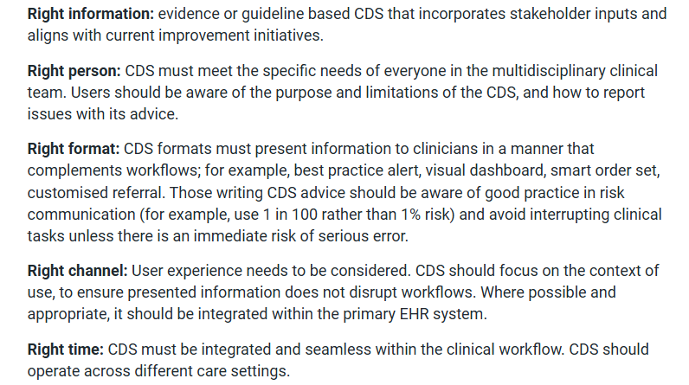
Image 1 illustrating the 5 rights as described by NHS England (2023)

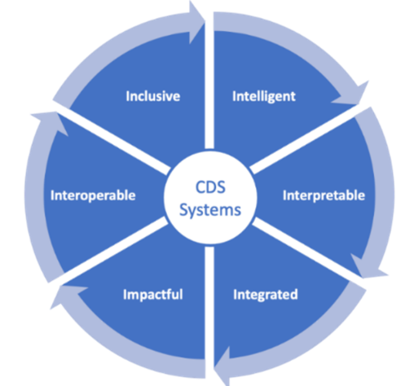
Image 2 illustrating the 6i model as described by NHS England (2023)

When applied to the system, the 6i model would be represented as follows:
Inclusive- can be applied to multiple roles (Doctors/nurses/pharmacists) and multiple specialities (medicine/surgery/paediatrics/critical care/mental health), rather than focused on one target group/speciality.
Intelligent- targeted with its messages, high severity, critical alerts (for high-risk medicines/drug-drug interactions/allergies) being prioritised to display ahead of lower severity alerts.
Interpretable- clear alerts in appropriate language for the clinical audience (clinical language rather than technical).
Integrated- warning alerts appearing during the prescribing process, not after the incorrect prescribing has occurred. Alerts focused on nurses should be visible on the medication administration record where they are easily viewed.
Impactful- the system should improve clinical care, reduce medication prescribing and administration errors, and should be easily auditable as proof of improvements.
Interoperable- the system should integrate seamlessly with other clinical systems to reduce duplication and enhance user experience, for example, by enabling ePMA access to pathology results and the bidirectional sharing of allergy information to support accurate clinical decision-making.
These models illustrate that the efficacy of CDSS is not solely dependent on the presence of alerts, but rather on how information is communicated to the relevant user at the most opportune time. This reinforces the claim that the system's design and its incorporation into workflows are crucial for achieving improvements in safety.
The practice of prescribing and administering medications on paper persists to varying degrees throughout the United Kingdom (UK). The UK Government had pledged to eradicate paper-based prescribing in hospitals and to implement digital prescribing across the National Health Service (NHS) by the year 2024. However, a Special Report rated the initiative as inadequate, highlighting significant disparities in digital maturity among NHS Trusts, leading the Government to acknowledge that they would not achieve the target they set (The Health and Social Care Committee, 2023).
Williams et al., (2022) acknowledge that global health system priorities involve the transition from paper-based processes to digital systems, asserting that this shift will enhance the modernisation, efficiency, and safety of healthcare.
Though global and government priorities, transitioning to digital prescribing and medication administration requires more than a policy pledge; it also depends on socio-organisational factors, including digital maturity and readiness for change.
Benefits of electronic prescribing include the elimination of prescription illegibility, enhancement of pharmacy efficiency, reduction in adverse drug reactions, and the encouragement of formulary adherence by prescribers. Furthermore, electronic prescribing systems that incorporate CDSS are generally considered to be of higher quality than those without (Aluga et al., 2021).
This assignment will critically evaluate the effectiveness, limitations, and implementation challenges of CDSS within ePMA systems

Evidence review
A comprehensive literature review was conducted to investigate the application of CDSS in ePMA, assessing the available evidence on the subject which incorporated both scholarly (academic) and grey literature sources. It is important to emphasise the distinctions between these categories of literature and to recognise the value that each contributes to the discourse.
Massachusetts College of Pharmacy and Health Sciences, (2025) outlines scholarly literature as encompassing peer-reviewed articles, systematic reviews, meta-analyses, and empirical studies; each of these adheres to a structured academic format and are authored by individuals recognised as 'experts' in their respective fields.
Grey literature refers to materials that have not been formally published and exist outside the realm of academic publishers; examples include government reports, unpublished clinical trials, and dissertations. While generally regarded as less prestigious than publications in peer-reviewed journals, it is acknowledged that when synthesising evidence, it is crucial to consider all available evidence (Massachusetts College of Pharmacy and Health Sciences, 2025).
Divergent perspectives exist regarding the potential for bias in grey literature. According to NHS England, (2023a) both grey and scholarly literature can be equally susceptible to bias. In contrast, Olandzobo, (2024) argues that grey literature is less prone to bias due to the absence of publication bias. Aston University, (2025) recommends exercising caution in the evaluation of grey literature, suggesting that individuals must consider whether the authors have affiliations with organisations that could influence their perspectives.
The year 2020 was selected as the initial point for incorporating time span reviews, with the intention of highlighting and evaluating the most recent advancements in the domain of these systems. It was anticipated that publications released prior to this year would be limited in number and potentially outdated. The Preferred Reporting Items for Systematic reviews and Meta-Analyses (PRISMA) flow diagram was used to facilitate the identification and selection of relevant literature (Page et al., 2021) (image 3).
An initial database search yielded a total of 239 scholarly articles and 13 sources of grey literature. Navigating through the PRISMA methodology, 224 studies were excluded following screening, and 15 studies were deemed suitable for inclusion (comprising of 9 scholarly and 6 grey literature sources).

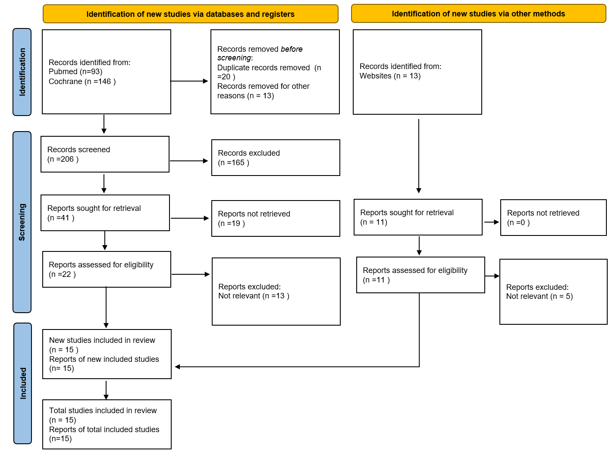
Image 3 PRISMA 2020 flow diagram for the conducted literature search (Page et al., 2021).

A review of the screened literature uncovered several recurring themes associated with the system; these themes will be explored through a thematic analysis and evaluated to highlight both analogous and divergent perspectives.
Reduction in medication errors/improving medication safety- the emerging consensus within the literature indicates that the systems have the potential to improve these outcomes, although it generally avoids claiming that this is guaranteed. Ruutiainen et al., (2024) reviewed 17 studies in their systematic review, finding that 8 of these reported a statistically significant reduction in paediatric dose errors when using these systems, however, this statistic lacks significance due to the methodology and results reporting variability across the studies.
Likewise, Taheri Moghadam et al., (2021) present a similar viewpoint based on the studies they reviewed, highlighting a positive correlation between the adoption of this system and a reduction in inappropriate prescribing. However, they failed to specify the exact number of the 45 studies they analysed that exhibited these enhancements, which leaves the audience unclear about the importance of their conclusions.
In a similar vein, Dahmke et al., (2024) reported that their system led to a reduction in the instances of duplicate anticoagulant prescriptions. This reduction was approximately 30%, indicating partial effectiveness of the system, however the continued occurrences of duplicate prescribing illustrate that CDSS alone is insufficient to eradicate all instances.
Corny et al., (2020) created a hybrid system that combined machine learning techniques with rule-based indicators to detect medication errors. Their aim was to demonstrate the system's efficacy through a retrospective evaluation study. The findings indicated improved identification of high-risk prescriptions, enabling pharmacists to prioritise their reviews more effectively. Although the study suggested that the system could help in mitigating medication errors, it did not provide a quantifiable measure of the actual reduction in errors following its implementation. As a result, claims of a threefold improvement in the efficiency and productivity of hospital medication reviews, along with increased patient safety, remain largely speculative. There is no direct evidence demonstrating a measurable reduction in medication errors attributable to the system.
Health Technology Wales, (2023) presented a summary of the clinical effectiveness of the system in their Topic Exploration Report, which is based on analysed systematic reviews and meta-analyses. The findings regarding its effect on medication errors are inconclusive. Nevertheless, some evidence was identified that suggests a reduction in medication administration errors. While this report can be considered a reliable source from a reputable organisation, its significance cannot be equated with that of peer-reviewed literature. The report does not introduce any new data to the audience and acknowledges several limitations in its data, including the heterogeneity of evidence and data collected from outside the UK.
Throughout the body of literature, no research conclusively shows the total eradication of medication errors. Phrases like "a substantial reduction" or "notable enhancement" can foster unrealistic anticipations regarding the system's effectiveness. Nevertheless, the data presented indicates that claims on the system's ability to reduce medication errors and improve medication safety should be approached with scepticism. A prevailing sentiment of cautious optimism exists concerning the system, acknowledging its capacity to lower medication error rates, while also emphasising the significance of system design and human elements as critical determinants of success.
Improved prescriber adherence/reducing alert fatigue- a recurring theme within the literature is the necessity of balancing the efficacy of alerts with the potential burden these notifications may impose on healthcare professionals. In their research, Sundermann et al., (2024) modified interruptive alerts concerning duplicate antithrombotic medications; they eliminated stat doses from activating the duplication alert, leading to a 29% decrease in alerts transmitted to the clinician.
By decreasing the frequency of alerts, the authors expressed their satisfaction in having effectively reduced the alert burden. However, this assertion seems premature as there is a lack of any referenced formal evaluation method, nor is there any inquiry aimed at the clinicians involved. The study does not provide sufficient evidence to refute that this conclusion is based on the authors' assumptions rather than on data derived from empirical research. They did provide statistics regarding the reduction in duplicate therapies, suggesting an improvement in prescriber compliance with alerts; nonetheless, many alerts remained unheeded without any exploration into the reasons behind this.
Similarly, Smith et al., (2024) employed a user-centred methodology to develop alerts for oral anticoagulation. Marketed as 'just in time' alerts, the notifications were presented when a prescriber activated an alert regarding inappropriate prescribing, emphasising the prescriber's response to that alert. Their study found that 34% of prescribers in the pilot responded to the alert and accordingly adjusted the prescription. This, however, also highlights that 66% of prescribers did not alter their practice despite being presented with an alert indicating a possible error. This ambiguity prevents determination of whether alerts were ignored or appropriately overridden. This distinction would have strengthened their case for promoting CDSS as improving prescriber adherence/reducing alert fatigue.
Russ-Jara et al., (2023), through their cognitive task analysis research, present limited evidence on how to improve prescriber adherence or reduce alert fatigue. The small sample size of 20 clinicians, along with incidents mainly documented from outpatient departments, constitutes a minor portion of the workforce and does not sufficiently evaluate the effectiveness of CDSS. The interviews with staff were conducted retrospectively, which may lead to unreliable recollections of incidents and introduces potential bias. Importantly, 52% of the drug-drug interactions identified during the study were recognised after alerts; however, this result was not highlighted by the authors, thereby failing to emphasise the benefits offered by the system. Their suggestions for significant additions to the alert text presented to users could unintentionally increase cognitive load and exacerbate alert fatigue, thus illustrating the challenges associated with designing CDSS aimed at reducing clinician workload.
A further study conducted by Weir et al., (2024) sought to enhance prescriber adherence and reduce alert fatigue. They integrated a digital and behavioural intervention for antimicrobial stewardship into the system, providing guidance and prompts to foster appropriate antibiotic usage in hospitals. However, the uptake among prescribers for utilising this system was notably low, with usage recorded at less than 5% of admissions. This limited engagement significantly hampers any substantial evaluation of adherence or alert fatigue, making it impossible to draw effective conclusions.
Listing alert fatigue as a challenge to implementation (The EPMA Hub, 2025a), this grey literature source did not provide any solutions to address this acknowledged issue; it simply recognises its presence. Although it is praiseworthy to identify this as a challenge for consideration, it does not deliver any substantial advantage to the reader or contribute to strategies for reducing system alert fatigue.
Generally, while strategies like reducing alert frequency and improving alert design are frequently recommended to improve prescriber adherence/ reduce alert fatigue, the presented evidence remains inconclusive. The critiqued studies suggest a reduction in alert volume or some improvements in prescribing practices; however, methodological shortcomings and low rates of adoption prevent the establishment of robust evidence for this.
Improved patient outcomes- measuring improved patient outcomes can be difficult to quantify, outcomes can rarely be attributed to a single intervention. Loh et al., (2025) in their study, evaluated the completion rates of venous thromboembolism (VTE) risk assessments before and after the implementation of CDSS and notably observed a significant increase in compliance following the addition of this. This can be regarded as a positive outcome for patients; the heightened uptake of VTE assessment completion facilitates a timelier prescription of VTE prophylaxis. However, the measurement of improved patient outcomes is limited by the absence of direct clinical patient outcomes, such as the recorded incidences of diagnosed VTEs - this has been identified as a potential area for future investigation.
One of the chosen grey literature sources cited CDSS ‘improves patient outcomes’ but did not provide an explanation regarding how it would achieve this. It only implied that by addressing user requirements, considering clinical workflows, and prioritising patient safety during the implementation of the system, patient outcomes could ultimately be improved (nhs.uk, 2023). This assertion lacks any cited evidence and does not specify the expected improvements, thus limiting its contribution to the discussion around the effectiveness of the system on patient outcomes as minimal and constrained. Consequently, its contribution to the discussion of system effectiveness is minimal and constrained, highlighting the limitations of relying on grey literature alone.
The EPMA Hub, (2025b), identified as grey literature source and referred to as a ‘digital pharmacy knowledge base’, offers a programme of learning on CDSS in ePMA within their website. The course offers a wealth of information on the topic, including key takeaway messages such as ‘Clinical Decision Support saves lives when used thoughtfully. Real-world use cases show that well-integrated, evidence-based CDSS can prevent harm, reduce variation, and improve prescribing safety, especially when it works with the clinical workflow, not against it’. While this recognises a practical concern for clinicians, the source fails to offer references or data to strengthen its assertions, limiting its validity.
Consequently, reliance on grey literature to support assertions regarding system efficacy is inherently limited. While these sources are useful for contextualising the challenges of implementation, they cannot replace peer-reviewed studies in evaluating the impact of the system on improving medication safety/reducing medication errors, improving prescriber adherence/reducing alert fatigue, or improving patient outcomes.
Lorenc et al., (2022) conducted a theoretical examination of the system, explicitly stating that they do not assert any enhancements in prescriber adherence or patient outcomes, nor do they suggest that there will be a decrease in medication errors or alert fatigue. They emphasise that the system has the potential to yield improvements in practice, but this is contingent upon meticulous planning and management. This reinforces the notion that positive outcomes are not intrinsic to the technology but are dependent on socio-technical factors, including system configuration, organisational support, and user engagement
In relation to the academic literature examined, although the studies reviewed generally present positive evidence supporting the effectiveness of this system, it is essential to recognise their limitations. Common limitations include weaknesses in their design, small or unrepresentative sample sizes, challenges with generalisability, and the potential for reporting bias. Several of the analysed studies (Dahmke et al., 2024, Sundermann et al., 2024, Loh et al., 2025) utilise retrospective designs, analysing historical data rather than current, real-time findings. While these studies provide valuable insights into the system's effectiveness, the results cannot always be considered reliable. There is no guarantee that the outcomes were exclusively due to the intervention, which restricts their ability to deliver conclusive evidence regarding the system's effectiveness and any improved patient outcomes.

Implementation issues
‘The potential of CDSS to transform healthcare is significant, but the challenges to their adoption and optimisation are substantial’ (Chen et al., 2023). As previously alluded to during the critical literature review, the system possesses the capability to enhance medication safety and lead to better outcomes for patients; however, this potential is subject to the configuration of the system and the acceptance by users.
The primary danger associated with the deployment of CDSS is the risk of clinicians becoming overly reliant on it.
Dzhezhora, (2023) presents a compelling argument on this issue, asserting that “blind acceptance can be dangerous not only for patients but also for clinicians and their skills.” This highlights how excessive reliance on clinical systems may lead to adverse outcomes for both patients and healthcare professionals.
In the context of the system discussed here, prescribers may become overly accustomed to decision-support alerts for allergy information, resulting in reduced verification of recorded data or failure to confirm details directly with the patient. Such overreliance poses a significant risk to patient safety and overall wellbeing. Similarly, nurses may become overly dependent on system-displayed maximum dose warnings within a 24-hour period, which can undermine their confidence in administering doses that are clinically appropriate but nonetheless trigger automated alerts. This risk reinforces the notion that the system can inadvertently cause patient harm if professional judgement is not maintained.
Sutton et al., (2020) indicate that systems ought to be designed to support clinicians rather than being overly prescriptive or compromising their autonomy. To facilitate this process, an initial configuration of the system would be necessary, followed by regular evaluations after implementation to ensure that the system continues to fulfil the users' needs, with mechanisms established for clinicians to propose changes aimed at system improvement. Regular prompts to users to persist in exercising their clinical judgment may also be advantageous to the initiative; it is essential to remind them that their clinical judgment should not be supplanted by the system.
On a similar theme, and drawing on their qualitative findings, Ash et al., (2007) highlight alert fatigue to be one of the biggest challenges users face with the system. This phenomenon is defined as the situation in which system alerts require an inordinate amount of time and cognitive effort, often resulting in clinicians becoming desensitised and dismissing relevant alerts alongside those that are clinically insignificant. Consequently, healthcare practitioners may exhibit diminished vigilance towards critical alerts, which in turn heightens the likelihood of medication errors (Wan et al., 2020).
Mitigations aimed at alleviating this burden may encompass the examination of overrides and their underlying reasons, the development of strategies to enhance alert specificity, and the exploration of personalised alert customisation (Légat et al., 2018). Additional research on this topic would be beneficial in assessing whether any evidence exists to successfully address this phenomenon; reducing this issue for clinicians could significantly impact patient safety outcomes.
Maintaining compliance with local practice regulations and organisational policies necessitates ongoing monitoring and governance. Conflicts may arise when system alerts contradict established organisational policies or local medication practices. Additionally, the presence of extra local security measures can hinder the efficient use of the system (Olakotan and Mohd Yusof, 2021).
A recent example from clinical practice was a case where the system did not mandate a witness for a pair of medications which, prior to the advent of the digital system, would have required verification and signatures from two staff. A review of the medication policy and examination of further guidance confirmed that the system configuration was accurate, however, the long-standing local practices were not aligned with this. This scenario acted as an educational update for numerous staff members, all of whom questioned the system configuration, all have subsequently been assured that this reflects appropriate practice.
Such situations underscore the significance of appointed 'business as usual' team members responsible for ongoing system monitoring, configuration evaluation, and maintenance. This encompasses the management of updates to reference data sets, including the NHS dictionary of medicines and devices (dm+d), which would frequently require configuration modifications within the system. Without these frameworks in place, system configuration and alignment to current policy would become outdated, posing a risk to patient safety and resulting in adverse outcomes for both healthcare staff and patients.
Disruption to workflow represents an inherent risk associated with the system and may act as a potential barrier to successful implementation (Fletcher et al., 2023). Salwei et al., (2021) suggest these difficulties can arise from poor usability and a lack of sufficient integration of these technologies into existing clinical workflows. These constraints can adversely affect the potential improvements in patient safety that could be realised through suitable integration. To mitigate against the risk of disruptive workflows it would be prudent to engage with clinicians during the pre-implementation phase, to become familiar with workflows, and to build as-is/to-be process maps to facilitate visualisation of tasks and processes.
The introduction of low-quality data into the system poses an additional threat to its seamless operation. In practice, legacy data issues can be exacerbated by digital integration. To cite an example within a local Health Board currently implementing ePMA, historic duplication of case record numbers (CRNs), arising from the amalgamation of multiple trusts, has persisted as a known corporate risk for several years. While previously regarded as an operational inconvenience, the introduction of ePMA has amplified the associated risks.
Specifically, integration messages transmitted from the Emergency Department to the ePMA system can inadvertently generate multiple encounters and medication charts for a single patient, with prescriptions recorded across separate records. This fragmentation of medication information increases the risk of missed doses, duplicate administrations, and prescribing errors, thereby posing a significant patient safety concern.
This example illustrates how unresolved data quality issues can undermine the effectiveness of decision support and introduce new safety risks during ePMA implementation. Such risks could have been mitigated through comprehensive data cleansing and robust testing cycles prior to system go-live; however, responsibility for undertaking a data cleanse had not been formally accepted by the Health Board, despite the issue having been raised on multiple occasions historically.

Evaluation
Evaluating the system requires a multidimensional approach, meaningful evaluation can capture the genuine insight into how the system functions in clinical environments. It is crucial to recognise the presence of various user groups, each engaging with the system in unique manners and prioritising different goals. For a clinician (a user of the system), the emphasis may be on the system's usability and its unobtrusiveness in their workflows. Conversely, for a patient (a recipient of the system), their foremost concern may be the safe and timely delivery of the correct medication.
Assessment of the user experience would form an essential component of an evaluation. Potential assessment strategies may encompass user surveys and structured questionnaires to aid capture of usability. These methods could be further enhanced by incorporating qualitative methods such as interviews and lessons learned groups. Stoumpos, Kitsios and Talias, (2023) argue that when systems disrupt clinical workflows, clinicians may develop workarounds that compromise patient care. This reinforces the perspective that the success of a system is influenced not solely by technical elements, but also by behavioural and socio-technical interactions. The socio-technical framework perceives healthcare technologies as embedded within a network comprising human, technical, task-related, and organisational systems, recognising that outcomes emerge from their interaction rather than from technology in seclusion. (Partanen et al., 2023)
Consequently, it is beneficial to thoroughly investigate clinician feedback and collect evidence for prospective system modifications and enhancements. Clinician feedback can be obtained through both quantitative and qualitative approaches, allowing for triangulation, with qualitative data providing the in-depth and nuanced insights into practical system use (Pyo et al., 2023). Incorporating quantitative metrics alongside clinician feedback guarantees that assessments reflect real-world efficacy, directly supporting the assertion that enhancements in CDSS depend on both system functionality and human elements.
To assess the safety and effectiveness of the system, it is crucial to conduct a thorough data collection to provide the requisite evidence. Relevant metrics may include statistics obtained directly from system reporting tools, such as the frequency of system alert overrides, the count of missed medication administrations, and the adherence of prescribers to CDSS recommendations.
After the data has been collected, it may be wise to integrate these quantitative figures with qualitative feedback to ascertain whether elevated override rates indicate irrelevant alerts being presented, sound clinical judgment, or insufficient clinician engagement and consideration of the system's recommendations. Alongside these interventions, safety could also be assessed comparing incident reporting pre and post system implementation; viewing the incidents categorised under the categories of medication and prescribing errors and the number attributed to the system.
Assessment of system efficiency would include detailed examination of clinical workflows. Time and motion studies to measure medication round durations, prescribing time, and the number of interruptive alerts encountered during an act of prescribing are all workflows that could be measured to prove any actual vs perceived inefficiencies. These metrics would be most insightful if compared to the baseline data collected prior to system implementation. In addition to the quantitative data obtained, it would be prudent to consider gathering clinician experience alongside this, to aid the capture of inefficiencies not apparent through the recording of numerical data alone. This mixed-methods strategy facilitates a deeper comprehension of the impact of CDSS on efficiency within actual clinical settings, particularly pertinent regarding alert fatigue and prescriber adherence.

Conclusion
Clinical decision support systems that are integrated into electronic prescribing and medication administration systems are often depicted as revolutionary instruments for enhancing medication safety. The evidence examined indicates consistent decreases in prescribing mistakes, duplicate therapies, and better adherence to clinical guidelines. Nevertheless, these enhancements require careful interpretation. This reinforces the earlier observation that error reduction remains partial rather than absolute and many assertions of ‘significant’ reductions stem from retrospective studies, varied outcome measures, and small or context-specific samples.
Although CDSS seems to have the potential to reduce risk, the existing evidence does not support claims of lasting or definitive improvements in patient safety. Crucially, enhancements in process indicators, such as alert response rates or compliance with documentation, cannot be assumed to lead to better patient-centred outcomes. Direct assessments of morbidity, mortality, and long-term harm reduction are still limited.
Additionally, challenges in implementation, including alert fatigue, disruptions in workflow, misalignment in governance, issues with data quality, and overreliance by clinicians, illustrate that the effectiveness of CDSS is fundamentally socio-technical rather than merely technological.
Overall, the current body of literature supports a stance of cautious optimism regarding the use of Clinical Decision Support Systems in electronic Prescribing and Medicines Administration systems. These systems possess the capability to reduce prescribing errors, avert duplicate therapies, and promote adherence to clinical guidelines; however, the enhancements noted are more gradual than conclusive, and their effectiveness is fundamentally socio-technical, shaped by system design, organisational context, and human behaviour.
As a result, CDSS ought to be regarded as a conditional safety intervention, with its main value lying in risk mitigation rather than the total elimination of risk. The existing evidence base exhibits considerable limitations. Most studies are retrospective, context-dependent, or limited by small sample sizes, and there is a notable absence of direct assessments of patient-centred outcomes, long-term clinical benefits, and sustained safety improvements.
Future research should prioritise prospective, controlled, multi-centre, and patient-centred studies to provide more substantial causal evidence, clarify the impacts on long-term patient outcomes, and identify strategies for optimising system implementation and clinician engagement. By addressing these shortcomings, a clearer understanding of how CDSS can consistently enhance medication safety and support clinical decision-making in practice will be attained.
I confirm this essay is my own original work and does not include text generated by a generative artificial intelligence tool.

References

Acosta-García, H. et al. (2022) “Computerized clinical decision support systems for prescribing in primary care: main characteristics and implementation impact—protocol of an evidence and gap map,” Systematic Reviews 2022 11:1, 11(1), pp. 283-. Available at: https://doi.org/10.1186/S13643-022-02161-6.
Aluga, D. et al. (2021) “Effect of Electronic Prescribing Compared to Paper-Based (Handwritten) Prescribing on Primary Medication Adherence in an Outpatient Setting: A Systematic Review,” Applied Clinical Informatics, 12(4), p. 845. Available at: https://doi.org/10.1055/S-0041-1735182.
Armando, L.G. et al. (2023) “Clinical decision support systems to improve drug prescription and therapy optimisation in clinical practice: a scoping review,” BMJ Health & Care Informatics, 30(1). Available at: https://doi.org/10.1136/BMJHCI-2022-100683.
Ash, J.S. et al. (2007) “Some Unintended Consequences of Clinical Decision Support Systems,” AMIA Annual Symposium Proceedings, 2007, p. 26. Available at: https://pmc.ncbi.nlm.nih.gov/articles/PMC2813668/ (Accessed: February 2, 2026).
Aston University (2025) Grey literature - Computer Science, Cyber Security, Data Science and AI - LibGuides at Aston University. Available at: https://libguides.aston.ac.uk/c.php?g=99973&p=5274186 (Accessed: February 13, 2026).
Chen, Z. et al. (2023) “Harnessing the power of clinical decision support systems: challenges and opportunities,” Open Heart, 10(2), p. 2432. Available at: https://doi.org/10.1136/OPENHRT-2023-002432.
Corny, J. et al. (2020) “A machine learning–based clinical decision support system to identify prescriptions with a high risk of medication error,” Journal of the American Medical Informatics Association, 27(11), pp. 1688–1694. Available at: https://doi.org/10.1093/JAMIA/OCAA154.
Dahmke, H. et al. (2024) “Development and validation of a clinical decision support system to prevent anticoagulant duplications,” International Journal of Medical Informatics, 187, p. 105446. Available at: https://doi.org/10.1016/J.IJMEDINF.2024.105446.
Dzhezhora, L. (2023) How to Facilitate Clinical Decision Support Software Adoption - Patient Safety & Quality Healthcare. Available at: https://www.psqh.com/analysis/how-to-facilitate-clinical-decision-support-software-adoption/ (Accessed: February 2, 2026).
Fletcher, E. et al. (2023) “Workload and workflow implications associated with the use of electronic clinical decision support tools used by health professionals in general practice: a scoping review,” BMC Primary Care 2023 24:1, 24(1), pp. 23-. Available at: https://doi.org/10.1186/s12875-023-01973-2.
Health Technology Wales (2023) Topic Exploration Report TER391 Electronic prescribing and medicines administration systems. Available at: https://healthtechnology.wales/wp-content/uploads/2023/02/TER391-EPMA-WEB.pdf (Accessed: January 1, 2026).
Jia, P. et al. (2016) “The effects of clinical decision support systems on medication safety: An overview,” PLoS ONE, 11(12). Available at: https://doi.org/10.1371/journal.pone.0167683.
Légat, L. et al. (2018) “Clinical decision support systems for drug allergy checking: Systematic review,” Journal of Medical Internet Research, 20(9), p. e8206. Available at: https://doi.org/10.2196/jmir.8206.
Loh, S. et al. (2025) “A clinical decision support tool for improving venous thromboembolism risk assessment and thromboprophylaxis prescribing compliance within an electronic medication management system: a retrospective observational study,” International Journal of Clinical Pharmacy, 47(3), pp. 699–707. Available at: https://doi.org/10.1007/S11096-024-01857-0.
Lorenc, T., Sowden, A. and Khouja, C. (2022) Electronic prescribing and Clinical Decision Support Underpinning theories . Available at: http://eppi.ioe.ac.uk/ (Accessed: January 1, 2026).
Massachusetts College of Pharmacy and Health Sciences (2025) Research Guides: Scholarly Literature Types: Scholarly Literature Types. Available at: https://mcphs.libguides.com/c.php?g=1147657&p=8377100 (Accessed: January 26, 2026).
NHS England (2023a) Grey literature | Knowledge and Library Services. Available at: https://library.hee.nhs.uk/learning-academy/learning-zone/grey-literature (Accessed: February 13, 2026).
NHS England (2023b) Supporting clinical decisions with health information technology. Available at: https://www.england.nhs.uk/long-read/supporting-clinical-decisions-with-health-information-technology/ (Accessed: December 6, 2025).
nhs.uk (2023) NHS England » Supporting clinical decisions with health information technology. Available at: https://www.england.nhs.uk/long-read/supporting-clinical-decisions-with-health-information-technology/ (Accessed: January 1, 2026).
Olakotan, O.O. and Mohd Yusof, M. (2021) “The appropriateness of clinical decision support systems alerts in supporting clinical workflows: A systematic review,” Health Informatics Journal, 27(2). Available at: https://doi.org/10.1177/14604582211007536.
Olandzobo, D. (2024) Using grey literature in your research: A short guide - Cranfield University Blogs. Available at: https://blogs.cranfield.ac.uk/library/grey-literature/ (Accessed: February 13, 2026).
Page, M.J. et al. (2021) “The PRISMA 2020 statement: an updated guideline for reporting systematic reviews,” BMJ, 372. Available at: https://doi.org/10.1136/BMJ.N71.
Partanen, T. et al. (2023) “Telerehabilitation in the Finnish Outpatient Rehabilitation Setting from the Perspective of the Socio-Technical Systems Theory,” International Journal of Environmental Research and Public Health 2023, Vol. 20, Page 6519, 20(15), p. 6519. Available at: https://doi.org/10.3390/ijerph20156519.
Pyo, J. et al. (2023) “Qualitative Research in Healthcare: Necessity and Characteristics,” Journal of Preventive Medicine and Public Health, 56(1), pp. 12–20. Available at: https://doi.org/10.3961/JPMPH.22.451.
Russ-Jara, A.L. et al. (2023) “Cognitive task analysis of clinicians’ drug–drug interaction management during patient care and implications for alert design,” BMJ Open, 13(12), p. e075512. Available at: https://doi.org/10.1136/BMJOPEN-2023-075512.
Ruutiainen, H. et al. (2024) “Use of Computerized Physician Order Entry with Clinical Decision Support to Prevent Dose Errors in Pediatric Medication Orders: A Systematic Review,” Pediatric Drugs, 26(2), pp. 127–143. Available at: https://doi.org/10.1007/S40272-023-00614-6.
Salwei, M.E. et al. (2021) “Workflow integration analysis of a human factors-based clinical decision support in the emergency department,” Applied Ergonomics, 97, p. 103498. Available at: https://doi.org/10.1016/j.apergo.2021.103498.
Smith, S.N. et al. (2024) “System-Wide, Electronic Health Record-Based Medication Alerts for Appropriate Prescribing of Direct Oral Anticoagulants: Pilot Randomized Controlled Trial.,” JMIR formative research, 8(1), p. e64674. Available at: https://doi.org/10.2196/64674.
Stoumpos, A.I., Kitsios, F. and Talias, M.A. (2023) “Digital Transformation in Healthcare: Technology Acceptance and Its Applications,” International Journal of Environmental Research and Public Health 2023, Vol. 20, Page 3407, 20(4), p. 3407. Available at: https://doi.org/10.3390/IJERPH20043407.
Sundermann, M. et al. (2024) “Optimising interruptive clinical decision support alerts for antithrombotic duplicate prescribing in hospital,” International Journal of Medical Informatics, 186, p. 105418. Available at: https://doi.org/10.1016/J.IJMEDINF.2024.105418.
Sutton, R.T. et al. (2020) “An overview of clinical decision support systems: benefits, risks, and strategies for success,” npj Digital Medicine 2020 3:1, 3(1), pp. 17-. Available at: https://doi.org/10.1038/s41746-020-0221-y.
Taheri Moghadam, S. et al. (2021) “The effects of clinical decision support system for prescribing medication on patient outcomes and physician practice performance: a systematic review and meta-analysis,” BMC Medical Informatics and Decision Making, 21(1). Available at: https://doi.org/10.1186/s12911-020-01376-8.
The EPMA Hub (2025a) Clinical Decision Support | The Epma Hub. Available at: https://www.epmahub.com/clinical-decision-support-1 (Accessed: January 1, 2026).
The EPMA Hub (2025b) Clinical Decision Support in EPMA: Safer Prescribing by Design | The Epma Hub. Available at: https://www.epmahub.com/challenge-page/aaf34f49-12e3-45a8-ac03-b9303a84619b (Accessed: January 1, 2026).
The Health and Social Care Committee (2023) House of Commons Health and Social Care Committee Government Response to the Health and Social Care Committee’s Expert Panel: Evaluation of Government’s commitments in the area of the pharmacy in England Thirteenth Special Report of Session 2022-23. Available at: www.parliament.uk/hsccom (Accessed: December 2, 2025).
Wan, P.K. et al. (2020) “Reducing Alert Fatigue by Sharing Low-Level Alerts with Patients and Enhancing Collaborative Decision Making Using Blockchain Technology: Scoping Review and Proposed Framework (MedAlert),” Journal of Medical Internet Research, 22(10), p. e22013. Available at: https://doi.org/10.2196/22013.
Weir, C.J. et al. (2024) “A complex ePrescribing antimicrobial stewardship-based (ePAMS+) intervention for hospitals: mixed-methods feasibility trial results,” BMC Medical Informatics and Decision Making 2024 24:1, 24(1), pp. 301-. Available at: https://doi.org/10.1186/S12911-024-02707-9.
Williams, J. et al. (2022) “Optimizing Hospital Electronic Prescribing Systems: A Systematic Scoping Review,” Journal of Patient Safety, 18(2), pp. E547–E562. Available at: https://doi.org/10.1097/PTS.0000000000000867.
Woosley, R.L. (2022) “Assisted prescribing: Clinical decision support with MedSafety Scan now available,” Trends in Cardiovascular Medicine, 32(1), pp. 44–49. Available at: https://doi.org/10.1016/J.TCM.2020.11.002.

