A working comparison of Warhol, Rider, Malanga, Rauschenberg and Kitching. Has technology impacted on the traditional processes of Print and Type?

Emily Pemberthy P146427
Submitted in partial fulfilment of the requirements
for the degree of BA (Hons) Graphic Design

University of Wales Trinity Saint David, Swansea

Word count

Table of Contents

Introduction…………………………………………………………………………………………………………………………3

Chapter 1

Screen Printing………………………………………………………………………………………………………...4
Letterpress……………………………………………………………………………………………………….........4
Artists –
Gerard Malanga……………………………………………………………………………………………………….5
Andy Warhol………………………………………………………………………………………………………......7
Robert Rauschenberg………………………………………………………………………………………………8
Alan Kitching………………………………………………………………………………………………………......8
Ben Rider………………………………………………………………………………………………………..........10

Chapter 2

Technology……………………………………………………………………………………………………….......11

Conclusion………………………………………………………………………………………………………....................13

Bibliography………………………………………………………………………………………………………..................14

Introduction

In this dissertation, I will be examining over the years, whilst technology has advanced, so have artists work due to new materials and equipment to persuade them into new ideas and creations. I decided to write about this topic because I am very passionate about print and the processes. It interests me how over the years, we only see these processes in colleges and universities. I will be examining artist’s work, and their outcome. I am going to show the difference from the work from the 60’s to this decade and how it has advanced with the new materials and better appliances. I will go into depth of the two print processes, and the brief history of them and where they were created.

My first chapter will be a broad range of print but firstly on the history of Screen-print, and the process on how to do the technique, with what materials and tools. I will then move onto the history and process of Letterpress and the equipment that is needed; a major development in this area to show the famous Johannes Gutenberg press. My chosen artists will begin with Gerard Malanga, a former assistant of Andy Warhol; He assisted Warhol with his screen-printing in the factory. Andy Warhol will be used to demonstrate the immediacy and creativity the lies behind the process of screen-printing; revolutionary his work pushed forward the use of screen-printing in the art world. From Warhol I will consider the work of Robert Rauschenberg who also worked with Andy Warhol using the same technique but experimenting in different ways and exploring with more materials. Alan Kitching the British ‘king’ of letterpress will be considered in terms of his work and what he has done. For my contemporary artist, I will be writing about Ben Rider, he uses screen-print for his pieces and explores with different methods within the screen-print process.

In my final chapter, I will be talking about how technology came about and has affected those who used the old print processes. How old machines worked and how new materials came about, and then altered old ways to new ways.

Chapter 1 – Print

Screen printing

Printing with stencils used to be a broadly used artistic movement in commercial practice in Japan and China, going as far back as 500.AD. This was at the same time as the Sung dynasty; the Japanese stencil printing was familiar as Kappazuri-e using complex paper stencil with delicate silk threads. The stencil layout was designed to print starch-resists onto materials which were then dyed, as the start of the pattern. Stencils were also occasionally used in conjunction with woodblock prints as a technique for printing coloured layers. Stencil printing finally found its way to Europe along trade routes. During the nineteenth and the twentieth century, an intricate method of printing called pochoir was introduced, which was stencil printing that was used broadly in Europe and in the United States of America for commercial reasons, specifically for book illustration and textile printing. The use of stronger stencils capable of printing hundreds of copies led to the practice of paper stencils fastened to frames, that were stretched with a fine-weave silk. Silkscreen operation was first patented in 1887 by Charles Nelson Jones in Michigan. (Fick et al: 2015)
Originally, inks were processed through silkscreen stencils with hard brushes. The introduction of the squeegee was revolutionary to screen printers, as the method of pushing ink through the mesh of the silkscreens gained huge potential to produce mass printing. Screen printing was essentially used for commercial applications. In the 1930’s screen-printing was used for fine art printing on paper, then in 1936 Anthony Velonis used screen-printing to print posters for the ‘Works Progress Administration’ (WPA), the biggest of the US New Deal plan during the Great Depression. Alongside support from WPA, Velonis set up a screen-printing studio that enabled artists work collaboratively with fellow designers and makers. These transactions spawned a wide interest in screen-printing as a fine art process, gaining respect as a genuine print process for fine artists in the USA and Europe. Besides the 1960’s Pop Art movement, screen-printing gained popularity as many artists including America’s Andy Warhol and Robert Rauschenburg, as well as Eduardo Paolozzi and Joe Tilson from the United Kingdom. Everyone engaged in the process of screen-printing as part of their artistic production. The artists, Eduardo Paolozzi and Richard Hamilton utilized screen-printing to employ a collage strategy, combinging photographic elements with hand drawn autographic stencils. (Fick et al: 2015)

Letterpress

Letterpress in a unique technical term for the process of printing text and images in relief, using a high type bed. The idea behind the process of relief printing started with the initial idea of using wooden blocks to carve individual letters to form structured words. This technique is thought to be invented as early as AD C. 200 in China, although, it is, Johannes Gutenburg from Germany who is mostly regarded as the pioneer of printing with reusable, moveable type. During the mid-fifteenth century, he invented a way to construct to replace handwritten type through the skill of calligraphy. The popular Gutenburg Bible was published in c. 1455 begun Gutenburgs moveable type machine, was a superior means of mass printing. Guttenberg was responsible for using the screw mechanism found in making wine and altering it to improve his first wooden hand press. The process put ink on the type surface, laying on paper and applying pressure using a padded surface to transfer the type onto paper. As time went by, presses that used a knuckle and lever mechanism were designed, and ink rollers came into the picture for use. The paper on these platen presses was still placed by hand but the rollers did the inking. As the ink had already been applied to the rollers, they would swing back and forth onto the inking plate to collect extra ink. While the platen was pressed onto the paper to create the print, the printed paper would then be removed from the press and replaced with a fresh sheet of paper, the action would be repeated for as many copies was needed.

The twentieth century came, and presses such as the Kluge and Heidelberg Windmill featured an automated feed and delivery system. Gutenberg’s press process remained constant for over three hundred years. The floor-standing hand-operated platen presses were direct offspring of the Gutenberg. Mid nineteenth century “the industrial revolution and improvements in engineering saw the creation of a huge number hand-presses”. These new presses tried to improve on the weighting and leverage needed to make an imprint, this process is still extensively used today by hobbyists, small stationary businesses and even through universities. Popular models involve the Chandler & Price and the Adana 8 x 5, the latter of which was created in England until 1999 (Rivers et al: 2010).

Coming to the end of the nineteenth century, full-sized platen presses, including the Chandler & Price and Golding Jobber, were still under the manufacturing process to be used throughout the twentieth century to print commercially. Throughout the years, the presses were modified and automatic feeds were added, the best common being Heidelberg Windmill press, which is still a popular automated press used by commercial letterpress printers today. By the 1930’s motorized flatbed cylinder presses such as the Heidelberg KSBA were becoming popular among commercial printers owing to their capability to handle big print runs (Rivers et al: 2010)

Artists

Gerard Malanga

According to Weathers (2010) Malanga helped Warhol for a mere $1.25 an hour at the age of 20, assisting him with his large silk screen paintings. A poet in his own right he was claimed to be the “the best American poet under 25 writing at that time” as stated by Daisy Alden and W.H Auden. (reference) Experienced in the literary field Malanga had spent time studying alongside Willard Maas, a poet at Wagner College, whilst also winning awards in competitions such as a poetry prize with Mount Holyoke College (reference). Progressing through the art field Malanga moved from poetry to screen printing to earn money. A figure of technological advancement, he developed quickly within his work, from cleaning screens to using newspaper pictures of accidents; some of these car crashes formed the basis for Warhol’s popular paintings at the time (reference). This was a time of progression within technology and the art field was evolving. Warhol moved quickly from paintings to film and Malanga alongside him, with this becoming the new focus of Warhol’s work, using his factory as a social space and the people within it, his new film-stars. Malanga was encouraged to be a part of this and between 1964-1966 they filmed 470 screen tests (reference). Art at the time was an ever-evolving field with creative expression now using many mediums and Malanga and Warhol in many ways developed together within this new technological advancement. (Weathers, 2010)

Malanga was a prominent force in developing pop culture and was responsible for making the famous factory, alongside Andy Warhol and Billy Linich. Together the team made many famous art pieces including the ‘Death & Disaster’ series and the well-known Marilyn’s. Known for his ‘radical self-expression’ (Faber, 2010), Malanga continued down this path creating films ‘Mary for Mary’, ‘Donovan meets Gerard’ and others in the same line. (Faber, 2010)

Whenever I do someone’s portrait I’m trying to locate the photo in the lens while recreating into that person psychologically. There the magic! I don’t always achieve it. It’s a hit or miss. The best way to accomplish this is to maintain a level of comfort at all times with the subject (Faber 2010).

Malanga utilised many techniques whilst photographing to ensure he didn’t simply get an exterior photo but instead took a more meaningful image that expressed their inner beauty, psychologically capturing their essence. A controversial photographer Malanga saw photography as a way inside the soul.

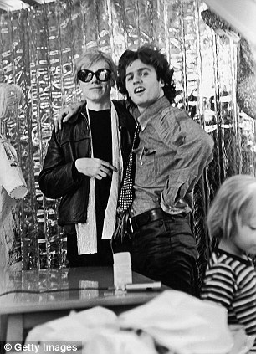
Figure 1: Levy. D & Scott-Clark. C., 2010.

Andy Warhol

Born in 1928 Warhol was a prominent figure in the Pop Art movement. An artist, producer and director, his work explored the influence of celebrity culture and its connection to advertising and artistic expression. His work was multi-disciplinary, experimenting first with painting and silkscreens (see figure 2 ‘Campbell’s Soup Cans) transgressing into film and photography in his later years (MoMA, n.d).

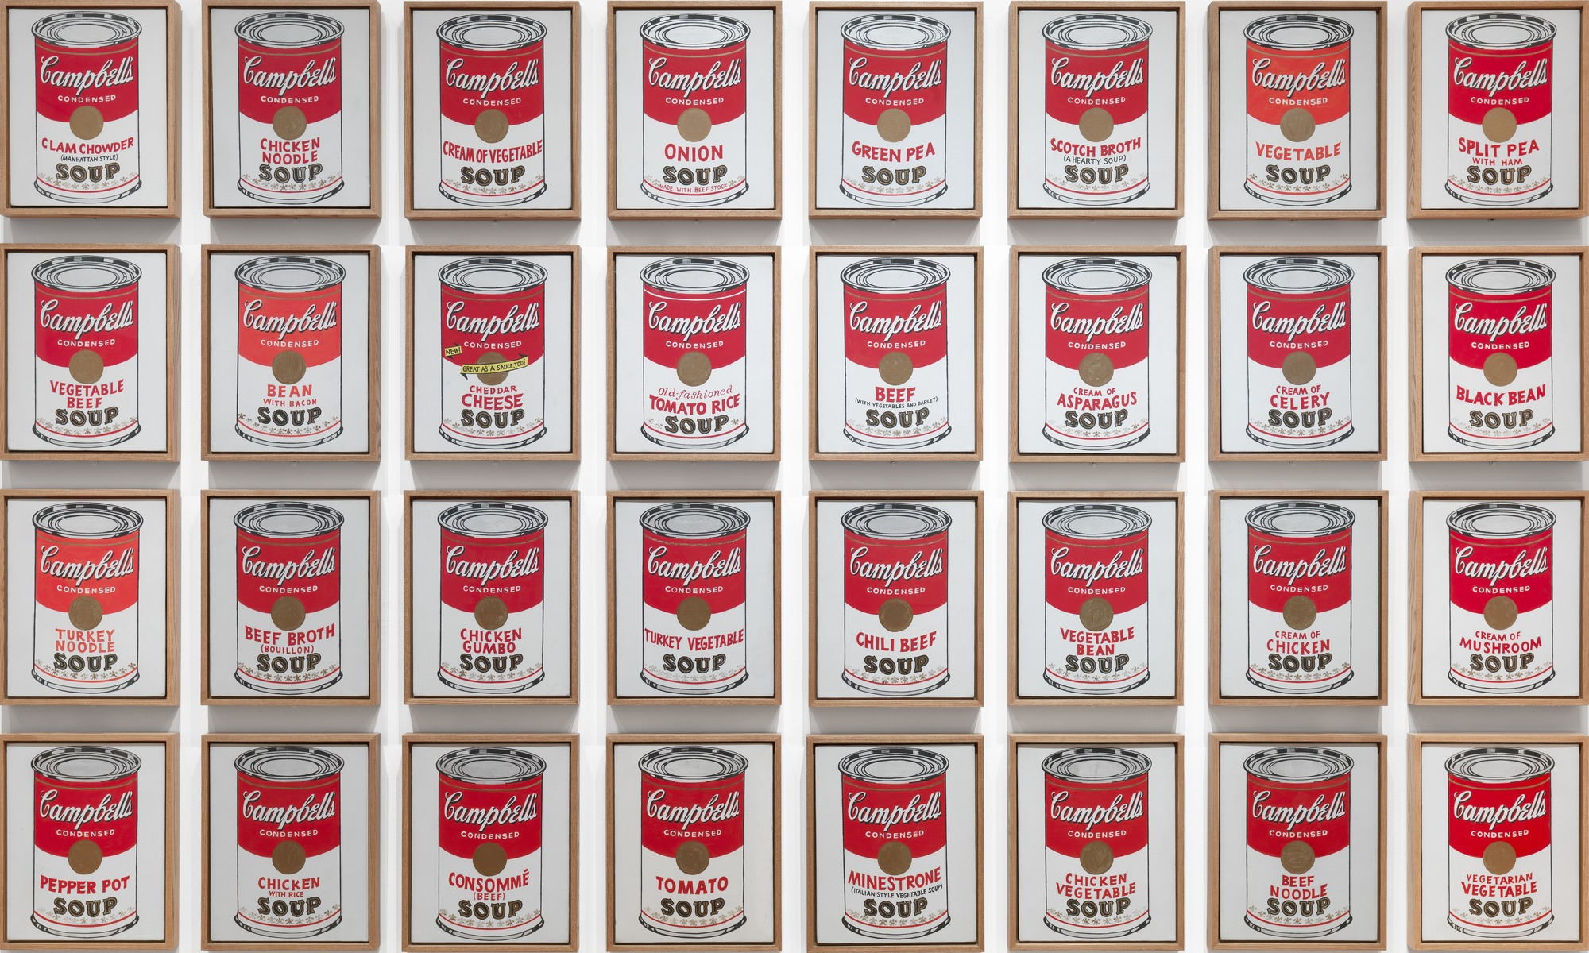
Figure 2: Warhol. A., Campbell’s Soup Cans. (1962)

Another of his famous pieces, the Marilyn Diptych.

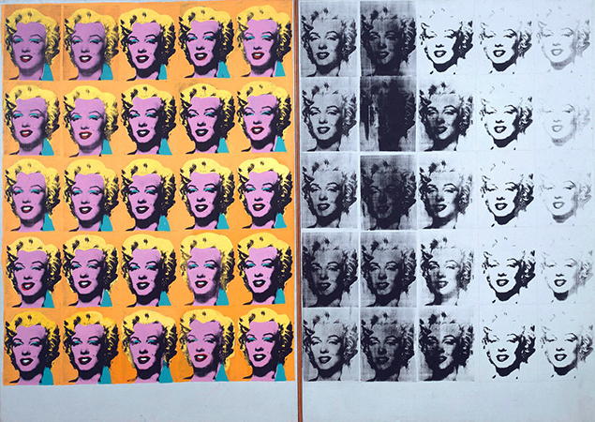
Figure 3: Warhol. A., Marilyn’s Diptych. (1962)

A commercial illustrator initially, Warhol became an influence when he opened his studio, The Factory In New York. This became an artistic hub, and where he made most of his art work. Artists became famous simply through association with Warhol; “Warhol promoted a selection of personalities known as Warhol’s superstars, and is accepted with coining the broadened used expression, ‘fifteen minutes of fame’ “. (TATE, n.d)
The Factory allowed Warhol’s celebrity influence to grow in addition to having the space to evolve his artwork throughout the years. A controversial artist, his work was primarily silk screened or hand painted when he initially entered the art world.

Robert Rauschenberg

Rauschenberg’s work has an important impact on several of the powerful changes in post war and American art, which brought endless blueprints for artistic modernisation by the younger generations to come. He avoided any form of categorisation as his artwork was exploratory and evolving. The National gallery of Australia has a very valuable selection of Rauschenberg’s work. The pieces held demonstrate how between the 60’s and 70’s his subject and use of material changed. Moving from a concentration on popular culture imagery, Rauschenberg started creating for the ‘handmade’ market, using only natural and sources found locally. His exhibition ‘Robert Rauschenberg 1967 – 1978’ brought his new aim into the foreground; “to drag ordinary materials into the art world for a direct confrontation” (Gallery of Works, 2007). Rauschenberg’s use of locally sourced material demonstrates his ability to make art from the environment around him. His lack of dependence on specific materials depicted him as a modern artist, evolving with his art form and becoming therefore an inspiration for artists to come.

Alan Kitching

Born in 1940, Alan Kitching is a British artist from Darlington. Kitching came into art in unusual circumstances. Despite a love for drawing, painting and printing he had to leave school at 14. Fortune shined upon him through and he gained employment as an apprentice in the school of art in Watford as a compositor, working under an experience printer. Kitching as a result progressed into a career in design working with software development, Graphic Design and Animation throughout his career.

In the world of letterpress, typography and print design Kitching is considered one of the world’s best. It is his use of letter forms, constructed from wood and metal, that he creates his visuals from, that he is most famous for, in addition to his unique prints. He has held his own solo shows in Barcelona and London and has donated pieces to a selection of exhibitions such as The Barbican Art Gallery in London and the Pompidou Centre in Paris. He became world designer for industry in 1994.

Kitching set up his own design practise in London, during 1973, in partnership, Derek Birdsall. At this time Kitching developed a serious interest in letterpress printing, mainly on the side but also occasionally for commissions. Before long, he began teaching typography at the royal college of art in London and he did that till the end of 2006. Kitching harshly stuck with wood and metal as his choice of material, producing graphic images considered extremely expressive by many and he became very talented in the way he used letters within his pieces, something that was with him to the end of his career. (Widewalls, n.d)

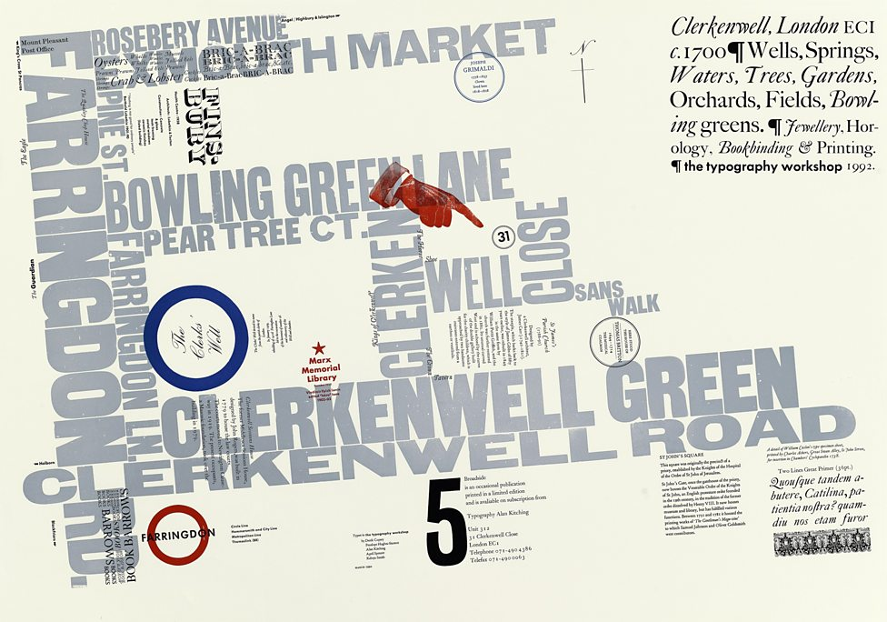
Figure 4: Kitching, A., Broadside No. 5. (1992)

The image above is one of Kitching’s earlier typographic maps, called the broadside series, an ad hoc publication dedicated to typographic arts, which indicated his return back to letterpress in the late 80’s and that was when he started to experiment with colours. Birdsall was a professor of graphics based in the royal college of art and persuaded Kitching to educate students in letterpress once weekly.

I didn’t want to do it but eventually I gave in so we went. In a way it was great, because they had all the printing gear. It soon came under threat from the rector though, who wanted to get rid of it all – take the college into the 21st century. But the students saved it (Muraben, 2016).

Kitching never had the intension of starting the letterpress class. He never thought it would go this far, it was something he simply enjoyed doing and the process of. Doing this, made him realise that the students had just as much of a passion for it as him.
Kitching began teaching workshops; he said he hadn’t told anyone about it, just produced the posters and put them up in the department. The Thursday coming, he goes in, there were students waiting for him and that’s how it all began. It got spoken about, made sure it was known everywhere, with baseline and creative review writing a piece on him. Without the students, the workshops would have ended. Letterpress and computers worked well together and they were achieving spotlight; Kitching’s popularity grew and in turn, the process of letterpress also. Kitching was able to maintain working with the college building a strong relationship up to 2006 and he continued his workshops up to this point, inclusive of the typographic workshop in Clerkenwell. Kitching interest did not solely lie in printing however and when entering the studio would state, “‘I’m not interested in letterpress printing, I’m interested in what you can do with this stuff.’ All this obsolete technology, what can we do new with it now” (Muraben, 2016).

Ben Rider

I feel it can really bring artwork alive. It is amazing what can be done with it and what it can do to your work, it’s like cooking with a microwave all your life then suddenly someone shows you a BBQ and loads of great marinades (Anon, 2014).

Ben Rider is an illustrator based in London, whose artwork has an edgy, punk feel to it. His process for creation involves starting with a collection of sketches, combined with imagery and layered colour. He has previously worked for many big companies such as the Victoria and Albert Museum, University of the Arts London, O2 Ireland, Samsung and Brew Dog. All his work is vibrant with bold black line work (Smith & Cooke et al: 2015). Riders work is colourful and eye-catching, considered inspirational through not only his imagery but by the influence of his colour palette also. Throughout his work his colours are never dull, always using a bright vibrant palette. Another piece of his work that can be considered in this way is Blisters: Sound Sessions.

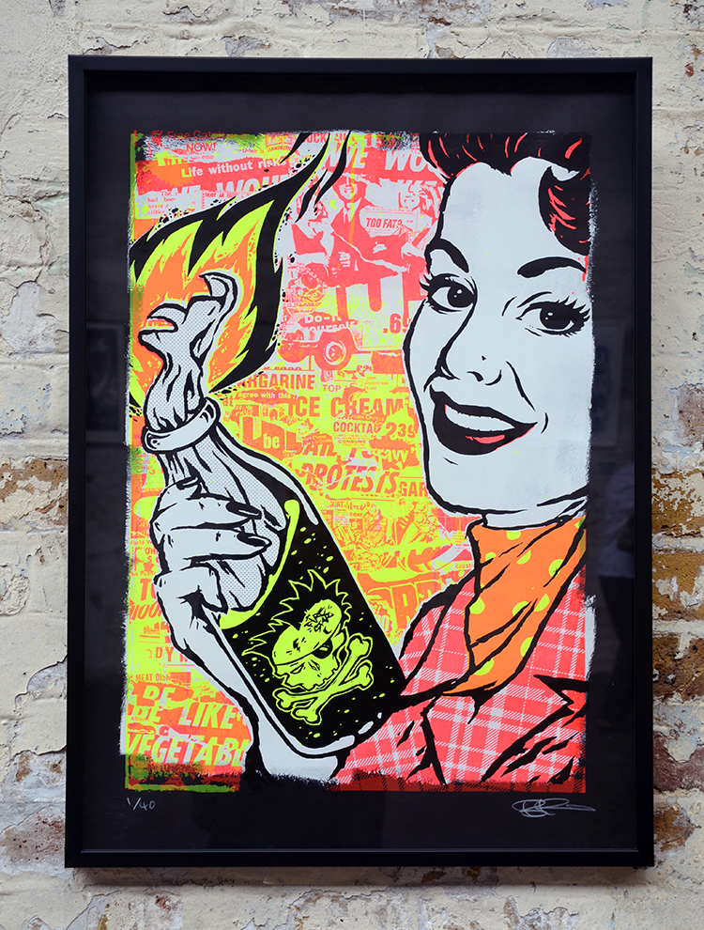
Figure 5: Rider, B., Blisters: Sound Sessions. (2014)

Rider had got black paper, and painted each one with a dirty roller with white paint. That would give it a rough edgy look when he applies the ink on top. He wanted to mix petrol with his mediums so during the exhibition he could set it alight and it would be scorched into the paper stock, but knew it would be a bad idea so he didn’t in the end. He set up a 3-layer print process, the red on the bottom so when the yellow would be printed over top it would make an orange, then finally a glossy black for the finishing touch.

Chapter 2 - Technology

Chester Calson first invented a dry printing process in 1938. It was called electrophotography; the laser printer was in development. In the 50’s, a high-speed printer was being developed to be used on the Univac computer created by Remington-Rand (Belvis, 2017).

Fine art prints, for most of their time were an independent art technique, created for collectors and experts whilst being published in limited editions. The twentieth century witnessed the progression of a public part for these prints, by taking up cheap techniques such as linocuts and lithographs made for public display; for those that were authorised by J. Lyons & Co. for their restaurants and great love for the ‘school prints’, during the 40’s and 50’s. In the 60’s and 70’s, it took a turn shown by the growth of print galleries such as Kelpra studio in the UK, and the Gemini GEL in the USA. This improvement inspired artists to seek the promising talents of printmaking and use it to make work that expressed large discoveries as visionary reports, putting print, undoubtedly for the first time, next to painting and sculpture as a sole means of expression. Rauschenberg and Warhol were renowned for silkscreen printmaking, from their exclusive pieces of work on canvas, ‘mixed’ with painting and centre pieces. (VAM. n.d).

(re write first pa

It will seem strange in an era of pushing buttons on a machine, screen printing was completed exclusively by hand just before the middle of this century. Whilst the turning presses of other graphic arts were spinning ahead at speeds of up to 10,000 impressions an hour, the screen printer continuously does 250 or more impressions an hour with a helper watching. Electrical screen presses had been working all the way since 1925, which was able to hit speeds of 1200 impressions an hour. The floor was mostly in the fact that the paints free at that time were not made to dry fast enough to hold up with the quick pace of the press. It will take several hours for the paint to dry and at times, overnight. Each individual print was placed on a rack, on its own shelf to be air dried. The request for quicker drying paints was requested by paint chemists, who were working firmly with press and drying experts; paints were then developed which dried in minutes plus the time could be cut down to seconds by using drying ovens. It has been said, it is doubtful that automatic presses will ever totally replace hand printing hand printing processing.

Though the popularity in mechanization is meant to continue, mainly in those areas of screen-printing where calibration is doable. Improvements have been made, in the progress of automatic screen-printing processes. There are machines on the market to meet the needs of the mixed requests in terms of fitness and nature of stock, size of printing surface, open floor space, and degree of mechanisation. The value of printing is higher than manual printing, with precision of register under endless mechanical control. Pressure is continued over the entire length of the squeegee. Larger models, holding these same features, are in stock. When it is about to complete its print, there are holes on the bottom of the bed that will have suction to keep the paper in place whilst it goes under the stencil, for the medium to then seep through by using the squeegee. The press will then continue with its cycle at a very fast pace. The print itself will travel through the machine in a straight line, starting at the feed-board, to then printing and then through to delivery at the end of the press. It will do up to 1800 impressions an hour. The general model 34, was created to print sheets up to the size of 24’ x 34’, doing 3500 impressions an hour. It is generated for precision printing on a small complex work, like greeting cards, decals, plastic sheet printing, foil printing and many more. Preparing is moderately easy with the process being accurate and automatic. (Biegeleisen, 1963)

(para can be added)

For those designers are used to using the mouse, a steamroller would be to much for them to jump straight onto. Every summer in Seattle, teams from different companies would come together, such as Amazon, Oracle, Starbucks, Facebook and a few other locals and artists would compete to steamroll a poster. Large pieces of linoleum were laid on the ground where they were painting ink by each respected team and pressed onto paper using a steamroller. The thinking behind this originated from Seattle School of Visual Concepts (SVC), and was aimed at attracting more students to the arts of letter press. During the 1980’s however, letterpress lost some of its appeal with companies moving to cheaper more efficient ways. It wasn’t till the turn of the millennium that this changed, with the price of the machine moving from $100 to $1000 in 2005; in contemporary society, a letterpress will cost $15,000 or more.

Beneath the old-timey patina of letterpress goods is a full-scale digital reinvention that drags Gutenberg’s great creation into the full embrace of modern technology (Fleishman, 2017).

It can be explained why letterpress looked to be at the end of its journey 30 years ago. Some would say that it was a fussy process, however with the fuss you also gained opportunity for artistic request. The first person to notice letterpress had faded was Martha Stewart and demanded a revival for it. Stewart’s lifestyle in the 90’s celebrated the handmade crafted appearance and impression of letterpress, particularly within invitation, with her outlets stocking relief prints, which are identified as debossing. In the 80’s letterpress ceased production as computers were introduced and many ends of type were simply thrown away.

In the twentieth century, the printing world went through a big change as it moved from a “handmade” market to a technical-lead profession. Whilst in the arranging room, there was a shift from a hand to a mechanical arrangement. Shortly after photo-arranging and digital meaning of letter assembly, the printers developed a move from letterpress to an offset lithography and finally digital methods of creation. Those three revolutions started with structural changes; those that had dealt with the process, moved out of the printing office and re-placed to trade typesetting. But printer focused on graphic copy and press work. Design was assumed by the professionals in typography working in secretive practice, even though it is distant from the printing office.

Conclusion

Overall, in this dissertation, I have learned the brief history of both the letterpress and screen-print processes and whom created the machinery and equipment. I have developed my knowledge upon the use of screen-printing and letterpress processes since looking into this field for my dissertation. I have gained varied knowledge of numerous artists, such as Warhol, and discovered their working process during the development of the process that they used. Further to looking at the processes behind letterpress and screen-printing, I have developed my understanding upon the amount of time that each process takes to develop, and the set up involved whilst using the Gutenberg press. I also looked at the consideration that must be taken when deciding the duration that is needed for screen-prints to dry, this is due to the use of old inks that were underdeveloped when in comparison to those of today. When comparing Warhol’s work to that of Rider, two artists both trained in the field of screen-printing, Warhol would create a piece of artwork with no original thought or process to what the final outcome would be. Whereas in comparison Rider’s work always had some form of meaning, even if it was a minute, and compared to Warhol he had a careful process in mind when thinking of his media outcome. When also comparing Kitching’s work to the previous, it was always clear to me that there was a defined purpose behind his pieces, be it for a project or a brief given to him by a company. However, to me there is more of a clear and obvious difference between Warhol and Rider’s work, due to the fact Rider would consistently use fluorescent colours and better inks compared to that of Warhol.

The digital age has also had many improvements over the years, such as the ones I have previously mentioned throughout this dissertation. I believe that today’s technology has vastly affected the print process in many ways due to the improvements that have been made with inks and paper stock, this is in turn due to the technological advances with equipment. I personal have come down to the conclusion that through the advances and ever changing times that letterpress has been greatly affected in comparison to that of screen-printing process. I believe this as letterpress was a fundamental aspect of the creation of books and many other products. I question whether in the years to come if these processes will become obsolete, and if that is to become the case the design industry, it will never be the same in my eyes, and that would be a great shame.

Images

Figure 1: Levy. D & Scott-Clark. C., 2010. Warhol and Gerard Malanga at The Factory in the Sixties heyday of the legendary studio. [Online]. Available at: http://www.dailymail.co.uk/home/moslive/article-1242915/When-Warhol-Warhol-The-2-million-self-portrait-turning-art-world-head.html (Accessed: 7 December 2017)

Figure 2: Warhol. A., 1962. Campbell’s Soup Cans. [Online]. Available at: https://www.moma.org/collection/works/79809 (Accessed: 13 November 2017)

Figure 3: Warhol. A., 1962. Marilyn’s Diptych. [Online]. Available at:
https://www.khanacademy.org/humanities/ap-art-history/later-europe-and-americas/modernity-ap/a/warhol-marilyn-diptych (Accessed: 13 November 2017)

Figure 4: Kitching, A., 1992. Broadside No. 5. [Online] Available at: http://www.thecounterpress.co.uk/journal/an-evening-in-mr-kitchings-london (Accessed: 25 November 2017)

Figure 5: Rider, B., 2014. Blisters: Sound Sessions. [Online] Available at: https://www.peopleofprint.com/best-of/blisters-2014-best-print-in-house-ben-rider/ (Accessed: 17 November 2017)

Bibliography

Books

Biegeleisen, J.I, 1963. The complete book of Screen-printing production. New York: Dover Publications

Faerna, J.M., 1997. Warhol. London: Harry N. Abrams

Fick, B., 2015. Printmaking, a complete guide to materials and processes. London: Laurence King

Madoff, S.H., 1977. Pop Art a Critical History. London: Berkley C.A.

Rivers, C., 2010. Reinventing letterpress: inspirational pieces by contemporary practitioners. Switzerland: RotoVison

Smith, M. & Cooke, A., 2015. People of Print. London: Thames & Hudson

Williamson, C., 2011. The little book of screenprinting. United States: Chronicle Books.

Websites

Anon. 2014. Blisters: Sound Sessions - Ben Rider. [Online] Available at: https://www.hungertv.com/feature/blisters-sounds-sessions-ben-rider/
[Accessed at: 17 November 2017]

BBC. 2016. Typecast: Alan Kitching on the art of letterpress. [Online] Available at: http://www.bbc.co.uk/programmes/articles/LKH84ry7v5zJWJHk3QDNyZ/typecast-alan-kitching-on-the-art-of-letterpress [Accessed 25 November 2017]

Debut Art. n.d. Alan Kitching. [Online] Available at: http://www.debutart.com/artist/alan-kitching [Accessed 25 November 2017]
Faber, G., 2010. Gerard Malanga’s Beautiful Soul [Online] Available at: http://www.dazeddigital.com/artsandculture/article/8186/1/gerard-malangas-beautiful-soul [Accessed 7 December 17]

Fleishman. G, 2017. How letterpress printing came back from the dead [Online] Available at: https://www.wired.com/story/how-letterpress-printing-came-back-from-the-dead/ [Accessed 10 December 2017].

Gallery of Works, 2007. Robert Rauschenberg
1967–1978 [Online] Available at: https://nga.gov.au/Rauschenberg/ [Accessed 9 December 2017].

Levy. D & Scott-Clark. C, 2010. When is a Warhol not a Warhol? The $2 million self-portrait turning the art world on its head [Online] Available at:
http://www.dailymail.co.uk/home/moslive/article-1242915/When-Warhol-Warhol-The-2-million-self-portrait-turning-art-world-head.html [Accessed 7 December 2017]

Macroy. 2014. Best print in house, Ben Rider. [Online] Available at: http://www.peopleofprint.com/best-of/blisters-2014-best-print-in-house-ben-rider/ [Accessed 17/11/17]

Muraben, B., 2016. It’s Nice That
https://www.itsnicethat.com/features/alan-kitching-life-in-letterpress-typography-300316 [Accessed 25/11/17]
MoMA, n.d. [Online] Available at: https://www.moma.org/learn/moma_learning/andy-warhol-campbells-soup-cans-1962 [Accessed 13/11/17]
National Print Museum, Dublin, 2017. [Online] Available at: http://www.heritagecouncil.ie/news/events/from-craft-to-technology-and-back-again-prints-progress-in-the-twentieth-century-conference-hosted-by-the-national-print-museum-30-31-march-2017 [Accessed 10 December 2017]
Ryan, T.R, n.d. [Online] available at: https://www.khanacademy.org/humanities/ap-art-history/later-europe-and-americas/modernity-ap/a/warhol-marilyn-dyptych [accessed 13 November 2017]
TATE, 2004. Robert Rauschenberg [Online] Available at: http://www.tate.org.uk/art/artworks/rauschenberg-almanac-t01135 [Accessed 9 December 2017]

Tate. n.d. Andy Warhol [Online] Available at: http://www.tate.org.uk/art/artists/andy-warhol-2121 [Accessed 30 October 2017]
The Guardian, 2002. [Online] Available at: https://www.theguardian.com/culture/2002/feb/06/artsfeatures.warhol [Accessed13 November 17]

VAM. n.d. Printmaking in the 21st Century. [Online] Available at: http://www.vam.ac.uk/content/articles/p/prints-21st-century/ [Accessed 30 October 17]

Walker, T. 2008. The Evolution of Print Technology: Then and Now. [Online] Available at: https://www.cartridgesave.co.uk/extract-from-alan-kitching-a-life-in-letterpress-by-john-l-walters/ [Accessed 10 December 2017]
Walters. J.L, 2016. Extract from Alan Kitching: A Life in Letterpress. [Online] Available at: https://www.creativereview.co.uk/extract-from-alan-kitching-a-life-in-letterpress-by-john-l-walters/ [Accessed 25 November 2017]

Weathers, C. 2010. Gerard Malanga’s Journey From Andy Warhol’s Stage Dancer To Factory Poet [Online] Available at: https://www.huffingtonpost.com/2010/08/04/gerard-malangas-journey-f_n_670629.html [Accessed 7 December 2017]
Widewalls. n.d. Alan Kitching. [Online] Available at:
https://www.widewalls.ch/artist/alan-kitching/ [Accessed 25 November 2017]

