

EXAMINATION OF THE IMPACT OF DIGITAL ADVERTISEMENT ON CUSTOMER BEHAVIOUR AND BRAND LOYALTY: AN ANALYSIS OF THE SMARTPHONE INDUSTRY

Student Name: Keval Hansraj Mange
Student ID: 2240155
Course: MBA- Marketing

Acknowledgment
I sincerely thank all the dedicated individuals who contributed to completing this study, “Examination of the Impact of Digital Advertisement on Customer Behaviour and Brand Loyalty: AN ANALYSIS OF THE SMARTPHONE INDUSTRY.” Firstly, I am immensely grateful to my mentors for their unwavering support, guidance, and resources. They patiently accompanied me and offered invaluable advice during the most challenging moments of my journey. Additionally, I would like to thank the participants who generously shared their insights and experiences. Your contributions were essential to this research, and I deeply appreciate your involvement.

Participation Consent Form
University of Wales Trinity Saint David (c


 | Participant Identification Number:
PARTICIPATION CONSENT FORM
(for researcher to fill)
Project Title:
Name of Researcher: Keval Hansraj Mange |  | Name of Supervisor: Tushara Balendren
Email of Researcher: _2240155@student.uwtsd.ac.uk
Aim of Research: The primary goal of study is to determine impact of digital advertisements on customer behaviour and brand loyalty on the smartphone industry.

(for participant to fill) |  |  |  |  | YES |  | NO
1 | I confirm that I have read and understood the information sheet dated 17/06/2024 for the above study.
2 | I understand there are no material benefits for participating.
2 | I have had the opportunity to consider the information, ask questions and have had these answered satisfactorily.
3 | I understand that my participation is voluntary and that I am free to withdraw at any time, without giving any reason.
4 | I understand that any information given by me may be used in future reports, articles or presentations by the researcher.
5 | I consent for my name and title to be used within this study.
 | Where applicable, I understand that my details will not be anonymous.
6 | I agree to be recorded (audio and/or audio-visual video).
7 | I agree to take part in the above study.
Researcher’s Name (Print) |  | Keval Hansraj Mange | Signature | Keval Mange | Date | 17/06/24
Participant’s Name (Print) |  |  | Signature |  | Date | 17/06/24

You may decline to participate in this study. You may end your participation in this study at any time. All data generated from this or any interview will remain confidential. For more information, please view the university’s Research and Data Management Policy.

When completed please email a copy to the below address to be kept on the file of the researcher and retain a copy for yourself.

Subject Title:– EXAMINATION OF THE IMPACT OF DIGITAL ADVERTISEMENT ON CUSTOMER BEHAVIOUR AND BRAND LOYALTY: AN ANALYSIS OF THE SMARTPHONE INDUSTRY
Participant Consent Form
Email: 2240155@student.uwtsd.ac.uk



Master’s Degrees by Examination and Dissertation
Declaration Form.

I, Keval Hansraj Mange, declare that this dissertation has been composed by myself, that the work contained herein is entirely my own except where explicitly stated otherwise in the text, and that this work has not been submitted for any other degree or qualification, in whole or in part, except as specified.

Signature: Keval Hansraj Mange

Date: 17th June 2024

University of Wales: Trinity Saint David

E-Thesis Deposit Agreement

Details of the Work
I would like to deposit the following item in the digital repository maintained by the University, and/or in any other repository authorized for use by the University:

Title- EXAMINATION OF THE IMPACT OF DIGITAL ADVERTISEMENT ON CUSTOMER BEHAVIOUR AND BRAND LOYALTY: AN ANALYSIS OF THE SMARTPHONE INDUSTRY

This item is a product of my own research endeavours and is covered by the agreement below in which the item is referred to as “the Work”. It is identical in content to that deposited in the Learning Resources Centre, subject to point 4 below.

I agree that the University of Wales: Trinity Saint David may electronically store, copy or translate the Work to any approved medium or format for the purpose of future preservation and accessibility. The University is not under any obligation to reproduce or display the Work in the same formats or resolutions in which it was originally deposited.

UW: TSD Digital Repository
I understand that work deposited in the digital repository will be accessible to a wide variety of people and institutions, including automated agents and search engines via the World Wide Web.

I understand that once the Work is deposited, the item and its metadata may be incorporated into public access catalogues or services, such as national databases of electronic theses.

I agree as follows:
- That I am the author or have the authority of the author/s to make this agreement and do hereby give the University of Wales: Trinity Saint David the right to make available the Work in the way described above.
- That the electronic copy of the Work deposited in the digital repository and covered by this agreement, is identical in content to the paper copy of the Work.
- That I have exercised reasonable care to ensure that the Work is original, and to the best of my knowledge, does not breach any laws including those relating to defamation, libel and copyright.
- That I have, in instances where the intellectual property of other authors or copyright holders is included in the Work, gained explicit permission for the inclusion of that material in the Work, and in the electronic form of the Work as accessed through the open access digital repository, or that I have identified and removed that material for which adequate permission has not been obtained and which will be inaccessible via the digital repository
- That University of Wales: Trinity Saint David does not hold any obligation to take legal action on behalf of the Depositor, or other rights holders, in the event of a breach of intellectual property rights, or any other right, in the material deposited.
- That I undertake to indemnify the University of Wales: Trinity Saint David against all actions, suits, proceedings, claims, demands and costs occasioned by the University in consequence of any breach of this agreement

Signature: Keval Hansraj Mange

Date 17th June 2024

Abstract

This study examines the influence of digital advertisements on consumer purchasing behaviour within the smartphone industry. Utilizing a mixed-methods approach, a survey was conducted among 50 smartphone users in London to gather quantitative data, complemented by qualitative insights. The findings indicate that visual elements and targeted messaging in digital advertisements significantly impact brand perception and consumer attitudes. Notably, advertisements with high-quality visuals and personalized content were found to enhance brand loyalty and influence repeat purchase behaviour; with that, an optimal digital advertisement frequency is also discussed. The study also reveals that long-term exposure to digital campaigns builds customer retention and strengthens brand loyalty. The research highlights the effectiveness of multi-channel digital marketing strategies in the smartphone industry and offers recommendations for optimizing advertising campaigns to improve consumer engagement and loyalty.

Table of Content
 | Acknowledgment | 2
 | Declaration | 3
 | Abstract | 4
Ch.1 | INTRODUCTION  Background & Industry Information  Rationale of the Research  Research Aims  Research Objectives  Research Questions  Research Outline | 8  8  9  10  10  11  11
Ch.2 | LITERATION REVIEW  Definitions  Objectives & Answers  Literature Gap  Theoretical Framework  Review of Related Literature | 13  13  15  18  20  31
Ch.3 | RESEARCH METHODOLOGY  Definitions  Research Onion Model | 39  39  39
Ch.4 | FINDINGS  Chapter Overview  Survey Results | 48  48  49
Ch.5 | DISCUSSION  Further Interpretation  Key Links Between Questions  Connection with Literature Review  Limitation of Primary Research | 64  64  65  66  66
Ch.6 | CONCLUSION & RECOMMENDATION  Conclusion  Recommendation  Scope of Further Research | 67  67  68  68
 | References | 71
 | Appendix | 76
Chapter 1- INTRODUCTION
In today's rapidly evolving digital landscape, the influence of digital advertising on consumer behaviour and brand loyalty has become a focal point of interest for marketers across various industries. This study aims to delve into the intricacies of this phenomenon within the smartphone industry, where competition is fierce and consumer preferences continually shift in response to technological advancements and marketing strategies.

BACKGROUND AND INDUSTRY INFORMATION
Smartphones have become indispensable tools for communication, messaging, and accessing the internet, deeply ingrained in people's daily lives worldwide, including those in the United Kingdom (UK), where more than 80 million mobile cellular subscriptions. The proliferation of smartphones has been remarkable over the years, particularly with the advent of innovative models such as foldable and AI-integrated devices, alongside the emergence of advanced telecom technologies like 5G. These factors contribute to the sustained and increasing popularity of smartphones across all age groups. (Laricchia, F. 2024)
In the UK, the smartphone industry is poised for substantial growth, with forecasted revenues exceeding £11 billion by 2028. This sector mirrors the global market dynamics, with Apple and Samsung emerging as the dominant players. Apple currently holds a commanding share of over 50% in the UK market as of 2023, outpacing Samsung, which has maintained approximately 30 %market share over time. However, in terms of operating systems, there's an even split between Apple's iOS and Android devices, with iOS commanding slightly over 50% of active devices, while Android holds almost 50%. (Laricchia, F. 2024)
The allure of smartphones extends beyond basic telephony, largely due to their capacity to run diverse applications leveraging the device's computational power, internet connectivity, cameras, and GPS capabilities. As of 2023, internet browsers, social media platforms, and email services emerged as the most popular app categories in the UK. WhatsApp and Facebook led in terms of user reach, followed closely by other social media platforms like YouTube, Messenger, Instagram, and TikTok. (Laricchia, F. 2024)
The evolution of the global smartphone industry is significantly influenced by the advent of 5G technology, the fifth generation of mobile broadband. In the UK, mobile providers began securing licenses for 5G-relevant frequencies as early as 2018, with major carriers such as EE, Hutchison 3G, Telefónica UK, and Vodafone collectively investing £1.16 billion to acquire spectrum in the 3.4 GHz range. Subsequent auctions in 2021 further expanded 5G capabilities, particularly in the 700 MHz frequency band. As a result, the adoption of 5G connections has been on the rise, with projections suggesting that by 2030, 5G will constitute approximately 90% of all mobile connections. (Laricchia, F. 2024)

With the production of smartphones, competition among manufacturers has intensified, motivating companies to employ sophisticated digital advertising strategies to grab consumer attention, create a need to purchase, and create brand loyalty. From captivating social media campaigns to immersive augmented reality experiences, brands continually innovate to stay relevant in an increasingly crowded marketplace. (Laricchia, F. 2024)

RATIONALE OF THE RESEARCH
Strategic Marketing Decisions, the technology explosion, and its widespread accessibility have notably disrupted both the market and marketing practices. Today's customers are empowered, wielding control over interactive online media, content, and communication processes. Traditional marketing tools and communications are losing their influence as consumers increasingly distrust corporate messages and brands. This technological shift is transforming the marketing landscape, compelling marketers to navigate a complex and ever-changing environment where they no longer have full control over media and messaging. Customer behaviour is evolving; consumers are now more sceptical, intelligent, informed, and proactive than ever before.
Consequently, modern and future marketers need new knowledge, skills, and approaches to understand and engage with this dynamic, technology-driven marketing landscape. Digital marketing is becoming the norm, and continuous technological advancements present both challenges and opportunities. Key areas for marketers include mobile marketing, the Internet of Things, analytics, big data, 3D printing, cloud computing, artificial intelligence, and consumer neuroscience/neuromarketing. Keeping pace with the rapid development of digital technology and social media is a formidable challenge, yet it is crucial to leverage these advancements to gain a competitive edge.
Increasing ROI, by utilizing various digital marketing channels, businesses can not only promote their products and services online but also expand their customer base, attract new clients, and enhance their Return on Investment (ROI) (Al-Azzam, A.F. and Al-Mizeed, K., 2021). In today's competitive market, driven by technological advancements and widespread internet use, digital marketing strategies have overtaken traditional marketing methods (Alnsour, 2018). Digital marketing encompasses a broad spectrum within the global market, employing digital technologies that lower costs and business growth worldwide (Rafiq & Malik, 2018). Digital marketing holds significant potential for future business expansion, as customers increasingly prefer online shopping and perceive digital marketing as safer than traditional methods (Alzyoud, 2018).

RESEARCH AIMS
This research intends to analyse the impact of digital advertisements on changing customer behaviour and customer loyalty. Through the data of leading companies like Apple, Samsung, Google Pixel, OnePlus, and Nothing, this report will analyse how these companies bend customer behaviour and activities toward themselves. Furthermore, this report will examine their strategies to increase customer loyalty. This proposal will use ABC and RACE models for customer attitude and digital marketing respectively.

RESEARCH OBJECTIVES
- To examine the relationship between digital advertisement exposure and customer purchasing behaviour within the smartphone industry.
- To investigate the influence of digital advertisement content (e.g., visuals, messaging) on customer attitudes and perceptions towards smartphone brands.
- To explore the long-term effects of digital advertisement campaigns on customer retention and repeat purchase behaviour within the smartphone industry.
- To determine the key factors contributing to digital advertisement campaigns' effectiveness in enhancing brand loyalty among smartphone consumers.
RESEARCH QUESTIONS
- What is the relationship between digital advertisement exposure and customer purchasing behaviour within the smartphone industry?
- How does digital advertisement content, such as visuals and messaging, influence customer attitudes and perceptions toward smartphone brands?
- What are the long-term effects of digital advertisement campaigns on customer retention and repeat purchase behaviour within the smartphone industry?
- What are the key factors contributing to the effectiveness of digital advertisement campaigns in enhancing brand loyalty among smartphone consumers?

RESEARCH OUTLINE

Background and Significance:
The rapid evolution and expansion of digital advertising have profoundly impacted consumer behaviour and brand loyalty, particularly in the highly competitive smartphone industry. This research aims to explore how various types of digital advertisements influence consumer purchasing decisions and brand loyalty within this sector.
Literature Review:
The literature review highlights the theoretical frameworks related to digital marketing, customer behaviour, and brand loyalty. It identifies the types of digital advertising (e.g., banners, pop-ups, social media ads) and their effectiveness. Additionally, it examines how digital ads shape customer behaviours and contribute to brand loyalty, while identifying gaps in the existing literature.
Methodology:
A mixed-method approach is proposed, combining quantitative and qualitative data collection. Surveys will be conducted with smartphone users to gather primary data, while secondary data will be sourced from industry reports and academic journals. Statistical analysis and thematic analysis will be used to interpret the data.
Findings and Discussion:
The research will present findings on the effectiveness of various digital advertising strategies, their influence on customer purchasing decisions, and the role of these ads in developing brand loyalty. It will discuss the implications of these findings for both academic understanding and practical marketing strategies.
Conclusion & Recommendations:
The study aims to provide valuable insights into the impact of digital advertising on customer behaviour and brand loyalty in the smartphone industry. It will offer recommendations for marketers to optimize their digital advertising strategies and highlight areas for future research.
Implications:
The results are expected to contribute to academic knowledge by filling existing research gaps and offering practical advice for marketers to enhance customer engagement and loyalty through effective digital advertising strategies.
This research underscores the critical role of digital advertising in shaping consumer behaviour and brand loyalty, offering a comprehensive analysis of its impact in the context of the smartphone industry.

Chapter 2-LITERATURE REVIEW
Definitions
Customer Behaviour
- "Consumer behaviour refers to the study of individuals, groups, or organizations and the processes they use to select, secure, use, and dispose of products, services, experiences, or ideas to satisfy needs and the impacts that these processes have on the consumer and society." - Solomon, M. R. (2016).
- "Consumer behaviour is the process individuals or groups go through to select, purchase, use, and dispose of goods, services, ideas, or experiences to satisfy their needs and desires." - Kotler, P., Armstrong, G., & Harris, L. C. (2013).
- "Consumer behaviour encompasses the totality of consumers' decisions with respect to the acquisition, consumption, and disposition of goods, services, time, and ideas by (human) decision-making units over time." - Engel, J. F., Blackwell, R. D., & Miniard, P. W. (1995).
Critical Review
In the three definitions discussed here, according to Solomon the whole process customers go through from selecting to disposing of the product is part of customer behaviour. This definition intends to study the impact of the whole process on customers and society. Similarly, Kotler and Engel also suggest the study of the process customers go through before, during and after purchase.
The only definition that intentionally indicates the impact of the buyers’ nature on other buyers and society is Solomon’s definition. Rationally, it is important that customers are studied in a group and what their behaviour results in.
Brand Loyalty
- "Brand loyalty refers to a consumer's commitment to repurchase or continue using a brand consistently over time, regardless of competing alternatives or marketing efforts by competitors." - Oliver, R. L. (1999).
- "Brand loyalty is the consumer's conscious or unconscious decision, expressed through intention or behaviour, to repurchase a brand continually." - Jacoby, J., & Chestnut, R. W. (1978).
- "Brand loyalty represents a consumer's preference for a particular brand manifested through repeat purchases or consistent patronage, often driven by positive experiences, emotional connections, and perceived value." - Aaker, D. A. (1996).

Critical Review:
Different authors have different takes on brand loyalty. Oliver states, the efforts of competitors are ignored by brand-loyal customers, and continuous purchases are made; whereas, Aaker suggests that brand-loyal customers have positive experiences, emotional attachment, and value towards the brand. Lastly, Jacoby has a simple definition highlighting conscious or unconscious decision-making favouring the brand they are loyal to.
Aaker’s definition seems more valid because responsible factors for brand loyalty are discussed; such as positive experiences, emotional connection, and perceived value, whereas others define brand loyalty broadly.

Digital Advertisement
- Digital advertising is the promotion of products or brands via one or more forms of electronic media, such as the Internet, social media, email, search engines, and mobile apps. It leverages online channels to distribute marketing messages and measure their impact through customer interaction and engagement metrics. (Batra, R. and Keller, K.L., 2016)
- Digital advertising involves the use of internet-based platforms to deliver promotional messages to consumers. This form of advertising utilizes channels such as search engines, social media, websites, and email to reach a targeted audience with tailored marketing content. (Chaffey, D. and Ellis-Chadwick, F., 2019)
- Digital advertising refers to any marketing conducted online via websites, mobile apps, search engines, and social media platforms. It includes tactics such as display ads, search engine marketing (SEM), social media advertising, and email marketing to connect with potential customers and influence their purchase decisions. (Kotler, P. and Armstrong, G., 2018)
Critical Review
The definitions by Batra and Keller (2016), Chaffey and Ellis-Chadwick (2019), and Kotler and Armstrong (2018) comprehensively cover digital advertising, highlighting its use of internet-based platforms. Batra and Keller emphasize measuring engagement metrics, which is crucial for evaluating effectiveness. Chaffey and Ellis-Chadwick focus on tailored content and targeted audiences, underlining precision in digital ads. Kotler and Armstrong provide a broad overview, detailing specific tactics.
Together, these definitions encapsulate the multifaceted nature of digital advertising, stressing interaction, targeting, and varied approaches.

Objectives and Answers:
To Examine the Relationship Between Digital Advertisement Exposure And Customer Purchasing Behaviour Within The Smartphone Industry.
The relationship between digital advertisement exposure and customer purchasing behaviour within the smartphone industry reveals a significant impact on consumer decisions. Digital advertisements, particularly those that leverage visually appealing and informative content, have been shown to enhance brand perception and consumer engagement. For instance, Apple's "Shot on iPhone" campaign and Samsung's "Unbox Your Phone" series effectively utilized high-quality visuals and innovative messaging to highlight their products' unique features, thereby influencing consumer preferences and driving purchase decisions. The consistent exposure to such targeted advertisements builds familiarity and trust, making consumers more likely to consider and eventually purchase the advertised smartphone brand.
Moreover, the interactive nature of digital advertisements on social media platforms, video streaming services, and mobile apps has amplified their effectiveness in shaping consumer behaviour. Campaigns like OnePlus's "Never Settle" and Xiaomi's "Mi Explorers" initiative have engaged users directly, creating a sense of community and loyalty among tech enthusiasts. This engagement often leads to repeat purchases and long-term brand loyalty, as consumers feel more connected to brands that value their input and involvement. Consequently, the strategic use of digital advertisements not only drives immediate sales but also cultivates ongoing consumer relationships, demonstrating the profound influence of digital marketing on purchasing behaviour in the smartphone industry.

To Investigate the Influence of Digital Advertisement Content (E.G., Visuals, Messaging) On Customer Attitudes And Perceptions Towards Smartphone Brands.
Digital advertisement content, particularly visuals and messaging, significantly shapes customer attitudes and perceptions toward smartphone brands. High-quality visuals, such as those in Apple's "Shot on iPhone" campaign, effectively showcase the product's capabilities and enhance its appeal. These visuals, combined with compelling messaging that highlights unique features and benefits, create a strong, positive impression on consumers. For example, Samsung's use of visually stunning imagery in its "Unbox Your Phone" campaign not only highlighted the innovative design of its smartphones but also positioned the brand as a leader in cutting-edge technology. Such content resonates with consumers, developing a sense of trust and admiration for the brand.
Messaging in digital advertisements plays a crucial role in influencing consumer perceptions. Informative and emotionally engaging messages can significantly impact how customers view a brand. OnePlus's "Never Settle" campaign, with its bold and user-centric messaging, effectively communicated the brand's commitment to quality and innovation. This messaging appeals to tech enthusiasts and creates a deeper connection with the brand. Similarly, humorous and relatable content, such as Samsung's playful jabs at Apple, can create a positive and memorable brand image. By strategically crafting visual and textual elements, brands can shape consumer attitudes, enhance their market position, and drive purchasing behaviour.

To Explore the Long-Term Effects of Digital Advertisement Campaigns On Customer Retention And Repeat Purchase Behaviour Within The Smartphone Industry.
Digital advertisement campaigns have profound long-term effects on customer retention and repeat purchase behaviour in the smartphone industry. Continuous exposure to engaging and innovative ad campaigns helps reinforce brand loyalty and keeps the brand top-of-mind for consumers. For instance, consistent high-quality advertisements from brands like Apple and Samsung ensure that existing customers remain engaged and interested in new product releases. This ongoing engagement creates a sense of loyalty, making customers more likely to stay with the brand and purchase new models as they are released.
Moreover, interactive and community-focused campaigns, such as Xiaomi's "Mi Explorers," contribute to long-term customer retention by creating a strong sense of brand community. By involving customers in the product development process and offering exclusive early access to new devices, Xiaomi builds a loyal customer base that feels valued and connected to the brand. This sense of belonging and involvement encourages repeat purchases and long-term commitment to the brand. Overall, the strategic use of digital advertisements not only attracts new customers but also strengthens the loyalty of existing ones, driving repeat purchases and sustaining long-term brand success.

To Determine the Key Factors Contributing To Digital Advertisement Campaigns' Effectiveness In Enhancing Brand Loyalty Among Smartphone Consumers.
Several key factors contribute to the effectiveness of digital advertisement campaigns in enhancing brand loyalty among smartphone consumers. Firstly, the quality and relevance of the content are crucial. Advertisements that effectively highlight the unique features and benefits of a smartphone, as seen in campaigns by Apple and Samsung, resonate more with consumers. High-quality visuals and compelling narratives that align with consumer values and preferences can create a lasting impact, making customers more likely to develop a strong affinity for the brand.
Secondly, the level of engagement and interactivity offered by the advertisement campaigns plays a significant role. Campaigns that encourage user participation, such as Xiaomi's "Mi Explorers" and OnePlus's community-driven initiatives, provide consumers with a sense of belonging and loyalty. When customers feel involved and valued by the brand, their commitment to the brand strengthens. Additionally, emotional and humorous content that creates positive associations with the brand, like Samsung's humorous ads targeting competitors, can enhance brand loyalty by making the brand more relatable and memorable. These factors, when combined, contribute to the overall effectiveness of digital advertisement campaigns in building and maintaining brand loyalty in the competitive smartphone market.

Literature Gap
In the rapidly evolving landscape of digital advertising, there remains a significant gap in the measurement of online advertising effectiveness. While Dr.Parul Deshwal highlights the challenges of tracking and quantifying the impact of online advertising, there is a lack of standardized methodologies or frameworks for accurately measuring effectiveness across various digital advertising formats. This gap inhibits our understanding of how different types of digital ads influence consumer behaviour and brand loyalty within the smartphone industry. Research is needed to develop standardized metrics and tools to comprehensively evaluate the effectiveness of digital advertisements, particularly regarding their influence on consumer purchasing decisions and brand loyalty.
Moreover, while interactive advertising holds promise for enhancing consumer engagement, there is a dearth of research specifically examining its impact within the smartphone industry. Sundaram et al. discuss the role of social media in influencing millennials' purchasing decisions, but there is limited analysis of how different types of interactive content, such as gamified ads or interactive videos, uniquely affect consumer behaviour and brand loyalty in the context of smartphones. Comprehensive studies are needed to investigate how various forms of interactive advertising contribute to consumer engagement, purchasing decisions, and long-term brand loyalty within the smartphone market.
Additionally, the role of social media advertising in shaping millennial behaviour and brand perceptions requires further exploration. While previous literature highlights the importance of social media in engaging millennials, there is limited comparative analysis of different social media platforms' unique impacts. Research is needed to understand how platforms like Instagram, TikTok, and Twitter influence consumer behaviour and brand loyalty differently within the smartphone industry. By examining the varying effects of different social media platforms, marketers can tailor their strategies to effectively engage millennials and develop brand loyalty in this demographic.
Furthermore, there is a gap in research examining the psychological and emotional factors driving brand switching behaviour within the smartphone industry. While studies like Isa et al. provide insights into brand switching patterns, there is limited exploration of the underlying motivations behind these decisions. In-depth research is needed to understand the psychological triggers that prompt consumers to switch brands and how marketing strategies can address these factors to retain customer loyalty. By uncovering the emotional drivers of brand switching, marketers can develop strategies to strengthen brand loyalty and minimize customer churn within the smartphone market.
Overall, addressing these research gaps will provide a more comprehensive understanding of how digital advertising influences consumer behaviour and brand loyalty within the smartphone industry. By developing standardized metrics for measuring advertising effectiveness, exploring the impact of interactive advertising, analyzing the role of social media across different platforms, and investigating the psychological drivers of brand switching, researchers can offer valuable insights to inform marketing strategies and enhance brand performance in the increasingly competitive smartphone market.

THEORETICAL FRAMEWORK:
RACE Model:
The RACE model consists of four key stages - Reach, Act, Convert, and Engage, serves as a fundamental framework for understanding and analysing digital marketing campaigns. It explains how digital advertisements can effectively reach target audiences, stimulate action, drive conversions, and sustain ongoing engagement, ultimately influencing consumer behaviour and brand loyalty.

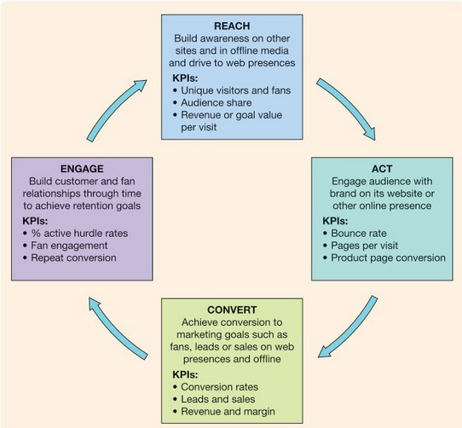
Source: (Chaffey, 2012)
- Reach:
Digital Advertisements build brand awareness to create more reach in the minds of potential customers
- Act
Digital advertisements increase brands’ customer engagement by bringing traffic to their websites or other online presence.
- Convert
Conversion is the ultimate goal of digital advertisement campaigns as it generates leads, reach, sales, and profit.
- Engage
After converting a reach into a customer, a company’s goal should be to sustain as many customers as possible. This step helps to create a relationship with customers to retain them for longer periods and create chances of repeat purchases.

Maslow's Hierarchy of Needs:
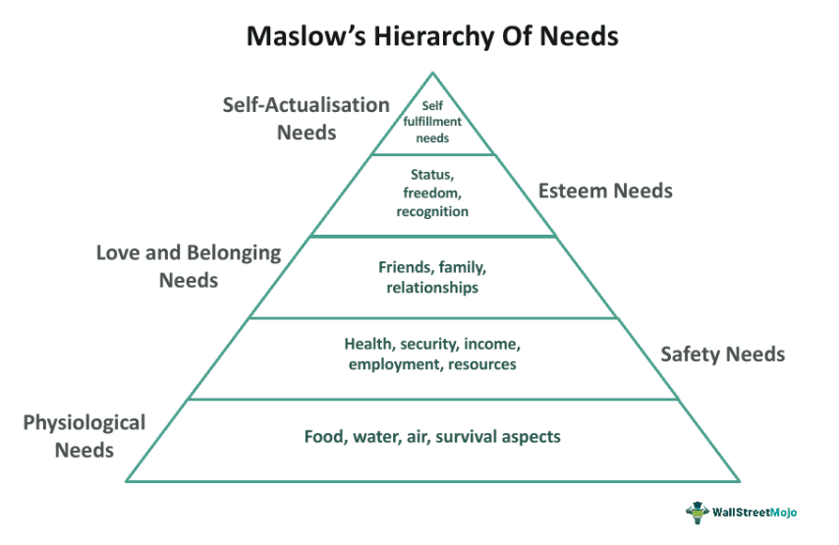
Source: Wallstreet Mojo
Each basic need is characterized by a common attribute and urgency level, with physiological needs being the most critical and self-actualization being the least. In 1960, psychologist Douglas McGregor famously organized these needs into the widely recognized pyramid graph. The most crucial needs are physiological, necessary for the healthy functioning of a person; essential elements such as oxygen, water, and food are vital for survival. Without these, survival is impossible. The next tier of needs pertains to safety, including shelter and protection, which Maslow argues is the primary reason humans form societies—recognizing that safety in numbers outweighs individual vulnerability. Physiological and safety needs are classified as essential, as survival hinges on their fulfillment.

Once the essential needs are fulfilled to some degree, other needs begin to gain importance. The third level pertains to love and affection, highlighting the necessity of feeling a sense of belonging within a group. Next is the need for self-esteem, which involves being accepted and valued by others. The final level is self-actualization, a concept first introduced by German psychiatrist Kurt Goldstein, referring to the drive to realize one's full potential. While the needs for love and self-esteem are frequently met in areas where basic needs are assured, self-actualization remains uncommon and often appears in creative pursuits, such as those undertaken by artists, musicians, or writers producing notable work.

Keller's Brand Equity Model:
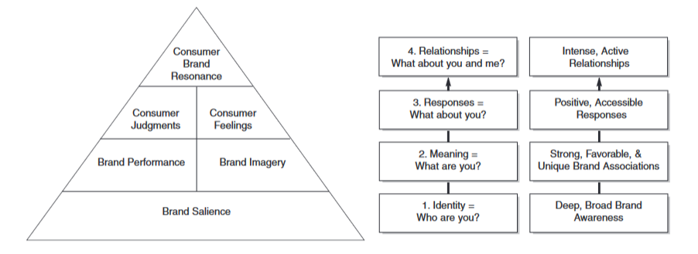
Source: Keller
Brand Salience:
Developing the right brand identity involves building brand salience, which refers to how much customers know about the brand. It examines how easily and often people think of the brand in different situations. It also looks at how well the brand sticks in people's minds and how easy it is for them to remember or recognize it. Additionally, it considers what reminders or prompts are needed for brand recall and how widespread the brand awareness is.
Brand Performance:
The core of brand equity lies in the product itself, as it shapes consumers' interactions with the brand, influences word-of-mouth referrals, and dictates the brand messaging communicated by the firm. Developing and delivering a product that effectively meets consumer needs and desires is essential for successful marketing, regardless of whether it's a physical product, service, or organizational offering. To cultivate brand loyalty and resonance, consumer experiences with the product must meet or exceed their expectations. Research consistently indicates that brands of superior quality typically outperform financially, yielding higher returns on investment.

Brand Imagery:
The second primary category of brand significance pertains to brand imagery. Brand imagery focuses on the external attributes of the product or service, encompassing how the brand endeavors to fulfill customers' psychological or social requirements. It represents the conceptual perceptions individuals hold about a brand, rather than its practical functionalities. Consequently, imagery relates to the less tangible elements of the brand.
Consumer Judgement:
Brand judgments center on customers' perspectives and assessments regarding the brand. These judgments entail how customers amalgamate various associations related to performance and imagery to shape diverse opinions. Customers may formulate various judgments regarding a brand, but four key types of overarching brand assessments hold particular significance for building a strong brand.
- Brand Quality
- Brand Credibility
- Brand Consideration
- Brand Superiority
Consumer Feeling:
Brand feelings encompass the emotional reactions and responses of customers toward the brand. These feelings also encompass the social value elicited by the brand. What emotions are elicited by the brand's marketing efforts or other channels? How does the brand influence customers' emotions regarding themselves and their connections with others? These emotions can range from subtle to intense and can be either favorable or unfavorable. There are six significant categories of emotions crucial for building the brand.
- Warmth
- Fun
- Excitement
- Security
- Social Approval
- Self-Respect
Brand Resonance:
The final stage of the model, brand relationships, centers on the ultimate connection and level of identification that customers establish with the brand. Brand resonance describes the quality of the relationship customers develop with the brand and the degree to which they perceive alignment with it. Brand resonance is characterized by the strength or depth of the emotional connection customers have with the brand, as well as the level of engagement created by this loyalty (such as repeat purchase behaviours, the extent of customers' search for brand-related information, participation in brand events, interaction with other loyal customers, etc.). More precisely, brand resonance can be categorized into four segments:
- Behavioural Loyalty
- Attitude Attachment
- Sense of Community
- Active Engagement
Advantages of Keller’s Brand Equity Model:
Keller's Brand Equity Model offers a customer-centric approach, emphasizing the importance of understanding customers' perspectives to develop marketing strategies that are closely aligned with their needs and preferences (Keller, 2001). It provides a comprehensive framework, detailing a step-by-step process for building brand equity by addressing brand identity, meaning, responses, and resonance. This systematic approach aids in creating a strong brand by covering all critical aspects of brand management, from brand awareness to brand loyalty. A key focus of the model is achieving brand resonance, which ensures that customers develop a strong emotional attachment and loyalty to the brand. Additionally, the model offers actionable insights and a clear roadmap for marketers to enhance brand equity through targeted marketing activities, making it a valuable tool for strategic brand management.
Disadvantages of Keller’s Brand Equity Model:
Keller's Brand Equity Model, despite its strengths, presents several challenges. Its complex nature can make it complex and difficult to implement, particularly for smaller businesses with limited resources. Additionally, building brand equity according to this model is a long-term process that demands significant time and effort, often not yielding immediate results. The model also relies heavily on subjective measures of brand perceptions and attitudes, which can be challenging to quantify and standardize. It tends to be more suitable for established brands, potentially limiting its effectiveness for new or lesser-known brands attempting to build equity from the ground up. Moreover, implementing the strategies suggested by Keller's model can be resource-intensive, necessitating substantial investments in marketing research and activities.

Aaker’s Brand Equity Model
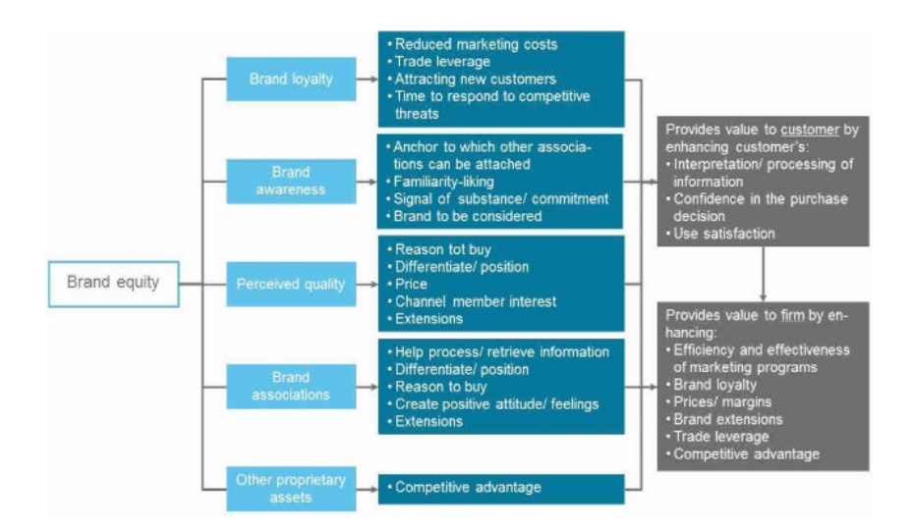
Source: D. Aaker
Aaker's concept of brand equity refers to the collection of positive and negative attributes associated with a brand - encompassing its name and visual symbols which contribute to either enhancing or diminishing the worth of a product or service. These attributes consist of elements such as customer loyalty, brand recognition, perceived product quality, and brand associations. While emphasizing the importance of the value that a brand adds, Aaker's model does not distinctly separate the value accrued by the customer/consumer from that gained by the brand owner/company.
Brand loyalty
Retaining loyal customers offers a distinct advantage in terms of cost-efficiency compared to the resource-intensive process of acquiring new ones through extensive marketing campaigns. Furthermore, loyal customers serve as a dependable revenue stream for distributors, ensuring stability in sales and providing a foundation for sustained business growth. Leveraging existing customers for brand advocacy amplifies brand awareness and facilitates the attraction of new clientele, thereby bolstering market presence. Moreover, customer loyalty acts as a strategic buffer against rapid brand defection, affording companies extended timeframes to effectively counter competitive pressures and adapt to evolving market dynamics with agility and resilience.
Brand awareness
The brand serves as the anchor point to which associations adhere, with the strength of its name dictating the extent of attachment, thus influencing overall brand awareness. Additionally, consumers who hold a favorable view of the brand are more likely to discuss it, thereby amplifying awareness through word-of-mouth. This underscores the importance of familiarity and positive perceptions to enhance brand awareness. Furthermore, brand awareness serves as a signal of the brand's credibility and unwavering commitment to its audience, contributing significantly to consumer trust. Lastly, the brand's integration into the consumer's decision-making process is crucial, reflecting its relevance and influence in guiding purchasing decisions.
Perceived quality:
The decision to purchase a product or brand is often influenced by several factors. Firstly, the perceived quality of the product or brand plays a significant role, as consumers are inclined to invest in items that offer superior quality. Additionally, the level of differentiation and positioning relative to competing brands can sway consumer preferences, with distinctiveness often attracting attention. Price also serves as a crucial determinant, particularly in complex product evaluations where consumers may equate higher prices with superior quality, especially in contexts where status is a factor. Moreover, the availability of a brand across various sales channels enhances its perceived quality, as consumers tend to associate widespread availability with reliability and trustworthiness. Furthermore, the breadth of line or brand extensions can communicate a brand's commitment to quality assurance on a broader scale, influencing consumer perceptions positively.
Brand associations:
The effectiveness of a brand name in eliciting associations from consumers' minds, often influenced by exposure through mediums like TV advertising, significantly impacts brand perception. Additionally, the contribution of these associations to brand differentiation relative to competitors, whether abstract or tangible, plays a pivotal role in shaping consumer preferences. Furthermore, the role that brand associations play in the buying process directly correlates with overall brand equity, with greater influence indicating higher brand value. Moreover, the creation of positive attitudes and emotions through brand associations further enhances brand equity, emphasizing the importance of favourable associations. Lastly, the presence of numerous brand extensions in the market presents ample opportunities to add varied brand associations, thereby enriching the overall brand experience and potentially increasing brand equity.
Other proprietary assets:
Examples such as patents and intellectual property rights, along with the quality of relationships with trade partners, and the acquisition of coveted landing slots by airlines, all exemplify the accumulation of proprietary rights that confer a competitive advantage to a brand within respective industries. The possession of such rights enhances the brand's market position, providing leverage over competitors and fortifying its market presence. Moreover, these proprietary assets serve as valuable assets, contributing to the brand's overall strength and resilience in the face of market challenges.
Advantages of Aaker's Brand Equity Model
Aaker's Brand Equity Model offers several key advantages for businesses looking to build and maintain strong brands. One significant advantage is its comprehensive framework, which includes five core components: brand loyalty, brand awareness, perceived quality, brand associations, and other proprietary brand assets (Aaker, 1991). This approach ensures that all aspects of brand equity are considered, leading to a more strong and sustainable brand strategy. The model's emphasis on brand loyalty helps businesses prioritize long-term customer relationships, which are crucial for sustained profitability and growth (Aaker, 1996). Additionally, by focusing on perceived quality and brand associations, the model helps companies understand and leverage the attributes that customers value most, enabling more effective differentiation in competitive markets (Aaker & Jacobson, 2001). The actionable insights provided by Aaker's model make it a practical tool for marketers aiming to enhance their brand's overall equity through targeted initiatives and continuous monitoring.

Disadvantages of Aaker's Brand Equity Model
Despite its strengths, Aaker's Brand Equity Model also has some notable disadvantages. One major challenge is its complexity and the significant resources required to implement it effectively. Smaller businesses, in particular, may struggle with the extensive data collection and analysis needed to assess each component of the model comprehensively (Aaker, 1991). The model's reliance on subjective measures, such as perceived quality and brand associations, can lead to variability in interpretation and difficulty in standardizing metrics across different contexts and industries (Yoo & Donthu, 2001). Moreover, Aaker's model tends to focus heavily on brand loyalty and established brand components, which may not be as applicable or beneficial for new brands trying to establish themselves in the market (Aaker, 1996). The resource-intensive nature of the model, requiring substantial investment in marketing research and brand management activities, can be a barrier for companies with limited budgets, potentially limiting its accessibility and practicality for all businesses (Aaker, 1996).

Comparison of Aaker’s & Keller’s Brand Equity Model.
Keller's Brand Equity Model: Keller's model conceptualizes brand equity as a set of consumer perceptions and attitudes about a brand. It emphasizes building strong, favorable brand associations in consumers' minds through brand awareness, brand image, brand meaning, brand responses, and brand resonance.
Aaker's Brand Equity Model: Aaker's model views brand equity as a set of assets and liabilities linked to a brand, its name, and symbol, which add to or subtract from the value provided by a product or service. It identifies five brand equity components: brand loyalty, brand awareness, perceived quality, brand associations, and other proprietary assets.
Keller's Brand Equity Model: Keller's model focuses on building brand equity through a series of interconnected components, including brand salience, brand performance, brand imagery, brand judgments, and brand feelings. These components collectively contribute to the strength and favorability of consumer-brand relationships.
Aaker's Brand Equity Model: Aaker's model identifies specific elements that contribute to brand equity, such as brand loyalty, which reflects the degree to which customers are committed to the brand; brand awareness, which indicates the brand's presence in the minds of consumers; perceived quality, which refers to consumers' perceptions of the brand's superiority; brand associations, which are the attributes and characteristics linked to the brand; and other proprietary assets, such as patents or trademarks.
Keller's Brand Equity Model: Keller's model primarily focuses on the consumer perspective, emphasizing how consumers perceive and respond to brands. It aims to understand and influence consumer-brand relationships to drive brand equity.
Aaker's Brand Equity Model: Aaker's model takes both consumer and managerial perspectives into account. While it considers how consumers perceive the brand, it also emphasizes the importance of managing brand assets and liabilities strategically to enhance brand equity.
Keller's Brand Equity Model: Keller's model is often applied in marketing research and practice to assess and manage brand equity from a consumer-centric viewpoint. It helps marketers understand the strengths and weaknesses of their brands and develop strategies to build stronger brand-consumer relationships.
Aaker's Brand Equity Model: Aaker's model is widely used in both academic research and managerial practice. It provides a framework for assessing brand equity comprehensively and guides strategic decision-making related to brand management, marketing communications, and brand extensions.
Keller's Brand Equity Model: Keller's model places significant emphasis on brand associations, which are the links consumers make between the brand and specific attributes, benefits, or values. These associations play a central role in shaping brand perceptions and driving consumer behaviour.
Aaker's Brand Equity Model: Aaker's model also acknowledges the importance of brand associations but places equal emphasis on other components such as brand loyalty, perceived quality, and proprietary assets. It recognizes that multiple factors contribute to overall brand equity and need to be managed effectively.
In summary, while both Keller's and Aaker's models offer valuable frameworks for understanding and managing brand equity, they differ in their conceptualizations, components, perspectives, and emphasis. Keller's model focuses more on consumer perceptions and relationships with the brand, whereas Aaker's model takes a broader view that includes both consumer and managerial perspectives. Both models provide marketers with insights and tools to strengthen brand equity and enhance brand performance.

ABC Model of Attitudes:
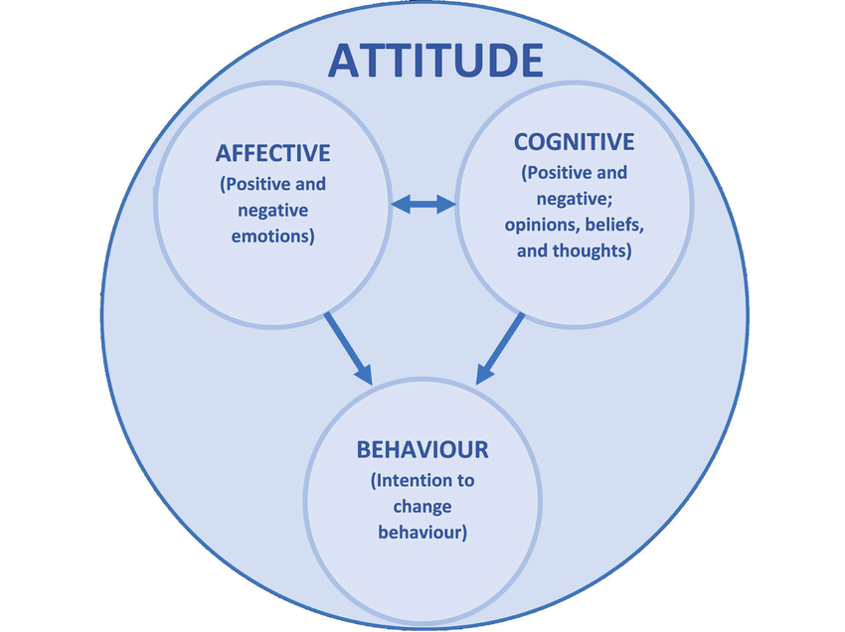
Source: ResearchGate
The cognitive aspect of attitudes involves the beliefs, thoughts, and characteristics we link to an object. Often, an individual's attitude is mainly shaped by the positive and negative qualities they attribute to that object.
The affective component of attitudes pertains to the emotions or feelings associated with an attitude object. Feelings play a significant role in shaping attitudes, particularly through emotional responses evoked by the attitude object. For example, many individuals express fear when encountering spiders, which can lead to a negative attitude towards them.
On the other hand, the behavioral component of attitudes refers to past behaviors or experiences related to an attitude object. For instance, individuals might infer that they hold a negative attitude towards factory farming if they recall signing a petition against the mistreatment of animals. Daryl Bem's self-perception theory (1972) proposes that people sometimes deduce their attitudes by reflecting on their past actions towards attitude objects, particularly when their actual opinions are not readily accessible (also discussed by Nisbett & Wilson, 1977).

Review of Related Research:
Online advertising and its impact on consumer behaviour- Dr. Parul Deshwal
In today's rapidly evolving landscape, the integration of contemporary technology has become indispensable in our daily lives. The scope and prevalence of online advertising have witnessed a significant surge, with businesses allocating larger budgets towards this digital medium. It is imperative to comprehend the underlying factors that shape the effectiveness of online advertising. Many leading advertisers aspire to emulate the format of traditional television advertising in the online sphere, if not surpass it. They seek to amalgamate the visual impact of traditional broadcasts with the added benefit of interactivity, thus enhancing consumer engagement. The objective is to create advertisements that are not only captivating but also interactive, allowing consumers to actively participate in the experience. Through such interactions, consumers form attitudes toward brands, ultimately influencing their purchasing behaviour. This study aims to dissect various forms of online advertising and delve into their impact on consumer purchasing decisions.
According to Dr.Deshwal’s research, with the widespread adoption and evolution of the Internet, it has emerged as a standard platform for advertising. Businesses now have access to a plethora of rich media tools, interactive services, and a global audience through the web. The key lies in understanding the target consumers and devising effective strategies to maximize the potential of this new advertising medium. Tracking and quantifying the actual impact of advertising, whether through traditional mass media or the Internet, presents challenges, but interactive technology offers new opportunities for the advertising industry. While traditional mass media relies on audience measurement tools like Nielson TV and radio ratings, the Internet allows for more targeted advertising, reaching audiences who are genuinely interested and receptive to the product or service being promoted. However, measuring engagement and effectiveness online remains a challenge. Some companies, like Proctor & Gamble, have adopted innovative payment models for online advertising, basing payment on the number of people who actively engage with the advertisement rather than just being exposed to it. This shift towards targeted advertising signifies a departure from traditional broadcast-based advertising methods, such as banner ads, which are increasingly viewed as less effective. As businesses seek alternative revenue sources, the landscape of online advertising is likely to evolve, with a greater emphasis on personalized and targeted advertising approaches. (Deshwal, 2016)

Power of Digital Marketing in Building Brands: A Review of Social Media Advertisement- Rammohan Sundaram, Dr. Rajeev Sharma, Dr. Anurag Shakya
With the rise of the internet, both businesses and individuals are exploring its potential to enhance customer loyalty and drive sales. However, many companies have faced setbacks as consumers use online platforms according to their convenience, often altering their purchasing decisions accordingly. As a result, companies are now closely analyzing consumer patterns and adapting their digital strategies accordingly. Successful brands like Louis Vuitton and Amazon have effectively utilized online marketing to engage customers, share valuable information, and build trust. Personalized communication through email marketing and efficient mobile marketing via SMS have empowered consumers and strengthened brand-consumer relationships. Digital marketing strategies are proving invaluable in understanding consumer behaviour and tailoring products accordingly. Keyword search ads have emerged as effective tools for brand recognition and image building, while influencer communities wield significant power in shaping brand perception. E-commerce platforms have become key drivers of profit margins and brand equity for companies like Apple, IBM, Dell, Hyundai, and Maruti Suzuki. Social media has revolutionized the market, offering vast opportunities for brand promotion, customer management, reputation protection, and network marketing. Previous literature suggests that brands are no longer solely controlled by companies but are shaped by consumer perceptions, with companies only able to manage the information transmitted through various platforms such as Facebook, Twitter, and blogs.

With the increasing influence of millennials, large corporations are shifting their focus toward strategies targeted specifically at this demographic. Analysis of previous literature indicates a positive correlation between millennials' buying behaviour and social media advertising. Social media platforms play a crucial role in entertaining, informing, incentivizing personalization, and influencing millennials' purchase decisions in India. Communication through social media advertising emerges as a key factor impacting millennials' decision-making processes. Popular marketing strategies to engage millennials include electronic word-of-mouth (e-WOM), celebrity endorsements, brand engagement, content creation, creativity, and cause-related marketing, all of which contribute to brand loyalty. Additionally, other factors such as brand experience, perception, peer recommendations, product placement, and status values also influence millennial behaviour. (Sundaram, 2020)

Enhancing Brand Image: Brand Trust, Brand Loyalty, and Social Media Influences on Building a Brand Image- Nalini Palaniswamy and Muruganandam Duraiswamy
The findings indicate that enhancing brand image, building brand trust, and developing brand loyalty through social media content are crucial. Positive social media reviews and ratings can bolster brand image, as customers place value on the content shared by the brand and how effectively the company addresses customer queries and complaints. Consistently delivering on promises and maintaining high-quality standards are essential for building brand trust. Customers who trust the brand believe that their expectations will always be met and their anticipated needs satisfied, leading to a positive brand image. Reviews and ratings play a significant role in shaping the perception of the brand among social media users, highlighting the shift from traditional word-of-mouth to electronic word-of-mouth (E-WOM). It is imperative for companies to proactively manage negative reviews and engage with customers on social media to build a positive brand image through effective marketing strategies. Moreover, the frequency of purchases also influences brand trust and loyalty, suggesting that companies can implement various sales promotion schemes to encourage repeat purchases. Any changes in brand trust, loyalty, and social media presence will undoubtedly impact the overall brand image, necessitating strategic planning, evaluation, and control to address these variables effectively.
Effect of Promotion, Positioning, and Brand Image on Samsung Smartphone Purchase Decisions- Dirwan
This study found a positive correlation between Promotion and Purchase Decision, while the partial test of the independent variables Positioning and Brand Image on the dependent variable of Purchase Decision revealed a positive and significant effect. All variables examined in the study—Promotion, Positioning, and Brand Image—had a significant simultaneous impact on purchasing decisions. Among these variables, Brand Image was identified as having the most dominant influence on purchasing decisions, as evidenced by its greater positive effect on the dependent variable in the partial test. The recommendation is to conduct further research on variables beyond Promotion, Positioning, and Brand Image that are part of marketing strategies affecting purchasing decisions. This is because these three variables only accounted for 55.8% of the variation in purchasing decisions. (Dirwan, 2022)

E-Marketing Strategy and its Development Trends- Hassan Ali Al-Ababneh
The study delves into the theoretical foundations of e-marketing strategy formation and its contemporary development trends. Through a comprehensive critical analysis of existing research, the necessity of integrating innovative technologies and tools in marketing strategies is underscored. The evolution of the global market alongside the rapid advancement of technology and the widespread adoption of the internet in business have emphasized the imperative for organizations to develop electronic marketing strategies and embrace modern trends. Despite various challenges, e-marketing is recognized as an essential avenue for company growth. Central to this trajectory is the selection of appropriate tools, which ultimately dictates commercial success. The foreseeable future of electronic marketing is anticipated to be dynamic, progressive, and mutually beneficial for all stakeholders in the modern economy. Key aspects of contemporary e-marketing, such as leveraging video hosting for product and brand PR, establishing virtual platforms for market information, and the rise of viral marketing via social networks and video platforms, highlight the importance of adapting email marketing strategies to current conditions. The study identifies the primary components utilized in marketing strategies by leading companies worldwide and highlights the prevalent channels for promoting goods and services. These findings can be effectively applied in practical organizational activities to formulate marketing strategies that leverage digital technologies, address global shifts, and consumer loyalty, carve out a niche in the global market, and identify compelling marketing avenues for consumers. (Al-Ababneh, 2022)

Digital platforms utilised for brand advertisement
Digital marketing tools are increasingly vital for businesses to engage with customers and maintain their brand credibility in a rapidly changing landscape (Wymbs, 2011). This encompasses various techniques aimed at acquiring customers, building relationships, promoting brands, and customer retention to drive sales. Major brands like Louis Vuitton and Amazon utilize online platforms not only to showcase their brand history and events but also to connect with customers through storytelling (Greenhill, 2011). Blogs have emerged as a crucial communication medium, offering ease of use and community identification (Ho et al., 2015; Vrana & Zafiropoulos, 2010). They are particularly effective in sharing experiences, building trust, and gathering marketing intelligence (Xiang & Gretzel, 2010).
Email marketing, as noted by Hartemo (2016), enables personalized communication and empowers consumers, yet its full potential remains underutilized by many markets. Case studies, such as that of "Beyond the Rack," demonstrate the significant traffic generated through effective email campaigns, highlighting its resonance with consumers. Mobile marketing, which focuses on relationship building and overcomes barriers of time and location, utilizes opt-in services and SMS alerts to engage consumers (Bouhlel et al., 2011). Luxury brands increasingly rely on digital platforms to understand consumer behaviour, conduct brand comparisons, and evaluate alternatives (Jain & Schultz, 2016). Search engine marketing, including keyword search ads, proves effective in creating brand recognition and shaping brand image (Ghose & Yang, 2009; Yoo, 2014).
Viral marketing, facilitated by social media, amplifies brand awareness and visibility through buzz creation and network marketing (Raja, 2012). Influencer communities wield significant power in shaping brand perception, especially when integrated with social media platforms (Booth & Matic, 2011). However, companies must recognize that brand control lies with consumers, necessitating strategic management of online platforms. Banner advertising, viral marketing, SEO, and widget development are key internet-based activities that influence brand perceptions (Booth & Matic, 2011). E-commerce has reshaped brand equity and profitability, with companies like IBM and Apple leveraging their online presence to gain a competitive edge (Mphapatra, 2012). Brands like Hyundai and Maruti Suzuki leverage their reputation and offer online discounts to enhance brand equity and drive sales.

Consumer attitudes towards internet-based and mobile-phone-based advertising
Attitude is described as a 'learned predisposition to respond in a consistently favorable or unfavorable manner concerning a given subject' (Robideaux, 2002). Understanding consumer attitudes has been a central topic of discussion (Schlosser et al., 1999; Robideaux, 2002; Tsang et al., 2004; Rettie et al., 2005). Consumer attitudes significantly impact the adoption of technology-related products, such as the Internet and mobile phones (Mort & Drennan, 2005). There is substantial literature addressing consumer attitudes towards advertising on the internet and mobile phones, and comparing these can offer valuable insights for advertising or marketing strategies.
Compared to internet-based advertising, consumer attitudes towards mobile phone-based advertising have received less scholarly attention. Among the few studies available, attitudes towards SMS-type mobile advertising are primarily examined. Tsang et al. (2004) found that consumers hold positive attitudes towards permission-based SMS advertising, with entertainment and source credibility influencing these attitudes. Other studies, such as Rettie et al. (2005), suggest that consumer attitudes towards SMS advertising are positive because it can stimulate consumer responses.

Brand switching through marketing mix: the role of brand effect on smartphone users
This research highlights the relevance of marketing mix elements—product, price, place, promotion, and service—in understanding brand switching among smartphone users. The findings emphasize the significant role of brand effect in influencing the switch to different smartphone brands. Notably, the study reveals that price and promotion significantly impact brand switching, with promotion being a more influential factor than price. Furthermore, the brand effect mediates the influence of certain marketing mix elements, such as product and price, on brand switching decisions for smartphones. Within the sample analyzed, Samsung emerged as the market leader in Malaysia, with many users switching to Samsung smartphones during their subsequent purchases. Although the study has limitations, its findings provide valuable insights into effective marketing strategies in the smartphone industry. Future research is anticipated to further enhance the understanding of brand-switching behaviour in this sector. (Isa, S.M., Kelly, L. and Kiumarsi, S., 2020)

A Critical Review of Digital Marketing
Consumers are increasingly favoring online platforms to discover the best deals offered by sellers throughout India, shifting away from traditional shopping methods. Cha (2009) identified that as more individuals perceive shopping services on social networking sites as convenient and user-friendly, they are more inclined to make purchases through these platforms. The widespread adoption of social networks enables businesses to effectively reach their target audiences (Cha, 2009). Similarly, Shankar et al. (2011) demonstrated that an increasing number of consumers rely on social media platforms such as Twitter, Facebook, MySpace, and LinkedIn to inform their purchasing decisions, underscoring the importance of promotions on these channels.

This study acknowledges that businesses can derive substantial benefits from digital marketing strategies, encompassing SEO, SEM, content marketing, influencer marketing, e-commerce strategies, and various forms of digital advertising. Vogus (2011) observed that many large corporations view social media platforms as strategic tools, often dedicating resources to manage their online presence. Mangold and Faulds (2009) emphasized the critical role of social media in an organization’s marketing strategy, advising against underestimating its potential.

The growing popularity of platforms like WhatsApp and Facebook presents new avenues for digital marketers to engage customers. Understanding consumer motivations is pivotal as it provides insights into the factors influencing users to generate content about a brand or store. Chu (2011) supported this notion by exploring the link between participation in Facebook brand-related groups, responses to advertising, and psychological aspects such as self-disclosure and attitudes. The research revealed that members of Facebook groups are more likely to share personal information and exhibit favorable attitudes towards social media and advertising compared to non-members.

Digital marketing proves cost-effective and significantly impacts businesses commercially, enabling small firms to effectively target niche markets at reduced costs, thereby enhancing their competitiveness against larger enterprises (Palumbo & Herbig, 1998).

Chapter 3-RESEARCH METHODOLOGY
Definition:
- “The theory of methods, it is the way in which one makes sense of object inquiry.” (Sarantakos, 1998)
- “The theoretical, political and philosophical backgrounds to social research and their implications for research and for the use of particular research methods.” (Robson, 2002)

Research Onion Model
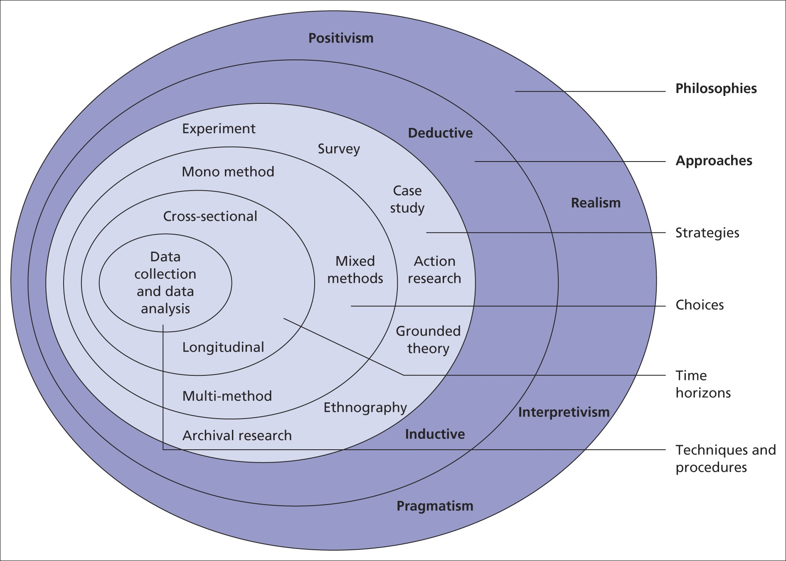
Source: Alturki, R.
Research Philosophy
Pragmatism
Pragmatism emphasizes that if a method yields effective results, it can be considered true. A pragmatic approach prioritizes using the most suitable methods for addressing research problems, rather than engaging in debates over which approach is superior. Therefore, pragmatic researchers have the flexibility to employ qualitative or quantitative techniques, methods, and processes as needed. Moreover, pragmatism in research philosophy supports the development of a practical foundation based on real-world applications and acknowledges that multiple correct answers may exist for any research inquiry. A significant advantage of this philosophy is its ability to integrate various research approaches, methods, and strategies to ensure research questions are addressed in a manner that enhances practical applicability. Ultimately, pragmatism empowers researchers to incorporate diverse perspectives as deemed appropriate in their studies (Alturki, 2021).
Approach
Deductive
Deductive approach involves progressing from broader principles to more specific conclusions. This approach begins with a well-established theory, which is then validated against empirical data to explore its implications. Deductive reasoning is closely linked to scientific inquiry, employing a structured method where conclusions logically follow from the initial premises. As a top-down approach, deductive reasoning emphasizes the necessity for conclusions to be logically derived from the hypothesis (Alturki, 2021).
Strategies
Survey
Saunders et al. (2016) outline several research strategies, including experiments, surveys, archival research, case studies, ethnography, action research, grounded theory, and narrative inquiry. However, in future studies, these strategies are categorized differently. A research strategy is the overarching approach that directs researchers in choosing primary data collection methods to address research questions and achieve objectives. According to List (2005), research methods are classified into quantitative and qualitative. Additionally, Kosow and Gaßner (2008) and Puglisi (2001) introduce explorative and normative methods alongside these approaches. Explorative methods concentrate on investigating multiple futures and potential developments, while normative methods aim to shape desirable or undesirable futures and devise pathways to achieve them. In future studies, these methods are employed to meet specific objectives, such as describing future development patterns, prescribing actions to achieve a desirable future, or exploring potential future events. Therefore, three main research strategies are identified: descriptive, normative (prescriptive), and explorative.

Primary Research
Definition
"Primary research is a methodology used by researchers to collect data directly from original sources, rather than relying on previously collected data. This approach is essential for obtaining firsthand information that is specific to the research question or hypothesis being investigated" (Creswell, 2014).
Advantages of Primary Research
One of the key benefits lies in the acquisition of firsthand and accurate data, without any dilution. This method can also be tailored to meet the specific requirements and preferences of organizations or businesses. Moreover, it squarely focuses on addressing the immediate problem, allowing undivided attention to explore potential solutions. Through primary research, researchers can delve deeply into a subject matter, examining all conceivable options comprehensively. Additionally, this approach offers control over the data collection process and its utilization, empowering businesses or organizations to derive meaningful insights. Its reliability is underscored by its time-tested nature, instilling confidence in the obtained results.
Disadvantages of Primary Research
One significant drawback associated with primary research is its potential for high costs, as substantial financial investment on be necessary depending on the chosen setup or method. This expenditure might not be feasible for all businesses or organizations. Additionally, primary research can consume a considerable amount of time, especially with tasks like conducting interviews or administering online surveys, which demand patience and dedication. Furthermore, analyzing results and implementing findings to enhance products or services can add to the time investment required. In some cases, relying on a single primary research method may prove insufficient, necessitating the adoption of multiple methods. However, this approach could prolong the research process and increase associated expenses.
Secondary Research
Definition
According to Saunders et al. (2019), "Secondary research, also known as desk research, involves the use of existing research data collected for other purposes, such as reports, articles, and previous studies, to answer the research question or to gain insights into the research problem" (Saunders, Lewis, & Thornhill, 2019).

Advantages of Secondary Research
Secondary research offers numerous advantages, including its typically low cost and easy accessibility. It serves as a valuable resource for providing background information, which aids in clarifying and refining research areas. By accessing a wide range of sources, secondary research broadens the researcher's knowledge base and introduces various examples of research methods. Moreover, it can reveal gaps in existing literature, pinpointing potential areas of difficulty for further investigation. The incorporation of diverse data allows for the exploration of opposing views and supporting arguments related to the research topic. Additionally, secondary research highlights key researchers and ongoing work within the subject area, providing context and insight. Overall, secondary research plays a crucial role in contextualizing research topics and enriching understanding within the field.
Disadvantages of Secondary Research
One significant drawback is the potential for the information to be outdated, as it may not reflect current trends or developments. Additionally, there is a risk of unreliability if the source or methodology of the research is unclear, underscoring the importance of critical thinking and careful evaluation. Furthermore, secondary research may not always align perfectly with the specific focus of your research question, as the aims and objectives of previous studies may differ. Therefore, while secondary research can provide valuable insights, researchers must approach it with caution and consider its limitations about their own research objectives.

Choices
Qualitative Method
According to Denzin and Lincoln (2018), "Qualitative research is a situated activity that locates the observer in the world. It consists of a set of interpretive, material practices that make the world visible. These practices transform the world by turning it into a series of representations, including field notes, interviews, conversations, photographs, recordings, and memos to the self" (Denzin & Lincoln, 2018).
Quantitative Method
According to Bryman (2016), "Quantitative research is a strategy that emphasizes quantification in the collection and analysis of data and that entails a deductive approach to the relationship between theory and research, in which the accent is placed on the testing of theories" (Bryman, 2016).
Mixed Methods
Mixed-model research integrates quantitative and qualitative methodologies for data collection and analysis. This approach combines diverse strategies, incorporating numerical and descriptive data, which are then examined simultaneously or sequentially. Researchers gain a comprehensive understanding of the phenomenon under study by employing a blend of quantitative metrics and qualitative insights. This methodology allows for a nuanced exploration of complex phenomena, providing a more general perspective than either approach alone. By embracing both quantitative rigor and qualitative depth, mixed-model research facilitates strong and insightful analysis, enhancing decision-making processes in various fields.
Time Horizons
Cross-Sectional
The time horizon refers to the defined timeframe encompassing a study's duration, including data collection and analysis. A cross-sectional time horizon involves a single snapshot within a specified period, capturing immediate cause-and-effect relationships. Conversely, a longitudinal time horizon entails multiple snapshots over time, enabling the observation of changes and the testing of inference consistency. This research adopts a cross-sectional time horizon, focusing on immediate associations between variables.
Techniques & Procedures
Definition of Sampling:
According to Babbie (2019), "Sampling is the process of selecting observations from a population to provide an accurate description or estimate of that population" (Babbie, 2019).
Sample Size:
Sampling size, also known as sample size, refers to the number of individuals, items, or observations included in a sample selected from a larger population for research purposes. The size of the sample is determined based on various factors such as the research objectives, the level of precision desired, the characteristics of the population, and the available resources (Babbie, 2019).
The sample size chosen for this survey is 50 people who use smartphones and are exposed to digital advertisements on smartphones in their daily lives.
Sampling Type:
Sampling type refers to the specific approach or method used to select individuals or items from a larger population for inclusion in a research study. It outlines the systematic procedure through which the sample is chosen, whether it involves random selection (probability sampling) or non-random selection (non-probability sampling). The sampling type determines the extent to which the sample is representative of the population and influences the generalizability and validity of research findings (Neuman, 2014).
Sampling Method:
In this research convenience sampling has been used for the data collection.
Convenience Sampling:
Convenience sampling is a non-probability sampling technique where subjects are selected because of their convenient accessibility and proximity to the researcher.
According to Etikan, Musa, and Alkassim (2016), "Convenience sampling (also known as availability sampling) is a specific type of non-probability sampling method that relies on data collection from population members who are conveniently available to participate in study."
Advantages of Convenience Sampling:
Convenience sampling offers several advantages, primarily its simplicity and speed in data collection. This method is highly practical for exploratory research where preliminary data is needed quickly and with minimal cost. According to Etikan, Musa, and Alkassim (2016), convenience sampling is advantageous due to its "low cost and time efficiency" (p. 3). Additionally, it allows researchers to gather data without the need for a complex sampling frame, making it particularly useful in situations where other sampling methods are impractical or impossible (Creswell, 2014). Convenience sampling is also beneficial in pilot studies where the primary aim is to test research instruments or to get a quick understanding of a phenomenon before conducting more rigorous research (Etikan et al., 2016).
Disadvantages of Convenience Sampling:
Despite its practicality, convenience sampling has notable disadvantages, particularly concerning the generalizability and validity of the research findings. This method often leads to sampling bias because it does not accurately represent the entire population, as noted by Etikan, Musa, and Alkassim (2016), who state that it "suffers from selection bias and does not allow generalization to the whole population". Furthermore, the non-random nature of convenience sampling increases the risk of over-representing specific groups within the sample, leading to skewed results (Creswell, 2014). This lack of representativeness can significantly limit the external validity of the study, making it difficult to apply the findings to a broader context (Bryman, 2016).

As the research onion is traversed step by step, it is observed that the final layer, encompassing techniques and procedures, directs the research design toward the collection and analysis of data. The choices made in the preceding layers determine the type of basic data collection and analysis procedures that will be utilized to address the research question.
Data Collection Method
In this research, the survey is used to get primary information. The platform used to create a questionnaire is Google Forms. Both, qualitative and quantitative questions are used in the survey. There are multiple types of questions in the questionnaire. Such as Multiple-choice (Single answer), Dichotomous (Yes/No), Likert scale, Multiple-choice (Multiple answers), and Open-ended questions. Number of questions
The questionnaire was sent to the participants via different social media platforms like WhatsApp, SMS, E-mail, LinkedIn, and Instagram; some surveys were filled in person and took 6-8 minutes to complete as the participants were required to fully understand the questions.
All in all, the whole process, from creating questions according to the research topic to creating Google forms as per questions to sending surveys to be filled and receiving the desired number of responses took two weeks.

Data Analysis
For quantitative data, MS Excel is used in this research to analyse data and statistical analysis. For qualitative data, Thematic analysis is used.

Research Ethics
Ethics profoundly influence every aspect of our lives, including the dos and don'ts that guide our moral decisions. Society and the economy are governed by numerous formal and informal rules and regulations, and new ethical issues continually arise as society and science grow more complex. In social research, such as business research, ethical considerations extend beyond simple right and wrong, encompassing the legitimacy and justification of knowledge production. Key ethical principles include informed consent, avoiding deception, preventing harm, and Kant’s principle of respect, which mandates treating individuals as ends in themselves and not merely as means. These principles apply universally to all research activities, regardless of the researcher's approach to knowledge creation.
Research ethics encompass how research is conducted and reported, addressing issues such as bias, proper citation, and the inclusion of diverse perspectives within the research community. Trust in the research community is fundamental, relying on adherence to accepted ethical principles that distinguish right from wrong in research contexts. Standards, codes, and normative principles are essential for making these ethical guidelines known and accepted as a code of conduct, and for establishing procedures to handle ethical issues that may arise.
Ethics are integrated into all aspects of life, including research, where new methods and materials continually raise new ethical questions. As society evolves, so too must the rules and regulations governing ethical conduct in research. This is particularly true in fields such as medical and biosciences, and increasingly relevant in business research, where issues of misconduct have gained attention from an ethical standpoint.
Despite their importance, research ethics are often overlooked in business research, even though the field encompasses numerous potential ethical challenges related to the conduct of businesses, corporations, and organizations. This oversight is evident in seminal works such as the Handbook of Organization Research, which only briefly touches upon ethical issues. Consequently, there is a need for greater emphasis on ethics within business research to navigate the complex ethical landscape of studying organizations, leadership, and economic activities.

Validity & Reliability
Validity refers to how accurately a concept is measured in quantitative research. For instance, if a survey intended to study customer behaviour ends up measuring brand awareness instead, it would lack validity.
Reliability, on the other hand, concerns the consistency of measurement. It reflects how consistently a research instrument yields the same results when used repeatedly in the same context. For example, if a participant responds similarly each time they take a motivation measurement test, the instrument is considered reliable. (Heale, 2015)

This research aims to find impact of digital advertisement on customer behaviour and brand loyalty of the smartphone industry and has objectives for working on the key themes of the research. Moreover, questions are also designed in a way that can contribute towards main themes.

Chapter 4- FINDINGS
Chapter Overview
This chapter aims to understand consumer behaviour and preferences regarding smartphone brands and digital advertising with the help of the results of the survey conducted. It identifies current smartphone brand usage, assesses the influence of digital ads on purchases, and examines the frequency and platforms where these ads are encountered. The survey also evaluates the impact of visual elements and messaging types in ads, such as informative or emotional content. Additionally, it explores brand loyalty, factors influencing it, and repurchasing behaviour. Demographic data like age, gender, and education provide deeper insights into different consumer segments. These findings will help companies refine their marketing strategies, create more effective ads, and enhance brand loyalty. Finally, an open-ended question provides highlighted moments of digital advertisement and memorable experiences that customers had based on digital advertisement. These experiences were crucial in influencing their behaviour toward brand or brand loyalty.

Survey Results
Note: All the numbers in the charts below are percentages.
- Age

The survey results reveal distinct age demographics that can guide strategic marketing decisions. The majority of respondents fall within the 18-24 age range, accounting for 44%, followed closely by the 25-34 age group at 42%. This indicates that young adults are the primary audience, characterized by their tech-savvy, high social media engagement, and openness to new trends and technologies. Marketing strategies should thus leverage digital platforms, social media, and influencer marketing to resonate with this group, emphasizing trendy, innovative, and interactive content. The 35-44 age group, representing 10% of respondents, is smaller but still significant. This demographic likely values reliability, long-term benefits, and brand trustworthiness, suggesting that marketing efforts should include detailed information, customer testimonials, and family-oriented campaigns. 45-54 age group has only 4% of respondents, indicating minimal engagement from these segments. This suggests a need to explore why these groups are less involved and to adapt marketing strategies accordingly, possibly by using more traditional media, email marketing, or personalized approaches that highlight reliability and ease of use. Overall, the survey underscores the importance of tailoring digital marketing efforts to engage young adults, while also considering targeted approaches to reach the less represented age groups effectively.

- Gender

The survey results indicate a gender distribution where 64% of respondents are male and 36% are female. This significant skew towards a male audience suggests that marketing strategies should consider the preferences and behaviours typically associated with male consumers. For the male demographic, emphasizing product specifications, performance features, and technical innovations in digital advertisements may be particularly effective. Campaigns could focus on aspects such as cutting-edge technology, gaming capabilities, and designs, which often resonate well with male consumers.
For the female demographic, which constitutes a substantial 36% of the audience, marketing strategies should not be overlooked. It's important to highlight features such as aesthetics, user-friendliness, and lifestyle integration. Campaigns could emphasize how the product enhances daily life, supports multitasking, or offers unique design elements that appeal to female consumers. Additionally, incorporating testimonials, influencer partnerships, and social proof can effectively engage this segment.

- Education Level

The survey results reveal a diverse educational background among respondents, providing key insights for tailored marketing strategies. A significant 50% of respondents hold a Master's or Post-Graduate degree, highlighting a highly educated audience. This group likely values advanced features, high performance, and brand prestige in smartphones. Marketing strategies should emphasize cutting-edge technology, superior functionality, and professional applications, catering to their sophisticated needs and willingness to invest in premium products. Additionally, the 4% with a Doctorate or higher represent a niche market that prioritizes innovation and professional-grade capabilities. For this segment, marketing should focus on the smartphone's advanced research capabilities, top-tier performance, and exclusive features that support their professional and intellectual pursuits.

Respondents with a Bachelor's Degree make up 28% of the sample, representing young professionals and graduates who seek a balance between cost and advanced features. Marketing efforts for this demographic should highlight productivity tools, seamless integration with work and personal life, and a blend of modern design and functionality at a moderate price point. The 18% of respondents currently in college are likely to be budget-conscious but interested in modern technology and connectivity. For this group, marketing should focus on trendy designs, social media capabilities, and educational tools that cater to their active lifestyles and academic needs.

- Which brand of smartphone are you currently using?

The survey results reveal that Apple leads the market with 34% of participants owning an Apple phone, indicating highly effective online advertising. Samsung follows with 20%, showing strong but less dominant marketing. Other brands like Realme, Nothing, Oppo, Vivo, and Poco together hold 20%, suggesting a competitive market where these brands could benefit from stronger individual marketing efforts. OnePlus, with a 16% share, demonstrates successful niche marketing. Google Pixel and Xiaomi each have a 10% share.
Overall, Apple's dominance suggests superior online advertising impact, while the distribution of shares among other brands indicates a highly competitive market with significant opportunities for growth through targeted marketing strategies.

- Have you ever made a smartphone purchase influenced by a digital advertisement?

The survey results reveal that digital advertisements significantly influence purchase decisions, with 72% of participants acknowledging their impact. This high percentage underscores the importance of digital marketing in shaping consumer behaviour. However, 28% of participants are not influenced by digital advertisements, suggesting that while digital marketing is crucial, it is not the sole factor in consumer decision-making. This segment may rely on other sources such as word-of-mouth, personal research, in-store experiences, or traditional advertising methods. Therefore, businesses should prioritize digital marketing to maximize their reach and impact, while also integrating diverse marketing strategies to effectively engage the 28% of consumers who are not influenced by digital ads.

- How frequently do you encounter digital advertisements for smartphones a day?

The survey results indicate varying levels of exposure to digital advertisements for smartphones among participants. A significant 56% encounter these ads 2-4 times daily, suggesting this frequency is effective for broad reach without overwhelming users. Conversely, 22% see these ads 0-1 time daily, pointing to a segment that is less engaged with digital platforms. Additionally, 10% of participants encounter ads 4-6 times daily, and 12% see ads 6 or more times a day, highlighting a highly engaged segment that may be at risk of ad fatigue.

- Which digital platforms do you most frequently encounter smartphone advertisements on? (Check all that apply)

The survey findings highlight the prevalence of smartphone advertisements across various digital platforms. Social media emerges as the dominant channel, with 68% of participants encountering ads on platforms like Instagram, Facebook, and Snapchat. This underscores the importance of social media advertising for reaching smartphone users, given its ability to offer highly targeted ads based on user demographics and behaviours. Following closely behind, 54% of participants report encountering ads on search engines such as Google and Bing, emphasizing the significance of search engine optimization and marketing strategies in smartphone advertising. Video streaming platforms like YouTube and Netflix also play a notable role, with 40% of participants encountering ads, indicating the rising popularity of video advertising formats for engaging smartphone users. Mobile apps (32%) and websites/blogs (22%) serve as significant channels for ads, reflecting the widespread use of smartphones for accessing digital content. However, email newsletters have the lowest presence, with only 6% of participants encountering smartphone ads in their inboxes. This highlights the need for advertisers to tailor their strategies to different platforms to engage with smartphone users across the digital landscape effectively.
- How would you rate the impact of visual elements (e.g., images, videos) in smartphone advertisements on your perception of the brand?

The survey reveals a varied response to the impact of visual elements in smartphone advertisements on participants' perception of the brand. 54% rate the impact positively, with 40% indicating a "Positive" rating and 14% a "Strongly Positive" rating, 26% express negative sentiments, with 14% rating the impact as "Strongly Negative" and 12% as "Negative." An additional 20% remain neutral in their assessment. These results highlight the importance of high-quality visual content in smartphone advertising, as well as the potential pitfalls of ineffective or intrusive visual elements. Brands should prioritize strategic and thoughtful visual content creation to effectively engage consumers and positively influence brand perception. Additionally, gathering and analysing feedback can help identify areas for improvement and ensure that visual elements relate to the target audience, contributing to a more compelling and impactful brand experience.

- What type of messaging in smartphone advertisements most appeals to you?

The survey results indicate a clear preference among participants for informative messaging in smartphone advertisements, with 54% expressing a preference for this type of content. Informative messaging useful and relevant information about products or services, aiding them in making informed purchasing decisions. Additionally, humorous messaging garners significant appeal, with 26% of participants favoring this approach. Humor can capture attention and evoke positive emotions, enhancing brand likability and memorability. Inspirational messaging also receives notable attention, with 10% of participants expressing a preference for content that uplifts and motivates. While emotional messaging and other unique or practical usage messaging each receive 6% of participant preferences, they play a lesser role in overall appeal. These results suggest that consumers value advertisements that inform, entertain, and inspire, highlighting the importance of diverse messaging strategies in effectively engaging smartphone users. Incorporating a mix of informative, humorous, and inspirational messaging can help brands create compelling and relevant advertisements that connect with their target audience on a deeper level.

- Have you ever repurchased a smartphone from the same brand after being exposed to their digital advertisement campaigns?

The survey findings reveal that a significant majority, comprising 68% of participants, have repurchased a smartphone from the same brand after being exposed to their digital advertisement campaigns. This indicates a strong correlation between digital advertising exposure and consumer purchasing behaviour, suggesting that well-executed digital advertisement campaigns can effectively influence brand loyalty and repeat purchases. Additionally, the 32% of participants who have not repurchased a smartphone from the same brand after exposure to digital advertisement campaigns suggest that while digital advertising can be influential, other factors such as product performance, pricing, and competitor offerings also play significant roles in purchasing decisions. Overall, these findings emphasize the significance of digital advertising as a powerful tool for brand promotion and consumer engagement in the smartphone market.

- On average, how long do you stick with a smartphone brand after your initial purchase influenced by their digital advertisement? (Years)

The survey findings illustrate the duration of brand loyalty among consumers following their initial smartphone purchase, influenced by digital advertisements. It is notable that a majority of participants, totaling 68%, remain loyal to the same brand for at least two years after their initial purchase, indicating a significant level of brand allegiance by effective digital advertising campaigns. However, there is a noteworthy segment, comprising 12% of participants, who switch brands within a year, suggesting that factors beyond digital advertisements, such as product satisfaction or the appeal of new offerings, may prompt swift changes in brand preferences. The gradual decline in retention rates beyond the 2–3-year mark, with 20% sticking with the brand for three or more years, emphasizes the challenges brands face in maintaining long-term customer loyalty in a competitive market. Overall, while digital advertisements play a crucial role in influencing initial purchases, sustained brand loyalty requires continuous investment in product quality, innovation, and customer engagement beyond the initial marketing impact.

- On a scale of 1 to 5, how strongly do digital advertisement campaigns influence your decision to continue purchasing your current smartphone over other brands?

The survey results indicate varied levels of influence that digital advertisement campaigns have on participants' decisions to continue purchasing their current smartphone over other brands. Notably, a majority of participants, comprising 68%, rated digital advertisements as either "Somewhat Influential" (38%) or "Influential" (30%), suggesting that digital marketing efforts play a significant role in shaping consumer decisions and preferences in the smartphone market. However, a considerable portion of participants, totaling 22%, rated digital advertisements as either "Not Influential" (8%) or "Less Influential" (14%), indicating that for some consumers, other factors may hold greater sway in their purchasing decisions. This highlights the importance for smartphone brands to utilize digital advertising effectively to engage consumers and reinforce brand loyalty, while also recognizing the need to address other key factors such as product quality, features, and customer service to maintain competitiveness and consumer trust in the market.

- Which of the following factors do you consider most influential in making you loyal to a smartphone brand after seeing its digital advertisements?

The survey reveals that participants consider various factors influential in creating loyalty to a smartphone brand after exposure to its digital advertisements. Product quality emerges as the most influential factor, with 34% of participants prioritizing this aspect. This suggests that consumers place high importance on the performance, features, and reliability of the smartphone when forming brand loyalty. Brand reputation follows closely behind, with 14% of participants valuing a brand's standing and credibility in the market. Additionally, customer service (24%) and innovation (18%) play significant roles in cultivating loyalty, indicating the importance of post-purchase support and continuous technological advancements. Price competitiveness, although less prominent at 10%, remains a consideration for some consumers. Overall, these findings underscore the multifaceted nature of brand loyalty in the smartphone market, emphasizing the need for brands to excel across various dimensions, including product quality, reputation, customer service, innovation, and pricing strategies, to engage consumers and lasting loyalty effectively.

- How likely are you to recommend a smartphone brand to others after exposure to their digital advertisement campaigns?

The survey findings reveal diverse sentiments regarding participants' likelihood to recommend a smartphone brand to others after exposure to its digital advertisement campaigns. While a majority of participants, totaling 46%, expressed some level of likelihood to recommend (10% Very Likely and 36% Likely), a significant portion, comprising 38%, remained neutral in their inclination to recommend. This suggests that while digital advertisement campaigns may positively influence brand perception and consideration, they may not always translate directly into active advocacy or word-of-mouth promotion. Moreover, 16% of participants expressed some degree of reluctance to recommend (14% Unlikely and 2% Very Unlikely), indicating that while digital advertisements may capture attention or interest, other factors such as personal experiences or perceptions may outweigh the impact of advertising alone in influencing advocacy behaviour. Overall, these findings highlight the nuanced relationship between digital advertising exposure and consumer advocacy, emphasizing the importance for brands to complement marketing efforts with exceptional product experiences, customer service, and value propositions to inspire genuine recommendations and loyalty from consumers.

- Please describe a memorable experience with a smartphone brand's digital advertisement campaign. What aspects of the campaign made it memorable, and did it influence your perception or behaviour towards the brand?

Several memorable smartphone digital advertisement campaigns have significantly influenced consumer perceptions and purchasing behaviour. Apple's "Shot on iPhone" series and ads highlighting new features like portrait mode and smooth user experience demonstrated the brand's commitment to quality and innovation and strong brand loyalty. Samsung's "Unbox Your Phone" campaign, AI smartphone ads, and humorous commercials targeting Apple showcased visually stunning and innovative approaches, positioning Samsung as a leader in smartphone technology. OnePlus's "Never Settle" series resonated with tech enthusiasts through bold messages and high-quality visuals, promoting trust and loyalty. Xiaomi's "Mi Explorers" initiative engaged users by inviting them to test new devices, highlighting the brand's community-centric approach. Poco's advertisements successfully altered perceptions of Xiaomi's brand quality, emphasizing affordable flagship features. Nothing Phone's pre-launch hype and unique design elements generated excitement and interest. Google Pixel's ads focused on AI camera features, leaving a strong impression regarding superior camera performance. RealMe consistently attracted users with their value-driven features highlighted in their advertisements. Overall, these campaigns effectively utilized digital platforms to enhance brand awareness, quality perception, and consumer engagement.

Chapter 5- DISCUSSION

Further Interpretation of Primary Data
The survey results provide a comprehensive understanding of how digital advertisements influence consumer behaviour and brand loyalty in the smartphone industry. The key insights can be summarized as follows:
Market Positioning and Brand Dominance:
Apple leads the market, demonstrating the effectiveness of its digital advertising strategies. Other brands, like Samsung, OnePlus, and niche players, show varied levels of success, indicating room for growth and the need for differentiated marketing efforts.
Impact of Digital Advertisements on Purchasing Decisions:
A significant majority of consumers are influenced by digital advertisements when making smartphone purchase decisions. This emphasizes the crucial role of digital marketing in shaping consumer behaviour, it also highlights the need for a multifaceted approach to capture the segment of consumers not as influenced by digital ads.
Ad Exposure and Consumer Engagement:
Consumers encounter digital advertisements at varying frequencies, with a majority experiencing ads multiple times daily. This suggests an optimal frequency for maintaining visibility without causing ad fatigue. However, there remains a segment that is less engaged with digital platforms, indicating the need for better targeting or increased ad spending on these platforms.
Platform Utilization:
Social media emerges as the dominant platform for smartphone advertisements, followed by search engines and video streaming platforms. This indicates the importance of these channels for reaching consumers and the need for a tailored approach to each platform's unique audience.
Visual and Messaging Impact:
High-quality visual content and informative messaging are crucial in shaping consumer perceptions and driving engagement. However, there are varied responses to visual elements, highlighting the need for continuous improvement and adaptation to consumer preferences.
Brand Loyalty and Repeat Purchases:
Effective digital advertisement campaigns significantly contribute to brand loyalty and repeat purchases. However, maintaining long-term loyalty requires continuous investment in product quality, customer service, and innovation beyond the initial advertisement impact.

KEY LINKS BETWEEN DIFFERENT QUESTIONS:
It is evident from the survey results that the customer group that received a digital advertisement 2-4 times, ended up buying the smartphone of the same brand; whereas, participants who received digital advertisements 5-6 times or more, were not converted into customers. This elicits traces of advertisement fatigue and showing advertisements more than 4 times can cost a smartphone company a valuable customer.
Moreover, Apple’s customers are more loyal when repurchasing than other brands. Thus, other brands can work on their customer retention ability with effective and interactive digital advertisements.

CONNECTION WITH LITERATURE REVIEW
The study on the influence of digital advertisements on smartphone purchases revealed that visual elements significantly impact consumer perceptions, aligning with Keller's (2009) findings on brand equity through visual content. Primary research indicated that younger consumers (18-34 years) are particularly responsive to digital ads, expanding on Solomon's (2016) work on consumer behaviour. This finding supports existing literature emphasizing age-specific marketing strategies (Aaker, 1996; Kotler et al., 2013). Additionally, high-quality visuals and innovative messaging in digital ads enhanced brand loyalty, corroborating insights from Batra and Keller (2016). A mixed-methods approach, as recommended by Creswell (2014), was employed to ensure comprehensive data collection and analysis, thereby strengthening the validity of the findings. The study confirms existing theories while addressing gaps in understanding the nuances of digital advertising’s impact on different age groups, providing valuable insights for marketing practitioners. These connections between primary research findings and the literature review demonstrate the relevance and applicability of established theories in contemporary digital marketing contexts.
LIMITATION OF PRIMARY RESEARCH
Based on a survey of 50 participants, the primary research offers valuable insights into the impact of digital advertising on consumer behaviour and brand loyalty in the smartphone industry. However, its small sample size limits the generalizability and statistical significance of the findings. Potential biases due to non-representative sampling and self-selection may skew the results, while the reliance on self-reported data raises concerns about accuracy and subjectivity. The survey's focus on digital platforms may overlook other influential advertising channels, and its snapshot nature fails to capture changes over time. Additionally, the lack of qualitative depth and cross-verification with other methodologies further constrains the validity of the conclusions. Therefore, while informative, these findings should be interpreted with caution, and future research should address these limitations to provide a more comprehensive understanding.

Chapter 6- CONCLUSION & RECOMMENDATION
CONCLUSION
The relationship between digital advertisement exposure and customer purchasing behaviour within the smartphone industry has been critically examined, revealing a significant impact on consumer decisions. Digital advertisements, particularly those leveraging high-quality visuals and compelling messaging, have been shown to effectively shape consumer perceptions and drive purchasing behaviour. Campaigns such as Apple's "Shot on iPhone" and Samsung's "Unbox Your Phone" not only highlight product features but also brand loyalty through engaging and innovative content.
The influence of digital advertisement content on customer attitudes and perceptions towards smartphone brands has been evident. Visual elements and messaging that resonate with consumers can create strong, positive brand associations. Informative, emotional, and humorous content, as seen in OnePlus's "Never Settle" and Samsung's playful ads, significantly enhance consumer engagement and trust in the brand. These advertisements help to position the brands as leaders in the market, appealing to both new and existing customers.
The long-term effects of digital advertisement campaigns on customer retention and repeat purchase behaviour have also been explored. Continuous exposure to engaging ads keeps consumers connected to the brand, developing long-term loyalty. Interactive and community-focused campaigns, like Xiaomi's "Mi Explorers," build strong customer relationships by involving users in the product development process. This involvement leads to higher customer retention and repeated purchases, reinforcing the brand's market position over time.
Key factors contributing to the effectiveness of digital advertisement campaigns in enhancing brand loyalty have been identified. High-quality content that aligns with consumer values, coupled with engaging and interactive campaigns, significantly boosts brand loyalty. Emotional and humorous advertisements create positive brand associations, making the brand more memorable and relatable. These factors, combined with strategic use of digital platforms, ensure that smartphone brands can maintain and grow their loyal customer base in a competitive market.

In conclusion, digital advertisement campaigns play a crucial role in shaping consumer perceptions, driving purchasing behaviour, and enhancing brand loyalty within the smartphone industry. By leveraging high-quality content, engaging messaging, and interactive elements, smartphone brands can effectively connect with consumers, and sustain long-term loyalty and market success.
RECOMMENDATIONS
To enhance the impact of digital advertising campaigns, smartphone brands should prioritize high-quality visual and interactive content. Investing in high-resolution images, videos, and interactive elements like augmented reality can significantly boost consumer engagement. Personalized advertising, utilizing data analytics and AI, allows brands to deliver targeted campaigns that resonate with individual consumer preferences. Emphasizing unique selling propositions such as camera quality or battery life and creating compelling brand narratives can differentiate a brand. Integrating a multi-channel approach ensures a consistent brand presence across social media, search engines, email marketing, and influencer partnerships, enhancing brand recall and customer engagement.
Focusing on customer retention is equally crucial. Developing loyalty programs that reward repeat purchases and long-term engagement can encourage brand loyalty. Offering exclusive deals, early access to new products, and post-purchase engagement through personalized communications keeps customers connected to the brand. Maintaining ethical and transparent practices, especially regarding data privacy, builds trust and enhances brand reputation. Highlighting corporate social responsibility initiatives in advertising can attract consumers who value social and environmental contributions, further boosting brand image and loyalty. These strategies, grounded in data-driven insights and strategic practices, aim to optimize the effectiveness of digital marketing efforts within the smartphone industry.

FURTHER RESEARCH
This research provides valuable insights into how digital advertisements affect customer behaviour before, during, and after purchase. However, one study can only cover some aspects of the topic, and there is always room for more connected research. For instance, while this research focuses on the impact of digital advertisements, other areas of digital marketing, such as Customer Relationship Management (CRM), Search Engine Optimization (SEO), and the application of machine learning in marketing, remain unexplored and present opportunities for further investigation. These areas could provide a broader view of how various digital marketing strategies influence consumer behaviour and brand loyalty.
Moreover, this research is confined to the UK market, primarily focusing on London. Future studies could expand this scope to include comparative analyses with other regions within the UK or internationally. This would help identify regional differences and similarities in consumer responses to digital advertisements, offering a more comprehensive understanding of global consumer behaviour patterns.
Additionally, future research could investigate the role of emerging technologies like artificial intelligence, augmented reality, and virtual reality in digital advertising. Exploring how these technologies enhance consumer engagement and decision-making compared to traditional digital advertising methods would provide valuable insights into the evolving landscape of digital marketing. Longitudinal studies tracking changes in consumer behaviour and brand loyalty over time due to digital advertisement exposure would also be beneficial, offering a deeper understanding of the long-term effects and sustainability of digital advertising strategies.
By pursuing these directions, future research can build on the foundation laid by this study, contributing to a more extensive and nuanced understanding of digital advertising's impact on consumer behaviour across different contexts and industries.

References:
Aaker, D. A. (1991). Managing brand equity: Capitalizing on the value of a brand name. New York, NY: The Free Press.
Aaker, D. A. (1996). Building Strong Brands. Free Press.
Aaker, D. A. and Jacobson, R. (2001). 'The Value Relevance of Brand Attitude in High-Technology Markets', Journal of Marketing Research, 38(4), pp. 485-493.
Aaker, D. A. (1996). 'Measuring Brand Equity Across Products and Markets', California Management Review, 38(3), pp. 102-120.
Al-Ababneh, H.A. (2022). 'Researching global digital E-marketing trends', Eastern-European Journal of Enterprise Technologies, 1(13), p. 115.
Al-Azzam, A.F. and Al-Mizeed, K. (2021). 'The effect of digital marketing on purchasing decisions: A case study in Jordan', The Journal of Asian Finance, Economics and Business, 8(5), pp. 455-463.
Alnsour, M. (2018). 'Digital marketing strategies and their impact on business', Journal of Marketing and Management, 12(2), pp. 45-60.
Alturki, R. (2021). 'Research Onion for Smart IoT-Enabled Mobile Applications', Scientific Programming, 2021, pp. 1–9. Available at: https://doi.org/10.1155/2021/4270998.
Babbie, E. R. (2019). The Practice of Social Research (15th ed.). Cengage Learning.
Bala, M. and Verma, D. (2018). 'A critical review of digital marketing', International Journal of Management, IT & Engineering, 8(10), pp. 321-339.
Batra, R. and Keller, K.L. (2016). 'Integrating marketing communications: New findings, new lessons, and new ideas', Journal of Marketing, 80(6), pp. 122-145.
Bhat, A. (2018). 'Primary Research- Definition, Examples, Methods and Purpose | QuestionPro'. Available at: https://www.questionpro.com/blog/primary-research/.
Booth, N. and Matic, J. (2011). 'Mapping and leveraging influencers in social media to shape corporate brand perceptions', Corporate Communications: An International Journal, 16(3), pp. 184-191.
Bouhlel, O., Mzoughi, N., Hadiji, D. and Slimane, I.B. (2011). 'Brand personality's influence on the purchase intention: A mobile marketing case', International Journal of Business and Management, 6(9), pp. 210-227.
Bryman, A. (2016). Social Research Methods (5th ed.). Oxford University Press.
Chaffey, D., Ellis-Chadwick, F. and Chaffey, D. (2012). Digital Marketing: Strategy, Implementation and Practice (5th ed.). Harlow: Pearson.
Cheng, J.M.S., Blankson, C., Wang, E.S.T. and Chen, L.S.L. (2009). 'Consumer attitudes and interactive digital advertising', International Journal of Advertising, 28(3), pp. 501-525.
Creswell, J.W. (2014). Research Design: Qualitative, Quantitative, and Mixed Methods Approaches (4th ed.). SAGE Publications.
Deshwal, P. (2016). 'Online advertising and its impact on consumer behaviour', International Journal of Applied Research, 2(2), pp. 200-204.
Denzin, N. K. and Lincoln, Y. S. (2018). The Sage Handbook of Qualitative Research (5th ed.). SAGE Publications.
Dirwan, D. (2022). 'Effect of Promotion, Positioning and Brand Image on Samsung Smartphone Purchase Decisions', Point of View Research Management, 3(1), pp. 14-29.
Engel, J. F., Blackwell, R. D. and Miniard, P. W. (1995). Consumer Behaviour.
Etikan, I., Musa, S. A. and Alkassim, R. S. (2016). 'Comparison of convenience sampling and purposive sampling', American Journal of Theoretical and Applied Statistics, 5(1), pp. 1-4. Available at: https://doi.org/10.11648/j.ajtas.20160501.11.
Ghose, A. and Yang, S. (2009). 'An empirical analysis of search engine advertising: Sponsored search in electronic markets', Management Science, 55(10), pp. 1605-1622.
Greenhill, A. (2011). 'Storytelling for a purpose: From Amazon to YouTube', Journal of Marketing Communications, 17(3), pp. 199-211.
Hartemo, M. (2016). 'Email marketing in the era of the empowered consumer', Journal of Research in Interactive Marketing, 10(3), pp. 212-230.
Heale, R. and Twycross, A., (2015). Validity and reliability in quantitative studies. Evidence-based nursing, 18(3), pp.66-67.
Isa, S.M., Kelly, L. and Kiumarsi, S. (2020). 'Brand switching through marketing mix: the role of brand effect on smartphone users', International Journal of Process Management and Benchmarking, 10(3), pp. 419-438.
Jacoby, J. and Chestnut, R. W. (1978). Brand Loyalty: Measurement and Management.
Kapferer, J.N. (2008). The New Strategic Brand Management: Creating and Sustaining Brand Equity Long Term (4th ed.). Kogan Page.
Keller, K.L. (1993). 'Conceptualizing, Measuring, and Managing Customer-Based Brand Equity', Journal of Marketing, 57(1), pp. 1-22.
Keller, K.L. (2001). 'Building Customer-Based Brand Equity', Marketing Management, 10(2), pp. 14-19.
Keller, K.L. (2009). 'Building strong brands in a modern marketing communications environment', Journal of Marketing Communications, 15(2-3), pp. 139-155.
Keller, K.L. (2013). Strategic Brand Management: Building, Measuring, and Managing Brand Equity (4th ed.). Pearson Education.
Kotler, P. and Armstrong, G. (2018). Principles of Marketing (17th ed.). Pearson Education.
Kotler, P., Armstrong, G. and Harris, L. C. (2013). Principles of Marketing.
Korgaonkar, P.K. and Wolin, L.D. (2002). 'Web usage, advertising, and shopping: Relationship patterns', Internet Research, 12(2), pp. 191-204.
Laricchia, F. (2024). 'Topic: UK smartphone market'. Available at: https://www.statista.com/topics/4606/uk-smartphone-market/#topicOverview [Accessed 9 Apr. 2024].
Maio, G.R. and Haddock, G. (2009). The Psychology of Attitudes and Attitude Change. London: SAGE.
Melnikovas, A. (2019). 'Towards an Explicit Research Methodology: Adapting Research Onion Model for Futures Studies', Journal of Futures Studies. Available at: doi:10.6531/JFS.201812_23(2).0003.
Mort, G.S. and Drennan, J. (2005). 'Marketing m-services: Establishing a usage benefit typology related to mobile user technology adoption', Journal of Database Marketing & Customer Strategy Management, 12(4), pp. 327-341.
Mphapatra, S. (2012). 'Impact of e-commerce on brand equity of high-tech companies', Journal of Internet Commerce, 11(4), pp. 328-344.
Neuman, W. L. (2014). Social Research Methods: Qualitative and Quantitative Approaches (7th ed.). Pearson.
Oliver, R. L. (1999). 'Whence Consumer Loyalty?', Journal of Marketing, 63, pp. 33-44.
Palaniswamy, N. and Duraiswamy, M. (2023). 'Enhancing Brand Image: Brand Trust, Brand Loyalty, and Social Media Influences on Building a Brand Image'. In INDAM: Indian Academy of Management at SBM-NMIMS Mumbai (pp. 233-243). Singapore: Springer Nature Singapore.
Rafiq, M. and Malik, A. (2018). 'Global market trends in digital marketing', International Journal of Business and Commerce, 10(4), pp. 100-115.
Raja, K. (2012). 'Viral marketing: A new age marketing strategy', International Journal of Business and Management Tomorrow, 2(2), pp. 1-8.
Rettie, R., Grandcolas, U. and Deakins, B. (2005). 'Text message advertising: Response rates and branding effects', Journal of Targeting, Measurement and Analysis for Marketing, 13(4), pp. 304-312.
Robideaux, D.R. (2002). 'A comparison of views on consumer satisfaction and consumer loyalty', The Journal of Consumer Marketing, 19(1), pp. 46-54.
Saunders, M., Lewis, P. and Thornhill, A. (2019). Research Methods for Business Students (8th ed.). Pearson.
Solomon, M. R. (2016). Consumer Behaviour: Buying, Having, and Being.
Sundaram, R., Sharma, D.R. and Shakya, D.A. (2020). 'Power of digital marketing in building brands: A review of social media advertisement', International Journal of Management, 11(4).
Tsang, M.M., Ho, S.C. and Liang, T.P. (2004). 'Consumer attitudes toward mobile advertising: An empirical study', International Journal of Electronic Commerce, 8(3), pp. 65-78.
Vrana, V. and Zafiropoulos, K. (2010). 'Online communities: a new approach for the service industry', Journal of Service Theory and Practice, 20(2), pp. 227-242.
Wymbs, C. (2011). 'Digital marketing: The time for a new “academic major” has arrived', Journal of Marketing Education, 33(1), pp. 93-106.
Xiang, Z. and Gretzel, U. (2010). 'Role of social media in online travel information search', Tourism Management, 31(2), pp. 179-188.
Yoo, B. (2014). 'Effects of keyword search ads on consumer perceptions and behaviour', Journal of Interactive Advertising, 14(1), pp. 1-10.
Yoo, B. and Donthu, N. (2001). 'Developing and validating a multidimensional consumer-based brand equity scale', Journal of Business Research, 52(1), pp. 1-14.

Appendix:
Survey Questionnaire
Age:
- Under 18
- 18-24
- 25-34
- 35-44
- 45-54
- 55-64
- 65 or above
Gender:
- Male
- Female
- Other (please specify)
Education Level:
- High school or below
- Some college
- Bachelor's degree
- Master's degree
- Doctorate or higher

- Which brand of smartphone are you currently using?
- Apple
- Samsung
- Google
- OnePlus
- Xiaomi
- Other (please specify)
- Have you ever made a smartphone purchase influenced by a digital advertisement?
- Yes
- No
- How frequently do you encounter digital advertisements for smartphones a day?
- 0-1 times
- 2-4 times
- Sometimes,
- Often, 12 to 18
- Very frequently, more than 18
- Which digital platforms do you most frequently encounter smartphone advertisements on? (Check all that apply)
- Social media (e.g., Facebook, Instagram)
- Search engines (e.g., Google, Bing)
- Video streaming platforms (e.g., YouTube, Netflix)
- Mobile apps
- Websites and blogs
- Email newsletters
- Other (please specify: ___________)
- How would you rate the impact of visual elements (e.g., images, videos) in smartphone advertisements on your perception of the brand?
- Strongly positive
- Positive
- Neutral
- Negative
- Strongly negative
- What type of messaging in smartphone advertisements most appeals to you?
- Informative
- Emotional
- Humorous
- Inspirational
- Other (please specify)
- Have you ever repurchased a smartphone from the same brand after being exposed to their digital advertisement campaigns?
- Yes
- No
- On average, how long do you stick with a smartphone brand after your initial purchase influenced by their digital advertisement?
- Less than a year
- 1-2 years
- 2-3 years
- More than 3 years
- On a scale of 1 to 5, how strongly do digital advertisement campaigns influence your decision to continue purchasing your current smartphone over other brands?
(1) Not influential at all
(2) Slightly influential
(3) Moderately influential
(4) Very influential
(5) Extremely influential
- Which of the following factors do you consider most influential in making you loyal to a smartphone brand after seeing their digital advertisements?
- Product Quality
- Brand Reputation
- Customer service
- Innovation
- Price competitiveness
- How likely are you to recommend a smartphone brand to others after exposure to their digital advertisement campaigns?
- Very likely
- Likely
- Neutral
- Unlikely
- Very unlikely
- Please describe a memorable experience with a smartphone brand's digital advertisement campaign. What aspects of the campaign made it memorable for you, and did it influence your perception or behaviour towards the brand?

Filled Survey Forms:

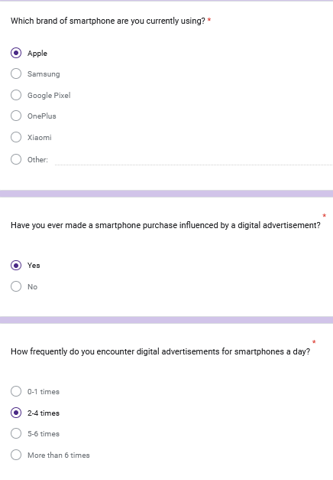

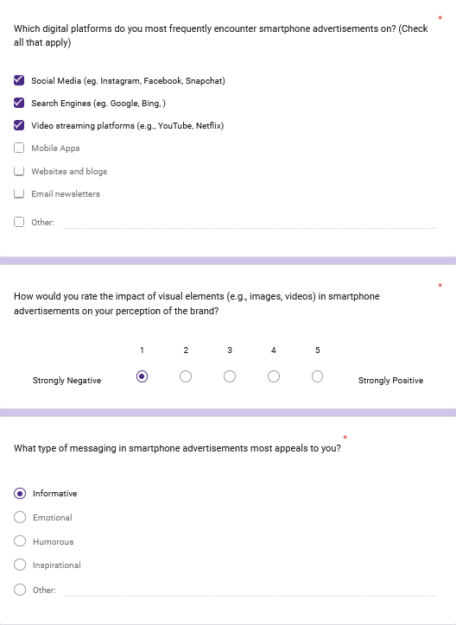

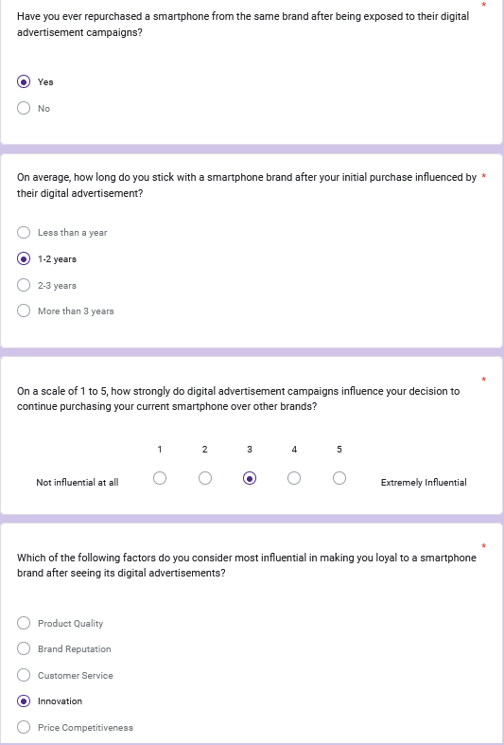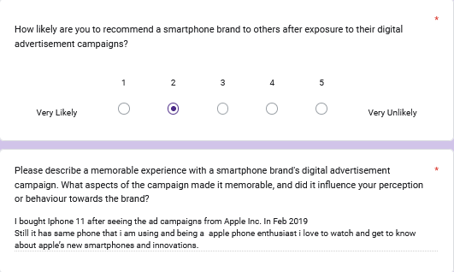

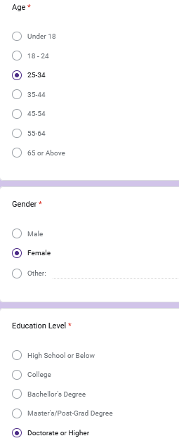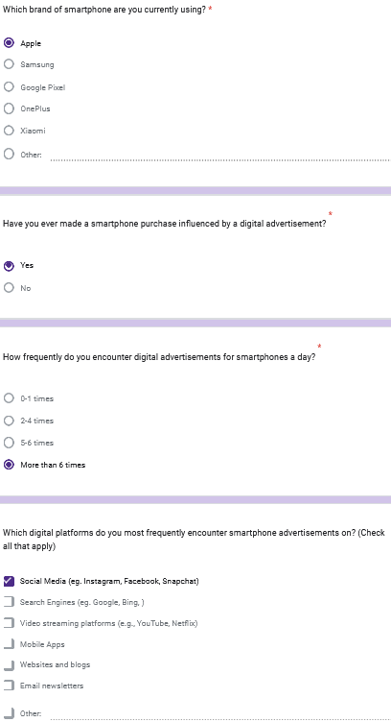
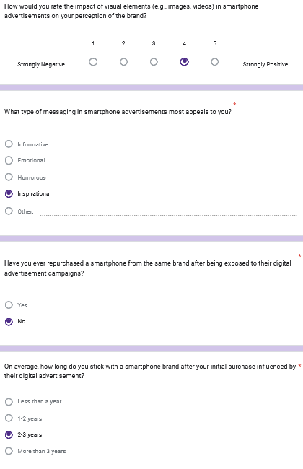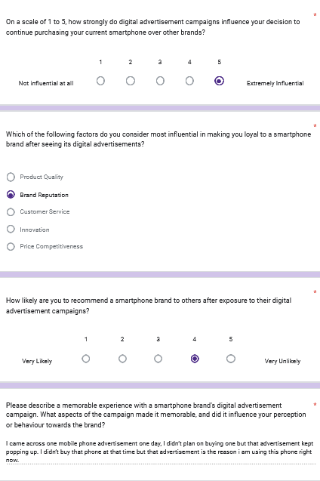

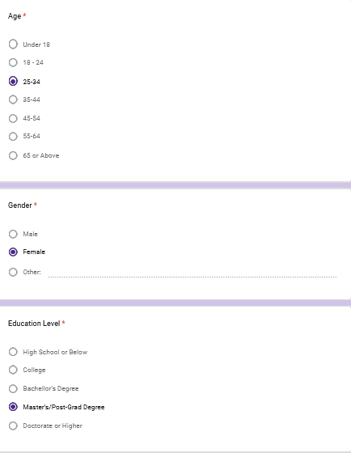
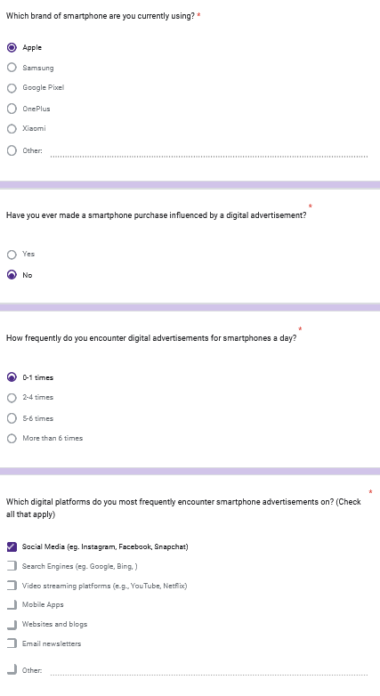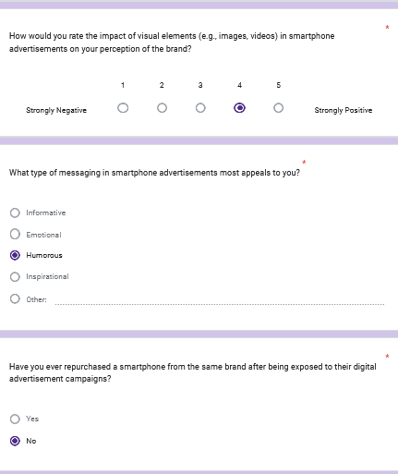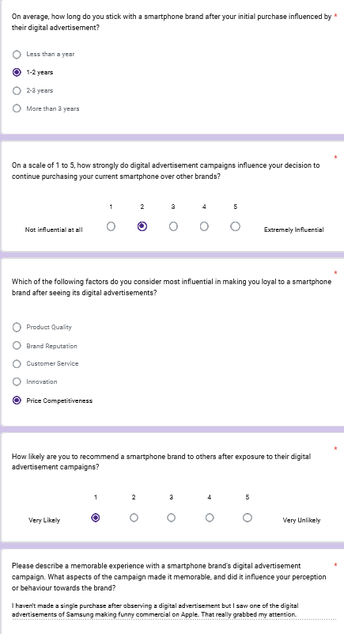

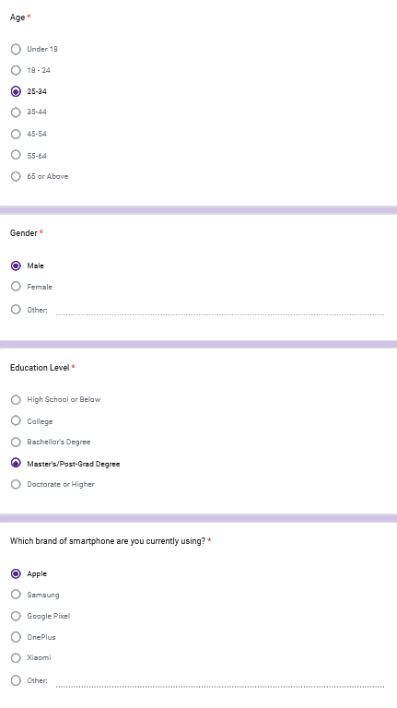

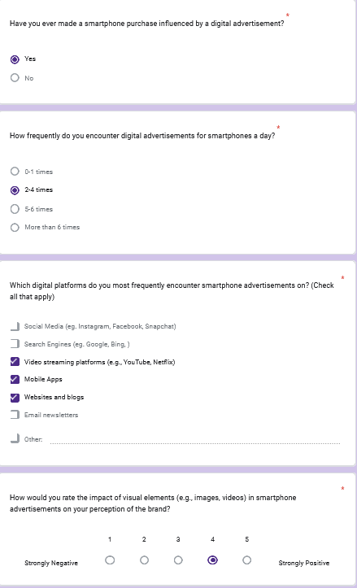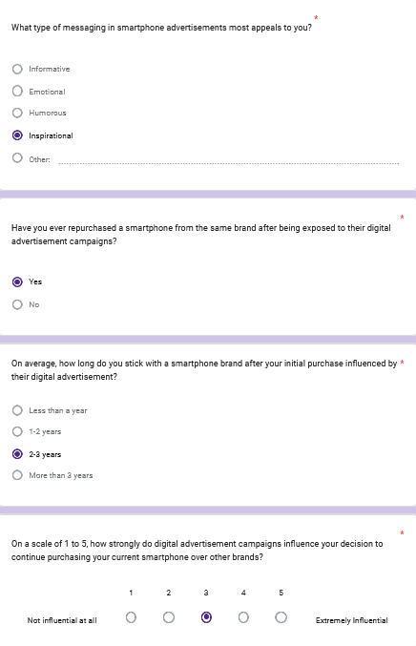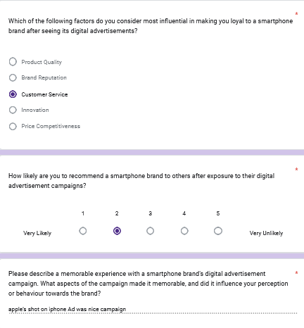
5.


