

Applied Computing
Wales Institute of Science and Art (WISA)

Advanced Networking (ACCA5024)

Home Work 1: Research IT and Networking Job
Opportunities (Regional/ International)

Submission Deadline: On or before 23/10/2020 23.59 Hrs.
Submission Via Moodle Link.


n.kaliyamurthy@uwtsd.ac.uk 1

Objectives
To understand the existing job opportunities related to Information Technology and Computer Networking.
Required Resources
• Device with Internet access

Task
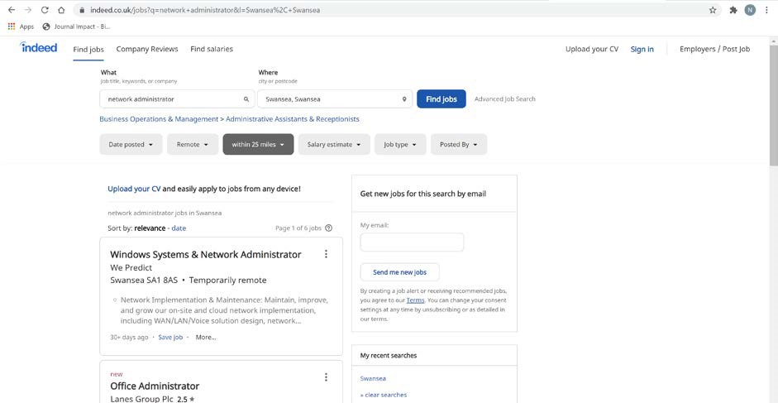
Do a Self-Study on Job Market related to networking skills in ANY Region of your choice (UK, Europe, Middle East etc). Analyze the requirements in the Industry, Skills Sets to be developed, Certifications required to apply for the Job, Salary ranges associated with the Jobs.
ACCA4024

2

n.kaliyamurthy@uwtsd.ac.uk

To complete this task,
You will use a web browser to visit the popular job listing websites, such as monster.com, indeed.co.uk, salary.com. Search on the “Networking” related jobs listed. You shall use keywords like “Network Administrator”, “System Administrator” etc.
Check out the Jobs available, its geographical location (Example: Swansea, Wales), the required technical skills, Certifications and Salary range.
Guidelines:
- Open a web browser and go to a job listing website. In the URL address bar type http://indeed.co.uk and press Enter.
- Search for networking related jobs. Type the word Network Administrator in the Keyword or Title box. Click Find Jobs to continue.

- Notice the search results. Now, focus your search by adding terms to the search for Network Administrator. Try terms like Cisco CCNA, CCNP, CCNA Security, CCNA Voice, etc.
- Try searching a different website. Add a search term like Information Technology to the Job title or Keyword field box and click Get my salary estimate.
- Note the large number of matching search results. Select a job title that interests you. Click
SHOW MY SALARY ESTIMATE RESULTS.
- Spend time searching for jobs and looking through the search results. Take note of what skills are required for different job titles and the range of starting salaries.

Write your report. (Word Limit 300 – 600)
Your report should be a summary of your search which should include (not limited to) the following:
- What job titles did you search for?
Network Administrator
System Administrator
- What skills or certifications were required?
Bachelor’s Degree in Computer Science, IT Systems, or a related discipline and 5 years + of related experience
MCSA certified or higher
- Did you find any jobs that you previously did not know existed? If so, what were they?
No although there was a variety of names for similar roles. Whilst I was not familiar with all these different names I am familiar with the various responsibilities of the jobs.
- Did you find any jobs that you are interested in? If so, which ones and what skills or certifications do they require?
No. My chosen profession is Cyber Security and as such I am not interested in securing a role in Networks.

ACCA4024

End of Document

3 n.kaliyamurthy@uwtsd.ac.uk

