Student Name: Elayne Da Cruz

Student ID:2016547

Module code: BMP6026

Component 1 – Suggested Plan

Table of Contents
1. Introduction 3
2. The Digital Innovation: NHS Virtual Wards and Remote Monitoring 3
3. Critical Evaluation of Impact Areas 4
3.1 Workforce Impact 4
3.1.1 Changes in Job Roles and Responsibilities 4
3.1.2 Digital Skills, Role Competencies, and Training Initiatives 5
3.1.3 Workforce Resistance, Workload, and Well-being Challenges 5
3.1.4 Evaluation: Benefits vs. Barriers for Sustainable Workforce Adoption 6
3.2 Service Delivery Impact 6
3.2.1 Transformation of Care Pathways and Patient Flow 6
3.2.2 Integration with NHS 111, Primary Care, and Hospital Discharge Systems 6
3.2.3 Efficiency Gains, Cost Implications, and Quality Improvements 8
3.2.4 Implementation Challenges and Long-term Scalability 8
3.3 Patient/Service User Impact 8
3.3.1 Accessibility, Convenience, and Continuity of Care 8
3.3.2 Patient Perceptions: Empowerment, Safety, and Privacy 9
3.3.3 Digital Inclusion vs. Exclusion 9
3.3.4 Evaluation: Personalised Digital Care and Equity Balance 10
4.Conclusion 10
5.References 12

Tables of figures
Figure 1:Lewis Change Model (Lock, 2018) 4
Figure 2:Illustration of the Technology Acceptance Model (TAM)(ResearchGate, 2024). 5
Figure 3:Consolidated Framework for Implementation Research(CFIR, 2023). 7
Figure 4:The Eight Principles of Patient-Centered Care(O’Neill, 2022). 9

1. Introduction
The UK health and social care has been rapidly changing digitally, and has increased the rate of incorporating technology-enabled models, e.g. NHS Virtual Wards that provide patients with the care level of a hospital in their homes. These are digitally facilitated services, which involve remote monitoring, data analytics and multidisciplinary coordination to decrease hospital admissions and maximise recovery (Vindrola-Padros et al., 2021). Virtual Wards introduced at the national level in 2019 and expanded in the course of the COVID-19 pandemic have played a crucial role in resolving bed shortages and improving continuity of care. Their adoption concurs with the NHS Long-term plan to improve patient-centred centred digitally enabled care in community and acute care settings. The importance of this innovation is that it transforms the way healthcare is delivered by providing the opportunity to intervene in time, enhance patient experiences, and contribute to the efficiency of the workforce.
In this report, NHS Virtual Wards and Remote Patient Monitoring (2019-present) have been critically assessed in relation to three areas, namely, the workforce, service delivery, and patient/service user experience, and it is necessary to note that these areas represent both advantages and disadvantages of modern UK healthcare.

2. The Digital Innovation: NHS Virtual Wards and Remote Monitoring
NHS Virtual Wards imply an innovative solution according to which patients receive the level of care provided by hospitals at home using digital technologies, wearable sensors, and telemonitoring systems. Patient data include pulse oximeters and ECGs, which are connected to clinician dashboards via these systems and allow continuous evaluation and prompt increase of worsening conditions (Vindrola-Padros et al., 2021). As a result of the NHS Long Term Plan (2019-2025) and developed at a fast pace over the course of the COVID-19 pandemic, Virtual Wards focus on increasing capacity in hospitals, reducing patient readmission, and facilitating continuity of care (Georghiou et al., 2022). It started being implemented in 2019, with national rollout (in large numbers) being implemented between 2020-2022, focusing on such conditions as respiratory illness, heart failure, and frailty (McGowan et al., 2024). The models are currently implemented in all England Integrated Care Systems, through the support of digital partners and multidisciplinary clinical teams. The positive results of the evaluations include fewer hospital admissions, increased patient confidence, and savings of money, though interoperability, digital inclusion, and sustainability of funding are still issues (Lyndon-Viney et al., 2025). Initial UK assessments of national potentials indicate that remote patient monitoring has a strong possibility of reorganising the UK healthcare delivery model and changing hospital-based acute care to the community environment without compromising the safety and quality of care (Wells et al., 2022).

3. Critical Evaluation of Impact Areas

3.1 Workforce Impact

3.1.1 Changes in Job Roles and Responsibilities
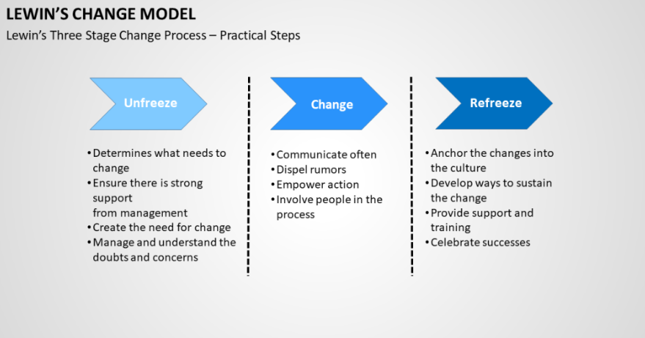
The emergence of the NHS Virtual Wards (VWs) and Remote Monitoring technologies has significantly altered the structure and functioning of healthcare teams. The hybrid team that comprises telehealth clinicians, remote monitoring coordinators, and digital nurse specialists now supports traditional ward-based care but allows overseeing it at the hospital level in communities (Fulop et al., 2023). According to the Wrightington, Wigan and Leigh NHS Trust, 1835 admissions were treated virtually in 2022-2024, and in only 12 % of instances, escalation was necessary, which is an indicator of better multidisciplinary coordination and role adaptation (Pugmire et al., 2025). This change is in line with the Change Management Model by Lewin (1951), within which unfreezing the conventional clinical roles was an essential step prior to refreezing the new digital practices into the everyday operations.
Figure 1:Lewis Change Model (Lock, 2018)

3.1.2 Digital Skills, Role Competencies, and Training Initiatives
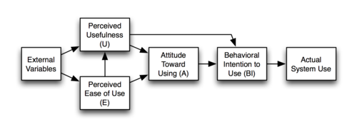
Implementation of VW requires high-level digital and clinical informatics skills in employees. According to the NHS Virtual Ward Evaluation (Fulop et al., 2023), more than 70 %of the employees needed further digital education to use monitoring dashboards and patient interaction applications safety. In addition, Shah et al. (2020) showed that mobile app-based monitoring resulted in a 47.6 hours/100 patients drop in clinician phone workload or the equivalent of 1.1 full-time equivalent (FTE) less per cohort. It is an increase in productivity, which is indicative of increased workforce flexibility and technology acceptance model (TAM) constructs, namely, perceived usefulness and ease of use, as motivators of adoption.
Figure 2:Illustration of the Technology Acceptance Model (TAM)(ResearchGate, 2024).

3.1.3 Workforce Resistance, Workload, and Well-being Challenges
Barriers still exist, regardless of the apparent benefits of the operation. Another 2024 study by McGowan et al. found that financial sustainability and technological interoperability were issues of concern to commissioners, and that front-line workers reported role ambiguity and digital fatigue to be the main stressors. On the same note, Lindsay, Cunnington and Dixon-Woods (2024) also found low uptake of remote monitoring in frailty wards with doubts on redistribution of work and appropriateness with older patients. These results emphasise resistance at the stage of the change of the Lewin model, which can be associated with the lack of co-design and organisational support most of the time.

3.1.4 Evaluation: Benefits vs. Barriers for Sustainable Workforce Adoption
The effect Virtual Wards have on the workforce is both good and bad. Given the efficiency benefits, Liverpool Liver VW resulted in a net cost savings of 3 days of hospital length of stay and produced a net cost saving of £1135 per patient episode (Rasoul et al., 2024), which is quantitatively efficient. Nevertheless, the qualitative data point to the issues of sustainability, i.e., continuous training, emotional labour in remote care, and the necessity to have concise governance. The solution to long-term success, therefore, lies in the insertion of continuous professional development (CPD) and a staff feedback loop as part of digital strategy models to create an equitable workforce empowerment.

3.2 Service Delivery Impact

3.2.1 Transformation of Care Pathways and Patient Flow
NHS Virtual Wards (VWs) have transformed acute, primary, and community care in terms of patient flow. VWs have been identified as a crucial system of integrated care pathways through their provision of early discharge and community-based management of acute conditions (Swift et al., 2021). To refer to the example, the Leicestershire and Rutland COVID-19 Virtual Ward resulted in the saving of 1,103 bed days and the accomplishment of the net financial savings of 529,719, which indicated the apparent improvement of the outcomes in the hospital throughput and efficiency (Swift et al., 2022). A 40 per cent decrease in hospital length of stay (LOS) after the implementation was reported in the Wrightington, Wigan and Leigh (WWL) NHS Trust (Jalilian et al., 2024), which demonstrates that virtual models allow the capacity of the system to be optimised without affecting safety. It is a change that indicates the dimensions of the Quality of Care Framework that represents structure-process-outcome, as the improved digital structures are associated with the quantifiable service outcomes.

3.2.2 Integration with NHS 111, Primary Care, and Hospital Discharge Systems
Effective VW delivery has been built on integration. Such models as the WWL service interface connect the acute hospital discharge trajectories to primary care and NHS 111 with a seamless transition and escalation plan (Pugmire et al., 2025). Going by the ratio of 62 % of all referrals in WWL were step-down patients of secondary care, and the remaining 38 % were community or GP as well, which demonstrated good coordination across the sectors. Based on the CFIR model, such success is attributed to the alignment of inner settings, i.e., organisational preparedness and digital interoperability (McGowan et al., 2024). Nonetheless, disjointed data systems and the disparity in the electronic health records (EHR) platforms still hinder the nationwide scalability.

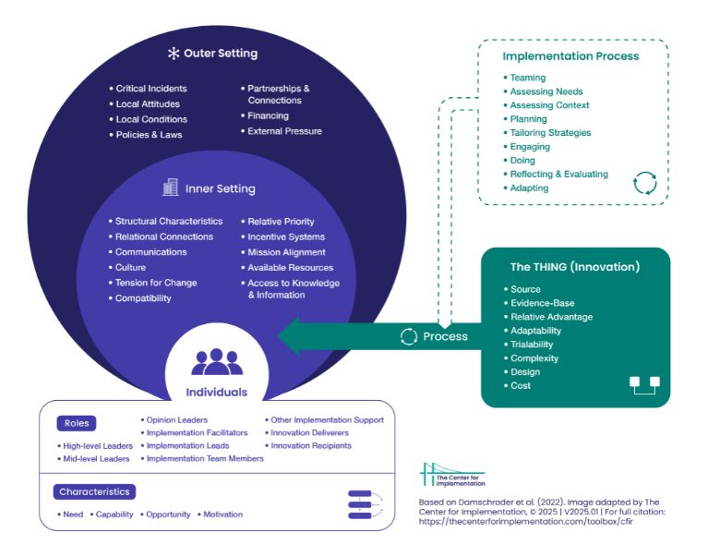
Figure 3:Consolidated Framework for Implementation Research(CFIR, 2023).

3.2.3 Efficiency Gains, Cost Implications, and Quality Improvements
Substantial operational and economic gains are proven based on empirical evidence. Jalilian et al. (2024) discovered that every single day spent under VW care is worth equivalent to £935, or 536 per conventional hospital bed day, which implies releasing three beds per day in a 40-bed model. On the same note, the AF Virtual Ward pilot saved three days of average inpatient stay and avoided 22 readmissions, and only 4% of ED reattendance (Saleh et al., 2024). The quality results also increased; 94% of VW patients assessed their care as excellent or good (Pugmire et al., 2025). However, commissioners doubt the financial sustainability in the long term due to the high cost of digital infrastructure and the reliance of the workforce (McGowan et al., 2024).

3.2.4 Implementation Challenges and Long-term Scalability
The common obstacles are data interoperability, lack of standardised procurement processes and digital maturity not being equal among NHS trusts. These are considered to be barriers to scalability in the CFIR framework as the outer setting barriers. Besides, it has been indicated that there might be variation in patient eligibility and cost-effectiveness, as Jalilian et al. (2024) caution that costs per saved bed day may increase up to 75 % when poorly scaled. The success in the long term is therefore dependent on a strong digital infrastructure.

3.3 Patient/Service User Impact

3.3.1 Accessibility, Convenience, and Continuity of Care
NHS Virtual Wards (VWs) have made access to acute care more readily available at home it offering convenience and continuity to patients with chronic or acute conditions. In Liverpool Heart Failure VW, the net cost benefit per ward episode was £1135, and the frequency of readmissions decreased by 22% with more than 10,950 patients treated at home by 2024 (Rasoul et al., 2024). Likewise, Wrightington, Wigan and Leigh VW recorded a 94% patient satisfaction level, the majority of them reporting it as being safe and reassuring (Pugmire et al., 2025). The results show that they are consistent with Patient-Centred Care Theory, which provides care continuity, autonomy, and relational communication as the determinants of perceived safety and trust.
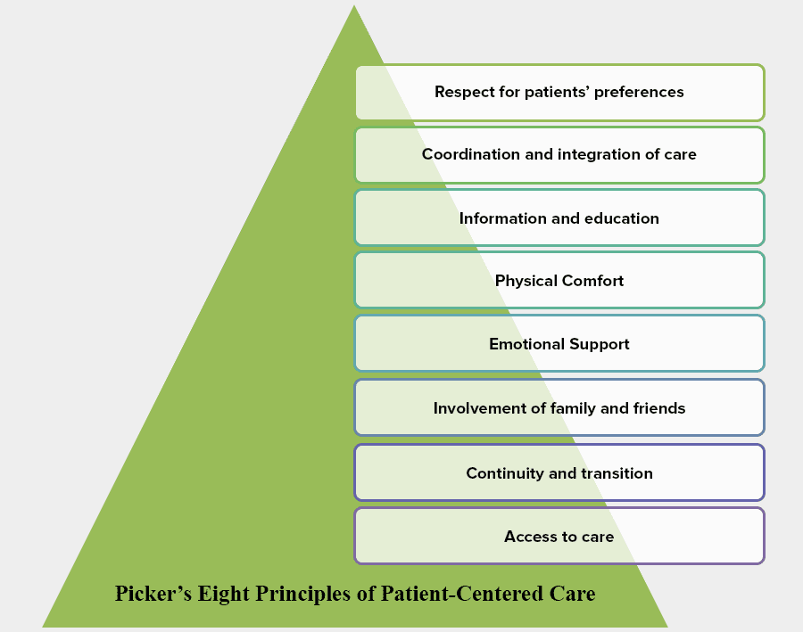
Figure 4:The Eight Principles of Patient-Centered Care(O’Neill, 2022).

3.3.2 Patient Perceptions: Empowerment, Safety, and Privacy
Cornwall VW evaluation also provided qualitative data, which revealed that patients reported their empowerment and safety at home and that the care was described as personalised and caring (Oxford Open Digital Health, 2025). Nonetheless, incompatibility of the systems decreased the level of confidence of clinicians about the reliability of remote data, which indirectly influenced patient reassurance. In the research on Atrial Fibrillation (AF) Virtual Wards, 100% of the respondents were satisfied positively (Kotb et al., 2023), and the level of acceptance was high when digital communication was easy and well facilitated. However, Vindrola-Padrós et al. (2021) reported weak evidence regarding the positive patient safety results because of inconsistent monitoring and escalation data failures--the proclamation of the necessity of standardised measures of digital safety in the care delivery process.

3.3.3 Digital Inclusion vs. Exclusion
Although VWs now have better access, there are still inequalities. In a study of 857 VW users, Gao et al. (2021) discovered that 36.9% of them were geriatric (mean age 81.5 years); older people had lower ease-of-use ratings (but higher adherence rates. This counters the beliefs of technological resistance by the older generation. However, Lindsay et al. (2024) noted a low adoption of frailty wards because of the usability barriers, ineffective design of the devices, and a deficiency of digital literacy. The Digital Divide Framework highlights the role of structural inequalities in the form of access to broadband and the usability of devices as the determinant of unequal experience among socioeconomic groups.

3.3.4 Evaluation: Personalised Digital Care and Equity Balance
More importantly, though virtual models make it more convenient and self-managed, there is a risk of increasing the exclusion of low-literacy or rural populations when there is not enough co-design and training. It has been indicated that digital interventions are effective when they are human-mediated, culturally aware and when the intervention is an extension of the same community service. In order to maintain a fair result, NHS policy should thus be made inclusive regarding design, interfaces that are appropriate in terms of language, and continued support systems that would keep patients trustful and engaged.

4.Conclusion
The introduction of NHS Virtual Wards and Remote Monitoring (2019-present) has fundamentally changed the UK health and social care, bringing in quantifiable improvements in efficiency, patient satisfaction, and workforce flexibility. It is shown that hospitals had fewer admissions, better continuity of care, and increased digital skills of clinicians (Fulop et al., 2023; Rasoul et al., 2024). Nevertheless, scalability is hampered by the incessant obstacles, including digital exclusion, lack of interoperability, and sustainability issues.The Virtual Wards, being a modern innovation, serve as a practical example of how the digital transformation can help to turn the objectives of the NHS Long Term Plan of integrated patient-centred care into reality. In order to cement the gains, it is suggested that NHS Trusts should invest in continuous professional development (CPD) of employees, introduce co-production models that would facilitate patient inclusion, and implement uniform digital frameworks that would guarantee data integration across systems. Mobilising the revenue to manage obstacles like workforce exhaustion and unequal access to digital technology, interoperability, and equity-driven policy options are needed to transform Virtual Wards into a need during a pandemic to a permanent pillar of 21st-century healthcare provision.

5.References
CFIR (2023). Consolidated Framework for Implementation Research (CFIR) 2.0. [online] The Center for Implementation. Available at: https://thecenterforimplementation.com/toolbox/cfir [Accessed 19 Nov. 2025].
Fulop, N.J., Walton, H., Crellin, N., Georghiou, T., Herlitz, L., Litchfield, I., Massou, E., Sherlaw-Johnson, C., Sidhu, M., Tomini, S.M., Vindrola-Padros, C., Ellins, J., Morris, S. and Ng, P.L. (2023). A rapid mixed-methods evaluation of remote home monitoring models during the COVID-19 pandemic in England. Health and Social Care Delivery Research, [online] 11(13), pp.1–151. doi:https://doi.org/10.3310/FVQW4410.
Gao, Q., Prina, A.M., Ma, Y., Aceituno, D. and Mayston, R. (2021). Inequalities in Older age and Primary Health Care Utilization in Low- and Middle-Income Countries: A Systematic Review. International Journal of Health Services, 52(1), pp.99–114. doi:https://doi.org/10.1177/00207314211041234.
Georghiou, T., Sherlaw-Johnson, C., Massou, E., Morris, S., Crellin, N.E., Herlitz, L., Sidhu, M.S., Tomini, S.M., Vindrola-Padros, C., Walton, H. and Fulop, N.J. (2022). The impact of post-hospital remote monitoring of COVID-19 patients using pulse oximetry: A national observational study using hospital activity data. eClinicalMedicine, 48, p.101441. doi:https://doi.org/10.1016/j.eclinm.2022.101441.
Jalilian, A., Sedda, L., Unsworth, A. and Farrier, M. (2024). Length of stay and economic sustainability of virtual ward care in a medium-sized hospital of the UK: a retrospective longitudinal study. BMJ Open, 14(1), pp.e081378–e081378. doi:https://doi.org/10.1136/bmjopen-2023-081378.
Kotb, A., Armstrong, S., Koev, I., Antoun, I., Vali, Z., Panchal, G., Barker, J., Mavilakandy, A., Chin, S.H., Lazdam, M., Ibrahim, M., Sandilands, A., Somani, R. and Ng, G.A. (2023). Digitally enabled acute care for atrial fibrillation: conception, feasibility and early outcomes of an AF virtual ward. Open Heart, [online] 10(1), pp.e002272–e002272. doi:https://doi.org/10.1136/openhrt-2023-002272.
Lindsay, R., Cunnington, P. and Dixon-Woods, M. (2024). Why is implementing remote monitoring in virtual wards (Hospital at Home) for people living with frailty so hard? Qualitative interview study. medRxiv (Cold Spring Harbor Laboratory). doi:https://doi.org/10.1101/2024.10.02.24314760.
Lock, D. (2018). Human Synergistics. [online] Human Synergistics. Available at: https://www.humansynergistics.com/blog/culture-university/2018/01/31/charting-for-change-in-the-workplace/ [Accessed 19 Nov. 2025].
Lyndon, H., Viney, T. and Slade, V. (2025). A Service Evaluation of Virtual Wards in Cornwall, UK. Oxford Open Digital Health. [online] doi:https://doi.org/10.1093/oodh/oqaf008.
McGowan, L.J., Graham, F., Lecouturier, J., Goffe, L., Echevarria, C., Kelly, M.P. and Sniehotta, F.F. (2024). The Views and Experiences of Integrated Care System Commissioners About the Adoption and Implementation of Virtual Wards in England: Qualitative Exploration Study. Journal of Medical Internet Research, [online] 26, p.e56494. doi:https://doi.org/10.2196/56494.
O’Neill, N. (2022). The Eight Principles of Patient-Centered Care. [online] Oneview. Available at: https://www.oneviewhealthcare.com/blog/the-eight-principles-of-patient-centered-care/.
Pugmire, J., Ashish, A., Chadwick, A., Wilkes, M., Meekin, D., Zaniello, B. and Zahradka, N. (2025). A 2-Year Retrospective Clinical Evaluation of a Novel Virtual Ward Model. Journal of Primary Care & Community Health, 16. doi:https://doi.org/10.1177/21501319251326750.
Pugmire, J., Wilkes, M., Kramer, A., Zaniello, B. and Zahradka, N. (2024). 2225 Geriatric patients in virtual wards; technology adoption style, ease of use, and adherence to remote monitoring technology. Age and Ageing, 53(Supplement_3). doi:https://doi.org/10.1093/ageing/afae139.080.
Rasoul, D., Chattopadhyay, I., Mayer, T., West, J., Stollar, H., Black, C., Oguguo, C., Kaur, R., MacDonald, R., Pocock, J., Uzdzinska, B., Umpleby, B., Hex, N., Lip, G.Y.H. and Sankaranarayanan, R. (2024). Economic evaluation of the Liverpool heart failure virtual ward model. European Heart Journal - Quality of Care and Clinical Outcomes. [online] doi:https://doi.org/10.1093/ehjqcco/qcae095.
ResearchGate (2024). Figure 1. Illustration of the Technology Acceptance Model (TAM). [online] ResearchGate. Available at: https://www.researchgate.net/figure/llustration-of-the-Technology-Acceptance-Model-TAM_fig1_228631114.
Saleh, K., Syan, J., Sivanandarajah, P., Wright, M., Pearse, S., Barrett, J., Bird, J., McQueen, G. and Khan, S. (2024). Insights from a single centre implementation of a digitally-enabled atrial fibrillation virtual ward. PLOS Digital Health, 3(3), pp.e0000475–e0000475. doi:https://doi.org/10.1371/journal.pdig.0000475.
Shah, S.S., Gvozdanovic, A., Knight, M. and Gagnon, J. (2020). Mobile App–Based Remote Patient Monitoring in Acute Medical Conditions: Prospective Feasibility Study Exploring Digital Health Solutions on Clinical Workload During the COVID Crisis (Preprint). doi:https://doi.org/10.2196/preprints.23190.
Swift, J., O’Kelly, N., Barker, C., Woodward, A. and Ghosh, S. (2022). An Economic Evaluation of a virtual Covid Ward in Leicester, Leicestershire, and Rutland. doi:https://doi.org/10.1101/2022.06.27.22276736.
Swift, J., woodward, A., Harris, Z., O’Kelly, N.I., Barker, C. and Ghosh, S. (2021). The implementation of a virtual ward using digital solutions informing community clinicians in early supported discharge of patients with SARS-Cov2 respiratory symptoms from an acute hospital setting. medRxiv (Cold Spring Harbor Laboratory). doi:https://doi.org/10.1101/2021.03.29.21254548.
Vindrola-Padros, C., Singh, K.E., Sidhu, M.S., Georghiou, T., Sherlaw-Johnson, C., Tomini, S.M., Inada-Kim, M., Kirkham, K., Streetly, A., Cohen, N. and Fulop, N.J. (2021). Remote home monitoring (virtual wards) for confirmed or suspected COVID-19 patients: a rapid systematic review. EClinicalMedicine, 37, p.100965. doi:https://doi.org/10.1016/j.eclinm.2021.100965.
Wells, E., Taylor, J.L., Wilkes, M. and Prosser-Snelling, E. (2022). Successful implementation of round-the-clock care in a virtual ward during the COVID-19 pandemic. British Journal of Nursing, 31(20), pp.1040–1044. doi:https://doi.org/10.12968/bjon.2022.31.20.1040.

