Veronika Marinova
Student Number: 1815123

This is a project business card for the Chinese lessons.

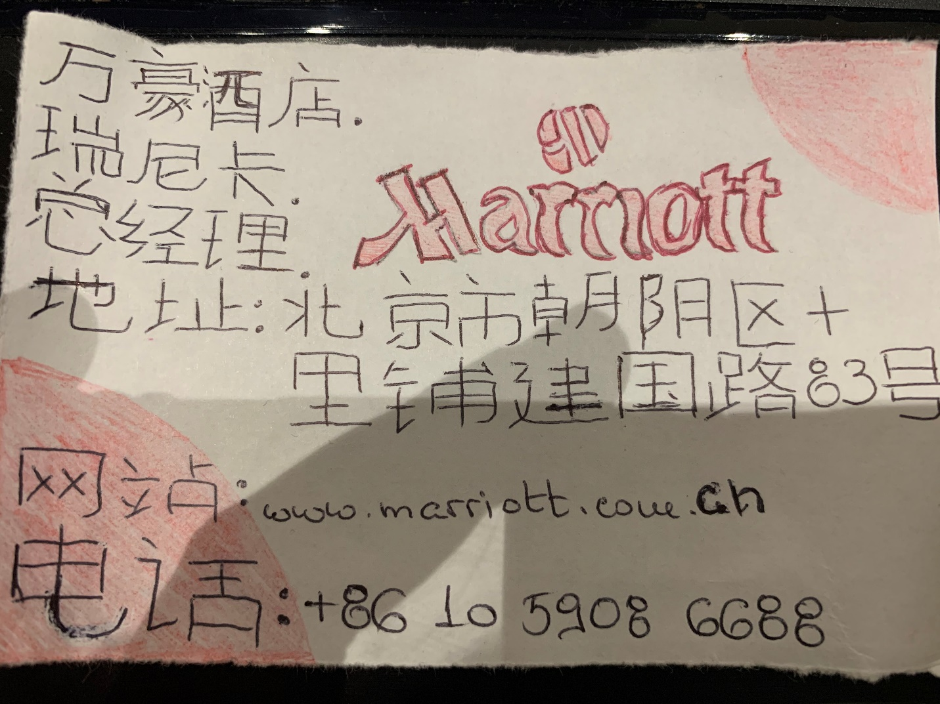

This is a project business card for the Chinese lessons.

