2403806
Task 15
Quiz
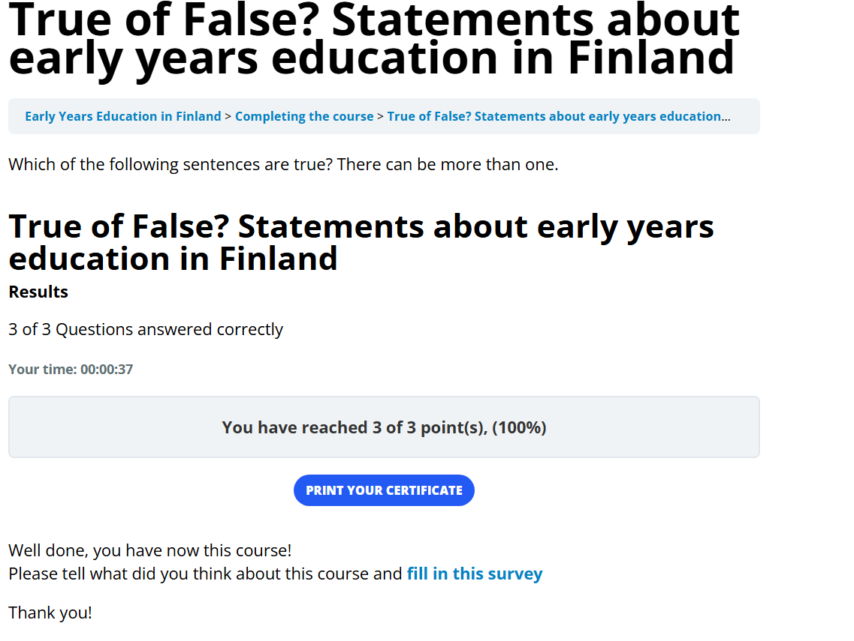

Turn it in said I had to have at least 20 words so I am just informing you so that I can upload the screenshot needed. Thank you.

