DS 1 Assignment

My Screenshots/Photos
- Please add 4–6 screenshots or photos of your digital life.
- You can use your phone or laptop.
- For each screenshot, write one or two sentences explaining what it shows.

Screenshot/Photo 1
I use my laptop to browse online whether its retail YouTube etc. I use it to also access moodle and university email. I create folders on my desktop to give direct links to work
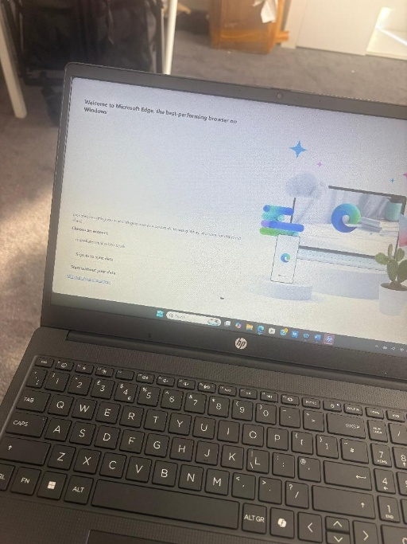

[Write what this shows of your digital life]

Screenshot/Photo 2
[Insert Photo/Screenshot below]

Daily i use my Apple iPhone on this device i can compose and respond to emails on my yahoo mail. I also use my phone to edit documents such as Microsoft word to edit my cv and other documents. I also use all my social media platforms on there such as snapchat, Instagram and TikTok.

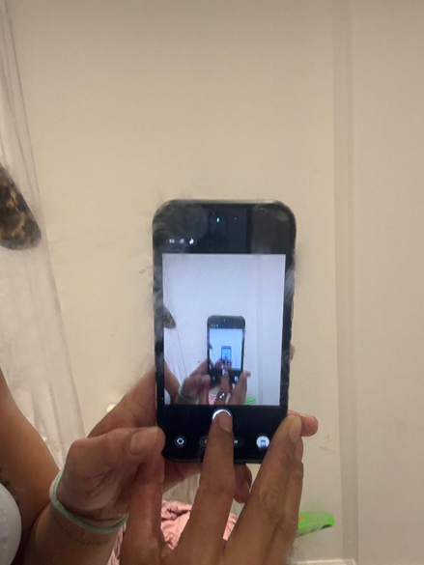

[Write what this shows of your digital life]

Screenshot/Photo 3
[Insert Photo/Screenshot below]
my air fryer daily as it uses less electric than my oven. I’m able to use different heating methods such as bake, max crisp and air fry my food is cooked quickly and thoroughly using different temperature modes to suit what I’m cooking.
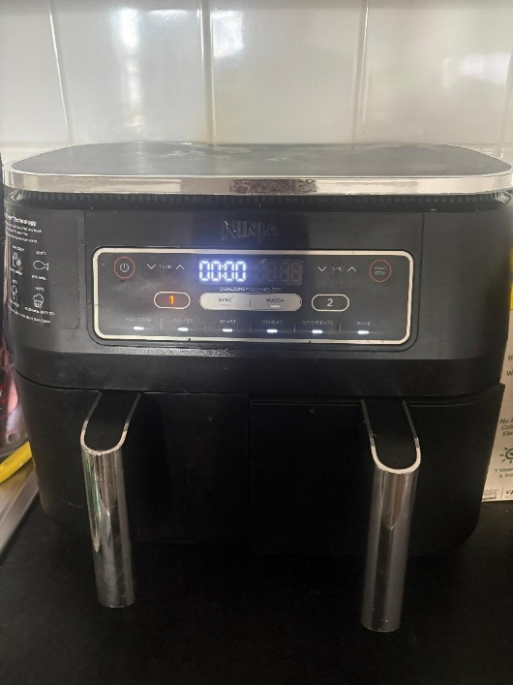

Screenshot/Photo 4
I use self-checkout regularly when I go grocery shopping as it's a quicker and easier alternative than waiting to be served at the tills by a staff member some also accept cash which is even better if you don't want to use card.
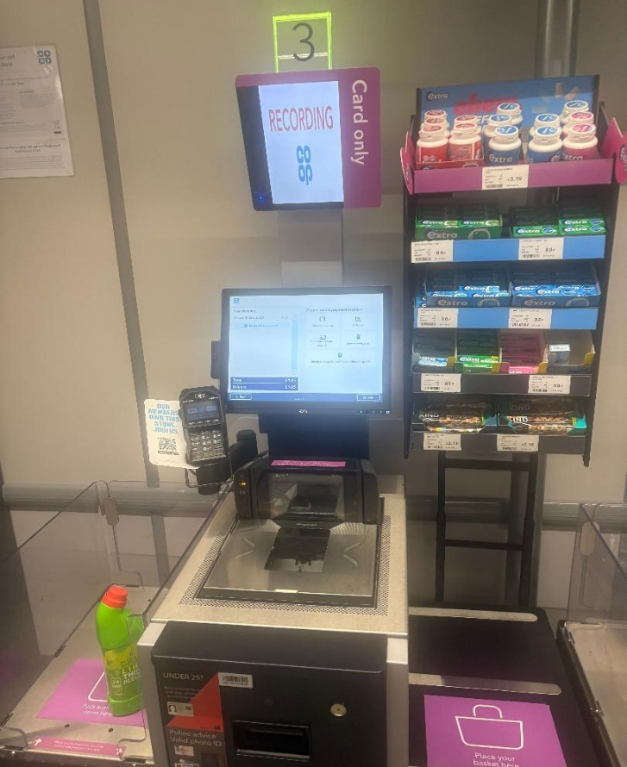

[Insert Photo/Screenshot below]

[Write what this shows of your digital life]

My Short Reflection
- Write 5–8 simple sentences about your digital life.
- You can use the sentence starters below if helpful.
I use digital skills in my daily life whether its for leisure work or browsing which includes using my phone, laptop, household appliances and digital items when I’m outside of the home. I feel confident when I use my phone as I am familiar with all the apps I use, and my device is personalised to me, so I feel comfortable when using it. I want to improve on my computer skills as even though I know how to use my laptop there’s still certain keys and methods I am not familiar with. I’m hoping this module takes me out of my comfort zone and allows me to learn new digital skills to implement in my daily life.

Sentence starters
- I use digital tools to …
- I feel confident when I …
- I want to improve …
- I often use these tools: …
- I sometimes feel nervous about …
- I hope this module will help me …
- Digital skills are important for me because …
You can write more if you want.

Submission Checklist
Before you submit, please check:
​​​ ☐ I added 4–6 screenshots
☐ I wrote short sentences for each screenshot
☐ I wrote my short reflection
☐ My work is my own
☐ My file opens correctly
​​☐ My file opens correctly

