BMSK5001
Developing Workplace Critical Thinking
Task 1 – Poster Reflection

What is reflection? Why do we need to reflect?
Tarrant notes that one of the advantages of reflection is that it makes an impact on professionalism. Through reflecting our practices, we become more self-aware, more in control, and be critical about our individual strengths and development needs. (Tarrant 2013 p.2)
David Kolb is a Psychologist who published the theory experiential learning cycle 1984. The theory works in two levels, a four-stage cycle or four separate learning styles. (please see appendix no1) The cycle is influenced on ‘learning from experience’, Kolb states that individuals must experience a situation before reflecting to improve or suggest development. (Bassot 2015 p.43-48)

To create the poster as a group we maximised our capabilities, worked exceptionally well, communicated effectively through WhatsApp. (please see appendix no2) My team were my motivators. We were enthusiastic and encouraged to make it happen. We understood our role and task, we asked for help and support from each other when we were unsure or needed guidance. Delegated our researches within the team for constructive feedback, shared ideas and concepts. we were trustworthy and had confidence in each other. we were comfortable with disagreements. We coordinated and accepted responsibilities with positive attitude. We were supportive and dependent on each other. We did not have conflict. We all financially contributed. Attended team meetings. My team had mixture of Belbin’s 9 team role characteristics, I am shaper and complete finisher. According to Meredith Belbin; the most consistently successful teams were ‘mixed’ with a balance of team roles. (Mullins and Christy 2010 p.343)

My contribution, I helped with the idea to create a book cover. I helped physically to make the poster with my team. As a team we came to the conclusion that I will start the presentation. I defined values, beliefs and attitudes, used RED critical thinking tool to analyse TSB to evaluate with evidence that they were value-led organisation.

I am proud of our teamwork, our poster was the best, the concept worked, it was fun working with Sabia, Nehar and Rima. Our team effort and hard work resembled through our poster and we have been awarded. Parker agrees that teamwork requires team players. It sounds like cliché, but it is the primary theme of this work that effective teamwork is based on an effective mix of people who exhibit variety of approaches to teamwork. (Parker 2008 p70)

The strengths of our poster; it was unique, creative, competitive, informative, descriptive, colourful, visually appealing, attractive, innovative, humour, knowledgeable, simple layout, easy to understand, our poster reflected our teamwork.

In comparison to other group posters, I did feel threatened by Tariqul, Momin and Mokbul’s poster; it was large, competitive, informative and descriptive. I did not feel threatened or demotivated by other group posters as I evaluated that they were still at the Tuckman’s storming stage at team formation. Conflict happens when team members challenge the authority of the leader, or when their roles have not been defined clearly, people start feeling overwhelmed with the workload. (mindtools.com 2019) evidently, the atmosphere felt hostile.

I do not think I would do anything differently next time; it all depends on professionalism and how we can adapt to different situations and environment.

Appendix

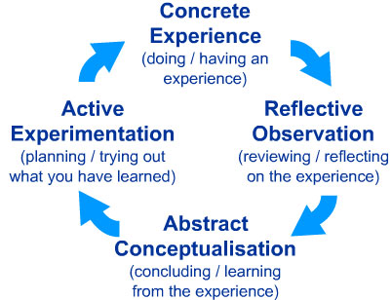

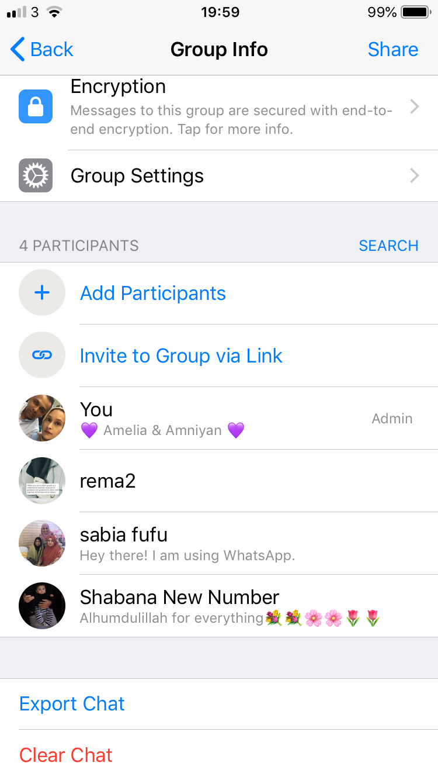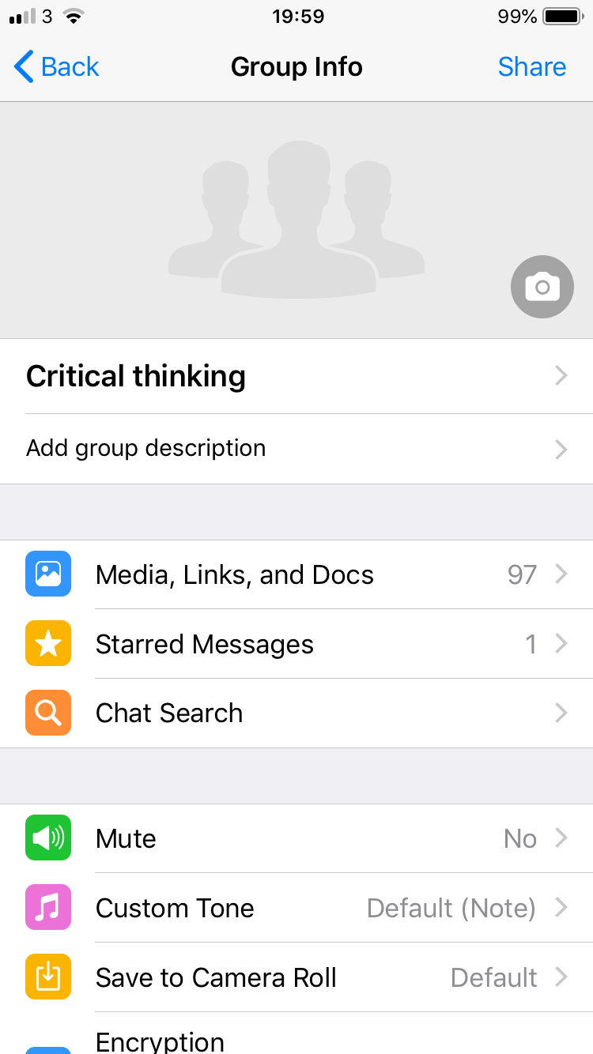

Reference List
Textbook:

Bassot, B. (2015) The Reflective Practice Guide. An Interdisciplinary approach to critical reflection. OXON: Routledge Taylor & Francis Group

Mullins, J. and Christy, G. (2010) Management and Organisation Behaviour. 9th ED. Essex: Pearson Education Limited

Parker, G.M. (2008) Team Players and Teamwork. New strategies for developing successful collaboration. 2nd ED. San Francisco: John Wiley & Sons

Tarrant, P. (2013) Reflective Practice and Professional Development. London: SAGE Publication Ltd

Website:

Mindtools (2019) Forming, storming, norming, and performing. Understanding the stages of Team Formation
Available at: https://www.mindtools.com/pages/article/newLDR_86.htm
(Accessed on 21st March 2019)

