Knowledge and Information Management of Amazon.com

Student Name******** Elizabeth Abiola Oladeji Johnson
Student Number*****1907179
Group******************2
Module Name*******Knowledge and Information Management Skills for the Workplace
Module Code*********BMSW5106
Module Tutor*********Mohamed Kalam
Date*********************April 2021

Executive Summary
This report relates to Amazon.com and its process of knowledge management was evaluated in a critical manner in this regard. The company is introduced and an overview is given.
Then the business information systems and their importance within the organisation will be discussed. The management information system that is used at Amazon was done as an attempt to link the information system as well as its development to the business goals of Amazon using a logical analysis of the business. It was identified also how the business was able to become a world-renowned giant in the industry by using such systems.
Also evaluated are the different information systems that have been successfully implemented by the organisation; the different aspects involved will also be discussed.
The fourth chapter critically analyses the different theories and models of knowledge management, four distinct theories of knowledge management relevant to this business will be discussed.
Finally, potential knowledge management challenges that can be faced by Amazon in the future and how best they could overcome such challenges effectively are discussed.

Contents
Executive Summary 1
Introduction 4
1.0 Company Profile 5
2.0 The Importance of Business Information Systems for Amazon 6
3.0 The information systems implemented by Amazon 9
3.1 Providing secure access to information 9
3.2 Interpretation 9
3.3 Decision support System 10
3.4 Communication driven decision support 10
4.0 Theories and Models of Knowledge Management 11
4.1 The Nonaka and Takeuchi Knowledge Spiral Model 11
4.1.1 Socialization 12
4.1.2 Externalisation 12
4.1.3 Combination 12
4.1.4 Internalisation 12
4.2 The KM Matrix by Gamble and Blackwell 12
4.3 The Knowledge Management Process Model 14
4.4 Von Krogh and Roos Model 15
5.0 Amazon’s potential knowledge management challenges 17
5.1 Getting and Keeping People Motivated 17
5.2 Keeping up with the Changing Technology 17
5.3 Measuring Knowledge Contribution 17
5.4 Security 18
5.5 Keeping Shared Information up to Date and Accurate 18
Conclusion & Recommendations 19
References 20

Introduction
The report will carry out a thorough evaluation of the organisation Amazon.com and the knowledge management principles that they tend to use. The business and the importance it place on the knowledge management principles and information systems were also considered here. The report also covered theoretical models of knowledge management as well as the potential conflicts that the business may have to face as well with regard to knowledge management. The key theories covered here were the Nonaka and Takeuchi Knowledge Spiral Model, The KM Matrix by Gamble and Blackwell, The Knowledge Management Process Model and the Von Krogh and Roos Model. The report was prepared for the purpose of understanding the best KM model to be implemented at Amazon and the potential outcomes that the business may gain from this.

1.0 Company Profile
Amazon.com was a company that initiated as a bookstore and has now been developed extensively into becoming a store that stocks almost any product in the market. The website Amazon.com offer diverse types of product such as books, clothes, office supplies, jewellery, software, grocery items, furniture and pet supplies. The organisation was initiated in the year 1994 in Washington by Jeffrey P. Bezos and was further re-incorporated in Delaware in the year 1996 (Amazon Website, 2021).
According to the Amazon Website, (2021) the organisation considered here, Amazon.com is involved in providing different online retail services for the purpose of shopping. The key segments that are used by this business are the Amazon Web Services (AWS), the international market segment as well as the North American segment. The AWS segment here is in relation with the global sales of distinct computer, database and storage service offerings that they provide for different markets, which may be either for businesses, educational institutes or start-up businesses. The international segment considered here tends to offer their diverse sales items related to consumer products that will be focused mainly throughout websites which are focused on international markets (Wittekind, 2012). The final North American segment considered here includes sales items of different consumer products that are focused on websites related to North America.
When considering the sales of the business, the USA is the largest market that the organisation Amazon.com obtains their sales. According to Wittekind, (2012) this amounts to approximately 50% of their total sales that occurs from the American market. The three most prominent markets internationally that bring in the next largest sales to Amazon are Germany, the United Kingdom and Japan. The organisation has over 175 centres that are focused towards operating fulfilment as well as over 150 million square feet of space that are owned by them for the associates to effectively pick the orders placed by their customers, pack them up and ship the orders. Since the company obtains millions of orders every year, this space has to be sufficiently large and impressive to manage all of them accurately (Shanahan, 2007).

2.0 The Importance of Business Information Systems for Amazon
Knowledge management is known as the process involved in defining, structuring and sharing the relevant knowledge and the experiences that employees have within an organisation.
The objective of using knowledge management is that it is used in order to enhance the level of efficiency of the organisation and also to save the knowledge that is present within the business as well. Knowledge management also involves a cycle that is involved with creating knowledge, sharing it with others, structuring it properly and also auditing knowledge effectively for the purpose of ensuring maximum effectiveness in the business with regard to knowledge.
Amazon is considered to be a leading E-commerce corporation that possesses a massive clientele in the market. In order to obtain a greater competitive advantage within the market, the business makes use of specialized information systems. The key aim in this instance would be to enhance their efficiency level in the areas of collecting data, storing information and analysis of consumer personal information (David, 2011).
According to Bennet, (2004) the organisation has been able to come up with different websites that could be utilised by millions of clients who can assess a massive range of products within such websites effectively. The device named as Kindle in this regard has helped writers so that they could publish the content that they have to offer, try to obtain publishers as well as develop their writing career in an effective manner (Davenport et al, 2002). The amazon web service is also extremely useful for the business in this regard as this help a business effectively in entering and working on diverse technology related programs in the market.
Alexander, (2018) states that one of the key factors of success for the organisation is the successful implementation of information systems that are extremely useful for the organisation in the long run. By effectively integrating the said information systems into the Amazon’s business process analysis has thus resulted in the decision making process becoming more decentralised, and thus increasing the process efficiency as a whole on the business. Amazon makes use of an information management software which is two piece in nature and this information management software that is used here is actually a simple storage service that tends to be connected towards the integrated database as well as to the Amazon Web so that the overall efficiency level of the business processes could be effectively enhance in this manner (Montgomery and Porter, 2001).
The management information system that is been used at Amazon was done as an actual attempt to link the information system as well as its actual development with the business organisational goals of Amazon using the key logical level analysis of the business (Quelle and Weiss, 2012). This system is extremely useful for the business as well as structured reports are formed for the business on different aspects considered. The information system used here will therefore evaluate the operations that are being carried out and will develop a report in this regard. The management information that will be utilised by the organisation will be a set of interrelated machines used and are arranged hierarchically, so that they can consider the different aspects of the business from the top right down to the bottom level. Here, Wittekind, (2012) states that the data that is obtain from the system will be used for the calculation of optimization concepts of the business. As a result, the information system that is used here tends to implement the principles of information organisation as well as principles of unity via the effective usage of information collection, storage processing as well as transmission of information by the use of technical means of support that will be the means of information collection, storage, processing and transmission via the help of analytical tools that could be utilised in instance (Neto et al, 2009).
Due to this level of development, Amazon has been able to successfully become one of the largest online stores through the world, being popular in the international market as well. Therefore, according to Sekhar, (2009) Amazon was successful in being the first to introduce this type of service in this market and was also a huge success which is a considerable achievement for them. Thus, they were able to achieve a successful competitive advantage within this market effectively.
The business has stated the importance of market in the success of their organisation as well and as such the business has analysed the sales rates that were observed after introducing a proper marketing strategy (Davenport and Prusak, 1998). The information systems that are used here had been used effectively in building a system of sales where normal people could also promote amazon’s products as well. Here the concept was that a site owner could effectively sell the products that are offered by amazon using their own resources, and thus will obtain a sales percentage for their efforts.
According to Koenig, (2009) the management information system that is utilised here has helped the organisation effectively in the creation of the cloud computing concept. Amazon has therefore decided to concentrate more on the types of earnings that they may obtain in the future effectively, so that that these aspects could be prioritised successfully within this market.
According to Chaundry, (2009) Amazon has also been able to be successful enough in offering the lowest prices to their customers which has been offered using the daily product pricing as well as by suing freight bids which has been done using the premium membership program that they use. This has been named as Amazon Prime and it has been helpful in identifying low price bids that are placed and the operational efficiencies of the business could also be enhanced using such a system as well (Dalkir, 2011).
User-friendly programs have been put in place by the business as well, that has helped them effectively in providing services that tend to be quick as well as reliable with the focus towards the consumer needs. Such distinct goods and programs that Amazon offers helps traders to provide a quick service to their consumers and also the customers will get their needs satisfied in a more efficient manner (Hill and Jones, 2012). Once amazon offers effective programs, the traders within the market could also sell their products and services effectively using the websites that are extremely accessible via either mobile phones or through computers.

3.0 The information systems implemented by Amazon
A key benefit that the business can face as a result having a well-integrated information system is that the process of decision making is then decentralised with the intention of decreasing the managerial diseconomies. This is especially significant for a business that has a major customer base to cater to (Bowman and Gatignon, 2010).
This will create a smooth flow into which the business processes involved within every functional unit will tend to operate in an extremely independent manner. At Amazon, it has further been stated that the components that are present within the information system of Amazon will therefore collect the relevant data from the said business processes and stores it within the main central database within the correct format. Therefore, such data will be utilised in the decision making process where all such data is analysed in an effective manner (Hill and Jones, 2012). There are distinct manners in which the information system will promote the process of decision making. Some of these would be as follows;

3.1 Providing secure access to information
According to Davenport (1996) the managers of Amazon need reliable information within their business operations and this information should be provided fast to them as well. Such information may relate towards marketing, employee performance, financial and inventory aspect of the business. Such information is essential for a business to identify the weak areas, the strengths of the business as well as any opportunities that are present in the market (Rabin and Miller, 2000). When the management obtains the relevant access to essential information as identified here, the business can easily automate the process of information collection, the sorting through stage and also during centralized information storage.

3.2 Interpretation
According to Shanahan, (2007) within the information management system of Amazon, there are certain specialized algorithms of data analytics that tend to be embedded into this so that the data could be more effectively interpreted by the management. This kind of trick is important due to the fact that it helps managers in evaluating the manner in which their decisions have an impact on the business processes that are involved here. Hence it is understood here that the raw data collected from the Amazon customer profiles will be thereafter collated into reports that will be specially formatted so that it is much easier to understand patterns and behaviours in relation to this. The data is collected in this regard form the profiles of their customers, the ordering processes, the aspect of product delivery and payment processes. This kind of reports will help the decision makers of the business to effectively coordinate the relevant action that should be taken and manage how such decisions will affect the different business processes as well (Rabin and Miller, 2000).

3.3 Decision support System
Further to allowing the access of relevant information as well as the interpretation of the same, the information of Amazon plays a key role within the decision support aspect of the business as well. The information system here also plays the role of a decision support system as well with regard to the use of the decision making processes that are taken into consideration in terms of both structured as well as unstructured decision making (MacLennan, 2010). The decision support system in this scenario tends to develop frameworks that are used for the analysis of data obtained.

3.4 Communication-driven decision support
According to Ferrell and Hartline, (2007) this type of information system provides the ability for many teams to effectively work together on a task that is common, so that actionable decisions may be taken by the management for the purpose of enhancing further the diverse business processes that are present. In such a scenario, the relevant processes of taking decisions tend to involve the interactions that takes place between the client and the server. These interactions may be in the form of either audio channels, video channels or even groupware channels.

4.0 Theories and Models of Knowledge Management

4.1 The Nonaka and Takeuchi Knowledge Spiral Model
According to Nonaka, (1994) the SECI model is a highly popular model of knowledge management and was developed in 1991 initially. This model explains the manner in which explicit and tacit knowledge tends to be generated, then is transferred towards other parties and is then recreated within organisations.
The model is involved with a spiral, and within this model this shows how the interaction of explicit knowledge and tacit knowledge take place in a continuous manner. The process contained here leads to the creation of totally new knowledge. The basis of this model is that when individuals have their own knowledge, they tend to share this knowledge with others which results in interconnecting this into a totally new knowledge. The level of knowledge keeps growing, which can be observed in the spiral as more rounds are completed here (Nonaka, 1994).

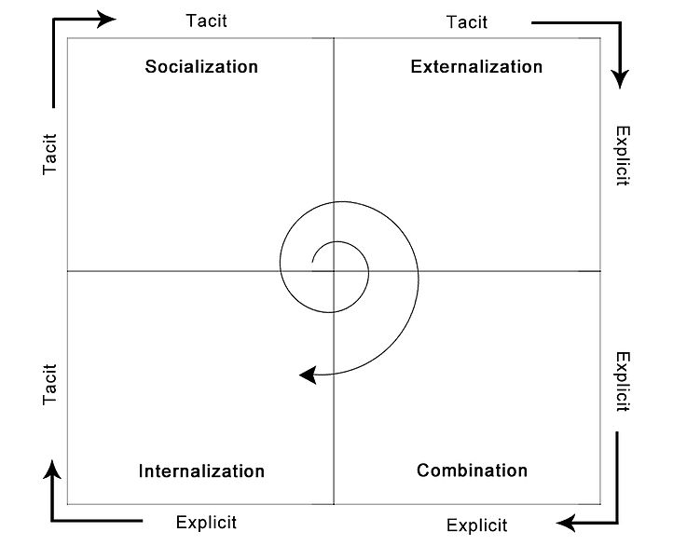
Figure 4.1: The SECI Model
Source: Nonaka, (1994)
The main purpose of using this model will be to make sure that everyone will have the relevant access to knowledge. The whole process of developing the relevant knowledge tends to be continuous and this will therefore exist in all the levels of the organisation in an effective manner. As a result, it could further be said that this process is unpredictable to all as well (Dalkir, 2005).
Within the model developed by Nonaka and Takeuchi, it has been identified that four distinct modes of knowledge are present when considering the conversion of knowledge (Davenport and Prusak, 1998). These are;
- Socialization (tacit to tacit),
- Externalization (tacit to explicit),
- Combination (explicit to explicit), and
- Internalization (explicit to tacit).

Socialization
This is the process involved with sharing the relevant tacit knowledge present via observation, through imitation, as well as via participating within diverse communities (Chaundry, 2009). The process takes place by having a space where communities have the ability to interact with each other on a social standing.

Externalisation
This is the process involved in converting tacit knowledge into the concepts involved din explicit knowledge. Since the concept of tacit knowledge tends to be heavily internalised, this specific process will be the key towards sharing knowledge and also in creating new knowledge (Montgomery and Porter, 2001).

Combination
This is the process involved in integrating the concepts identified into a system of knowledge. For example, a trend analysis that is carried out, a newly organised database or an executive summary.

Internalisation
This aspect involves the process involved in the aspect of representing the explicit knowledge into actual tacit knowledge (Davenport and Prusak, 1998).

The KM Matrix by Gamble and Blackwell
According to Montgomery and Porter, (2001) this model of knowledge management involves a theoretical framework in addition to the guides that will be useful for the implementation of the model as well. The illustration is given in the image below.
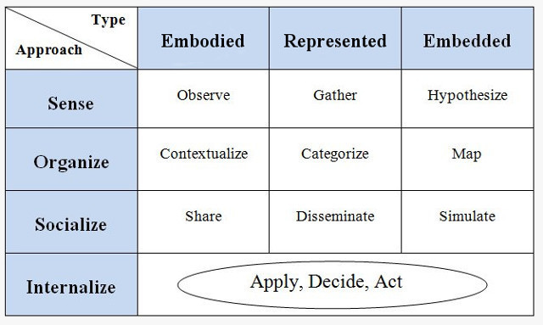
Figure 4.2: The KM Matrix
Source: MacLennan, (2010)
According to this matrix, the process of knowledge management has been divided into four distinct stages. Initially, the management of an organisation will have to identify the sources of knowledge. Then this knowledge will have to be organised in an effective manner in order to evaluate the diverse strengths and weaknesses of the business so that they can in turn evaluate the level of relevancy that this has on the business and how well it could be used again (MacLennan, 2010). This will therefore be followed by the concept of socialization, where different techniques tend to be used for the purpose of sharing knowledge to anyone who needs it within the business. Finally, this model talks of the knowledge being internalized with the use of it.
Ferrell and Hartline, (2007) states that as with the case in all models that uses a sequential path, these exact stages may not be followed exactly when it is being used in practice. However, this model is good to obtain an overview of the roles played by a relevant manger in knowledge management. A limitation that was identified within this model is that the role of knowledge management tends to be limited towards the aspect of sharing knowledge, and it tends to neglect the creation of knowledge or the manner in which knowledge is gained (Neto et al, 2009).

The Knowledge Management Process Model
This model of knowledge management provides a better and more realistic version of the process of knowledge management and its elements. There are three categories considered here and these three broad categories are said to overlap with each other effectively. The focus here will mainly be on the initiatives of the management. However, this model too identifies the omission of the strategic focus of the business, however the development process of new knowledge is specified in this model (Koenig, 2009).
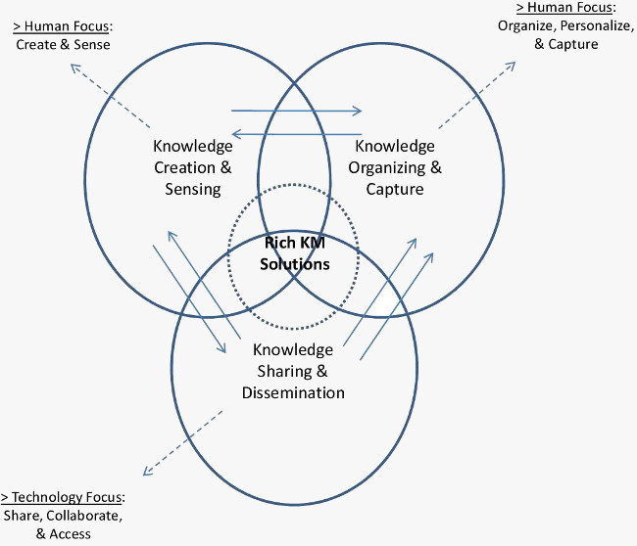
Figure 4.3: The Knowledge Management Process Model
Source: Neto et al, (2009)
The model also specifies as to what category of the three are more oriented towards people and which is more towards technology as well. However, the fact whether knowledge sharing and the process involved here should be ideally focused on technology or not is a fact that is debatable and different organisations have their own views on this matter (Quelle and Weiss, 2012). However, in the business world most organisations tend to treat this as a more technological aspect than as an organisational or social challenge.

4.4 Von Krogh and Roo’s Model
The model of KM that has been built up here and the logic behind this model could be effectively identified using this figure given below.
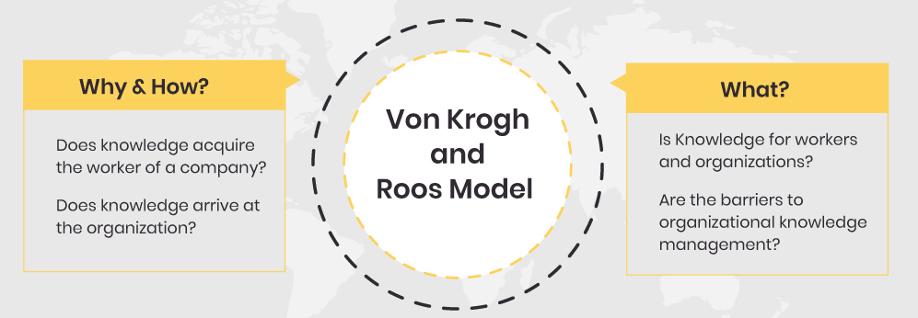
Figure 4.4: The Von Krogh and Roos Model
Source: Dalkir, (2011)
The KM model identifies here that the authors von Krogh and Roos have come up with a framework that is extremely innovative here with a solution that will usually occur in the minds of the people considered or else in the links that are present between people (Bennet, 2004).
According to Rabin and Miller, (2000) the basis of knowledge management has therefore been evaluated in this aspect using certain terms which could be identified as follows.
- Knowledge Workers
- Better Communication Skills
- Enterprise Structure
- Network of Workers
- HR Management
This is a cognitive system that is being used in either the human form or in a virtual level. This system will be responsible for the creation of a model of KM that will be extremely realistic in the business world. The process of learning will come into action here once such a model is used in order to manipulate data effectively (Wittekind, 2012).
Sekhar, (2009) states on the other hand when considering the term cognitive epistemology, this will be the system that possesses effective knowledge possessing within an organisation. This type of functionalities that use such self-service levels are considered here. In such a situation, the member of a specific team has the ability to select information and to work with such information in an effective manner so that it will be obtained transparently from sources that are external to the business.
This model further states that the KM perspective that is present within organisations will help the brain of an individual to be able to work as a machine so that it will be useful for the purpose of logic creation and thinking. In this type of situation, the business is in need of an expressive framework that will help to obtain the relevant information that is presented to them (Shanahan, 2007).
The brain of an individual however do not have the ability to process the symbols that portray the sequences, but the potential will therefore be present to handle certain complex level perspective, diverse models of KM as well as the effective processes considered (David, 2011). Here the connection that tends to be interrelated between the components of KM is impressive and this type of learning is possible when the relevant knowledge is obtained from the different environments considered – both interior and exterior.

5.0 Amazon’s potential knowledge management challenges
Basically, knowledge management is about converting raw data into information that could be effectively usable in the business world. Therefore, according to Bowman and Gatignon, (2010) knowledge management will tend to contribute effectively towards the streamlining process of ideas, creating new products, starting new projects and solving problems. More than just identifying what Amazon has learnt previously within the past, knowledge management will also involve synthesizing the different aspects of people as well as information so that the total output obtained could be greater than that of the different parts that are considered here.

5.1 Getting and Keeping People Motivated
Amazon may find it a challenge to get all their employees to think in the same way in the aspect of storing and sharing data and information. Usually, people tend to be more comfortable in the way that things are done at present and how they are used to it rather than adapting themselves to new situations. Therefore, Amazon may find it hard to get their team sufficiently motivated enough to share their work ideas as well as their space even though it is important towards the success of the business (David, 2011).

5.2 Keeping up with the Changing Technology
With the development of globalisation, the whole world tends to change rapidly at an instance in the modern world. New releases and software updates are enhancing daily and the level of frequency tends to increase with regard to the technology that is used. The technology used is constantly changing and therefore there is a certain sense of urgency within Amazon to try to keep up with it at all times. This is especially important since ultimately, technology will be the key for new opportunities that will present itself to the business (Dalkir, 2005).

5.3 Measuring Knowledge Contribution
The concept of knowledge cannot be quantified and measured easily, due to the fact that it is extremely complex in nature (Davenport et al, 2002). Knowledge is obtained from experience as well as from relationships with other humans. Therefore, with regard to the concept of contribution of knowledge, Amazon should ideally focus on the aspect of shared purpose, and not on the actual efforts put here.

5.4 Security
For any business, it is extremely important to use the correct level of security that is needed for the protection of the data that is used within the business. According to Nonaka, (1994) at Amazon as well, this may be a potential challenge that they may have to face in terms of knowledge management. Therefore, they could effectively make use of security level and distinct permissions to protect the information that is stored. This will help to ensure that the information is only shared with those that it should be shared with.

5.5 Keeping Shared Information up to Date and Accurate
Amazon will also have to face the challenge of moderating their content effectively as this is a common issue in knowledge management that most business tend to face. The data that is generated by the users of the Amazon site is valuable to the business and therefore it will to be routinely updated and should be verified regularly as well. The organisation may also keep their information on an up to date manner by having reminders of validation so that all relevant information may be properly validated and kept secure at any given time (Alexander, 2018).
Conclusion & Recommendations
Conclusion
At Amazon, one of the key benefits that the business can face as a result of having a well-integrated knowledge and information system is that the process of decision making is decentralised with the intention of decreasing the managerial diseconomies. This is especially significant for a business that has a major customer base to cater to (Bowman and Gatignon, 2010).
This will create a smooth flow into which the business processes involved within every functional unit will tend to operate in an extremely independent manner. Effective information systems were identified to promote the process of decision making through communication-driven decision support, decision support systems, interpretation and providing secure access to information. The models of knowledge management were also critically evaluated in relation to this concept and the author also identified the potential challenges that the business may have to face in terms of knowledge management. The key theories covered here were the Nonaka and Takeuchi Knowledge Spiral Model, The KM Matrix by Gamble and Blackwell, The Knowledge Management Process Model and the Von Krogh and Roos Model.
The Spiral model beneficially makes sure that everyone will have the relevant access to knowledge, however it was critiqued for the process being unpredictable to all as well. Considering the KM Matrix, this model was identified to be good to obtain an overview of the roles played by a relevant manger in knowledge management; nevertheless, a limitation that was identified within this model is that the role of knowledge management tends to be limited towards the aspect of sharing knowledge, and it tends to neglect the creation of knowledge or the manner in which knowledge is gained. Considering the Von Krogh and Roos Model, this system was beneficially identified to be responsible for the creation of a model of KM that will be extremely realistic in the business world. The process of learning will come into action here once such a model is used in order to manipulate data effectively.
A range of potential knowledge management challenges in relation to Amazon have also been identified in this report. Once such involves getting and keeping people motivated where Amazon may find it a challenge to get all their employees to think in the same way in the aspect of storing and sharing data and information. Another challenge is keeping up with continuous changes and advancement in technology. This is especially important since ultimately, technology will be the key for new opportunities that will present itself to the business. A further challenge being measuring knowledge contribution, the concept of knowledge cannot be quantified and measured easily due complex in nature. Security is another key challenge to knowledge management where it is extremely important to use the correct level of security that is needed for the protection of the data that is used within the business.
Recommendations
Considering the critical evaluation of the various knowledge management models discussed in this report, it is recommended that the Amazon organisation can use the Nonaka and Takeuchi Knowledge Spiral Model for creating and managing the knowledge that they possess. The basis of this model is that when individuals have their own knowledge, they tend to share this knowledge with others which results in interconnecting this into a totally new knowledge. The level of knowledge keeps growing, which can be observed in the spiral as more rounds are completed. This model can be implemented successfully within the organisation in order to facilitate successful knowledge sharing. This implementation will enhance the knowledge management culture at Amazon to become more enriched and to ensure that the functioning is further effective as well.

References
Alexander, C. (2018) Strategic Marketing Management, 9th Edition, Cerebellum Press
Amazon , (2021) About Us, (Online). Available from: https://www.amazon.com/ [Accessed on: 17.03.2021]
Bennet, D. (2004). Organizational survival in the new world: the intelligent complex adaptive system, Butterworth-Heinemann Publishers.
Bowman, D. and Gatignon, H. (2010) Market Response and Marketing Mix Models: Trends and Research Opportunities, Now Publishers Inc
Chaundry, A. S. (2009). Knowledge Management. Tallinn University Press Publishers.
Dalkir, K. (2005). Knowledge Management in Theory and Practice. Butterworth Heinemann Publishers.
Dalkir, K. (2011). Knowledge Management in Theory and Practice. Cambridge, Massachusetts: the MIT Press Publishers
David.F. R. (2011) Strategic Management - Concepts & Cases. 13th ed., PHI Learning Private Limited
Davenport, T. (1996). Knowledge Management at Ernst & Young, Center for Business Innovation: Ernst & Young Publishers
Davenport, T. H., Thomas, R. J., & Cantrell, S. (2002). The mysterious art and science of knowledge-worker performance. Sloan Management Review, Fall 2002, 23-30.
Davenport, T. and Prusak, L. (1998) Working Knowledge: How Organizations Manage What They Know. Cambridge, MA: Harvard Business School Press.
Ferrell, O. C. and Hartline, M. (2007) Marketing Strategy, illustrated 4th Edition, United States: Cengage Learning Publishers
Hill, C. and Jones, G. (2012) Strategic Management: An Integrated Approach, 10th Ed. Cengage Learning
Koenig, M. (2009). Knowledge Management. Tallinn University Press Publishers.
MacLennan, A. (2010) Strategy Execution: Translating Strategy into Action in Complex Organizations, Routledge Publishers
Montgomery, C. A. and Porter, M. E. (2001) Strategy: Seeking and Securing Competitive Advantage, Harvard Business Press
Neto, R, C, D, de Alvarenga, Souza R, R, Queiroz J, G and Chipp H. (2009). Knowledge Management Implementation: a Process Design Proposition at Brazil’s ONS (National Operator of the Interconnected Power System). Electronic Journal of Knowledge Management, 7 (5), 593 - 604. http://www.ejkm com
Nonaka, I. (1994) A Dynamic Theory of Organisational Knowledge Creation. Organization. Science, 5(1), 14-37.
Quelle, G. and Weiss, A. (2012) Profitable Growth: Release Internal Growth Brakes and Bring Your Company to the Next Level, Springer Science & Business Media Publishers
Rabin, J. and Miller, G. J. (2000) Handbook of Strategic Management, 2nd ed, CRC Press Publishers
Sekhar, G. V. (2009) Business Policy and Strategic Management, I. K. International Pvt Ltd
Shanahan, F. (2007) Amazon.com Mashups, John Wiley & Sons Publishers
Wittekind, E. (2012) Amazon.com: The Company and Its Founder: The Company and Its Founder, ABDO Publishing Company

