BSc Cloud Computing
Learning in the Digital Era
ACCA4025
Assessment 1: E-Portfolio
[Shahzad Khawaja 2128045]
https://sites.google.com/view/
shahzad-khawaja

Some of the high-level qualities, skills and competences which will develop such transferable skills are as:
- creative thinking
- critical thinking
- making presentations

Creative Thinking
Creative thinking is all about developing innovative solutions to problems. Creative thinkers brainstorm not only many ideas but also a variety and range of them. You can manipulate ideas in unusual ways and make unconventional connections to outline novel possibilities that have the potential to elegantly meet a given purpose. Creative thinking is the ability to look at things differently and find new ways of solving problems.

Critical Thinking
Critical thinking is the ability to think clearly and rationally, understanding the logical connection between ideas. critical thinking does not mean looking only for the most important aspects of a topic or just criticizing ideas. It is also about not accepting what you read or hear at face value, but always questioning the information, ideas, and arguments you find in your studies.
Making Presentations
Making a presentation is a way of communicating your thoughts and ideas to an audience. When someone gives a presentation, they give a formal talk, often to sell something or get support for a proposal.

Automatic Referencing tool
Mendeley is a program for adding references lists and in-text citations to Microsoft Word documents [1]. By clicking "References" to locate a Mendeley Cite-O-Matic section, we may choose citations from our desktop Mendeley and insert them as in-text citations in your Word document. We can also choose our required reference style from the Style option box. We will select "Insert Citation" from the Mendeley Word plug-in bar and then use the search box to look up the pertinent citation [2].
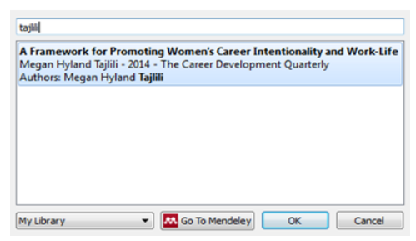
Figure 1: Mendeley Search Box [2]
Additionally, by choosing "Go to Mendeley" and selecting "Cite," we can choose a citation from our Mendeley library and add it to our work.
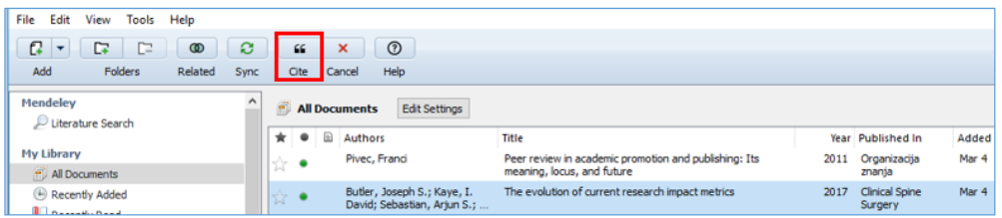
Figure 2: Mendeley library [2]
After making the necessary changes in our Mendeley library, we will amend the in-text citations in our Word document by clicking the "Refresh" button on the Mendeley Word plug-in bar [3].

Figure 3: Editing in-text citations [2]
When we click an in-text reference in your document, the button labelled "Insert Citation" in the Mendeley Word plug-in bar changes to "Edit Citation," allowing us to delete an author or add a page number [4].
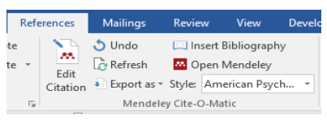
Figure 4: Edit citation [2]
We'll select "Insert Bibliography" to begin compiling our list of references. Each time we include a new in-text citation in our document, the reference will be immediately added to our reference list.

Figure 5: Insert Bibliography [2]

References

[1] | Mendeley, "Getting started with Mendeley Reference Manager," 2022. [Online]. Available: https://www.mendeley.com/guides/mendeley-reference-manager/.
[2] | A. Library, "Using Mendeley Cite," 1 April 2022. [Online]. Available: https://aut.ac.nz.libguides.com/mendeley/word.
[3] | ULS, "Introduction to Citation Management," 29 April 2021. [Online]. Available: https://pitt.libguides.com/citationmanagement/mendeley.
[4] | U. o. C. Irvine, "Mendeley Research Manager: Why Mendeley?," 15 June 2022. [Online]. Available: https://guides.lib.uci.edu/Mendeley.

'Life is a Team Sport' Activity


Teamwork relies on the team members’ ability to be flexible, and for a team to work together successfully, it is important to consider everyone’s habits and unique personality traits.
In cloud computing, the ability to
collaborate and work as a team is critical in a project’s success. (Alan
Zucker,
Project
Founding
principal
of
Management
Essentials
LLC). When you work on a team,
you know you have the support of the entire group to fall back on in case of failure. That security typically allows teams to take the kind of risks that create “Eureka!” ideas.

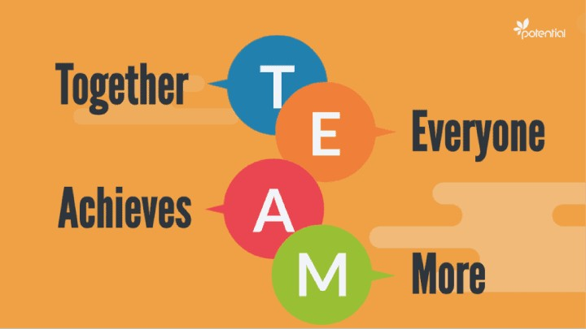
Becoming an effective team member
- Creates a smoother and looser structure by developing a friendly environment
- Encourages flexibility
- Enhances problem-solving
- Improves productivity
- Motivates the workforce and creates a healthy environment
Activity Findings
Teamwork based projects challenge the student to apply the technical knowledge they gain in school to solve meaningful and complex problems. These include planning,
estimating,
corrective controlling maintaining
tracking
actions,
and ethical
progress, taking
managing change, managing risks,
and
professional
conduct, communicating complex ideas
clearly and concisely, using design automation tools, leveraging web-based tools for team collaboration, and most importantly participating effectively as team members.
References
- Lingard, Robert, "Teaching and Assessing Teamwork in Engineering and Computer Science, Proc. International Symposium on Engineering Education and Educational Technologies: EEET 2009, Orlando, FL, July 2009.
- Denis Gillet, Isabelle Vonèche-Cardia, "Promoting Critical and Design Thinking Activities to Tackle Sustainable Development Goals in Higher Education", 2021 World Engineering Education Forum/Global Engineering Deans Council (WEEF/GEDC), pp.224-230, 2021.
- Øystein Nytr⊘, Anh Nguyen-Duc, Hallvard Trætteberg, Madeleine Lorås, Babak Amin Farschian, "Unreined Students or Not: Modes of Freedom in a Project-Based Software Engineering Course", 2020 IEEE 32nd Conference on Software Engineering Education and Training (CSEE&T), pp.1-10, 2020.
- Dan Zhang, Na Yao, Laurie Cuthbert, Steve Ketteridge, "A suggested strategy for teamwork teaching in undergraduate engineering programmes particularly in China", 2014 IEEE Frontiers in Education Conference (FIE) Proceedings, pp.1-8, 2014.

