Research Report
Student Name:Kristina Zebi
Student Number: 2127039
Lecturer Name: Seyed Navid Nasirpour
LCHS4002_BIRM
Digital Skills and Research Methods

Contents
1. Introduction 3
2. Research design 3
Research Question 3
Method 3
Ethical Considerations 4
3. Analysis 5
4. Results 13
5. Discussion 15
6. Conclusion 17
7. References 18
8. Appendices 20
Appendix A: Survey questionnaire 20
Appendix B: Digital Skills and Research Method Table 21

1. Introduction
Technologies play an integral part in the context of different organizations. In the present scenario, technologies have bought about robust modifications across the domain of different organizations. Successful companies in the domain of the UK and across different parts of the world have been able to maintain effective integration of a customer in the company profile directly or indirectly with the help of this technological underpinning. In popular companies such as Amazon Corporations, this technological leverage and significant scaling up have provided a huge impetus to the business proliferation. The broad spectrum of this extensive research and analysis will address the extensive research designs, deduction of the desired results along with an analytical discussion of the major findings.

2. Research design
Descriptive research design aims to gather information through systematically process and it also describes situation, population and different phenomenon. It also helps the researcher to identify the answer when, what, where, how and which questions are appropriate to comply with the research problems. As opined by Doyle et al. (2018), descriptive research design helps the researcher to develop an in-depth understand of the specific topic or any subjects or any situations. Therefore, in this research paper descriptive research design has been used for deep understanding of the research problems and problems of a company in the recent days.

Research Question
The research question for the study is formed based on the relevant research objectives
Q1) Are students confident in using technology to collaborate?”
The use of advanced technology to make team collaboration helps the students to make effective study and enhances team collaboration. In case, the students get confident about the use of advanced technology that helps the students to improve their study. This study mainly focuses on digital skills effective communication and teamwork. Therefore, in this case, the use of technology helps the students to make effective communication and good team collaborations. The team collaboration helps the students to overcome the study-related issues and gain better markets in the paper. At present, the use of advanced technology is highly increased to make effective communication and team collaboration.

Method
The selected research method that is used in the study is primary data analysis. As per the view of Islam and Aldaihani, (2022), this has been done with help of the survey method of the respective respondents in the research.This has also helped in the effective interpretation of the key findings (Dps.mn.gov, 2022). Another major advantage that has been derived while utilizing the survey method is that it helped in deep dive and navigation into the corporate profile of the Amazon Corporation. The overall precision and accuracy of the data have helped in bringing more clarity to the process. The information pertains to the industry floor directly hence there are more degrees of data authenticity that can be guaranteed in this respect.
The dispersion of greater control over the data can be assessed in this case. Moreover, effective data privacy can be maintained in this respect. The target issue and central problem are clearly understood with the help of the primary data analysis. The primary mode of data collection will also help in case of the effective deduction of the desired result from the data consolidated in the study. The selected research design for the study is a descriptive research design that is used extensively in the study. The proficient use of this descriptive research design will help to ideate systematic information for describing the phenomenon from the data collected relating to the Amazon Corporation. This research design has helped to analyse the non quantified issue pertaining to the research for the technological aspect in the domain of the company. This has also fostered the possibility of noticing the data sets in a completely unchanged ambience. According to the opinion of Agustine, (2022), the descriptive research design has also played a pivotal role in effectively integrating qualitative and quantitative data sets. This has also helped to make more informed decisions and has framed the projection route for the data analytics in the study. The research philosophy that has been used in the research and analysis is Interpretivism (Interpretivism). As opined by Junjie and Yingxin (2022), using this philosophy in the research the data set has been able to align properly as per the research.

Ethical Considerations
Ethical consideration has been given greater emphasis in the development of extensive research and study. The respondents who have been surveyed are the IT manager and IT supervisor of Amazon Corporation. They have been previously informed about the survey process and the extensive purpose of this survey as well. They have voluntarily consented to participate in the survey process (Mypeer.org.au, 2022). There has been no element of fraud, coercion or undue influence that has been plated for instigating them to provide the information in the research. There is proper informed consent from the pivotal parties engaged in the survey process. There has been no element of harm used in the study; all types of consent forms and required approval have also been taken in this regard. The confidentiality of the data sets has also been used maintained in the research. The anonymity has also been properly maintained in the study extensively. There has been no element of Copyright infringement that has taken place in the drafting and development of the study. All the relevant material that is extensively used in the study confirms to the stricter compliance of the Copyright law in force. The assessment of only those relevant and integral components has been used in the study that is relevant.

3. Analysis
Question 1: What is your age?
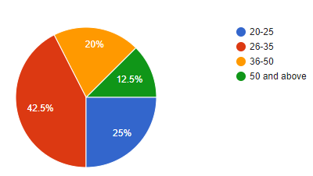
Figure 1: Question 1 Analysis
(Self-developed)
Analysis:
The result depicts that more than 40% of the participants in this study belong to the age group of 26 to 35 years.

Question 2: What is your gender?
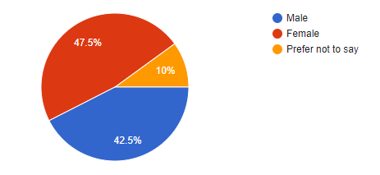
Figure 2: Question 2 Analysis
(Self-developed)

Analysis:
A maximum number of female respondents have been observed in this case, with an estimation of more than 45%.
Question 3: Have you ever used technology to make collaboration?
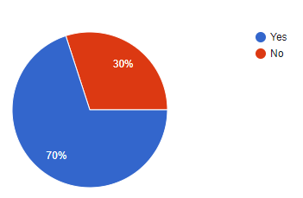
Figure 3: Question 3 Analysis
(Self-developed)

Analysis:
The pie chart represented above depicts that about 70% of the participants have used technology for any collaborative project.
Question 4: Do you feel happy collaborating using technology?
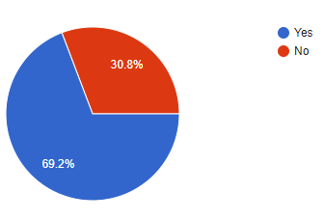
Figure 4: Question 4 Analysis
(Self-developed)
Analysis:
The result depicts that more than 69% of the participants feel happy collaborating using technology. Therefore, it indicates that technology helps to make good collaborations.
Question 5: Do you ever use technology for study purposes?
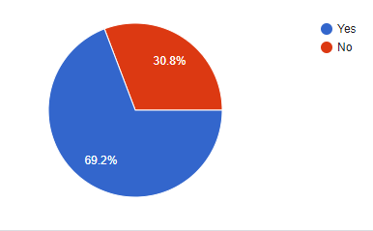
Figure 5: Question 5 Analysis
(Self-developed)
Analysis:
The pie chart represented above depicts that about 69% of the respondent have used technology for study purposes. Therefore, it indicates that technology helps the students for study purposes.
Question 6: Are you confident in using technology to collaborate?
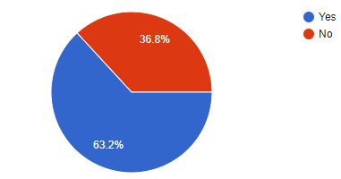
Figure 6: Question 6 Analysis
(Self-developed)
Analysis:

The result depicts that almost 63% of the participants are confident in using technology to collaborate. Therefore, it shows that people like to use technology to collaborate.

Question 7: Do you feel anxious using technology to collaborate?
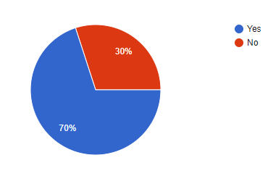
Figure 7: Question 7 Analysis
(Self-developed)
Analysis:

The result depicts that almost 70 % of the respondent feel anxious about using technology to collaborate. Therefore, it shows that most of people feel anxious about using technology.

Question 8: Is the use of technology help to improve team collaborations?
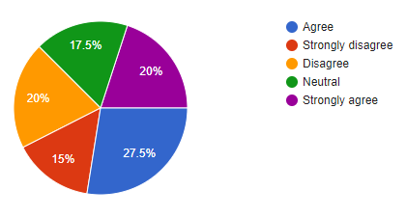
Figure 8: Question 8 Analysis
(Self-developed)
Analysis:

The pie chart represented above depicts that about 27.5% of the respondent agree and 20% of the respondent strongly agree that the use of technology help to improve team collaborations. In this case, 15% of the respondent strongly disagrees about the concept. Therefore, it indicates that technology helps to improve team collaborations.

Question 9: Do you feel online collaboration is challenging?
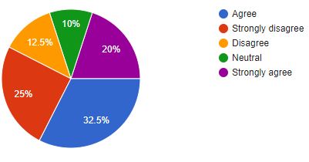
Figure 9: Question 9 Analysis
(Self-developed)
Analysis:

The pie chart represented above depicts that about 32.5% of the participants agree and 20% of the respondent strongly agree that they feel online collaboration is challenging. In this case, 25% of the participants strongly disagree about the concept. Therefore, it indicates that online collaboration is challenging.

Question 10: Do you think the use of advanced technology help to improve communication?
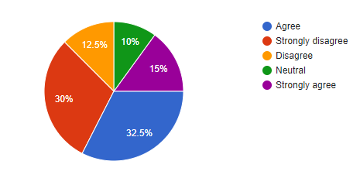
Figure 10: Question 10 Analysis
(Self-developed)
Analysis:

The result depicts that about 32.5% of the respondent agree and 15% of the respondent strongly agree that the use of advanced technology help to improve communication. In this case, 30% of the respondent strongly disagrees about the concept. Therefore, it indicates that the use of advanced technology help to improve communication.

Question 11: Do you think the use of advanced technology help to improve your work?
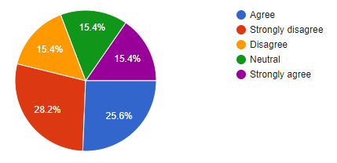
Figure 11: Question 11 Analysis
(Self-developed)
Analysis:

The result depicts that about 25..6% of the participants agree and 15.4% of the participants strongly agree that the use of advanced technology help to improve their work. In this case, 28.2% of the participants strongly disagree about the concept.
Question 12: Does Amazon encourage the students to use technology?
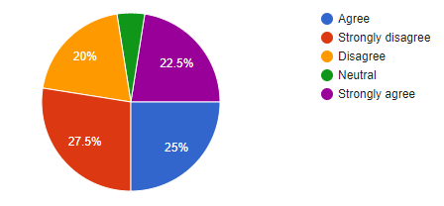
Figure 12: Question 12 Analysis
(Self-developed)
Analysis:

The pie chart depicts that about 25% of the participants agree and 22.5% of the participants strongly agree that they feel online collaboration is challenging. In this case, 27.5% of the participants strongly disagree about the concept. Therefore, the result shows Amazon moderately encourage the students to use technology.

Question 13: Have you ever used technology to collaborate with your peers?
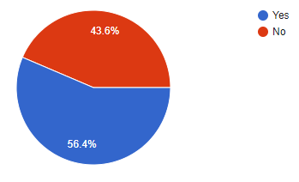
Figure 13: Question 13 Analysis
(Self-developed)
Analysis:

The above picture shows that almost 56 % of the respondents have used technology to collaborate with their peers and they feel happy.

Question 14: Do you think the use of advanced technology help to improve study and teamwork?
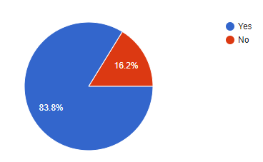
Figure 14: Question 14 Analysis
(Self-developed)

Analysis:

The above picture depicts that almost 83 % of the respondents feel that the use of advanced technology help to improve study and teamwork.
Question 15: Do you feel hesitant in online collaboration?
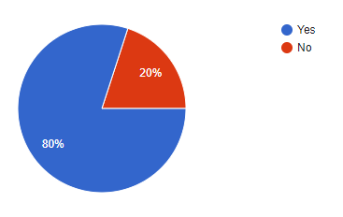
Figure 15: Question 15 Analysis
(Self-developed)
Analysis:

The pie chart depicts that almost 80 % of the respondents feel hesitant about online collaboration.

Question 16: Do you feel online collaboration help to save time and cost?
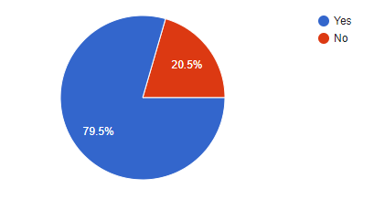
Figure 16: Question 16 Analysis
(Self-developed)
Analysis:

The above figure depicts that almost 89 % of the respondents feel online collaboration help to save time and cost.

Question 17: Do you feel confident using OneDrive to collaborate with teammates?

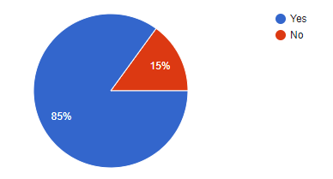
Figure 17: Question 17 Analysis
(Self-developed)
Analysis:

The pie chart depicts that 85 % of the participants feel confident using OneDrive to collaborate with teammates.

4. Results
The survey conducted for the research explores different dimensions of the company as stated.
Theme1. Technologies used to enhance employability and workplace efficiency
Amazon Corporation is one tech-savvy corporation hence, the technology is not only the end product of the company but in the internal framework of operation, these are extensively used to simplify and amplify the working pattern and work culture for the employees. Technologies such as “Ernie” are one such technology that helps the employees to remain in more stable conformable and ergonomically sound positions. This also curtails the need for bending to pick up and fetch things for them (Aboutamazon.com, 2022). This helps in limiting the strenuous movements of the employees. This helps in saving almost 38.8% of their time. Proportionately this can be contributed to some other progressive purposes. This plays an active role in increasing workplace efficiency. “Bert” is another popular autonomous mobile robot that is used to increase workplace efficiency in the company. Another major carrier system that is deployed in the company to enhance work efficiency is “Scooter” and “Kermit”. Taking the help of the Primary analysis, the research papers have been conducted. However, in this research paper, the survey analysis has been held on. The 40 participants have responded to this survey as well based on the research questions the 17 questions have been created in an effective manner. Therefore, by analyzing these research papers the readers can be getting a lot of information. These robotic systems help to initiate a lot of physical performance that has reduced the dependency on human labour by considerable proportions. Technologies that Amazon Corporation uses the increasing employability are Social Media Platforms through developing effective collaboration with respective universities. This helps them to penetrate into the university profile and gather relevant human resources profiles to incorporate into the corporate profile of the company. Talent acquisition software, gamification techniques, HRM information system and software are used in the Amazon Corporation for increasing employability aspects in the market of operations.
Theme2. Identification and evaluation of information sources
Amazon Corporation uses diverse information from different available sources. The external data are collected using external databases such as census data for gathering demographic indices and allied information. The core business information is effectively handled using advanced technologies such as “Hewlett-Packard servers” such as Linux and oracle. Other information about the company is also gathered using advanced research tools and software such as “SurveyMonkey”, “Alchemer”, and “SurveyLegend” and others. Amazon Corporation’s unique interface connects to every prospective customer segment. Proficient usage of online social media platforms is also seen in the domain of this company (Aws.amazon.com, 2022a). This helps them to ideate the buying trend and pattern for every individual customer segment. This also aids them to suggest interacting offers to those consumer profiles. Thus with help of these advanced information sources and analytics, the company is able to integrate more customers.
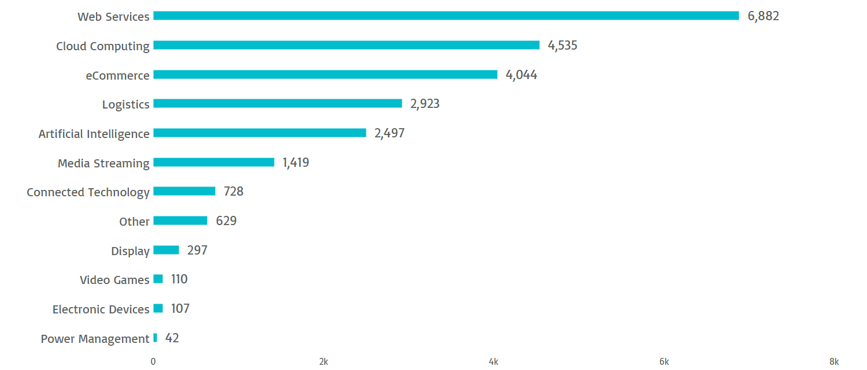
Figure 1: Technology usage in Amazon Corporation
(Source: Insights.greyb.com, 2022)
Theme3. Analysis of competence in Data handling for workplace scenario
Amazon Corporation believes in the effective monitoring of the data handling and privacy legislation landscape and evolves itself. The above table reflects technology use across different services for the company. These evolutions help them to be at par with the changing dynamics of the market of operations. The detail of the content that is uploaded to the server is encrypted using proper encryption technologies such as “AWS identity”, “AWS management”, “AWS cloud tail”, and “AWS organizations” (Aws.amazon.com, 2022b). The storage is also supported by the AWS regional database. This helps in creating departments based on regions and storing the data. For effective competence in workplace data handling the company uses different use cases such as “Cloud single-sign-on (SSO) service”, “Automate vulnerability management”, “Filter malicious web traffic”, and others. The use of these advanced versions of systems and integrated software helps in the protection of data infringements and addresses the core issue pertaining to data thefts and management. The use of these advanced systems reflects the level of competence of the Amazon Corporation in maintaining and management of the data.

5. Discussion
Theme1.
Amazon Corporation understood the main nerve impulse of the scenario. As said by Gotenget al. (2022), the use of this advanced software and technologies in the domain of the company helps them to increase its productivity by almost 68.85% more than any of its nearest market competitors such as eBay, Alibaba group and others (Williamson et al. 2022). It helps in bringing the automation and systematizes the overall workflow processes. This also propagates an open line of effective communication throughout the profile of the Amazon Corporation. Advanced level of strategic planning and time management is also facilitated by the use of these technologies.
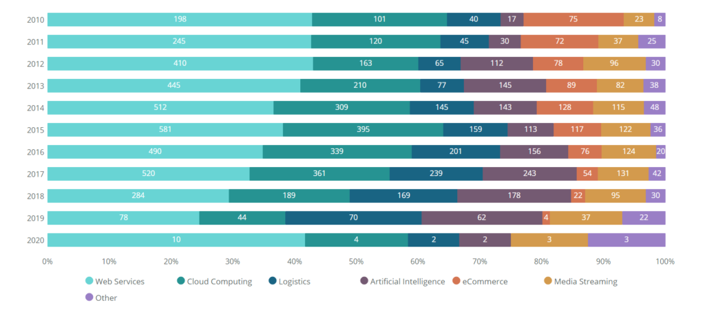
Figure 2: Portfolio of services featuring technological underpinning
(Source: Insights.greyb.com, 2022)
Theme2.
Advance technologies such as Linux and oracle, “SurveyMonkey”, “Alchemer” and others help the amazon corporation in different ways. It facilitates customization of data there by supporting the decision making prospects more effective. It also helps in bringing operational efficiencies to the company (Nibusinessinfo.co.uk, 2022). The stakeholders can be managed in a proper manner along with providing a seamless experience to the customers. It also opens up new alternatives for expansion and growth. This has effectively helped Amazon corporation is expanding its branches of operation.
Theme3.
The use of advanced analytics in the company has helped Amazon to scale up its business portfolio in consecutive years. The data management system such as “AWS identity”, “AWS management”, “and AWS cloud tail” and others have facilitated customer retention and management for the Amazon Corporation (Shapiro, 2022.). This has also helped to identify the potential risk for the business and take rectifying measures accordingly. The use of advanced data analytics to innovate constantly and reinforce effective cost optimization for the company has been supported by the technologies. As opined by Maccario and Naldi, (2022), this has also helped to increase the overall efficiency of the company. The leverage of the business is also supported by these technologies by aiding the complex supply chain of the company.

6. Conclusion
Amazon Corporation is one of the largest technological multinational corporations that have its diverse branches spread across different domains of the global market. The company primarily operates in digital streaming, cloud computing, e-commerce, and artificial intelligence. Thus technology plays a pivotal part in the domain of the Amazon Corporation. The above reflected study encompasses the development and subsequent progression of the study based on underpinning research questions. The overall emphasis of the research has been on the effective interpretation of effective technologies to improve the workplace efficiency and employability factors. The wide range of information sources that are deployed and used by the Amazon Corporation are also discussed in the study.
The chosen primary method of data collection and gathering has provided in bringing a lot of practical essence to the research. The competence depiction in the handling of workplace related data is also illustrated in the study. Modern technologies such as “Ernie”, “Bert”, and others have somewhere simplified the diverse functioning in the context of Amazon corporations. This has amplified the workplace culture and safety indices across different sections. The above developed study navigates through the research design and the results and discussions of those results. Amazon Corporation believes in the contrast scaling up of technological efficiency. This also provides huge impetus to the business performance and provides a competitive edge to the company in the market of operations.

7. References
Aboutamazon.com, (2022). From testing new workstations to innovating on high-tech autonomous vehicles, Amazon’s Robotics and Advanced Technology teams focus on making work safer for employees. Available from https://www.aboutamazon.com/news/innovation-at-amazon/new-technologies-to-improve-amazon-employee-safety.Accessed on 26/7/2022.
Agustine, F.S., 2022. AN ANALYSIS OF THE STUDENTS’DIFFICULTIES IN WRITING DESCRIPTIVE TEXT. In NATIONAL SEMINAR OF PBI (English Language Education) (pp. 303-308).
Aws.amazon.com, (2022a). Analytics on AWS. Available from https://aws.amazon.com/big-data/datalakes-and-analytics/. Accessed on 26/7/2022.
Aws.amazon.com, (2022b). AWS Cloud Security. Available from https://aws.amazon.com/security/?nc=sn&loc=0.Accessed on 26/7/2022.
Doyle, L., McCabe, C., Keogh, B., Brady, A. and McCann, M., 2020. An overview of the qualitative descriptive design within nursing research. Journal of Research in Nursing, 25(5), pp.443-455. DOI: https://doi.org/10.1177%2F1744987119880234
Dps.mn.gov, (2022). GATHERING INFORMATION. Available from https://dps.mn.gov/divisions/ojp/forms-documents/Documents/Wilder_Program_Evaluation_8.pdf.Accessed on 26/7/2022.
Fra.europa.eu, (2022). Technological advances and data protection should go hand-in-hand. Available from https://fra.europa.eu/en/news/2021/technological-advances-and-data-protection-should-go-hand-hand. Accessed on 26/7/2022.
Goteng, G.L., Shohel, M.M.C. and Tariq, F., 2022. Enhancing Student Employability in Collaboration with the Industry: Case Study of a Partnership with Amazon Web Services Academy. Education Sciences, 12(6), p.366. https://doi.org/10.3390/educsci12060366
Insights.greyb.com, (2022). Amazon Patents - Key Insights and Stats - Insights;Gate. Insights;Gate. Available from https://insights.greyb.com/amazon-patents/.Accessed on 26/7/2022.
Islam, M.A. and Aldaihani, F.M.F., 2022. Justification for Adopting Qualitative Research Method, Research Approaches, Sampling Strategy, Sample Size, Survey Method, Saturation, and Data Analysis. Journal of International Business and Management, 5(1), pp.01-11.
Junjie, M. and Yingxin, M., 2022. The Discussions of Positivism and Interpretivism. Glob Acad J Humanit Soc Sci, 4.
Maccario, G. and Naldi, M., 2022. Alexa, Is My Data Safe? The (Ir) relevance of Privacy in Smart Speakers Reviews. International Journal of Human–Computer Interaction, pp.1-13. https://doi.org/10.1080/10447318.2022.2058780
Mypeer.org.au, (2022). Ethical considerations. Available from https://mypeer.org.au/monitoring-evaluation/ethical-considerations/. Accessed on 26/7/2022.
Nibusinessinfo.co.uk, (2022). Benefits of information systems in business. Available fromhttps://www.nibusinessinfo.co.uk/content/benefits-information-systems-business. Accessed on 26/7/2022.
SHAPIRO, J., 2022. Why Digital Privacy Is So Complicated.
Williamson, B., Gulson, K.N., Perrotta, C. and Witzenberger, K., 2022. Amazon and the new global connective architectures of education governance. Harvard Educational Review, 92(2), pp.231-256. https://doi.org/10.17763/1943-5045-92.2.231.

8. Appendices

Appendix A: Survey questionnaire

https://docs.google.com/forms/d/e/1FAIpQLSc6yqilkEqNMsN0ZjZ54GSXeFsfTD6K4Y0WA3pzhgZUu6uz3A/viewform?usp=sf_link

Appendix B: Digital Skills and Research Method Table
ID | Start time | Completion time | Email | Name | I consent to take part in this questionnaire voluntary | Are you confident in using MS teams to work with your peers? | Do you feel confident when using One Drive to collaborate with peers? | Have you received training on how to use the One Drive to collaborate with others? | Do you feel anxious if peers want to use One Drive to collaborate? | Do you feel anxious if you are asked to collaborate using technology? | Have you ever avoided using technology to collaborate? | I feel confident using technology to collaborate with my peers | I am confident in completing tasks that involve working with others using the One Drive | There are times i feel anxious about using the one drive to collaborate with others | I actively avoid using technology to collaborate | Using technology to collaborate with others improve my work | Collaborate online to create a group task feels easy for me | Collaborate online to create a group task feels challenging for me | What is your age? | What is your gender? | what is your nationality
1 | 7-24-22 15:31:13 | 7-24-22 15:32:39 | 2132691@student.uwtsd.ac.uk | Ifrah Yassin | yes | Yes | Yes | Yes | No | No | No | Agree | Strongly agree | Disagree |  |  |  |  | 35-44 | Woman | Africa
2 | 7-24-22 15:31:00 | 7-24-22 15:32:47 | 2128229@student.uwtsd.ac.uk | Abeer Ishal | yes | Yes | Yes | No | Yes | No | No | Strongly agree | Neither agree nor disagree | Strongly agree | Disagree | Neither agree nor disagree | Neither agree nor disagree | Neither agree nor disagree | 35-44 | Woman | Europe
3 | 7-24-22 15:39:29 | 7-24-22 15:40:59 | 2129244@student.uwtsd.ac.uk | Karen Tobin | yes | Yes | Yes | Yes | No | No | No | Strongly agree | Agree | Disagree | Disagree | Agree | Agree | Disagree | 45+ | Woman | British
4 | 7-24-22 15:48:37 | 7-24-22 15:49:02 | 2128132@student.uwtsd.ac.uk | George Manole-Mihut | yes | No | Yes | Yes | No | Yes | No | Strongly agree | Neither agree nor disagree | Neither agree nor disagree | Strongly disagree | Agree | Disagree | Strongly agree | 25-34 | Man | Europe
5 | 7-24-22 15:49:02 | 7-24-22 15:50:35 | 2133278@student.uwtsd.ac.uk | Joseph Browne | yes | Yes | Yes | Yes | No | No | No | Agree |  |  |  |  |  |  | 35-44 | Man | British
6 | 7-24-22 23:08:09 | 7-24-22 23:11:37 | 2127944@student.uwtsd.ac.uk | Hasena Khatun | yes | Yes | Yes | Yes | No | No | No | Agree | Strongly agree | Neither agree nor disagree | Neither agree nor disagree | Strongly agree | Neither agree nor disagree | Neither agree nor disagree | 35-44 | Woman | British

