EFFECTIVE TEAM WORKING & COMMUNICATION

Name: Justyna Szkibiel
Student Number: 1919904
Module Title: BMSW4002_LON
Module Lecturer’s Name: Magdalena Wronska

Executive summary
Communication is an integral component of teamwork; for instance, poor communication often leads to unnecessary anxiety and tension. This report has shed light on effective team working and communication. The report has focused on communication skills and models, provided in class. Case studies have been referred in order to show facilitation of understanding with reference of provided theories of communication. Poor communication examples have been provided, affecting productivity of healthcare workplace. Furthermore, suggestions have been provided through utilising findings with help of theory.

Table of Contents
Introduction 4
Communication skills and models 4
Illustration of case studies 6
Poor communication examples 7
Improvement of communication 9
Conclusion 10
Reference List 11

Introduction
Communication plays a vital role at workplace, specifically in case of social and health care. This report has discussed communication models of Schramm, Weaver and Shannon and Berlo. Furthermore, a case study of social and health care has been discussed for analysing these models. Additionally, examples regarding poor communication have been provided that have impacted at the healthcare workplace. With help of models, suggestions have been provided for communication improvement.

Communication skills and models
Berlo’s model
David Berlo proposed a Sender-Message-Channel-Receiver or SMCR model that focuses on decoding and encoding as it takes place before sending messages by senders and receiving messages by receivers (Gharaveis, Hamilton and Pati, 2018).
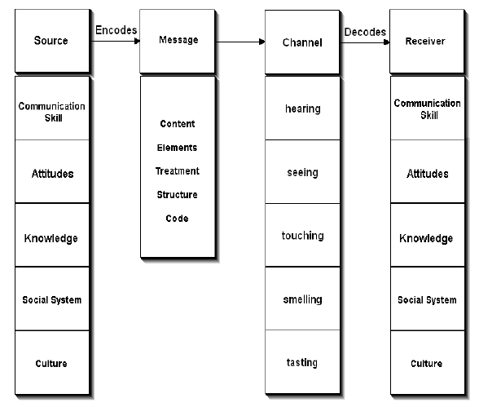
Figure 1: Berlo’s communication model
(Source: Communicationtheory.org, 2020)
From senders perspective, communication skills, knowledge, attitude, culture and social systems are essential to send messages. However, from a messaging perspective, content, treatment, elements, code and treatment are essential factors, affecting messages (Acai et al. 2017). This model believes that information cannot create same effects if senders and receivers are not responding in a similar way. On other hand, Young and Travis (2020) have stated that technical machines have been utilised such as internet and telephone. Additionally, five senses in human being facilitate to maintain communication flow; senses involve tasting, smelling, touching, seeing and hearing. Besides, information receivers need to consider culture, social systems, knowledge, communication skills, attitudes and thinking pattern during communication. However, Ritter et al. (2018) have argued and opined that this model considers communication process as a linear one and does not highlight interaction barriers.
Weaver and Shannon’s communication model
According to this model, senders encode messages and send to receivers through technological channels such as telegraph and telephone (Acai et al. 2016). After that, senders convert messages into codes into an understandable format to a machine. Receivers decode messages and then conduct processes of interpretation and understanding.
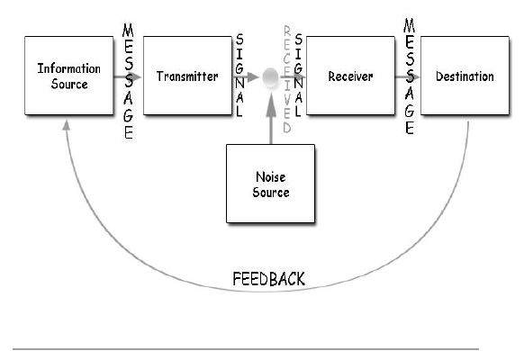
Figure 2: Weaver and Shannon’s communication model
(Source: Businesstopia.net, 2018)
In specific cases, receptor machines can work in form of decoders; channels can create noise, and receiver may not possess capacity for decoding in communication procedure. This model has focused on communicable problems on three levels (Businesstopia.net, 2018). These levels are semantic, effectiveness and technical problems. This model is advantageous as it describes communication in form of a two-way procedure and concerned model can be applied in any general interaction. Furthermore, Li et al. (2018) stated the noise concept facilitates communication efficiency by removing factors that are causing problems. However, Coffelt, Baker and Corey (2016) have argued and opined that this model is not competent enough as feedback has been considered as less significant than sending messages. On other hand, specified model is well-suited in purpose of interpersonal communication rather than mass and group communication. Additionally, receivers play passive roles in interaction procedure, while senders play a primary role in sending messages.
Schramm’s communication model
According to this model, information is useless until and unless information has been put carefully into words and conveyed to other persons (Managementstudyguide.com, 2020). In this regard, encoding plays an essential role in initiating interaction process through thought conversion into content.
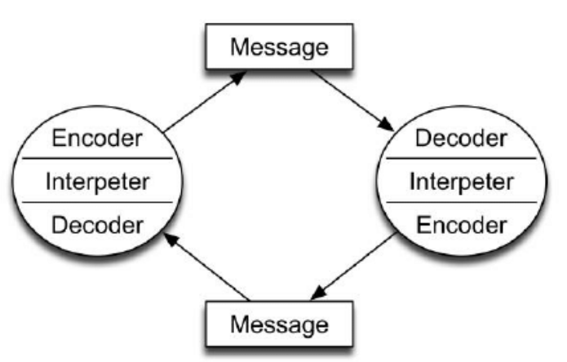
Figure 3: Schramm’s communication model
(Source: Managementstudyguide.com, 2020)
While information reaches recipients, it is responsibility of recipients to understand those messages. This communication process remains incomplete without feedback, gained from recipients (Bezemer et al. 2016). According to this model, cultural background, experience and knowledge of an individual play a competent role in interaction. People from diverse religions, cultures and backgrounds interpret information in multiple ways.

Illustration of case studies
In order to interpret effectiveness of Berlo's model, it can be illustrated that attitude and skills of a sender and receiver are vital drivers for effective communication. I can give one example of casev study discussed in class namely- professor and the village people. This example clearly shows how communication skills play a crucial role in this model. One attitude and noise in relation to the message send changes all meaning and consequence of the message.
On other hand, model of Shannon Weaver has stressed on feedback as without addressing reviews and feedback, a communication process cannot be completed (Reising et al. 2017) as a example I can talk about one case studies about Maria and Pedro when it was about a kitchen and chicken ,this situation provides how send message can be received wrongly because noise between . In contrast, according to Schramm's model, while a receiver cannot analyse information, conveyed by a sender, that message becomes inactive .In this model I can bring case studies from the class about Max the multitasker ,when Max couldn’t hear what Tamara was saying it means there was misunderstanding in this communication.

Poor communication examples
At health along with social care workplace, I have noticed that productivity can be troubled due to poor communication in following ways-
- Aggressive, passive communication
I have observed that aggressive and passive communication works as an incompetent practice. For example- while healthcare staff has to work for additional hours including night shifts and handle immense work pressure, they often become disrespectful and aggressive towards patients (Wyatt, 2020). This practice creates negative impacts directly on feelings of team members about themselves as well as other members in workplace. As stated by Tulsky et al. (2017), passive-aggressive behaviour seems to be a critical issue, as negative things are subtle. As a consequence, receivers feel ill-treated or neglected, and whole interaction process becomes damaged. Such as a problem of passive-aggression occurs while team members refuse to communicate directly.
- Intimidation at workplace
According to my analysis, intimidation techniques are negative interaction aspects that can create a fear-filled and toxic work environment. For example- in certain cases, patients or practitioners of healthcare have not voiced concern as they are intimidated through stellar reputation of prescriber (Cooke, 2016). Such intimidation can be illustrated with examples of taking over space physically, loud speech and standing firmly in order to cause discomforts. Such activities lead to low productivity and engagement to achieve goals at workplace.

Figure 4: Poor communication examples
- Incidents of blame game
According to my observation, poor communication in this workplace includes avoiding responsibilities and ethics. As propounded by Tingle (2018), failing to own mistakes and accept responsibilities creates negative impacts on work collaboration. For example- missing deadlines and blaming co-workers or hierarchy affects satisfaction of service receivers. Such counterproductive behaviours cannot lead to solutions for success (Mao and Woolley, 2016). Furthermore, it has been noticed that blaming other individuals for their own mistakes damages relationships among co-workers and can cause a feeling of rejection. Under these circumstances, team members have to learn accepting responsibilities and moving forward towards solutions is an effective strategy.
- Lack of listening
I have understood that lack of active listening leads to poor communication as team members are impatient enough to consider opinions of other individuals in this specified workplace. For example-in healthcare sector, if any service or product receives negative feedback and this feedback has not been correctly heard responded, customers, become dissatisfied (Lee and Doran, 2017). As a consequence, patients switch to another service provider. On other hand, Ritter et al. (2018) stated that while team leaders try to apply any service strategy by discarding opinions of other members, such behaviours drive a feeling of disrespect and lose interest to engage actively for achieving goals. I have noticed that problems remain unchecked, and colleagues feel that their inputs do not matter at all. However, individuals want to believe that ideas and suggestions have competent value as they are valuable contributors for achieving mission.

Improvement of communication
In order to improve communication at specified workplace, following strategies can be followed to improve communication-
- Learning the basics of non-verbal communication.
Communicate clearly and positively adopt proper posture ,avoid folding your arms or making yourself smaller than you are .
- Making communication as a segment of workplace
Through analysing examples of poor communication at specified health and social care workplace, I have observed that lack of listening, intimidation at workplace and incidents of blame game are causing troubles. Hence, such incidents prove that simply telling individuals about significance of communication is not sufficient (Jain et al. 2016). According to Berlo’s model, decoding as well as encoding messages are equally important in purpose of successful interaction.
- Develop listening skills
No judgement and is not good to be distracted by thinking what we wanna say next. Respond not react.
- Keep eye contact
Positive eye contact help you keep your listener with you while presentation, also involved everyone in your conversation.

Conclusion
Hence, this report concludes that effective communication is necessary for managing activities at workplace, correctly, in health along with social care workplace. Schramm's model summarises that communication remains unproductive without addressing feedback from receivers. Besides, from model of Shannon Weaver, it can be concluded that effectiveness, semantic and technical problems can hamper a communication procedure.
Besides, Berlo’s model describes this communication as a linear process. In context of the healthcare workplace, it can be concluded that unnecessary blaming, avoiding responsibilities, aggressive, passive communication and lack of active listening are causing significant issues. In this situation, effective communication implementation in a training program and recognising communication as an integral segment of workplace can be suggested. Furthermore, conducting surveys on patient satisfaction and scheduling regular meetings can be recommended.

Reference List
Book
Young, K.S. and Travis, H.P., 2020. Business and Professional Communication: A Practical Guide to Workplace Effectiveness. Illinois: Waveland Press.
Journals
Acai, A., McQueen, S.A., Fahim, C., Wagner, N., McKinnon, V., Boston, J., Maxwell, C. and Sonnadara, R.R., 2016. ‘It's not the form; it's the process’: a phenomenological study on the use of creative professional development workshops to improve teamwork and communication skills. Medical humanities, 42(3), pp.173-180.
Acai, A., McQueen, S.A., McKinnon, V. and Sonnadara, R.R., 2017. Using art for the development of teamwork and communication skills among health professionals: a literature review. Arts & Health, 9(1), pp.60-72.
Bezemer, J., Korkiakangas, T., Weldon, S.M., Kress, G. and Kneebone, R., 2016. Unsettled teamwork: communication and learning in the operating theatres of an urban hospital. Journal of advanced nursing, 72(2), pp.361-372.
Coffelt, T.A., Baker, M.J. and Corey, R.C., 2016. Business communication practices from employers’ perspectives. Business and Professional Communication Quarterly, 79(3), pp.300-316.
Cooke, M., 2016. TeamSTEPPS for health care risk managers: Improving teamwork and communication. Journal of Healthcare Risk Management, 36(1), pp.35-45.
Gharaveis, A., Hamilton, D.K. and Pati, D., 2018. The impact of environmental design on teamwork and communication in healthcare facilities: a systematic literature review. HERD: Health Environments Research & Design Journal, 11(1), pp.119-137.
Jain, A.K., Fennell, M.L., Chagpar, A.B., Connolly, H.K. and Nembhard, I.M., 2016. Moving toward improved teamwork in cancer care: the role of psychological safety in team communication. Journal of oncology practice, 12(11), pp.1000-1011.
Lee, C.T.S. and Doran, D.M., 2017. The role of interpersonal relations in healthcare team communication and patient safety: a proposed model of interpersonal process in teamwork. Canadian Journal of Nursing Research, 49(2), pp.75-93.
Li, J., Talari, P., Kelly, A., Latham, B., Dotson, S., Manning, K., Thornsberry, L., Swartz, C. and Williams, M.V., 2018. Interprofessional Teamwork Innovation Model (ITIM) to promote communication and patient-centred, coordinated care. BMJ quality & safety, 27(9), pp.700-709.
Mao, A.T. and Woolley, A.W., 2016. Teamwork in health care: maximizing collective intelligence via inclusive collaboration and open communication. AMA journal of ethics, 18(9), pp.933-940.
Reising, D.L., Carr, D.E., Gindling, S., Barnes, R., Garletts, D. and Ozdogan, Z., 2017. An analysis of interprofessional communication and teamwork skill acquisition in simulation. Journal of Interprofessional Education & Practice, 8, pp.80-85.
Ritter, B.A., Small, E.E., Mortimer, J.W. and Doll, J.L., 2018. Designing management curriculum for workplace readiness: Developing students’ soft skills. Journal of Management Education, 42(1), pp.80-103.
Schmutz, J.B., Meier, L.L. and Manser, T., 2019. How effective is teamwork really? The relationship between teamwork and performance in healthcare teams: a systematic review and meta-analysis. BMJ open, 9(9), p.e028280.
Singer, S.J., Molina, G., Li, Z., Jiang, W., Nurudeen, S., Kite, J.G., Edmondson, L., Foster, R., Haynes, A.B. and Berry, W.R., 2016. Relationship between operating room teamwork, contextual factors, and safety checklist performance. Journal of the American College of Surgeons, 223(4), pp.568-580.
Tingle, J., 2018. Poor communication and an opaque complaints process. British Journal of Nursing, 27(22), pp.1338-1339.
Tulsky, J.A., Beach, M.C., Butow, P.N., Hickman, S.E., Mack, J.W., Morrison, R.S., Street, R.L., Sudore, R.L., White, D.B. and Pollak, K.I., 2017. A research agenda for communication between health care professionals and patients living with serious illness. JAMA internal medicine, 177(9), pp.1361-1366.
Wyatt, D., 2020. Our Shared Purpose: Teamwork. AORN Journal, 111(6), pp.583-584.
Yi, Y.J., 2016. Effects of team‐building on communication and teamwork among nursing students. International Nursing Review, 63(1), pp.33-40.
Websites
Businesstopia.net, 2018. Shannon and Weaver Model Of Communication. Viewed on: 3/7/2020<https://www.businesstopia.net/communication/shannon-and-weaver-model-communication>
Communicationtheory.org, 2020. Berlo’sSMCR model of communication. Viewed on: 3/7/2020<https://www.communicationtheory.org/berlos-smcr-model-of-communication/>
Managementstudyguide.com, 2020. Schramm’s Model of Communication. Viewed on: 3/7/2020<https://www.managementstudyguide.com/schramm-model-of-communication.htm>

