COMMUNITY ENGAGEMENT
Student name: Muscinschi Elena 2114907
Module code :LCBB4002

Table of Contents
Introduction 3
Discussion 3
Use of human and material resources by Fujitsu 3
Key theme that helps this company to carry out the community engagement activities 5
Service users of Fujitsu and services that they require 6
Importance of community engagement 7
Skills and knowledge 8
The way they can acquire the identified skills 9
Analysis 9
Conclusion 12
Reference list 13

Introduction
Information and communication technology organizations are used to handle communication procedures such as telecommunication and so on. This essay going to describe the organization’s (Fujitsu) uses of human resources and materials resources for better productivity levels. Here it can be mentioned that community engagement activities are the main focus of this research. Basically, the CSR program refers to the business model through which organisations make concerted efforts in order to operate that enhanced. There also discussed the key themes on which this ICT organization carries out their community engagement activities in an effective way.

Discussion

Use of human and material resources by Fujitsu
Fujitsu is an ICT (information and communication technology) company that satisfies costumes with innovative and advanced technological services, making this world a better place is one of its missions. In this context, effective approaches have been included that help this company to make sustainable changes within its workplace. According to Okuhara et al. (2019), sustainability within an organization can help in making positive changes that may lead this world to positive outcomes. Digital transformation becomes an utmost desire of today’s world and Fujitsu helps in getting this, in addition, this gives people a workplace which is human-centric, by providing innovative IT infrastructure. In addition to this, Fujitsu has also included additional strategies to make effective changes in its workplace.
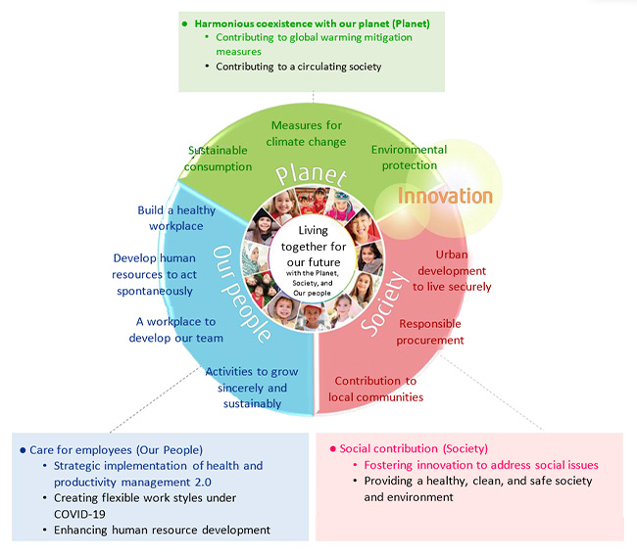
Figure 1: policies of Fujitsu
(Source: Miyajima et al. 2018)
The given figure highlighted organizational policies of Fujitsu. Miyajima et al. (2018), stated that human resources of any organization play a very important role to achieve an organizational goal, in this concrete each stakeholder related to a company needs to work together to deal with each obstacle. At present times, this company include more than 7000 employees in the UK who help in satisfying customers at a greater level. This company hire employees with significant business knowledge and technical skills; however effective training session can make an employee more efficient. Material resources such as products, raw materials and services can be changed with time and requirements. Moreover, Fujitsu uses advanced technologies and numeric data is being arranged to deal with business activities.

Key theme that helps this company to carry out the community engagement activities
According to Evans and Lewis (2018), community engagement activities help in providing products or services to an individual, community or group as a whole. Moreover, creating innovative tools, community murals, volunteering effective practices, helping trusts, and collaborating with organizations are some examples of community engagement practices. In this context, EMEIA themes have been identified, these significant themes help Fujitsu with its practices. Key themes such as youth employment, volunteering, charities, marketing and STEM, and digital and social innovation are being done by Fujitsu that further help this company carry out activities related to community engagement. These activities have been dealt with from 2007 to 2020.
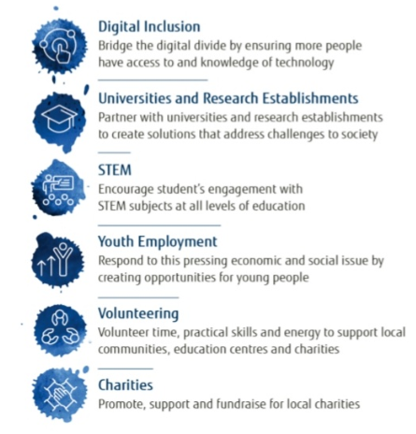
Figure 2: themes followed by Fujitsu
(Source: provided)
Thai figure shows key themes that Fujitsu follows. In addition to this, Fujitsu included an “environmental action plan” along with “corporate social responsibilities” into great concern that also further helps in achieving “sustainable development goals”. Wray‐Lake and Abrams (2020) also stated that innovative activities that can impact the environment and society with a positive impact can further allow a particular company with additional opportunities and scopes. Fujitsu is an organization that provides customers innovative technological services along with infrastructure in addition to this making a human-centric workplace is one of the significant goals of this company. Therefore, making sustainability canes become important for this company which is also considered as greet innovative. Furthermore, this company has decided to collaborate with other organisations for better outcomes.

Service users of Fujitsu and services that they require
Fujitsu provides various services that include “business and application services, multi-cloud, managed infrastructure services, artificial intelligence, co-creation work-life shift, cyber security and internet of things”. Providing IT services and solution is the main concern of this company in this context effective techno-social services become the most desirable outcomes that customers required. In addition to this in present times, innovative approaches and services of technologies play a very important role in business growth. According to Okuda and Shoda (2018), an organisation is liable to satisfy its customers with requirements and demands. In this regard, significant identification of such demand needs to be done.
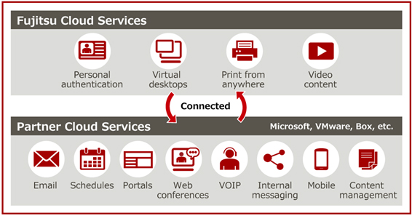
Figure 3: cloud services of Fujitsu
(Source: Barker et al. 2020)
The given figure highlighted significant services provided by Fujitsu, as this company provided IT services; therefore, satisfying people with innovative technological porches became its main desire. Moreover, Barker et al. (2020), proactively managing important data and information can be done by effective technologies, in present times additional activities can be done by such technologies. Communication technology plays a significant role in the present world, in this technical work effective implementation of such technologies helps in getting desired outcomes more efficiently. In present times, customers required more effective technology and services that are sustainable with great quality and at cheaper prices.

Importance of community engagement
Ueda et al. (2018) stated that community engagement allows an organization to promote its products and services to a large audience moreover it also aids in promoting values of an organization. It ensures members of a particular community to vale effective social and environmental responsibilities furthermore these activities developed functional activities as well. Sustainable decisions of organisations can be easily developed with such engagement; moreover, it includes various activities that also can help origination with further activities. Social and environmental responsibilities are some significant duties of each organization; however, Fujitsu has included effective activities to implement sustainability within its workplace.
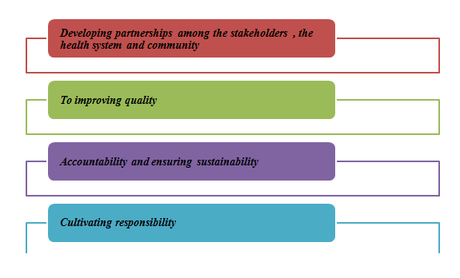
Figure 4: goal of community engagement
(Source: self-created)
This figure shows some significant goals that can be achieved by adopting community engagement. Community engagement helps to improve quality, develop partnerships with respondents and other stakeholders and also ensure sustainable implementations. Ashworth et al. (2021) stated that Fujitsu has decided to address social issues that affect the community in which this company operates. In addition to this company's convenience, its stakeholders with long-term sustainability and also asked for the engagement of each respondent with great encouragement. Moreover, digital inclusion, sustainable changes, volunteering and youth employees are some significant areas that Fujitsu focuses on.

Skills and knowledge
Community engagement skills refer to Promoting the behaviour of the product, recruiting new skilled members, listening and analysing and so on. For instance, community engagement includes various knowledge of conceptualization of the community and working definition of the community engagement. Ayton and Ibrahim, (2018), skills and knowledge that are required for the members of the organisation are effective communication skills, critical thinking ability, technical knowledge, leadership capabilities, high productivity level and so on. Community engagement through effective communication skills maintains the relationship with the members of an organisation. Apart from those skills such as the ability to articulate the importance of inclusion and equity in engaged work provides various opportunities for engaging the other members too.

The way they can acquire the identified skills
Bu developing advertising strategies in order to promote the product if the organisation can effectively engage the community with a specific topic. Strategic implementation knowledge and developing skill requires the most to enhance the productivity level of the member of the community along with this organization. According to Jackson et al. (2019), effective listening skills, analysing skills, and communication skills can be developed through affordable practices. Recruiting new members can engage the community as the members of the community continuously looking for more strength within the employees and better productivity levels. Their performances engaged the community members to observe the result of their effort. HR management of this company works effectively to identify effective employees in order to achieve organisational objectives and goals, in addition to these additional approaches are being taken into account to make the existing employees even more efficient. With the help of effective and efficient employees, productivity and profitability can be obtained easily.

Analysis
Fujitsu is a multinational company that provides a range of technology products, services and solutions, moreover, this compo nay ensures to empowers creativity and innovativeness by providing smarter solutions. In present times, sustainable implementation plays a significant role, as it denotes social and environmental responsibilities that further influence customers and other respondents with great effectiveness. Poenaru et al. (2021), identified a significant effort of organizations in terms of getting desired outcomes, it can be seen that in present times, UK organization include sustainable implementations for effectiveness. Sustainability in Fujitsu aims toward achieving carbon neutrality within 2050, in this context, a great number of organizations from UK targeted to achieve zero carbon emission within a particular time. Moreover, this company has observed the uptake desire for globalization. According to Marnerides et al. (2019), digitalization plays a significant role in organizational growth and development in addition to this people become more reliable to such technological implementations in their everyday life. However, this company has the desire to make better changes in this world through its innovative implementations; moreover, achieving a sustainable society is the main concern of this company.
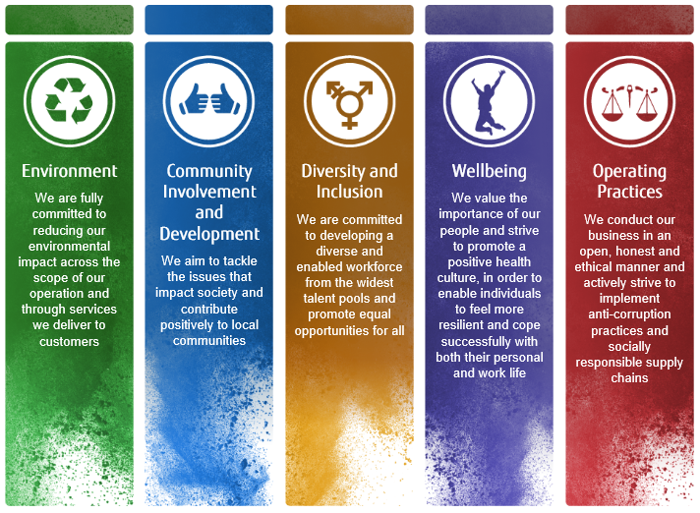
Figure 5: Fujitsu as a responsible business
(Source: Nakata et al. 2020)
This given figure shows some significant responsibilities that Fujitsu took into account to get desired outcomes; diversity, wellbeing, and environmental community involvement are some core areas that Fijutsu have identified to work more sustainably. In addition to this, Nakata et al. (2020), Fujitsu has promoted its sustainment activities on a broader scale as the company believes in making people with positive proactive that may also help in beginning a positive and sustainable society. Therefore, it identified social issues that need more concern and attention to put away any negative impact as well. Corporate and social responsibility of an organization is very important as it helps each organization deal with activities in a more sustainable way. The human resource management team of each organization play a significant role in hiring employees to make them more effective and efficient with their respondent works, this organization also include defective employees as per their requirements. Fujitsu also nourishes corporate philosophy in this context by providing equal opportunity and scopes to its employees are being done which also helps this company to mitigate any issues regarding discrimination.
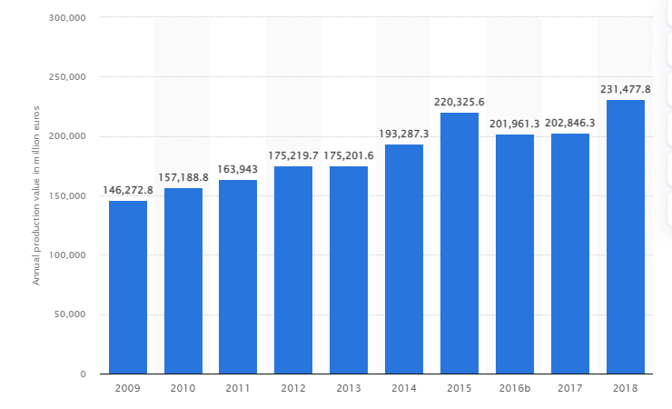
Figure 6: market worth of ICT companies in UK
(Source: Statista, 2020)
This figure shows the market worth of ICT companies in UK, production value of these companies was about 28.6 million USD in 2018, in addition to this report suggests the ultimate growth of ICT industries. In this regard, it is observed that the revenue of Fujitsu is 32.860 dollars and its market value is 1,937 dollars (Fujitsu.com, 2022). Moreover, this company operates its business with 7000 employees in its UK branch who also helps in satisfying customers at a greater level. This company want to ensure “Respect for human rights”, significant legal policies and regulation is very important to operate organizational activities in an effective manner. Moreover, this company also included some effective initiatives that can help in getting more desired results, however, this company decided to make a sustainable society within. Volunteering, social innovation along with digital inclusion helps organisations to deal with community engagement activities, these kinds of activities help in making people aware of such positive initiatives that further help them to influence society positively.

Conclusion
In this concluding section, it can be stated that this particular essay typically focuses on community engagement activities for enhancing the productivity of the organisation. Apart from taht, here also depicts various skills and knowledge which needs the employees to maintain the relationship with the members. Effective communication skill enhances the positive attitude of the members. This particular context is required for engaging the community member through motivational aspects in order to enhance their productivity level. Knowledge such as critical thinking ability, communication, problem-solving ability, and leadership has become essential for engaging the community to stay connected with this particular organisation for further growth. Identification of the service users along with various services required from this particular organization has also been discussed throughout this essay. Here also illustrated the various facts regarding the importance of community engagement. Skills of engaging the community to mitigate various risk factors of communication systems. Capacity building of an organization like ICT also depends on community engagement activities as well.

Reference list
Journals
Ashworth, H. C., Dada, S., Buggy, C., and Lees, S. (2021). The importance of developing rigorous social science methods for community engagement and behavior change during outbreak response. Disaster medicine and public health preparedness, 15(6), 685-690.
Ayton, A., and Ibrahim, A. (2018). Does UK medical education provide doctors with sufficient skills and knowledge to manage patients with eating disorders safely?. Postgraduate medical journal, 94(1113), 374-380.
Barker, K. M., Ling, E. J., Fallah, M., VanDeBogert, B., Kodl, Y., Macauley, R. J., ... and Kruk, M. E. (2020). Community engagement for health system resilience: evidence from Liberia’s Ebola epidemic. Health policy and planning, 35(4), 416-423.
Clarke, R. (2019). Optimising Global Solution and Service Delivery Models for Retail. Fujitsu Scientific and Technical Journal, 55(1), 38-44.
Evans, C., and Lewis, J. (2018). Analysing semi-structured interviews using thematic analysis: Exploring voluntary civic participation among adults.
Jackson, D., Fleming, J., and Rowe, A. (2019). Enabling the transfer of skills and knowledge across classroom and work contexts. Vocations and learning, 12(3), 459-478.
Marnerides, A., Prince, D., Couzins, J., Mills, R., Giotsas, V., McEvatt, P., ... and Irvine, C. (2019). Fujitsu white paper: Cyber threat lab.
Miyajima, T., Tanida, Y., Matsuura, A., and Oshima, H. (2018). New Materials/Devices that Revolutionize the Existing Paradigm. FUJITSU SCIENTIFIC and TECHNICAL JOURNAL, 54(5), 70-75.
Nakata, T., Araki, T., Tsuchiya, S., Nakao, Y., Naseer, A., Arahori, J., and Yamamoto, T. (2020). Initiatives for AI Ethics: Formulation of Fujitsu Group AI Commitment. Fujitsu Scientific and Technical Journal, 56(1), 13-19.
Okuda, T., and Shoda, S. (2018). AI-based chatbot service for financial industry. Fujitsu Scientific and Technical Journal, 54(2), 4-8.
Okuhara, M., Kayama, K., Mimura, T., and Suzuki, T. (2019). Training of Cybersecurity Human Resources to Support Future Social Development. FUJITSU SCIENTIFIC and TECHNICAL JOURNAL, 55(5), 35-40.
Poenaru, A., Deakin, T., McIntosh-Smith, S., Hammond, S. D., and Younge, A. J. (2021, July). An Evaluation of the Fujitsu A64FX for HPC Applications. In Presentation in AHUG ISC 21 Workshop.
Ueda, Y., Matsumoto, K., and Zempo, H. (2018). User Experience Design in Fujitsu. Fujitsu Sci Tech. J, 54(1), 3-8.
Wray‐Lake, L., and Abrams, L. S. (2020). Pathways to civic engagement among urban youth of color. Monographs of the Society for Research in Child Development, 85(2), 7-154.
Websites
Fujitsu, (2022), about us, accessed on: 27/06/2022, accessed from: https://www.fujitsu.com/global/about/csr/
Statista, (2022), production-value-ict-services-industry-uk/, accessed on: 27/06/2022, accessed from: https://www.statista.com/statistics/419005/production-value-ict-services-industry-uk/

