Public Services

Full Report

The SA80 project: An analysis on the of whether the project was successful and what to learn from it.

Alexander Morgan Jones
1802225

Keywords, Acronyms and Explanations

- Small arms: handheld guns such as rifles, pistols, and machine guns.
- SA80: Small Arms 1980s project.
- NATO: North Atlantic Treaty organisation, a military defensive alliance designed to protect their nations against the growing power of the Soviet Union post-World War 2
- APC: Armoured personnel carrier. Type of military transport for infantry such as the British Warrior.
- Rail: Mounting systems for equipment such as scopes, lasers, and torches.
- 5.56 NATO – 5.56 X 45mm standardised NATO rounds, a newer, lighter, and smaller bullet.
- 7.62 NATO – 7.62 X 51mm Standardised NATO rounds, an older, heavier, and larger bullet.
- SUSAT – Sight Unit Small Arms Trilux, scope found on the SA80s early versions.
- ACOG – Advanced Combat Optical Gunsight, scopes found on many small arms, common on M16 rifles.
- L1A1 SLR – Self-loading rifle, battle rifle that came before the SA80 program.
- M16 – American Rifle, same calibre as the SA80 and had similar problems early in its production.
- SMG – Sub-machine gun
- GPMG – General Purpose Machine Gun
- Doctrine – Doctrine in a military sense is guiding principles that give direction to military units on how to perform and counter enemy action. The basic idea on how units should be performing their actions.
- Chambered – What ammunition the weapon fires.
- LSW – Light Support weapon
- IW – Infantry weapon
- RPM – Rounds per Minute, how fast a weapon fire
- Bullpup Rifles – Rifles that have their loading systems (where the bullets are put into the gun) behind the trigger mechanism. This leads to shorter weapons with barrels just as long as a conventional rifle with a reduced length. This means the weapon is more compact and better for Urban (City) fighting.
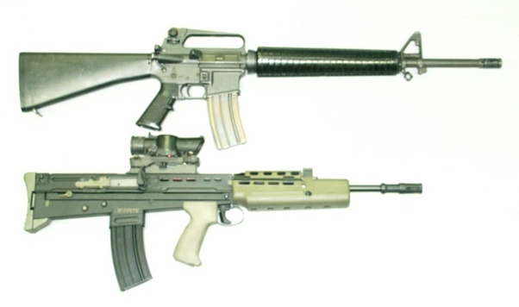

Image A – (Giang, 2019) – The Top weapon is an American M16, with the below being the SA80 which is the bullpup gun, notice the Trigger further forward and the magazine being behind. The Source was only used for the picture not the information given.
- Carbine Rifle – A shorter and lighter version of a Rifle, these give those in close combat situations or vehicle crews a better fitted weapon for their position.

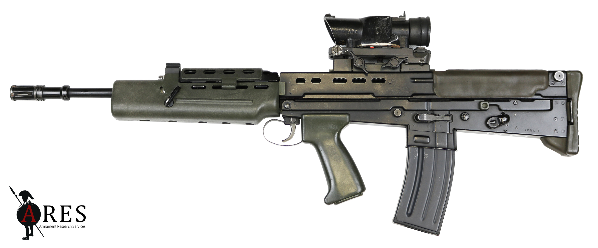
Image B – (Ferguson, British Enfield SA80 Part 4: XL80 Series, 2017) – SA80 L85A1 IW rifle, general combat rifle of the British Military.

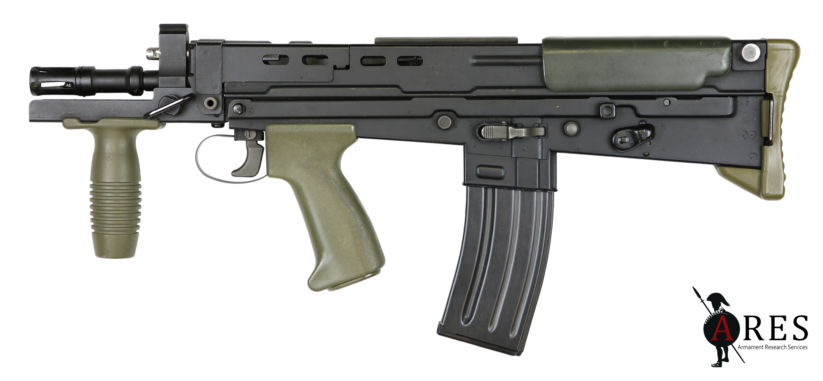
Image C – (Ferguson, British Enfield SA80 Part 6: Carbines, 2017) – SA80 L22A2, the carbine variant of the Rifle, its barrel is shorter and its overall length being 571mm in length compared to the General rifle having a length of 780mm.

- Magazine – What holds the bullets into a rifle, usually counted in rounds (bullets).

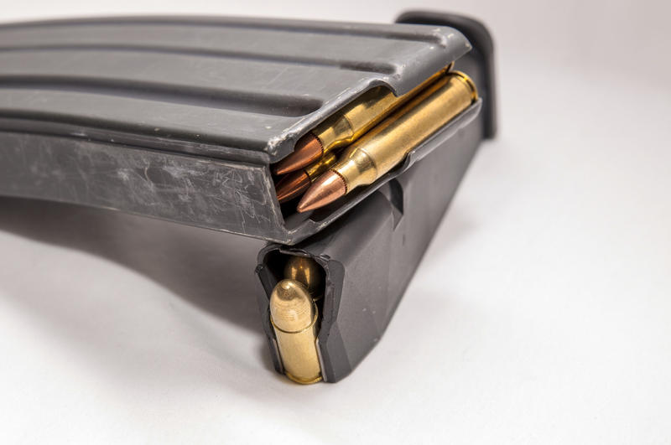
Image D - (Jane Lindholm, 2020)- an example of a rifle and pistol magazine

- Belt-Fed – Instead of being reloaded by a magazine, its bullets are fed into the gun through a belt system made with metallic belt links.

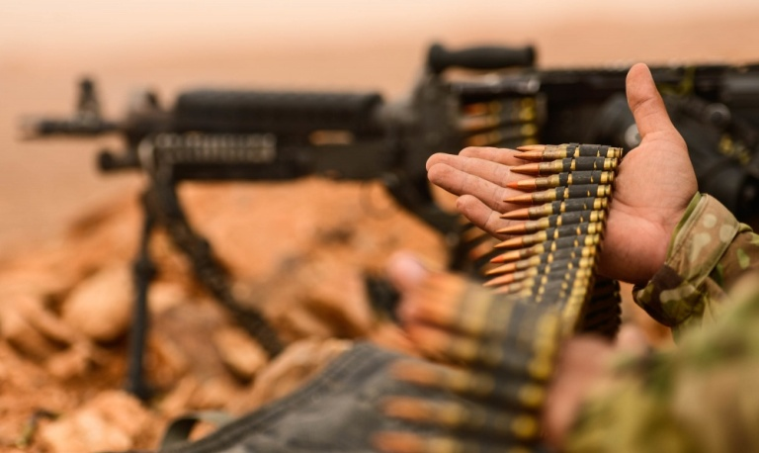
Image E – (Overt Defence, 2018) – An example of a belt for a belt-fed machine gun.

- Bolt-action – Requires cocking of the Bolt, or simply to load a new bullet into barrel every time you shot.
- Semi-automatic – Fires the Rifle every time the trigger is pulled until the magazine is out of Ammunition.
- Fully-Automatic – Fires the Rifle Continuously while the trigger is being pulled until the magazine is out of ammunition.

Introduction

The Rifle (or small arms) of a soldier is the most important piece of equipment for them to stay alive and for them to complete their objectives. This Weapon system needs to be able to output good firepower with good reliability, flexibility, and weight for the soldiers to use. With the British Army believing itself to be one of the most

This report is on the British military small arms of the L85 IW and L86 LSW, these weapons were designed to replace the older weapons of the United Kingdom’s military to have an updated weapon system that use updated ammunition and share similar components to ease training and logistics (Grant, SA80 Assault Rifles, 2016).

This weapon became the main rifle to most military personnel in the United Kingdom (not including Special forces such as the SAS and Marines in Close quarters conditions) with members of the forces requiring training on this weapon yearly even if not performing front-line roles (Raw, 2003).

The Goal of this Report is to discuss the SA80 Projects adoption, the strengths and weaknesses of the weapon system, the views of the troops who use it and what is the future of British Small arms.

Both Acronyms and explanations of keywords and theory can be found in the Keywords, A of more in-depth military concepts can be found in the Keywords, Acronyms and Explanations section above the Introduction.

The importance of this Report

“In my opinion, the M1 Rifle is the greatest battle implement ever devised” - George Smith Patton in a letter to General Levin Campbell, 26th of January 1945 (Miles, 2016).

The above Quote is from US Second World War General George Patton from a letter that was written to the Chief of Ordnance General Levin Campbell, in this he praises the M-1 Rifle over any of the other pieces of fighting equipment. General Patton is considered one of the greatest generals of the Second World War, especially given his tactical brilliance shown in the Sicily and Normandy campaigns (Holland, 2020).

This quote embodies the importance of a rifle to the army, it is the backbone of all the forces in the military, it is what the foot-soldiers run into battle with, it is what artillery-personnel sling on their back in-case of attack, it is what a truck driver has if he is ambushed. It is the greatest defence to anyone on the front lines and what protects the people back home. The rifle is the most important piece of equipment that a soldier will ever use.

Although the above General is from the US army, the ideals still hold true for any military, used during the First and Second World War the British Army used the famous Lee-Enfield Rifle. This Rifle was known for its excellent reliability, accuracy and with training the lethality of the weapon. The Lee-Enfield was the last great rifle design completely created in the United Kingdom (Pegler, 2012). Once the 1950s came around it was out of date, the older style bolt-action approach was not good enough for the modern battlefield and adoption of a new rifle was needed. The Ministry of Defence decided to adopt the L1A1 SLR, a Belgium weapon design (FN FAL) that was bought to be made in the United Kingdom. This weapon was considered a greater than the Lee-Enfield Rifle, with it managing to fire semi-automatic with a 20-round magazine. This continued to be used in the military from just after the Korean war in 1954 to the end of Service in 1991 (Cashner, 2013).

The L1A1 SLR was a well-balanced Battle Rifle, having good reliability, accuracy and was well acclaimed by the troops using it, the rifle served through the Troubles and in the Falklands War (Cashner, 2013).

Therefore, the Weapon to replace it these as well as other support weapons such as machine guns and sub-machine guns had to compare to these past weapons, this report is designed to discuss how the SA80 project compares to the past weapons used as well as the weapons of other countries (Grant, SA80 Assault Rifles, 2016). And whether the weapons need replacing in the near future.

The goal of the firearms project
As stated above the weapons project was designed to replace the L1A1 SLR Rifle, along with this it was required to replace 3 other weapons, with those being
The L2A3 Sterling Sub-machine gun – an upgraded World War 2 Sub-machine gun, these weapons were outdated for a fair time before the SA80 program replaced them in service. These hold 9mm Pistol ammunition that lacks range (cant shoot very far) and do not have enough power to break body-armour (Moss, 2018). These guns do best in Urban fighting due to their light weight and the bullets not causing a lot of recoil. In its magazine it usually holds 32-34 rounds of ammunition (depending on magazine used).
The L7 GPMG – The General Purpose machine gun (British licence built FN MAG machine gun), a belt fed machine gun that fires NATO 7.62x51mm ammunition (McNab, 2018). It requires to be supported by either a bi-pod or tri-pod due to the weapon being heavy and the ammunition being fired causing heavy recoil which makes the gun difficult to aim. Each belt would usually hold 100 rounds of ammunition as well as once close to being finished a new belt could be easily clipped onto the end. These weapons were still planned to be used mounted on vehicles (Rottman, 1993).
The L4A4 Bren Light Machine gun – Another upgraded World War 2 Weapon, this time being a light Machine gun. This weapon is used as a replacement for the GPMG in arctic conditions due to belt fed machine guns having reliability issues when dealing with snow. The Bren started being used in 1938 and spare-parts were almost completely diminished by the 1980s with the Ministry of Defence not interested in producing parts themselves or commissioning new parts, cannibalising other weapons (Grant, The Bren Gun, 2013). Holds 30 rounds in a magazine.
During the 1960s the Ministry of Defence believed that a new weapon was needed for the Armed forces, with the limited capacity of fully-automatic fire out of a rifles 7.62x51mm ammunition due to recoil meant that if the Ministry of Defence wanted a fully-automatic weapon to be used then a smaller calibre ammunition would be needed.
United Kingdom Doctrine changed at this time, Doctrine being how the military guides itself during wartime. It was believed that the Doctrine from World War 2 was outdated, especially when the enemy was far different to the Germans fought in World War 2, the predicted enemy of the United Kingdom was the Soviet Union and the Warsaw pack which used Soviet Deep Attack Operations. Deep attack doctrine in basic terms involves a quick artillery bombardment supported quickly by charging tanks and infantry, this is best shown in Operation Bagration in 1944. This was to be countered by NATO with making town and villages strong points (using them similar to castles) to hopefully slow down the Soviets hoping that the NATO air-forces would slowly destroy the soviet forces. This new fighting style for the United Kingdom needed weapons that worked well in urban fighting, requiring a weapon that could fire full-automatic, and thus move away from their current ammunition type.
To be Noted: The EM2
After the Second World War both German and British Military analysts believed that most conflict in the second world war was done at short range, usually around 300 metres. The rifles used during this could fair well at this range but semi-automatic and automatic weapons faired better at this range. Once NATO was formed in the late 1940s it was decided that standardisation was needed between the nations within NATO, the British and German analysts believed that weaponry more designed around the German StG-44 and FG-42 (which used light ammunition) were going to fair better in most combat encounters. Thus development of the EM-1 and EM2 started (Grant, SA80 Assault Rifles, 2016).
This weapon was in the 7x49mm ammunition, more commonly known as British .280. It was developed as a bullpup rifle with the ability to fire both semi and fully automatic. From the views of Weapon historian Ian McCollum he found the weapon far lighter than the FN FAL and believed it would be a better for the Infantry of the early cold war period describing the rifle as “The Best Cold War Battle Rifle that Never Was” (McCollum, 2017).
Unfortunately, the United States believed they required ammunition that could fire at longer ranges (heavier ammunition) and wanted to continue using their 7.62x63mm ammunition already being used in their M1 Garand’s, thus after debate and negotiations the NATO 7.62x51mm Round started to be used as the United States had more power in changing the views of other NATO nations.
Development of the project – Preliminary studies
Once the decision was made to create a new rifle for the British Forces in the 1960s was discussed what was the most likely scenarios this weapon was to find itself in, with the above information on doctrine believing that most combat was to be done at shorter ranges, preferably in urban warfare situations. It was chosen to change ammunition from the current 7.62x51mm ammunition found in the L1A1 SLR and GPMG, during the 1960s the Rifle was thought to have a bullet being around 6.5mm diameter. The Ministry of Defence contracted Royal Small Arms Factory Enfield (to be referred to as Enfield) to design and Produce these new rifles and thus development began.
Once the initial studies were done by Enfield the Ministry of Defence were given 4 options for the style of rifle that would be produced for them, those options being

- Conventional configuration with a dropped stock similar to the L1A1 SLR (stock is the part of the gun that sits into the shoulder)
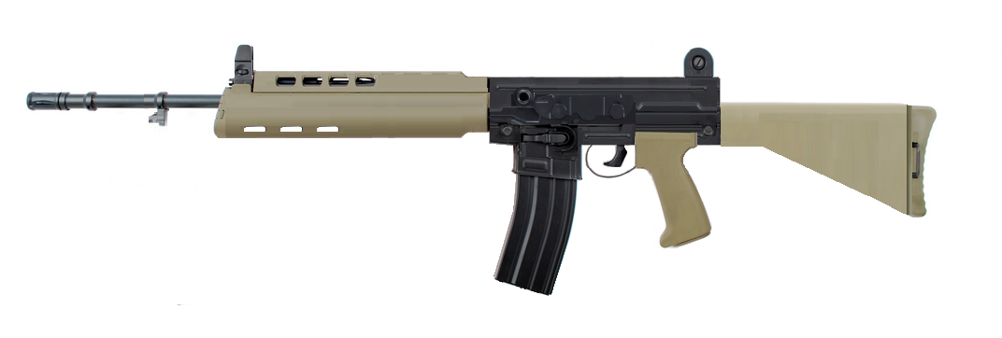
Image F - (Hendrick, 2019) – Artist Rendition of a Conventional styled L85 with a dropped stock.

- Conventional configuration with in-line stock with similarity the M16 (the stock makes the weapon almost straight along the top of it)
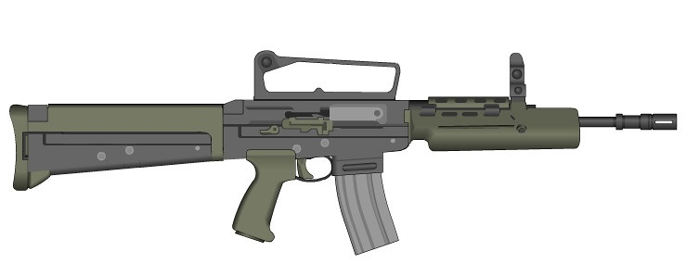
Image G – Unknown source – Artist Rendition of a Conventional styled L85 with an in-line stock

- Bullpup Configuration with a dropped stock similar to the L1A1 SLR
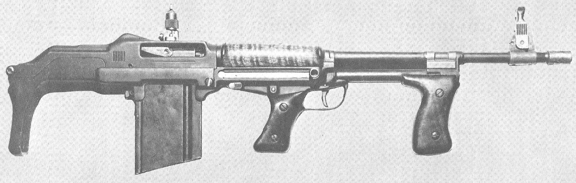
Image H – (Hodges, 2012) – A bullpup BAR, for reference of what this configuration could look like.
- Bullpup Configuration with in-Line stock
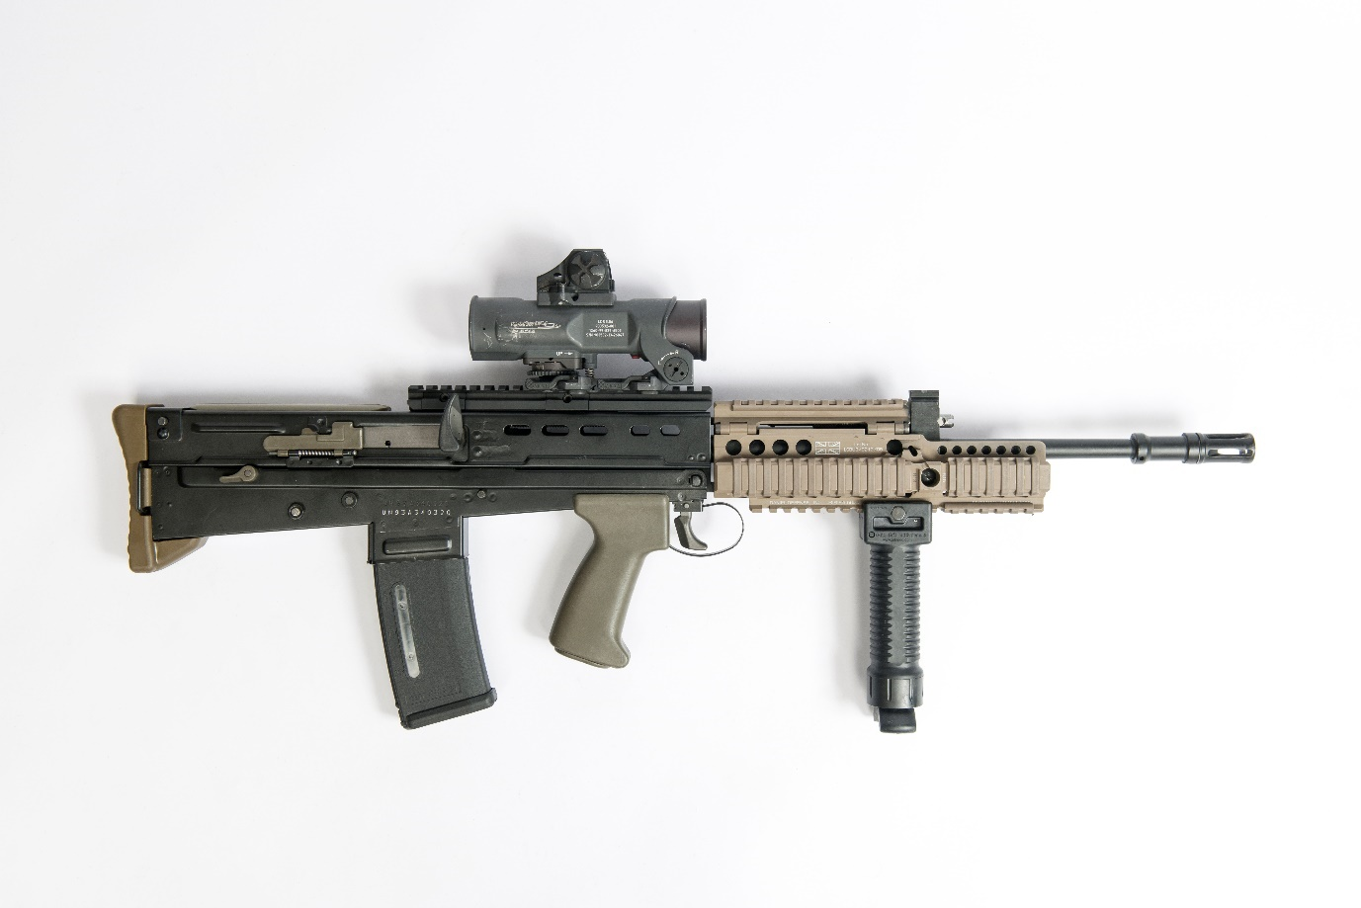
Image I - (Ministry of Defence, 2017) – an L85A2 with the in-line stock
The Ministry of Defence choose the fourth option to have a Bullpup Rifle with an in-line stock. This decision came with the knowledge of the EM-2 programs known strengths and weaknesses and thus full development began.
Something that changed before the next stage of development was the size of the bullet, it changed during the 1970s due to 5.56x45mm NATO round being adopted by NATO. It was decided to create a smaller round then this, hoping to use a new 4.85x49mm bullet. This would mean the bullet would be even lighter and be more controllable than other NATO guns at the time. This was the first flaw when the development of these weapons began, this is due to the rest of NATO and non-aligned Western European countries started developing new weapons for this specific bullet, with notable examples being the German G36 and two types of bullpup rifles, the French FAMAS and Austrian AUG. This made it unlikely for other NATO nations to adopt this new ammunition, especially the United States as it just started mass-producing the M16 rifles.
Development of the project – Initial feasibility studies
Once development was underway the requirements for the weapons were created, with the MOD requiring two weapon systems to come from this project, the first being an Infantry weapon (IW) which was the regular rifle and the Light Support Weapon (LSW) which was going to replace the machine guns. These weapons had the following requirements –
- For the majority of parts to be interchangeable, the goal was 80% of parts to be shared. This will be referred to as commonality.
- For the effective range of the weapons to be 300 meters for the Infantry weapons and 600 meters for the Light Support Weapon
- For the Light Support Weapon to have quick change barrels
- For both to hold magazines between 20 and 30 rounds
- For both to be steel-stamped weapons, meaning they are cheaper to produce and have stronger builds at the cost of being heavier.
- For Left-handed conversion kits to be available for both weapons
These requirements were presented to Enfield who now had a long and arduous job ahead of them with a limited budget for development of both weapons (Raw, 2003), and this meant that cheaper solutions had to be found somehow, which Enfield found in the Armalite AR-18 design.
Development of the project – The Armalite AR-18
The AR-18 is an American weapon design from the Armalite company, it came as a cheaper alternative to the M16 that had just been introduced into US service. The M16 required expensive materials and complex tooling to create the weapons so the AR-18 was designed for countries that lacked the funds or tools to create or repair these weapons. It would be made mainly out of steel and for the construction the steel would be stamped, this required little labour and basic tools to create.
The AR-18 was tested by both the British Army and American Army where it impressed neither, the testing showed the flaws of the weapons with it requiring good quality (and expensive) ammunition to continuously run well as well as notes from the British Army finding it having very poor reliability in Desert and Mud tests, leading to a complete dismissal for both services.
This weapon started production in several factories around the world, one of which was Sterling Armaments company which was close to Enfield’s factories, it was decided to review the weapon and once tested it was decided that the new weapons would use components from the AR-18 despite its flaws (Grant, SA80 Assault Rifles, 2016).
Development of the project – The initial prototypes
The prototypes for the weapons came in two phases, that of the ‘Double 0’ series and three XL stages (the XL a designation for experimental weapons). The ‘Double 0’ Series involved the production of 12 prototypes, to 8 of the Infantry Weapon and 4 Light support Weapons. Each of these prototypes had slight differences in them with the two of greatest note being prototypes of a single left-handed version of the Infantry weapon and Light support Weapons.
A questionable decision during this time was that one of the Light support weapon prototypes had a muzzle break on the end of the barrel, this performed greater than the other Light support weapons, with greater handling and recoil reduction and control but in the end was rejected with 3 reasons given. The first being cost with the extra metal and tooling needed for the weapons, the second would be the added weight onto the weapons, and the third being it would lose commonality with the Infantry weapon.
The cost of a muzzle brake in the US market today for the ammunition that this weapon fires will cost $80 and add 99 grams in weight to the weapon, with the cost including both tax and shipping. Once you take into account the cost reduction when mass-producing equipment and tooling these pieces yourself the $80 would be substantially less, accounting for inflation (the average being around inflation difference per year being 3.64%) the difference and reducing the cost in half due to mass-production saving and the tooling already available means on average the 5.86 US dollars in 1970, with the exchange rate being 2.35 Dollars to British Pound means that production cost would be 2.49 British Pounds. With the L86 LSW costing £986 in 1983 (Grant, SA80 Assault Rifles, 2016) then using the Bank of England inflation calculator (Bank of England, 2021) the cost of a completed weapon would be 69.81 British Pounds. Therefore, the difference in price for a consumer-grade muzzle break on the Light support weapon would be £72.3, a difference in price of 4%.
Considering that the tooling was already available for the weapon (as the muzzle break was created on a prototype) and the weight difference changing from 5.4Kg to 5.49Kg which is negligible and commonality not being an issue with this part due to this part needing to be added on the interchangeable barrel, one of the parts both Enfield and the Ministry of Defence knew was going to only be on the Light support weapon. Therefore, the most likely reason for this feature being dropped was because the Ministry of Defence believed that the effect was not worth the cost difference and/or they wanted the cheapest weapons that could be produced.
With the basic layout of the rifle selected and the Ministry of Defence being satisfied with the weapons being shown, development of the XL64/65 started.
Development of the project – The XL series
After the ‘double 0’ series came the XL series of weapons, which came in 3 different stages, the XL 64/65, the XL70/73 and the XL 85/86 series. The XL 64/65 series were created in 1976 with the intention of showing the updated capacity of both the weapons and the new British bullets in the NATO ammunition trials of the Late 1970s. The Ministry of Defence and Enfield believed their new weapons could impress during the NATO trials, believing they had a superior round to the 5.56x45mm NATO currently being used.
The Trials began in 1977 and the British 4.85x49mm bullet found itself in a difficult situation, all other member states of NATO other than West Germany brought their own modified version of the 5.56x45mm bullet, with some countries already having Rifles for this ammunition type, with the United States being the largest. With this knowledge in mind the likelihood of a different ammunition was unlikely, especially with costs on many member states having to adjust to this new cartridge.
The British 4.85x49mm bullet did not win the trials, although some noted it being better than the American standard M193 rounds, with the winner of the ammunition trials being the Belgium SS109 5.56x45mm Round, it won due to the fact it would require little tooling to change the American M16s already in service as well as its performance was overall the greatest at the trials (Bussard, 2011).
The Weapon systems did not fair much better, with it being considered unreliable throughout its testing. The MRBF figure (Mean Rounds Between Failures) came in at 97 rounds, this was considered very poor, with the likelihood of most weapons in a section (squad) having failures in every engagement.
Due to its performance no NATO members were interested in the weapons project and the 4.85x49mm having to be changed to the NATO standard 5.56x45mm rounds. Thus, the major difference between the XL 64/65 and the XL70/73 was the change of bullet.
There were other modifications to the weapon, with a new release catch for the magazine (a button that lets the magazine come out of the rifle) and a new safety system for the weapons (a switch to let the gun shoot or not). This however came at the same time as the Ministry of Defence wanted the weapons to be more cost efficient and this led to what is known as ‘value engineering’ or as the design team named it ‘engineering by accountants’ (Grant, SA80 Assault Rifles, 2016). This led to the mean time of production being cut down from ten hours to 7 and a half hours, but quality control would suffer with this decision meaning this should be noted.
Development of the project – The initial prototypes – Ordnance board trials
Once the XL 70/73 weapons had some prototypes for the Ministry of Defence to use, the Ministry of Defence set up an ordnance board to conduct trials on the weapons, wanting to view how reliable the weapons were.
The reliability of the weapons was conducted with the MRBF model (Mean Rounds between Failures) to determine the reliability, this would be done by shooting many bullets (within the tens or hundreds of thousands) through a single weapon and counting how many times it failed and how it failed, the failures were categorised into three different ‘incident’ types, those being –
- Minor incidents, this is when a failure could be addressed quickly with little action, the majority of which would be done by re-cocking or reloading the weapon.
- Serious incident, these failures would require more action by the user, most likely having to take apart the weapon and clean and repair the parts inside.
- Critical incidents, this is when it is completely un-repairable and would require a armourer to repair the weapon.
This is how generally NATO categorise failures during trials, and the Ministry of Defence ordnance trials would do the same until the results started to reflect negatively on the weapon, especially when doing the MRBF model in worse conditions with sand, mud and water test (similar to fighting in deserts, marshlands and beach assaults). The number including these variables and all failure incidents had the weapon failure rate between 100 and 300 bullets, far from the 2500 that was estimated and wanted. It was chosen by the Ministry of Defence to change how the trials would be conducted, with only critical incidents being counted for the final published results (Raw, 2003).
This was not the only measures taken to improve the result, with some critical incidents being classed as serious due to specialist parts (such as the bolt) being available and the problem theoretically being plausible to be rectified there. This however was unrealistic due to those parts not being available as spares in infantry kits as well as not easily being repaired especially in combat conditions.
Even with such advantageous trail conditions for the weapon it still scored at between 1000 and 1500 bullets shot between failures, which is incredibly poor considering the circumstances. This meant that every weapon was likely to require intensive repair often, bullets get shot in the thousands easily during training and tens of thousands in combat. It was a telling sign of things to come.
The ordnance board was persuaded to change the number to 2500 rounds before failure due to Enfield’s design team stating that they believed that half of the faults identified could be fixed with light design changes that could be done before the final weapon template was used. This led to the agreement of 2500 rounds being the result on these tests where the result would be no-where close to that.
Although the Light support weapon was also tested during these trials the final scores are the only notes left over from these, with scores between 2300 and 4700 (Grant, SA80 Assault Rifles, 2016).
Development of the project – The initial prototypes
The final prototype of the Weapons were the XL85/86 Variants, with the Infantry weapon some of the reliability issues were fixed but not to the original ordnance trial standards, still failing in sand and mud tests.

Unlike all prototype variants beforehand there was no left-handed variant available, although the requirement was still there and the Ministry of Defence in statements beforehand promised this feature.

During this Time the Ministry of Defence started doubting the effectiveness of the LSW, this was due to similar reliability problems to the Infantry Weapon as well as output of fire, the weapon was struggling to fire fully automatic for long periods of time. A Light support weapon was designed to replace the Machine guns being used by the British Army and thus needed good fully automatic fire to support the infantry. The Ministry of Defence warned Enfield that it would have to meet a new requirement of reliability before being adopted, and if it does not perform well enough then they would start discussing adoption of other options, including talking to FN for their Minimi machine gun.

The LSW was adopted into service alongside the IW as with some light changes it met the requirement of the Ministry of Defence, and full production started in June 1985 (Grant, SA80 Assault Rifles, 2016).
Adoption into service
Once the initial SA80 project was finished and both Enfield and the Ministry of Defence were satisfied with the final weapons, the first order of 175,000 weapons was contracted in June 1985, with the first British Army Regiments being given the weapons in October of 1985 (Grant, SA80 Assault Rifles, 2016).
Once brought into service it was found to have many of the issues that were found in its prototypes, with the largest of its problems being reliability especially in poor weather and climate conditions.
The Views of the Soldiers – Primary Research
For this report interviews were undertaken to determine the views of military personnel on the weapons systems that they have used during their career, these were for the purpose of
The interviews were conducted without any electrical recording software, this was done so that if hardware was compromised to outside sources during the creation of this report than any information of the individuals would not be stolen, this is especially important due to military personnel being possible targets for certain organisations.
All information was noted using pen and paper, no names were noted so if the notebook with this information was lost or stolen no valuable personal information would be able to be retrieved from them.
Before interview due to the Sensitive topics being covered there was no compulsion for anyone to answer every question given to them, thus not all question will have the complete 32 answers.
The interviews were conducted either in person or over encrypted peer-to-peer electronic communication.
When interviewing the following questions were asked
      - When did you join the forces?
      - Which Force did you join?
      - What role did you have in the military?
      - What weapons have you used?
      - Opinions on any of the weapons stated in question 4?
      - If not mentioned what is your opinion on the reliability of the L85 rifle?
      - If not mentioned your opinion on the L85 not being able to be fired Left-handed?
- When did you join the Forces?
When this question was asked the year of recruitment was usually given, for easier data analysis the years of have been sorted into decades with the results being

- What Branch did you serve in

The majority of interviewed personnel have served in the British Army, with over half of those covered.
- What role did you have in the military?
For this question the answers were sorted into 3 categories, those being Infantry (this includes marines, paratroopers and pathfinders), non-infantry frontline forces (including armoured and medical forces) and Support forces (Logistics, engineers and naval crew). With the results being

These results correlate fairly well with the organisations projected strengths, especially with the British Army numbers reflecting, with the RAF being the only exception with high numbers of Infantry being questioned compared to their force composition being limited in infantry.
- What weapons have you used?
Do have a greater focus on views of the SA80 weapons project, experience with at least the L85 was needed to have their answers to be considered relevant to the project. When asked the Breakdown of weapons used were as follows –
- 32 Have used the L85 Individual weapon
- 30 Have used the L86 Light Support weapon
- 20 Had used the L7 GPMG
- 12 Had used the L1A1 SLR
- 10 Had used the Sterling sub-machine gun
- 7 had used the L129 Sharpshooter rifle
- 5 Had used the FN Minimi
- 4 Had used the C7 Rifle
- 4 Had used the Bren Machine gun
- Opinions on the weapons used in Question 4?

Here the views on weaponry show the reputation of the SA80 Program weapons being show, with an overwhelmingly negative reception, especially compared to the SLR and GPMG which the weapons were designed to replace.
The L86 LSW was a highly mixed bag, some believed it was a great weapon but not the greatest machine-gun, some believed it was useless compared to the GPMG and others thought it was fine but other guns did a greater job. During one interview in a park the created a scene with surrounding landmarks being the objective, he created a story to describe his views on the weapon
“So imagine our section has to assault that tree? The way we would do it is we set up the machine guns here and the rest of the boys would attack from another angle, classic pincer really. The problem was that although the gun could shoot bloody well and on target is the 30 round magazine, both these guns are going to have to reload and both would probably start doing that at the same time, we could just clip-on another clip onto the GPMG and that thing will just keep bashing them till your guys running at them start to get close”
This story above showed the frustration most people interviewed had with this gun, although it was a very accurate weapon and could damage the enemy, a machine gun or Light support weapon is for suppressing the enemy, to keep them hiding from the bullets while the rifleman (non-gender specific)
The GPMG scored the highest Positive reception amongst those interviewed, this is mainly due to its firepower, one of the soldiers interviewed commented ‘They could never replace that thing, it just does everything it needs to do’ and another stating ‘It’s a heavy piece of kit to lug around, but once set up it will make them duck and run’.
The L85 has the Highest ratio of negative reviews, this was mainly from Frontline and support staff who viewed the Rifle as too heavy and big for what they need or want, while infantrymen have a greater view of the weapon citing high accuracy and specifically the later model having fine reliability.
A fair number of negative reviews came from those in the Armoured Corps, with the weapon being too big and bulky for storage in their vehicles that are used (the Warrior APC and the Challenger tank). With one of the interviewed saying “we just kept the sterling for a while, it was easier to put away in the tank then like the Rifle. Its cramped as fuck in there”.

The L1A1 SLR which the L85 was designed to replace has a greater review then the L85 from most interviewed while still having some faults to it, the majority of faults people had with the weapon was due to it not being able to fire fully automatic as well as the weapon was too large to use in compact spaces including inside vehicles, one of the interviewed described it as “an elephant gun, it was huge and powerful but it was exciting watching the targets fall in the range at 800 meters, couldn’t do that with the SA80”.
3 Weapons that were introduced due to poor performance of the SA80 weapons were the L129 Sharpshooter rifle, the FN Minimi and the C7 which all respectfully have a better reputation then the SA80 weapons.
The L129 Sharpshooter rifle was reviewed highly by those interviewed due to its high reliability, accuracy, and firepower output. One of the interviewed described it as “like a cool little sniper”. The FN Minimi had 3 positive outlooks and 2 mixed, with those who viewed it as mixed saying “It just wasn’t as good as the GPMG, just not enough power”, with those viewing it positively commending its firepower and fair reliability.
The C7 is the best comparison to the L85 with them both firing the same bullet type, and both being introduced in the Mid 1980s (Rottham, 2011), this weapon is used by the Royal Marines and some members of the Parachute Regiment. Of the 4 reviews of the weapon 3 are by the Royal Marines and one is by a Parachute regiment member, they all view the weapon as compact, light, and reliable with a similar output to the L85. Although when asked the accuracy is not as good as the L85 but with reloading being easier and quicker as well as the weapon is lighter and easier to move it is well worth the trade off in these soldiers’ opinions.
- If not mentioned what is your opinion on the reliability of the L85
Most interviewed already had given their opinion on the reliability of the L85, most believed that the early versions of the weapon were unreliable while the new versions were reliable. 3 of those interviewed found the L85 to always be reliable and 4 of those interviewed both the early and late models are unreliable.

- If not mentioned what is your opinion on the L85 not being able to be fired Left-handed?
The Majority of people interviewed had no real issue with there not being a left-handed variant of the gun, especially considering most of them are left-handed. But those who were left handed as a whole were fairly disappointed with the fact that they were not able to have the gun suited to them. Some infantry personnel commented with a tactical viewpoint stating “its unfortunate really, when you have to shoot around right-hand corners you have to bring your whole body out with little cover for yourself, makes you a big easy target”.

The Problem with the weapons
When the SA80 weapons were introduced into service there where many issues that were found with the weapons, the major issues were that:
- The reliability was very poor, stoppages were frequent, and the weapons needed repairs often.
- Parts were poorly made and needed replacing often.
- Issued insect repellent melted the little plastic on the weapons.
- The metal was of poor quality and was prone to rusting, especially in humid conditions.
- The Mud and Sand reliability problems were not addressed making weapons were even more unreliable in these conditions.
- The weapons were damaged from the cold in artic conditions.
- The Cleaning kits were of poor quality.
- Cleaning needed to be done more often than most rifles.
- The Rifle was too large for Armoured crews, especially those in tanks.
- The magazine release (the button that lets the magazine come out for reloading) was easy to catch on clothes and would release the magazine onto the floor, which would not always be noticed to some of the soldiers horror.
Most of these problems were seen during development and not addressed while other problems were only found once the weapon was in the hands of infantryman, the Ministry of Defence dismissed many of the issues as being initial teething problems that come naturally with these weapons, with them citing the United States M16 rifle for comparison, this comparison is unfair and, in some ways, embarrassing for the Ministry of Defence to use as a defence for themselves.
The Ministry of Defence when citing the problems with the inception of the M16 rifle admitted that they had known of these problems, if the Ministry of Defence knew of the problems that caused the M16 problems during its inception then it comes to question why didn’t they act on this knowledge? The M16 had faults with cleaning kits during its initial inception, it had feeding problems like the SA80 weapons that would be addressed in a similar fashion. The M16 was rushed into service during the Vietnam war while the SA80 weapons had been developed for years (Rottham, 2011). It is fair to say that the SA80 was not having the same problems that the M16 faced during its initial adoption into service.
When the SA80 weapons were working as intended they were found to be good weapons, having great accuracy and its smaller design compared to the L1A1 SLR it replaced meant that it was easier to use in Urban environments, with it being used well in Northern Ireland coming to the end of the Troubles.
The weapon would have its first real baptism by fire once Kuwait was taken by Saddam Hussein.
The Gulf War
When Iraq invaded Kuwait in the early 1990s the British Government decided that Britain would become part of the US-led coalition to push Iraq out of the region. This was the going to be the first real army-to-army combat for the SA80 weapons and it would not be the best location for these weapons to be used.
The Location of the fighting for the British was Southern Iraq and Northern Kuwait, with the land being mainly desert. The terrain was mainly flat which meant that the 5.56x45mm NATO round that the SA80 weapons used were at a disadvantage compared to the older and larger bullets found in the Iraqi AK-47 and Type 56 Rifles.
So in summary the SA80 was designed for short range combat in urban environments, it had poor reliability in good conditions and failed testing in sand conditions. Its first real engagement would be in an open desert mainly at longer ranges against weapons with bigger bullets that did better at longer ranges.
It was predicted by some in the Ministry of defence for the operation to show the negatives of the rifles that they had to the world, and the troops using the weapons were not feeling confident in their ability to fight, then Operation Desert Shield changed to Desert Strom and the Coalition advanced.
Luckily for British troops the majority of the fighting in their sector was against lightly armed conscripts with low morale, many of which surrender when their tank and armoured support was destroyed by British long-range missiles or British tanks. The little fighting the British infantry had to do was done quickly and would usually consist of taking the official surrender of Iraqi troops.
Luckily due to the success of the United States Air Force and the Royal Air Force, the Iraqi troops had lost a large amount of morale before the fighting even started, and the superiority of NATO tanks managed to keep the soldiers safe, however the SA80 weapons would be under heavy scrutiny.
Right after the Gulf war ended the Army’s Land Systems Evaluation Team (LANDSET) found would show the full extent to how badly the SA80 weapons in a full report, where it stated all the past problems with the weapons stated beforehand as well as added the following:
“infantrymen did not have CONFIDENCE in their personal weapon. Most expected a stoppage in the first magazine fired. Some platoon commanders considered that casualties would have occurred due to weapon stoppages if the enemy had put up any resistance in the trench and bunker clearing operations” – Third report on the SA80 Infantry and Light Support Weapon (Defence Committee, 1993)
This report also concurs with the interviews that were conducted for this report, stating that the early versions of the SA80 weapons were unreliable.
This was a shameful display of how the Ministry of Defence and Enfield had failed to create a weapon that could be used effectively by the British Army, this report would later be leaked to several news outlets, when initially asked on it the Ministry of Defence said that the whole report was fake, before after scrutiny they agreed that it was real but the tried to suggest that the issues were not as significant as the report suggested, which unfortunately it was as bad as the report was suggesting.
Conclusion
The SA80 project should be considered a failure, it was designed to be a cheap rifle that would replace the 4 weapons in British use at the time with 2 weapons, this became 7 weapons during the wars in Afghanistan (The L85A2 Individual weapon, The L86A2 Light support weapon, The L22 Carbine, the FN Minimi, the L129 Sharpshooter rifle and the GPMG) with new weapons being introduced to the military today. It required an expensive weapon upgrade program from Hecklar and Koch to gain some confidence back in the weapon, with the A2 upgrade program costing £92 million pounds to upgrade 200,000 weapons. This made the full cost (adjusted for inflation) of the weapon higher than what the US Government paid for M4 carbine Rifles (Grant, SA80 Assault Rifles, 2016) which was a voluntary upgrade program rather than an upgrade program out of necessity.
Along with the cost of upgrading, some of the pieces that had to be changed were found to be some of the parts that were downgraded during the value engineering stage of the weapons program, thus this upgrade program may have been cheaper or averted without so much emphasis on the cost reduction during development.
Some people believed that the weapon should have been replaced after the failure in the Gulf War, but the cost of the upgrade program was £92 million where the Ministry of Defence quotes a new weapon procurement program would cost at least £500 million to complete.
The SA80 weapons are very mixed right now, the project is a failure because both weapons are not seen as being used in the British Army’s arsenal, the L86A2 is not even listed on the British Army website under Small arms (British Army, 2020) with it being withdrawn from service in 2019. With it a replacement being considered and its role ironically being covered by the GPMG that it was designed to replace. The L85A2 is still currently being used by the military with an update program to an L85A3 being developed. This will change the railing system and bring in new more advanced sighting systems.
Along with the current weapons being used the British Forces have started using the C7 more prominently, with the British army website on the 5th of May 2021 having the first picture be of the 7 in the hands of a soldier rather than its main combat rifle (British Army, 2021). This was one of the weapons that was going to be suggested as a replacement for the British Forces, it is being used for special forces and close quarters combat, ironically what the SA80 wanted to achieve over the M16, the weapon the C7 is based on.
At the start of this report the plan was to start discussing a future replacement for the SA80 weapons but coming to the end of this report it is unlikely to happen. Especially with Covid-19s shock on the United Kingdom Economy and the Austerity measures that affect all our public services including the military, the Resistance of cost of a new rifle will be greater than the outcome that the Ministry of Defence would have to put into the Project.
Using the Gleichers formula the dissatisfaction in the weapon is too low, the vision of the future is fair and the first steps could be possible, but the cost of a new weapon would be too great thus creating the greatest resistance to change, economic.
If a new weapon was to be chosen as a rifle a great suggestion would be the FN SCAR, the weapon has conversion kits that can change the bullet it uses between 5.56x45mm and 7.62x51mm eliminating any disadvantage in the weapons by having the availability of both depending on the situation the troops find themselves in, the major issue is this weapon is very advanced and expensive meaning its mostly used by Special forces, but with the British Army losing troop numbers year on year it could be a better option to outfit the Reserves with the old SA80 rifles and for the regulars to be outfitted with the greater FN SCAR.

Bibliography
Bank of England. (2021). Inflation calculator. Retrieved from Bank of England: https://www.bankofengland.co.uk/monetary-policy/inflation/inflation-calculator
British Army. (2020, 9 8). EQUIPMENT Small Arms and Support Weapons. Retrieved from The British Army Website: https://www.army.mod.uk/equipment/small-arms-and-support-weapons/
British Army. (2021, 5 5). Army Be the Best. Retrieved from Army.mod.uk: https://www.army.mod.uk/
Bussard, M. (2011). Ammo Encyclopedia 2nd Edition. Minneapolis: Blue Book Publishings.
Cashner, B. (2013). The FN FAL Battle Rifle. Oxford: Osprey Publishing .
Defence Committee. (1993). The SA80 Rifle and Light Light Support Weapon (Third Report). London: Her Majesty's Stationery Office.
Ferguson, J. (2017, 5 17). British Enfield SA80 Part 4: XL80 Series. Retrieved from Armament Research Services.: https://armamentresearch.com/british-enfield-sa80-part-4-xl80-series/
Ferguson, J. (2017, 5 24). British Enfield SA80 Part 6: Carbines. Retrieved from Armament Research Services: https://armamentresearch.com/british-enfield-sa80-part-6-carbines/
Giang, P. (2019, 4 5). What do you think is better, rifles with a bullpup configuration or a standard configuration? Why? Retrieved from Quora: https://www.quora.com/What-do-you-think-is-better-rifles-with-a-bullpup-configuration-or-a-standard-configuration-Why
Grant, N. (2013). The Bren Gun. Oxford: Osprey Publishings.
Grant, N. (2016). SA80 Assault Rifles. Oxford: Osprey Publishing.
Hendrick, H. (2019). Arsenal Non Bullpup L85. Retrieved from Pinterest: https://www.pinterest.co.uk/pin/589056826234938020/
Hodges, R. J. (2012). The Browning Automatic Rifle. Oxford: Osprey Publishing.
Holland, J. (2020). Sicily '43 The First Assault on Fortress Europe. London: Bantam Press.
Jane Lindholm, M. S. (2020, 7 1). Vermont Supreme Court Hears Challenge To State's Ban On High-Capacity Magazines. Retrieved from Vermont Public Radio: https://www.vpr.org/post/vermont-supreme-court-hears-challenge-states-ban-high-capacity-magazines#stream/0
McCollum, I. (2017, 7 12). British Janson E.M.2 automatic rifle. Retrieved from Armament Research Services: https://armamentresearch.com/british-thorpe-e-m-1-automatic-rifle/
McNab, C. (2018). The FN MAG MACHINE GUN, M240, L7 and other Varients. Oxford: Osprey Publishing.
Miles, S. (2016, 12 16). Patton’s Garand Quotes, Legitimate Approval or Hype? Retrieved from The Firearm blog: https://www.thefirearmblog.com/blog/2016/12/16/pattons-garand-quotes-legitimate-approval-hype/
Ministry of Defence. (2017, 2 14). SA80 A2 5.56mm Rifle MOD. Retrieved from Defence Imagery: http://www.defenceimagery.mod.uk/fotoweb/cmdrequest/rest/Download.fwx/45162150.jpg
Moss, M. (2018). The Sterling Submachine Gun. Oxford: Osprey Publishing.
Overt Defence. (2018, 8 27). US SOCOM Wants Lightweight Belt-Fed Machine Gun Ammunition. Retrieved from Overt Defence: https://www.overtdefense.com/2018/08/27/us-socom-wants-lightweight-machine-gun-ammunition/
Pegler, M. (2012). The Lee-Enfield Rifle. Oxford: Osprey Publishing.
Raw, S. (2003). The Last Enfield - SA80; The Reluctant Rifle. Coburg: COllector Grade Publications.
Rottham, G. (2011). The M16. Oxford: Osprey Publishing.
Rottman, G. (1993). Armies of the Gulf War. Oxford: Osprey Publishing.

