
Management Economics (LCBB5003)

Price changes and the impact on customer behavior. Are prices the only factor in determining consumers choices?

Student:
Ina Stancheva 2010542
Lecturer: Vasilios Tavlaridis

Contents
Introduction 3
Economic definition 3
Consumer behavior 4
Factors Determining Consumer’s Behaviours and Choices 4
Price 4
Supply, demand, and price 5
Determinants of demand 6
Supply 8
Determinants of supply 9
Summary 11
Conclusion 11
Reference list 12

Introduction
Any business has to deal with economics at some point. Everything from company forecasts to investments are predicated on this one simple premise. "Economics is a social science concerned with the production, distribution, and consumption of goods and services," according to Investopedia (Investopedia, 2022). There are a variety of stakeholders involved in resource allocation decisions. It's important to remember that economic theories are more than simply words on a page. Economists also have a role in the creation of national policies. Economics is defined in this paper, including microeconomics. In addition, the study explains consumer behaviour, demand and supply, and the factors which have an impact on the demand and supply, as well as how these factors impact the consumer choices. Finally, all of the information in the report has been summarized and conclude.

Economic definition
The study of the production, distribution, and consumption of goods and services is one common definition of economics. The study of choice in relation to the allocation of scarce resources is a second definition. According to the first definition, economics covers any business, nonprofit organization, or administrative body. The second definition indicates that economics is at the heart of what these organizations managers perform. Microeconomics and macroeconomics are two conceptually distinct approaches to economics. To put it another way, microeconomics is the study of products and services from the point of view of households and enterprises. There are advantages to studying both microeconomics and macroeconomics. Understanding the economic behavior of atoms requires the use of the microeconomic approach. It would be impossible to appreciate the complicated interplay between homes and enterprises based on descriptions of individual units. The macroeconomic approach gives measures and theories to help understand the overall systemic behavior of an economy. Most of the content in managerial economics focuses on microeconomics because the goal of managerial economics is to apply economics to enhance managerial decisions in an organization (Nellis and Parker, 2006).

Consumer behavior
Consumer Behavior is a term used to describe the actions that consumers do while looking for, acquiring, using, assessing, and discarding items and services that they believe will meet their requirements. Consumer behaiviour focuses on how people decide to spend their available resources (money, time, etc.) on consumption-related products (Gray, 2019). In the context of consumption, the word consumer behaviour refers to two types of consumers: the individual consumer and the organisational consumer. Purchases made by the personal consumer are for his or her own personal use, as well as for the use of his or her home or gift for someone. Individuals who are referred to as end users or ultimate customers purchase the items in each of these scenarios with the intention of using them extensively. Those who fall into the second category of consumers, the organisational consumer, include profit and not-for-profit organisations; government agencies at all levels of government; and institutions (schools, hospitals, and prisons), all of which must purchase products, equipment, and services in order to operate their organisation. Customers may expect pricing adjustments in the future, but it's possible that their predictions may be wrong. They are expected to alter their consumption, borrowing, and saving in order to restore the optimality under the newly revealed pricing.

Factors Determining Consumer’s Behaviours and Choices

Price
A product's pricing is determined by two factors: the price you paid and the price it is currently selling for. Simply said, the price at which a product or service will be sold is determined by the seller. According to Business Dictionary (www.dictionary.com, 2011), price is a value that will purchase a finite quantity, weight, or other measure of a good or service. In addition price is a customer will pay, a seller will accept, and the competition will allow. Costs and prices are not synonymous. Cost refers to the expenses incurred by a business organisation when developing a product or service. Price refers to the amount paid by the consumer for the product or goods which he pay for. A markup or margin is defined as the difference between the cost of producing or purchasing something and the price you charge for it (Nordqvist, 2016). When we consider that the coffee we consume on a daily basis costs 5 pounds to purchase, and that the cost of creating and selling this coffee is 2 pounds, the markup for a business that produces this type of coffee is 3 pounds. There are certain aspects that influence customer choices. We can divide the factors into two categories: behavioural and economic. Demand and supply are critical components of economics that explain why we make the decisions we do.

Supply, demand, and price
What buyers are willing to buy at any price is known as the demand.

Demand curve
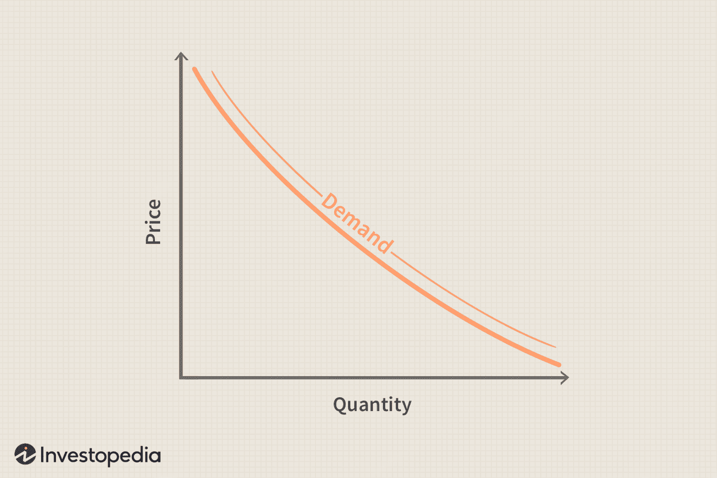 (Kenton, 2019)

Demand is governed by the law of supply and demand. The law of supply and demand asserts that, as a function of price, the smaller the quantity required is, and vice versa. Consumption decreases as a result of the increase in price, as is natural. As a result, the demand curve begins to slope downward.

Conditions of demand
When it comes to the product demand curve, these are called "circumstances of demand," a phrase used to describe variables that might cause the curve to change on both sides according to Griffiths, A. and Wall, S. (2011). Economic growth is driven by demand. Businesses strive to raise demand in order to increase profits. To end recessions, governments and central banks increase demand. To combat inflation, they slow it down throughout the growth phase of the economic cycle. When you provide any paid services, you are trying to increase demand for them.

Determinants of demand
So, what causes demand? For each customer, there are countless variables that play a role in their decision to buy a product. The equation is reduced in economics to highlight the five key variables of individual demand (thebalancecom, 2012).
- The price of the product or service
- Consumers' earnings
- The costs of items and services that are either complementary to, or substitutes for, the primary item under consideration.
- Demand will be influenced by the preferences of consumers.
- Consumers' expectations for future product price increases or decreases
The following equation depicts the link between five different aspects of demand:
QD = f (price, income, prices of related goods, tastes, expectations), (Bccampus.ca, 2016). This equation, on the other hand, shows how demand and its essential variables are linked. Buyer income, pricing of comparable commodities, consumer tastes, and any future supply and price predictions all play a role in determining QD (quantity desired). What's needed shifts as a result of these circumstances. Consider that these factors don't alter in a vacuum and must be taken into account. All of the variables are constantly shifting. If you want to know how one factor impacts demand, you have to make the theoretical presumption all other factors might retain the same.
The price of a product is one of the most important aspects that might determine demand. But the price isn't the only factor that affects the market's demand. Because demand fluctuates in response to changes in price, the price is a constant. The five other parameters we take into account are all linked to the shifts in demand. There may be non-price factors of demand that could be taken into account.
(thebalancecom, 2012)

Consumers income - increase in demand is a result of a growth in income. Our ability to purchase more expensive furniture and other products increases as our income rises. When people's earnings drop, demand for these things goes down.
Price of related goods - As a result, this includes all variables that could affect the demand curve. Price, household income, and other variables. Demand for milk will rise as prices decline, making it more affordable for consumers to purchase larger quantities of milk. We can better understand how demand affects the economy by looking at two factors.
- Two types of consumption are recognised: substitution and compliment. Products and services that are viewed by consumers as alternatives, e.g. different brands of coffee, are included in the first group of products and services. Second, when customers believe that purchasing one item necessitates the purchase of another, this idiom is often used (Nellis and Parker, 2006). Consumption complements, such as sugar and milk for coffee, are a good illustration.

Number of buyers - A rise or fall in the marketplace's population of purchasers.
Investment in equities and bonds has seen a increase in demand attributed to the a growth of global reach of capital markets made possible by advancements in communication technology.
Demand for infant diapers soared following World War II due to a baby boom.
Taste preferences for a good and product - Increasing the demand for a product increases its value at every price point if the change makes it more attractive. The demand curve will shift to the right as a result of the increase in sales. The quantity demanded will shift to the left if customer preferences change in an unfavourable way. The introduction of mobile phones significantly reduced demand for landline phones, indicating how new goods can alter consumer preferences.
Expectations - In anticipation of higher future prices, buyers may decide to buy now in an effort to "beat" the projected price increases, hence increasing present demand.

Supply
In economics, supply is the amount of a commodity that providers are willing to sell at a particular price to the general public.
Supply curve
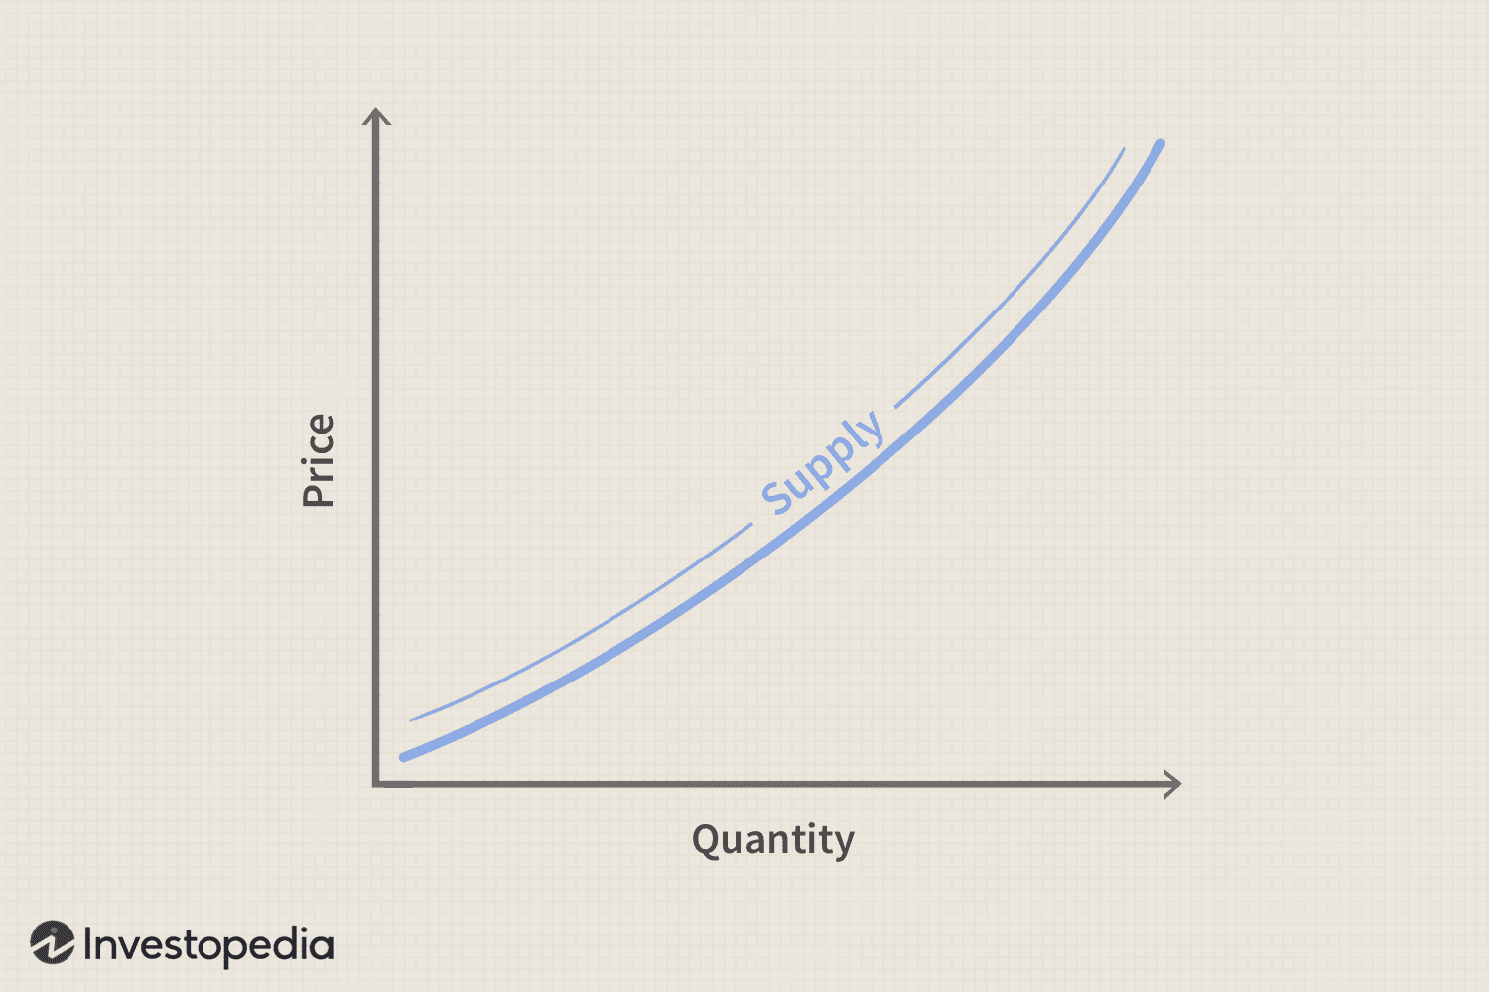 (Kenton, 2019)

In order to maximise their earnings, suppliers will strive to increase the quantity of an item they are offering for sale when the price of the item rises in price. Thus, the quantity supplied decreases in direct proportion to the price paid; conversely, the higher the price, the greater the quantity supplied. Only the most efficient providers can make a profit at low price levels, resulting in a limited supply. Profit motivation drives the addition of more resources to the market as the price rises, while the higher price permits less efficient manufacturers to turn a profit. Price rises as a result of increased demand. The price of a good or service is what causes movement along the supply curve.

Determinants of supply

Price - the starting point for developing a supply model is the product's pricing. It is a basic tenet of the supply model that pricing and supply are inextricably linked.

Non price factors

Availability of factors - Production and supply can be affected by the availability of factors of production, such as materials and labour. An automobile manufacturer's ability to construct vehicles will be hampered, for example, by a lack of steel for the body panels of its vehicles.
Cost of factors - The amount of product a company can sell for a given price will fluctuate as costs rise or fall. Costs will rise for each vehicle if, for example, the same manufacturer sees increasing labour prices as a result of higher wage rates. As a result, the manufacturer's anticipated profitability will grow. Things being equal up a sizable portion, if the cost doesn't really rise, less is supplied.
Technology - As a result of technological advancements, the demand for goods and services has increased.
Taxes - Value Added Tax (VAT), for example, has a direct impact on the supply of a particular product. As a result, an indirect tax on a product has same impact on a producer's decision to supply or how much to supply as a tax.
Subsidies - It is possible for companies to expand their output or lower their prices by receiving financial assistance from the government. For example, a government subsidy can change a company's motivation to manufacture and supply.
Weather condition - Weather changes can have a significant influence on the capacity of some products, such as agricultural goods and services, to be generated. It has a greater impact on the primary industry than on manufacturers.

Summary

A market's supply and demand show how suppliers and buyers are in constant communication with one another. The supply and demand curves for an item or service determine the price and quantity of that good or service. The level of the price and the volume of the good sold will fluctuate as a result of fluctuating supply and demand. Producers and consumers will both be impacted by this decision.

Conclusion
In economics, there are a range of factors that might impact a customer's purchasing decision. A consumer's wants and how he or she decides to acquire a product are not only determined by the price, and there is no evidence to support this assertion. Supply and demand are always influenced by a number of things when we talk about the economy. Consumer demand cannot be predicted just on the basis of pricing. In order to understand how the consumer market moves, economists look at many different variables. The term "economics" relates to both what we see in the real world and what we can imagine happening in different scenarios, according to the definition. The consumer's options change as well as the price, but the price is not the only factor contributing to the shift. In economics, the ability to comprehend all of the other factors that could impact our decision is crucial. Everything that is done or thought about that has a direct impact on the economic and consumer choices.

Reference list

Griffiths, A. and Wall, S. (2011). Economics for business and management. Harlow: Financial Times Prentice Hall.
Nordqvist, C. (2016). What is price? Definition and... [online] Market Business News. Available at: https://marketbusinessnews.com/financial-glossary/price-definition-meaning/.
www.dictionary.com. (2011). Definition of price | Dictionary.com. [online] Available at: https://www.dictionary.com/browse/price.
Gray, R. (2019). What Is The Theory of Consumer Behaviour & Why Is It Important? [online] FastPay Ltd. Available at: https://fastpayltd.co.uk/blog/consumer-behaviour-theory-how-has-it-changed/.
Nellis, J.G. and Parker, D. (2006). Principles of business economics. Harlow U.A.: Financial Times/Prentice Hall.
thebalancecom (2012). 5 Determinants of Demand with Examples and Formula. [online] The Balance. Available at: https://www.thebalance.com/five-determinants-of-demand-with-examples-and-formula-3305706.
Bccampus.ca. (2016). 3.3 Other Determinants of Demand – Principles of Microeconomics. [online] Available at: https://pressbooks.bccampus.ca/uvicecon103/chapter/3-3-other-determinants-of-demand/.
Kenton, W. (2019). Demand Curve. [online] Investopedia. Available at: https://www.investopedia.com/terms/d/demand-curve.asp.
Kenton, W. (2019). Tracing the Supply Curve. [online] Investopedia. Available at: https://www.investopedia.com/terms/s/supply-curve.asp.

‌

‌

‌

