‘Are you ok?’

A song cycle play written and directed by
Chloe Rae Williams

Module Code: ADPA600
Student Number: 2104042
University of Wales Trinity Saint David, Wales Academy of Voice and Dramatic Arts

Contents
Table of Contents
Introduction & Proposal 3
Literature Review 4
Development, Collaboration and Exploration Portfolio 9
Initial Ideas: Mind Map 10
Creative Tasks 11
Writing Tasks 12
Monologue Writing 14
Music Creation- Mind map 16
Drafts of Script 17
Music Score Choices 26
Structure 29
Rehearsal Schedule 31
Tech Week & Practical Performance 34
Journey of my piece 36
Final Script 39
Appendix 40
Bibliography 42

Introduction & Proposal

In this dissertation, I will be discussing my Individual Project, covering everything I undertook to create a successful piece. I will explore the research through a literature review format, followed by a step-by-step development process showcasing the journey to my final product. I will be focusing on the effects of life changes on an individual’s mental health and how having people by your side is important. For this project I want to achieve a clear message that can sit with any audience as I believe that as young people, we all have ambitions, goals, and people we want to impress in life. I want to showcase that no matter what you’re going through, there are people out there that are willing to listen, Miricyl; There’s Always Light at the End of the Tunnel (1).
My vision for this project is to create a song cycle play that explores into the struggles two women have when faced with life changes such as relationships, loss or pregnancy and the affect that has on their mental wellbeing. Zooming into how anxiety can make a person feel and sometimes take over their life. The story will follow two young women as they navigate through day-to-day life, struggling to succeed and find happiness within themselves. They are sisters who are lost, missing out of each other’s lives who are both experiencing pregnancy whilst grieving their late mother.
There will be a third character appearing and she will be situated as a ghostly figure. It is undecided yet whether I would like her to be a figure of their imagination or an overlooker from above watching over them. The two females are lost, not knowing where their life is going to head, and they’ve always known something is missing in their lives. As the story continues, it’s revealed that the ghostly figure is in fact their late mother and then it becomes clear that the two girls are sisters. At the end of the piece, the two girls realise they need each other, and these feelings will be showcased in a duet. I want to include music scores in my piece because I feel it will create a more rich and meaningful performance. When conducting research, I will be looking at resources that heighten and explain the uses of music in a piece and how to approach it correctly.
The inspiration for my piece will be taken from a girl named Claire Wineland. Claire is my inspiration for a portion of this project as she has always been one of my heroes and someone who has led and left such an inspiring story for people to gain morality from. She is an American activist and has performed many Ted Talks which gave me hope when in a dark place. She gives people hope and courage to do what is needed to be free, hence why she is such a large inspiration for this piece. By taking ideas from Claire’s story, I want one of the characters in my piece to hold onto the same qualities as she has. At the end of the piece, they come together as family, but realise that you can’t just get on with your life if your disconsolate, you must thrive in it.
Overall, the message I want to send across to an audience would be to always keep pushing yourself to be happy and knowing that you must make that change and decide your future. It’s a story about beating those thoughts inside your head of self-doubt and the importance of other humans.

Literature Review
How can life changes affect an individual’s mental health and wellbeing?
In this element of my dissertation, I will be gathering my research together to justify the themes in my piece. My piece focuses on the themes of anxiety, toxic relationships, parental loss and pregnancy displaying the affects these can have on the mental health of an individual. I wanted my piece to come across as a very positive piece with an essence of these issues intertwined in it. In dark times in my life, I look to people around me for support, especially my family. I have always believed that family is forever and no matter what happens that you should never choose to be apart from them. A good relationship with a parent produces the ‘familial relationship goods that people need to flourish’; Harry Brighouse and Adam Swift; Family Values (1). My piece explores the idea of how important family is and how certain life changes can affect one’s mental wellbeing and anxiety.
When first starting research for my project, I came across the book ‘How to Understand and Deal with Anxiety’ by Rasha Barrage (2). Reading this allowed me to have more of an insight into anxiety. I have found a lot of research from this book that could potentially contribute to my project and the character development that needs to be created. I want the two sisters to experience anxiety in some form or another so therefore this book and the information it entails will enable me to have a better understanding of anxiety as a whole and how it affects people differently.
The book firstly covers the definition of anxiety. Rasha Barrage states that ‘anxiety is an emotional experience and is part of what makes you human, it’s a normal response your body must make so that you are aware of situations you may be in’. However, by your anxiety being your body’s protector it can sometimes gauge the situation wrongly, causing you to be on high alert a lot more and experience more frequent anxiety than normal. The author talks about how there are three terms people can get mixed up with sometimes which are fear, anxiety, and stress. Fear is described as ‘real world danger’, something in the present that’s making you feel unsafe. Stress is when you are struggling to cope or deal with demands or expectations that are being placed on you. Both these terms mean different things to anxiety as anxiety isn’t always accurate and can just occur in a situation you may find frightening, but it may not be like that for others. This piece of information from the book allows me to have a deeper understanding of anxiety, I will use this in my character development to make them all more realistic to an audience. Even though the two sisters are very different in nature and live different lives, they are both struggling with different types of anxiety. I believe that everyone has some form of anxiety within them, it’s just that more people struggle than others. Anxiety can also cause physical effects on the body such as insomnia or chest pain states Kristeen Cherney; Effects of Anxiety on the Body (3). I would like my characters to be struggling in their lives but see the positive side to the darkness. To justify this point, positive self-concept is a trait that is more deserving than practice; Timothy Judge, Amir Erez and Joyce E Bono, The Power of Being Positive (4).
Rasha also talks about the ‘power of now’ and how you should live in every moment because life is short, and you never know what could come your way. It talks about how sometimes anxiety can put your thoughts into the past or future and how you need to accept mindfulness to relax more. She speaks about different types of anxiety and how they can affect people. She mentions social anxiety disorder that is known as the anxiety that makes you excessively worry about social situations. It usually centres around the way that you think other people see you rather than how you see yourself. It’s said that social anxiety makes an individual disorder with fear, avoiding the scrutiny of others as written in ‘The Lancet: Social Anxiety Disorder Seminar’ by Prof Murray B Stein MD (5). In my piece, the character of Katie will suffer with social anxiety, and this will be shown in the opening scene.
Sometimes when life is not going the right way, when you feel like everything around you are turning upside down, you need something or someone to help you find the light again. That person for me was Clair Wineland. During the lockdown in 2020, my anxiety reached a point that I found myself lacking the motivation to do daily things. The same thought would come into my head of ‘What is the point?’
After scrolling on YouTube, I came across a Ted Talk video of a woman named Claire Wineland. She talked about how she has suffered with Cystic Fibrosis (CF) all her life and how she still finds a way to live a ‘normal life’. Claire inspired millions around the world to make a change. She wanted to put it out there that those children who know they are going to die young can still live the most fulfilling life. When watching the documentary, I was able to find out more information about Claire, that even by 21 years of age she had undergone over 35 surgeries and spent most of her life in hospital. She thought that her illness didn’t define her as a human being and that anyone can live their life to the full if they put their mind to it. She was a YouTube sensation and made videos that gained popularity online, showcasing the realities and positivity of people suffering with CF. She has been a massive inspiration for this project, and other people around the globe. In words of Claire Wineland ‘Death is inevitable. Living a life, we can be proud of is something we can control’ Jessica Ravitz; Living while Dying (6).
In my story, I want to put the message out there that some people have barely any life to live but they still make it meanwhile. I know I want one of my characters to possess the same qualities as Claire and for them to be the vessel that brings the other characters together. I will put these qualities in the mother and even though she died from terminal cancer, she found a way to bring these two sisters together from her death. To conclude my thoughts on this theme, I argue that anxiety is something you can heal from as an individual and sometimes you need a push to do it.
As well as exploring the theme of anxiety within a lifestyle, I want to look at the negative effects a toxic relationship can influence on an individual’s life. When conducting research, I concluded that there are so many different arguments by people that support points. Firstly, I came across an article from Glamour Magazine named ’11 Women Share their Stories: Why I Stayed Unhappy in Love’ by Akirah Robinson (7). The article states that one in four women will have experienced some sort of abuse by an intimate partner and that it’s important for women to speak up if they feel they are in a toxic relationship. The character of Ella will be struggling in a negative marriage where she feels her husband doesn’t support her or have time for her. Choosing his work over being there for his wife and her pregnancy. This will then assist me in helping choose a solo song for Ella. For this to look realistic, I will be taking inspiration from other women’s stories to make my own. Akirah Robinson states ‘I stayed in an unhealthy relationship because I didn’t want to be seen as a failure’. She also stated that people are usually afraid of the future without them, terrified of being lonely and never finding someone else. To contrast this, some women should endure an intervention policy to protect themselves from this type of abusive behaviour, this point is supported by Nazaria Solferino and Maria Elisabetta Tessitore who wrote an article on ‘Human Networks and Toxic Relationships’ (8). These two women believe that there is always a way out, and that finding strength in the existence of a third party that acts as a benchmark such as: a family member or a private organisation that helps victims, can help get the person out of danger. These two articles state different views but I can take both viewpoints into consideration.
To conclude my argument, women struggle with relationships, and some women don’t even try and break free from them. If you’re not happy in a relationship, you shouldn’t be in it. The work of repetitive abuse in a relationship will prepare the survivor for testing the exits in the process of breaking free, as said in Marilyn Merritt Gray and Judith Wuest’s article: ‘Counteracting abuse and breaking free: The Process of leaving through women’s voices’ (9). This relates back to my main theory of knowing that family will always be there. Family can come in all sorts of different ways, but nobody is truly alone.
The next theme I want to explore in my piece is parental loss and the effects that can have on adulthood. Women are usually found to struggle more with adjusting to the loss of a parent and have a more intense grief period, as said by Bert Hayslip, Jessica Pruett and Daniela Caballero; The ‘How and When’ of parental loss in adulthood’ (10). In the play, the mother’s death is dealt differently by the two girls as one feels guilt while the other feels sadness. I want to display this by using proxemics and possible exploration of the relationship through a movement piece. Using Proxemics will give a clear picture to the audience about the sisters as the distance describes their attitude toward each other, Edizoni Di Pagina; Proxemics On Stage (11).
Losing a parent is something that most people go through at some stage of life, however losing a parent from a terminal illness is extremely difficult. I intend to have both sisters grieving together but also finding strength in being as one. When conducting research on this theme, I investigated the effects that a terminal illness death can have on a family member. This relates back to my point about Claire Wineland, and how her family helped support her through her disease. The sisters are very different as people, and ultimately don’t understand their mother in the same ways. Therefore, when thinking about the cause of death for their mother, I researched into various reasons. I investigated how adult bereavement from suicide can affect an individual developing mental health problems, Jstor; Early parental Death and Risk of Hospilization for Affective Disorder in Adulthood (12). However, when trying to think of a subject that is close to me as an individual, I decided to bring cancer into the story. Everyone has experienced some form of cancer loss in their lifetime and throughout my life I have unfortunately lost many family members and friends to the terrible disease. When caring for someone with cancer it can affect the caregiver’s health behaviours and cause changes in height or weight, stated by Vanessa Beesley and others of the Quality-of-Life Investigators; Loss of lifestyle (13). The character of Katie will be experiencing and facing many hard times when caring for her dying mother, even though I don’t intend on showcasing this in my piece, I may place a flashback scene in those transitions into her death, so it remains more positive. Parental Loss can have such a major effect on an individual’s life, this also justifies the fact that both sisters are pregnant, and the mother has been through most of Katie’s pregnancy with her. However, she sadly won’t live to see the baby being born.
I thought that when conducting research, it was important to chat to my cast members about if they’d had any experiences with cancer in their families to collect some secondary research. They were able to tell me that each of them has either known someone who has been affected by cancer or has died from the disease. This was eye opening and laid out the fact that so many people die of cancer per year. According to Cancer Research UK (14) there are currently around 167,000 cancer deaths per year in the UK, which roughly calculates to almost 500 every day. It states that every four minutes in the UK somebody dies from the disease. This was shocking to find out and helped to justify my point of the effect this death will have on Katie’s mental wellbeing. In my piece, I would like the character of Katie to read out a eulogy at the funeral scene where she can then explain to the audience her relationship with her mother. Eulogies can be done by minister or a family member/friend. However, by her daughter conducting the speech, this can be very rare but also courageous. I want this scene to show the strength Katie has to have this baby without her mother but then comparing it to Ella’s situation and realizing they both need someone. Overall, the theme of parental loss in my piece is what brings this family back together again and is very important for my storyline.
Lastly, the theme of pregnancy has presence within my piece with both sisters being pregnant throughout the storyline. I have always had a keen interest in pregnancy and the development of a baby. As the character of Katie is 28 weeks pregnant, I researched into what a stress induced pregnancy would look like. Stress induced pregnancies can cause preterm labour, low birth weight babies or development delays of the fetes according to Cardwell, Michael; Stress Pregnancy Considerations (15). Therefore, I learnt that stress could cause problems in the birth and growth of the baby. Psychosocial factors also play a major role in triggering postpartum depression in adults’ states Laura Miller; Postpartum Depression (16). This then applies to both characters as they are both pregnant and may experience depression after birth due to the death of their mother.
To conclude my literature review, I have used many research sources to help structure and create my storyline. Reviewing my themes, I have been able to gather reliable research points to justify my findings. All four of the themes I have included in my piece all return to the statement of ‘the effects of life changes on mental health and wellbeing’.

Development, Collaboration and Exploration Portfolio

In this element of my dissertation, I will be discussing the development process of my project, taking you through the steps and paths I followed to get my result. There were many tasks completed in class lectures with Elen Bowman that I found to be very helpful and allowed me to set forth on the journey of developing structure, storyline, and characters. Throughout the process of this project, I have been able to source good information from valuable sources but also take part in tasks that have assisted to stem ideas.

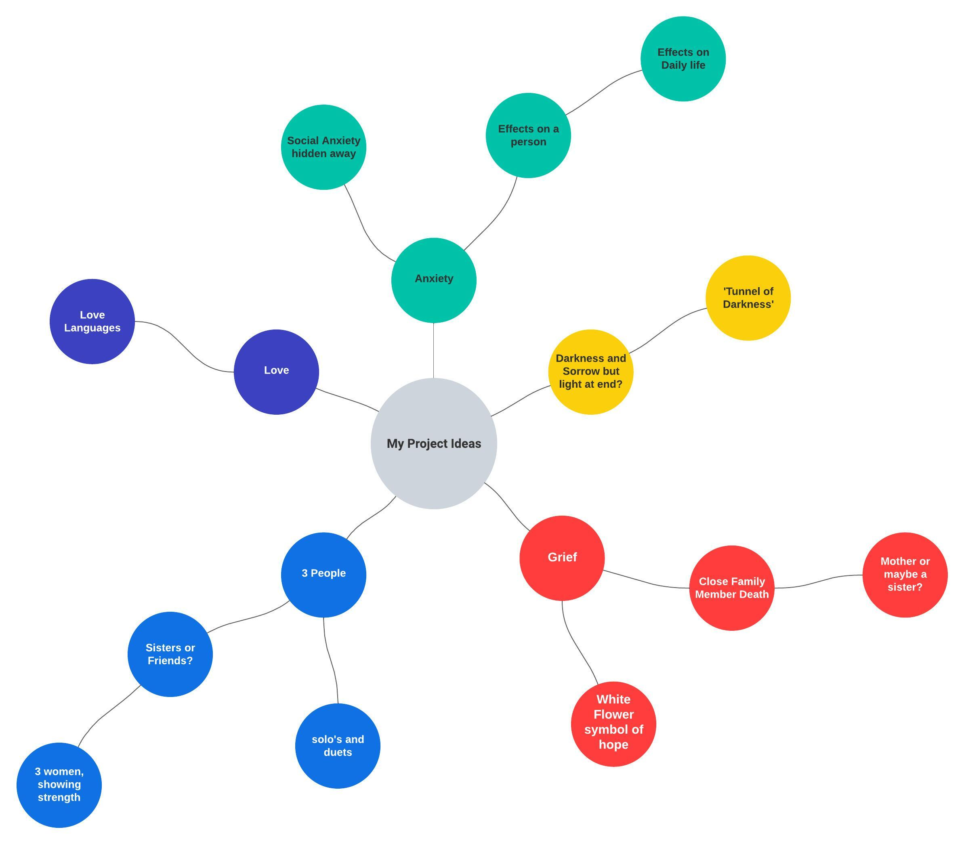
Initial Ideas: Mind Map

Creative Tasks
After gathering my ideas and initial thoughts together, I was able to get a clear image in my head about what I envisioned my piece to look. In this section, I have included every devised piece of my final script that I felt assisted me with the result. This includes, writing tasks, devised monologues, music creations mind map, music scores chosen, structure of my piece, etc.
When creating content and storylines for my piece, I felt that writing monologues for potential characters was the best way for me to be able to create dialogue and begin to select music scores. After writing one in class, I then found that if I felt lost with no sense of where my project was going when writing, I would write a monologue about the initial feeling that the character would endure in the scene, and then just let the words flow onto the page.

Writing Tasks
- Write a Blurb
‘When you lose someone, it can change your life. Grief comes in many forms; I just don’t know if I can deal with it anymore. I wonder if there is a light at the end of the tunnel like everyone says, guess I just need to meet someone who gets me.’

- Write an email/letter in mirror
Dear Emily,
I can’t believe you left me. You chose to leave me alone with a mother who cares more about her cat than my feelings. I wish you knew what you did to me, not getting help when I told you to. I want to see you and be able to talk to you about what’s going on, but you can’t listen to me. I don’t know if you can hear me, I want you to know I do love you.

- Minute consciousness
I remember waiting outside in the rain for so long for him. I remember the way she looked at me when I told her. I remember my face when I looked in the mirror. I remember him lying on top of me. I remember yesterday’s coffee. I remember everyone looking at me when I walked away.

- Pick object & create story
Ella is sitting at her dressing table after having a argument with her boyfriend who can be emotionally/verbally abusive to her. She has mascara pouring down her face from crying. She starts to take a makeup wipe to wipe off her mascara and starts to reapply her makeup using the brush. She angrily applies it to her face, feeling as though she needs to cover up her tears from him.

- Beginning scene & draft structure

- Starts with two young girls’ solos of problems
- Watches a documentary about Clair and her Ted Talks, she sings and then there is dialogue
- ‘She’ appears as a ghost and is not real.
- Petals falling on floor throughout play to symbolize love and light being there
- Two girls have duet to end

- Conflict of my piece idea task:
Two women who don’t get along too well in the waiting room, but ultimately is about the sister breaking way from the toxic relationship she is in. Her other sister pushes her to do this.

Monologue Writing

(A girl appears to be sitting on a hospital bed talking out to the audience. She is hooked up to monitors and an oxygen tank next to her.)
BELLA
I have never slept with anyone. It’s ridiculous, like I’m 20 years old and never done half of the things most adults have experienced. ‘Having sex is normal’ my sister who’s 16 says to me. Everyone knows I am not a fraction of normal. Spending most of my nights in a hospital bed isn’t really going to put me on a boy’s radar, or any radar for that matter. How do you even know who you want to sleep with? I mean there’s millions of people out there, how do I go about choosing one? I know that most people invest in dating apps these days, but I don’t think there’s a Tinder hospital version out there, is there? Who knows, I mean people invent some weird stuff this day and age.

(A girl is sitting in a hospital bed chair, talking to the audience.)
BELLA
I can’t imagine my life without CF, I mean it’s been my entire life if I can remember. I was born with the disease and the fact that I won’t live past 25 years old, even if I wanted to. I don’t know if I do. I mean the thought of being in my 40’s is something I’ve never imagined. All my life people assumed I was weak because of my illness but I think it makes me stronger. Even though your feelings are valid, you need to make a change and only you can choose to live life to the fullest potential. Doesn’t matter how shit it might feel, you don’t need him! You can thrive by yourself and find ways to be strong within you!

(A girl is sitting on a bench in what appears to be in a park, people are around her, but she is in her own world and speaking to herself.)
Anxiety surrounds me when he’s there. Most people think I’m exaggerating because how on earth could I be saying that about a man that is known as the most high-end person in the whole street? People don’t know what goes on behind closed doors or what can really affect someone they love. You’re not going to believe me, nobody ever does. It’s like everything I say or do is wrong somehow. I just want to feel like me again, to be able to be the girl I used to be and speak my voice to be heard. I wish I could sometimes disappear as easy as snow melting. Suddenly vanish and see if he would even care.

(A girl appears to be having an argument with her partner who doesn’t understand how she feels anymore.)
How could you say that? I can’t even leave the house because every time I move, I feel like the ground is going to swallow me whole. I know life is short and I shouldn’t keep myself locked away in my room away from it but it’s too scary to face. You don’t know what it’s like to fear your own every move and to constantly feel like everyone’s against you. Leaving the house is haunting to me, probably my worse fear honestly. How do I go on? I want to be able to do everything, but it feels like I’ll never be able to.

I found these monologues helpful when trying to characterize Ella as a realistic individual, as I wanted her to feel vulnerable and raw on stage. They both cover the toxic relationship theme, which is what I wanted one character to experience.

Music Creation- Mind map
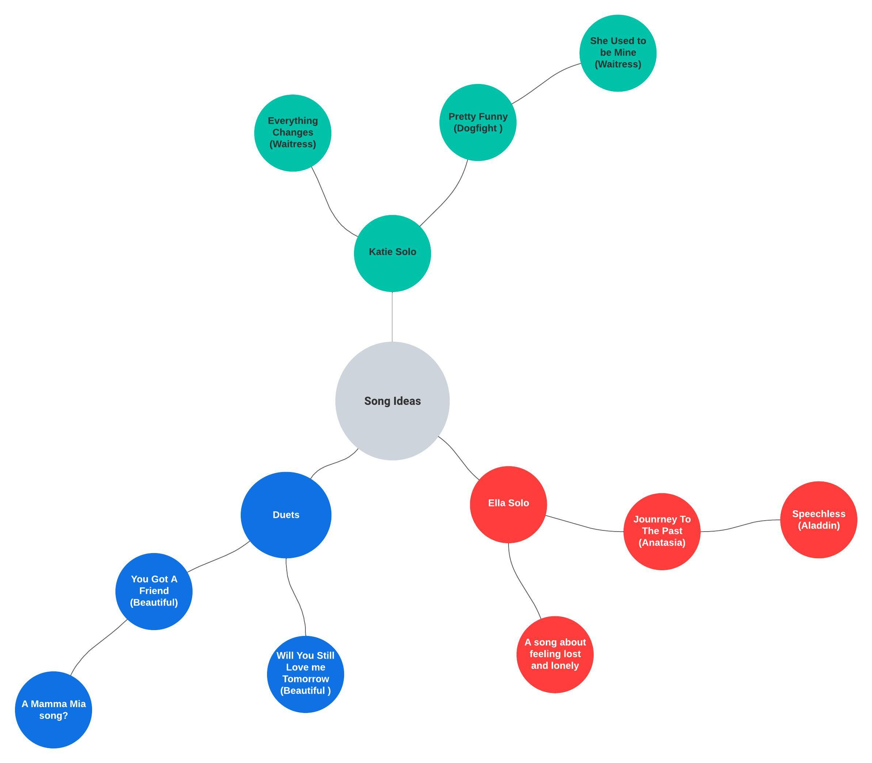

Drafts of Script
SCENE 1
This scene has been the only scene with no changes, I wrote it right at the start of the process and have kept it since. I like the way it has comedy to it and comes with a strong opening.
(‘The White Flower’ is situated at the top back of the stage to symbolize The Mother throughout the piece. All the girls come on to the stage and place flower in the middle of stage at back with the music ‘Rue Des Trois Freres’ playing in the background.)
The white flower is a centrepiece for my production, showing the symbol of hope surrounding them all the way through. (More to follow in my journey of my piece section)
(The lights then come up on two chairs with Katie and Ella sitting on them waiting for something, their location appears to be in the waiting room of a hospital. Katie appears to be heavily pregnant. Lights come up on the pair as we are introduced to their conversation.)
ELLA
Are you ok?

KATIE
Huh? (Not realising Ella is talking to her)

ELLA
Are you ok?

KATIE
Oh yeah, I’m fine, thanks.

Beat.

ELLA
How far along are you?

KATIE
28 weeks… I’m sorry do I know you?

ELLA
No, sorry I... uh. I’m only 13 weeks, just found out.
Beat.

ELLA
This would be me and my husband’s first baby together and he keeps telling me all about how I shouldn’t drink caffeine when your pregnant and I’m not sure I can make it through nine months without a cup of coffee. You know how men are, I mean even the smallest problem stresses them out. What about your husband? I bet you he’s excited about having a baby girl.

KATIE
It’s a boy.

ELLA
Yeah, that what I said.

KATIE
Oh, right.

(Nurse calls out the name ‘Katie Weston’ with a clipboard in her hand)

KATIE
That’s me.
Beat.
KATIE
See you around. (Begins to walk away)

(Ella has a moment where she realises, she recognises her name)
ELLA
Oh, and good luck with your baby, I really do hope everything goes well. You’re going to be such an amazing mum.
Katie walks into Nurse’s room with her.
(End of scene.)

SCENE 2 (FIRST DRAFT)
(Scene opens to Ella on the phone to this unknown woman. It then becomes a split screen where we see the other person on the phone speak too.) I kept the ‘on the phone’ aspect in final piece.
ELLA
Hello?

WOMAN
Hi there, it’s Clair from the registry office?

ELLA
Oh... Hi!

CLAIR
I was just calling to inform you that I can confirm that you do have a sister. Her name is Katie, and she should be in her mid-twenties by now.

ELLA
Oh…wow. That’s amazing, thank you.

CLAIR
However, I would need to get in contact with her first to be able to determine whether you would be able to communicate with her. Would you like me to reach out to her?

ELLA
Ok, yes. And thank you so much.

(Phone call ends. Ella then begins to sing her solo)
ELLA’S SOLO- I STILL BELIEVE IN LOVE FROM THE MUSICAL THEY’RE PLAYING OUR SONG.
This was a potential song choice for Ella, however when discussing with Elise, she felt it wasn’t going to be successful vocally for her.
I originally had the idea of putting this scene in to introduce Ella’s situation, she is on the phone to a woman from an adoption agency who informs her about her sister. I decided to then change this scene and make it just about Ella to show she is more alone than Katie. I then decided to change the duologue to a monologue as I felt it created more tension in the scene and symbolised her loneliness. I used the monologue writing technique (see page 15) to enable me to spawn ideas.

.

SCENE 2 (FINAL DRAFT)
ELLA
Hi, I guess you’re caught up with work again or something, but I need to talk to you so please call me back when you get this message.
Pause.
I just found out some news and I thought that as my husband I should be telling you these things. Well, I thought you’d be interested or even care. Do you even care about me? I mean the last time I spoke to you on the phone was a week ago and even then, it was only for a minute because you said you had a ‘work meeting’. Do you even care that I’m having your baby? Do you even want a family with me? You know you haven’t even stopped to ask how I am, haven’t thought ‘maybe she needs some support, you know in 6 months, when her vagina is going to become 10 centimetres wide.’ No, it’s all about you, just you, no one else. I found out that my mum died, and I have to go to her funeral on Friday, so I hope that’s enough for you and your businesses ventures.
Pause.
This marriage won’t work, can’t work if you don’t care about me or pick up the phone and give me a fucking call. If you don’t call me back, I’m assuming it’s over. Or let’s put it this way, it will be.
This monologue adds context into Ella’s relationship and leads well into the song ‘Speechless’.

SCENE 4 (FIRST DRAFT)
KATIE
I never thought I’d be standing here. Having to make this speech, say these things I never thought I’d say. Bella was the light of my life, an inspiration to all, she taught the world to be a better place, to be bright and cheerful. Her smile would light up a room every time she walked in. I know that Mum would have been proud of her, but knowing they’re together somewhere bringing me joy, but also loneliness. Loneliness that I’ll never have anyone in my life, apart from you (touches her stomach).
As you can see, I had the original idea of having the sister (Bella) die and not the mother, however I felt it made more sense for the mother to bring the two sisters together over a third sister.
Katie exits.
(Score music plays as we go back to the character who is unknown walking around the stage. Spotlight then goes to Katie who is remembering a time with her sister through song. Bella lingers over her, but Katie can’t see her.) I had the sister lingering like a ghost, similarly to the ghost of the mother.

SCENE 4 (DEVELOPED MONOLOGUE)
KATIE
I never thought I’d be standing here. Having to make this speech, say these things I never thought I’d have to say. She was the light of my life, an inspiration to all, she taught the world to be a better place, to be bright and cheerful. Mum and I were very close, she was my best friend and supported me through everything I went through in life. She saw it all, my first steps, first words, first laugh and even my first kiss where she proceeded to take pictures of eleven-year-old me who thought she was living the dream. Mum always said, ‘family is forever’ and I never understood quite what she meant because I never left her side. She believed that family came first, and that life is too short to forget people you love. When she found out she had cancer, she knew she wanted to live the rest of her life to the full, and even on her darkest days, she still found a way to find the light. My mother was my best friend, an inspiration, a role model, and I will forever miss her.
I have highlighted the pieces of the monologue that were added, in relation to the mother & daughter relationship, referring back to the theme of parental loss.
(Score music plays as we go back to the character who is unknown walking around the stage. Spotlight then goes to Katie as she begins to walk forwards to the front of the stage, while we then go into a movement segment where we see Ella and Katie’s relationship with each other as strangers who are unsure of each other.)
I then decided to add in a movement segment using lanes to demonstrate the relationship both sisters have with their mother (more to follow on page 19)

SCENE 5 (FIRST DRAFT): SISTERS MEET
KATIE
I had a phone call telling me I had another sister and that she wanted to meet with me. My mother had another baby when she was just a teenager and I she never told me. I didn’t believe it when I found out, but when she showed me the documents, I couldn’t believe it.
ELLA
I had a calling to come here as I knew you’d be here, and when I found out what happened to your sister… I had to come.
I had the sisters meet in a graveyard overlooking the grave of the lost sister, and then Katie revealing how the adoption agent called her and told her she had another sister.

SCENE 5 (DEVELOPED)
KATIE
When I was clearing out Mum’s attic, I came across this picture I’d never seen before, which was weird to me because Mum would always show me all my childhood photos but not this one. It was me as a baby, her holding me with this other little girl stuck to her side. There were three of us, even though it’s always ever been me and mum.
ELLA
(scoffs) Guess she never mentioned me. Typical. I mean I didn’t think she would.

KATIE
Why?

ELLA
Probably not worth mentioning.
I decided to have Katie as the person who goes up to Ella and explains what she’s saw. In the first draft, I wanted Ella to find out about having a sister from an adoption agency, but then when talking to my cast I decided that Ella did know her mother, just not in a good way.

Music Score Choices

My piece explores many themes and some of these themes can be difficult to portray to others. Therefore, by incorporating music into my piece, I was able to showcase my own musicality and ability to contain both song and dialogue into one.
Link to a playlist containing the scores used:
https://music.apple.com/gb/playlist/are-you-ok/pl.u-BNA6z9bu1PxraEv
Link to YouTube video for ‘You Got a Friend’:
https://www.youtube.com/watch?v=A1Ja1MvlWyo

Score 1
‘Rue De Trois Freres’ by Fabrizio Paterlini
This song is a piano track written by composer Fabrizio Paterlini who is a well-known pianist, originally from Italy. He makes beautiful sound and composes music that has a ‘sonic palette’ says Fabrizio Paterlini’s official web page (18). I have decided to use this melody in my piece as it creates an ethereal, unnaturalistic approach to the beginning of the performance, this will then snap into the first scene which has a more realistic tone.

Score 2
‘Speechless’ from the Disney sensation Aladdin
Ella was a character that I struggling to find a song choice for, but when discussing with Elise the options we were then able to come up with some songs that matched the monologue beforehand. We decided on the song ‘Speechless’ from the Disney movie, ‘Aladdin’ as I felt it symbolized the fact that Ella feels as though her voice isn’t heard by her husband. I wanted Ella’s character to come across as feeling lonely and living with the regret of wanting to live with her husband instead of staying with her mum.

Score 3
‘Slipping Through My Fingers’ from the musical Mamma Mia!
When choosing a song for the flashback duet, I needed to have something that created a special moment between mother and daughter. The fact that Katie sings the last bit alone in the funeral gives the sensation she’s all alone now her mother’s gone. This is bittersweet as Ella is a part of her, she just doesn’t know it yet. In the musical, this song features when the character of Sophie is about to get married and her mother is getting emotional watching her grow into her new life. Mamma Mia is classified as a ‘joyful musical’ and has intervened people’s lives out of depression, Cambridge University Press (19).

Score 4
Zen Music by Meditation
This music was used for the lanes movement section of my piece showcasing relationships.

Score 5
‘You’ve Got a Friend’ from the Carole King musical: Beautiful
This song is one that I knew from the start that I wanted in my piece. I had the idea for it when I went to see the musical in Cardiff’s New Theatre and witnessed this scene happen in the show. The song is about friendship and telling someone you are always there when you need them and that’s exactly what I wanted to send across in my piece.

Structure

Mother Walks on stage and stands at back with bouquet of white flowers
Katie and Ella enter a waiting room and meet for the first time.
Ella goes back home, confronts her husband for not caring and then breaks into song.
Katie has a flashback scene to when her mother helped her get ready for a date with a boy.
Funeral Scene where Katie does a eulogy for her mother
Transition into lanes movement sequence to demonstrate relationship of trio
Confrontation scene where two Ella reveals her story and is confirmed they are sisters.
Two sisters agree to come together as be there for each other
END.

Rehearsal Schedule

When directing any show, it is vital that you have a rehearsal schedule that you can follow instructing you what needs to be completed and worked on by the end of that session. I felt that creating a schedule enabled me to improve my time management skills as well as my ability to use my time effectively surrounding my other studies. Although organizing is one of my major strengths, at times Elise who plays Ella wasn’t available for many rehearsals so therefore I had to re arrange slots so that I could also fit around her day. I found this difficult to maintain as during tech week it was a struggle, but manageable.
Date | Time & Place | Cast needed | Objectives
05.05.2023 | 5:00-6:30pm  Studio 1 | All cast members | Read through of script  Talk through any questions or ideas they may have for the storyline
06.05.2023 | 1:00-2:30pm  Studio 1 | Tyrion Price (Mother)  Fflur Jones (Katie) | Improvisation for dialogue in flashback scene (record on voice memo)  Sing through Slipping Through my Fingers and establish parts.
07.05.2023 | 3:00-4:30pm  Studio 1 | Elise Turner (Ella)  Fflur Jones (Katie) | Work on opening scene  Improvise the ending scene and record on voice memos  Structure Lanes movement scene, choose music.  Sing through ‘You Got a Friend’ duet and work on harmonies.
10.05.2023 | 5:15-6:00pm  Recital Room | All Cast needed | Go over opening scene  Discuss the upcoming weeks
12.05.2023 | 3:30-5:00pm  Recital Room | All cast needed | Music call to run all songs and work on them individually  Check harmonies also
15.05.2023 | 2:30- 4:00pm  Studio 1 | All cast needed | Run whole piece + time it  Work on duets vocally  Work on Ella’s monologue & solo
16.05.2023 | 9:30-12:00pm  Studio Theatre  1:30-3:00pm  5:30-6:30  Studio Theatre | All cast needed for whole day | Tech Rehearsal  Clean all scenes and numbers  Work on any notes from tech  Running pieces 1-6  Top and Tail for lights and sound cue
17.05.2023 | 12:30-2:00  Studio 1 | All cast needed | Music call to run all songs  Change some aspects of opening scene
18.05.2023 | 3:30-4:45  Studio 2 | All cast needed | Practice with changed lines  Change Lanes movement slightly & practice with petals
19.05.2023 | 9:15- 10:30  Studio 2 & Studio Theatre | All cast needed | PERFORMANCE DAY  Run piece in morning

Tech Week & Practical Performance

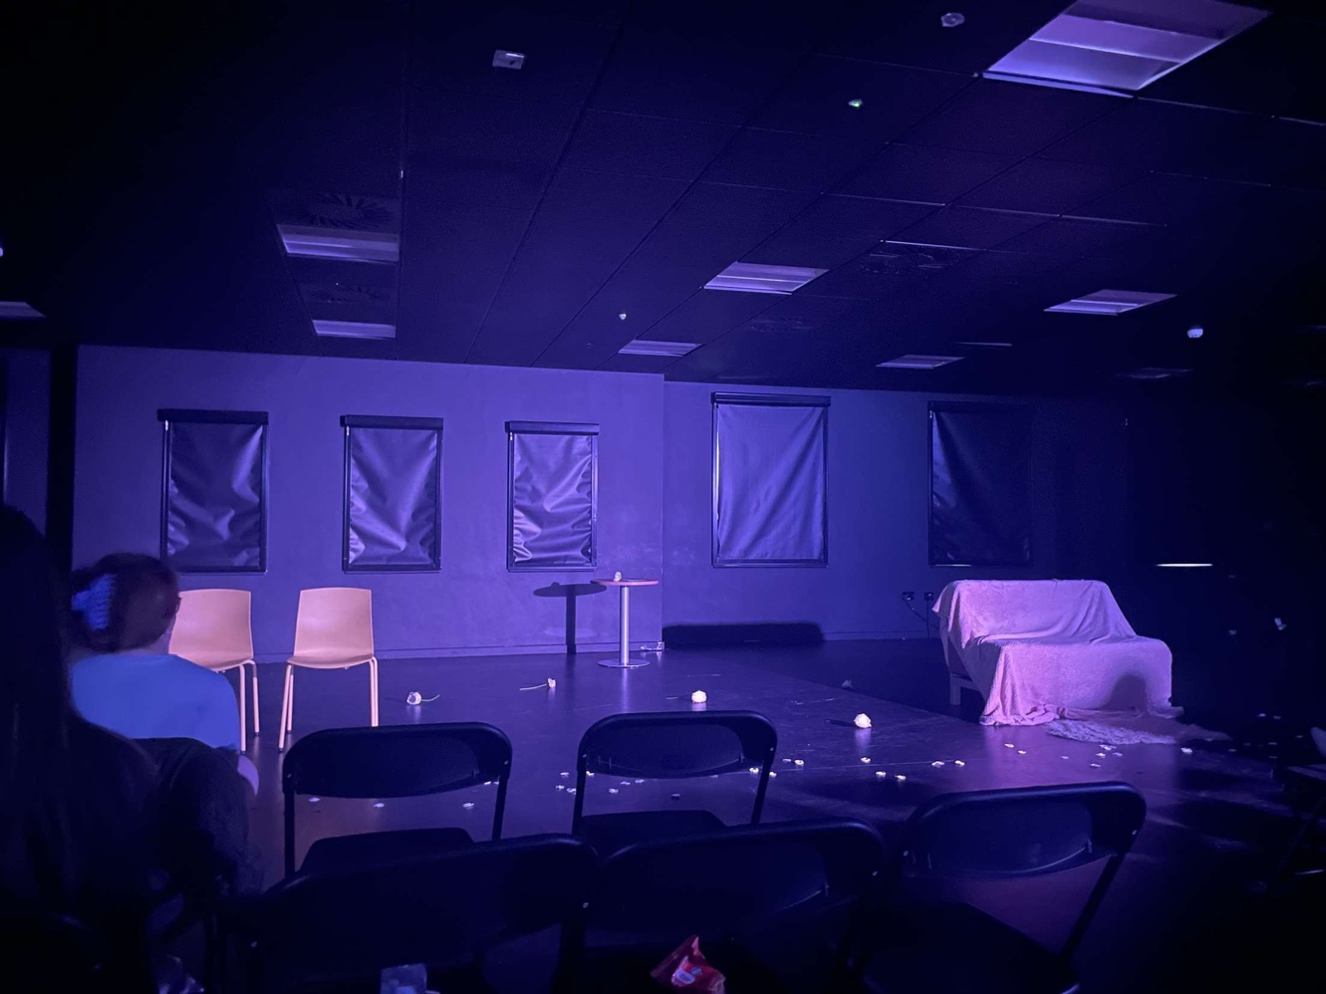
During tech week, I learnt many new skills. One of those being heightening my direction by coming up innovative ideas for lighting and sound choices. Throughout my piece all my lighting was kept quite simple and warm with snaps into sharp reds and blues for more unnaturalistic scenes. I found that one of my weaknesses was sometimes trying to choose the correct lighting for a particular scene as the mood of the story would always change quite quickly. However, I had Zoe to help with my tech while I the assisted with her piece also.

Above is a photograph of the set on the day of the performance.

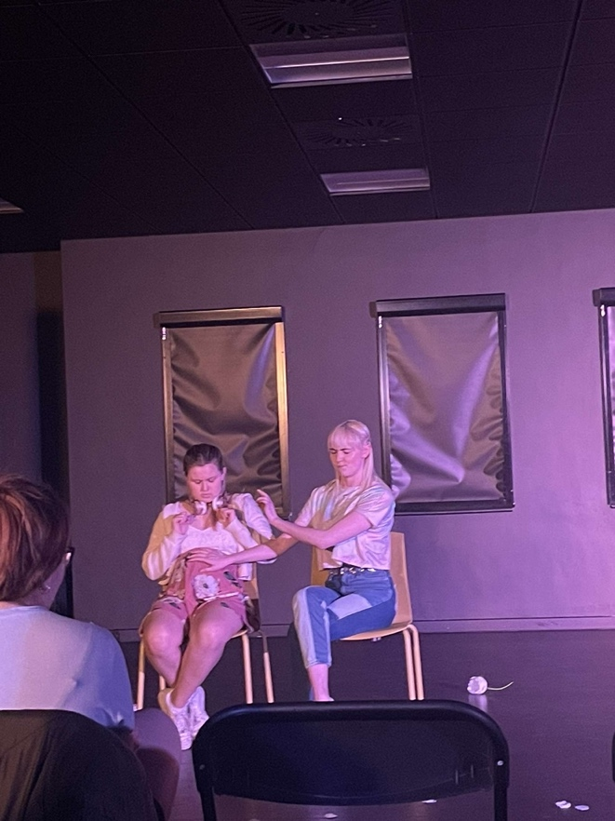
The opening scene. Ella’s solo scene
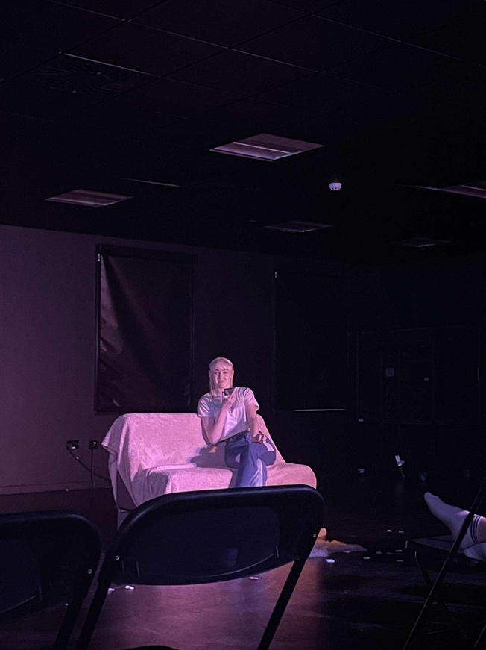

The ending scene:
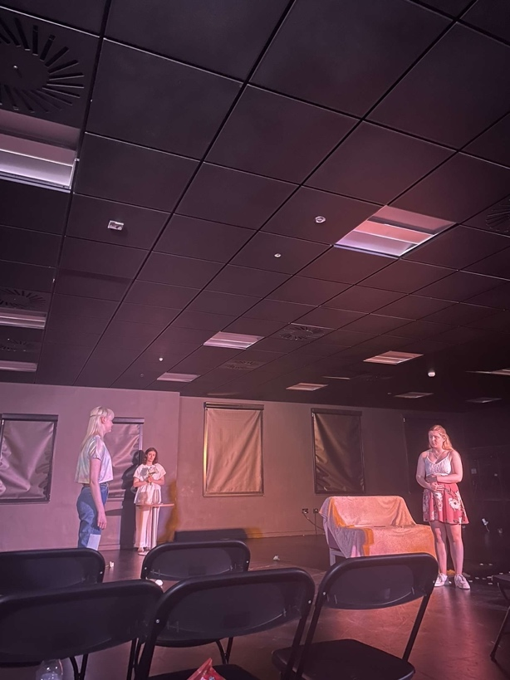

Journey of my piece

When working on my piece, I believe that keeping a journal is very important. It allows me to see the progress of my piece and the skills I have learnt throughout the weeks of the project. This allows me to showcase my organisation skills as well as showing that I can look through the journey of my piece in detail. In this section, I will be taking you through the full journey of my piece.
In the first few weeks, I started off with the initial story of there being three sisters and them coming together due to one of the sister’s deaths to a terminal illness called Cystic Fibrosis. I wrote a scene where we were introduced the third sister named ‘Bella’ but then I decided to cut it out. I thought that this was a valuable decision as the storyline was becoming more and more confusing and difficult to understand.
After having discussions with Elen, I then decided to have the mother’s death and funeral bring the two sisters together. This was more logical as then both girls would be feeling lost and in need of someone, and with them both being pregnant, I felt that was the perfect reason for Ella to want to forgive her family. When conducting my research, I found out that pregnant women can feel stressed without their partner supporting them, this can even lead to post-natal depression, Refer to reference (17).
It was decided that Ella did have a relationship with her mother, but it wasn’t a very strong one. They only spoke on holidays, and she wasn’t even aware that Ella was pregnant before she died. Ella knows that she has a little sister but has never reached out to her as she felt that Katie was a better daughter than she could ever be. The song ‘Speechless’ expresses feelings of not looking back and regaining the power of her voice and doing what’s best for her. I liked the vision of the play beginning with them being strangers and ending with them being family.
When writing the script, I always had a beginning and an end but never knew how I wanted the piece to flow into the dramatic reveal at the end. To write the end scene, I decided to let Elise (Ella) and Fflur (Katie) improvise the characters meeting in the funeral and finding out the truth. I then recorded this and used it to assist me in writing an ending for the story (see appendix 1).
I then immediately envisioned the duet to go after the dialogue as I felt it gave a positive ending to the story and reiterated my message of knowing you are never alone; you always have somebody. The song ‘You’ve Got a Friend’ by Carole King, is a song that I chose right at the beginning of the development process. This is because I knew I wanted the ending to be a happy one, and to symbolize friendship. When learning the song with the cast, we went through each segment in detail and spoke about what the lyrics meant to them personally to give more emotion to the piece.
In comparison, I went through the same process when creating dialogue for the flashback scene between Katie and her mum. I wanted the scene to be a cherished moment between mother and daughter, therefore I asked Tyrion and Fflur to improvise a scene (see appendix 2) where Fflur’s character was getting ready for her prom and needed her mother’s advice. I then directed them with different scenarios but with the same objective. For example, we improvised Katie getting ready for her wedding and then also her going on a first date with a boy she liked. This then gave me some inspiration to the duet ‘Slipping Through my Fingers’ from Mamma Mia. The flashback is cherished greatly by both women but is only a memory of Katie’s as the scene transitions into the funeral of her mother. I wanted this scene to become emotional for the audience, as they watch the love between the pair slowly change into being apart forever. I had Elise’s character (Ella) stay in her position from doing her solo in the previous scene, for the audience to differentiate each daughter and the contrasting relationship their both had with their mother.
When rehearsing with my cast, we discovered a new element of movement with relationships to add to the piece that would enable my audience to see the relationship between the two sisters with their mother. We incorporated gestures, speeds, and proxemics into the lanes, whilst having the mother walk through them with them using eye contact techniques (see appendix 3). This allows the cast to ‘write with their body’, Jaques Lecoq (20). We used the ‘Meisner Repetition’ technique in rehearsals to establish strong connections also.
When creating the design behind my piece, I knew I always wanted to have a white flower to be the centrepiece and symbol for the story. A white flower represents hope and light and the colour ‘white is love’, P.J Heather (21). The idea sprung to mind when I saw a poem on Pinterest (see appendix 4) that was explaining how the white rose is a ‘sprit flower’. Alongside the main bouquet I also had individual flowers and white petals scattered across the stage, giving the envision that the mum is all around them.
After writing the first draft of my script I asked first year performance students whether they’d want to be in my piece (see appendix 5). After hearing the responses, I then set up a group chat with all the members and send emails out for an audition. This showcases my organizational and professional skills.
Overall, this experience has taught me lots of skills that I will now carry with me into the near future, it’s given me an insight into directing and made me consider it professionally.

Final Script

To conclude my dissertation, developing my script over the past few weeks has allowed me to put a successful script together. Throughout this project, I have been able to evolve my time management, organizational, communication skills and my ability to problem solve. I have developed a piece that is heartfelt & sends a message across to an audience that keeping relationships is important, but good or bad you have the power to change.

PDF of full final script:
Full Script.pdf

Appendix
Link to voice recording of improvisation used in assisting end scene:
https://youtu.be/WEcLDHtzjKY
Link to voice recording of improvisation used for flashback scene:
https://youtu.be/Ic11C9e-wI8
Video of creation of the lanes movement sequence:
https://youtu.be/vdGx7lCGyqU

APPENDIX 4 -
Flower Poem, created inspiration for white roses:

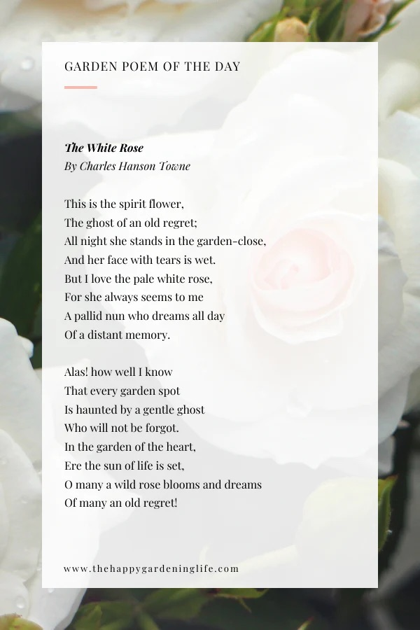

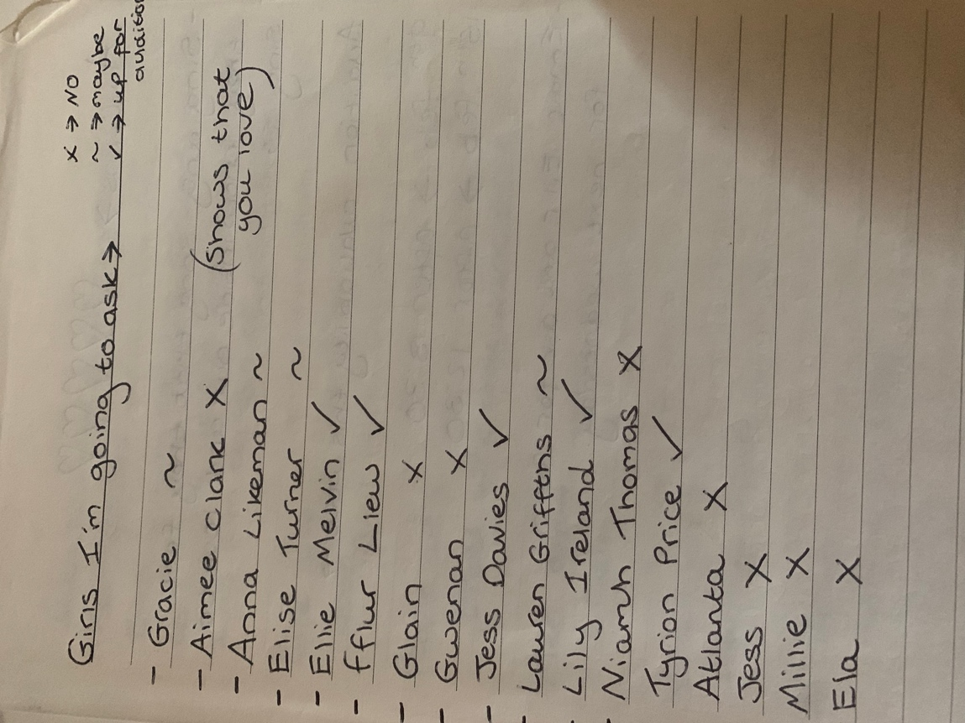
APPENDIX 5 –
List of first year female students I inquired about auditioning.

Bibliography
- Miricyl, Mental Illness Research in Childcare & Young Lives, There’s Always a Light At The End Of The Tunnel; https://www.miricyl.org/theres-always-light/

- Harry Brighouse and Adam Swift (2014) Family Values; The Ethics of Parent-Child Relationships. Published by Princeton University Press; https://www.degruyter.com/document/doi/10.1515/9781400852543/html?lang=de

- Rasha Barrage (2022) How to Understand and Deal with Anxiety. Published by Summersdale Publishers Ltd.

- Kristeen Cherney and medically reviewed by Debra Rose Wilson (2022) The Effects of Anxiety on the Body, Healthline. 3rd Edition; https://www.healthline.com/health/anxiety/effects-on-body#bonus-moves

- Timothy A. Judge, Amir Erez & Joyce E. Bono (2011) Human Performance, The Power of Being Positive: The Relation Between Positive Self-Concept and Job Performance. Published online by Taylor & Francis Online. Volume 11, Issue 2-3, Pages 167-187; https://www.tandfonline.com/doi/abs/10.1080/08959285.1998.9668030

- Prof Murray B Stein MD & Prof Dan J Stein MD (2008) The Lancet, Social Anxiety Disorder Seminar. Published by Science Direct. Volume 371, Issue 9618, Pages 1115-1125; https://www.sciencedirect.com/science/article/abs/pii/S0140673608604882

- Jessica Ravitz CNN (2017) “Living While Dying” ‘Little Buddha Wisdom From a Terminally ill ‘Goofball’, Claire Winelands’s Battle with Terminal Cystic Fibrosis; https://www.stealthskater.com/Documents/Medical_09.pdf

- Akirah Robinson (2014) Smitten, 11 Women Share Their Stories: Why I Stayed Unhappy in Love. Published by Glamour Magazine; https://www.glamour.com/story/why-i-stayed-bad-relationship

- Nazaria Solferino & Maria Elisabetta Tessitore (2021) Mathematics, Human Networks and Toxic Relationships. Published by the Econmoics Department, University of Calabria UNICA, Italy & Economics Department, University of Rome Tor Vergata, Columbia; https://www.mdpi.com/2227-7390/9/18/2258

- Marilyn Merritt-Gray RN, MN & Judith West RN, MN, Ph (C) (2009) Health Care for Women International, Counteracting Abuse And Breaking Free: The Process of Leaving Revealed Through Women’s Voices. Published online by Taylor & Francis Online. Volume 16, Issue 5, Pages 399-412; https://www.tandfonline.com/doi/abs/10.1080/07399339509516194

- Bert Hayslip, Jr, Jessica H. Pruett & Daniela M. Cabellero (2015) OMEGA- Journal of Death and Dying, The ‘How’ and ‘When’ of Parental Loss in Adulthood: Effects on Grief Adjustment. Published by SAGE Journals. Volume71, Issue 1; https://journals.sagepub.com/doi/abs/10.1177/0030222814568274?journalCode=omea

- Tornqvist, Egil (2008) North West Passage, Proxemics on Page and Stage: O’ Neill’s Long Day’s Journey into Night – and Bergman’s. Published by Edizioni Di Pagina; https://www.torrossa.com/en/resources/an/2412508

- Charlotte Weiling Appel, Christoffer Johansen, Isabelle Deltour, Kirsten Frederiksen, Henrik Hjalgrim, Susanne Oksbjerg Dalton, Annemarie Dencker, Jes Dige, Per Bøge, Bo Andreassen Rix, Atle Dyregrov, Preben Engelbrekt, Eva Helweg, Ole Abildgaard Mikkelsen, Mette Terp Høybye and Pernille Envold Bidstrup (2013) Jstor, Early Parental Death and Risk of Hospitalization for Affective Disorder in Adulthood. Published by Lippincott Williams & Wilkins, Netherlands. Volume 24, No. 4, Pages 608-615; https://www.jstor.org/stable/23486705

- Vannessa L. Beesley, Melanie A. Price, Penelope M. Webb, Austrailan Ovarian Cancer Study Group & Quality of Life Investigators (2010) Supportive Care in Cancer, Loss of lifestyle: health behaviour and weight changes after becoming a caregiver of a family member diagnosed with ovarian cancer. Published by Springer Link; https://link.springer.com/article/10.1007/s00520-010-1035-2

- Cancer Research UK, Cancer Mortality; https://www.cancerresearchuk.org/health-professional/cancer-statistics-for-the-uk#heading-One

- Cardwell, Michael S. MD, JD, MPH, MBA (2013) Obstetrical & Gynaecological Survey, Stress Pregnancy Considerations. Published by Lippincott Williams & Wilkins, Inc. Pages 119-129; https://journals.lww.com/obgynsurvey/Abstract/2013/02000/Stress__Pregnancy_Considerations.21.aspx

- Laura J. Miller, MD (2002) Clinician’s Corner, Postpartum Depression. Department of Psychiatry, University of Illinois at Chicago; https://jamanetwork.com/journals/jama/article-abstract/194624

- Fabrizio Paterlini Official Webpage (2022) “Making Sad Music Makes me Happier”; https://fabriziopaterlini.com/about

- Silje Marie Haga, Filip Drozd, Carina Lisoy, Tore Wentzel-Larsen & Kari Slinning (2018) Psychological Medicene, Mamma Mia – A randomized controlled trail of an internet-based intervention for perinatal depression. Published online by Cambridge University Press; https://www.cambridge.org/core/journals/psychological-medicine/article/mamma-mia-a-randomized-controlled-trial-of-an-internetbased-intervention-for-perinatal-depression/2649942EC889C5FFFF62CA0D91064428

- Jaques Lecoq (2006) Theatre of Movement and Gesture. Published by Routledge: https://books.google.co.uk/books?hl=en&lr=&id=rbp_AgAAQBAJ&oi=fnd&pg=PP1&dq=movement+in+theatre&ots=coMm59n0uk&sig=di_bTWqplu5YWclzH25L8GNsCSM&redir_esc=y#v=onepage&q=movement%20in%20theatre&f=false

- P. J Heather (2012) Folklore, Colour Symbolism: Part I. Published by Taylor & Francis Online. Volume 59, Issue 4; https://www.tandfonline.com/doi/abs/10.1080/0015587X.1948.9717906?journalCode=rfol20

