Research proposal

Investigating the Effects of Lossy Compression on Steganographic Images

Student Name: Jonathan S. Davies
Student Number: 1707239
Project Supervisor: Gordon Dickers
Module Code: ACCA5004
Module Tutor: Dr. Mabrouka Abuhmida
Word Count: 3868

Table of Contents
Table of Figures 2
1. Introduction 3
1.1 – Working Title 3
1.2 – Background 3
1.2.1 – What is Steganography? 3
1.2.2 – Steganographic Methods 3
1.3 – Critical Review 4
1.4 – Rationale for the Study 5
1.5 – The Aim of the Study 5
1.6 – Expected Outcomes and Deliverables 5
1.6.1 – Minimal Expected Outcome 5
1.6.2 – Expected Outcome 5
1.6.3 – Extended Outcome 6
1.6.4 – Report 6
1.4 – Conclusion 6
2. Research and Development 6
2.1 – Introduction 6
2.2 - Research Philosophy 6
2.3 – Research Strategies 7
2.4 – Credibility 8
2.4.1 – Reliability 8
2.4.2 – Validity 8
2.5 – Data Collection 8
2.6 – Development Methods 9
2.7 – Risks 9
2.8 – Limitations 10
2.9 – Data Analysis and Evaluation 10
2.10 – Ethical and Legal Concerns 10
2.11 – Conclusion 10
3. – Resources and Planning 10
3.1 – Introduction 10
3.2 – Physical Resources 10
3.3 – Human Resources 10
3.4 – Gantt Chart and Timeline 11
3.5 – Conclusion 12
4. Report Summary 12
References 13

Table of Figures
Figure 1 - LSB Example [4] 4
Figure 2 - Inductive Research Method [12] 6
Figure 3 - Deductive Research Method [13] 7
Figure 4 - Gantt Chart Part 1 11
Figure 5 - Gantt Chart Part 2 11

Introduction
The aim of this report is to present a collated and informed project plan to the reader. It will explore various aspects of the proposed project and embolden the key features such as background material, research methodology and required resources.

– Working Title
The title of this project is Investigating the Effects of Lossy Compression on Steganographical Images.

– Background
This section will explore the background research surrounding Steganography and various methods that are used in modern industries.

– What is Steganography?
Steganography is the science of hiding files or messages inside other files with the purpose of it being undetectable to all but the targeted recipient and has been a favoured among military and rebel organisations for centuries due to its secretive yet simple methodologies [1]. It is a method of secret communication that relies on the message drawing no suspicion from external entities under a “hide in plain sight” modus operandi.
Unlike cryptography whereby the material is encrypted so that the contents of the message are illegible to undesired parties but drawing attention to the fact that there is an act of secret communication underway, the aim of steganography is not to hide the contents of the message, but to hide the actual existence of the message in the first place so that no suspicion of secret communication is raised [2] [3].
Throughout ancient history there are many recorded instances of the use of steganography as a method of communication, from the Greek King Demaratus in 480BC sending warnings of war via beeswax tablets with concealed writings underneath [4] to Histaieus, a Greek tyrant, who shaved the head of a slave, tattooed a message on the scalp and then allowed the hair to regrow, upon which sending the slave to the recipient who could re-shave the slave’s head to read the message [5].

– Steganographic Methods
Within this section, emphasis will be placed on digital steganographical methodologies rather than more traditional, physical forms.

– Least Significant Bit
The Least Significant Bit (LSB) approach is regarded as one of the simplest methods to hide a message inside an image. It works by replacing the smallest bit values (the least significant bits) from each pixel’s Red, Green and Blue (RGB) value on the original image with the largest bit values (most significant bits) from the secret message. The data chosen from the pixel will generally be the smallest value of each RGB component as to avoid large colour changes within the image so that an unsuspecting onlooker would not notice a difference.
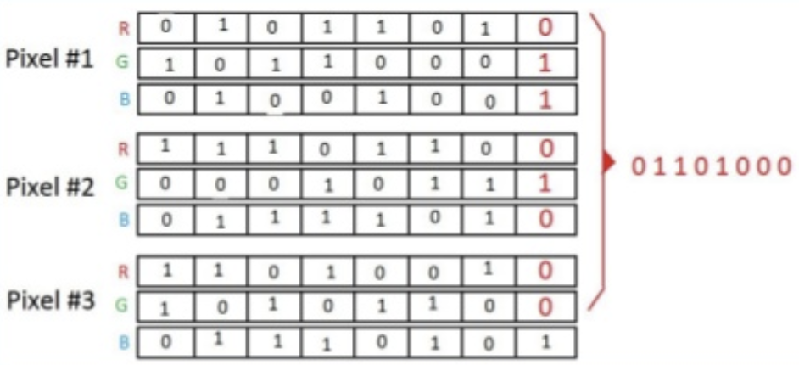
Figure 1 - LSB Example [6]

In the image above, the red value on the right-hand side is the secret message that is to be entered in place of the least significant RGB values of each pixel.

– Discrete Cosine Transform
The Discrete Cosine Transform (DCT) method involves stepping through the image in 8x8 blocks, designating them as either high, medium or low frequency depending on the quality of the image [7]. In the lower frequency, the parts of the image that contain the critical elements of the image are found and is henceforth considered an unacceptable sub-band in which to embed the message. On the other end of the scale, the high frequency sub-band contains parts of the image that are less visually important so would be thought to be a good starting place for replacement, however, these are usually removed if the file is subject to compression, rendering it pointless to change these values. For this reason, the middle frequency sub-band is used in the majority of cases as a safe location in which to embed information [8].

– Critical Review
There are two main areas of file compression which are lossless and lossy. Lossless, as the name suggests, will reduce the size footprint of the target file but will retain all information that is attributed to it, therefore allowing a complete and fully preserved file to be restored. Lossy however will remove parts of the file that are deemed to be so insignificant that the human eye and/or ear (in the case of video and audio files) would have great difficulty in detecting any change, perhaps even not noticing any change whatsoever.
Elmahi et al. created a system whereby a steganographic image is generated and goes through both the process of encryption and compression. The compression method chosen by the researchers is called the Huffman algorithm, which is a lossless based methodology [9]. While their proposed system clearly has its merits, a lossless compression algorithm cannot decrease a file’s size footprint to the same level that a lossy compression can. Successful implementations of a lossy compression system coupled with steganographic images are harder to come by due to lossy compression removing minor lesser significant bits. There is however a need for this technology as stated by M. MaryShanthi Rani and S. Lakshmanan’s [10] journal article outlining the troubles faced when digitally transmitting large quantities of medical data that can contain thousands of images of varying type. They propose a lossy compressed steganographical approach to the transmission and storage of patient’s files as personal data could be stored within the images that are related to them, such as their identification photos, which would both secure the data during transport and provide a way of decreasing the storage space needed for the same amount of patient records.

– Rationale for the Study
Hiding files or messages within images or documents can lead to an increased file size when compared to the original, as extra information is effectively packed inside. Should the hidden message be very small, it is possible that the increased size of the image may go unnoticed, however, this heavily limits the size of the secret information allowed. If an investigator were to come across a JPEG image that had an abnormally large file size, it may fall suspect to tampering and undergo further inspection, rendering the steganographic implementation a failure. Video games however, as of 2019, can have file sizes anywhere between a few hundred megabytes, to a massive 150GB, providing a perfect hiding ground for hidden files to be implanted. Video game’s file sizes vary not only from game to game, but also platform to platform, making it extremely difficult to track exactly how much space a game should be using. Steganographers with this knowledge could theoretically plant gigabytes of information into a game’s file system with relative safety knowing that it is extremely unlikely to arouse suspicion.

– The Aim of the Study
The aim of this project is to find and implement a method by which large steganographic files could be implanted into a cover file after having undergone a lossy compression cycle which would lead to the ability of hiding larger file sizes without attracting attention. A list of objectives has been formulated and documented below to help achieve this aim:
- Investigate current steganography methods and how they are used in the modern world.
- Analyse and evaluate steganographical software currently available.
- Investigate and analyse how steganographical files react when subjected to lossy compression.
- Design and develop steganographic software that will allow the user to embed documents or images into a separate image file.
- Analyse and evaluate the newly created software.

– Expected Outcomes and Deliverables
The project in question could potentially encompass many primary features depending how far it is taken. For example, the user could initially choose a document (such as a ‘.txt’ file) and embed it into an image, or they could choose an image (such as a ‘.jpg’) an embed it into a video file. For this reason, not only has the expected outcome been outlined but also an extended outcome that will only be completed should the expected outcome be reached, and a minimal expected outcome to ensure that the core goals have been implemented in the event that the expected outcome is unreachable.

– Minimal Expected Outcome
The user will have the ability to select a document (the message to be hidden) and a cover image (the file that will conceal the message) from within the program. Once the files are selected, the document will be hidden inside the cover image, producing a file that shall be named the stego-image. The user can then select this stego-image and extract any hidden information, storing said information into a new document.

– Expected Outcome
The expected outcome enhances on the previous point by way of implementing a more complex algorithm such as DCT while also allowing image to image embedding and extraction.

– Extended Outcome
Should the practical element of this project move along at a faster pace than anticipated, then extra functionality may be added such as encryption of the data and embedding documents/images inside video (‘.mp4’) files.

– Report
Whichever outcome is achieved, it shall be accompanied with a report that will document all research findings, a literature review, provide results from unit testing and user feedback, user documentation and software design sheets.

– Conclusion
This section of the report has provided the reader with background information related to steganography to a point where a basic understanding of the topic should be understood. Two commonly used techniques to produce a steganographic image have been outlined along with a review of compression methods that can be applied and where in a real world setting they could be found or implemented. Reasoning behind the project has been discussed and examples have been provided that document how it is related to the gaming industry, which is the field of study that the researcher is currently undertaking. Finally, the aims and objectives of this venture have been explored and committed with an accompanying deliverables list describing exactly what the project will output.

Research and Development

– Introduction
Within this section, research and development methods will be explored, highlighted and documented to reflect the approach that will be taken to ascertain project success.

- Research Philosophy
Selection of philosophical methodology is done via the manner in which the researcher wishes to conduct the project and how results are to be interpreted and evaluated, and this must be done before the start of the project. There are multiple research philosophies that are each suited to a different style of project such as Positivism, Critical Realism, Interpretivism, Postmodernism and Pragmatism. For this project however, positivism has been deemed the most appropriate methodology as it incorporates the psychosis of the ‘natural scientist’, and a concentration has been placed on facts, statistical data and quantitative results rather than incorporating a philosophy such as Phenomenology, which holds its focus upon subjective data and qualitative results [11] [12] [13].
Choosing a philosophy is a major first step towards the completed framework of the project, but to further build this framework, a research approach is also required and should reflect the type of philosophy chosen. The two main approaches are inductive and deductive (sometimes referred to as qualitative and quantitative respectively). An inductive approach involves starting at a specific data point and moving towards a generalised theory, usually allowing the researcher to change the course of the research during the project. Found below in Figure 2 - Inductive Research Method [14], a small timeline shows the method of research:
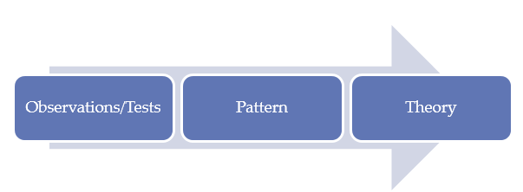
Figure 2 - Inductive Research Method [14]

A deductive method is the reverse of the inductive approach, whereby a generalised theory is first constructed or determined, and the research will then lead onto specific data that confirms or denies the original theory. A timeline has been included in Figure 3 - Deductive Research Method [15] to highlight the operation of a deductive method:
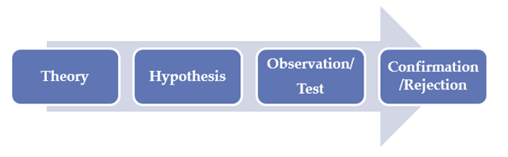
Figure 3 - Deductive Research Method [15]

The approach chosen for this project is deductive, as a solution to a theoretical hypothesis shall be designed, implemented and eventually tested, producing a hard result that will confirm or reject the proposed theory. Also, as the topic area has a broad range of material, is software based and can be expected to have a rigid, well-designed structure that is going to deliver quantifiable data, these traits are closely aligned to a deductive approach’s principles.

– Research Strategies
This project will fall mainly under the strategy umbrella of developmental and as such encompasses the software development, document review and case study strategies. Each of these components will cover a different aspect of the project. The document review element is essentially the collection and analysis of as much relevant information regarding the topic area as possible along with identifying some of the key researchers that are associated to the field. This is an extremely important stage of the project as it forms not only the background knowledge, but also allows the researcher to understand what work is currently being undertaken within the topic area. Next is the case study phase, and this refers to finding a prominent case of importance in the field and studying it in its entirety to further understand the intrinsic details of that particular case. Finally, there is the software development section whereby all the design, development and testing of the software is undertaken.
A cross-sectional time horizon shall be applied as any results found from the completed software will not need to be examined over an extended period of time, as would be the case with a longitudinal approach. The cross-sectional method is believed to be better suited towards a positivist philosophy as there is less chance of interference from the researcher or observers, thus providing an unbiased result [16].

– Credibility

– Reliability
Reliability aims to reach a consensus on whether the same results would be consistently achieved should the process be repeated multiple times, possibly with a different researcher. The resulting data should remain the same no matter the amount of times that the test to get these results is completed [17]. A project with a high level of reliability is preferred as less time and effort is wasted to achieve success.
In a qualitative project, reliability can be enhanced by returning the information that has been interpreted by the researcher back to the individuals that initially provided the primary data to check that it has indeed be interpreted correctly. Another method is to invite different researchers to inspect the same data and see if they draw the same conclusion [18].
For a quantitative proposal however, measuring the accuracy of each question can be accomplished by offering a different question that is geared towards the same focus [18].

– Validity
The validity of a project refers to, in some degree, how authentic and trustworthy the entire process is. Various factors surrounding validity can turn even the most prominent and informed research projects into work that is disregarded by peers and other researchers.
In a qualitative project, one of the major concerns is that of researcher bias. It is far easier for the researching individual/team to interpret data in a way that agrees with their ideology no matter how much they try and remove their opinions from view. Subtle ques when interviewing candidates can lead to massive volumes of false information and render days, weeks, months or years’ worth of research inadmissible. Another issue is sample selection, by involving a wide array of subjects within the test sample, the researcher avoids accusations of having ‘ideal’ candidates that can be seen as a method of swaying the results [18].
Quantitative projects suffer from different, but equally damaging problems. Firstly, sample size is a huge concern because in theory, the more samples that are collected, the more reliable and accurate the results will be. Small sample sizes may not correctly represent the true underlying data. The methods of analysis by the researcher also need to be considered as using outdated or inefficient methods to reach the outcome can be seen as unreliable [18].

– Data Collection
All research projects will at some point in its lifetime produce data, regardless of its size or sources, and as a result a plan needs to be erected that outlines how the data will be gathered at different points during the process and highlight any specific needs that the data requires. For example, during the evaluation and analysis stage of this project, interviews will be conducted that will provide essential data for cross-comparative evaluation of the produced stego-images, but each interview will need to be transcribed into a word document for easier analysis [19] [20].
Surveys will also be used in this project as, again, a method for establishing how stego-images compare to their original counterparts. One key thing to note when constructing a survey is to ensure its unbiased footprint upon the user that is currently engaged with it. An example of this may look as follows; the user is presented with two images, one marked ‘Original Image’ and the other marked ‘Modified Image’. Many people would immediately begin scouring the modified images looking for defects because they have been explicitly told that there is a change of some sort present. If the images were both unmarked however, and the user was asked to see if they notice anything different in either image, it is fairer as the user is unaware of which is the original and which is not.
The main mode of data collection for the project will be a documentation review as it allows for access to the research conducted by prominent figures in this field. The final objective, which is the evaluation and analysis of the finished software, will adopt an interview approach to attain data on the success of the project.
Observations will naturally be a major component in this experimental/developmental type of research as ‘hard data’ will be produced. Whether it be from testing the RGB value of each pixel during the LSB method or ensuring that data is correctly encrypted before it is ready to be embedded, the finding of hard data through observation is inevitable.

– Development Methods
This point will explore the different methods that will be used to design and develop the software that is set to be one of the deliverables for this project. It is unlikely to be an exhaustive list, but it will cover the core development methods that contribute the most to the project.
A subset of an Agile methodology shall be decided on as a way in which the entire project will work upon. There are many Agile software design processes to choose from such as Extreme Programming (XP), SCRUM, Crystal and Feature-Driven Development (FDD) to name but a few, but Scrum has been selected as the preferred model to use for this project as it is lightweight and a relatively simple concept to understand. It allows the individual/team to tackle a large, usually overwhelming, problem and break it down into smaller chucks, referred to as sprints, and engage each one iteratively. Using a technique called ‘user stories’ to create the goal of each sprint allows the developer(s) to imagine a clear, concise task and visualise the expected outcome before the work is started. The construction of a user story is as follows:
“As a [type of user],
I want to [do this thing],
So that I can [accomplish this goal].” [21]
UML (Unified Modelling Language) diagrams shall be created to better outline the class relationships within the developed program.

– Risks
There are many risks involved with starting any project, especially a software project. Listed below are some of the major risks to the project:
- A lack of skill or knowledge that would result in valuable time being used or extending the timeframe on a sprint.
- Development of ‘gold plated’ features. (Features that do not necessarily need to be in the finished project, but the developer adds them in for their own satisfaction, and while this does not appear too threatening, it will use up valuable time, research and resources).
- Illness from either the student or the supervisor that results in a week or more of missed work.
- Any software that is relied upon for project completion is updated by the manufacturer and the newer version is susceptible to bugs or otherwise not backwards compatible.
- Any unexpected maintenance work that needs to be done at the SA1 campus (it is a very new building and problems can occur).
- Data loss via corrupt mechanical devices, fire, theft, accidental damage etc.

– Limitations
The limitations mainly congregate around the software development aspect of the project as this has the greatest potential for extendable features that are either too difficult or would take to much time to implement. For this reason, the practical aspect of this project will not have a graphical implementation to it and will go no further than the extended outcome noted in section 1.6.3.

– Data Analysis and Evaluation
As the results that are output from the created software will be a steganographic images, one simple way of evaluating whether or not it has been successful is to ask candidates to compare the original image with the stego-image to see if they can find any flaws. This can be done with a multitude of different samples ranging from lossy versus lossless images to LSB versus DCT images. As information about the candidates will not need to be recorded, each test will have anonymous candidates when viewed in the aftermath. Unit testing shall be enacted on all software to ensure that the results that it is outputting are as accurate as possible.

– Ethical and Legal Concerns
No personal data is being received, stored or used by the researching team and all work shall be done from the confines of a lab environment in the university campus. As such there are no legal or ethical issues that will affect the project.

– Conclusion
To summarise, this section has focused on the philosophical, strategical and methodological elements that comprise the basis of this project. Emphasis has been placed on various strategies that will be used to collect and document results along with informing the user on issues surrounding research credibility and evaluation techniques.

– Resources and Planning

– Introduction
This section aims to showcase both the physical and human resources that are to be cultivated in this project and provide a timeline in the form of a Gantt chart.

– Physical Resources
Physical resources for the project are as follows:
- Laptop – Primary hardware to be used
- University Computers/Virtual Machines – used in the case of laptop damage, loss etc.
- Visual Studio 2017 Enterprise – Primary software tool used
- University Campus SA1 – Location to meet supervisor and work
- OpenStego – Open source steganography software to use as a reference point
- Microsoft Word – For report writing
- Mendeley – To be used as a reference manager
- SA1 Library – Utilise books and journals for referencing

– Human Resources
Human resources for the project are as follows:
- Project Supervisor – Point of reference, assistance and direction for the project
- Lecturing staff – Source of additional assistance
- Lee Cobley – Technical assistance in case of hardware/software issues
- IT Support Desk - Technical assistance in case of hardware/software issues
- Fellow Students - Source of additional assistance

– Gantt Chart and Timeline
A Gantt chart has been attached in Figure 4 - Gantt Chart Part 1 and Figure 5 - Gantt Chart Part 2 below to show the reader a planned timeline that formalises the timed approach of the entire project from start to end.
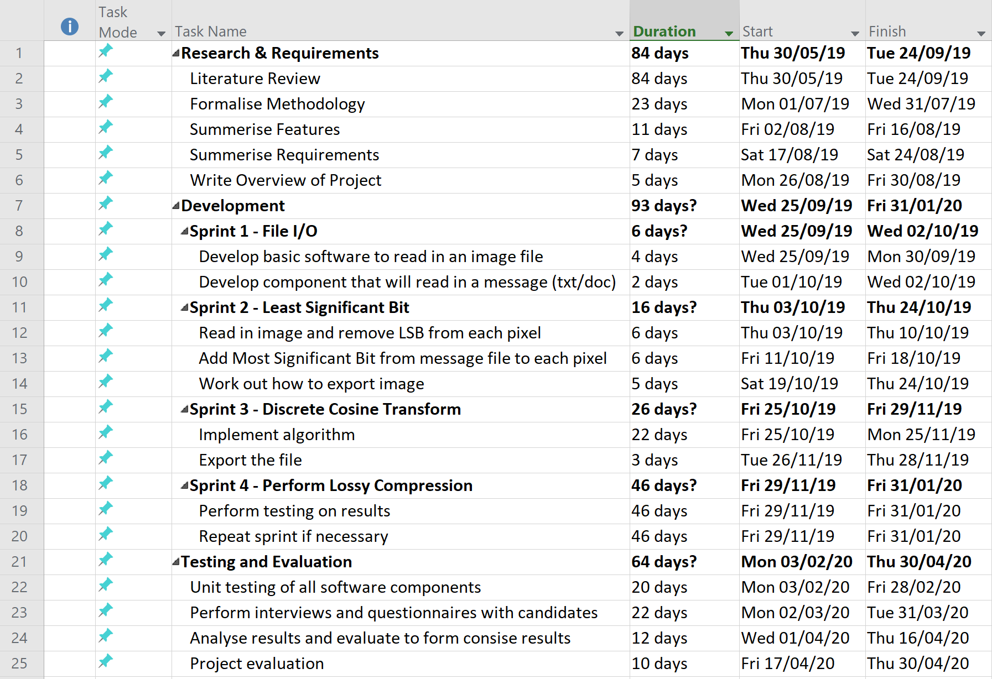
Figure 4 - Gantt Chart Part 1

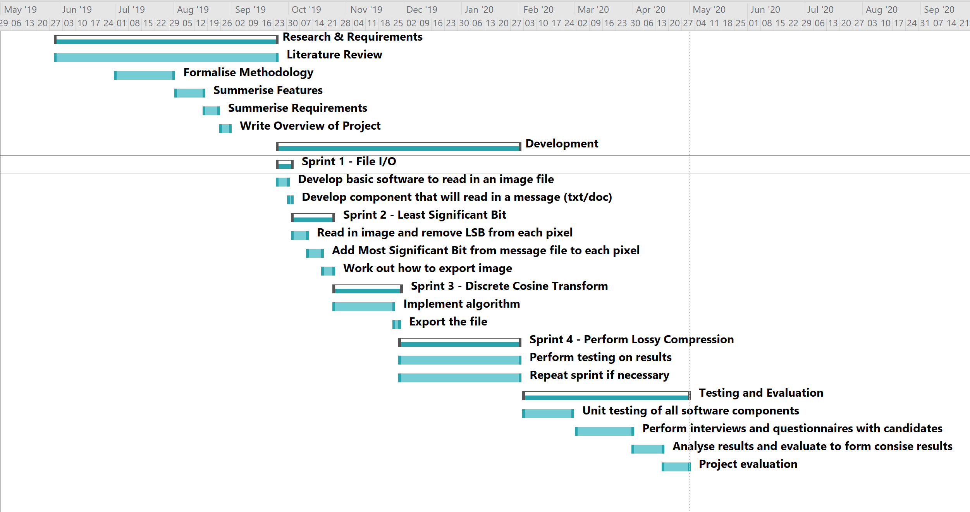
Figure 5 - Gantt Chart Part 2

– Conclusion
Although brief, this section has provided the user with all of the major resources needed for the project’s execution, both physical and human, and also generated a timeline of events that will ensure the project is kept on track.

Report Summary
In summary, this report has offered an insight to the layout and planning behind the proposed project. Most significantly, a research philosophy and strategy have been chosen along with methods for collecting and analysing data. Background material pertaining to the topic has been explored with related aims and objectives taking form, providing a clear view of the task that is to be completed. Finally, a timeline, resource list and potential risks and limitations have been noted for the readers convenience.

References

[1] | T. Jamil, “Steganography: the art of hiding information in plain sight,” IEEE Potentials, vol. 18, no. 1, pp. 10-12, 1999.
[2] | Z. Josef, “Cryptology,” in 7th Summer School Applications of Mathematics and Informatics, Hradec Králové, 2003.
[3] | S. Channalli and A. Jadhav, “Steganography An Art of Hiding Data,” International Journal on Computer Science and Engineering, vol. 1, no. 3, pp. 137-141, 2009.
[4] | J. C. Judge, “Steganography: Past, Present, Future,” SANS, 2001.
[5] | D. Kahn, “The history of steganography,” in Information Hiding, New York, 1996.
[6] | M. Solabarrieta, “Steganography: LSB technique,” SlideShare, 20 May 2017. [Online]. Available: https://www.slideshare.net/MikelSolabarrieta/steganography-lsb-technique. [Accessed 14 April 2019].
[7] | F. J. Mohammed and I. M. Alwan, “Image Hiding Using Discrete Cosine Transform,” Journal Of College for Women, vol. 27, no. 1, pp. 393-399, 2016.
[8] | M. Gunjal and J. Jha, “Image Steganography Using Discrete Cosine Transform (DCT) and Blowfish Algorithm,” International Journal of Computer Trends and Technology, vol. 11, no. 4, pp. 144-150, 2011.
[9] | A. Fernandes, “Data Compression with Huffman Coding,” Stantmob, 8 February 2018. [Online]. Available: https://medium.com/stantmob/data-compression-with-huffman-coding-ad7bcb07c5d5. [Accessed 30 April 2019].
[10] | M. M. Rani and S. Lakshmanan, “An Intergrated of Data Hiding and Compression of Medical Images,” International Journal of Advanced Information Technology, vol. 6, no. 1, pp. 43-51, 2016.
[11] | A. A. Aliyu, M. U. Bello, R. Kasim and D. Martin, “Positivist and Non-Positivist Paradigm in Social Science Research: Conflicting Paradigms or Perfect Partners?,” Journal of Management and Sustainability, vol. 4, no. 3, pp. 81-84, 2014.
[12] | J. Dudovskiy, “Positivism Research Philosophy,” Research Methodology, [Online]. Available: http://research-methodology.net/research-philosophy/positivism/. [Accessed 25 April 2019].
[13] | M. &. L. P. Saunders and A. Thornhill, “Understanding research philosophies and approaches,” Research Methods for Business Students, pp. 106-135, 2009.
[14] | J. Dudovskiy, “Inductive Approach (Inductive Reasoning),” Research Methodology, [Online]. Available: http://research-methodology.net/research-methodology/research-approach/inductive-approach-2/. [Accessed 25 April 2019].
[15] | J. Dudovskiy, “Deductive Approach (Deductive Reasoning),” Research Methodology, [Online]. Available: https://research-methodology.net/research-methodology/research-approach/deductive-approach-2/. [Accessed 25 April 2019].
[16] | A. Rindfleisch, A. Malter, S. Ganesan and C. Moorman, “Cross-Sectional Versus Longitudinal Survey Research,” Journal of Marketing Research, vol. 43, no. 3, pp. 261-279, 2008.
[17] | H. Taherdoost, “Validity and Reliability of the Research Instrument; How to Test the Validation of a Questionnaire/Survey in a Research,” International Journal of Academic Research in Management, vol. 5, no. 3, pp. 28-36, 2016.
[18] | MESHGuides, “How can validity and reliability be improved?,” MESHGuides, [Online]. Available: https://www.meshguides.org/guides/node/450. [Accessed 01 May 2019].
[19] | D. Z. Austin and J. Sutton, “Qualitative Research: Data Collection, Analysis, and Management,” The Canadian Journal of Hospital Pharmacy, vol. 68, no. 3, pp. 226-231, 2015.
[20] | Cleverism, “Overview of Qualitative And Quantitative Data Collection Methods,” Cleverism, 26 February 2017. [Online]. Available: https://www.cleverism.com/qualitative-and-quantitative-data-collection-methods/. [Accessed 26 April 2019].
[21] | E. Taymor, “AGILE Handbook,” [Online]. Available: http://agilehandbook.com/agile-handbook.pdf. [Accessed 26 April 2019].

