Foreign Languages and Cultural Awareness
BMIH5003
Intercultural Competence Report

Lecturer:
Student name:
Student id:
Date:

- Executive summary

This paper compares the Inclusivity Hotel & Spa in London with its Spanish equivalent to examine cultural and operational differences in the hospitality industry. It explores each country's cultural, sociological, and commercial norms to improve service by helping Spanish professionals integrate into a multicultural context. The research uses Hofstede's cultural dimensions and the GLOBE Project to show Spain's greater Power Distance and Uncertainty Avoidance indices than the UK. Cultural competency is crucial to improving service delivery and managing different teams in hospitality. The research highlights the importance of cultural awareness in the industry's performance by identifying coordination concerns and the necessity for continual leadership assistance in intercultural leadership.

Table of Contents
1. Executive summary 2
2. Introduction 4
3. United Kingdom vs. Spain 4
4. Comparison of Spain with UK 5
5. Challenges of intercultural leadership in the hospitality industry 6
6. Recommendations 8
7. References 9

- Introduction

This report examines the operational and cultural differences between England and Spain as they pertain to the hospitality industry, with a specific focus on the London branch of the Inclusivity Hotel & Spa and its relationship with its Spanish counterpart. Through a comparative examination of the unique cultural, societal, and commercial practices of England and Spain, this analysis seeks to reveal potential approaches to augmenting the passenger service experience. The aim is to support the comprehension and assimilation of Spanish staff by the management team, thereby guaranteeing their efficient input into the hotel's functioning and provision of exceptional service within a multicultural setting.

- United Kingdom vs. Spain
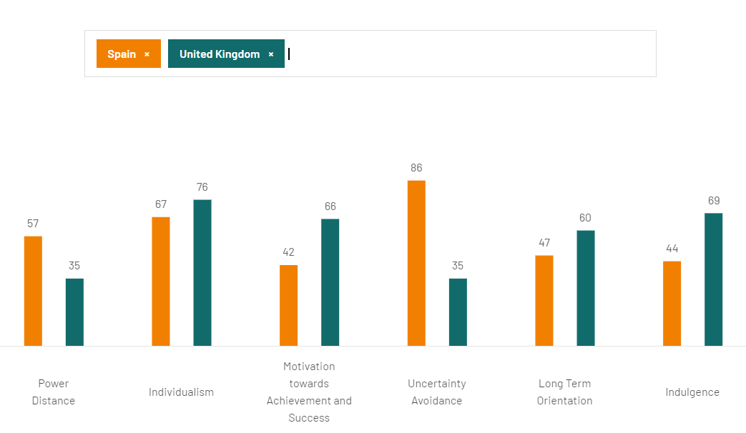
Fig 1. Hofstede Insights (2023). Spain vs. UK

The analysis of Spain's cultural setting demonstrates a societal inclination towards prioritizing hierarchical systems, as indicated by a greater Power Distance Index in contrast to the United Kingdom's inclination towards the reduction of social inequalities. Spain and the United Kingdom share a strong emphasis on individual accountability and familial support, as evidenced by their high Individualism scores (Hofstede Insights, 2023). However, the United Kingdom ranks higher in this regard, suggesting that its society places a greater value on personal autonomy and satisfaction. In contrast to the decisive and performance-driven nature of the United Kingdom, Spain adopts a consensus-oriented approach that prioritizes harmony over competition (Hofstede, Hofstede, and Minkov, 2010). It is worth noting that Spain exhibits a higher Uncertainty Avoidance Index, suggesting that its society prefers to regulate ambiguity by adhering to established norms. This stands in remarkable contrasting to the United Kingdom, which demonstrates greater adaptability and a lower aversion to uncertainty (Hofstede Insights, 2023). The pragmatic orientation of the United Kingdom fosters adaptability and frugality, in contrast to Spain's normative predilection for immediate gratification and a lifestyle centred on the present. Further distinguishing the two are indulgence scores; a higher score for the United Kingdom indicates a society that places a premium on leisure and optimism, whereas a lower score for Spain implies a more circumspect and possibly pessimistic attitude toward pleasure and leisure. The impact of cultural dimensions on workplace dynamics and management practices in the hospitality industry is substantial, emphasizing the criticality of cultural competence in improving service provision and overseeing diverse teams (Abramson and Moran, 2018).
- Comparison of Spain with UK

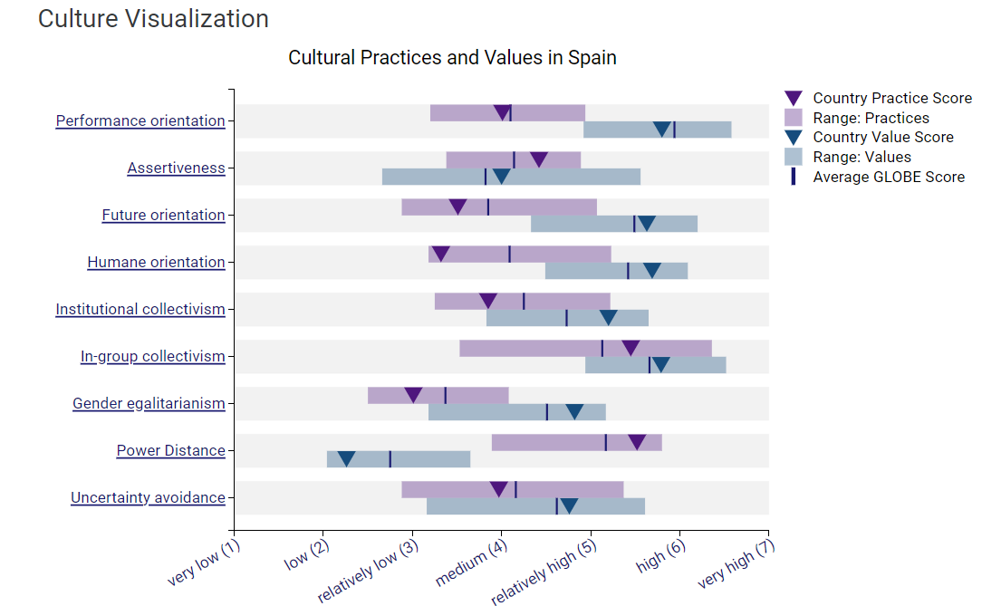
Fig 2. Globe Project (2020). Spain
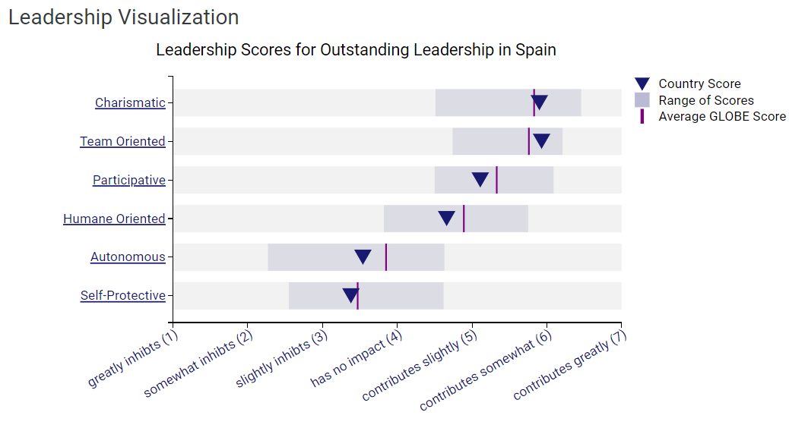
Fig 3. Globe Project (2020). Spain

By employing the dimensions of the GLOBE Project, a comparison between the United Kingdom and Spain reveals significant cultural differences. The United Kingdom's comparatively lesser Power Distance signifies a societal inclination towards egalitarianism and decentralised decision-making, in contrast to Spain's higher score which suggests a tolerance for hierarchical systems. Individualism in Spain promotes a harmonious coexistence of personal and communal concerns, which stands in opposition to the United Kingdom's more rigid commitment to personal independence (Globe Project, 2020). In contrast to Spain, which values stability and established norms, the United Kingdom exhibits a more flexible and adaptable stance towards change and ambiguity, as evidenced by its lower Uncertainty Avoidance scale. In contrast, Spain values humane, team-oriented leadership, while the United Kingdom values charismatic, participative techniques. In the hospitality industry, these distinctions influence distinctive workplace dynamics and management strategies, which are critical for the successful integration of intercultural teams (Hoftede, Hoftede and Minkov, 2020).

- Challenges of intercultural leadership in the hospitality industry
Cultural diversity presents intercultural leadership in the hospitality industry with several obstacles, which may result in conflict zones when it comes to the management of intercultural teams. Coordination issues stemming from culturally programmed attitudes, in which foreign partners and staff of local companies hold divergent perspectives that impede joint efforts, represent a significant obstacle (Grobelna, 2015). In the hospitality industry, where effective collaboration and mutual understanding among a diverse staff are essential for delivering exceptional visitor experiences, this is an especially difficult obstacle to overcome. The performance of the staff being contingent on the manager's presence is an additional aspect that may give rise to debate (Christiansen, Branch, and Karmowska, 2020). When personnel tasked with overseeing international operations are not directly supervised during the process of adjusting to changes in their environment, their performance may be negatively impacted as they may be unable to effectively regulate and control their actions (Deresky, 2017). This situation highlights the significance of ongoing leadership and support in an industry recognized for its rapidity and the requirement to consistently adjust to the demands and anticipations of guests. Moreover, the establishment of teams within the hospitality industry is further complicated by the involvement of proprietors, who frequently symbolize individuals of prominence and individual success, thereby diminishing the incentives for collaborative efforts (Epsilon, 2023). Effectively administering a culturally diverse team, where success hinges on collective effort and unity, can pose significant challenges in this regard.

- Conclusion

In conclusion, the report highlights the critical significance of linguistic expertise and cultural sensitivity in promoting worldwide interconnectedness and improving personal connections. This emphasizes that the acquisition of foreign languages and cultural sensitivity not only facilitates effective communication but also contributes to one's professional and personal development. This understanding empowers individuals to effectively navigate and value the wide array of cultures that exist on a global scale, thereby making a substantial contribution to the promotion of international cooperation and mutual respect. The report proposes the implementation of integrated strategies in education and professional development that give priority to these competencies. It argues that by doing so, individuals will be better equipped to navigate the intricacies of the global arena, thereby fostering a more interconnected, empathetic, and inclusive society.

- Recommendations

- Leadership styles should be more inclusive and adaptable to accommodate the varied workforce's culture. This technique entails customizing management to address the individual and communal needs of personnel from different cultural backgrounds. Leaders should learn individualist and communitarian methods to organize themselves and their teams (Hampden-Turner and Trompenaars, 2020).
- Establishing a regular feedback and support structure for personnel is crucial. This system should help multinational professionals adjust and resolve cultural misunderstandings and adjustment concerns quickly and effectively. An open workplace where personnel may share their issues and experiences can help team cohesion and understanding (Maheshkar, and Sharma, 2018). This proposal supports the idea that an organization's success depends on its members' and the community's cooperation.
- To ensure cultural awareness and competency, thorough training programs for personnel are crucial. This type of program should include knowledge of different nations' commercial, cultural, and sociological traditions to improve cooperation, communication, and service delivery in a multicultural setting. Training may address cultural issues and structure experiences to cover a wide range of information via regulations while admitting unique circumstances (Hampden-Turner and Trompenaars, 2020).

- References

Abramson, N.R. and Moran, R. (2018) Managing Cultural Differences: Global Leadership for the 21st Century. 10th Ed. Abingdon: Routledge

Christiansen, B., Branch, J.D. and Karmowska, J. (2020) Cultural Factors and Performance in 21st Century Businesses. Hershey : IGI Global

Deresky, H. (2017) International Management: Managing Across Borders and Cultures: Text and Cases. 9th Ed. Harlow: Pearson Education Ltd.

Epsilon, R. (2023). Council Post: The Case For Change Management In The Hospitality Industry. [online] Forbes. Available at: https://www.forbes.com/sites/forbestechcouncil/2023/02/01/the-case-for-change-management-in-the-hospitality-industry/?sh=1e0ac42d6c27 [Accessed 6 Feb. 2024].

Globe Project (2020). Results - Spain GLOBE Project. [online] Available at: https://globeproject.com/results/countries/ESP%3Fmenu=list.html#list.

Grobelna, A. (2015). Intercultural Challenges Facing the Hospitality Industry. Implications for Education and Hospitality Management. Journal of Intercultural Management, [online] 7(3), pp.101–117. doi:https://doi.org/10.1515/joim-2015-0023.

Hampden-Turner, C. and Trompenaars, F. (2020) Riding the Waves of Culture. 4th Ed. London: John Murray Press.

Hofstede Insights (2023). Country comparison tool. [online] www.hofstede-insights.com. Available at: https://www.hofstede-insights.com/country-comparison-tool?countries=spain%2Cunited+kingdom.
‌Hofstede, G., Hofstede, G.J. and Minkov, M. (2010) Cultures and organizations: software of the mind. 3rd Ed. New York: McGraw-Hill
Maheshkar, C. and Sharma, V. (2018) Handbook of Research on Cross-Cultural Business Education. Hershey: IGI Global.

