Electronic Systems Design Assignment –
14 Day Weather and Air
quality measurement and
logging system

Corey Taylor - 1708443

BEng Electrical and Electronic Engineering - ACDA6002

Wales Institute for Science and Art
University of Wales Trinity Saint David



Lecturer: Dr Gary Jones Submission Deadline: 16.01.2023
Contents
Abstract 3
Introduction 3
Research 4
Current weather recording systems 4
MicroP-dl GSM Weather Station & Data Logger: - 4
H21-USB Hobo Micro Weather Station: - 5
Intellisense Systems MWS-C600: - 6
Intellisense Systems MWS-M625: - 7
Comparison Table: - 8
Hardware 8
Equipment 15
Specification 16
Method 18
PCB Design 18
Proteus 19
Flashing LED 21
Costing 23
Conclusions 28
References 29
Appendices 30

List of Tables
Table 1 8
Table 2 9
Table 3 10
Table 4 10
Table 5 11
Table 6 12
Table 8 12
Table 9 12
Table 10 13
Table 11 13
Table 12 13
Table 13 14
Table 14 14
Table 15 14

Abstract

The aim of this report is to demonstrate the design of a simple, microcontroller-based weather and air quality monitoring system, which is to take measurements and log data over a 14-day period.
The system is intended to aid amateur weather forecasters with their predictions and therefore requires specific measurements to be taken, however, kept simple at the same time. The system is to be made portable and adaptable for any number of potential monitoring sites the amateur forecasters may decide to use.
Schematics of the chosen components were created using ‘Proteus’ and ‘Easy-PC’ by ‘Number One Systems’, and a printed circuit board was also created for the data logger, using Easy-PC.
The report below discusses the chosen microcontroller, various components that were required for the PCB and how these were implemented into the design.
Current weather forecast systems on the market have been researched and are included in the report with comparisons, including pros and cons of each. Several of each required sensor currently on the market, available for purchase and use have also been researched and added to the report. These have again been compared and the chosen sensor from each type has been highlighted in green.
The report also gives an insight into the design and build of the PCB, the factors considered and the cost of building this type of system as a prototype, as well as on a wholesale or bulk type scale using multiple units.

Introduction

This report focuses on the design of a microcontroller based, 14-day rolling weather and air quality measurement and logging system. The system is to be portable and adaptable for any number of various potential weather monitoring sites and is intended to be used by amateur weather forecasters to aid in their weather predictions and air quality measurements.
The system is to be designed to collect and store data to a non-volatile, internal based memory, which can be externally read and cleared, if need be, when connected via USB to a PC. The system therefore includes SD Card and USB compatibility.

The data to be measured over a rolling 14-day cycle is as follows: -

- Temperature
- Humidity
- Wind speed
- Wind direction
- Airbourne particle count
- Sunlight brightness
- UV levels
- GPS position
- VOC level

This data will be acquired over a 14-day period using various sensors chosen below, which are connected to individual pins on the chosen microcontroller. The design does not show data on a display but has the capability, as mentioned above, to store it onto the included memory, for viewing on a PC.
As the design does not contain a display, it includes a single LED to indicate operation by flashing on for 1 second, every 10 seconds.
The design does not require a permanent supply of electricity. It will be run from an enclosed battery, so that it can be used out in remote areas with no power and be left on site for periods to continue to monitor weather and air quality 24/7 when not manned.
The system is designed using Proteus and Easy-PC software, and the PCB is then generated, designed and tweaked using Easy-PC. This is then converted to a Gerber file and uploaded to a site capable of building and shipping PCBs to an individual design specification. This is included in the report and attached files.

The following parameters will also be considered and are included in the report below: -

- Package design
- PIC Microcontroller design and selection
- Memory sizing
- Sensor selection and specification
- Circuit diagrams (using Proteus and Easy-PC)
- PCB Design (Using Easy-PC)
- Software structure

Research

Current weather recording systems

There are many different weather station data logging systems on the market with various specifications and set ups depending on the data required. These vary from basic home/hobby weather data loggers to more professional, industrial type forecasting systems.
Pros and cons of current products available are shown below: -

MicroP-dl GSM Weather Station & Data Logger: -

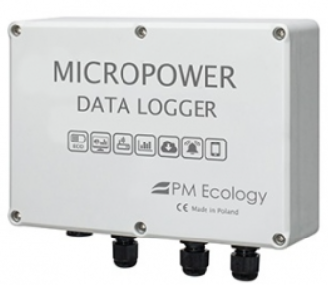

“The Micropower Data Logger is a universal device used for accurate, cost-effective and energy efficient applications used in environmental monitoring.
Remotely configurable inputs include voltage (0-10V), current (4-20mA) and pulse type signals as well as SDI-12 standard. Serial communication is enabled with the use of RS- 232 and optional RS-485 ports (Modbus RTU).
An integrated GSM/GPRS modem provides data transmission with user-selectable upload rates (1min – 24h). All measurements can be accessible through the intuitive web-based System or sent directly to the user’s server.
The Micropower Logging unit has an extremely high level of power efficiency (power consumption of <250μW in sleep mode) making the device perfect for off-grid applications and for long-term measurements.
An optional 30W PV panel can extend the lifetime of the logger and eliminate the need for battery replacement.” [1]

H21-USB Hobo Micro Weather Station: -

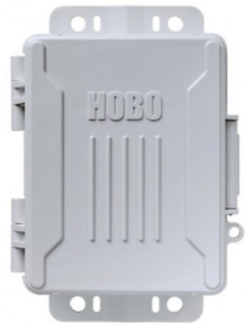

“Rugged and compact, the redesigned HOBO USB Micro Station is a weatherproof data logger for multi-channel monitoring of microclimates. This battery-powered station accepts up to five plug-and-play Smart Sensors and has a hinged door to make sensor installation simple and quick. The Micro Station is equipped with a built-in USB port for fast, efficient data readout to a computer, and an integrated mounting tabs for easy installation.” [2]

Intellisense Systems MWS-C600: -

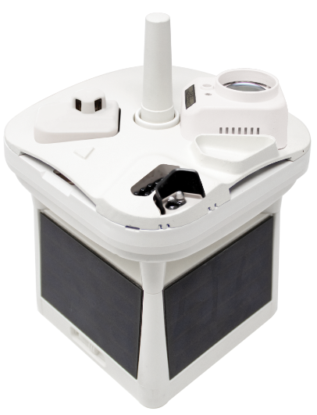

“The MWS®-C600 features all the same great qualities as our line of commercial Micro Weather Stations – including professional-grade construction and autonomous operations – and adds cloud height measurement and cellular communications for even more accurate and reliable meteorological reporting. The engineers at Intellisense integrated the world’s smallest lidar ceilometer into an already compact and wireless weather sensing package to capture 28 environmental parameters. Alongside its temperature, barometric, wind speed/direction, and visibility measurements, the C600 can measure cloud height up to 10,000 feet with 10% accuracy.

Every system component and sensor in the C600 is fully integrated into a single, robust, and wireless unit that weighs just 3.8 pounds. The C600 is always connected via its built-in cellular LTE-M modem, which enables cloud-based data logging so that users always have access to environmental data at any time. In addition, the solar power array and internal rechargeable batteries ensure sustained operations without the need for external power. An on-board battery pack also ensure continuous operations for up to 7 days without ideal solar conditions. This makes the C600 the perfect solution for small airports or heliports that need proximate weather conditions.

The addition of cloud height measurement makes the C600 the most rugged, dependable, and cost-effective solution for businesses that need environmental data delivered accurately and reliably.” [3]

Intellisense Systems MWS-M625: -

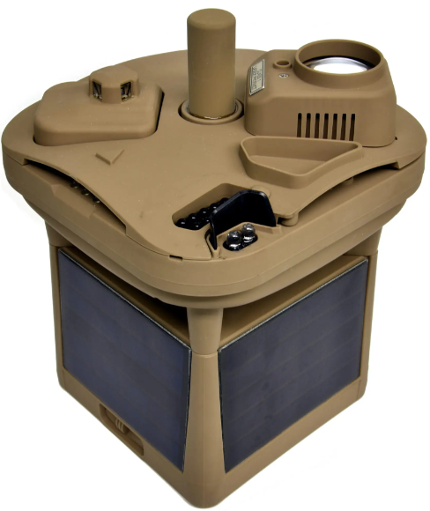

“The MWS®-M625 includes all the same great features as our line of proven line of Micro Weather Stations (MWS®) and adds cloud height measurement and two-way Iridium satellite for more accurate and reliable meteorological reporting. The engineers at Intellisense designed the world’s smallest lidar ceilometer and integrated it into the already compact and wireless weather-sensing package. Alongside its temperature, barometric, wind speed/direction and visibility measurements, the M625 can measure cloud height up to 10,000 feet with 10% accuracy.
With this breakthrough, the M625 becomes the most ruggedized, lightweight and low-cost solution for weather sensing with cloud height measurement. Every system component and sensor in the M625 is fully integrated into a single, robust, self-contained unit that weighs just 3.8 pounds. As an unattended ground sensor (UGS), it is capable of being deployed globally in remote or denied locations for meteorological monitoring to improve situational awareness. The M625 can be hand- or air-emplaced and supports continuous, real-time weather reporting without the need for data loggers, processors or communication units being deployed into the field.
The addition of the world’s smallest cloud height measuring sensor and Iridium satellite connectivity makes the M625 a superior weather-sensing system that is rugged, lightweight and available at a significantly reduced cost compared to other meteorological systems.” [4]

Comparison Table: -

Sensor | MicroP-dl GSM Weather Station & Data Logger [5] | H21-USB Hobo Micro Weather Station [2] | Intellisense Systems ‘MWS-C600’ [6] | Intellisense Systems ‘MWS-M625’ [4]
Image
Price | £1,008.00 Inc. VAT | £345.60 Inc. VAT | Quote request required | Quote request required
IP Rating | IP65 (IP67 & IP68 Optional) | IP66 | IP67 | IP68
Power | 5 – 10V | 3 – 10V | 5 – 10V | 5 – 10V
Operating temperature | -40° to +60°C | -40 to +70°C | -40 to 60°C | -40 to 60°C
Features | - Port for additional sensors  - Text and Email alerts available | - Multiple optional extras available  - Expandable for more sensors | - 360° Colour imaging sensor  - Cloud height measurement sensor included | - 360° Colour imaging sensor  - Cloud height measurement sensor included
Advantages | - Large internal memory  - Phone connectivity (For alarms) | - Expandable  - IP66 | - Strong materials  - Lightweight | - Strong materials  - Very accurate sensors
Disadvantages | - Expensive | - Cheap materials  - Uses disposable (AAA) batteries | - 110v supply required for power/charging | - 110v supply required for power/charging
Table 1
[3] [4] [2] [5]

Hardware

The tables below contain the chosen components to support the build of the PCB. This includes a case, connectors, cable and battery selection: -

Case: -

Case | Peli 1050  Plastic case | Peli 1150 Protector Waterproof case | Pelican 1450  Protector Case | Peli Storm iM2620 Case
Image | 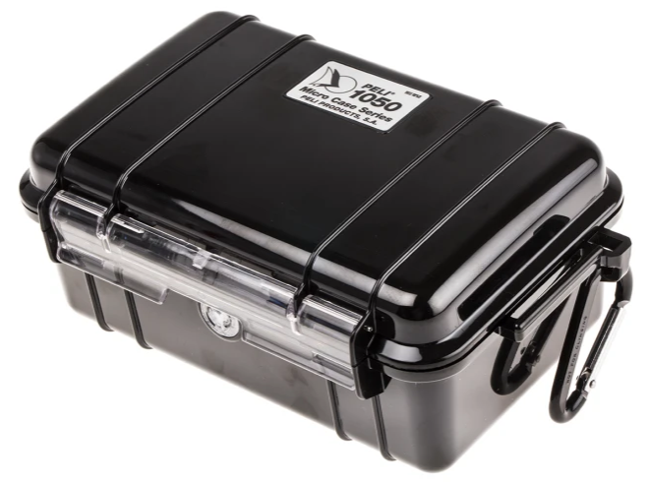 | 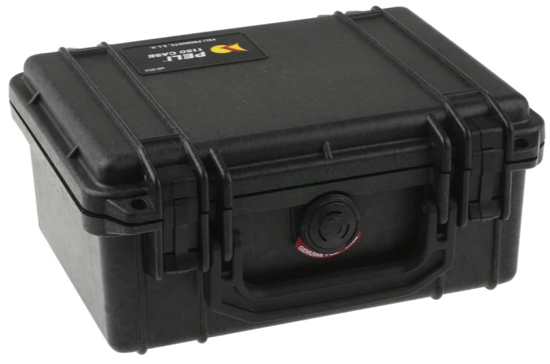 | 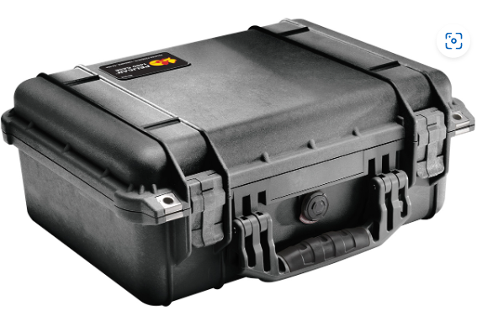 | 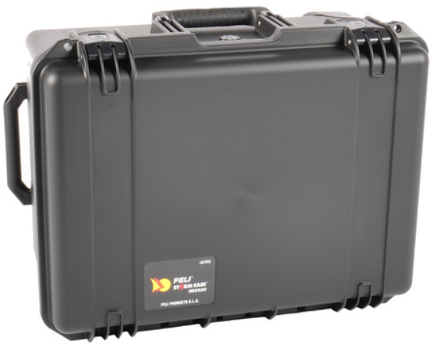
IP Rating | IP51 | IP67 | IP67 | IP67
Body Material | Plastic | Plastic | Polypropylene | HPX High Performance Resin
Weight | Weight: 382g | Weight: 820g | 2.5kg | 5.7kg
Price | £42.31 (inc. VAT) | £56.95 (inc. VAT) | $149.95 (US Imported) | £325.10
Advantages | - Lightweight  - Cheap  - Foam inserts included | - Lightweight  - Cheap | - Watertight  - Stronger material than plastic | - Watertight (IP67)  - Wheels for pulling case  - Strong body material  - Foam inserts included
Disadvantages | - Plastic material compromises strength  - Not watertight | - Too small for requirements  - No foam inserts | - Small  - No foam inserts | - Higher cost  - Heavier than some other options
Table 2
[7]
- ‘Peli Storm iM2620’ case chosen due to strength, body material and IP rating over the other options. This case also features wheels so that case & contents can be pulled, this may be useful at times where longer walks are required for placement of weather station in remote areas.

Connectors: -
Connector | Lemo 0B Cable Mount Connector, 4 Contacts, Plug | Hirschmann CA Cable Mount Connector, 4 Contacts, M22 Connector, Plug | S PRO Cable Mount Connector, 4 Contacts, M12 Connector, Plug | RS PRO Cable Mount Connector, 3 Contacts, M8 Connector, Plug
Image | 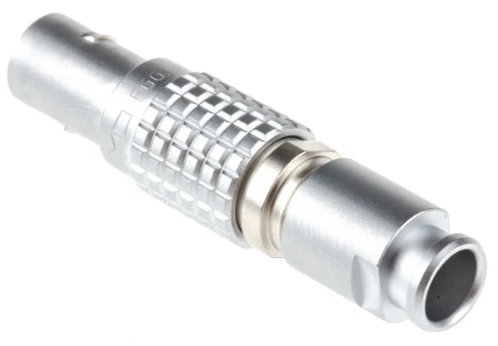 | 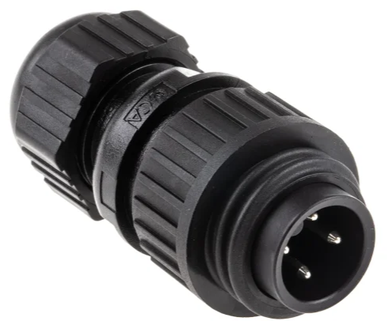 | 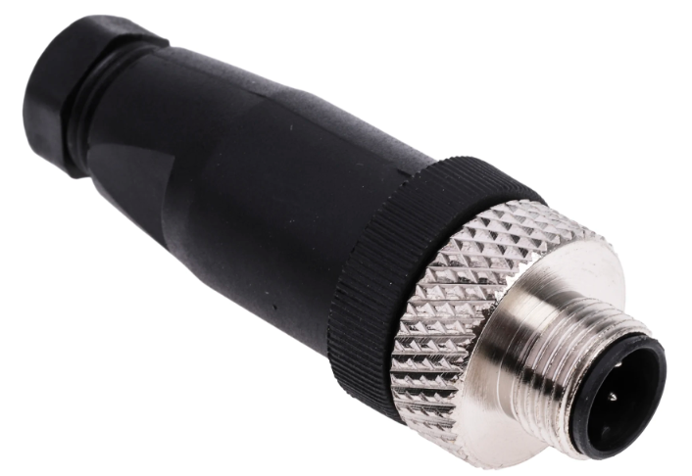 | 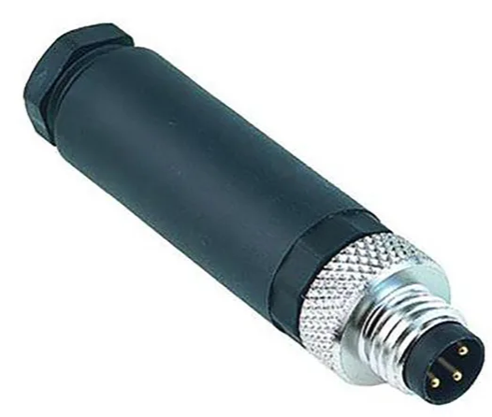
Contact plating | Gold over Nickel | Silver | Brass nickel plated | Gold Flash
IP Rating | IP50 | IP67 | IP67 | IP Rating
Price | £31.60 (inc. VAT) | £5.219 (inc. VAT) | £12.90 (inc. VAT) | £19.62 (inc. VAT)
Advantages | - Strong materials  - Better contact plating materials | - Cheap  - Lightweight | - IP67 rated  - Cheap | - IP67 rated  - Good contact plating material
Disadvantages | - Expensive  - Poor IP Rating | - Easily broken | - Easily broken | - Easily Broken  - Not enough contacts
Table 3

- ‘Lemo 0B Cable Mount Connector’ chosen due to superior contact plating, reputation and minimalist design.
Cable: -
Cable | RS PRO Dark Blue 1 mm² Tri-rated Cable, 18 AWG, 32/0.2 mm, 100m, PVC Insulation | 1mm² Tri Rated Cable - Black - BS6231 100m | Flexiplast TPE Insulated Cable Black 2.7mm (1.0mm²) x 25m - 60.7190-21 | Pitacs Weather Resistant Rubber (Pond) Flex Cable (3183P) 0.75mm2 Drum
Image | 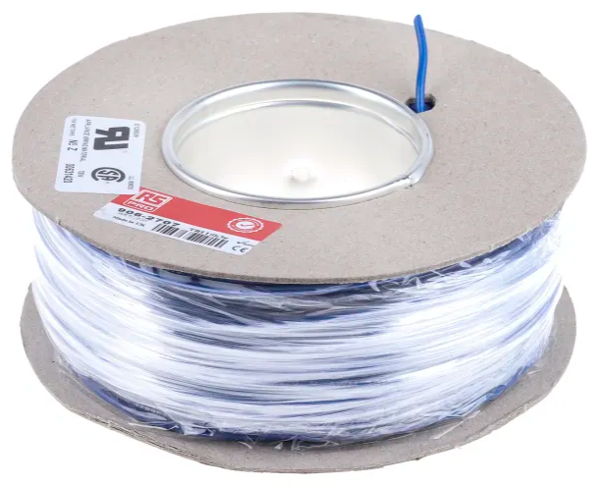 | 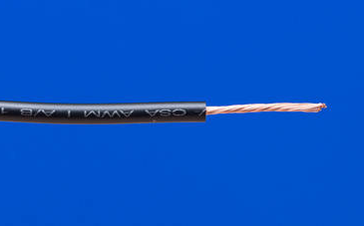 | 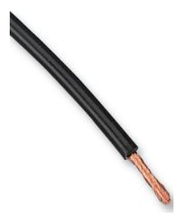 | 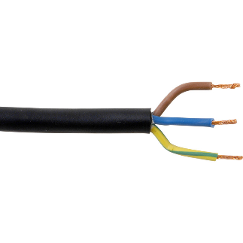
Price | £33.42 (inc. VAT) | £20.40(Inc. VAT) | £25.06 (Inc. VAT) | £20.99 (inc. VAT)
Table 4
[8] [9]
RS PRO cable chosen due to being tri-rated, price and suitability.

Battery: -

Battery | Fiamm 12V Faston F1 Sealed Lead Acid Battery, 2Ah | RS PRO 12V NiMH Rechargeable Battery Pack, 2Ah - Pack of 1 | Energizer EN91F6 | LiTime 12V 50Ah LiFePO4 Lithium Battery
Image | 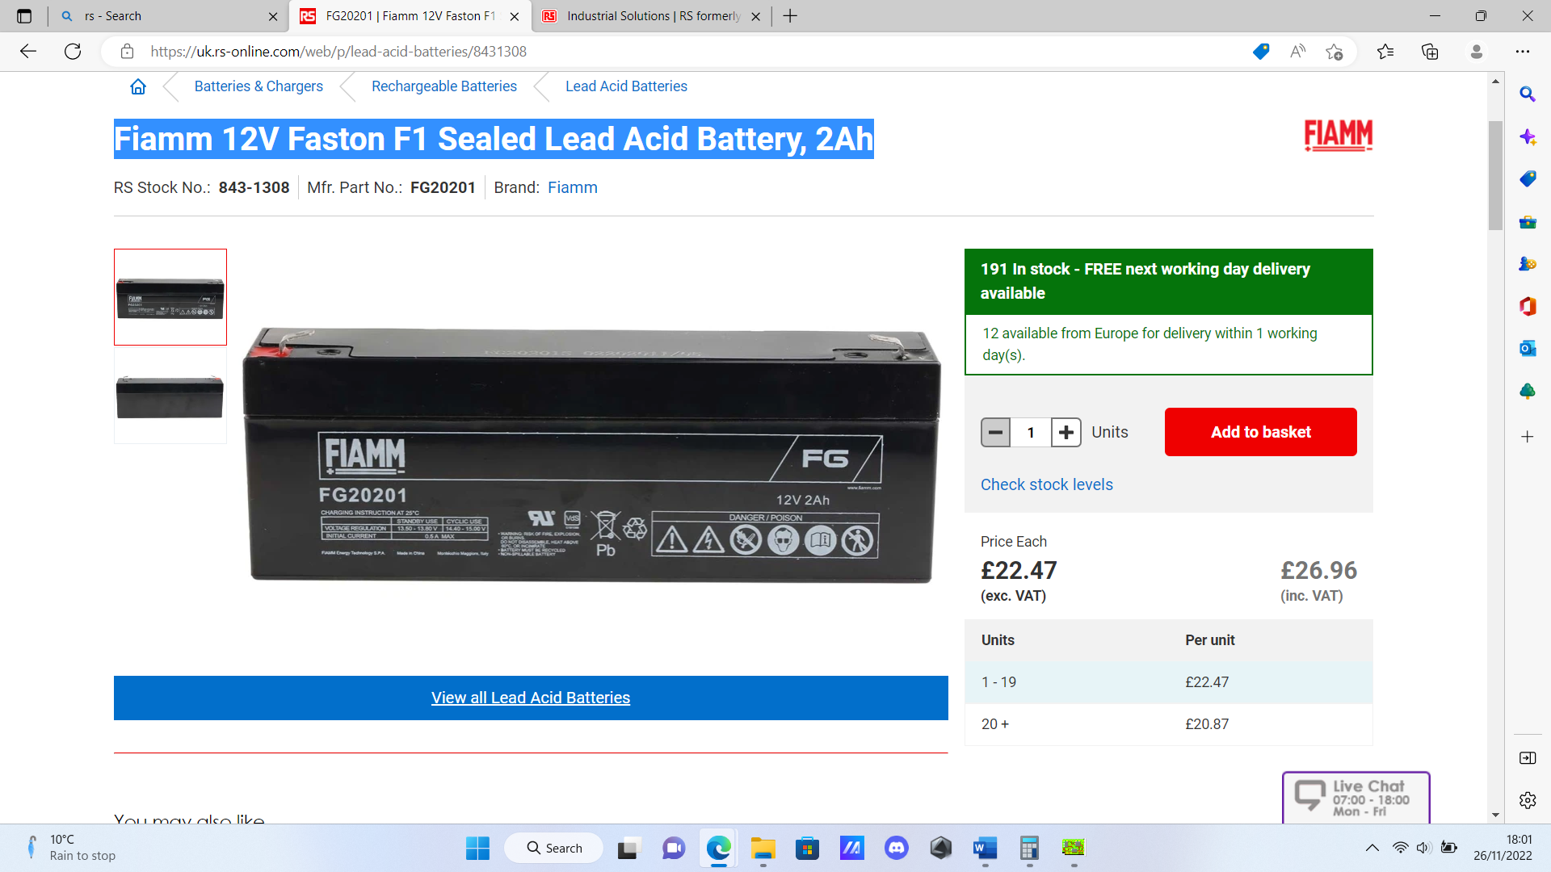 | 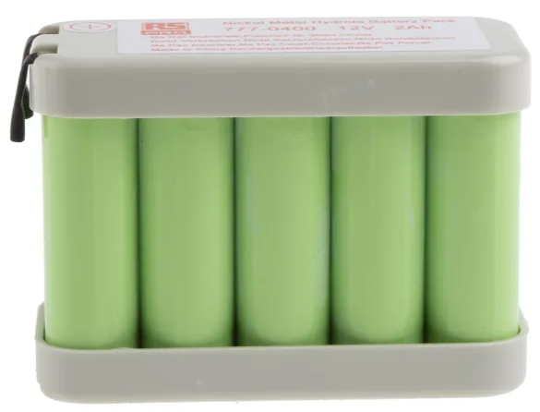 | 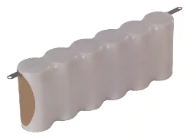 | 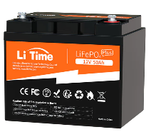
Voltage | 12V | 12V | 5V | 12V
Chemistry | Lead Acid | Nickel Metal Hydride | Alkaline Manganese Dioxide | Lithium-ion
Ampere-hours | 2AH | 2AH | 4AH | 50AH
Operating temperature | -20 - +50°C | -10 - +60°C | Unknown | -20 - +60°C
Price | £26.96 (inc. VAT) | £45.43 (inc. VAT) | £4.22 (inc. VAT) | £149.99 (inc. VAT)
Table 5
[9]

LiTime 12V 50Ah LiFePO4 Lithium battery chosen due to it’s Amere-Hours capacity and lithium chemistry make-up for easy recharging capability.
Combined with the voltage regulator to drop to 5V, this battery will keep the weather station powered for a period of time to be left alone whilst recording of elements is being carried out.
A 5V battery was considered due to sensors being generally 5V. However, a 5V source can be more restrictive, due to the nature of voltage drops, as opposed to 12V, although more efficient. [10]

Required measurements: -

The table below shows the necessary frequency of measurements to be taken for monitoring by each of the 9 sensors in the design. Depending on which element is being measured, more frequent measurements may be required, or less may be adequate. This is decided based on the rate of change of the element being measured. As an example, temperature can be measured less frequently than wind speed, as this is less likely to change as rapidly as wind speed might do so.
GPS Position could require continuous measurement in the use of navigation, for example, due to covering a lot of ground in a short space of time. However, if the weather station is being stationed somewhere and will not require much movement in a short space of time, then the GPS would not need to be monitored as frequently, as the weather station is unlikely to move from its original position. In this case, it will be measured frequently to make it more versatile, and routes between various points of measurement can be recorded whilst the weather station is being transported.

Time(s) | UV | APC | Wind Direction | VOC | Humidity | Sunlight | Temp. | Wind Speed | GPS
0.00 | / | / | / | / | / | / | / | / | /
0.01 |  |  |  |  |  |  | / | / | /
0.02 |  |  |  |  |  |  | / | / | /
0.03 |  |  |  |  |  |  | / | / | /
0.04 |  |  |  |  |  |  | / | / | /
0.05 |  |  |  | / | / | / | / | / | /
0.50 |  |  | / | / | / | / | / | / | /
1 |  | / | / | / | / | / | / | / | /
15 | / | / | / | / | / | / | / | / | /
Table 6
Sensor research: -

Sensors have been researched for each required data to be logged and are shown in the tables below. Several sensors of each type are included in the tables and their various specifications are compared. Each sensor is chosen by the required specification according to the brief, and the chosen sensor in each table is highlighted in green.

Temperature: -

Sensor | ‘Electronic Wings’ LM35 Temperature Sensor | ‘Electronic Wings’ DHT22 Humidity and Temperature Sensor | ‘Electronic Wings’ DHT11 Temperature and Humidity Sensor | Outdoor temperature sensor TiTEC AUTFext/MUA
Image | 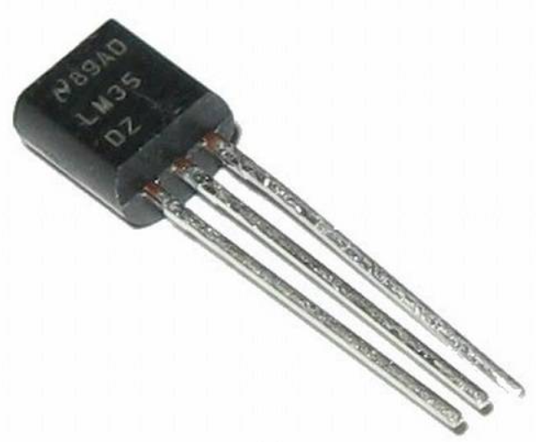 | 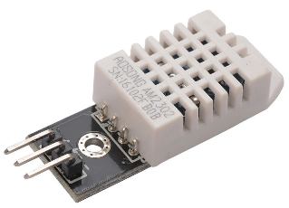 | 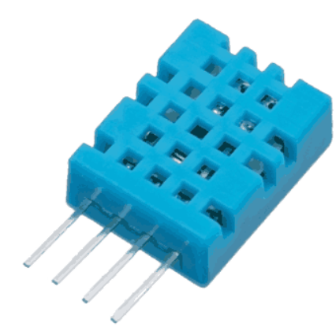 | 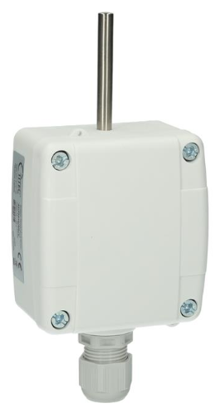
Range | -55 to 150°C | 0 to 100% humidity | 0 to 50°C | -50 to 180°C
Voltage | 4V – 30V | 3V – 5V | 3V to 5V | 12V
Accuracy | +/- 0.5°C | +/- 2% | +/- 2°C | +/- 5%
Advantages | - Compact  - Cheap  - Very accurate | - Measures both temperature and humidity | - Measures both temperature and humidity | - Sleek design  - mountable anywhere
Disadvantages | - Only measures temperature alone | - Expensive | - Expensive | - Expensive
Table 8
[11] [12] [13]
Humidity: -

Table 9
Sensor | ‘Electronic Wings’ DHT11 Humidity and Temperature Sensor | ‘Electronic Wings’ DHT22 Humidity and Temperature Sensor | Air quality monitor TiTEC LQM-CO2-T/F-12V-ES
Image | 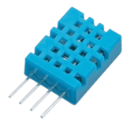 | 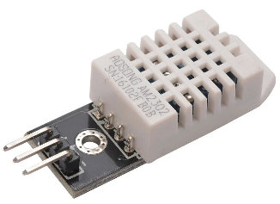 | 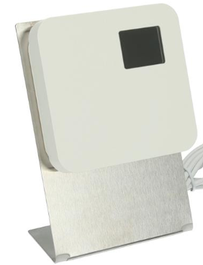
Range | 20 – 80% humidity | 0 – 100% humidity | 0 – 100%
Voltage | 3V – 5V | 3V – 5V | 12V – 34V AC/DC
Accuracy | +/- 5% | +/- 2% | +/- 3%
Advantages | - Measures both temperature and humidity | - Measures both temperature and humidity | - Can be mounted anywhere
Disadvantages | - Expensive | - Expensive | - Standalone unit  - Expensive
Table 10
[11] [12]

Wind speed: -

Table 11
Sensor | ‘WindSonic’ Solid State Wind Speed and Direction Sensor | Anemometer Wind Speed Sensor w/Analog Voltage Output | Wind and Rain Sensors for Weather Station (Wind Vane / Anemometer / Rain Gauge) | The RS-GZ*-*-2 solar light sensor
Image | 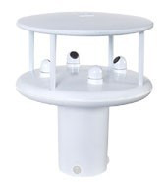 | 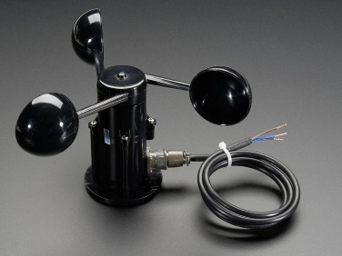 | 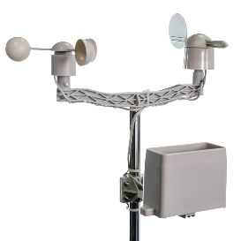 | 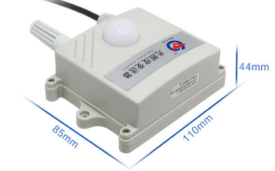
Range | Speed: 0 – 75m/s (0 – 146 knots)  Direction: 0 – 359° | 0.4V (0 m/s wind) up to 2.0V (for 32.4m/s wind speed) | Unknown | Unknown
Voltage | 5-30vDC | 7V – 24V DC | 5V – 24V DC | 10V – 30V DC
Accuracy | +/- 2% | +/- 5% | +/- 5% | Unknown
Advantages | 2 in 1 Wind speed and direction measurement | - Analogue voltage output | - Measures both wind speed & direction | - cheap  - compact
Disadvantages | - Expensive | - Expensive | - Expensive  - Includes other irrelevant measurements  - Unknown range | - Unknown range and accuracy  - Limited information on datasheet
Table 12
[14] [15]

Wind direction: -

Table 13
Sensor | ‘WindSonic’ Solid State Wind Speed and Direction Sensor | Wind and Rain Sensors for Weather Station (Wind Vane / Anemometer / Rain Gauge) | Anemometer Wind Speed Sensor w/Analog Voltage Output | Wind Sensor Garden Signal Output Aluminum Alloy Wind Direction Sensor Wind Vane Speed Measuring Instrument
Image |  |  | 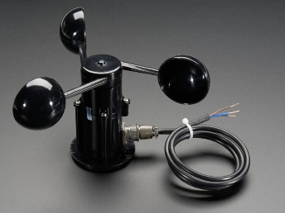 | 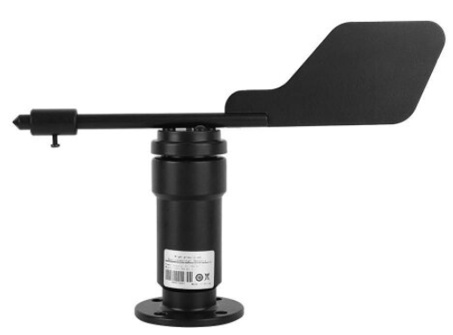
Range | Speed: 0 – 75m/s (0 – 146 knots)  Direction: 0 – 359° | Unknown | 0.4V (0 m/s wind) up to 2.0V (for 32.4m/s wind speed) | 0 - 360°
Voltage | 5V – 30V DC | 5V – 24V DC | 7V – 24V DC | 0V – 10V
Accuracy | +/- 2% | +/- 5% | +/- 5% | +/- 2%
Advantages | 2 in 1 Wind speed and direction measurement | - Measures both wind speed & direction | - Analogue voltage output | - Compact  - Sleek design
Disadvantages | - Expensive | - Expensive  - Includes other irrelevant measurements  - Unknown range | - Expensive | - Expensive
Table 14
[14] [15]

Airbourne particle count: -

Table 15
Sensor | ‘WaferSense’ Airborne Particle Sensor | Airborne Particle Counter: Lasair Pro | AirSens - Airborne Particle Sensor
Image | 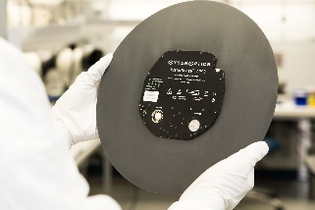 | 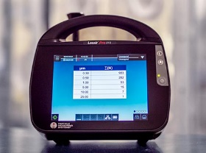 | 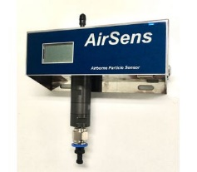
Operating Range | Measures particles greater than .14 microns  Reports particles in 0.1μm and 0.5μm and larger particles in 2, 5, 10 and 30 μm. | 0.3 - 25 µm | 0.3 um to 20.0 um
Voltage | 0V – 10V DC | 5V to 24V DC | 0V – 10V DC
Accuracy | +/- 1% | +/- 3% | +/- 3%
Advantages | - Extremely accurate  - Sleek design | - Complex, Multifunctional | - Many functions
Disadvantages | - Very expensive | - Self housed, standalone unit | - Large in size  - Expensive

[16] [17]

Sunlight brightness: -

Sensor | ‘SenseCAP’ S2102 - LoRaWAN Wireless Light Intensity Sensor | Grove - Sunlight Sensor
Image | 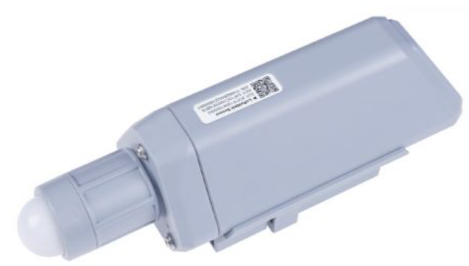 | 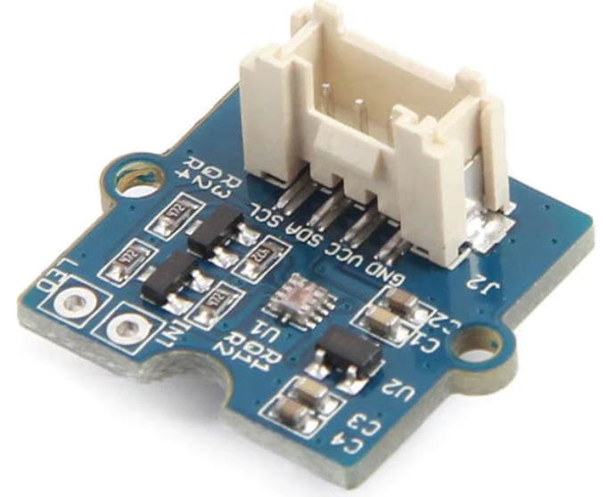
Voltage | 5V DC | 3V to 5.5V DC
Range | -40°C to 85°C | -45 to 85°C
Further Info/features | IP66 Rating  +/- 5% Accuracy | - Works with Raspberry Pi/Arduino
Advantages | - +/- 5% Accuracy | - Cheap  - Compact
Disadvantages | - Expensive | - Accuracy unknown

[18] [19] [20]

UV levels: -

Sensor | UV Detection Sensor Module VEML6075 UVA UVB Ultraviolet Ray Module Light Sensor | BeMatik - Ultraviolet UV electronic sensor with analog output GY-ML8511 | UV Detection Sensor Ultraviolet Ray Module DC 3.3-5V 200nm-370nm | DC3.3-5V 200nm-370nm Response Wavelength UV Detection Sensor
Image | 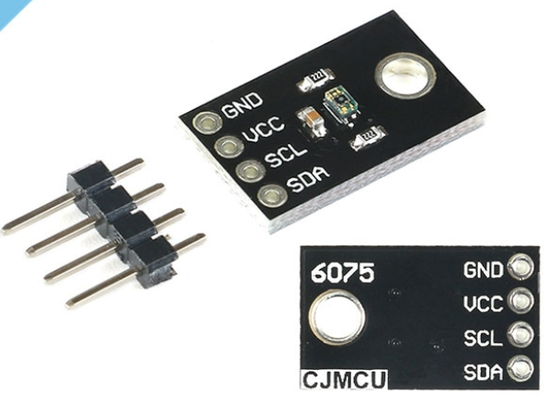 | 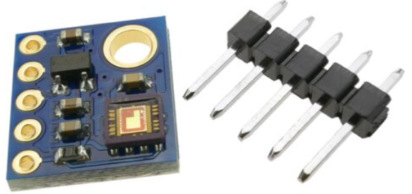 | 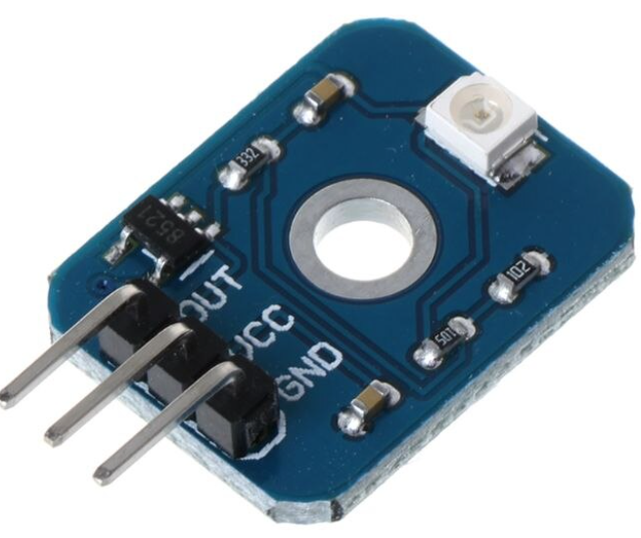 | 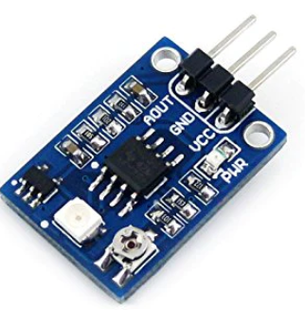
Voltage | 3V to 5V DC | 3.3V to 5V DC | 3.3V to 5V DC | 3.3V to 5.5V DC
Accuracy | +/- 2% | +/- 10% | +/- 5% | +/- 10%
Advantages | - Compact  - High accuracy | - Compact  - Cheap | - Compact  - Relatively high accuracy | - Cheap  - Compact
Disadvantages | - Expensive | - Low Accuracy | - Not great accuracy  - Expensive | - Low Accuracy

[21] [22] [23]

GPS position: -

Sensor | Garmin GPS 16xLVS | USGlobalSat BU-353-S4 | The Pi Hut - Grove - GPS Module | Antenova M20048-1 GPS Module
Image | 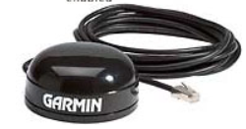 | 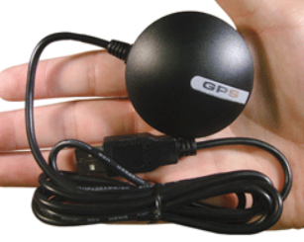 | 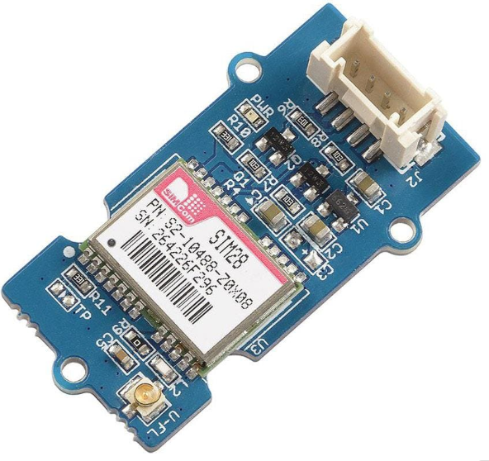 | 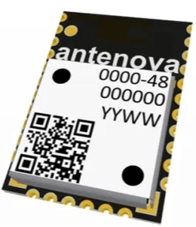
Voltage | 3.3V to 6V DC | 4.5V to 5.5V DC | 3.3V to 5V DC | 2.8V to 4.2V
Accuracy | <15m | N/A | 2.5m | <2.5m
Further Info/features | - Analogue signal | - Analogue signal | - uart | - uart
Advantages | - Easily installed and contained in housing | Easily installed and contained in housing | - Compact | - Compact
Disadvantages | - Larger than other options | - Accuracy Unknown | - Poor accuracy at high altitude | - Poor accuracy at high altitude

[24] [25] [20]

VOC level: -

Sensor | PS1-VOC-200  Gas Detection Sensor, Volatile Organic Chemicals (VOC), 200 ppm, 1 Series | AGS01DB Air Quality Sensor MEMS Technology of VOC Gas Sensor Module | DPWQ306000 - Carel Wall mounting VOC sensor with a 0 to 10 Vdc or 4 to 20 mA output | QPA2002 - Room CO2/VOC Sensor, 0-10V / 4-20mA Output (Selectable)
Image | 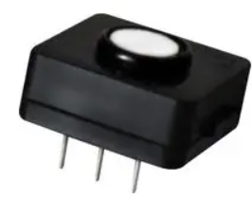 | 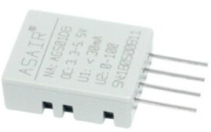 | 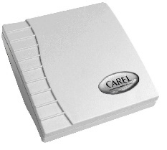 | 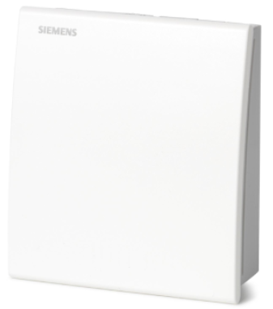
Operating Range | 0 – 200ppm | 0 – 175ppm | 0 – 100ppm | Unknown
Voltage | 3.3V to 5.5V DC | 3.3V to 5V DC | 0V to 10V DC | 24V DC
Advantages | - Large cross section of gases measured  - Compact | - Compact | - Sleek design | - Sleek design
Disadvantages | - Expensive | - Expensive | - Large  - Standalone unit | - Indoor use only  - Low number of gases measured

[26] [27] [28] [29]

Equipment

Below is a list of software and equipment used in the building of the design and report: -

- Number One Systems – Easy-PC
- Used to create schematic design of weather station, with all required components included. Microcontrollers and sensor circuits, as well as 555 timer and flashing LED circuit is built using this programme. Schematic is then translated to a PCB design window, where components are added to a clear board and tracks/pads are added as needed. This is then used to receive a quote (from jlcpcb.com) using the files created in the design.

- PIC Microcontroller Datasheet
- Used to determine where each sensor and component is to be connected to each pin on the Pic18f25k50 Microcontroller.

- Proteus 8 Professional
- Used to create schematics for the design, including all sensors and the microcontroller. These designs are then moved over to Easy-PC to create the PCB design itself.

- Datasheets for each sensor/USB/SD Card used
- Used to compare various sensors to be used, and to determine where each is to be connected on the microcontroller, and which pins are to be used where when connecting the USB/SD Card etc, depending on specification requirements.

Specification

Microcontroller Selection: -

What is a Microcontroller?

“Microcontrollers are essentially stand-alone processors, intended to be embedded into some electronic device that is definitely not a ‘computer’. They are inexpensive and easy to use, and they let you put the intelligence of a computer into pretty much anything electronic. In doing so, they trade off some of the terrifying speed of computer-orientated processors in favour of built-in memory and peripherals.” [8]

A Microcontroller is used to control other parts of an electronic system, using memory and a few other peripherals. Microcontroller Units use additional pieces of hardware connected to them to control a system, rather than specific commands and data storage.

Microcontrollers typically include the following elements: -

- 8/16bit Microprocessor
- Serial and Parallel I/O
- Small measures of RAM
- Analogue to Digital and Digital to Analogue conversion
- Timers and signal generators
- Programmable ROM and flash memory [9]

In this instance, a Pic18F25K50 Microcontroller was chosen for the weather station build.
This was due to the requirements considered necessary, such as the number of analogue and digital inputs, and the requirement of an SPI SD Card for memory storage and USB connectivity.

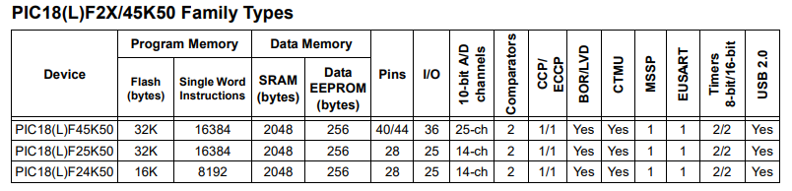
- Pic18f25k50 Family types

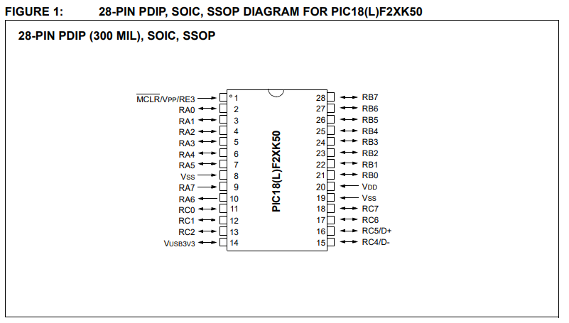
- Pic 18f25k50 Diagram, taken from datasheet.

The necessary microcontroller specification for this build is shown below: -
Pic18f25k50: -
- 28pin
- 4 Digital inputs
- 11 Analogue inputs
- 16MHZ
- 8K Prog
- 256B RAM
- 1 USB
- 1 R5232
- 1 SPI
The PCB design’s requirements are as follows: -

- 28pin
  - 8 Analogue inputs required for sensors.
  - 1 digital input required for flashing LED.
Clock Frequency 40MHz.

- 8K Prog
- 256B RAM
- 1 USB Port
- 1 R5232
- 1 SPI – SD Card with 4 digital pins for memory
- 4 pins for power
- 1 digital output for flashing LED
- 4 digital pins – VDD, VSS, D+, D-

Method

PCB Design

The schematic design is created on Proteus 8 Professional, where circuits can be created easily and connected to the Microcontroller as required. The Pic18f25k50 is added to this schematic and each sensor circuit is then created and placed alongside the microcontroller. The SD Card and USB is also added to this schematic, as well as the DC power supply (from battery) circuit and the flashing LED Circuit. Inputs and outputs are added to each of the components/sensors and these are then connected to the Microcontroller on the corresponding pins.
Once this is complete, the schematic is also drawn-out using Number One Systems – Easy-PC. This programme is more tailored to building the PCB design itself, and therefore it is easier to initially draw out certain aspects of the design onto Proteus. Once this is copied over to Easy-PC, and nets are created to each sensor/microcontroller pin, including power supplies for the Pic, then the ‘translate to PCB’ function can be used. This creates a PCB building window where an empty board can be dropped onto the page and components can be added where required. Tracks can then be added to connect each component and then connect each circuit to the microcontroller, as per the schematic design.
Various layers can be added (in this case the design is to create a 4-layer board) and electrical connections and power planes can be separated by using various layers of the board.
Tracks as laid out on the board in such a way that none cross or come into contact with one another (using various layers helps with this), and in as short a route as possible, with the most straightforward routes. This is done for both aesthetic purposes, and can aid with fault finding or repair in future, as well as it can help keep costs down due to having less copper on the board etc.
The layout of the PCB in a certain manner ensures that all sensors and components have their designated areas on the PCB, with their respective connectors placed around the outside edge of the board. The USB port and SD Card are also situated on the outside edge of the board to ensure they can be accessible when required.
Once this is complete, the ‘Design rule check’ function can be used to highlight any errors in the design, and these can then be rectified where needed. The design, once complete, is then uploaded to ‘jlcpcb.com’ to generate a quote to manufacture and ship the PCB to the customer.

Proteus

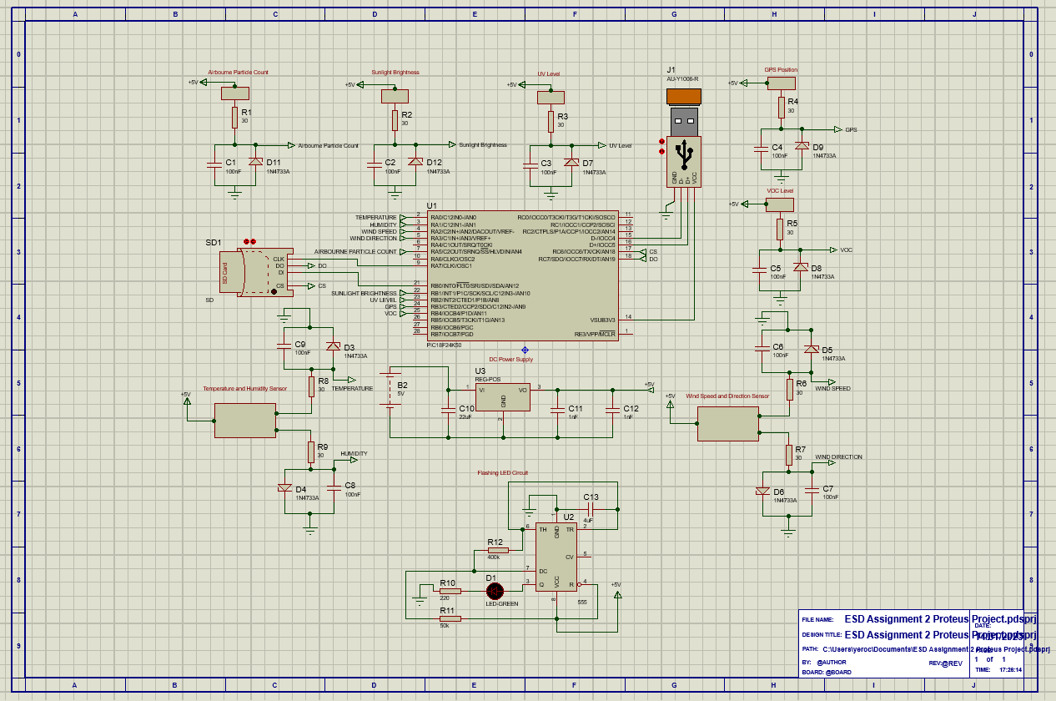
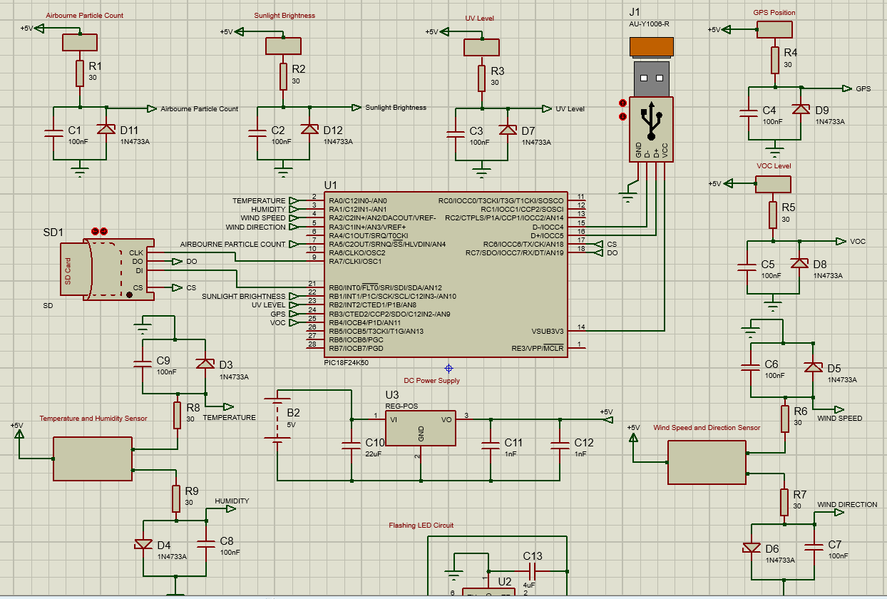
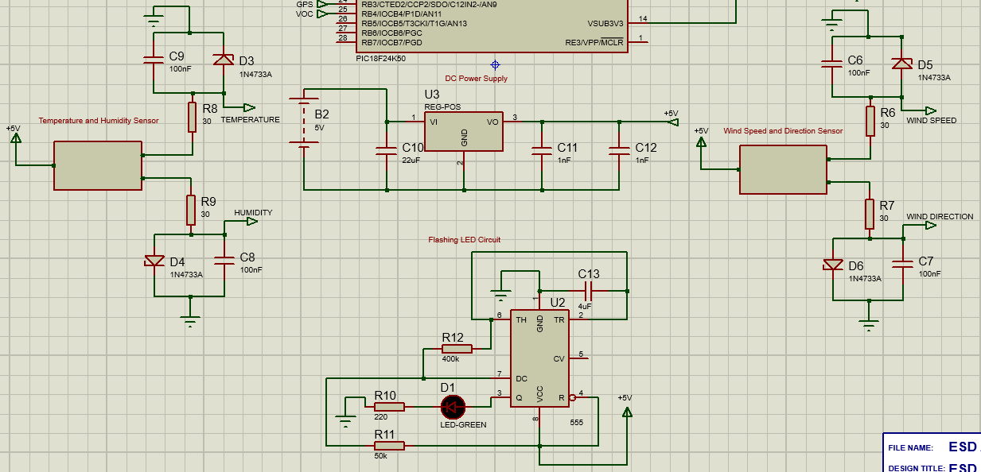
- Images to show the Proteus design of the weather station, including Microcontroller, 9 sensors, SD Card, USB & LED Circuit.

Flashing LED

A circuit was added to the design to include the required flashing LED as part of the weather station. This basic circuit, with the inclusion of a 555 timer, allows the green LED to illuminate for 1 second, every 10 seconds. This will be used instead of a display, to indicate operation.
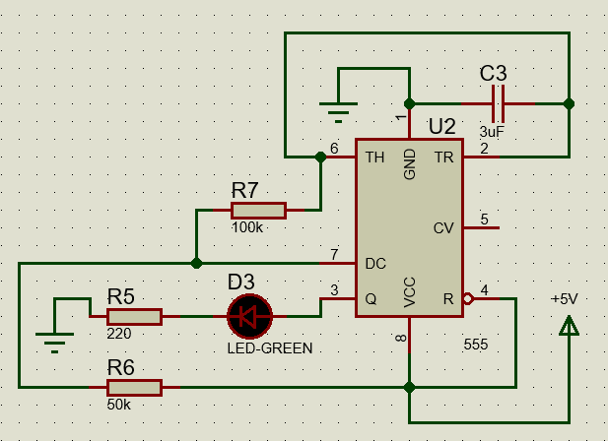
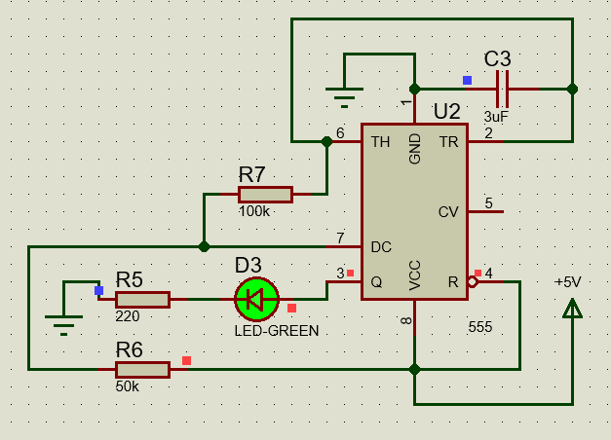
- Images to show flashing LED circuit on Proteus, with both the LED illuminated and not.
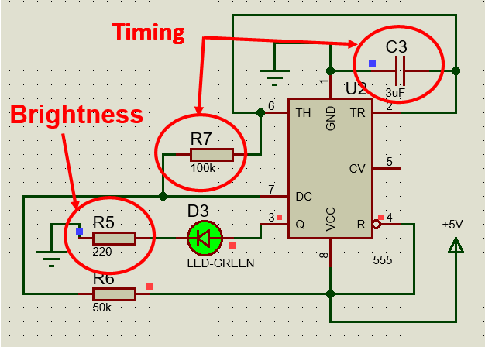
- Timing and Brightness altered by adjusting values of these resistors/capacitor.

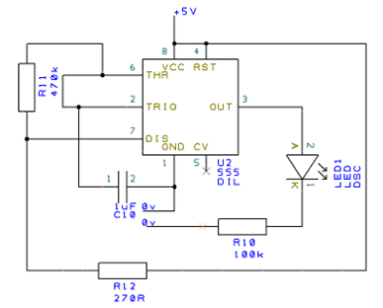
- The same circuit schematic, drawn on the Easy-PC software.

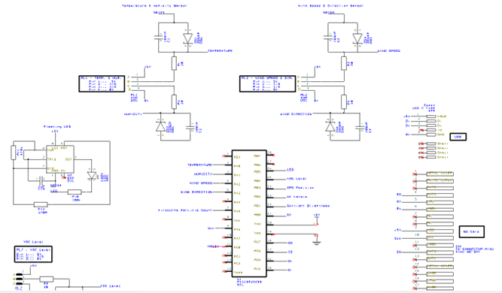
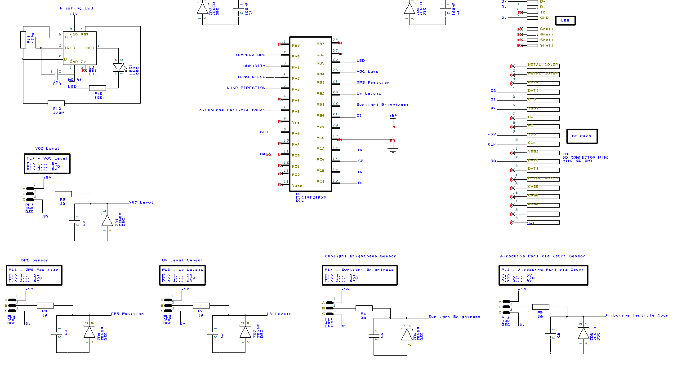
- Easy-PC Schematic for Microcontroller, sensors, USB, SD Card and LED circuits.
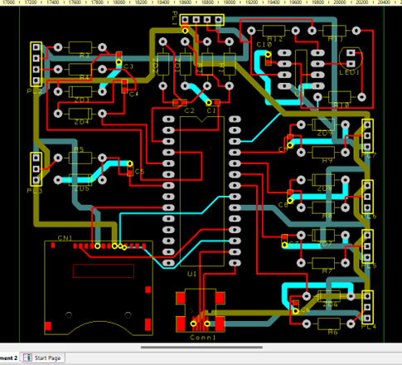
- Schematic translated to PCB, with all components and tracks added.
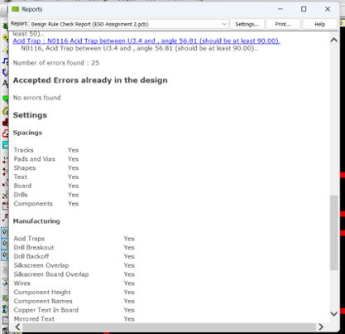
- Image to show errors in initial build, with all boxes checked when using ‘design rule check’.
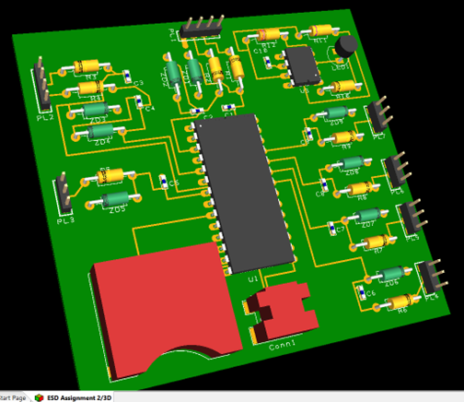
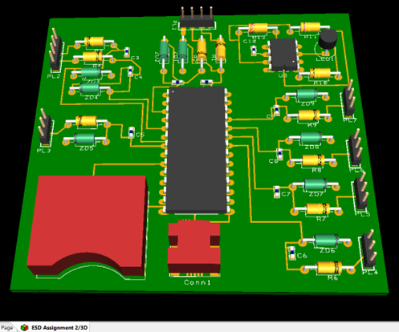
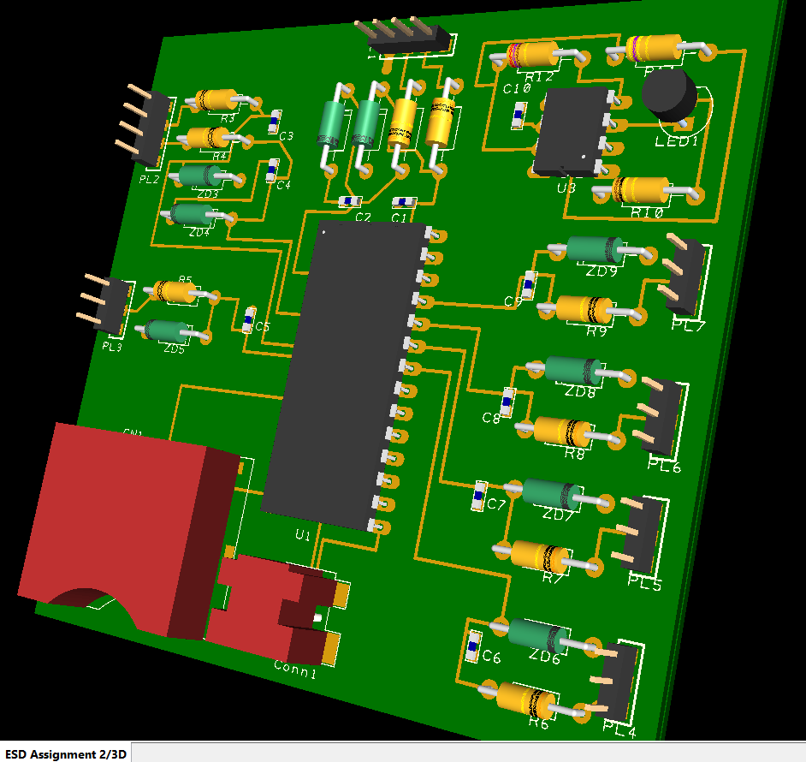
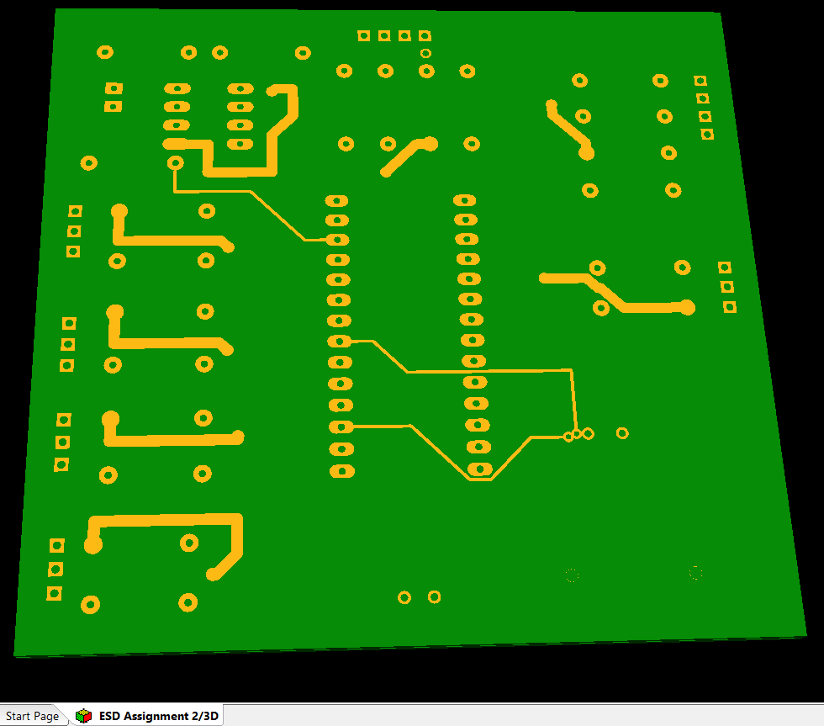
- Images to show 3D projection of built PCB, at various angles.

Costing

The section below shows the quotation received from an online retailer, ‘jlcpcb.com’, to manufacture and ship a quantity of PCB’s made to the required specifications from the Easy-PC design. These files are stored as ‘Gerber files’ and uploaded to the website. Options such as number of layers, board colour, materials etc. can be specified when quoting the product and these can then be purchased as a one off or in large quantities such as in the thousands of units.
In this instance, the received quote is for a quantity of 5 units, which works well as a quantity for a prototype sample. The PCB specification for this generated quote is listed below: -
- Base Material: FR-4
- Layers: 4
- PCB Quantity: 5
- PCB Thickness: 1.6mm
- PCB Colour: Green
- Silkscreen: White
- Material Type: FR-4 Standard TG 135-140
- Surface Finish: Lead Free HASL
As stated above, the board itself is made from FR-4, a flame retardant, epoxy laminated material. The surface finish is ‘Lead Free HASL’ (Hot Air Solder Levelling), which is a requirement for the UK. Lead free HASL uses lead-free alloys instead of tin-lead alloys, and is used as an alternative for countries where regular HASL is no longer in use.
To achieve this surface finish, molten solder is applied to the board and excess solder is scraped used air knives set at a temperature higher than that of the solder. When the solder cools down and solidifies, the PCB is then put through a washing process, where any excess solder flux residues are removed.
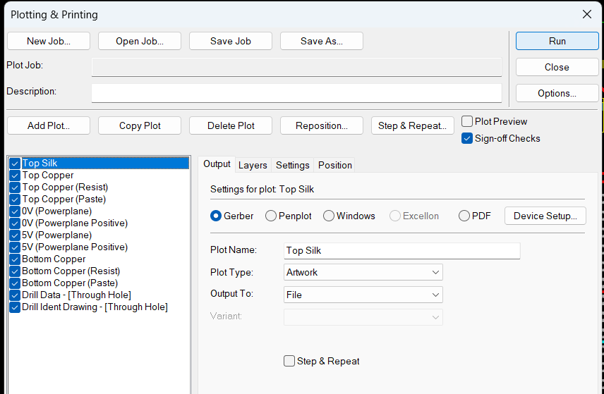
- Image to show ‘Plotting & Printing’ page, used for configuration of Gerber files for upload to jlcpcb.com from the Easy-PC design.
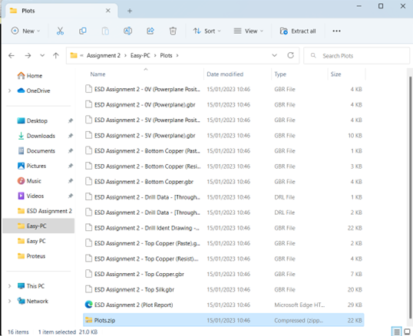

- Gerber files for the design specification, compressed to a zip folder ready to be uploaded to jlcpcb.com for quotation.
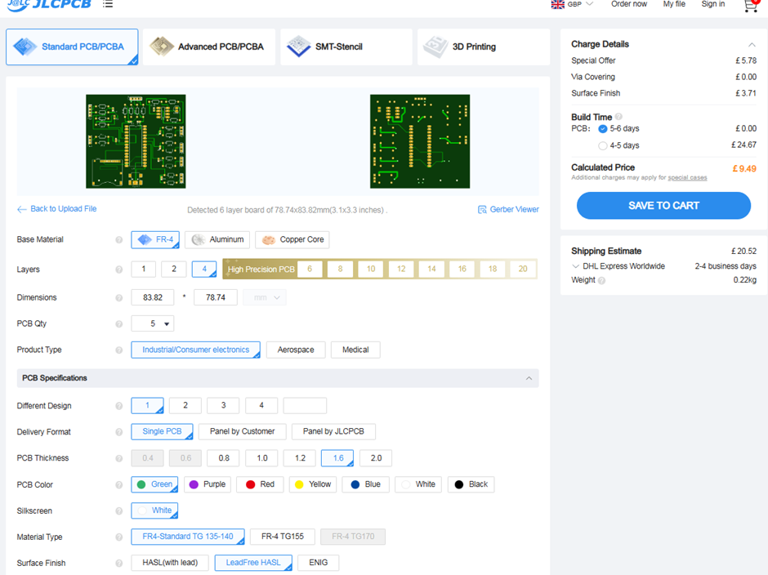
- Image to show the jlcpcb.com website overview when quote is specified and received on the right hand side. All options mentioned above (and more) are available to be altered on this page.
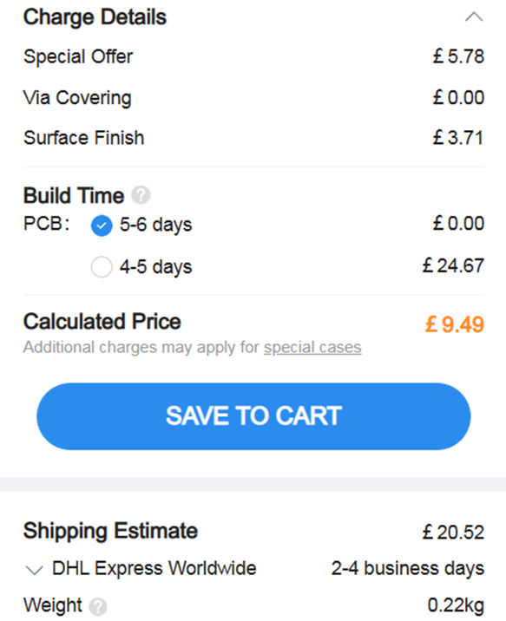
- Image showing quote received from jlcpcb.com, price based off a quantity of 5 units of a 4-layer board.
The quote shown above for 5 units at the required specification is calculated at £9.49 for a build time of 5-6 days. This can be reduced to 4-5 days for an extra £24.67, and a shipping cost of £20.52 is also added, which is estimated to be delivered within 2-4 business days.
Total: -
5 – 6-day delivery: £30.01
4 – 5-day delivery: £54.68

Sensors Total: £573.47
Components Total: £540.11
Total Cost: £1,143.59

Conclusion

In Conclusion, the hardware and components used in the build worked well together and all were compatible with the Pic18f25k50 Microcontroller, utilizing the corresponding pins where required.
The PCB seemed to be built as needed and each sensor was connected to the correct pin on the Microcontroller. The PCB design itself seems to have worked well, with each sensor and component fitting on the board well aesthetically. The tracks do not cross or interfere with one another, and the different layers helped to achieve this in some parts that were busy with tracks/components.
Compared to the other Weather Stations found in the research, the build itself seemed to work well and have some features that may improve on some of the ones already available on the market.
Some of the available products on the market that were research include Wi-Fi/Bluetooth or 5G connectivity. This could be implemented into a build to allow for continuous monitoring of the results being measured, even when the system is left out on a site and the person(s) are no where near. This could be by use of a website or app on a phone to connect and view measurements being taken in live time by the system.
A mast kit or wall clamp could also be a good idea to incorporate in a future build, where the system could be placed at a higher altitude and therefore could gather more accurate readings, depending on the requirements of the system on that particular site.

References

[1] | “MSL - Enivronmental Monitoring,” [Online]. Available: https://www.measurementsystems.co.uk/environmental-monitoring/weather-stations/gsm-weather-station-amp-data-logger.
[2] | “MSL - H21-USB Hobo Micro Weather Station,” [Online]. Available: https://www.measurementsystems.co.uk/environmental-monitoring/weather-stations/h21-002_hobo_micro_weather_station.
[3] | I. S. MWS-C600. [Online]. Available: https://www.intellisenseinc.com/products/weather-stations/mws-c600/.
[4] | I. S. MWS-M625. [Online]. Available: https://www.intellisenseinc.com/products/weather-stations/mws-m625/.
[5] | “Measurement Systems - MicroP-dl GSM Weather Station,” [Online]. Available: https://www.measurementsystems.co.uk/Environmental-Monitoring/Weather-Stations/gsm-weather-station-amp-data-logger.
[6] | “Intellisense MWS-C600 Overview,” [Online]. Available: https://www.intellisenseinc.com/products/weather-stations/mws-c600/?utm_source=bing&utm_medium=cpc&utm_campaign=uk-weather-stations.
[7] | “RS,” [Online]. Available: https://uk.rs-online.com/web/.
[8] | P. H. &. W. Hill, The Art of Electronics, Cambridge University Press, 2015.
[9] | “Microcontroller types and applications,” [Online]. Available: https://www.elprocus.com/microcontrollers-types-and-applications/.
[10] | H.-U. H. M. W. Station. [Online]. Available: https://www.measurementsystems.co.uk/Environmental-Monitoring/Weather-Stations/h21-002_hobo_micro_weather_station.
[11] | “Temp Sensor 1,” [Online]. Available: https://www.automation24.co.uk/outdoor-temperature-sensor-titec-autf-muv .
[12] | “Temp Sensor 2,” [Online]. Available: https://www.spluss.de/en/sleeve-sensor-with-temperature-measuring-transducer-thermasgard-hftm-d101-1150-0000-000-p4110/?price=from .
[13] | “Honeywell Temperature Sensor,” [Online]. Available: Honeywell Outdoor Temperature Sensor | Temperature & Humidity Transmitters | Sensors | Temperature & Humidity Transmitters | Honeywell Building Solutions.
[14] | “Peli Storm iM2620 Case,” [Online]. Available: waterproof-cases.co.uk.
[15] | “JLCPCB.com (PCB Quote),” [Online]. Available: jlcpcb.com.
[16] | “1mm² Tri Rated Cable - Black - BS6231 - 100m,” [Online]. Available: tlc-direct.co.uk.
[17] | “Pitacs Weather Resistant Rubber (Pond) Flex Cable (3183P) 0.75mm2 Drum,” [Online]. Available: Toolstation.co.uk.
[18] | “EN91F6 Energizer Battery Company | Battery Products | DigiKey,” [Online]. Available: EN91F6 Energizer Battery Company | Battery Products | DigiKey.
[19] | “https://www.litime.com/products/litime-12v-50ah-lifepo4-lithium-ion-battery,” [Online]. Available: https://www.litime.com/products/litime-12v-50ah-lifepo4-lithium-ion-battery .
[20] | “Air quality monitor TiTEC LQM-CO2-T/F-12V-ES | Automation24,” [Online]. Available: Air quality monitor TiTEC LQM-CO2-T/F-12V-ES | Automation24.
[21] | “Wind Speed Sensor 1,” [Online]. Available: https://thepihut.com/products/anemometer-wind-speed-sensor-w-analog-voltage-output .
[22] | “sun light sensor, illumination sensor for weather - Renke,” [Online]. Available: renkeer.com.
[23] | “APC Sensor 1,” [Online]. Available: https://www.cyberoptics.com/products/wafersense-airborne-particle-sensor/.
[24] | “Airborne Particle Counter: Lasair® Pro - Particle Measuring Systems PMS,” [Online]. Available: pmeasuring.com.
[25] | “APC Sensor 2,” [Online]. Available: https://www.environmental-expert.com/products/airsens-airborne-particle-sensor-809444.
[26] | “Grove - Sunlight Sensor | The Pi Hut,” [Online]. Available: Grove - Sunlight Sensor | The Pi Hut.
[27] | “SenseCAP S2102 - LoRaWAN Light Intensity Sensor - Unmanned Tech UK FPV Shop,” [Online]. Available: unmannedtechshop.co.uk.
[28] | “Wind and Rain Sensors for Weather Station (Wind Vane / Anemometer / Rain Gauge) | The Pi Hut,” [Online]. Available: Wind and Rain Sensors for Weather Station (Wind Vane / Anemometer / Rain Gauge) | The Pi Hut .
[29] | “UV Sensor 1,” [Online]. Available: UV Detection Sensor Module VEML6075 UVA UVB Ultraviolet Ray Module Light Sensor UV Light Intensity Sensor For Arduino I2C Port – Grandado.
[30] | “vBeMatik - Ultraviolet UV electronic sensor with analog output GY-ML8511,” [Online]. Available: manomano.co.uk.
[31] | “DC3.3-5V 200nm-370nm Response Wavelength UV Detection Sensor Module Ul – DirectNine - United Kingdom,” [Online]. Available: DC3.3-5V 200nm-370nm Response Wavelength UV Detection Sensor Module Ul – DirectNine - United Kingdom.
[32] | “UV Sensor 4,” [Online]. Available: https://www.directnine.uk/products/dc335v-200nm370nm-response-wavelength-uv-detection-sensor-module-ultraviolet-ray-uv-sensor-module-for-arduino?msclkid=adedbf13b5e719aa19a8dcd7f242ee64&utm_source=bing&utm_medium=cpc&utm_campaign=pmax-01&utm_term=45886743.
[33] | “Brief Specifications for GPS 16x Series,” [Online]. Available: starlite-intl.com.
[34] | “Grove - GPS Module | The Pi Hut,” [Online]. Available: Grove - GPS Module | The Pi Hut.
[35] | “PS1-VOC-200 Amphenol Sgx Sensortech, Gas Detection Sensor, Volatile Organic Chemicals (VOC), 200 ppm | Farnell UK,” [Online]. Available: PS1-VOC-200 Amphenol Sgx Sensortech, Gas Detection Sensor, Volatile Organic Chemicals (VOC), 200 ppm | Farnell UK.
[36] | “AGS01DB Air Quality Sensor MEMS Technology of VOC Gas Sensor Module on OnBuy,” [Online]. Available: AGS01DB Air Quality Sensor MEMS Technology of VOC Gas Sensor Module on OnBuy.
[37] | “DPWQ306000 - Carel Wall mounting VOC sensor with a 0 to 10 Vdc or 4 to 20 mA output (i-acs.co.uk),” [Online]. Available: DPWQ306000 - Carel Wall mounting VOC sensor with a 0 to 10 Vdc or 4 to 20 mA output (i-acs.co.uk).
[38] | “QPA2002 - Room CO2/VOC Sensor, 0-10V / 4-20mA Output (Selectable) (i-acs.co.uk),” [Online]. Available: QPA2002 - Room CO2/VOC Sensor, 0-10V / 4-20mA Output (Selectable) (i-acs.co.uk).

