Name: Chris Wilkin
Business Plan for: Sky Casual Restaurant

Lecturer: | Chris Wilkin
Date: | 04.03.2024
Team members: | Mariana Muresan (2210334)  Ana Maria Stoica (2210328)  Madalin Popescu (2207349)  Cristian Tenea (2211743)
Business plan contents
Executive Summary…………………………………………………………………………………………………………….3
1 Executive summary 3
2 Business details 4
3 Key personnel 5
Vision 6
4 The bsiness idea 6
5 Business goals 6
6 What the business does 7
7 What makes the business different 7
8 Legal requirements 7
Marketing 8
9 Market research 8
10 Profiling customers 8
11 Profiling competitors 9
12 Managing market risks 9
13 Pricing 9
14 Promotion and advertising 10
Running the business 11
15 Staff 11
16 Premises 11
17 Suppliers 11
18 Equipment 12
19 Managing operational risks 12
Finance 13
20 Start-up costs 13
21 Profit and loss forecast 15
22 Sourcing finance 16
23 Managing financial risks 16
24 Cash flow forecast 17

1 Executive summary

The current project has been connected with the business idea named “Sky Casual Restaurant” which is associated with providing hygiene and healthy food to the people in the UK. The business has been comprised of its efficient presence on social media platforms with fresh capturing minimum marketing cost and is initiated with the minimum pricing strategy in order to cover the maximum customer base. The mission is to achieve this goal by offering customers outstanding food experiences through our use of superb quality, food that meets their unique tastes and different preferences. We attempt to fill the atmosphere with excitement and thrill, where observers will have an unforgettable dining experience by emphasising maintaining the standards of food safety laws, keeping the balance of the inventory, providing customers with the highest level of satisfaction and using the latest technology. We believe that Sky Casual Restaurant will eventually climb up the ladder in the food service industry by making client satisfaction and strategic expansion our priorities, which will largely contribute to economic development and will reinforce our brand as a reliable partner in outstanding gastronomy.

2 Business details

Company name:
Sky Casual Restaurant

Address: Fronting South End, south of Croydon High Street, London
Picture in Appendix

Primary contact method
Individual and Family sitting area. Food Delivery System supported by the social media pages.

The business will:
Sky Casual Restaurant has been associated with fresh food and drink services with the aim to provide hygienic fresh food to the customers within their budgets. The restaurant provides a unique dining system with significant customer care services by highlighting the organic ingredients in the food promoting healthy food on the streets of the UK. Restaurant is also committed to developing a sound presence in digital platforms by reaching out to the maximum customer by considering their need and value for healthy food. Fresh Foods business has also created a survey about the people of the surrounding community in order to add diversity to the food by targeting the cultural ingredients in the selected dishes of the restaurant.

3 Key personnel

Details of owner(s):
Name: Mariana Muresan
Position/main responsibilities: Administration and Operation Manager
Experience and knowledge of our industry: Each customer perceives a different opinion on what makes an effective restaurant. UK restaurant industry has been consistent in categorising positive restaurant experiences which possess good value to the customer with high quality hygienic food, greater customer care service with cleanliness.
Previous employment: Trattoria Raffaele
Key skills brought to the business: Administrative and management skills which provide value to the customer through viable products. Developing sound communication and greater customer care service to the customer.
Business experience and any training undertaken: training required
Academic/professional qualifications: High School
Salary expectations: £ 30,000 Per Year

Name: Cristian Tenea
Position/main responsibilities: Finance Manager
Experience and knowledge of our industry: The food service profit in the United Kingdom has been recorded at around £72.6 billion in the year 2022 which shows significant potential and opportunity for the start-ups to initiate a food business with customer customer-targeted approach with profitability.
Experience and knowledge of our industry: a 1-year internship in managing finance and achieved employee of the month award twice.
Previous employment: MM Fried Chicken
Key skills brought to the business: Have the ability to maintain cost structure of the selected food item without compromising the required hygienic ingredients. Problem solving skills and ability to maintain the same cost over long period.
Business experience and any training undertaken: N/A
Academic/professional qualifications: Certification in Restaurant Management and Hospitality approved by Food Safety and Health Standards of UK.

Salary expectations £ 50,000 Per Year

Name: Madalin Popescu
Position/main responsibilities: Restaurant Manager
Experience and knowledge of our industry: Having experience of managing restaurant premises to accommodate the maximum number of customers at the same time along with the management of waiting customers.
Previous employment: Department Manager. Event Associate / Hotel Pietroasa, Buzau, Romania & Hotel Complex Turistic Magura, Buzau, Romania
Key skills brought to the business: Have the ability to manage customers with high service standards.
Business experience and any training undertaken: 12 Years experience of running restaurants and evets
Academic/professional qualifications: High School Diploma in Tourism
Salary expectations £ 30,000 Per Year
Name: Ana Maria Stoica
Position/main responsibilities: Marketing Manager
Experience and knowledge of our industry: Ana has worked in the hotel industry for the past ten years, specialising in Housekeeping Department.
Previous employment: Ana previously worked as room attendant ans supervisor in The May Faire Hotel in London.
Key skills brought to the business: Leadership and team management, staff training and development, attention to details and quality standards.
Business experience and any training undertaken: Ana has completed Hire Great People training in Edwardian Academy, First Aid, Duty Manager and Yes I Can training.
Academic/professional qualifications: High School Graduation
Salary expectations £ 35,000 Per Year

Vision

4 The business idea

Sum up your business idea:
The business idea associated with successful start of the sustainable restaurant which provides taste in food by considering the major factor of hygienic and healthy food preventing the element of obesity and other heart disease. Our dishes have very low levels of cholesterol by including green vegetables considering the health factor of the customer as a priority. Moreover, our priority also connects to providing an environment-friendly atmosphere to our customers with greater customer care services adding value to the product and customers at the same time.

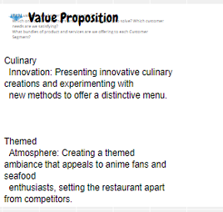

5 Business goals
- What do you want to achieve in your first year of business?
- The goal of the business is to raise a significant customer base in the first year as a priority motive covering all the expenses to maintain the restaurant and payroll.

- Where do you see your business in 3-5 years’ time?
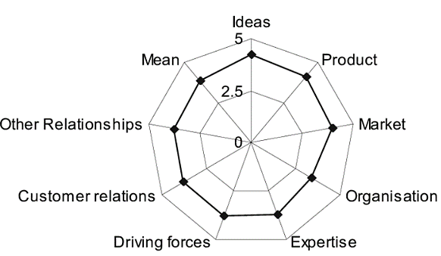
Figure 1: Klofsten Business Model
Source: (Research Gate 2021)

Sky Casual Restaurant has the idea of making a brand that is diversified to all types of customers and can target the food market by maintaining loyal relationships with customers. The restaurant wants to keep its expertise in its selected products by maintaining the incremental profit approach without compromising the cost and taste of the food. Therefore, the driving force of Sky Casual Restaurant is surrounded by the promotion of hygienic food through using both traditional and digital media platforms to penetrate the food industry in an effective manner as derived from the research of (Li, Mirosa and Bremer 2020).

6 What the business does

Product/service | Features | Benefits
- Fish and Chips | - Cooked with small quantity of Olive oil | - Higher protein and carbs
- Scotch Eggs with Green Salad | - Inclusion of natural green vegetables | - Higher Protein healthy food
- Green Tea | - Inclusion of natural ingredients | - Beneficial to lose cholesterol and useful for freshness

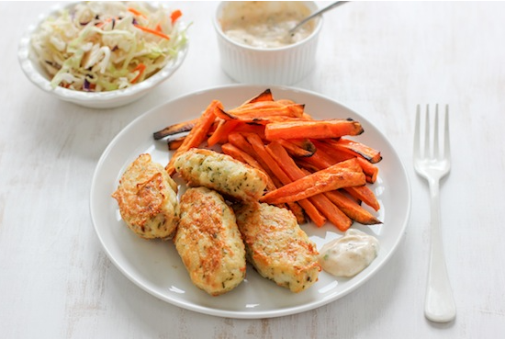
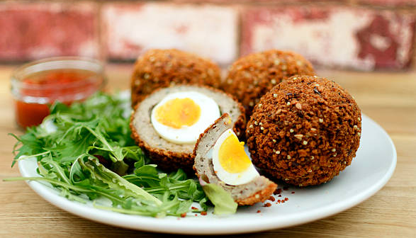


7 What makes the business different (Value Proposition)
Your product/service is unique or different compared with the competition because:
- The products are normal but those have the message to promote sustainability in the food by promoting natural ingredients and process to prevent the level of obesity in the UK (Culliford, Bradbury and Medici 2023). Therefore, this concept makes the business of Sky Casual Restaurant different from other because the profitability margin for the business is secondary after acquiring large customer base.

8 Legal requirements (including regulations and licences particular to your business)
The legal and insurance requirements that apply to your business are:
- It is necessary to recognise the business first as a sole trader, partnership or limited liability company to initiate the process of registration to the local registrar along with the food premises permission. Filimonau et al. (2020) stated that the restaurant business must acquire a license for the sale of alcohol with the guidance and its effect on the human body. The other license includes a music license and a parking license. Kamboj et al. (2020) added that the business must comply Food and Safety Act of 1990 along with the Food Hygiene Regulation Act of 2006 (DeWaal, Roberts and Plunkett 2021). The business also needs to comply with the Honest Advertisement Act 2000 to show the truth about food quality and hygiene and must be associated with the “General Data Protection Regulation” (GDPR).
You will meet your legal and insurance requirements by:
- The legal and insurance requirement will be met by covering public liability insurance covering compensation to customers and employees added with employer’s liability insurance. The business must also cover the insurance related to building safety and equipment and any interruption insurance (Abraham and Liebman 2021).

Marketing

9 Market research

Trends in your chosen market are:
- According to Lupo and Stroman (2020), the business might reassess its marketing strategy to attract more customers, leading to higher future sales. Diversified Marketing Strategy: Execute diverse marketing tactics including targeted advertising, loyalty programmes, partnerships, and special events to boost sales. Sky Casual Restaurant aims to adapt to market changes by diversifying marketing strategies and consistently tracking sales performance compared to projections. This technique aims to reduce the effects of lower-than-anticipated sales by being flexible and adaptable in marketing efforts to maximise revenue creation.(Verma and Mishra ,2023).

How you know this:
- Enhancing services requires integrating technology and improving operational efficiency (Sjödin et al., 2020). It fosters a favourable reaction to marketing automation by enhancing comprehension of client demands and preferences. The restaurant business enhances customer experiences by using customised digital menus and online payment systems, adding value for customers. This creates potential for businesses by increasing the number of guests and improving satisfaction rates to attain success. Prasetyo et al. (2021) said that food delivery services are favoured by clients, enhancing profitability and creating value for the younger generation. Food delivery businesses offer convenience by delivering products to customers' homes based on their requirements. This also increases client attention towards purchasing meals and promotes profitability. Enhancing market awareness is essential for optimising internal processes and establishing customer relationships. Manzoor et al. (2020) asserted that social media usage improves the comprehension of client demands and preferences, fostering trust. This improves marketing strategies and develops promotional campaigns to raise consumer awareness of products and services, ultimately increasing customer engagement.

10 Profiling customers
Using Similar web, based on our competitor customers, Beefeater, we will address to the fallowing age group of customers between 25 years old and 34 years old. (Similarweb, 2024)

The customer groups you will be selling to are:
- BUSY PROFESIONALS: Description: Frederick and Bhat (2021) mentioned that people with busy schedules valuing convenience, speed, and quality food. Needs and Preferences: Need easy to order, pay and receive food. Prefer fresh, hot, tasty options with variety. Willing to pay premium for convenience. Behaviours: Order food online or through apps, individually or in groups. Loyal to consistent, reliable brands.
- FAMILIES: Description: Harris, Jansen and Rossi (2020) pointed that Individuals with children or relatives valuing family, comfort, and fun in dining. Needs and Preferences: Need food suitable for different ages, tastes, and dietary needs. Prefer wholesome, nutritious options offering value for money. Behaviours: Dine out or order food with friends, classmates, or alone for study breaks, parties, or convenience.
- STUDENTS: Descriptions: Enrolled individuals with limited budgets valuing variety, affordability, and socialisation in food. Needs and Preferences: Need cheap, filling, satisfying food catering to different cravings. Prefer fun, trendy, customisable options with discounts and deals. Behaviours: Dine out or order food with friends, classmates, or alone for study breaks, parties, or convenience.
- TOURISTS: Description: According to Kim, Park and Xu (2020) Visitors valuing experience, adventure, and authenticity in food. Needs and Preferences: Need easy to find access and enjoy food enhancing travel experience. Prefer local, fresh, unique options offering cultural insight. Behaviours: Dine out or order food with travel companions or locals. Try new cuisines for sightseeing, exploring or curiosity.

Your customer research has shown what your customers want is:
- The research related to the customer data in terms of their choice and preference of food will be initially acquired through online survey with the help of Google Forums and other reliable online survey sources. The survey has been comprised with the choice of customers to acquire hygiene food within their budgets.
- The data related to the choice of customer has also been taken in accordance with the ratings of the food restaurants in UK and the type of food customer prefer to eat in their daily proceedings. The ratings have been acquired through reliable rating websites like similarweb (2024).
- The data of customers also ben acquired from the social media pages and groups of different food restaurants in UK which is comprised with the trend and flow towards online delivery system.

How you know this:
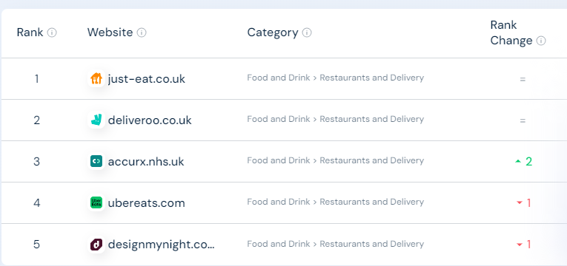
Figure 2: Food Restaurant Current Rating in UK
Source: (similarweb 2024)
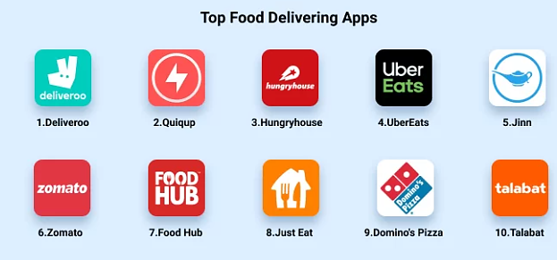
Figure 3: Food Restaurants Delivery application ratings
Source: (Idea Usher 2021)

Number of customers you expect to win in each group and what they might pay:
Group | Number of customers | Price they might pay per unit
Busy Professionals | 50 | £10/unit
Families | 150 | £15/unit
Students | 100 | £5/unit
Tourists | 150 | £15/unit

11 Profiling competitors

Competitor name | Strengths | Weaknesses
- Urban Eats Dinner | - Trendy ambiance, social media presence.  - Similarweb (2024) admits its annual revenue from $2 to $5 million. | - Inconsistent Food Quality. Low hygienic and healthy ingredient inclusion.
- Elements Restaurants | - Flexible Pricing in order to target divers customers. | - Poor seating capacity. Variable service quality.
- Tasty Treat Bistro | - Inclusion of High-Quality ingredients. Different dishes | - High Pricing. Targeted Customers
- The Restaurant at St Martins Lane | - Environment Friendly Food. Reasonable revenue and customer base | - Outdoor Seating capacity. Low social media presence and delivery system.

How you can improve on their offer and/or price(s) unique offerings:
- Sky Casual Restaurant can take over these competitors by showcasing its value-added abilities in terms of including hygienic food with high quality service which includes fast delivery service ranging large surrounding.
- Low pricing structure of Sky Casual Restaurant is going to facilitate the business to attain large number of customer base in this potential area and provide productive advantage to the business in acquiring potential customers.
- The sustainable food slogan will be going to put soft image among the society that will going to enhance the customer experience about the awareness of hygienic food and drinks.
- The maximum social media presence of Sky Casual Restaurant with low marketing cost will be going to provide productive start to acquire large number of customers at rapid pace.

12 Managing market risks

Write down the risks you have identified:
- The intense competition because of the large number of restaurant business at the chosen location.
- Change in the consumer spending particularly after the pandemic affect and economic downturn which increased the cost of living in the UK.
- Ingredient supply cost will be going to increase with time which require evident connection with the primary suppliers like farmers.

How will you manage these risks so that they become less of a threat:
- Sky Casual Restaurant is committed to build its own farming field for the basic natural green vegetables and salad which will facilitate the business in managing its cost of the product.
- The business will implement flexible pricing strategies and promotional campaign to appeal to budget-conscious consumer during economic downturns.
- Sky Casual Restaurant will diversify its supplier base to minimise the impact of supplier disruption.
- Sky Casual Restaurant remains agile, updating menus with health-conscious options and engaging customers for insights into evolving dietary trends.

13 Pricing

How you can calculate your prices:
- As derived from the competitors price trend in similarweb (2024), the price computation of the Sky Casual Restaurant food product depends upon the cost of various raw materials, its sourcing, transportation to the restaurant premises and including the variable overheads of the restaurant by manging fixed cos adjustment at low level will be going to decide the total price of the product. It is necessary to add that the business wants to keep the profitability very minimal at starting year of the business which is focused to cover the cost of the product.

How your prices compare with the competition:
Product/service | Your price(s) | Range of competitor prices (per unit)-Average approx..
Fish and Chips | £15 | £30-35
Scotch Eggs with Green Salad | £12 | £20-25
Green Tea | £3.5 | £3.75-4
Water | £1.2 | £1.2

Reasons for the difference between your price(s) and your competitors’ price(s):
- The main reason for the difference in prices of Sky Casual Restaurant and its competitors is that the restaurant has maintained its profit level to minimum in comparison with the other restaurants. The business wants to get large customer base with providing maximum value and satisfaction level. Moreover, Sky Casual Restaurant develops the basic vegetables and other raw materials by itself.

14 Promotion and advertising

How and where will you promote your product/service?
The main platform for Sky Casual Restaurant to promote its food is the social media platform which require minimum marketing cost in comparison with the other traditional marketing method in organic manner. Sky Casual Restaurant will be going to avoid unnecessary cost which burden the overall cost structure of the business product. Utilizing social media platforms like Instagram, Facebook, Tik-Tok for visually appealing content showcasing your dishes (Cash et al. 2022). Moreover, the restaurant has been partnered with food delivery services to reach a broader audience.

Running the business

15 Staff

Role | Total cost | Necessary experience | Specialist skills and/or qualifications
- Head Chef | £40,000 | - Experience of Making Traditional Organic Food. | - Knowledge about vegetables and other green ingredients
- Operation Manager | £30,000 | - Operational Management Operator since a year | - Managing Larger Capacity of customers in smaller premises
- Finance Manager | £50,000 | - Experience of analysing customer data in terms of shifted preference and choice | - Expert of minimising cost structure without compromising the quality of per unit product.
- Marketing Manager | £40,000 | - At least 5 years’ experience in digital marketing | - Digital Marketing skills in terms of interpreting the trend analysis to capture larger market size.

16 Premises

 | Cost £
Premises required at start-up: | £30,000
Premises required in the future (if different): | £50,000

17 Suppliers

Your key suppliers and their credit terms
Supplier | What you’ll buy from them | Number of days’ credit
- Farmers | - Vegetables-Sustainable Ingredients | - 90
- Equipment and Furniture | - Cooking Accessories, equipment, sitting and decorating furniture. | - 50
- Sustainable Crockery and Packaging Supplier | - Sustainable packaging material for delivery which can be disposed easily. | - 30
- Legal Advisor | - Deal with the Legal issues of the business | - Payment after service

One of Sky Casual Restaurant's best suppliers is represented by Riverford Organic Farmers. (Riverford, 2024)

18 Equipment
Resource | When | How funded | Cost £ per unit
Kitchen | - At start | - Equity | £6,000
Sustainable Packaging | - At start | - Equity | £2
Furniture | - At start | - Equity | £5,000
Utensils/Crockery | - At start | - Equity | £8
Appliances | - At start | - Equity | £5,000
Computer System | - At start | - Equity | £2,000
Safety Equipment | - At start | - Equity | £1,000
Office Equipment | - At start | - Equity | £1,000
Inventory management | - At start | - Equity | £10

19 Managing operational risks

Risk | Solution
Staff  - Mariana Muresan  - Madalin Popescu  - Ana Maria Stoica  - Cristian Tenea | - Allocating experts in accordance with tasks and activities.  - Contingency plans  - Training and development program
Suppliers  - Costco Wembley  - Ikea  - Local Farmers | - Positive Relations with supplier.  - Extra benefits for suppliers in supplying respective materials.  - Promoting sustainability in the supply chain process with suppliers

Finance

20 Start-up costs

Calculate how much money you need before you start trading

IT and Computers | 5000
Telephones and Broadband | 2000
Equipment | 25000
Stock | 10000
Tools | 10000
Vehicles | 15000
Professional Fees | 5000
Insurance | 15000
Rent | 45000
Stationary | 5000
Marketing | 25000
Consumables | 10000
Licences | 10000
Training | 10000
Association Fees | 10000
Wages/Recruitment | 100000
Security/Health and safety equipment | 30000
Market research costs | 8000
Overheads provision | 15000
Security and contingency provision | 10000
Farming cost per season | 50000
Total | 415000

* Total from here should be used in 22 Sourcing finance below

21 Profit and loss forecast

22 Sourcing finance

Total borrowing requirement for the business

Borrowing cost for start the business of Sky Casual Restaurant can be generated through bank loan from any significant financial institution against suitable bank interest in order to start the business in productive manner. Bank loan is external source of finance which is evident to start a medium level business against potential security.

23 Managing financial risks

The risks that you have identified for your financial forecast are:
- The potential risk connected to financial forecast is the non-financial factors such as inflation rates, political instability and any fiscal tax imposition that could influence the price of the restaurant product. Moreover, there is potential chance of actual sales being lowered than budgeted sales which require more detail approach to drive evident forecasting.

24 Rental Information
The rental information is gathered from the On The Market website which is a rental space platform. It provides information regarding location, street, history of the building and the price of the rent that will be spend. The finance can be effectively calculated as the rent/deposit.

How you will minimise their impact:

The business might reassess its marketing strategy to attract more customers, leading to higher future sales. Diversified Marketing Strategy: Execute diverse marketing tactics including targeted advertising, loyalty programmes, partnerships, and special events to boost sales. Sky Casual Restaurant aims to adapt to market changes by diversifying marketing strategies and consistently tracking sales performance compared to projections. This technique aims to reduce the effects of lower-than-anticipated sales by being flexible and adaptable in marketing efforts to maximise revenue creation.

24 Cash flow forecast (Click on the tabs within the Microsoft Excel sheet to view the second 6 months and summary)

25 Conclusion.
Sky Casual Restaurant has been a business with the purpose of establishing hygiene restaurants providing healthy food to consumers with high value and satisfaction levels in the community. Sky Casual Restaurant’s research emphasis covering market intelligence, consumer profiling and strategy vision makes a good background for both obstacles and opportunities in dynamic food marketing. By recognising the market trends, and understanding customers' preferences as well as competitors’ strengths and weaknesses. The Restaurant will produce customised offerings and pricing that are responsive to the market in order to meet the customer's demand as well as ensure profitability. Sky Casual Restaurant tries to make it stand out, appeal to customers with diverse interests and become the best-growing business by applying smart marketing techniques, operating cost-setting effectiveness and responsible handling of risk. Through attention to quality, price, and customer experience. Sky Casual Restaurant is poised to take a respectable share in the market, dropping in value wording to both clients and stakeholders. In essence, by analysing all the aspects of the restaurants, the business will succeed effectively. This is because that the revenue and the profit are the major indicators of the success as they show how much money form the sales are generating after paying the expenses.

26 References
Abraham, K.S. and Liebman, L., 2021. Private insurance, social insurance, and tort reform: toward a new vision of compensation for illness and injury. In Governing Risks (pp. 161-204). Routledge.
Cash, S.B., Alhabash, S., Fretes, G. and Ma, M., 2022. 13. Food, beverages and social media: trends and tools for economic research. A Modern Guide to Food Economics, p.297.
Culliford, A.E., Bradbury, J. and Medici, E.B., 2023. Improving Communication of the UK Sustainable Healthy Dietary Guidelines the Eatwell Guide: A Rapid Review. Sustainability, 15(7), p.6149.
DeWaal, C.S., Roberts, C. and Plunkett, D., 2021. The legal basis for food safety regulation in the USA and EU. In Foodborne infections and intoxications (pp. 563-581). Academic Press.
Filimonau, V., Todorova, E., Mzembe, A., Sauer, L. and Yankholmes, A., 2020. A comparative study of food waste management in full service restaurants of the United Kingdom and the Netherlands. Journal of Cleaner Production, 258, p.120775.
Frederick, D.P. and Bhat, G., 2021. Review on customer perception towards online food delivery services. International Journal of Creative Thoughts (IJCRT), 9(7), pp.b301-b314.
Harris, H.A., Jansen, E. and Rossi, T., 2020. ‘It's not worth the fight’: Fathers' perceptions of family mealtime interactions, feeding practices and child eating behaviours. Appetite, 150, p.104642.

Idea Usher. (2021). Top 10 Best Food Delivery App London List | 2021 Edition. [online] Available at: https://ideausher.com/blog/food-delivery/10-best-food-delivery-app-london-list-2021-edition/.
Kamboj, S., Gupta, N., Bandral, J.D., Gandotra, G. and Anjum, N., 2020. Food safety and hygiene: A review. International Journal of Chemical Studies, 8(2), pp.358-368.
Kim, S., Park, E. and Xu, M., 2020. Beyond the authentic taste: The tourist experience at a food museum restaurant. Tourism Management Perspectives, 36, p.100749. Kim, S., Park, E. and Xu, M., 2020. Beyond the authentic taste: The tourist experience at a food museum restaurant. Tourism Management Perspectives, 36, p.100749.. Beyond the authentic taste: The tourist experience at a food museum restaurant. Tourism Management Perspectives, 36, p.100749.
Li, C., Mirosa, M. and Bremer, P., 2020. Review of online food delivery platforms and their impacts on sustainability. Sustainability, 12(14), p.5528.
Lupo, C. and Stroman, J.R., 2020. Social media marketing adoption strategies: An exploratory multiple case study of landscape industry small businesses. Journal of Social, Behavioral, and Health Sciences, 14(1), pp.211-220.
Manzoor, U., Baig, S.A., Hashim, M. and Sami, A., 2020. Impact of social media marketing on consumer’s purchase intentions: the mediating role of customer trust. International Journal of Entrepreneurial Research, 3(2), pp.41-48.
OnTheMarket (2024) Restaurants to Rent in London. Available at: https://www.onthemarket.com/to-rent/commercial/restaurant/london/#result-13298445 (Accessed: 4 March 2024).

Prasetyo, Y.T., Tanto, H., Mariyanto, M., Hanjaya, C., Young, M.N., Persada, S.F., Miraja, B.A. and Redi, A.A.N.P., 2021. Factors affecting customer satisfaction and loyalty in online food delivery service during the COVID-19 pandemic: Its relation with open innovation. Journal of Open Innovation: Technology, Market, and Complexity, 7(1), p.76.
Research Gate (2021). 130+ million publications organized by topic on ResearchGate. [online] ResearchGate. Available at: https://www.researchgate.net/publication.
Riverford (2024). A-Z of fruit & veg. [online] Available at: https://www.riverford.co.uk/recipes [Accessed 28 Feb. 2024].
Similar Web (2024) Beefeater.co.uk/ Audience. Available at: https://www.similarweb.com/website/beefeater.co.uk/#demographics (Accessed: 24 February 2024).
similarweb (2024). Top Websites Ranking. [online] Available at: https://www.mybib.com/#/projects/yy6yPv/citations/new?q=https%3A%2F%2Fwww.similarweb.com%2Ftop-websites%2Funited-kingdom%2Ffood-and-drink%2Frestaurants-and-delivery%2F&source=webpage [Accessed 27 Feb. 2024].
Sjödin, D., Parida, V., Kohtamäki, M. and Wincent, J., 2020. An agile co-creation process for digital servitization: A micro-service innovation approach. Journal of Business Research, 112, pp.478-491.
Verma, M.A.K. and Mishra, V.P., 2023. Impact of Online Food Delivery on Customers Buying Experience. Journal of Production, Operations Management and Economics (JPOME) ISSN 2799-1008, 3(02), pp.24-31.

27 Appendix
SWOT Analysis
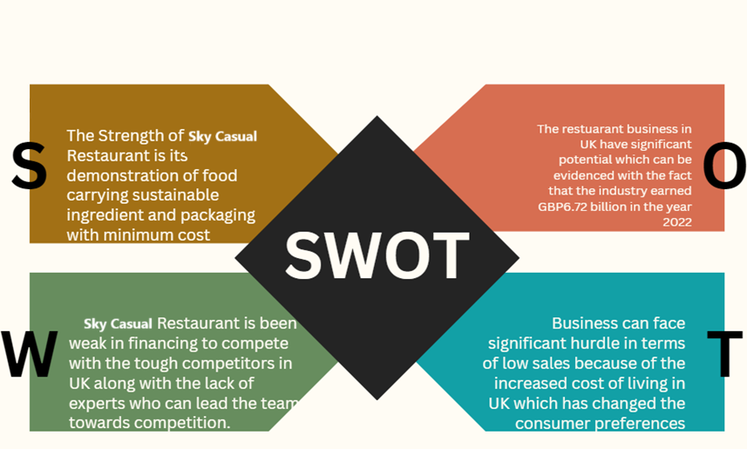

PESTLE Analysis
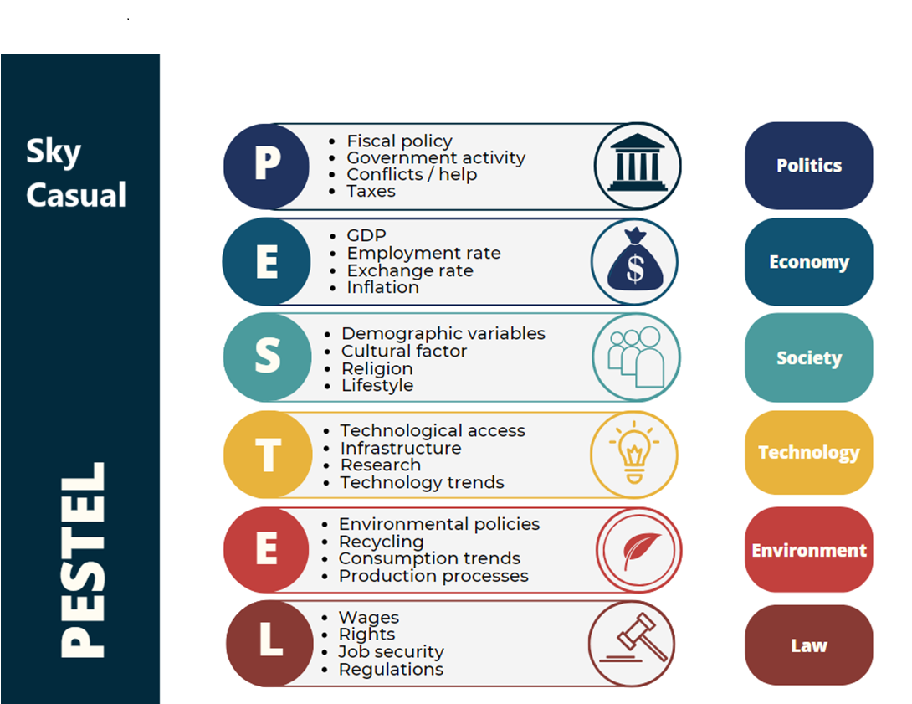

Smart Analysis
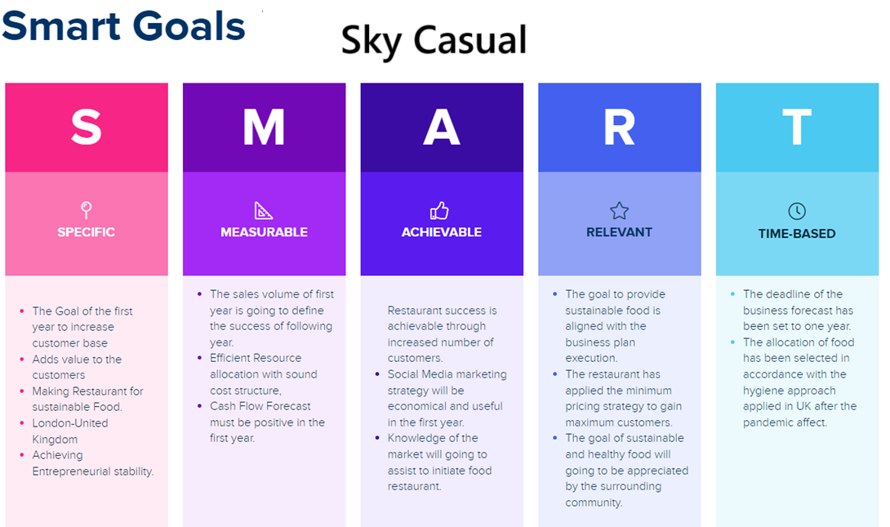

Porter Five Forces

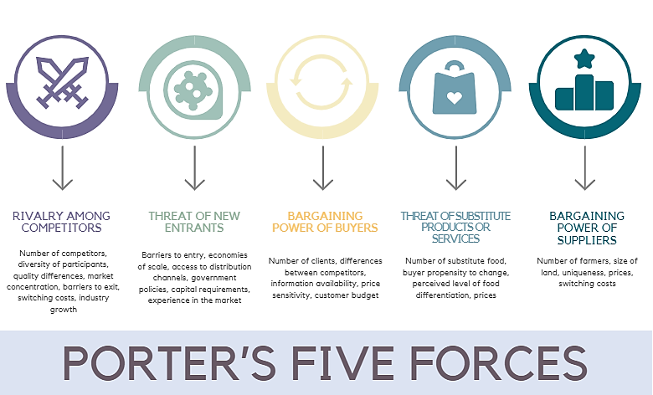

Location details
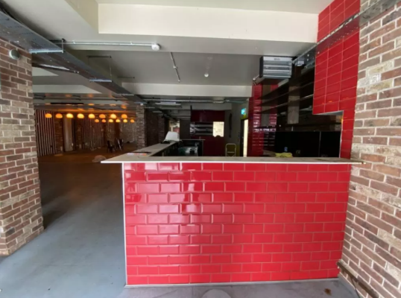
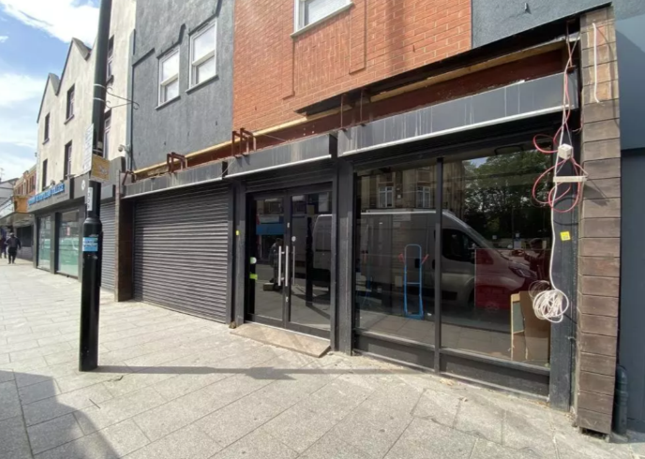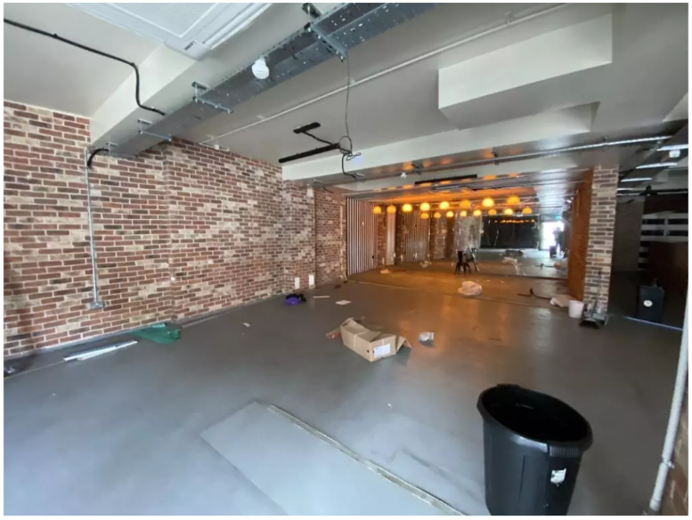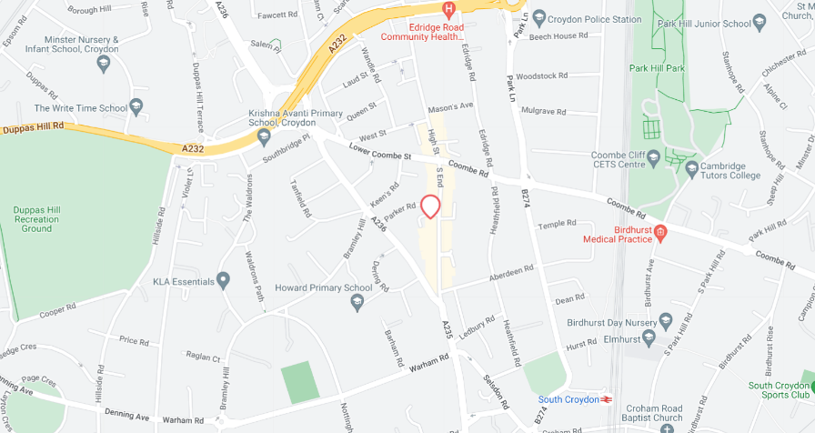

PowerPoint Slides


