Website specification
Brandon Philip Gorman AMBCS (1909188)
University of Wales Trinity Saint David
Gareth Jones | Introduction to web and database concepts (ACCA4023)

Table of Contents
Introduction 3
Requirements 3
Implementation 4
Validation 8
Evaluation 9
References 12
Appendices 12

Introduction

The following report will document the client requirements along with the implementation plan, validation and evaluation of the development of the website. The report will also include previews of the website as well as HML and CSS for further analysis.

Requirements

The United Conservative Party (referred to as the United Conservatives) is a political party who wishes to promote their vison online. The website will be the official party website which will be the central repository for the party’s message, vision and values. The purpose of the site is to ensure the party can engage potential voters across the country and ensure their core messages are known. The website will emphasise the key messages of the party in a simple and friendly way. The website is to have the following:
- Home Page
  - Welcome video on loop, highlighting key policy areas.
  - Contact methods, telephone, email and HQ office.
  - The ability to allow the user to sign up for updates.
- Our Plan
  - Positive and simple feel, listing the party’s key priorities.
  - Another section about the priorities but giving more information about the policy.
  - The ability to allow the user to sign up for updates.
- News
  - A news board summarising what the party has done and upcoming events.
  - Highlight the party shop.
  - The ability to allow the user to sign up for updates.
- Join
  - Members of the public how subscribe to the party’s vision and values can join the party.
  - Have three membership types.
    - Young Member
    - Standard Member
    - Army Member
- Donation Page
  - Give individuals and those who wish to promote the party’s message the ability to donate to the party.

In addition to the pages, the colour scheme used must also promote the party and also be athletically pleasing to the site viewer. The colour scheme to be used includes:
- Dark Blue, #14213D
- Orange, #FCA311
- White, #FFF
- Black, #000

The colour scheme was chosen not only because of its aesthetic appeal but its phycological meanings.
Blue has been related to conservativism and tradition. This colour will match the party and also relate favourably to those who have conservative views. According to verywellmind.com “Because blue is favored by so many people, it is often viewed as a non-threatening color that can seem conservative and traditional.” [1]

Orange was used as it’s a bold colour and its used universally as a colour to draw attention. The orange colour gives a welcoming touch, which meets the requirements of the website. Along with the blue colour the website is stating a message of positivise conservatism. Again, according to verywellmind.com “Orange calls to mind feelings of excitement, enthusiasm, and warmth”. [2]

Implementation

The design layout of the website followed some basic rules. A navigation bar at the top of the website and a footer at the bottom. There are two main websites where this design took inspiration from are: The Conservative and Unionist Party [3] website and the Liberal Party of Canada [4] website.

Home Page.

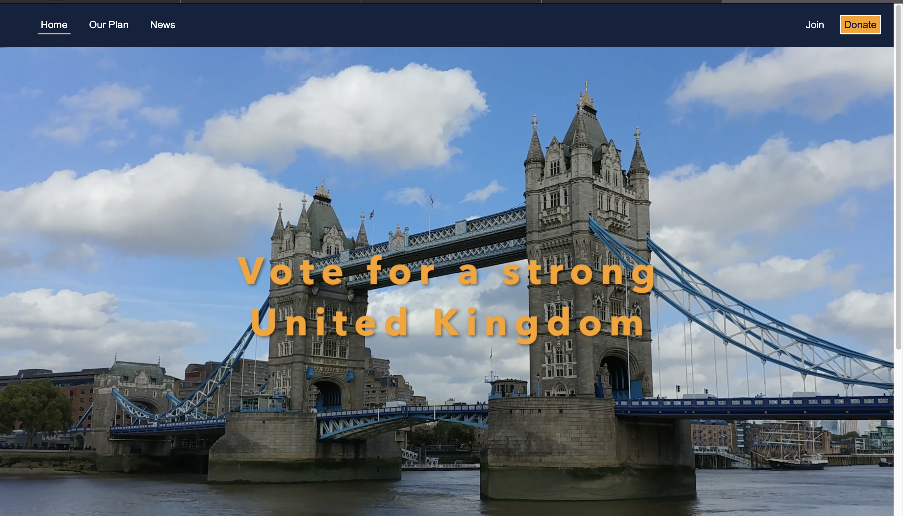
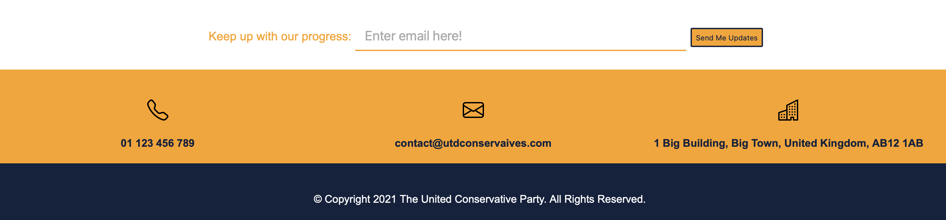

Our Plan
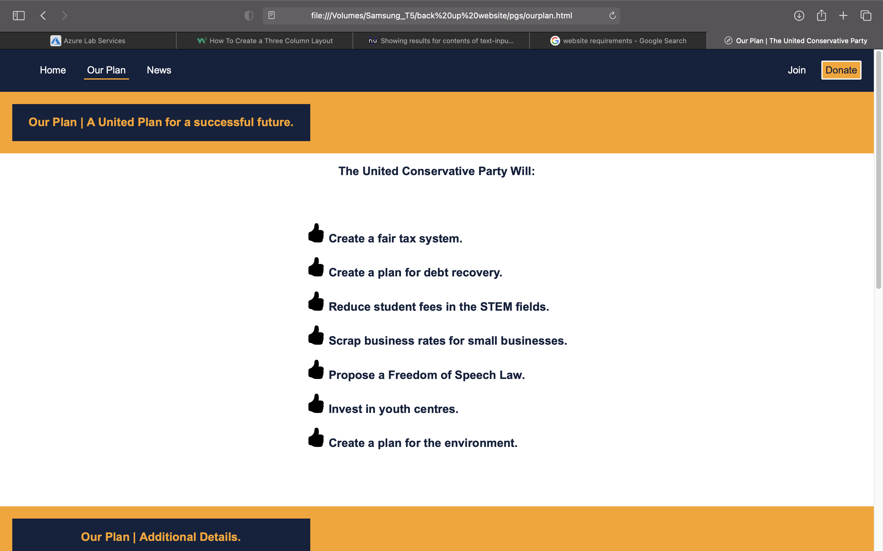
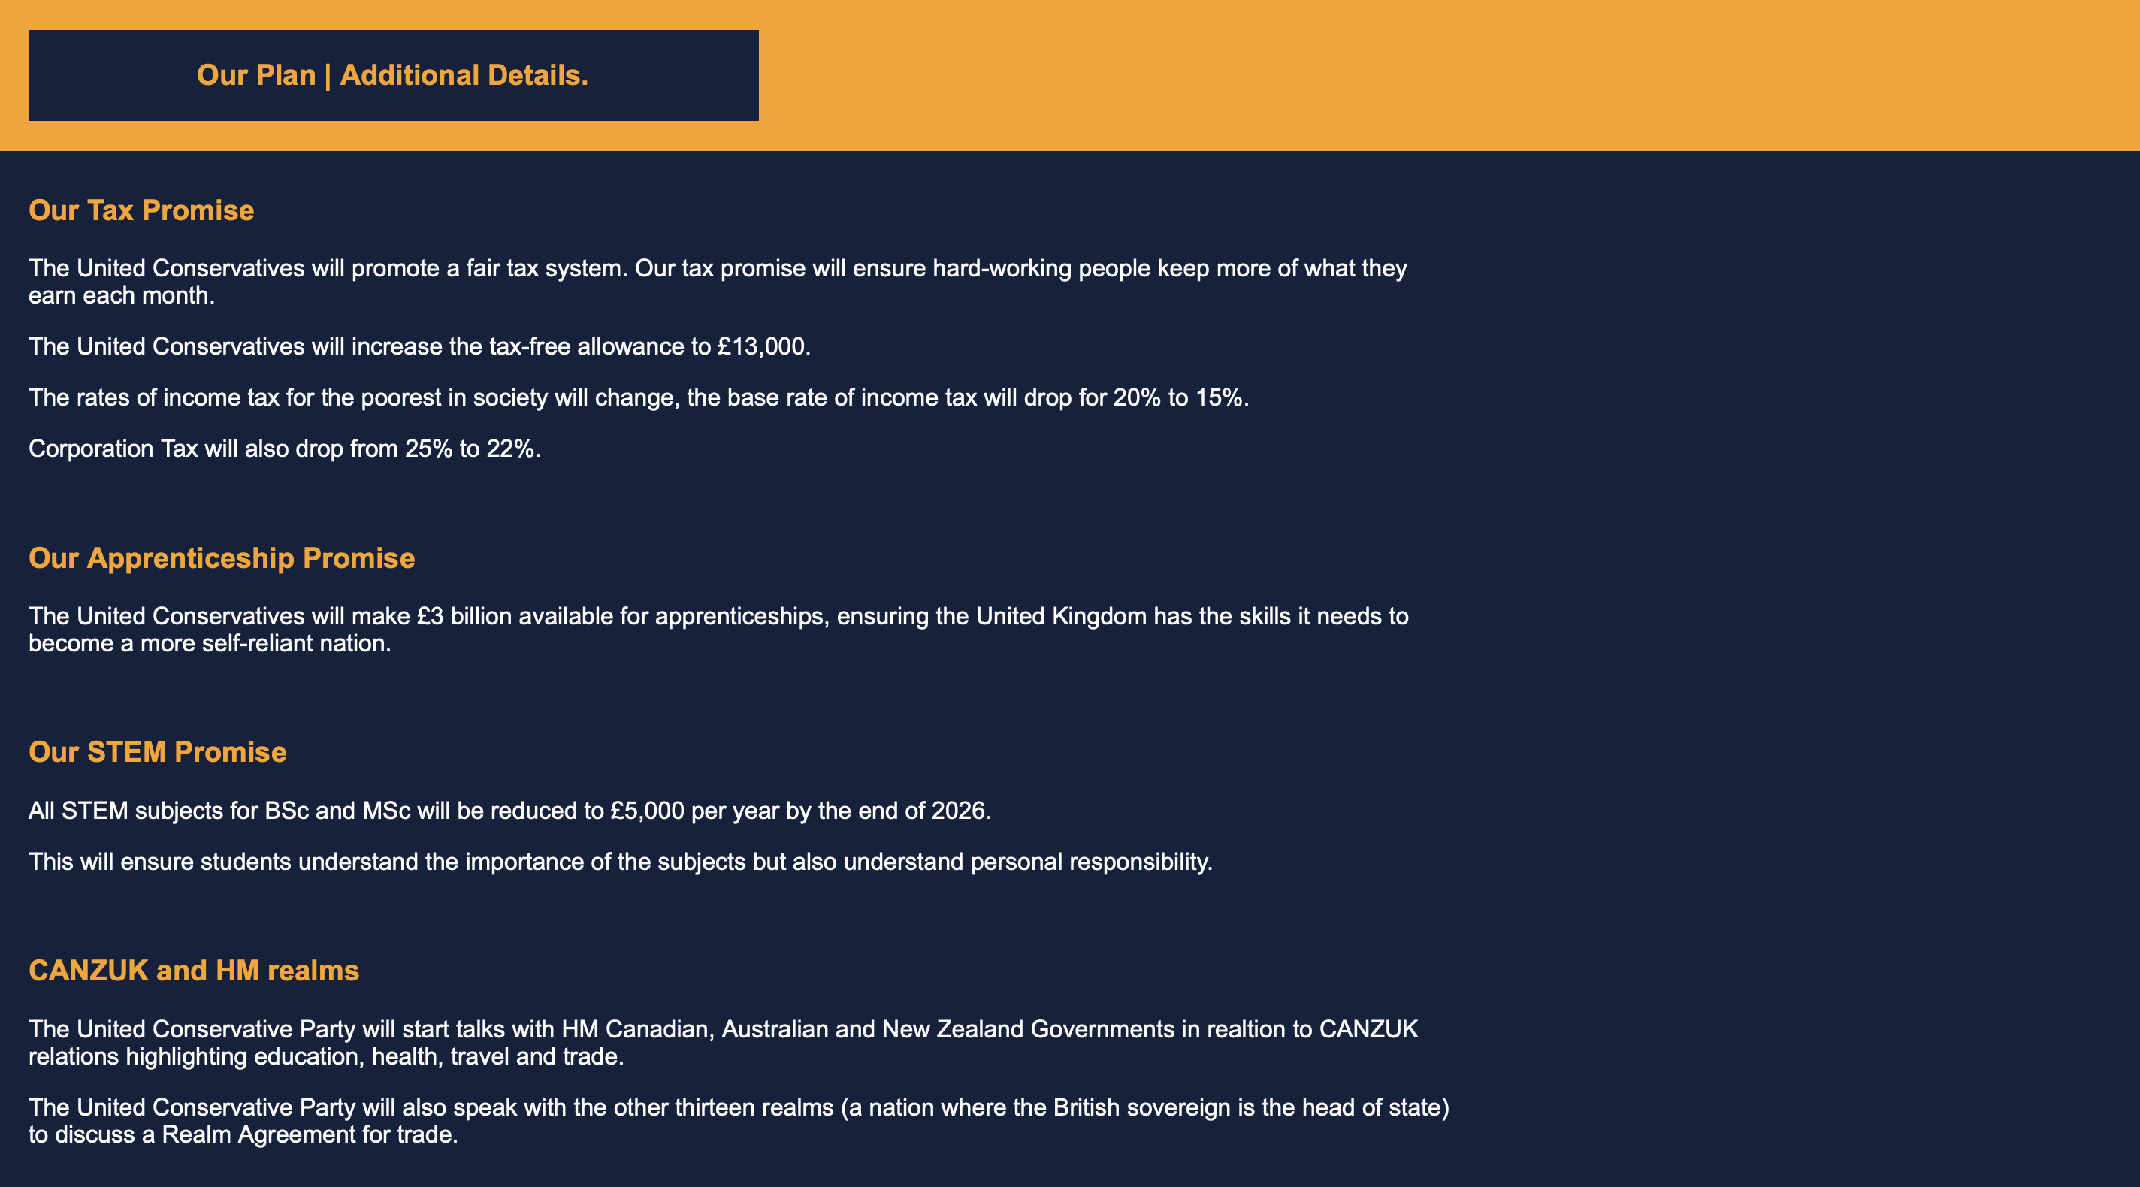

News

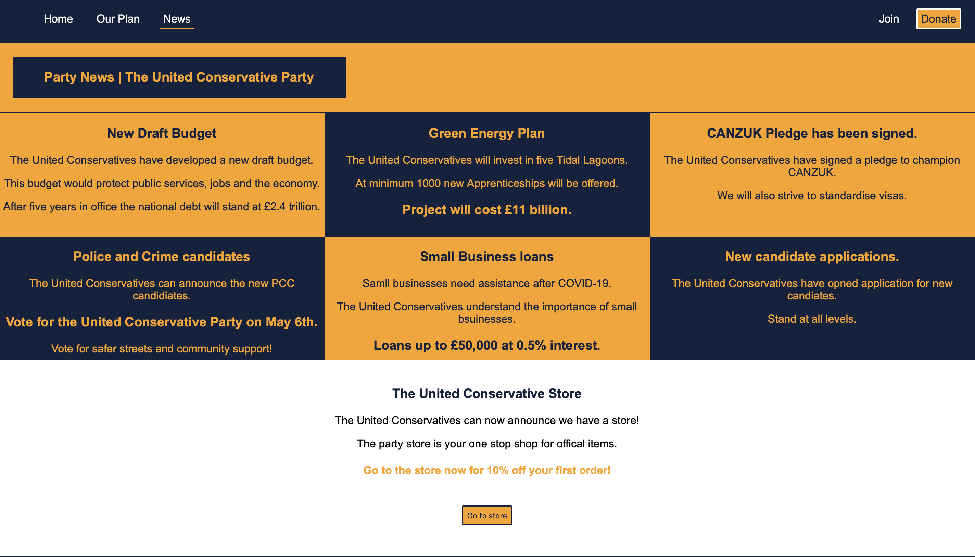


Join

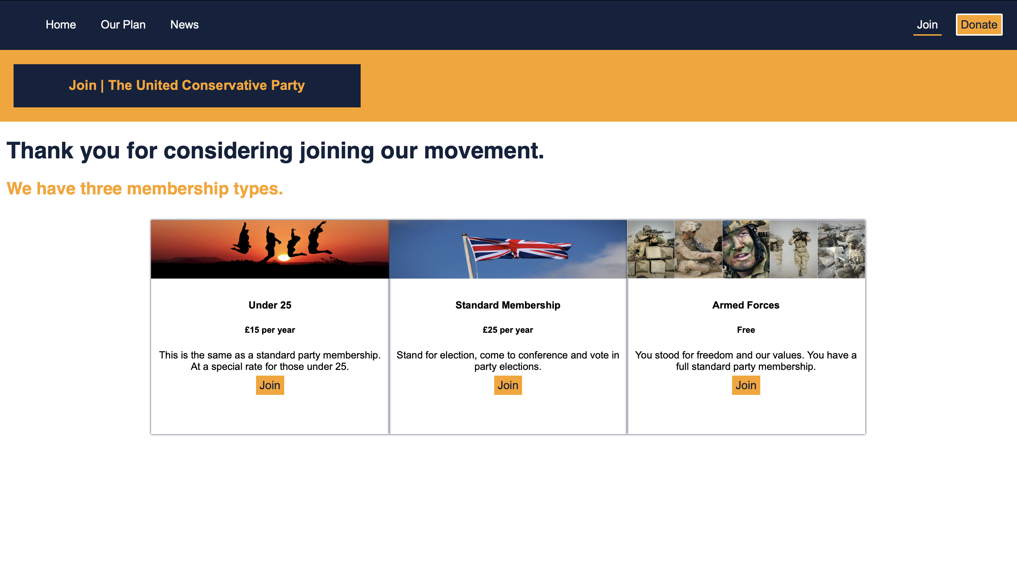

Join | Young Member
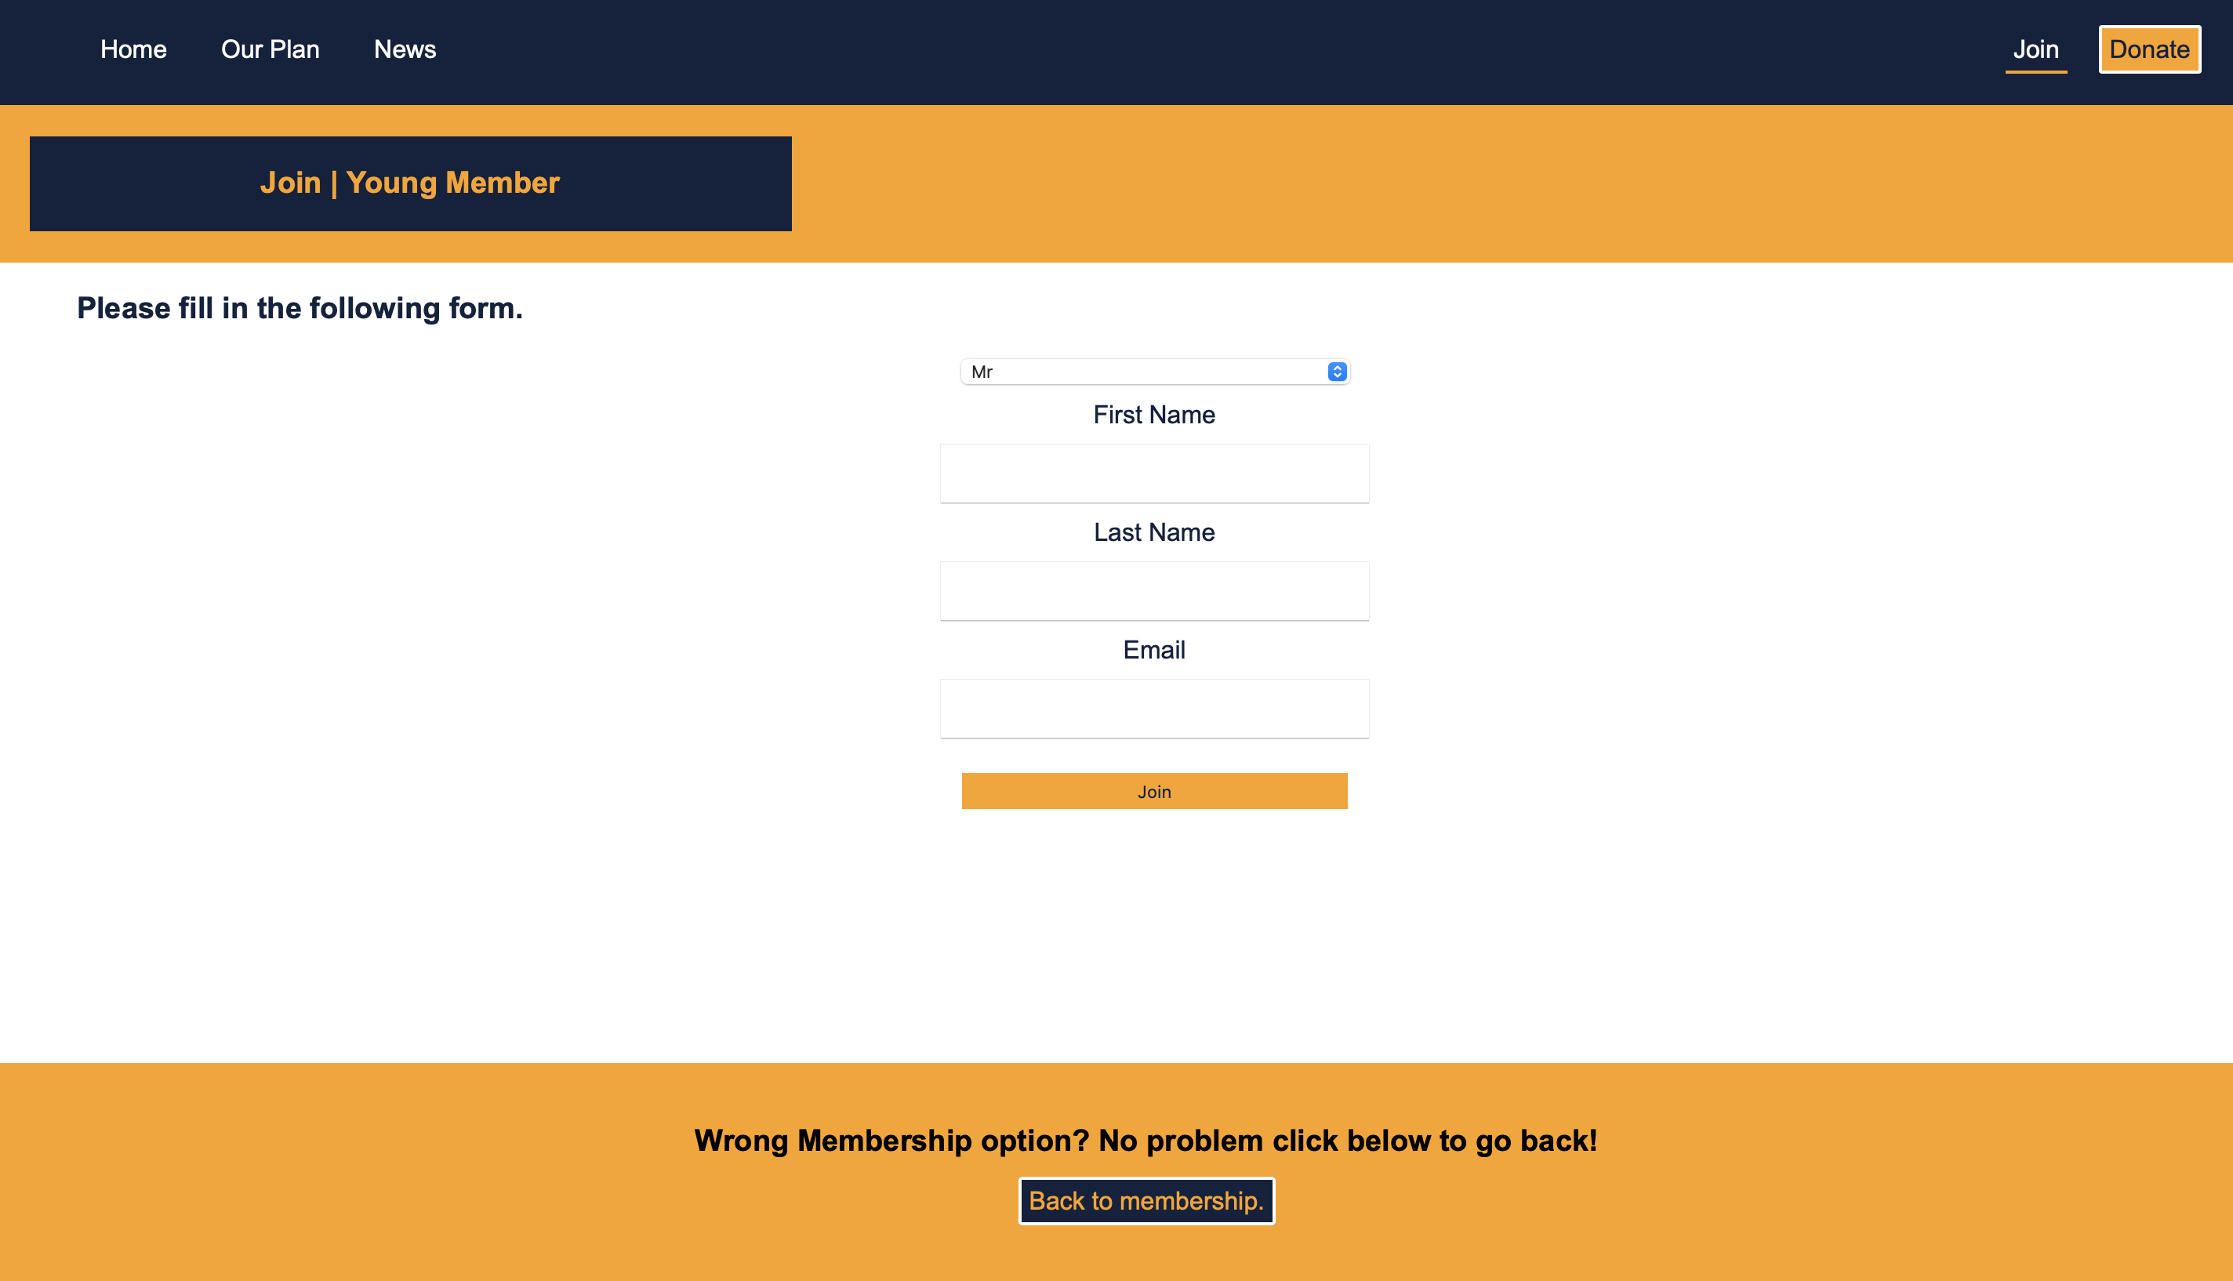

Donate

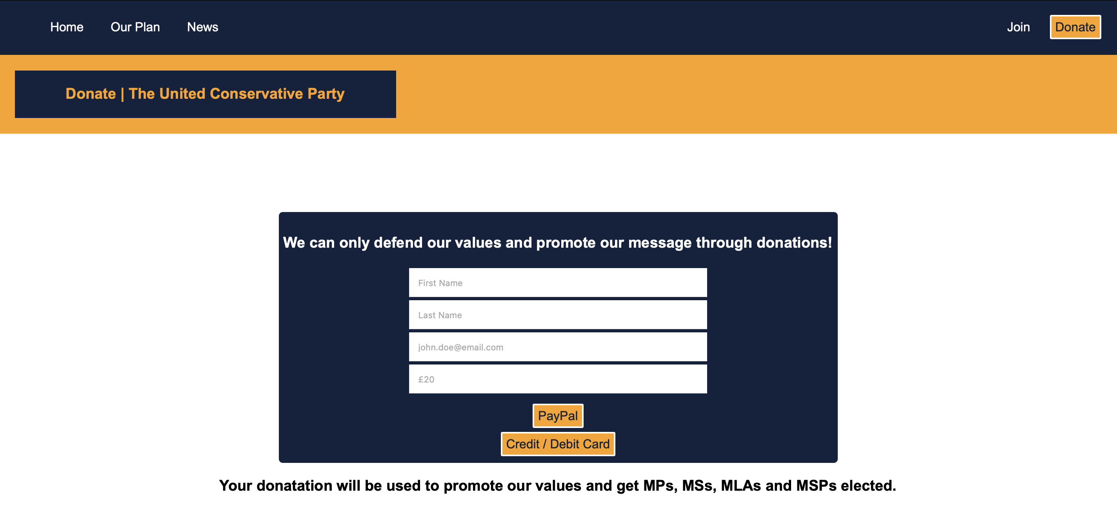

Validation

To ensure the website is compliant to national and international standards. The HTML and CSS were validated using the W3 validator.

Upon reviewing the HTML via the validation tool, one error was highlighted.
The “For” attribute on a label outside of a form. There are two ways to fix this problem. Firstly, remove the attribute or encapsulate the label within a form element.

By removing the “For” attribute the web browser won’t attempt to detect a form. By making this change and re-running the validation tool the index.html page passed validation testing.

Placing the websites CSS through the same validation servers two errors were highlighted.

Firstly, Value Error: Border Lexical error, encountered #. This simply means a duplicate # has been placed next to a hex code. To amend this issue, the duplicate # was removed.

The final error in relation to the CSS was PARSE error, a parse error relates to errors in the custom CSS such as spelling. Upon reviewing the donate-box class the PARSE error was highlighting that the padding-top and padding-bottom could have been used as a single command as they were the same amount of px. In this case the CSS was changed to padding: 10px 0; this was then re-run through the validation and passed with no errors to report.

Evaluation

Usability is the core determinator of a website’s success. If the website isn’t usable then potential viewers and customers will be deterred from going to the website. The Daily Egg defines website usability as “ user-centered design. Both the design and development process are focussed around the prospective user — to make sure their goals, mental models, and requirements are met — to build products that are efficient and easy to use.” [5] There are many areas in usability. Usability areas include:

The most important being availability, ensuring the site is up and running and is available on different devices and different screens lengths. This also includes the infrastructure as well as hosting services which will host the website.

Next simplicity. The website must be straight to the point and cannot confuse the user. Any confusion can lead to bad publicity, which in turn can have financial repercussions. Simplicity also allows the user / customer to make better and informed decisions on how to further engage with the website.

To continue, relevance. Is a website needed? If so, can the business identify their stakeholders? If not, perhaps a website isn’t yet appropriate.

Finally, flexibility to change. An important part of usability is having the flexibility to change.

The Daily Egg highlights that usability is requirements based, this suggests that a fully functioning website that follows accessibility laws etc. may not be relevant or appropriate for the user, meaning the usability criteria hasn’t been met. To ensure usability can be met, it is vital that the relevant user cases and requirements are taken and can be translated in and IT solution.

Website accessibility refers to technologies that can be implemented to support those with disabilities access websites appropriately. Examples of this include: Alternative Text, Font size amendments and keyboard navigation. W3C sets out the global standards for web-based solutions. W3C has stated that “The WCAG documents explain how to make web content more accessible to people with disabilities. Web “content” generally refers to the information in a web page or web application, including:
- natural information such as text, images, and sounds
- code or markup that defines structure, presentation, etc.”[9]
The statement for W3C suggests that as technology isn’t static the tools that support those who need additional support need to keep up with the change. The article by W3C has highlighted the importance of text-alternatives, pre-recorded sign language and contrast control. From a development perspective adding such features will require additional skill sets from organisations which can add pressures to smaller companies who wish to remain compliant with global standards. The articles overall messages were although development into supporting technologies has improved the need to more improved solutions is required.

Search Engine Optimisation (SEO) is a process that aims to maximise a websites visibility on the world wide web. Many companies aim to have their website of the first page of a search engine. SEO is a tool used for marketing and is vital across all sectors to ensure sales of goods and services. There are several ways to implement SEO, forms of SEO include: Keywords, Off-Page SEO, and Content SEO.

Firstly, Key Words. Key words are one of the most important forms of SEO. A key word is a word used on a search engine to gain certain results online. To make the most of Key Word SEO, developers and the marketing teams must choose words that best relate to their goods or services and compare them with the top searches and trending words of the day. This is usually performed through data models and analytical tools such as Google SEO. Key Word SEO can be implemented on websites through website titles, web content and in some cases website URLs. The Journal of economics & management strategy, vol. 25 states “The indirect effect stems from our finding that search engines tend to place higher quality sites in better positions, which results in additional clicks because consumers tend to click links in more favorable positions”. [6] In a development context, Key Word SEO will impact the users experience with particular words being used, this may cause confusion or lack of focus when reviewing the information on a website. However, many companies place key words in a hidden area on a website, making sure they utilise Key Word SEO without compromising the website appeal.

Next Off-Page SEO. Off-Page SEO refers to the external elements that drive traffic to a website. Off-Page SEO tactics includes: Links linking back to the website, which builds a website and its content creator credibility. Website references, where professional institutions such as government and educational authorities highlight a site as credible and business cards, when a client is handed a card, they may refer to the site at a later date.
From a development perspective, to ensure the credibility is maintained the website must be continually updated with fresh content to keep customers coming back. According to moz.com “Off-page SEO relies on human behavior (namely, that people only reference and share content they like). As such, it applies to both organic and local SEO. Even in a brick-and-mortar business, high-quality products get a lot of word-of-mouth referrals from current customers — the in-person equivalent of off-page SEO.” [8]

Finally, Content SEO. Content SEO relates to the type of content a website produces, for example Podcasts and blogs. Content SEO takes the two previous forms (key word and off-page) highlighted and emphasises them. Content SEO is about ensuring the website and its content are designed in such a way that a SEO analyser can quickly determine if a website is relevant to a user based on their key word search. Content SEO also assists website manager identify new ways of gaining traffic to their website, this can be through social media and infographics for example. Once SEO techniques are included on a website the number of website results available to a user will increase. According to J Wonhong “SEO application in April, 2014, Science Land had 61,300 pages indexed in Google, 2,872 pages in Naver, and 45,500 pages in Daum. After SEO in September, 2014, the numbers increased to 221,000 pages in Google, 23,000 pages in Naver, and 53,600 pages in Daum.” [7] This shows that the SEO content when applied correctly massively impacts the available web sources.

When developing content, it is vital form a development perspective that the content is designed in a way that its relevant for the user, however, also has the ability to emphasise key words and infographics, this can be done through PodCasts and promotional videos and make the key words available in the scripts or descriptions.

The academic journals selected all suggest that SEO is a core tool used in marketing and if used correctly can enable smaller businesses to compete on the same level as medium and large-scale businesses, basing the search criteria on credibility. The journals highlighted that On-Page SEO is the most popular with key word SEO being the primary driving force of most businesses. The reports also suggested the increased use of local SEO, getting the local communities involved in “spreading the word” which has resulted in an increase in goods and services sales. Off-Page SEO however, mentioned is a primary recourse and businesses would prefer to utilise the On-Page SEO.

The United Conservatives website has a modern feel and has connotations of tradition, and calmness. Although the website has a modern feel and meets certain accessibility criteria the website still requires further development. Development includes, use of media queries to ensure the website is 100% responsive and adaptable to different devices. The website needs to be fully compliant with UK disability laws and with the W3C accessibility criteria, for example voice overs and keyboard navigation. The website will also need the ability to change the home page video to a static image if the video can’t be played. This will ensure that although the user hasn’t got access to the video, they have access to a United Conservatives branded image.

The United Conservatives website has made use of On-Page Search Engine Optimisation (SEO). It has done this by:
- Adding key words to titles, such as conservative which relates to a conservative audience.
- Adding key works in descriptions, such as politics and MP which are key words for certain political topics.
- Adding key words as a paragraph and hiding it from the user. This has been done by adding a paragraph of key words on the home page (index.html) and formatting the area to be invisible to users.

The United Conservatives website has taken into consideration the accessibility of users. The United Conservatives website has ensured where appropriate alternative text has been used to assist with the visually impaired. In addition to this, main site content has either been placed on a white background or on a dark background with light text to ensure contrasting issues for those with epilepsy. The website has used the correct HTML elements, meaning interpretation software and communicate to those who are blind.

To conclude, the website has a clean finish and has the flexibility for improvement. The website meets certain accessibility criteria which assists those with disabilities. The website also makes use of search engine optimisation to improve the website’s chance of appearing on the top list when certain key words are inputted. The website has used different web techniques such as CSS flexbox for example which allows a certain level of flexibility when the screen resolution changes.

References

[1] | K. Cherry, 22 February 2020. [Online]. Available: https://www.verywellmind.com/the-color-psychology-of-blue-2795815. [Accessed 25 April 2021].
[2] | 6 October 2019. [Online]. Available: https://www.verywellmind.com/the-color-psychology-of-orange-2795818. [Accessed 25 April 2021].
[3] | conservatives.com, “Conservative and Unionist Party,” Conservatives, [Online]. Available: www.conservatives.com. [Accessed 25 April 2021].
[4] | Liberal Party of Canada, “Liberal Party of Canada,” [Online]. Available: liberal.ca. [Accessed 25 April 2021].
[5] | S. Idler, “The Daily Egg,” 26 March 2013. [Online]. Available: https://www.crazyegg.com/blog/principles-website-usability/. [Accessed 25 April 2021].
[6] | D. l. S. B. a. W. M. R. Baye Michael R, “Search Engine Optimization: What Drives Organic Traffic to Retail Sites?,,” Journal of economics & management strategy, vol. 25, no. 1, pp. 6-31, 2016.
[7] | S. Lee, J. Wonhong, E. Lee and S. G. Oh, “Search engine optimization,” Library Hi Tech, vol. 34, no. 2, pp. 197-206, 2016.
[8] | Moz.com, “Off SIte SEO,” [Online]. Available: https://moz.com/learn/seo/off-site-seo. [Accessed 25 Aptil 2021].
[9] | W3C, “WCAG,” W3C, [Online]. Available: https://www.w3.org/WAI/fundamentals/components/#top. [Accessed 25 April 2021].

Appendices

Appendix One - HTML

<!DOCTYPE html>
<html lang="en" dir="ltr">

<head>
<meta charset="utf-8">
<title>Home | The United Conservative Party</title>
<link rel="stylesheet" href="style/style.css">
</head>

<body>
<nav>
<ul>
<li><a href="index.html" id="active">Home</a></li>
<li><a href="pgs/ourplan.html">Our Plan</a></li>
<li><a href="pgs/news.html">News</a></li>
<li class="nav-right"><a href="pgs/donate.html" id="donate-btn">Donate</a></li>
<li class="nav-right"><a href="pgs/join.html">Join</a></li>
</ul>
</nav>
<div class="video-welcome">
<video src="media/webpge.mp4" loop autoplay muted></video>
</div>
<div class="search-bar">
<label>Keep up with our progress: </label>
<input type="email" id="search-bar-email-input" name="email-input" placeholder="Enter email here!">
<button type="submit" class="search-bar-btn">Send Me Updates</button>
</div>
<div class="contact-us">
<div class="contact-column">
<img src="img/telephone.svg" alt="Telephone" width="32" height="32">
<h4>01 123 456 789</h4>
</div>
<div class="contact-column">
<img src="img/envelope.svg" alt="Telephone" width="32" height="32">
<h4>contact@utdconservaives.com</h4>
</div>
<div class="contact-column">
<img src="img/building.svg" alt="Telephone" width="32" height="32">
<h4>1 Big Building, Big Town, United Kingdom, AB12 1AB</h4>
</div>
<div class="keyword">
<p>UK Politics</p>
<p>Who to vote for in UK election?</p>
<p>Conservative</p>
</div>
</div>
<footer>
<p>© Copyright 2021 The United Conservative Party. All Rights Reserved.</p>
</footer>
</body>

</html>

<!DOCTYPE html>
<html lang="en" dir="ltr">

<head>
<meta charset="utf-8">
<title>Our Plan | The United Conservative Party</title>
<link rel="stylesheet" href="../style/style.css">
</head>

<body>
<nav>
<ul>
<li><a href="../index.html">Home</a></li>
<li><a href="ourplan.html" id="active">Our Plan</a></li>
<li><a href="news.html">News</a></li>
<li class="nav-right"><a href="donate.html" id="donate-btn">Donate</a></li>
<li class="nav-right"><a href="join.html">Join</a></li>
</ul>
</nav>
<div class="our-plan">
<div class="ourplan-title">
<h3>Our Plan | A United Plan for a successful future.</h3>
</div>
</div>
<div class="our-plan-sections">
<div class="our-plan-main">
<h3>The United Conservative Party Will:</h3>
</div>
<div class="pledge-area">
<ul class="key-pledge">
<li>
<h3><img src="../img/hand-thumbs-up-fill.svg" alt="thumbs-up" width="32" height="32" class="thumbs-up"> Create a fair tax system.</h3>
</li>
<li>
<h3><img src="../img/hand-thumbs-up-fill.svg" alt="thumbs-up" width="32" height="32" class="thumbs-up"> Create a plan for debt recovery.</h3>
</li>
<li>
<h3><img src="../img/hand-thumbs-up-fill.svg" alt="thumbs-up" width="32" height="32" class="thumbs-up"> Reduce student fees in the STEM fields.</h3>
</li>
<li>
<h3><img src="../img/hand-thumbs-up-fill.svg" alt="thumbs-up" width="32" height="32" class="thumbs-up"> Scrap business rates for small businesses.</h3>
</li>
<li>
<h3><img src="../img/hand-thumbs-up-fill.svg" alt="thumbs-up" width="32" height="32" class="thumbs-up"> Propose a Freedom of Speech Law.</h3>
</li>
<li>
<h3><img src="../img/hand-thumbs-up-fill.svg" alt="thumbs-up" width="32" height="32" class="thumbs-up"> Invest in youth centres.</h3>
</li>
<li>
<h3><img src="../img/hand-thumbs-up-fill.svg" alt="thumbs-up" width="32" height="32" class="thumbs-up"> Create a plan for the environment.</h3>
</li>

</ul>
</div>
<div class="our-plan">
<div class="ourplan-title">
<h3>Our Plan | Additional Details.</h3>
</div>
</div>
<div class="more-info">
<div class="more-info-cont">
<div class="promise">
<h3>Our Tax Promise</h3>
<p>The United Conservatives will promote a fair tax system. Our tax promise will ensure hard-working people keep more of what they earn each month.</P>
<p>The United Conservatives will increase the tax-free allowance to £13,000.</p>
<p>The rates of income tax for the poorest in society will change, the base rate of income tax will drop for 20% to 15%.</p>
<p>Corporation Tax will also drop from 25% to 22%.</p>
</div>
<br>
<div class="promise">
<h3>Our Apprenticeship Promise</h3>
<p>The United Conservatives will make £3 billion available for apprenticeships, ensuring the United Kingdom has the skills it needs to become a more self-reliant nation.</p>
</div>
<br>
<div class="promise">
<h3>Our STEM Promise</h3>
<p>All STEM subjects for BSc and MSc will be reduced to £5,000 per year by the end of 2026.
<p>This will ensure students understand the importance of the subjects but also understand personal responsibility. </p>
</div>
<br>
<div class="promise">
<h3>CANZUK and HM realms</h3>
<p>The United Conservative Party will start talks with HM Canadian, Australian and New Zealand Governments in realtion to CANZUK relations highlighting education, health, travel and trade.</p>
<p>The United Conservative Party will also speak with the other thirteen realms (a nation where the British sovereign is the head of state) to discuss a Realm Agreement for trade.</p>
</div>
</div>
</div>
</div>
<div class="keep-up-to-date">
<label>Keep up with our progress: </label>
<input type="email" id="search-bar-email-input" name="email-input" placeholder="Enter email here!">
<button type="submit" class="search-bar-btn">Send Me Updates</button>
</div>
<footer>
<p>© Copyright 2021 The United Conservative Party. All Rights Reserved.</p>
</footer>
</body>

</html>

<!DOCTYPE html>
<html lang="en" dir="ltr">

<head>
<meta charset="utf-8">
<title>Party News | The United Conservative Party</title>
<link rel="stylesheet" href="../style/style.css">
</head>

<body>
<nav>
<ul>
<li><a href="../index.html">Home</a></li>
<li><a href="ourplan.html">Our Plan</a></li>
<li><a href="news.html" id="active">News</a></li>
<li class="nav-right"><a href="donate.html" id="donate-btn">Donate</a></li>
<li class="nav-right"><a href="join.html">Join</a></li>
</ul>
</nav>
<div class="our-plan-blueline">
<div class="ourplan-title">
<h3>Party News | The United Conservative Party</h3>
</div>
</div>
<div class="news-area">
<div class="card">
<h3>New Draft Budget</h3>
<p>The United Conservatives have developed a new draft budget.</p>
<p>This budget would protect public services, jobs and the economy.</p>
<p>After five years in office the national debt will stand at £2.4 trillion.</p>
</div>
<div class="card-blue">
<h3>Green Energy Plan</h3>
<p>The United Conservatives will invest in five Tidal Lagoons.</p>
<p>At minimum 1000 new Apprenticeships will be offered.</p>
<h3>Project will cost £11 billion.</h3>
</div>
<div class="card">
<h3>CANZUK Pledge has been signed.</h3>
<p>The United Conservatives have signed a pledge to champion CANZUK.</p>
<p>We will also strive to standardise visas.</p>
</div>
</div>
<div class="news-area">
<div class="card-blue">
<h3>Police and Crime candidates</h3>
<p>The United Conservatives can announce the new PCC candidiates.</p>
<h3>Vote for the United Conservative Party on May 6th.</h3>
<p>Vote for safer streets and community support!</p>
</div>
<div class="card">
<h3>Small Business loans</h3>
<p>Samll businesses need assistance after COVID-19.</p>
<p>The United Conservatives understand the importance of small bsuinesses.</p>
<h3>Loans up to £50,000 at 0.5% interest.</h3>
</div>
<div class="card-blue">
<h3>New candidate applications.</h3>
<p>The United Conservatives have opned application for new candiates.</p>
<p>Stand at all levels.</p>
</div>
</div>
<div class="store">
<h3>The United Conservative Store</h3>
<p>The United Conservatives can now announce we have a store!</p>
<p>The party store is your one stop shop for offical items.</p>
<h4>Go to the store now for 10% off your first order!</h4>
<br>
<button type="submit" class="search-bar-btn">Go to store</button>
</div>
<div class="keep-up-to-date-blueline">
<label for="email-input">Keep up with our progress: </label>
<input type="email" id="search-bar-email-input" name="email-input" placeholder="Enter email here!">
<button type="submit" class="search-bar-btn">Send Me Updates</button>
</div>
<footer>
<p>© Copyright 2021 The United Conservative Party. All Rights Reserved.</p>
</footer>
</body>

</html>

<!DOCTYPE html>
<html lang="en" dir="ltr">

<head>
<meta charset="utf-8">
<title>Join | The United Conservative Party</title>
<link rel="stylesheet" href="../style/style.css">
</head>

<body>
<nav>
<ul>
<li><a href="../index.html">Home</a></li>
<li><a href="ourplan.html">Our Plan</a></li>
<li><a href="news.html">News</a></li>
<li class="nav-right"><a href="donate.html" id="donate-btn">Donate</a></li>
<li class="nav-right"><a href="join.html" id="active">Join</a></li>
</ul>
</nav>
<div class="our-plan">
<div class="ourplan-title">
<h3>Join | The United Conservative Party</h3>
</div>
</div>
<div class="join-area">
<div class="join-title">
<h1>Thank you for considering joining our movement.</h1>
<h2>We have three membership types.</h2>
</div>
<div class="member-cards">
<div class="member">
<img src="../img/sunset.jpg" alt="Young Members" class="member_img">
<div class="member-info">
<h4>Under 25</h4>
<h5>£15 per year</h5>
<p>This is the same as a standard party membership. At a special rate for those under 25.</p>
</div>
<div class="join-now">
<a href="join-y.html" id="join-btn">Join</a>
</div>
</div>
<div class="member">
<img src="../img/UK.jpg" alt="Standard Member" class="member_img">
<div class="member-info">
<h4>Standard Membership</h4>
<h5>£25 per year</h5>
<p>Stand for election, come to conference and vote in party elections.</p>
</div>
<div class="join-now">
<a href="join-s.html" id="join-btn">Join</a>
</div>
</div>
<div class="member">
<img src="../img/army.jpg" alt="Standard Member" class="member_img">
<div class="member-info">
<h4>Armed Forces</h4>
<h5>Free</h5>
<p>You stood for freedom and our values. You have a full standard party membership.</p>
</div>
<div class="join-now">
<a href="join-a.html" id="join-btn">Join</a>
</div>
</div>
</div>
</div>
<footer>
<p>© Copyright 2021 The United Conservative Party. All Rights Reserved.</p>
</footer>
</body>

</html>

<!DOCTYPE html>
<html lang="en" dir="ltr">

<head>
<meta charset="utf-8">
<title>Join | The United Conservative Party</title>
<link rel="stylesheet" href="../style/style.css">
</head>

<body>
<nav>
<ul>
<li><a href="../index.html">Home</a></li>
<li><a href="ourplan.html">Our Plan</a></li>
<li><a href="news.html">News</a></li>
<li class="nav-right"><a href="donate.html" id="donate-btn">Donate</a></li>
<li class="nav-right"><a href="join.html" id="active">Join</a></li>
</ul>
</nav>
<div class="our-plan">
<div class="ourplan-title">
<h3>Join | Young Member</h3>
</div>
</div>
<div class="membership-join-area">
<h3>Please fill in the following form.</h3>
<div class="sign-up-member">
<form>
<select id="titles">
<option>Mr</option>
<option>Mrs</option>
<option>Miss</option>
<option>Ms</option>
<option>Other</option>
</select><br>
<label for="fname">First Name</label><br>
<input type="text" name="fname" required><br>
<label for="lname">Last Name</label><br>
<input type="text" name="lname" required><br>
<label for="email">Email</label><br>
<input type="email" name="email" required><br>
<input type="submit" value="Join" id="donate-btn">
</form>
</div>
</div>
<div class="wrong-membership">
<h3>Wrong Membership option? No problem click below to go back!</h3>
<a href="join.html" id="join-back-btn">Back to membership.</a>
</div>
<footer>
<p>© Copyright 2021 The United Conservative Party. All Rights Reserved.</p>
</footer>
</body>

</html>

<!DOCTYPE html>
<html lang="en" dir="ltr">

<head>
<meta charset="utf-8">
<title>Join | The United Conservative Party</title>
<link rel="stylesheet" href="../style/style.css">
</head>

<body>
<nav>
<ul>
<li><a href="../index.html">Home</a></li>
<li><a href="ourplan.html">Our Plan</a></li>
<li><a href="news.html">News</a></li>
<li class="nav-right"><a href="donate.html" id="donate-btn">Donate</a></li>
<li class="nav-right"><a href="join.html" id="active">Join</a></li>
</ul>
</nav>
<div class="our-plan">
<div class="ourplan-title">
<h3>Join | Standard Member</h3>
</div>
</div>
<div class="membership-join-area">
<h3>Please fill in the following form.</h3>
<div class="sign-up-member">
<form>
<select id="titles">
<option>Mr</option>
<option>Mrs</option>
<option>Miss</option>
<option>Ms</option>
<option>Other</option>
</select><br>
<label for="fname">First Name</label><br>
<input type="text" name="fname" required><br>
<label for="lname">Last Name</label><br>
<input type="text" name="lname" required><br>
<label for="email">Email</label><br>
<input type="email" name="email" required><br>
<input type="submit" value="Join" id="donate-btn">
</form>
</div>
</div>
<div class="wrong-membership">
<h3>Wrong Membership option? No problem click below to go back!</h3>
<a href="join.html" id="join-back-btn">Back to membership.</a>
</div>
<footer>
<p>© Copyright 2021 The United Conservative Party. All Rights Reserved.</p>
</footer>
</body>

</html>

<!DOCTYPE html>
<html lang="en" dir="ltr">

<head>
<meta charset="utf-8">
<title>Join | The United Conservative Party</title>
<link rel="stylesheet" href="../style/style.css">
</head>

<body>
<nav>
<ul>
<li><a href="../index.html">Home</a></li>
<li><a href="ourplan.html">Our Plan</a></li>
<li><a href="news.html">News</a></li>
<li class="nav-right"><a href="donate.html" id="donate-btn">Donate</a></li>
<li class="nav-right"><a href="join.html" id="active">Join</a></li>
</ul>
</nav>
<div class="our-plan">
<div class="ourplan-title">
<h3>Join | Armed Forces Member</h3>
</div>
</div>
<div class="membership-join-area">
<h3>Please fill in the following form.</h3>
<div class="sign-up-member">
<form>
<select id="titles">
<option>Mr</option>
<option>Mrs</option>
<option>Miss</option>
<option>Ms</option>
<option>Other</option>
</select><br>
<label for="fname">First Name</label><br>
<input type="text" name="fname" required><br>
<label for="lname">Last Name</label><br>
<input type="text" name="lname" required><br>
<label for="email">Email</label><br>
<input type="email" name="email" required><br>
<input type="submit" value="Join" id="donate-btn">
</form>
</div>
</div>
<div class="wrong-membership">
<h3>Wrong Membership option? No problem click below to go back!</h3>
<a href="join.html" id="join-back-btn">Back to membership.</a>
</div>
<footer>
<p>© Copyright 2021 The United Conservative Party. All Rights Reserved.</p>
</footer>
</body>

</html>

<!DOCTYPE html>
<html lang="en" dir="ltr">

<head>
<meta charset="utf-8">
<title>Donate | The United Conservative Party</title>
<link rel="stylesheet" href="../style/style.css">
</head>

<body>
<nav>
<ul>
<li><a href="../index.html">Home</a></li>
<li><a href="ourplan.html">Our Plan</a></li>
<li><a href="news.html">News</a></li>
<li class="nav-right"><a href="donate.html" id="donate-btn" id="active">Donate</a></li>
<li class="nav-right"><a href="join.html">Join</a></li>
</ul>
</nav>
<div class="our-plan">
<div class="ourplan-title">
<h3>Donate | The United Conservative Party</h3>
</div>
</div>
<div class="donate-container">
<div class="donate-box">
<h3>We can only defend our values and promote our message through donations!</h3>
<input type="text" placeholder="First Name" required><br>
<input type="text" placeholder="Last Name" required><br>
<input type="email" placeholder="john.doe@email.com" required><br>
<input type="txt" placeholder="£20" required><br><br>
<a href="#">PayPal</a><br><br>
<a href="#">Credit / Debit Card</a>
</div>
<h3>Your donatation will be used to promote our values and get MPs, MSs, MLAs and MSPs elected.</h3>
</div>
<footer>
<p>© Copyright 2021 The United Conservative Party. All Rights Reserved.</p>
</footer>
</body>

</html>

Appendix Two – CSS

body {
font-family: Arial, sans-serif;
padding: 0;
margin: 0;
overflow-x: hidden;
}

nav {
background: #14213D;
padding: 10px;
}

nav li {
list-style: none;
display: inline-block;
}

nav li a {
color: #FFF;
padding: 5px;
text-decoration: none;
margin: 0 10px;
}

nav li a:hover {
transition: .5s ease-in;
border-bottom: 2px #FCA311 solid;
}

.nav-right {
float: right;
}

#active {
border-bottom: 2px #FCA311 solid;
}

#donate-btn {
border: 2px #FFF solid;
padding: 5px;
border-radius: 2px;
background: #FCA311;
color: #14213D;
}

#donate-btn:hover {
background-color: #14213D;
color: #FCA311;
border: 2px solid #FCA311;
transition: all .5s ease-in;
}

.main-page-video {
background: url('../media/webpge.mp4');
}

video {
width: 100%;
height: 30%;
display: inline;
margin-bottom: 0;
padding-bottom: 0;
}

.search-bar {
background-color: #FFF;
width: 100%;
margin: 0 auto;
padding: 20px;
text-align: center;
}

#search-bar-email-input {
width: 35%;
padding: 10px 15px;
margin: 8px 0;
box-sizing: border-box;
border: none;
border-bottom: 2px solid #FCA311;
outline: none;
display: inline-block;
font-size: 20px;
}

.search-bar {
border-style: none;
width: 100%;
height: 15vh;
}

.search-bar label {
color: #FCA311;
font-size: 18px;
}

.search-bar-btn {
background-color: #FCA311;
color: #14213D;
border: 2px solid #14213D;
padding: 6px;
text-decoration: none;
border-radius: 2px;
}

.search-bar-btn:hover {
background-color: #14213D;
color: #FCA311;
border: 2px solid #FCA311;
border-radius: 2px;
padding: 6px;
transition: all .5s ease-in;
cursor: pointer;
}

.contact-us {
background: #FCA311;
width: 100%;
height: 90px;
text-align: center;
color: #14213D;
}

.contact-column {
float: left;
width: 33.33%;
background-color: #FCA311;
color: #14213D;
text-align: center;
margin: 45px 0;
}

.contact-us:after {
content: "";
display: table;
clear: both;
}

.our-plan {
background-color: #FCA311;
color: #14213D;
padding: 20px;
}

.our-plan-blueline {
background-color: #FCA311;
color: #14213D;
padding: 20px;
border-bottom: solid #14213D 2px;
}

.ourplan-title {
background-color: #14213D;
color: #FCA311;
padding: .5px;
width: 35%;
}

.ourplan-title h3 {
text-align: center;
}

.our-plan-main {
background: #FFF;
width: 100%;
height: 50px;
;
text-align: center;
color: #14213D;
}

.ourplan-column {
float: left;
width: 33.33%;
background-color: #FCA311;
color: #14213D;
text-align: center;
margin: 45px 0;
}

.ourplan:after {
content: "";
display: table;
clear: both;
}

.key-pledge {
padding: 10px;
color: #14213D;
list-style: none;
text-align: left;
padding-left: 35%;
padding-right: 35%;
}

.keep-up-to-date {
background-color: #FCA311;
width: 100%;
margin: 0 auto;
padding: 20px;
text-align: center;
}

.keep-up-to-date-blueline {
background-color: #FCA311;
width: 100%;
margin: 0 auto;
padding: 20px;
text-align: center;
border-top: solid #14213D 2px;
}

.card {
float: left;
width: 33.33%;
background-color: #FCA311;
color: #14213D;
text-align: center;
height: 180px;
}

.card-blue {
float: left;
width: 33.33%;
background-color: #14213D;
color: #FCA311;
text-align: center;
height: 180px;
}

.news-area:after {
content: "";
display: table;
clear: both;
}

.join-area {
text-align: center;
}

.join-title {
text-align: left;
font-weight: lighter;
margin-left: 10px;
}

.join-title h1 {
font-family: sans-serif;
color: #14213D;
}

.join-title h2 {
font-family: sans-serif;
color: #FCA311;
margin-bottom: 30px;
}

.join-area {
height: 75vh;
}

.member-cards {
margin: 0 auto;
max-width: 1000px;
height: 300px;
display: grid;
grid-template-columns: repeat(3, 1fr);
padding: 0 10px;
}

.member {
box-shadow: 0 0 3px #14213D;
}

.member_img {
width: 100%;
display: block;
height: 10vh;
}

.member-info {
font-size: 90%;
padding: 10px;
}

.member-info>p:first-of-type {
margin-top: 0;
}

.member-info>p:last-of-type {
margin-bottom: 0;
}

#join-btn {
border: 2px #FFF solid;
padding: 5px;
border-radius: 2px;
background: #FCA311;
color: #14213D;
text-decoration: none;
}

#join-btn:hover {
background-color: #14213D;
color: #FCA311;
border: 2px solid #FCA311;
transition: all .5s ease-in;
}

#join-back-btn {
border: 2px #FFF solid;
padding: 5px;
border-radius: 2px;
background: #14213D;
color: #FCA311;
text-decoration: none;
}

#join-back-btn:hover {
background-color: #FCA311;
color: #14213D;
border: 2px solid #14213D;
transition: all .5s ease-in;
}

.membership-join-area {
margin-left: 50px;
color: #14213D;
height: 60vh;
}

.sign-up-member {
text-align: center;
}

.sign-up-member input {
padding: 10px;
width: 250px;
margin: 10px 0;
}

.sign-up-member label {
color: #14213D;
padding: 10px;
}

#titles {
width: 250px;
margin-bottom: 10px;
height: 10px;
font-size: 11px;
}

.wrong-membership {
width: 100%;
height: 20vh;
background: #FCA311;
}

.wrong-membership {
text-align: center;
padding: 20px;
}

.pledge-area {
height: 60vh;
}

.donate-container {
text-align: center;
height: 67vh;
}

.donate-box {
background-color: #14213D;
margin: auto;
width: 50%;
height: 300px;
padding: 10px 0;
border: solid 2px #FCA311;
border-radius: 5px;
color: #FFF;
margin-top: 100px;
}

.donate-box a {
text-decoration: none;
border: 2px #FFF solid;
padding: 5px;
border-radius: 2px;
background: #FCA311;
color: #14213D;
margin: 10px;
}

.donate-box a:hover {
border: 2px #FCA311 solid;
border-radius: 2px;
background: #14213D;
color: #FCA311;
transition: .5s;
}

.donate-box input {
width: 50%;
padding: 10px;
font-size: 11px;
outline: none;
}

footer {
background-color: #14213D;
width: 100%;
padding: 10px;
height: 18vh;
}

.more-info {
width: 100%;
background-color: #14213D;
color: #FFF;
}

.more-info h3 {
color: #FCA311;
}

.more-info-cont {
padding: 10px;
margin: 0 10px;
}

.promise {
width: 950px;
}

.store {
text-align: center;
padding: 20px;
height: 30vh;
}

.store h3 {
color: #14213D;
}

.store h4 {
color: #FCA311;
}

.keyword {
visibility: hidden;
}

footer p {
color: #FFF;
text-align: center;
}

