An individual reflective response to the Professional Teaching Experience.

Following my first Professional Teaching Experience (PTE1) in Cadle Primary School, I intend to reflect on my feelings and any developments that took place in PTE1. My initial response to PTE1 is that, although there are more skills that need to be learnt, I am confident that I am constantly gaining the required skills needed to become a Primary School teacher. Throughout PTE1, I have developed many skills which will be reflected on in this assignment. Critical reflection is an important part of teaching as it will improve students’ learning as well as my individual teaching practice (Brookfield, 2017, p.80). Therefore, I believe that reflection is essential after PTE1 as it will allow me to reflect on my weaknesses and improve them in the following three weeks for my second Professional Teaching Practice (PTE2).
Beginning PTE1 was a nervous experience for me as I was worried that the children would not like or respect me as a student teacher. Therefore, I tried to get to know the pupils as much as possible, learning their individual needs and personalities, before teaching in the following fortnight, to ensure I could give them the best opportunities to learn. This is supported by Standard 1.2, in the Qualified Teacher Status (QTS) standards, which shows that relationships with learners should be built on mutual trust and respect to maximise their learning potential (Education Wales, 2009). Furthermore, the first QTS standard conveys trainees should understand the diverse learning needs of learners to provide the best education to allow the children to maximise their full potential no matter their personal circumstance (Education Wales, 2009). Therefore throughout my observation week, I conducted research of the catchment area of the school and asked my mentor about any personal circumstances of the children in the class, whilst building relationships of respect and trust with the pupils, in an attempt to understand how to help each pupil in a way that is personal to them to ensure they achieve their work to their best ability. For example, one pupil I observed was abused at a young age and is now in a foster home. My teacher explained that because of this, the pupil tends to seek attention from the other pupils and prefers to talk to their peers instead of focussing on the task. This could show Maslow’s (1943) hierarchy of needs to be true as he shows the fourth tier being ‘Esteem needs’ which is broken down into two sections, “(i) esteem for oneself (dignity, achievement, mastery, independence) and (ii) the desire for reputation or respect from others (e.g., status, prestige)”(Saul McLeod, 2018). A solution to this is to have a teacher or teacher assistant with the group that the pupil is in, so the teacher can control the amount of conversation that takes place. However, this was not always available. Therefore, another suggestion would be setting a target for the pupil to complete and rewarding them once they have completed this. Russell Grigg (2010) suggests “use of rewards” as a frequently used strategy relating to dealing with poor behaviour. I briefly tried this in PTE1 when one pupil was not working to their full potential, so I set an achievable target that I knew would challenge the pupil. This seemed an effective strategy as the pupil was engaged with the learning and finished their work in time to have their reward. After seeing this strategy work well, I tried it on another pupil. However, this pupil did not respond well to the reward as they are not very competitive. Therefore, I believe that this strategy only works for children who have a competitive personality. In PTE2 and future teaching experiences I will ensure to gain a relationship of mutual trust and respect with the children and will continue to use a reward system to encourage pupils who have competitive personalities and use various strategies to engage the pupils. A target for my future teaching is to find a classroom management strategy that will work for my teaching style that children will learn and respect.
As I was nervous about planning for the maths class with such a wide range of abilities and knowledge, my mentor and I agreed that my target should be based on planning lessons. This target would help achieve QTS S3.1.2 which states that trainees should use teaching and learning objectives to plan lessons whilst supporting the various needs of the learners to ensure they make good progress (Education Wales, 2009). To complete this target, I planned a Mathematics lesson (See Appendix 1) allowing my mentor to check that the resources, lesson objectives and overall plan would allow the pupils to learn to their best ability. When making the lesson objectives, I wanted to ensure that they were differentiated for each ability group to ensure that all the pupils were in Vygotsky’s Zone of Proximal Development (ZPD) so they reached their full potential through scaffolding (McLeod, 2019). Using the skills from the National Curriculum for Mathematics as lesson objectives worked well as I knew that the children were developing the necessary skills from the curriculum. When planning these lesson objectives, I checked with my mentor if it was appropriate to give the lower ability pupils a Year 3 lesson objective based from the skill, “order and compare items up to £10” (Department for Education and Skills, 2015) as we had discussed. I was informed that the lower ability pupils were working at the Year 3 level, so this lesson objective was suitable and achievable for these pupils. Therefore, I will continue to use the National Curriculum documents to set lesson objectives in PTE2. I know that I had planned successful lesson objectives as the children from higher ability groups all completed their worksheets in the 40 minutes allocated. Some pupils from the lower ability group took control in the group starter activity and could easily order the items, not allowing some of the quitter pupils to participate. Therefore, I sent them off to complete the worksheet which they completed and then worked on the higher ability worksheet. The other pupils in the lower ability group, who did not participate in the group starter unless prompted, struggled with the worksheet so I continued the starter activity with them for the rest of the lesson, gradually using more difficult prices to test their understanding of ordering money. Haylock (2007, p. 109) suggests, “the more connected are our experiences, the more secure and the more useful is the learning” which was present in this lesson as the pupils who struggled with the worksheet, were able to use the concrete materials to achieve the lesson objective. After this experience I concluded that it doesn’t matter if I don’t stick completely to the lesson plan because the children may surprise you and know more or less than what was expected. Therefore, when planning I will continue to have differentiated worksheets that the children can complete if they are over-achieving as well as have a plan if the children struggle.
I was given the target of assessment by my mentor because I was not using enough Assessment for Learning (AFL) strategies in my lessons. The QTS S3.2.2 states that trainees should assess pupils throughout the lesson, giving feedback to the children to allow them to reflect and improve their learning (Education Wales, 2009). I would achieve this target by planning and using different AFL strategies in lessons throughout the week and recording the pupils’ progress. According to The National Foundation for Educational Research, “pupils make more progress when they are actively involved in their own learning and assessment” (The National Foundation for Educational Research, 2015). This shows that it is important for the pupils to assess their work, conveying this as a target that is vital for effective teaching and learning in future experiences. Therefore, in lessons throughout the week, I planned to use various AFL strategies such as peer-assessment and self-assessment. Peer-assessment allows children to compare their work with others’ work to understand different approaches to the task (University of Reading, no date). However, a study shows that interpersonal relationships between pupils can mean that when doing peer-assessment, pupils may alter their friends’ marks so they don’t get offended when confronted with their weaknesses (Özdemir, 2016, p.1863). I will continue to use peer-assessment in future practices but will ensure that it is monitored by a teacher or teaching assistant to ensure fair marking is taking place. According to Patricia Broadfoot (1992), self-assessment develops pupils’ reflection, self-criticism and motivation. I will continue to use self-assessment in future practices because, in PTE1, the pupils set themselves achievable targets which I monitored and assessed, and it was clear that they had gained the skills stated by Broadfoot (1992) as most of their targets were developed by the end of the week. Overall, I have learnt that peer-assessing and self-assessing, along with other AFL strategies, are an efficient way to assess pupils’ knowledge and understanding throughout the lesson and I will continue to use them in future teaching experiences.
To conclude, I believe that it is important for the teacher to understand all aspects of the school and class to enable to pupils so learn to reach their full potential. I believe my main target for PTE2 and future teaching experiences is to create a management strategy that works best for me to help manage future classes. I believe that my planning skills have majorly increased throughout PTE1 as I am able to plan effective lessons where the children learn to their best ability. I will continue to use the National Curriculum documents as a basis for my lessons to ensure the children are learning the correct skills they need to progress. Finally, I will further my understanding of AFL strategies for future teaching experiences and use them more regularly throughout my lessons.

Appendix 1
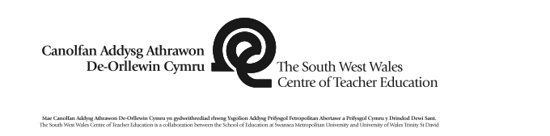 |  |  |  |  |  |  |  |  |  |  | 1B

Session Plan – Key Stage 2
Name of trainee: |  | Caitlin Wright |  |  |  | Session ref: |  |  | Week Commencing 5-3-19
Personal target(s) in relation to QTS: |  |  |  | Behaviour Management – have a firm tone of voice.
Year group: | 5 |  | No. of learners: |  | 29/6 |  | ALN: | The tasks will be differentiated
Additional Adults: |  |  | 1 Teacher and 1 Teaching Assistant
Learning objective(s):  LA To be able to order and compare items up to £10  MA To be able to order and compare items up to £100 |  |  |  |  |  |  | Success criteria:  The pupils will be able to:  - order the amounts as a group  - order the amounts individually
Links to previous learning:
The children need to practice their times tables every lesson to improve their knowledge.
The children have done an ‘Over To You’ (4/3/19) which will tell me what they already know and what they need to improve on.
Curriculum coverage (range, skills)
Mathematics
- LA order and compare items up to £10 (Year 3)
- MA order and compare items up to £100 (Year 4)

Literacy(LNF)  - listen to others, asking questions and responding to both the content and the speakers’ viewpoints  - contribute to group discussion, taking some responsibility for completing the task well, e.g. introducing relevant ideas, summing up |  |  |  |  |  | Numeracy (LNF)  N/A
DCF  Children will be using the interactive whiteboard in the starter. |  |  | Thinking  Build on existing skills, knowledge and understanding of managing money.  Identify, describe and begin to explain patterns and relationships between differently priced items. |  |  | ESDGC  N/A |  |  |  | YCC  Incidental Welsh will be used throughout the lesson.
Key vocabulary(English/Welsh):
Values
Pennies
Pounds
Pence
More than
Less than
Expensive
Cheap

Time | Session activities, organisation and management | Key questions & Assessment for Learning opportunities
10 minutes | Introduction
10 minutes | Firstly, I will lead a multiplication game on Top Marks called ‘Hit the Button’ where the children have one minute to answer as many multiplication questions as possible. Use this game as a drilling method to ensure the children are improving and understanding more of their times tables. Ensure that the children have enough thinking time.
40 minutes | Main activities  Split the children into their maths group tables.  LA – Lower Ability  MA – Middle Ability  LA  Begin by asking the children key questions (right), for example, ask the question, “How many pennies are in £1?”  Use real life situations to hook the children into learning. Get concrete materials such as a ruler, pens and pencils and label them with price tags. Ask the children to name the highest priced item and then the lowest priced item. Then ask the children to order and move the items from lowest to highest. Repeat this using different combinations of prices until you believe the children are confident to order and compare items up to £10.  Then give the children the worksheet 1 to complete individually and stick in their books.  MA  Firstly, ask the children key questions (right), for example, “If you have two identical chocolate bars, one is £1 and one is £3, which one would you buy? Why?”  Briefly go over ordering and comparing items up to £10, by giving each pair price tags and asking them to put them in ascending order.  Then give the pairs more difficult price tags with prices up to £100 asking them to order them. Once the children are confident with this, give out worksheet 2 for them to complete and stick in their books. |  | “Where do you use money?”  “Does anyone know how many pennies are in £1? £5?”  “What words can we use to describe money? If something is a lot of money we say…? If something costs less money we say…”  “If you have an apple that costs 40p and an orange that costs 50p, which is more expensive?”  “What is bigger? 5p or £5?”  “What is bigger? 10p or £10?”  “What is bigger? 70p or £70?”  “If you have two identical chocolate bars, one is £1 and one is £3, which one would you buy? Why?”
10 minutes | Plenary
10 minutes | Allow the children to go on the laptops (1 laptop between 3/4 children) with one child on the teacher computer to lead a multiplication game of Kahoot.

LA Worksheet
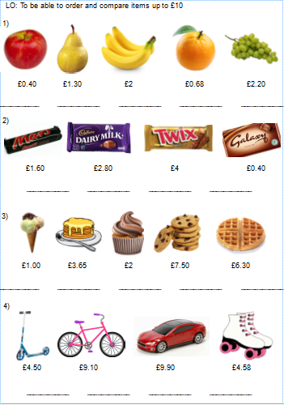

MA Worksheet
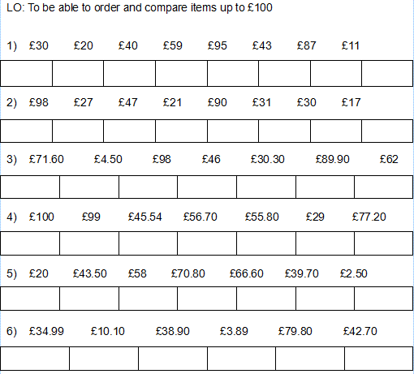

References
Broadfoot, P. (1992), Self Assessment in the Primary School Available at:- https://www.researchgate.net/publication/248970867_Self-assessment_in_the_Primary_School [Accessed 19 April 2019]
Brookfield, S. (2017), Becoming a Critically Reflective Teacher (2nd Edition), San Francisco, CA: Jossey Bass.
Department for Education and Skills (2015) Curriculum for Wales Programme of Study for Mathematics Key Stages 2 – 4. Cardiff: Welsh Government. Available at:- https://learning.gov.wales/docs/learningwales/publications/150717-nc-maths-en-v2.pdf [Accessed 15 April 2019]
Education Wales. (2009) Qualified Teacher Standards Wales 2009. Cardiff: Welsh Government
Grigg, R. (2010) Becoming an Outstanding Primary School Teacher (1st Edition), Abingdon: Routledge South West Wales Centre of Teacher Education (2010) Professional Teaching Experience Guidelines, South West Wales Centre of Teacher Education.
Haylock, D. (2007), Key concepts in teaching primary mathematics, London: SAGE Publications Ltd.
Mcleod, S. (2018), Maslow's Hierarchy of Needs, Simply Psychology. Available at:- https://www.simplypsychology.org/maslow.html [Accessed 16 Mar. 2019].
McLeod, S. (2019) Simply Psychology,
Available at:- https://www.simplypsychology.org/Zone-of-Proximal-Development.html
[Accessed 12 April 2019].
Özdemir, S. (2016) The opinions of prospective teachers on peer assessment Available at:- https://www.researchgate.net/publication/309434497_The_opinions_of_prospective_teachers_on_peer_assessment [Accessed 19 April 2019]
The National Foundation for Educational Research (2012), GETTING TO GRIPS WITH ASSESSMENT: PRIMARY self and peer assessment, Available at:-https://www.nfer.ac.uk/pdf/getting-to-grips-with-assessment-4.pdf [Accessed 19 April 2019]
University of Reading (no date) Why should I use peer assessment?, Available at:-https://www.reading.ac.uk/engageinassessment/peer-and-self-assessment/peer-assessment/eia-why-use-peer-assessment.aspx [Accessed 19 April 2019]

