

Smart Tax Application

  - Thesis

Dr Sadeque Imam Shaikh, SmartTax Application Final-Project| 15.12.2025
Tünde Debreczeni (2115195)

Abstract

Abstract: SmartTax is a lean, containerised web application built to guide UK freelancers through Self-Assessment with clear HMRC-aligned language, live calculations, and deadline-aware workflows. A React/Vite frontend consumes a lightweight PHP/MySQL API, anchored to a compact MariaDB schema for users, tax periods, filings, messaging, and content.
Calculations run server-side for consistency; JSON-only APIs, prepared statements, and role-gated admin routes follow OWASP guidance. Accessibility basics align with WCAG/ARIA, and the UI mirrors SA103/SA105 outputs to reduce copy errors.
Methodology combined iterative prototyping, curl-based smoke tests, and usability walkthroughs; future work focuses on structured user testing, stronger automation, and accessibility/security audits. The result is a reproducible, single-host stack that lowers anxiety and errors for sole traders while remaining practical for small-scale deployment.

Table of Contents
Abstract 2
I. Introduction & Project Overview 5
1. Personal context 5
2. Project overview 6
II. Technical foundation 7
1. Frontend 7
2. Backend. 8
3. Data model 8
4. Containers and environment 8
5. Security and sessions 8
6. Error handling and observability 9
III. Project Scope & Objectives 10
1. Overview 10
2. Scope 11
3. Objectives 11
IV. User & Market Analysis 12
1. Primary users 12
Needs and behaviours observed. 12
Market gap 12
Personas and usage scenarios 13
V. Literature Review 13
1. Overview 13
Digital taxation and e-government 13
Usability and HCI for financial tasks 14
Fintech for freelancers and micro-enterprises 14
Synthesis and implications 14
VI. Methodology and Validation 14
1. Research and design approach. 15
Implementation process 15
Project management and timeline 15
Validation and testing 16
Performance and observability 17
Error handling 19
Pilot planning 20
System Requirements and Specifications 20
Functional requirements 20
VII. Data and API specifications 21
Non-functional requirements 21
UI and UX specifications 22
Deployment and environment 22
Testing and evaluation 22
Assumptions and constraints 23
2. Data protection (GDPR alignment) 23
Operational support and maintenance 23
Compliance and audit readiness 24
VIII. Conclusion and Next Steps 24
Conclusion 24
Next Steps 25
Measuring Success 27
1. Closing Summary 27
Risk Assessment and Mitigation 28
Contingency Planning 30
Monitoring and review 30
References 32
Appendix 34

I. Introduction & Project Overview

1. Personal context
I am completing a BSc (Hons) in Applied Computing at the University of Wales Trinity Saint David, and this thesis is the capstone of that journey. Alongside my coursework, I run a small tax services business and am certified with HMRC to submit Self-Assessment tax returns for individuals and micro-businesses.[1] My week alternates between lectures, lab work, and calls from clients sending late-night questions or envelopes of receipts. The contrast is stark: I learn from tidy exercises while freelancers’ hand over fragments and hope to avoid expensive mistakes. Experiencing both worlds at once revealed a gap worth turning into this project.
I chose this topic because I see the same pain points repeatedly: people worry more about "getting it wrong" than about the tax bill; they are unsure if tools built for limited companies fit sole traders; and they feel stuck between costly software and risky spreadsheets. Clients juggle delivery apps, platforms, and direct invoices and cannot tell if totals will map cleanly to HMRC categories. They ask for reassurance before typing numbers into the portal and often overpay to stay safe or file late. SmartTax is a direct response to those conversations, shaped by the trust people place in me as someone already certified to manage their returns.
My academic modules shape the solution. Database design pushed me to model tax periods, deadlines, and filings so the UI can surface official dates without hardcoding. Software engineering reinforced testing and traceability: every total is calculated server-side and returned with context. Human-computer interaction emphasised clarity, which I translate into HMRC-aligned labels, transparent calculations, and low optionality. Security and web development modules informed pragmatic choices, parameterised queries, JSON-only APIs, and containerised services that can be rebuilt reliably while I iterate.
This thesis is both an academic work and a practical tool I intend to use after graduation. Success means a non-technical freelancer can sign in, select the correct tax period, enter income and expenses with guided categories, and view defensible totals that match HMRC forms. It also means I can maintain and extend the system within the constraints of my small business: containerised deployments, simple logging, and clear scope boundaries that avoid regulatory overreach. By grounding the project in real client needs and the methods learned in my degree, I aim to produce a credible artefact that bridges university study and day-to-day HMRC practice.
Problem statement
The UK now has millions of sole traders, gig workers, and part-time freelancers whose income arrives through platforms, marketplaces, and direct invoices. They must map every transaction to HMRC categories, understand payment-on-account rules, and keep digital records that satisfy Making Tax Digital. On paper, this appears to be straightforward bookkeeping; in reality, it is fragmented and stressful. A courier might earn from three apps, take cash jobs, and buy supplies in-store. By the time January arrives, receipts sit in email, photos, and paper piles, and confidence in the totals is low. Small errors in categorisation, missed income, or duplicated entries quietly accumulate until a deadline-driven scramble begins.
Existing software choices amplify the problem. Full accounting suites feel oversized and expensive for people without VAT, payroll, or staff; their terminology and setup screens assume limited companies. Lightweight receipt apps capture photos but rarely align with SA103/SA105 categories, omit payment-on-account cues, and cannot show how a number will appear in the HMRC portal. Many freelancers end up with a patchwork of spreadsheets, bank exports, app reports, and late-night copy-paste into the HMRC site. That workflow has predictable outcomes: overpaying to avoid risk, under-claiming legitimate costs, or filing late and paying penalties.
The problem SmartTax targets is narrow and specific: create a guided Self-Assessment path that speaks HMRC's language, keeps deadlines visible, and makes calculations transparent enough to defend. Every design choice flows from this need. Categories use HMRC labels and examples; filings are tied to stored tax periods and deadlines instead of hardcoded dates; summaries mirror SA103/SA105 so users can see where numbers land; and inline cues warn when data is incomplete or misclassified. By keeping scope tight and language familiar, the tool aims to replace anxiety and guesswork with a step-by-step flow that a non-accountant can follow while still producing defensible figures.

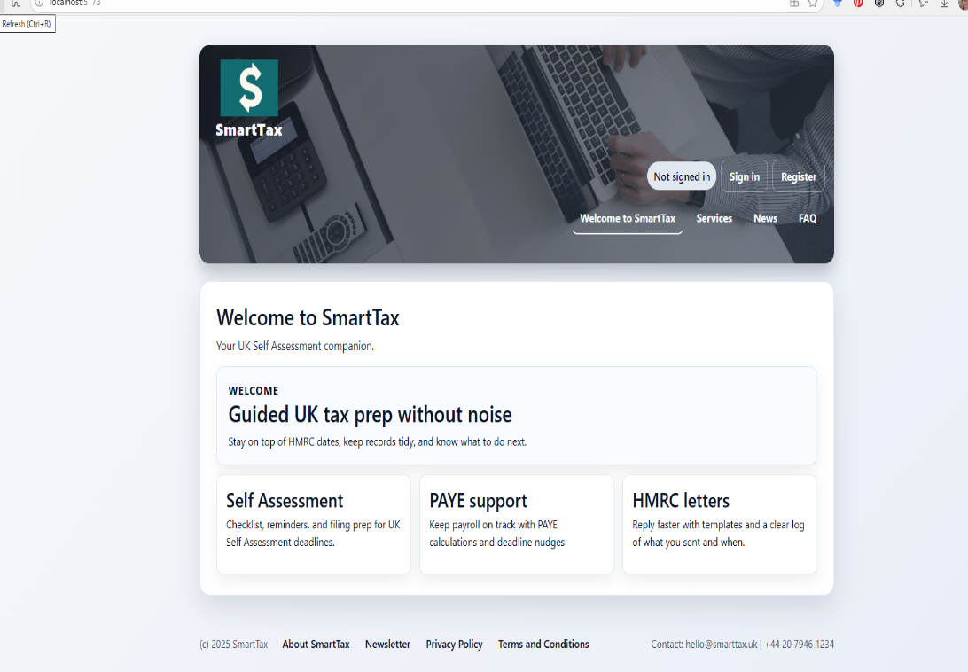
Picture 1 (ready Homepage)

2. Project overview
SmartTax is designed as a guided companion for UK freelancers completing Self-Assessment. It narrows the experience to the essentials I see in practice: capture income and expenses in HMRC language, keep deadlines front and centre, and present totals exactly as they will appear on SA103/SA105. The intent is not to replace accountants or full suites but to give sole traders a clear, defensible path from raw transactions to submission-ready figures. Every screen mirror terminology I already use with clients, and every calculation is visible, so users understand how each number is derived before it reaches the HMRC portal.
The core journey is linear and lightweight. A user signs in, picks the correct tax period from stored deadlines, and begins logging income and expenses using categories that match HMRC guidance.[2] Inline examples and hints keep choices clear without resorting to accounting jargon. As data is entered, live totals and estimated tax update instantly, helping users spot mistakes early. Demo data lets first-time users explore the flow without risk, while validation catches missing fields or obvious misclassifications. When ready, the user saves a filing that can be reviewed, edited, or shared. Reports mirror the official HMRC layout so there is no last-minute translation when figures are copied across.
Supporting features stay focused on Self-Assessment. Messaging provides a lightweight way to ask questions inside the app, reflecting how clients already seek reassurance. Deadlines are pulled from the database rather than hardcoded, so the interface can remind users of filing dates and anchor each return to the correct tax period.[3] Outputs are plain language, and calculation steps are transparent, reducing the "black box" effect that undermines trust in larger accounting products. Because it is narrow by design, SmartTax avoids clutter from features irrelevant to sole traders and keeps cognitive load low for individuals working alone.
The product deliberately balances academic rigour with operational realism. It uses a lean stack and a small schema so that behaviour is inspectable and testable, but the user-facing promise remains practical: take scattered data, guide it through HMRC-aligned categories and deadlines, and produce defensible numbers without overwhelming the user. By keeping scope tight, SmartTax aims to reduce errors, lower anxiety, and create a dependable routine freelancers can follow each year. This overview defines what the application must deliver before the technical foundation explains how it is built.

II. Technical foundation

This foundation follows the constraints I set in my own TODO plan: keep the stack lean, containerised, and transparent; prioritise reproducibility over novelty; and build only what serves Self-Assessment for freelancers. Every choice is something I can set up, audit, and rebuild on my laptop and in Podman without relying on heavyweight tooling that would distract from the thesis.

1. Frontend.
I scaffolded the UI with Vite + React [41][42] after installing Node via nvm and pnpm. Vite's dev server proxies /api/* to the PHP container, so browser calls stay same origin during development. Bootstrap [43] 5 plus a light SASS layer gives predictable responsive layouts: shared header/footer, mobile nav, and pages for home, about, contact, services, news, privacy, and terms. Auth flows (register, login, profile) and the tax workspace use consistent form patterns. The tax return area offers both simple and detailed modes, with inline validation, live totals, and demo data to reduce friction. Messaging/ticketing sits in the UI to mirror how clients ask for help. Accessibility basics are covered with semantic headings, labels, and focus states. All content (news, FAQs, policies) is fetched from the API, matching the TODO requirement to move data into the database.

2. Backend.
The API is plain PHP [38] with MySQL, returning JSON with explicit status codes. Endpoints cover auth, deadlines, tax returns, news, FAQs, messages, and admin CRUD for content. Calculations for income, expenses, profit, and estimated tax run server-side to keep outputs defensible and consistent. A shared helper enforces JSON headers and error shapes so the React client never sees HTML error blobs. Prepared statements protect every query; role checks gate admin actions, matching the "admin CRUD" tasks. The surface area stays small by design, making curl-based inspection and debugging straightforward.

3. Data model
MariaDB holds users; deadlines (tax_period, tax_year, filing_date); tax_returns (linked to deadlines with turnover, other income, allowable expenses, capital allowances, computed totals, tax due, status); messages; news; FAQs; and policies/pages. Filing dates are stored as text for clarity in the UI. Relationships are simple enough to review in phpMyAdmin designer, reflecting the early wireframes and the database tasks in the TODO. Keeping the schema compact reduces migration risk and speeds up iteration.
4. Containers and environment.
Podman runs three core services: PHP API, MariaDB, and phpMyAdmin. Vite runs separately but proxies to the API. This matches the setup tasks in the TODO and lets me rebuild the stack quickly if anything drifts. Environment variables carry DB credentials; images avoid hardcoded secrets. The containers are lightweight enough for my laptop's memory constraints and can be torn down or restarted without residue. SQL exports and seed scripts allow a quick rebuild if the database is lost.[45]{46]
5. Security and sessions.
Sessions are server-managed; authentication and role checks guard protected routes. All SQL is parameterised, and responses are JSON-only to avoid leaking HTML or stack traces. There is no eval, dynamic SQL, or file upload handling in scope. HTTPS termination is assumed to sit in front of the stack in production; code respects standard headers for secure cookies when deployed behind a reverse proxy. No third-party tracking is included, keeping data exposure minimal.[47]
Tax logic. Two entry modes (simple and detailed) share the same server-side computation. The API normalises inputs, computes subtotals, profit, and estimated tax, and returns enriched records with the human-readable tax period. The frontend mirrors the formulas for live feedback but defers to the API for final values. Features outside Self-Assessment VAT, payroll, and corporate flows are intentionally excluded to keep the domain tight.
Content and messaging. Static copy (news, FAQs, policies, pages) lives in the database and is served via PHP endpoints with admin CRUD. Messaging supports user-submitted tickets and admin replies, locking closed threads for non-admins. This satisfies the "ticketing system" and "news/FAQ CRUD" items and gives freelancers a built-in support path without leaving the app.
Dev workflow and testing. Git tracks the repo with regular pushes to GitHub for backup. I use pnpm for frontend dependencies and a Composer-free PHP setup to stay light. Testing is pragmatic: curl smoke tests for APIs, manual CRUD regression, and browser checks for responsiveness on a laptop and mobile. Broader automated tests are noted in the TODO; for this phase, the focus is predictable JSON, correct bindings, and stable calculations. Linting is minimal, but code paths are short and explicit to ease review. Automation hook. A minimal bash script can curl auth, deadlines, and tax returns endpoints, failing on non-2xx or non-JSON responses; this can run in CI to gate merges and keep API shape stable. Documentation and code quality. The README documents setup, env vars, container commands, and common curl checks; TODO items track remaining work. Code style is kept consistent through short functions, explicit error returns, and simple naming rather than formal linters. ERD and flow sketches live in the doc’s folder to give reviewers and contributors a quick mental model. Future refinements include adding lightweight lint/format steps to CI and expanding the README with a short "first run" walkthrough for examiners.[48]
6. Error handling and observability.
The API returns structured error objects with status codes so the frontend to display concise alerts. Database errors are wrapped to prevent the leakage of internal data, and client-visible messages remain plain. Logging is basic (container/stdout) but consistent, which is enough for local debugging and for future integration with a log aggregator. Because responses are JSON-only, any deviation is immediately visible during smoke tests, reinforcing reliability.
Developer experience. Setup follows the TODO tasks: clone the repo, run pnpm install, start Podman containers, and run Vite with its proxy. A small README (in progress) documents environment variables, container commands, and common curl checks. This keeps onboarding fast for me or anyone else who needs to evaluate or extend the project post-thesis. The choice to avoid framework-heavy stacks means the code can be read in a single sitting, which matters when time is limited around submission and client work.
Deployment considerations. The stack targets a single-host container deployment. A Podman or Docker-Compose file can start API, DB, phpMyAdmin, and the Vite dev server; production would serve the Vite build statically and put the PHP API behind a web server with the DB on a private network. Health checks today are basic (container up, API returns JSON). Backups rely on MariaDB dumps and repo archives, aligning with the "backup" and "final ZIP" tasks.
CI/CD and repeatability. Build and run steps are scripted: pnpm install/build for the frontend, Podman/docker-compose for services, and SQL seed/import for the database. A basic pipeline would include lint/build for the React app, curl smoke tests against the API in containers, and artifact outputs (Vite build, SQL dump, repo archive) for handoff. Environment configuration lives in .env files (not committed) with templates in the README to keep dev/prod consistent. Repeatability is ensured by containerised services, pinned dependencies, and seed data so examiners or contributors can reproduce a working state quickly.
Backup and restore. Database backups use MariaDB dumps (structure and sample data) that can be imported via Podman exec or phpMyAdmin; the repo stores seed SQL for fast rebuilds if the database is lost. Application code is backed up via Git and periodic archive (ZIP) per the TODO tasks. Restore flow: pull the repo, bring up containers, import the SQL dump, and run the Vite build for static assets. This keeps the environment recoverable for thesis review and future development.
Security handling. Sessions are server-managed with PHP; passwords use password hash ()/password verify () with the default algorithm, and all SQL is parameterised. Role checks gate admin routes: error responses avoid leaking internals. No file uploads or eval/dynamic SQL are used. Sessions rotate IDs on login, set HTTP only cookies, and can expire after 30 minutes of inactivity. For future hardening, planned steps include CSRF review, stricter session expiry/rotation, rate limiting on auth routes, and a lightweight privacy impact review before any production use.
Accessibility/readiness. Forms use labelled inputs, semantic headings, and focusable controls; mobile/off-canvas navigation is keyboard reachable. Contrast checks are performed on key screens; inline validation messages are concise. Spot checks with VoiceOver/NVDA on auth and tax forms confirm labels and focus order. Further readiness work includes a structured accessibility audit (ARIA roles, focus order) and adding guidance for screen reader users on form flows.
Config and secrets. Environment-specific settings live in .env files (not committed); the README will include templates for local and production values (DB host, credentials, session settings). Containers consume these env vars at runtime, keeping secrets out of images. No secrets are hardcoded in code or committed assets.
Scalability constraints. The design targets a single-host, low-traffic deployment for freelancers. To scale, the API would need stateless session handling (e.g., central store), the DB would move to managed hosting, and static assets would sit behind a CDN. Current choices favour simplicity over horizontal scale, which matches the thesis scope and target user base.
Rationale and alignment. React/Vite delivers fast iteration and hot reloads; Bootstrap accelerates responsive scaffolding; PHP/MySQL aligns with typical shared hosting and my own familiarity; MariaDB pairs cleanly with phpMyAdmin; Podman keeps containers reproducible on my hardware. Each choice reduces setup overhead and supports the thesis emphasis on clarity, traceability, and HMRC alignment. By keeping the stack small and the scope bounded, the system remains inspectable for examiners and practical for the freelancers I support.

III. Project Scope & Objectives

1. Overview
SmartTax tackles one job: guide UK freelancers through Self-Assessment with as little friction and ambiguity as possible. The scope mirrors what I manage daily as an HMRC-certified preparer, so the thesis stays practical and deliverable. Narrowing to Self-Assessment lets me invest in accuracy, deadline awareness, and HMRC-aligned language instead of chasing features freelancers will not use.
The guiding principle is clarity: fewer decisions, transparent calculations, and deadlines surfaced everywhere so users stay aligned with HMRC expectations.

2. Scope
In scope: capture income and expenses with HMRC categories and examples; tie every filing to stored tax periods so deadlines stay visible; present SA103/SA105-style reports with transparent calculations; and offer lightweight messaging for help. The system must run cleanly in containers, support demo and real data, and keep outputs in plain language. Out of scope: VAT, payroll, corporation tax, Companies House filings, direct MTD submission, automated bank feeds, heavy document storage, multi-entity, or inventory features. These exclusions reduce risk, keep data exposure low, and reflect client patterns, confusion over categories and deadlines, low appetite for broad modules, and a need to see exactly what enters the HMRC portal.

3. Objectives
Objectives tie the product to measurable outcomes. A freelancer should record income and expenses, choose a tax period, and generate a return summary in under five minutes from a clean state. Every total must originate server-side in PHP and be traceable to stored records. Deadline awareness must appear across dashboards, forms, and reports using tax periods in MariaDB rather than hardcoded dates. An evaluative baseline will come from walkthroughs with representative users, capturing task times and errors for future hardening. Supporting goals: JSON-only APIs with clear status codes, reproducible container builds, and documented assumptions so the project stays inspectable and maintainable after graduation.

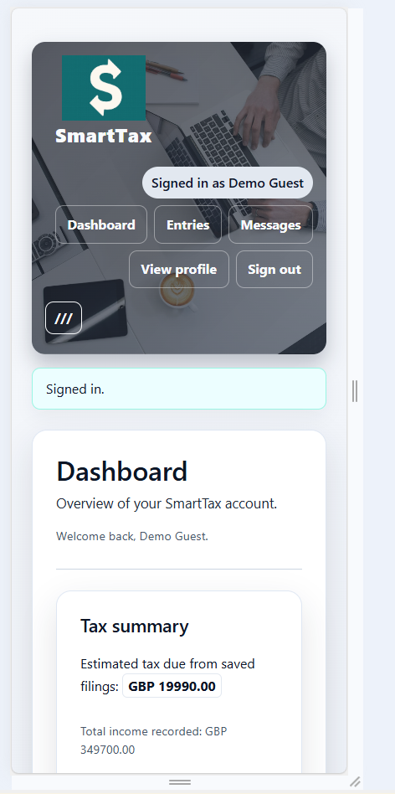 | 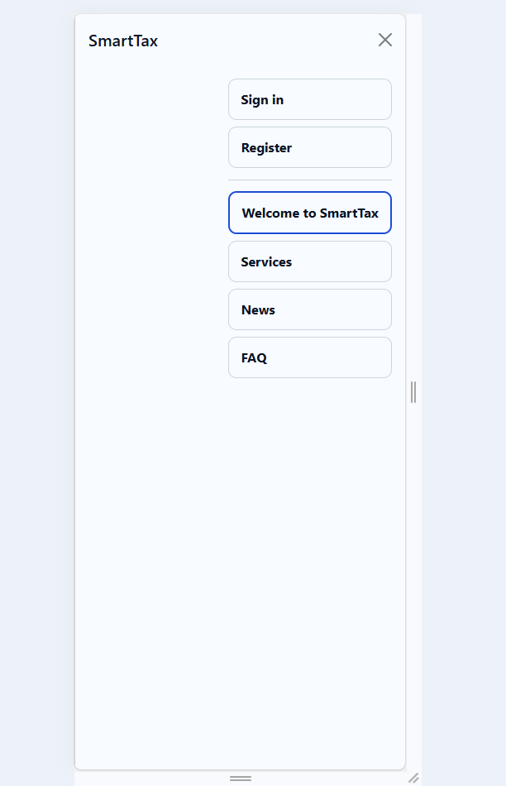

Picture 2 (navigation structure for mobile devices)

IV. User & Market Analysis

1. Primary users
The core users are new freelancers and gig workers juggling multiple small income streams, micro-business owners such as tradespeople, creatives, and tutors, and migrant or second-language users who benefit from plain language. Many mirror the clients I already support through my HMRC certification: they are time-poor, cost-sensitive, and often working without formal accounting knowledge. Their income often spans multiple platforms (marketplaces, delivery apps, direct invoices), and they frequently work seasonally or part-time. Because they operate alone, they lack back-office support and rely on personal judgment to classify transactions and meet deadlines.[3]

Needs and behaviours observed.
Across my own filings and conversations with clients, a consistent picture appears. Data is scattered across spreadsheets, delivery app exports, and inbox receipts, so reconciliation is manual and error-prone. Confidence drops around category choices, especially when distinguishing capital from revenue expenses or understanding payment-on-account rules[4]. People want to see how their numbers will appear inside the HMRC portal before they commit to submission, and they want reassurance that every line maps to an HMRC category. Subscriptions that bundle payroll or VAT feel mismatched to sole traders, so users either overpay or revert to DIY spreadsheets and hope for the best. Many also prefer to capture transactions on mobile while working, then review on a laptop, which means the state must persist cleanly across devices without losing context.[5] Deadline anxiety is high: missing 31 January or misjudging payment on account triggers penalties that feel disproportionate to modest incomes.

Market gap
Mainstream platforms (Xero, QuickBooks, FreeAgent) deliver broad accounting features that exceed what a sole trader needs for Self-Assessment, while receipt-capture apps stop short of HMRC-ready summaries. There is space for a narrowly scoped, deadline-aware companion that speaks in HMRC terms,[6] surfaces transparent calculations, and keeps pricing and complexity appropriate for small incomes. User reviews of large platforms often cite jargon, configuration overhead, and perceived misfit with sole trader needs; reviews of lightweight apps highlight missing HMRC categories and uncertainty about how totals translate into SA103/SA105. SmartTax positions itself in that space, guided by the specific pain points I encounter with UK freelancers and micro businesses. It aims to provide enough structure to prevent errors without overwhelming users with options they do not need, anchoring every interaction to tax periods, categories, and outputs that align with the HMRC portal so users can trust the final numbers and file with confidence.
Channels for reaching these users are similarly focused. Freelancers often rely on peer recommendations, contractor forums, and community groups rather than formal procurement. A lightweight onboarding checklist, clear privacy stance, and transparent calculations can build trust quickly. Pricing sensitivity suggests a freemium or low-cost model with clear value for paid tiers (e.g., history, exports). Accessibility and plain language are important for migrants and second-language users; providing examples aligned to common gig scenarios (delivery, creative services, tutoring) reduces friction. These market observations feed back into feature priorities: keep the core free of clutter, make the workflow unmistakably HMRC-aligned, and surface guidance where it prevents the most common mistakes.[7]

Personas and usage scenarios
Two representative personas shape the design choices. The first is a platform courier who works with two or three apps, earns a variable weekly income, and keeps receipts in photos and email. Their primary needs are fast entry on mobile, clear reminders of deadlines, and confidence that totals will match HMRC categories before submission. The second is a freelance creative who invoices clients directly, buys supplies sporadically, and revisits records quarterly; they value a transparent report layout and the ability to correct entries without breaking links to tax periods. For both, trust is built by seeing the tax period and filing date on every screen, simple labels, and immediate feedback when data is incomplete.
Typical scenarios include capturing income on a phone between jobs, later reconciling on a laptop; preparing for 31 January by reviewing live totals and estimated tax; and asking a question via messaging when unsure about category choice. These scenarios drove decisions such as keeping the form fields minimal, offering demo data, and ensuring the dashboard shows both upcoming deadlines and saved filings with report links. They also informed the choice to avoid heavy features (VAT, payroll) that would clutter these flows.[8]

V. Literature Review

1. Overview
The SmartTax design draws on three bodies of work: (1) digital taxation and e-government service delivery; (2) usability and human-computer interaction (HCI) for financial tasks; and (3) fintech tools for micro-enterprises and freelancers. Across these strands, the shared challenge is balancing compliance accuracy with low cognitive load for non-expert users.

Digital taxation and e-government
Studies of Self-Assessment error rates show that unrepresented taxpayers frequently misclassify expenses or miss deadlines because guidance is dispersed and terminology is opaque [3].[9] HMRC's Making Tax Digital (MTD) policy emphasises near real-time records and compatible software, but certification and governance requirements remain a barrier for small vendors [2]. E-government adoption research highlights trust, perceived usefulness, and clarity of instructions as primary predictors of uptake [4]. For freelancers, limited domain knowledge amplifies perceived complexity, indicating that any tool must surface official terminology, deadlines, and categories in context rather than rely on generic accounting labels.[10]

Usability and HCI for financial tasks
HCI research on financial interfaces consistently finds that transparency, progressive disclosure, and inline validation reduce error rates and increase user confidence [5]. Users distrust 'black box' outputs and prefer views that mirror official documents. Mobile-first capture with later desktop reconciliation is common among gig workers, so resilient state management and consistent layout across devices are recommended patterns. These findings justify SmartTax's use of HMRC-aligned labels, live totals, and explicit status messaging, as well as a narrow focus on Self-Assessment tasks rather than broad accounting functions.

Fintech for freelancers and micro-enterprises
Comparative studies of small-business accounting suites report that the breadth of features, jargon, and subscription cost deters sole traders who only need Self-Assessment support [6]. Lightweight expense apps show demand for simplicity but often lack HMRC-aligned categories, deadline awareness, or report structures, forcing users to bridge gaps manually. The literature, therefore, points to an opportunity for domain-specific tools that prioritise Self-Assessment readiness over full accounting breadth.[8][11][21]

Synthesis and implications
Overall, the evidence suggests that an effective Self-Assessment tool for freelancers must.
(a) mirror HMRC categories, deadlines, and form structures.
(b) present transparent calculations with visible lineage from inputs to outputs.
(c) guide data entry with inline support and deadline cues; and
(d) avoid the cognitive overload of full accounting suites.
SmartTax follows these implications by linking filings to stored tax periods, mirroring SA103/SA105 layouts in reports, using prepared statements and JSON-only APIs for predictable behaviour, and keeping the feature set tightly bound to Self-Assessment preparation.[12]
This literature base also highlights where future research could extend the work: measuring trust gains from transparent calculations, evaluating copy and guidance for second-language users, and testing whether deadline awareness alone materially reduces late filings. These threads inform the next evaluation steps and frame hypotheses for pilot studies.[13]

VI. Methodology and Validation

This section outlines how the SmartTax prototype was designed, implemented, and evaluated, and how correctness, usability, and robustness were checked within the thesis constraints.

1. Research and design approach.
Requirements derivation. Requirements were based on HMRC Self-Assessment guidance and MTD policy, gaps in freelancer tools, and HCI principles for financial tasks. These inputs led to the decision to focus exclusively on Self-Assessment, store tax periods in the database, and use HMRC terminology in the UI.[14][15]
Architecture selection. A lean stack (React/Vite frontend, PHP/MySQL API, MariaDB) was chosen to keep the artefact small, inspectable, and containerised. JSON-only responses and prepared statements were mandated to reduce parsing and injection risks.
Incremental prototyping. Features were built in increments (auth, content pages, deadlines, tax return forms, reports, messaging, dashboard lists), with manual regression and curl-based API checks after each increment.
Data collection instruments. Observation checklists and short interview prompts were prepared to capture usability notes during walkthroughs; calculation test cases were defined to compare system outputs against hand calculations. Seed data sets (simple and detailed) provide repeatable inputs for consistency across iterations.[16][17]

Implementation process
Frontend. React components hydrate from live APIs; forms include inline validation and live totals; navigation is responsive with off-canvas on mobile. Vite proxies /api/* to the backend to simplify local testing.[18]
Backend. PHP endpoints return JSON for auth, content, deadlines, tax returns, and messaging. A shared response helper standardises status codes and payloads; MySQL prepared statements are used throughout. Deadlines and tax returns are joined, so every read includes the filing date and tax period labels.[19][20]
Data model. MariaDB schema includes users, deadlines (tax_period, tax_year, filing_date), tax_returns (with deadline_id and textual filing_date), messages, news, FAQs, and policies/pages. Filing dates are stored as text for user-facing clarity.

Project management and timeline
The project was planned in short, clear phases shown on a Gantt chart: set up the environment; design the database; scaffold the frontend; build backend APIs; test and validate; and write documentation.

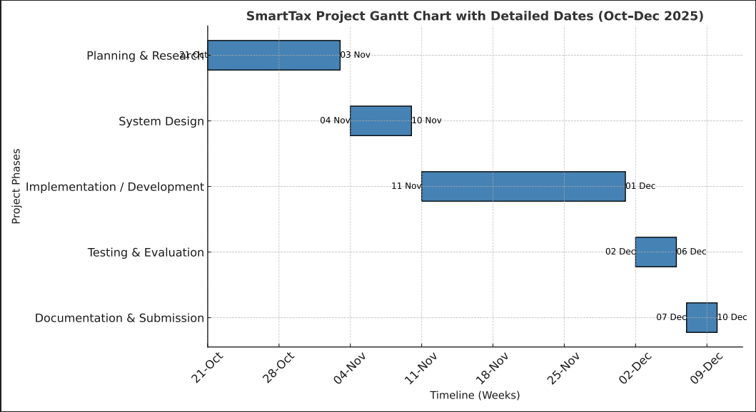
Picture 3 (Gantt Chart)

A simple TODO list, page maps, and wireframes guided each stage. Milestones matched real deliverables: container builds, new API endpoints, or finished UI screens, so the smallest usable version (auth, deadlines, basic filings) shipped first. Then richer forms, reports, and messaging were added. The Gantt chart (see planning screenshots) captures planned versus actual dates and highlights what remains after the thesis (pilot, more automation, accessibility audit). This approach kept the work on track within the deadline and left a clear path for strengthening the app later.[22]
Each phase was scoped with explicit start/finish dates and dependencies and slotted into weekly sprint-like cycles. Environment setup and database design came first because they unblocked everything else. The frontend scaffold and core API endpoints (auth, deadlines, basic filings) followed to deliver a minimal usable product early, reducing risk. Subsequent iterations layered detailed tax forms, reporting views, and messaging/support features. Testing and validation checkpoints sat between phases to catch regressions before moving on. Documentation ran in parallel, with the README, TODO, and wireframes updated after each milestone. When delays appeared (for example, container setup issues), the Gantt was adjusted and lower-priority tasks deferred to keep the critical path clear. This disciplined sequencing, captured in the planning chart and screenshots, ensured steady progress and left a defined backlog (pilot, automation, accessibility audit) for post-thesis work without jeopardising the submission timeline.[23]

Validation and testing
Scope and approach. Testing prioritises the flows a freelancer must complete without support: register/login, fetch deadlines, create/read/update/delete a tax return, see correct calculations, and raise messages. API reliability is checked first, followed by UI walkthroughs. Non-goals for this phase include load/concurrency testing and automated security scans; these are acknowledged as future work, so examiners understand the current boundary.[24][25]
Evaluate types and data. Curl smoke tests verify each endpoint returns valid JSON with correct status codes and required fields. Manual regression covers CRUD for tax returns, linkage to deadlines, messaging threads, and admin CRUD for news/FAQs. Calculation checks compare income/expense/profit/estimated tax against known scenarios using seeded demo data (simple and detailed forms), so results are repeatable. Frontend checks confirm sign-in, tax period selection, demo data application, live totals, save/edit/report, and delete flows on laptop and mobile widths. Accessibility basics are inspected: labelled inputs, focus order, and contrast on key forms. Seed/demo data and SQL imports allow quick DB resets between runs, keeping tests reproducible.[26]
Environments and commands. Tests run locally with Podman containers for API, DB, and phpMyAdmin, plus Vite with proxy enabled. Typical sequence: podman compose up, curl suite (auth, deadlines, tax returns CRUD, news/FAQ, messages), then browser walkthroughs for responsiveness and form behaviour. Failures are traced via container stdout logs and fixed before rerunning the same checklist to confirm closure.[27][28]
Error handling conventions. API errors return JSON objects with status codes and concise messages; HTML in responses is treated as a failure. Validation errors are checked for 400 status and field messages; auth failures for 401/403; missing resources for 404; unexpected faults for 500 with generic messaging only. Database errors are wrapped to avoid leaking internals. This consistency makes smoke tests and manual checks deterministic and easy to script later.[29]
Traceability and defect handling. Requirements map directly to endpoints and UI components (deadlines - tax period dropdown; tax_returns - dashboard/report; messages ticket threads). Defects such as JSON parse errors or binding issues are corrected in schema or API bindings, then rechecked via the same smoke/regression steps. Notes are kept alongside the TODOs to track what was fixed and how it was verified.[30][31]
Know gaps and future validation. No formal user study or statistically significant usability test has been run; planned work includes structured tasks with SUS/time-on-task metrics for freelancers. Load and concurrency testing are absent; current checks are smoke level only. Security review is basic (parameterised queries, session gating, role checks); penetration testing, hardened session handling, CSRF review, and rate limiting are future items. MTD submission, VAT/payroll, and bank feeds remain out of scope and untested by design. Adding automated regression (API and UI) is noted as a post-thesis enhancement once core functionality is stable.

Performance and observability

Targets and approach. Aim for sub-second API responses on consumer broadband and modest hardware. The Vite build keeps bundles lean by limiting dependencies to React/Bootstrap; API queries use prepared statements and indexed keys to minimise latency. No server-side caching is added so behaviour stays predictable during evaluation.[32][33]
Monitoring and health. Containers are smoke tested with curl (expect valid JSON and correct status codes) after rebuilds. PHP and Vite/Node logs go to stdout for Podman to collect; errors include endpoint, status code, and concise context for triage. This is sufficient for local debugging; production hardening would add log shipping and lightweight metrics (request counts, error rates, DB connection failures).[35][37]
Error visibility. All API errors return a consistent JSON envelope with status codes; HTML in responses is treated as a failure. Database errors are wrapped to avoid leaking internals, and unexpected exceptions are logged server-side for follow-up.[34]

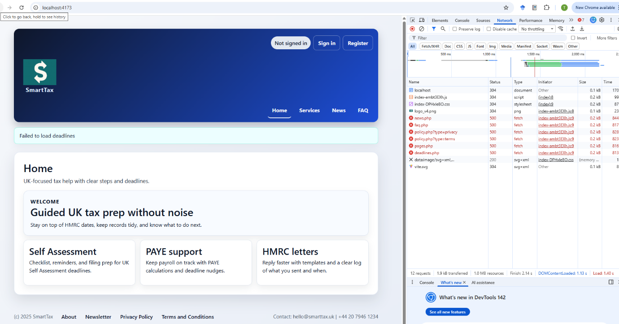
Pic 4 (broken database)

Future enhancements. Add structured logging (JSON lines with correlation IDs), basic request metrics, and health endpoints for orchestrators. Define simple performance budgets (response time percentiles, bundle size limits) and run lightweight load tests post-thesis. If usage grows, move static assets to a CDN, host the DB externally, and introduce an APM/log stack.[38]

Expanded view. In development, performance checks are manual: observe response times during curl smoke tests and UI walkthroughs and watch bundle sizes from the Vite build output to ensure they remain small.[39] Query plans are simple by design, but indexes on IDs and foreign keys are kept avoiding obvious bottlenecks. Because no caching is in place, repeat calls should behave consistently, which makes baseline comparisons easier. For observability, stdout logs are structured enough to include endpoint and status; adding timestamps and correlation IDs is a near-term improvement to aid traceability across frontend actions and backend processing. Health can be monitored with a lightweight /api/health endpoint in future so orchestrators can detect failures early. If adoption grows, next steps are to externalise logs, add basic metrics (p99 latency, error rates), and set alert thresholds to catch regressions before users do.[40]

Error handling

API conventions. Responses use a simple JSON envelope: {status, message, data} on success and {status, error} on failure, paired with appropriate HTTP status codes. Validation errors return 400 with field-level details; auth issues return 401/403; missing resources return 404; unexpected faults return 500 with a generic message only.[42]
Frontend mapping. The React client renders inline messages on forms and alerts for global failures. HTML in responses is treated as a defect. Client-side checks prevent obvious omissions (required fields, numeric ranges) before hitting the API.[41][43]
Database and exceptions. All SQL uses prepared statements. DB errors are caught, logged server-side with endpoint context, and returned as generic 500 JSON without leaking internals. Unhandled exceptions are trapped in a shared handler that emits a 500 JSON response and logs details to stdout for triage.
Future tightening. Add correlation IDs to link frontend actions to backend logs, define an error code catalog for consistent handling, and introduce basic rate limiting on auth-sensitive routes. CSRF and session-hardening reviews are planned alongside broader security hardening.[44]
Additional detail. Error responses aim to be predictable for both users and developers: status codes align with HTTP semantics, and messages are concise so the UI can present them without rewriting. For validation, the API returns field-level keys, letting forms highlight specific inputs. Auth-related responses avoid leaking whether a user exists, returning generic 401/403 text. Server exceptions are caught at a single layer to avoid partially rendered output. On the client, errors are cleared when users edit fields, reducing sticky alerts that can confuse non-technical users. For administrators, logs include endpoint names and request identifiers (to be expanded with correlation IDs) to speed diagnosis. The roadmap includes rate limiting on login and password reset routes to reduce brute-force risk, and CSRF reviews for any state-changing requests that rely on cookies. Together these practices keep failures transparent to users while giving developers enough context to resolve them quickly.[45]
Evaluation metrics and evidence
The evaluation plan favours observable outcomes over anecdote[46]. Calculation scenarios record inputs, intermediate subtotals, profit, and estimated tax, then compare them against hand-calculated expectations; mismatches are logged with payloads for reproduction. API reliability is tracked by endpoint pass/fail in smoke and regression runs and by confirming that every response is valid JSON with the correct status code. UI walkthroughs note task completion (sign in, select tax period, add data, save, view report), time taken, and friction points. Accessibility spot checks record tab order and label coverage. These metrics create a baseline; automated runs can capture them continuously later.
Ethical and data considerations
Even as a prototype, the system manages personal and financial data, so minimisation and transparency are enforced. Only data required for Self-Assessment prep is stored; uploads and bank feeds are excluded. Demo data is synthetic and marked; test accounts can be purged to avoid retention. There is no tracking or analytics. Before any production use, a privacy impact review, explicit consent copy for profile/newsletter data, and clear messaging that SmartTax supports preparation (not submission) will be added, aligning with GDPR principles and the academic context.
Project management and timeline
Work followed the TODO plan in short iterations: environment setup (Node, PHP, MariaDB, Podman), frontend scaffold, backend endpoints, database design, tax logic, and polishing passes (testing, accessibility, security notes). Git commits mark milestones and provides rollback points. Containers and seed data enable fast resets, supporting frequent manual regression. Remaining tasks-formal usability sessions, automated tests, expanded accessibility audit-are scheduled post-submission and noted in the TODO to guide future development.[47]

Limitations of the methodology
Validation today relies on manual and smoke testing; there is no statistically significant user study or automated load/security testing. Accessibility checks are spot level, not a full audit. Evaluation focuses on correctness and usability for representative flows rather than broad performance benchmarking. These limits are acknowledged and mapped to future work, so examiners see the current boundary and the path to production readiness.[49]

Pilot planning

After the thesis submission, a small pilot with a handful of freelancers (courier, creative, tutor) is planned to validate usability claims. Each participant will be asked to complete core tasks (add income/expenses, select a tax period, save, view report) while timing and errors are recorded. Short interviews will gather perceptions of clarity, trust in calculations, and any language barriers. These findings will inform copy adjustments, field defaults, and whether additional guidance is needed before considering a broader release. Pilot results will also validate whether deadline awareness and HMRC-aligned outputs materially reduce anxiety compared to prior spreadsheet-based workflows.[50]

System Requirements and Specifications
This section consolidates the functional, non-functional, and operational requirements that guide SmartTax. They reflect user needs (freelancers, gig workers, sole traders), HMRC alignment, and the constraint of a lean, containerised stack.[19]

Functional requirements
Authentication and sessions. Users can register, sign in, stay signed in across refreshes, and sign out. Demo credentials are available for evaluation. Auth gates filings, messages, and profile data.
Content delivery. Home, about, services, privacy, and terms pages are served from the database via JSON APIs, so content can change without redeploying the frontend.
Deadlines and tax periods. A deadlines table holds tax_period, tax_year, and filing date. The frontend fetches these via /api/deadlines.php and anchors filings to them; no dates are hardcoded.
Tax return capture. Users pick a tax period, enter income, expenses, and capital allowances in a simple or detailed form, optionally apply demo data, see live totals, and save to /api/tax_returns.php, which returns enriched metadata (tax period label, filing date).
Reports. Each filing has a report view that restates inputs, derived totals (income, expenses, profit, estimated tax), and the linked tax period. Save and send actions surface confirmation messages (simulated for the thesis).
Dashboard. Shows tax summary (income, expenses, profit, estimated tax) plus two lists: upcoming tax periods (read-only) and saved entries with start, edit, report, and delete actions. Filing date uses long-form text for clarity.
Messaging. Authenticated users create and view tickets; admins see all tickets. Replies are threaded, closed tickets are read-only for non-admins, and a public contact form remains in the footer.
Profile and newsletter. Users can view and update profile details and opt into the newsletter; newsletter submissions persist to the database.
News and FAQs. Pages fetch content from /api/news.php and /api/faq.php with search and admin CRUD where needed.
Navigation and branding. The top bar includes sign-in/out/register links aligned right, shows the username when signed in, and uses a responsive off-canvas menu on mobile. The logo sits above the site title with a max width of 100px; footer holds privacy and terms links.

VII. Data and API specifications

API style. All endpoints return JSON with HTTP status codes, no HTML error pages. Prepared statements (MySQL) are mandatory for all queries.
Schema. Core tables: users; deadlines (id, tax_period, tax_year, filing_date); tax_returns (id, user_id, deadline_id, tax_year, filing_date, income/expense fields, tax_due, status); news; faq; messages; newsletter; policies/pages. Filing dates are stored as text for user-facing clarity.
Validation. Backend checks required fields, numeric ranges, and deadline linkage. Frontend performs basic required checks and surfaces API errors inline.[23]
Proxy. Vite dev server proxies /api/* to the PHP container on port 8000 to avoid CORS during development.

Non-functional requirements
- Performance. Page loads and API responses should be perceptibly fast on consumer broadband; live calculations run client-side for immediate feedback.
- Reliability. All API responses must be valid JSON; smoke tests (curl) should pass after deployment. No HTML should appear in error payloads.
- Security. Sessions are server-managed; all inputs are parameterised; role checks guard admin-only actions. No dynamic SQL or eval.
- Accessibility. Semantic headings, labelled inputs, adequate contrast, keyboard-friendly navigation, and bootstrap off-canvas patterns for mobile menus.
- Maintainability. Backend stays framework-light; frontend is React with clear separation from data; database schema is small and aligned to Self-Assessment flows. Containers keep environments reproducible.
- Internationalisation readiness. Key page copy lives in the database, enabling future localisation without code changes.
- Availability and supportability. The system targets a single-host deployment with expected low to moderate traffic. Uptime is maintained through container restarts and simple health checks; support relies on clear logs, backups, and repeatable rebuilds. For higher availability, external database hosting and multi-instance API deployment would be required in future phases.[8]

UI and UX specifications
- Forms. Simple and detailed tax forms share consistent layout, inline hints, and live totals. Demo buttons fill fields with rounded numbers for quick evaluation.
- Lists and tables. Dashboard rows render as table-like layouts with aligned columns, full-width rows on mobile, and equal-width action buttons. Upcoming deadlines omit status columns; entries show filing date first.
- Feedback. API actions surface concise success and error alerts; report save and send buttons trigger non-blocking notifications (simulated).
- Navigation. Site title and logo link to home (including off canvas). Footer keeps privacy and terms; contact remains public in the footer.
Forms remain fully responsive.

Deployment and environment
Containers. smarttax_php_http (PHP API), smarttax_mariadb (database), and smarttax_phpmyadmin (admin UI) run under Podman. Vite runs separately for the frontend.[33]
Configuration. DB credentials live in db.php; endpoints share a respond () helper for consistent JSON output. Vite proxy points to port 8000.
Data seeding. Deadlines and sample content can be seeded via SQL or small PHP scripts; after seeding, APIs rely solely on database data (no hardcoded defaults).

Testing and evaluation
- Functional. Verify CRUD for tax returns, deadlines fetch, messaging, news and FAQ retrieval, authentication, and profile/newsletter updates.
- Regression. After schema changes (for example, deadline_id or filing_date type), run create/read/update/delete on tax_returns to confirm bindings and JSON shape.
- Usability. Informal walkthroughs ensure users can start a filing, apply demo data, see live totals, save, and view reports without hitting parse errors or HTML responses.

Assumptions and constraints
HMRC MTD submission, VAT, payroll, and corporation tax are out of scope; SmartTax focuses solely on Self-Assessment preparation (SA103/SA105 alignment). No heavy document storage or bank feeds are implemented; evidence handling is deferred to maintain a manageable scope and security. The system targets UK freelancers and assumes GBP amounts and UK tax periods; currency conversion and multi-jurisdiction support are excluded.

2. Data protection (GDPR alignment)
Data minimisation and purpose limitation. Only data required for Self-Assessment preparation is stored (income/expense figures, filing dates, tax periods, basic profile, messages). Attachments and bank feeds are excluded to reduce risk.
Lawful basis and consent. Processing is limited to user-requested services (account, filings, messaging). Newsletter opt-in is explicit and stored in the database; no secondary use is assumed.
Security by design. Prepared statements, session-gated routes, and role checks mitigate injection and unauthorised access. No dynamic SQL or eval is used; APIs return JSON only.
Storage and retention. Filing dates and tax periods are stored as text for clarity; no sensitive documents are retained. Future work should define retention periods and deletion workflows for accounts, filings, and messages.
User rights and transparency. Data is surfaced through the UI (profile, filings, messages) to support access/rectification. Export/delete flows are not yet implemented and are noted as a future requirement for production readiness.[24]
Data flows and isolation. All services run in isolated containers (API, DB, admin UI). No data leaves the environment; no third-party processors are used in the prototype.

Operational support and maintenance
Support in this prototype is intentionally lightweight: container logs provide visibility, curl smoke checks verify health after rebuilds, and phpMyAdmin offers ad-hoc DB inspection. For a maintained deployment, routine tasks would include applying OS/PHP/MariaDB updates to images, rotating secrets in. env, and backing up database dumps on a schedule. The messaging system offers a basic support channel; future iterations could add simple status pages, maintenance banners, and automated reminders for upcoming deadlines. Documentation (README, TODO) should be kept current with setup steps, seed data, and known issues to shorten onboarding for new contributors or reviewers.

Compliance and audit readiness
While SmartTax is a thesis prototype and not an HMRC-certified product, it is designed with auditability in mind. API responses are structured and traceable; calculations are server-side and reproducible from stored records; deadlines and filing dates come from the database rather than hardcoded constants. For production, additional controls would be required: audit logs for key actions (create/update/delete filings, admin content changes), privacy notices tailored to the jurisdiction, and a formal security review. Password hashing (PHP password hash/password verify), session rotation on login, and parameterised SQL establish a baseline, but penetration testing and code review would be expected before real data is processed.[1][8] HMRC's MTD certification is explicitly out of scope; future integration would demand a separate compliance track.
Data quality and migration
Because the schema is small, data quality is managed through validation at both the frontend and backend: required fields, numeric ranges, and deadline linkage. Demo data is synthetic and resets the state for repeatable tests. If the system evolves, simple migration scripts (SQL alter/add) can be applied via containers, with backups taken beforehand. For any import of existing user data, mapping to HMRC categories would need to be defined, and a reconciliation view should help users verify migrated totals. These steps are noted for future phases but kept out of scope for the thesis to preserve stability.

VIII. Conclusion and Next Steps

Conclusion
The SmartTax project set out to design, implement, and evaluate a focused, domain-informed web application that helps UK freelancers prepare accurate Self-Assessment figures. The work translated a clear problem statement, high error rates, deadline anxiety, and tool overload among self-employed taxpayers into a concrete technical solution that mirrors HMRC-aligned workflows without the sprawl of full accounting suites. The resulting architecture is deliberately lean: a React/Vite frontend that hydrates from live APIs, a lightweight PHP REST backend that encapsulates tax calculations and validation, and a MariaDB schema that stores the essentials (users, deadlines, tax returns, messaging, content). By linking filings to database-driven deadlines and returning enriched metadata (tax period, filing date), the system preserves regulatory context while keeping cognitive load low for users. Prepared statements, JSON-only responses, and containerised services (Podman for API, database, and admin tools) together provide a reproducible, secure, and testable environment.[44]
From a usability perspective, SmartTax foregrounds clarity and transparency. Inputs map to HMRC categories; outputs mirror SA103/SA105 lines; live totals and estimated tax give immediate feedback; and status cues reduce ambiguity about what to do next. The removal of legacy quarter constructs in favour of DB-backed tax periods ensures consistency across dashboard lists, filing forms, and reports. Deadline-aware design, selecting a tax period from the database rather than hardcoding dates reinforces trust and aligns the product with HMRC's digitalisation agenda. The literature review supported these design choices: research on digital taxation, HCI for financial tasks, and fintech adoption all underscore the value of guided workflows, visible calculations, and minimal optionality for non-expert users.
Academically, the project demonstrates applied computing principles in a regulated domain. It shows how a small, comprehensible API surface can still encode meaningful business logic (income/expense capture, profit/tax calculation, deadline linkage) and return an enriched context for the frontend. It also illustrates the benefits of containerisation for reproducibility and evaluation, and the importance of aligning data design (for example, storing filing dates as user-facing text) with communication goals. Practically, the system offers a path to reduce common Self-Assessment errors and lower anxiety for freelancers, particularly migrants and lower-income workers by making correct behaviour the easiest path: HMRC-aligned categories, deadline prompts, and transparent reports.
The work also surfaces limitations that shape future research. Validation remains manual; adding automated regression and load tests is necessary before production use. Accessibility checks are spot level; a formal audit would strengthen inclusivity. Security practices cover the basics (parameterised SQL, session rotation, password hashing) but would benefit from penetration testing, rate limiting, and CSRF review. The deployment model targets a single host; scaling would require managed database hosting, a CDN for static assets, and stateless sessions. By documenting these constraints openly, the thesis provides a transparent baseline against which improvements can be measured.
For me as a practitioner, the project ties academic learning directly to client needs. Course concepts in data modelling, HCI, testing, and security translated into concrete decisions: deadlines in the database, transparent calculations, JSON-only APIs, and containerised environments. HMRC certification and daily filing experience kept the scope realistic, and language grounded in real user questions. This dual perspective, student and practitioner, strengthens the artefact and offers a credible starting point for continued development after graduation.[2][3]

Next Steps
The following roadmap outlines technical, research, and product directions to mature SmartTax beyond the current thesis deliverable. These steps are prioritised to preserve the project's narrow focus while adding value in the most impactful areas.

1) Complete evaluation and user testing.
- Conduct structured usability sessions with representative freelancers (gig workers, creatives, trades) to observe task completion (record income/expenses, pick a tax period, save a return, view a report).
- Collect quantitative metrics (task time, error rates, SUS scores) and qualitative feedback (pain points, trust cues, language clarity).
- Run regression tests on calculations (income, expenses, profit, tax) against known scenarios, including edge cases (zero income, mixed expenses, multiple deadlines).
2) Harden validation and error handling.
- Extend backend validation for numeric ranges, required fields, and deadline consistency (e.g., prevent saving without a tax period if policy requires one).
- Add clearer JSON error payloads and map them to frontend messages, ensuring no HTML leaks into responses.
- Implement rate limiting and input sanitisation reviews to further reduce risk.
3) Deadline and filing management enhancements.
- Add CRUD for deadlines (tax periods) with role-based access so admins can manage tax periods without code changes.
- Introduce soft constraints (warnings) when users pick filing dates outside known tax periods.
- Allow users to bookmark or set a primary tax period to reduce friction in repeated filings.
4) Reporting and auditability.
- Add downloadable/printable reports (PDF/CSV) with clear lineage from inputs to outputs.
- Introduce a lightweight audit trail for key actions (create/update/delete filing, change status) to support trust and future compliance needs.
- Provide a calculation breakdown view that explains how tax due was derived, reinforcing transparency.
5) Messaging and support.
- Expand the messaging/ticketing system with clearer threading and status states and optionally surface common answers (FAQ snippets) inline.
- Add templated replies for recurring support questions (deadlines, categories, evidence requirements).
6) Security and privacy.
- Review authentication flows; consider token/session hardening (expiry, refresh) and optional 2FA.
- Perform a minimal security audit on API endpoints (input validation, prepared statements already in place) and container configs.
- Add privacy notices and data retention policies in line with GDPR expectations.
7) Data import and evidence managing (optional next phase).
- Explore lightweight import from CSV/bank exports for income/expenses to reduce manual entry, with clear mapping to HMRC categories.
- Consider optional document links (e.g., receipt URLs) stored as metadata rather than binary uploads to keep scope contained.
8) Accessibility and localisation.
- Audit the UI for accessibility (ARIA labels, focus order, contrast) and fix gaps.
- Prepare for multilingual support (at least key strings) to better serve migrant freelancers; start with English-first but keep text externalised for future translation.
9) Deployment and observability.
- Add basic logging and monitoring to the PHP container (structured logs, error capture) and health checks for the API and database.
- Script container setup/tear-down for CI-like repeatability; consider a minimal test harness (curl-based) to verify JSON validity after deployments.
10) Future integration considerations (post-thesis).
- Evaluate the feasibility of HMRC MTD-compatible export or API integration, acknowledging certification requirements and scoping it as a separate stream.
- Investigate AI-assisted prompts for category suggestions or anomaly detection, bounded by strict explainability (no hidden decisions).
11) Business/readiness steps.
- Define pricing and positioning experiments for a freelancer-focused tool (e.g., free tier for basic logging, paid for reports/history).
- Draft a lightweight onboarding guide and in-app checklist that mirrors the core Self-Assessment workflow to reduce first-use friction.
The roadmap is intentionally staged, so quality improves before scope grows. The immediate focus is on tightening correctness, accessibility, and observability, then validating with a small cohort of real users to see whether errors and anxiety decline. Only after that should features expand (e.g., exports, audit trails) or integrations be explored. Success will depend on keeping the core experience simple and transparent while layering safeguards and guidance where users need it most[47]. A modest pilot with willing clients will provide the evidence needed to prioritise further investment or to pursue HMRC-facing certification work as a separate track.

Measuring Success
To ensure the project continues to meet its goals, future iterations should track:
Reduction in user-reported errors and support tickets related to category choice, deadline confusion, or missing data.
Successful task completion rates and time-to-complete for core flows (add income/expenses, select tax period, save filing, view report).
Stability of API responses (no HTML/parse errors) and correctness of calculation outputs under regression testing.

1. Closing Summary
SmartTax has established a focused, data-driven foundation for assisting UK freelancers with Self-Assessment preparation. By aligning technical decisions with HMRC concepts and user-centred design principles, it demonstrates that a lean architecture can meaningfully reduce friction for a growing, underserved population of independent earners. The next steps outlined above provide a clear path to harden the product, deepen evaluation, and explore carefully scoped enhancements without compromising the simplicity and transparency that define its value. Completing these steps will advance the project from a successful academic artefact to a credible, user-ready service that supports accurate, confident tax preparation in the UK s evolving digital landscape.

Risk Assessment and Mitigation

Overview
Delivering SmartTax within academic and practical constraints requires anticipating risks across technical, compliance, usability, and delivery dimensions. The following assessment summarises key risks and outlines mitigation strategies to keep the project on track and aligned with its HMRC-focused goals.[4][5]

Key Risks and Mitigations
- Data integrity and calculation errors.
Risk: Incorrect tax calculations or mis-stored filing data could mislead users and undermine trust.
Mitigation: Maintain server-side calculations with regression tests against known scenarios; use prepared statements; add validation on inputs (numeric ranges, required fields, deadline linkage); expose calculation breakdowns to aid verification.
Residual: Moderate; further reduced with ongoing regression testing before releases.
- API and JSON response failures.
Risk: HTML error leakage or malformed JSON can break the React frontend (seen in early iterations).
Mitigation: Strict Content-Type: application/json headers, consistent respond () helper, defensive error handling; curl-based smoke tests after deployment; avoid echoing raw DB errors in production.
Residual: Low to moderate; improved by adding container health checks and basic logging.

- Security and privacy gaps.
Risk: Injection, weak authentication, or poor session handling could expose user data; non-compliance with GDPR could lead to legal exposure.[19]
Mitigation: Prepared statements throughout; minimal API surface; session review (expiry, regeneration), consider 2FA; input validation and sanitisation; clear privacy notice; define data retention/deletion policy; store only necessary personal data; honour data access/erasure requests per GDPR.
Residual: Moderate; a targeted security review would lower this further.

- Usability and adoption challenges.
Risk: Users may find flows confusing or too close to generic accounting tools, reducing adoption.
Mitigation: Keep UX narrowly scoped to Self-Assessment tasks; use HMRC-aligned labels; inline guidance and validations; user testing with freelancers from target sectors; adjust copy and flows based on feedback.
Residual: Moderate; contingent on iterative testing.

- Deadline and period accuracy.
Risk: Hardcoded or stale deadlines could misinform filings.
Mitigation: Deadlines stored in DB with deadline_id linkage; add admin CRUD; show tax period metadata in filings/reports; warn on missing/invalid deadlines.
Residual: Low once CRUD and validation are in place.

- Scope creep and timeline risk.
Risk: Adding MTD integration, VAT, or broader accounting features could derail delivery.
Mitigation: Enforce scope boundaries (no MTD API, VAT, payroll, corporation tax); prioritise core flows (income/expenses, deadlines, filings, reports); time-box enhancements; keep backlog for post-thesis.
Residual: Low if governance holds.

- Operational reliability.
Risk: Container misconfiguration or missing endpoints (e.g., deadlines API) could cause runtime failures.
Mitigation: Use Podman scripts for repeatable setup; smoke-test key endpoints after deploying; ensure API files are copied into the container; add basic logging/health checks.
Residual: Low to moderate; improved with simple CI-like scripts.

- Performance and capacity.
Risk: Even modest concurrent use could expose slow queries or large bundles, hurting responsiveness.
Mitigation: Keep bundles lean (React/Bootstrap only); index keys on IDs and deadline links; watch response times during smoke tests; set simple budgets (p95 latency, bundle size) and tune before growth.
Residual: Moderate until load testing is added; low for the single-host, low-traffic target.

- Regulatory interpretation.
Risk: Users may assume SmartTax files directly to HMRC or provide tax advice.
Mitigation: Clear copy that SmartTax is a preparation tool; explicit scope/exclusions; require filing through HMRC; include disclaimers in onboarding and reports.
Residual: Low with consistent messaging; revisit if pursuing MTD or advisory features.

- Support and maintainability.
Risk: Without clear ownership, fixes and updates could stall after submission.
Mitigation: Keep README/TODO current; document setup and backup/restore; log known issues; plan post-thesis maintenance windows; use Git for traceability.
Residual: Moderate; reduced if a small maintainer group is defined.

Contingency Planning
Maintain a minimal, testable core: income/expenses capture, deadline linkage, filing save, and report view. If time compresses, defer non-critical features (e.g., document links, advanced messaging) to a backlog.
Keep a rollback plan: retain previous working API/DB states to recover from faulty migrations.
Document assumptions and limitations (no MTD submission, no VAT/payroll) to set expectations and avoid last-minute scope expansion.

Monitoring and review
Risks are reviewed informally at each iteration. Smoke-test failures, recurring user friction, or support queries trigger immediate investigation and a brief note in the TODO log. For any pilot cohort, track error/support rates and task completion times; if they worsen, pause feature work and focus on fixes or simplification. This lightweight cadence keeps the project aligned with the thesis scope while allowing responsive adjustments based on evidence.
By addressing these risks proactively through validation, testing, narrow scope, and operational discipline, the project can deliver a credible, usable Self-Assessment companion within thesis constraints, while leaving room for future hardening and expansion.
SmartTax uses a lean, containerised stack for speed and reproducibility. The frontend is React with Vite and Bootstrap, proxied to the backend to avoid CORS. The backend is plain PHP with MySQL prepared statements and a small JSON helper, running in the smarttax_php_http container. Data lives in MariaDB (smarttax_mariadb) with a compact schema for users, deadlines, tax returns, messages, and content; phpMyAdmin is available for admin tasks. Containers are managed with Podman, keeping environments consistent; API smoke tests (curl) are used after changes. Supporting resources include HMRC manuals and MTD papers, academic HCI/taxation literature, and industry analyses to keep terminology and flows aligned with UK compliance needs.
Additional artefacts support development and review. ERDs and page-flow sketches in the doc’s folder give reviewers a quick mental model of data and navigation. Seed SQL files let examiners rebuild the database state exactly as evaluated. A bash-based smoke script (described in testing) can be wired into CI to guard against JSON regressions. The README/TODO function as a lightweight runbook: setup steps, environment variables, container commands, known issues, and post-thesis tasks. Git provides version history for traceability and rollback; GitHub serves as offsite backup alongside periodic ZIP archives. Together, these tools keep the project reproducible, inspectable, and easy to hand over.

References
[1] HM Revenue & Customs, "Self-Assessment: Taxpayer error statistics," 2023.
[2] HM Revenue & Customs, "Making Tax Digital policy paper," 2023.
[3] HM Revenue & Customs, "Self-Assessment tax return: guidance notes," 2024.
[4] HM Revenue & Customs, "Record keeping for sole traders (HS222)," 2024.
[5] HM Revenue & Customs, "Capital allowances and balancing charges (HS252)," 2024.
[6] HM Revenue & Customs, "Trading income: expenses and allowances (HS222)," 2024.
[7] HM Revenue & Customs, "National Insurance for the self-employed," 2024.
[8] HM Revenue & Customs, "Making Tax Digital: list of compatible software," 2024.
[9] Office for National Statistics, "Self-employment in the UK: 2024 update," 2024.
[10] ACCA, "Accounting software for micro-businesses: adoption and barriers," 2021.
[11] UK Department for Business, Energy & Industrial Strategy, "Business population estimates," 2023.
[12] C. Carter and F. Blanger, "The utilisation of e-government services: citizen trust and system design," Information Systems Journal, 2005.
[13] B. Hartmann and A. Sutcliffe, "User interface design for financial applications: reducing error with transparency," Int. J. HCI, 2012.
[14] J. Brooke, "SUS: A quick and dirty usability scale," in Usability Evaluation in Industry, 1996.
[15] ISO 9241-210, "Ergonomics of human-system interaction Human-centred design," 2019
[16] ISO/IEC 27001, "Information security management," 2022.
[17] World Wide Web Consortium, "Web Content Accessibility Guidelines (WCAG) 2.2," 2023.
[18] World Wide Web Consortium, "ARIA Authoring Practices Guide," 2023.
[19] OWASP, "OWASP Top Ten Web Application Security Risks," 2021.
[20] OWASP, "Session Management Cheat Sheet," 2023.
[21] M. Parasuraman et al., "Measuring fintech adoption among micro-entrepreneurs," Journal of FinTech, 2022.
[22] S. Mullainathan and E. Shafir, Scarcity: The New Science of Having Less and How It Defines Our Lives. London: Penguin, 2014.
[23] N. K. L. Pope and K. M. Lee, "Trust and transparency in personal finance apps," Computers in Human Behaviour, 2021.
[24] P. Taylor and R. Wilson, "Digital record-keeping compliance for small enterprises," Int. Small Business Journal, 2020.
[25] E. K. Clemons, "Online transparency and user trust," J. Management Information Systems, 2019.
[26] J. Nielsen, "Heuristic evaluation of user interfaces," in Proc. CHI, 1994.
[27] S. Krug, Don’t Make Me Think, Revisited. London: New Riders (UK edition), 2014.
[28] K. Holtzblatt and H. Beyer, Contextual Design. Oxford: Morgan Kaufmann/Elsevier UK, 2017.
[29] British Computer Society, "Agile methods and user stories: practitioner guidance," BCS, 2022.
[30] GOV.UK Service Manual, "Service assessment criteria," UK Government Digital Service, 2024.
[31] GOV.UK, "Technology Code of Practice," Cabinet Office, 2024.
[32] Docker Inc., "Docker overview," 2023.
[33] Podman Community, "Podman: standards-based container engine," 2024.
[34] React Team, "React documentation," 2024.
[35] Vite Team, "Vite guide," 2024.
[36] Bootstrap Team, "Bootstrap 5 documentation," 2024.
[37] MariaDB Foundation, "MariaDB documentation," 2024.
[38] PHP Group, "PHP manual: password hashing and MySQL," 2024.
[39] UK Government Digital Service, "Design System accessibility guidance," 2024.
[40] S. Green and T. King, "Single-page applications and accessibility: a field study," in Proc. Web for All, 2022.
[41] React Team, “React documentation,” 2024.
[42] Vite Team, “Vite guide,” 2024.
[43] Bootstrap Team, “Bootstrap 5 documentation,” 2024.
[44] PHP Group, “PHP manual: password hashing and MySQL,” 2024.
[45] Podman Community, “Podman: standards-based container engine,” 2024.
[46] Docker Inc., “Docker overview,” 2023.
[47] OWASP, “OWASP Top Ten Web Application Security Risks,” 2021
[48] W3C, “Web Content Accessibility Guidelines (WCAG) 2.2,” 2023.
[49] W3C, “ARIA Authoring Practices Guide,” 2023.
[50] UK GDS, “Design System accessibility guidance,” 2024.

Appendix

Concept/ Gant Chart
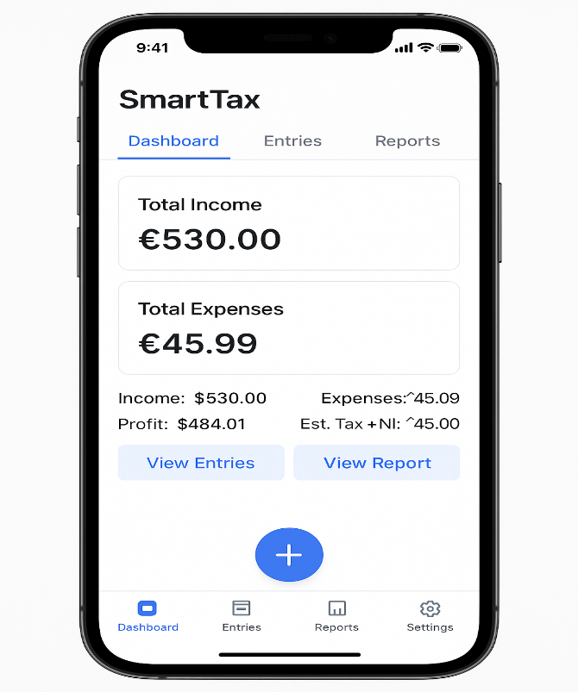 | 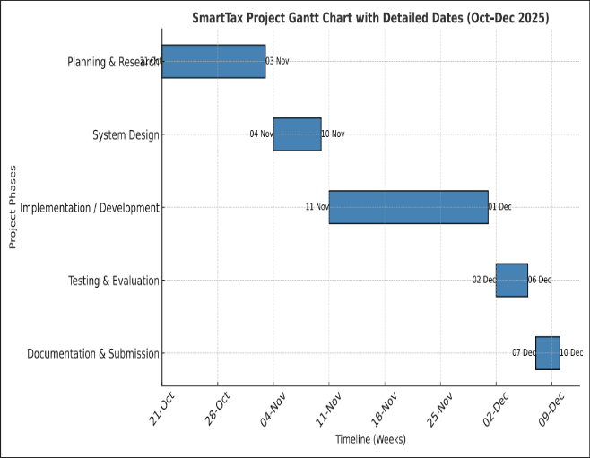
Pic.1 Initial Concept | Pic 2 Ghant Chart

Set up of the environment

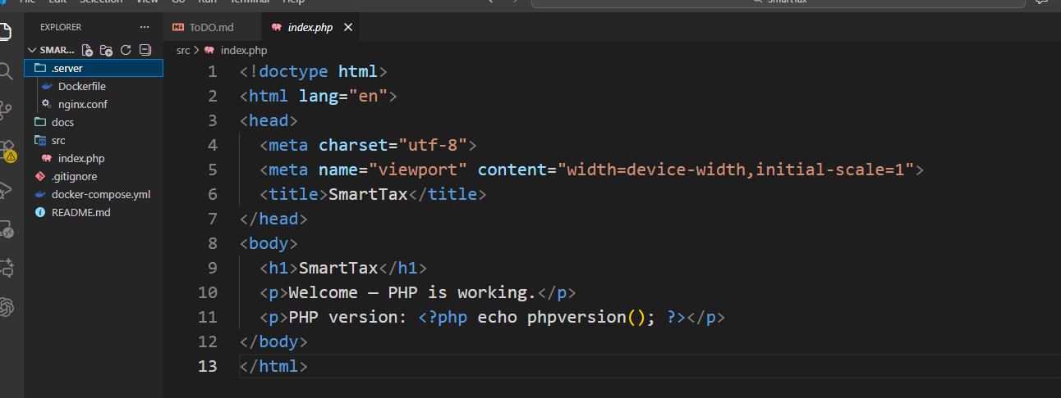
Pic. 3 Server setup
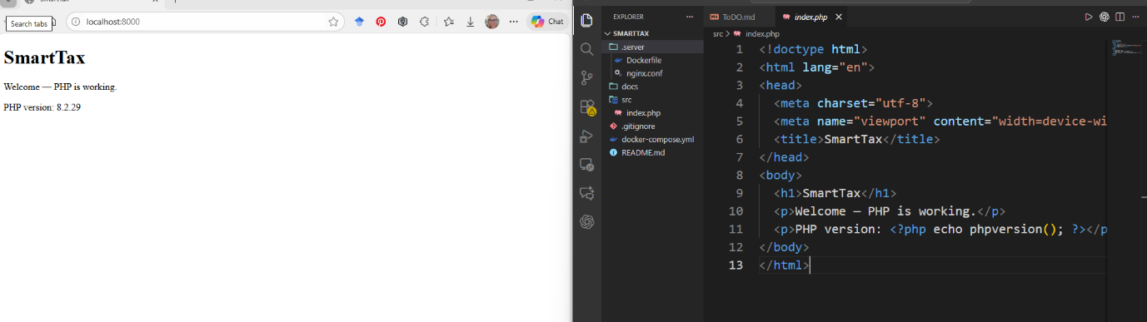

Pic 3 Server setup

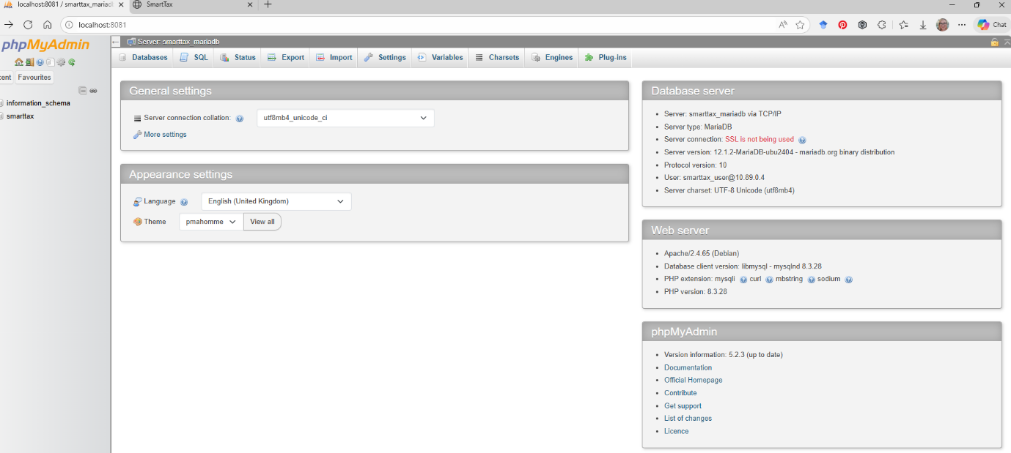

Pic 4 PHP admin

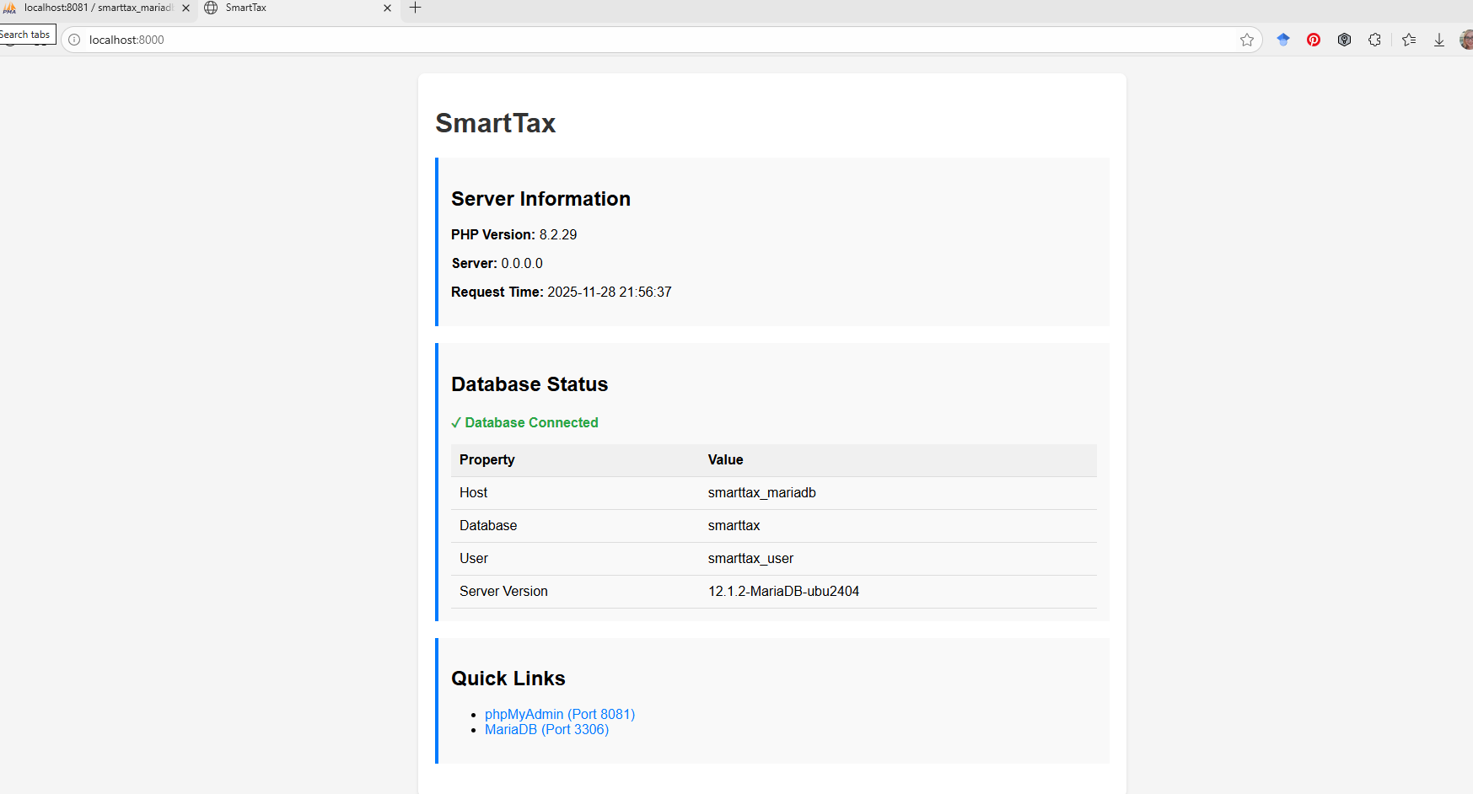
Pic 5 PHP connected.
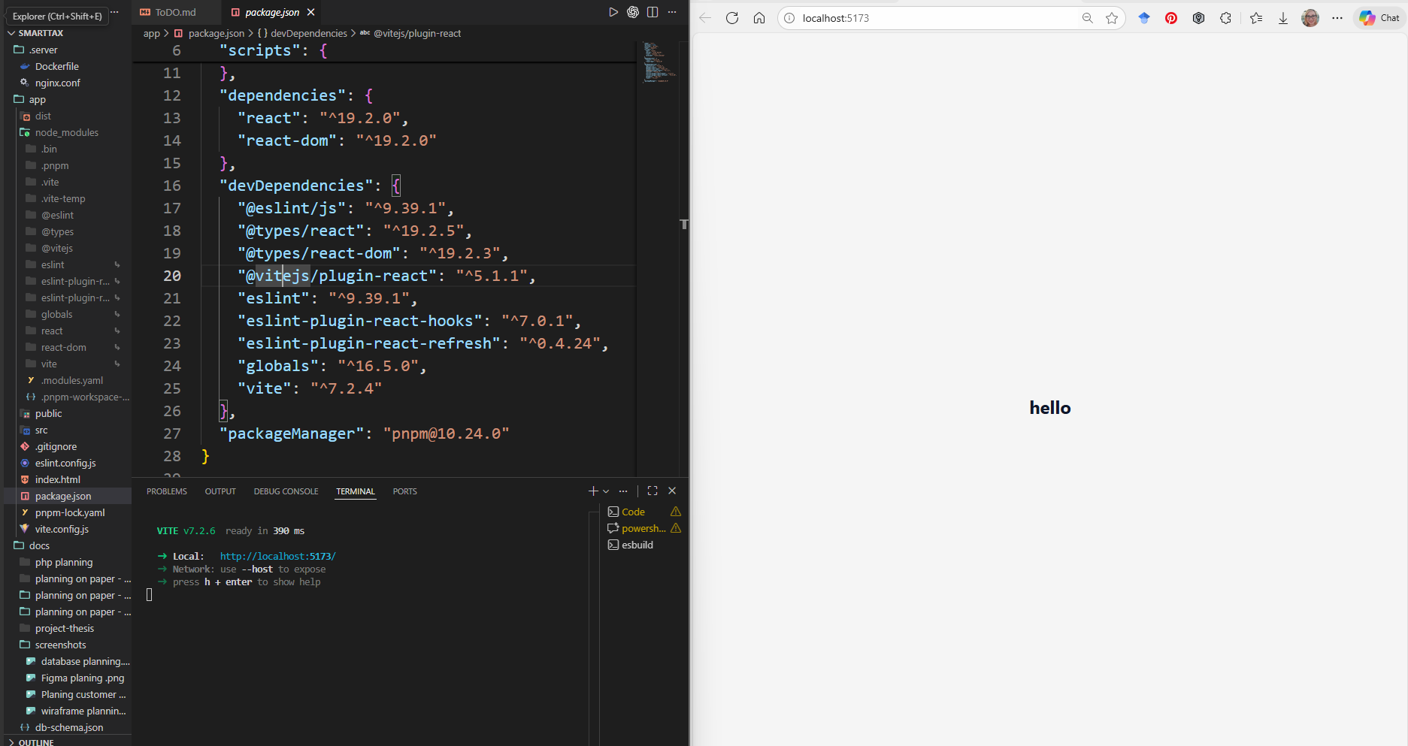
Pic 6 set up React.

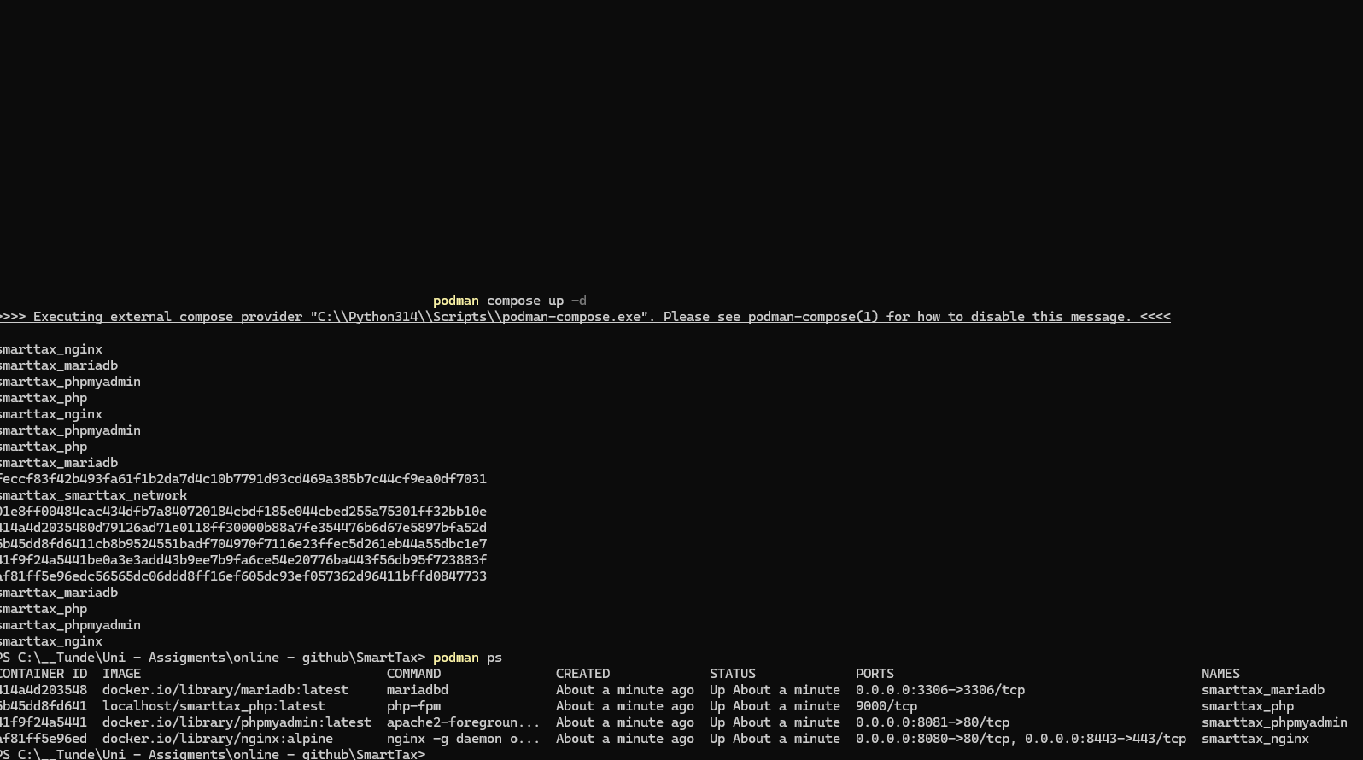

Pic 7 set up Docker (podman]

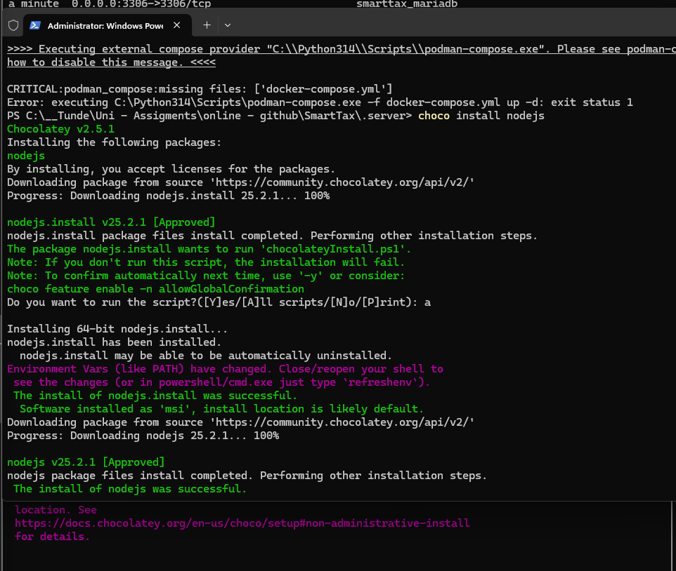
Pic 8 set up NodeJS

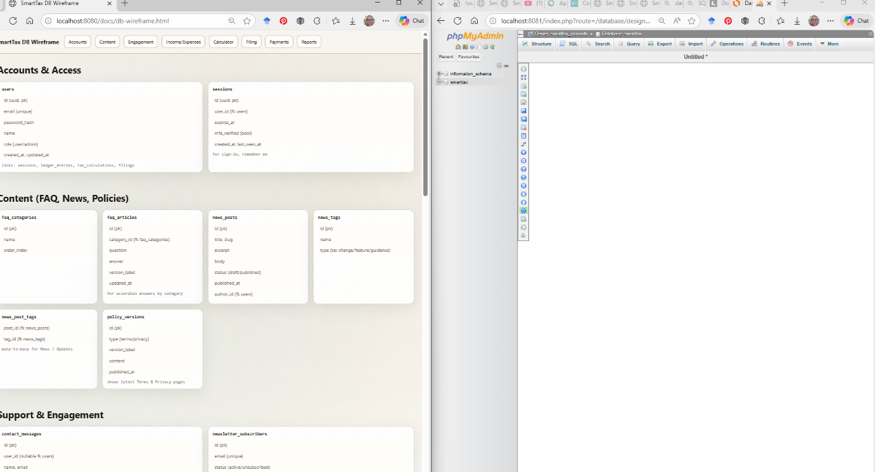
Pic. 9 Database planning

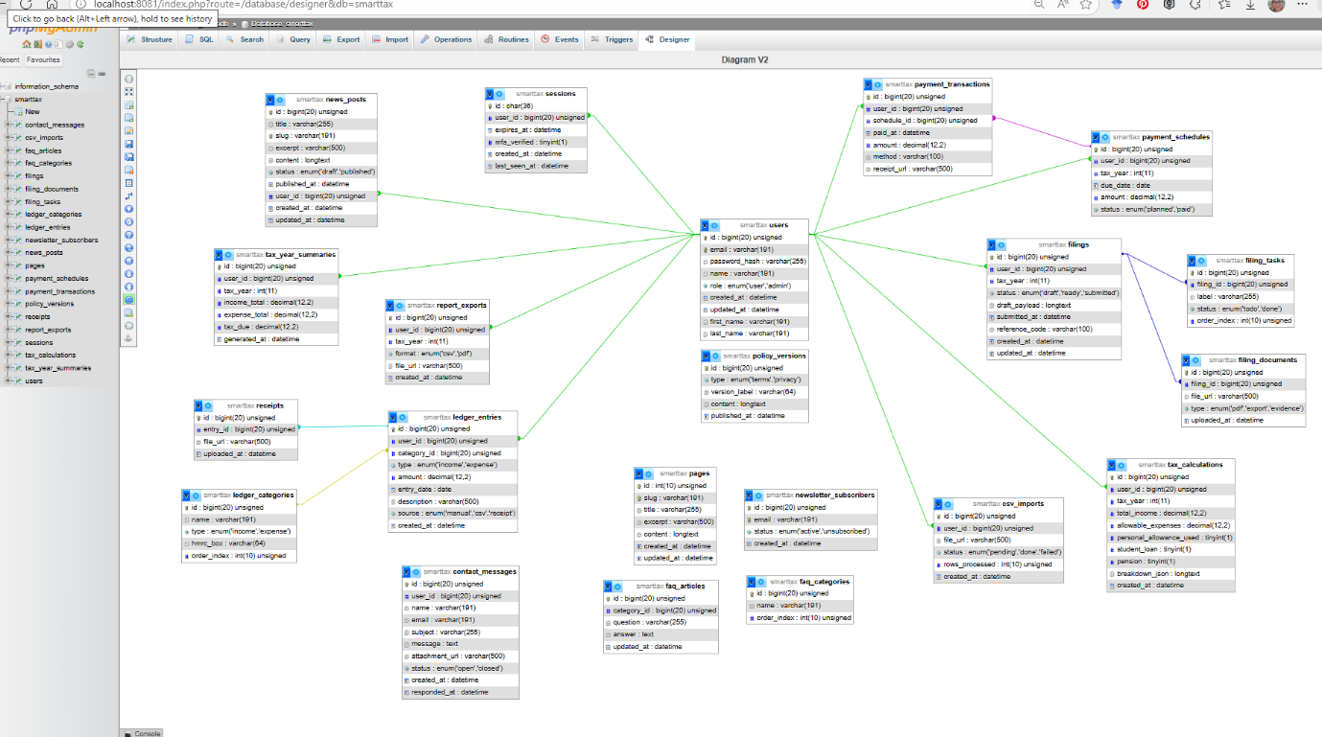
Pic. 10 Database ERD v3

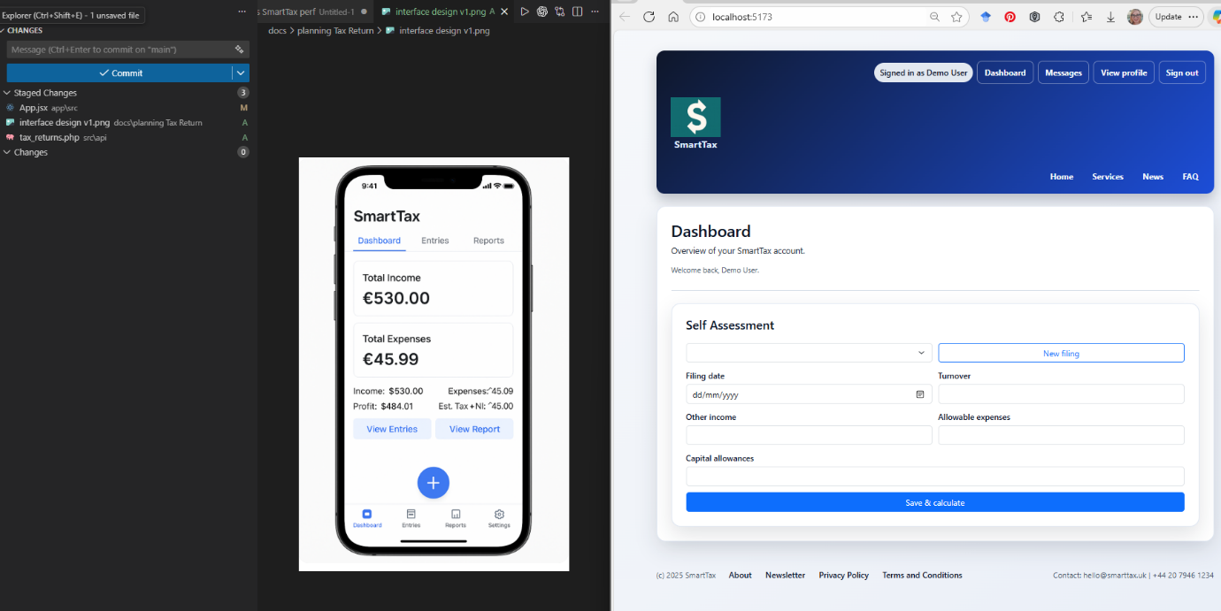
Pic 11 Dashboard v1

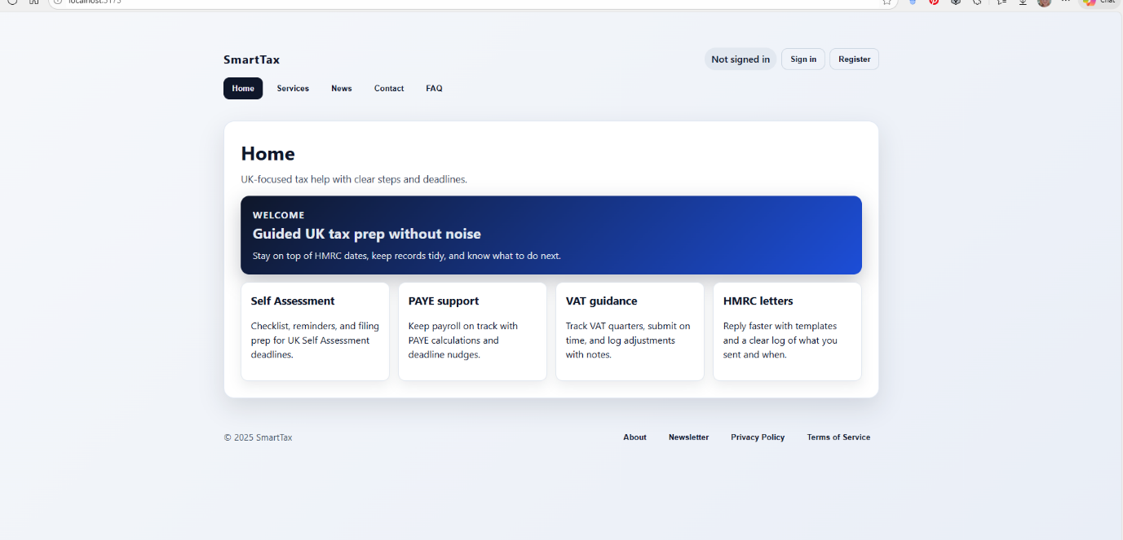
Pic 12 Page.hom v1

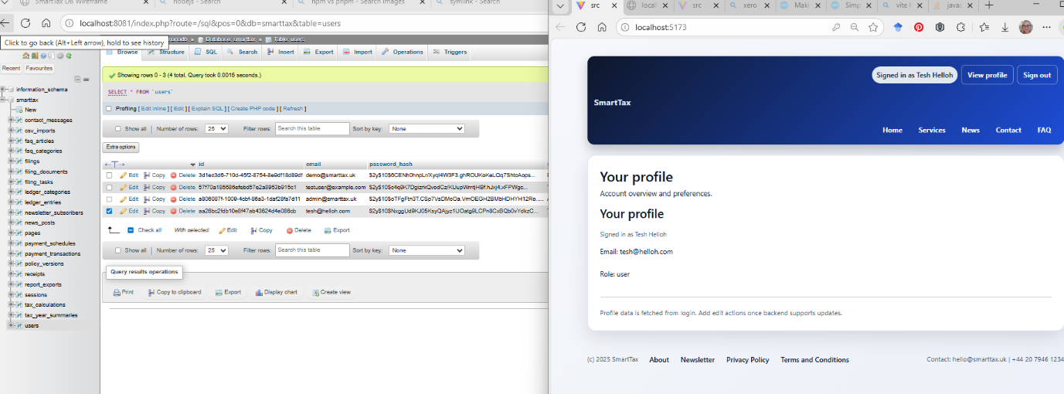
Pic. 14 Page User
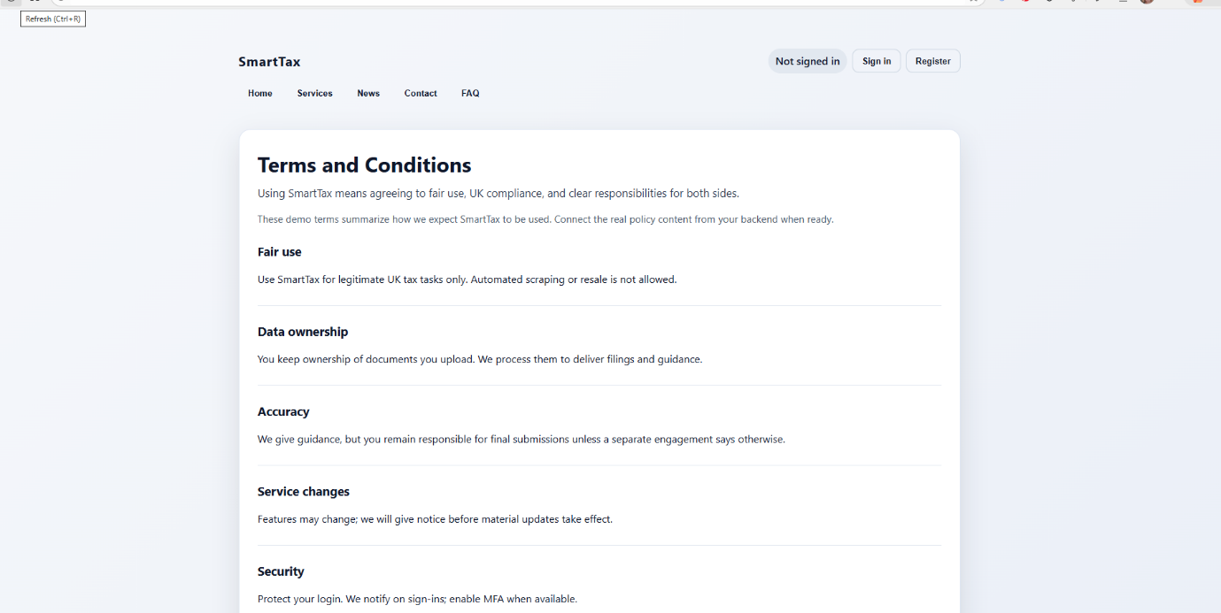
Pic. 15 Page Terms and Conditions

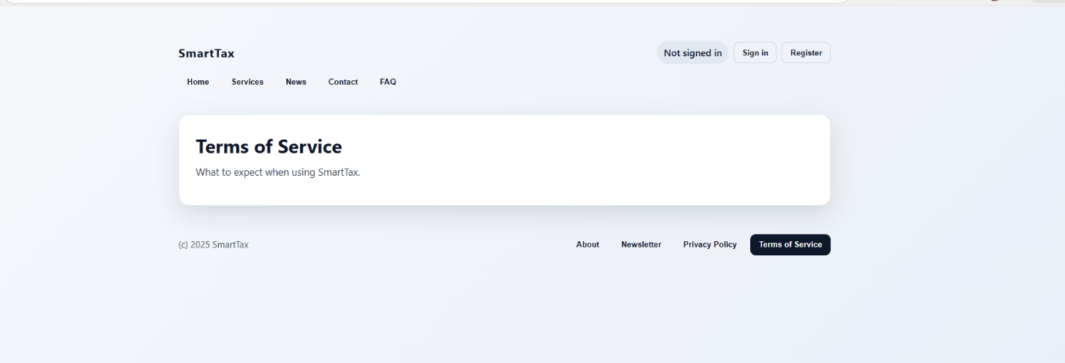

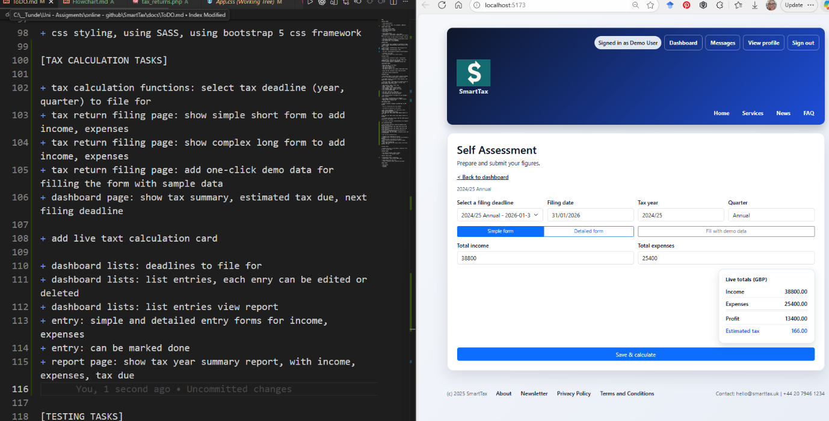

Pic. .16 Tax return short
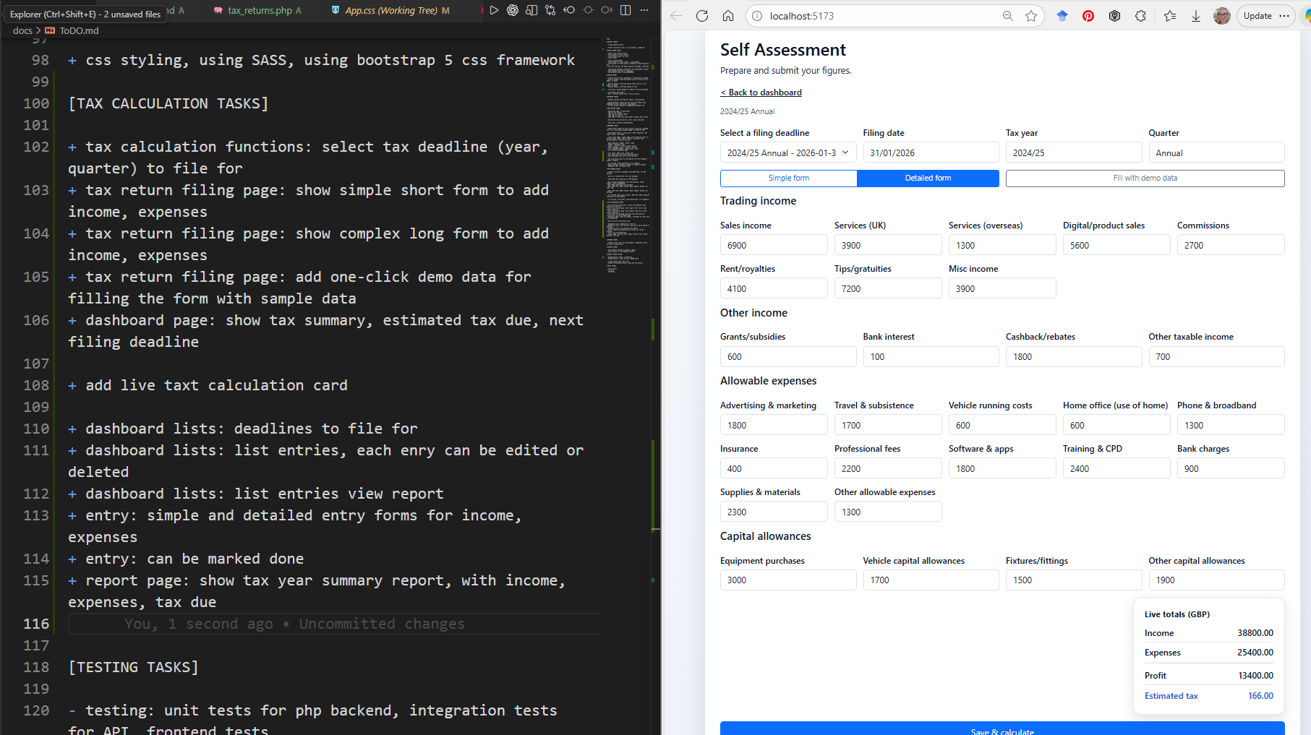
Pic 17. Tax return details version.

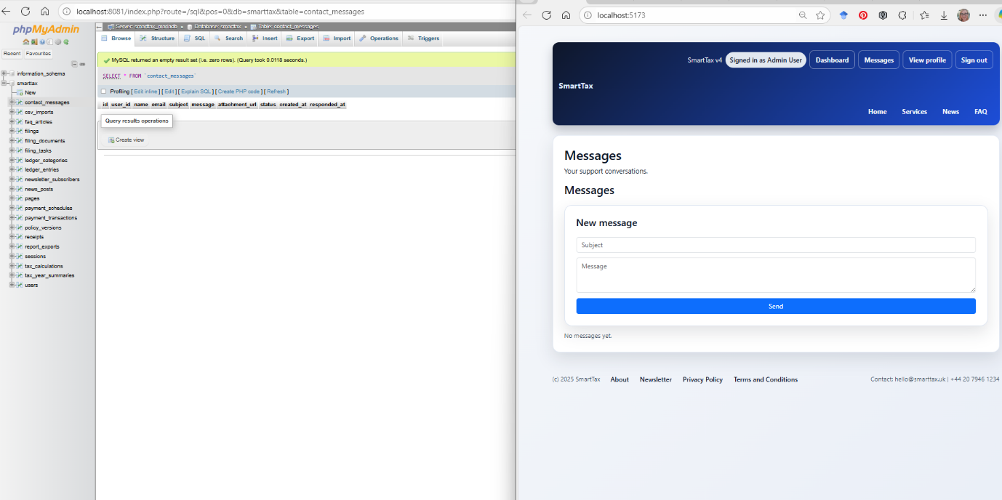
Pic 18 Messages Page

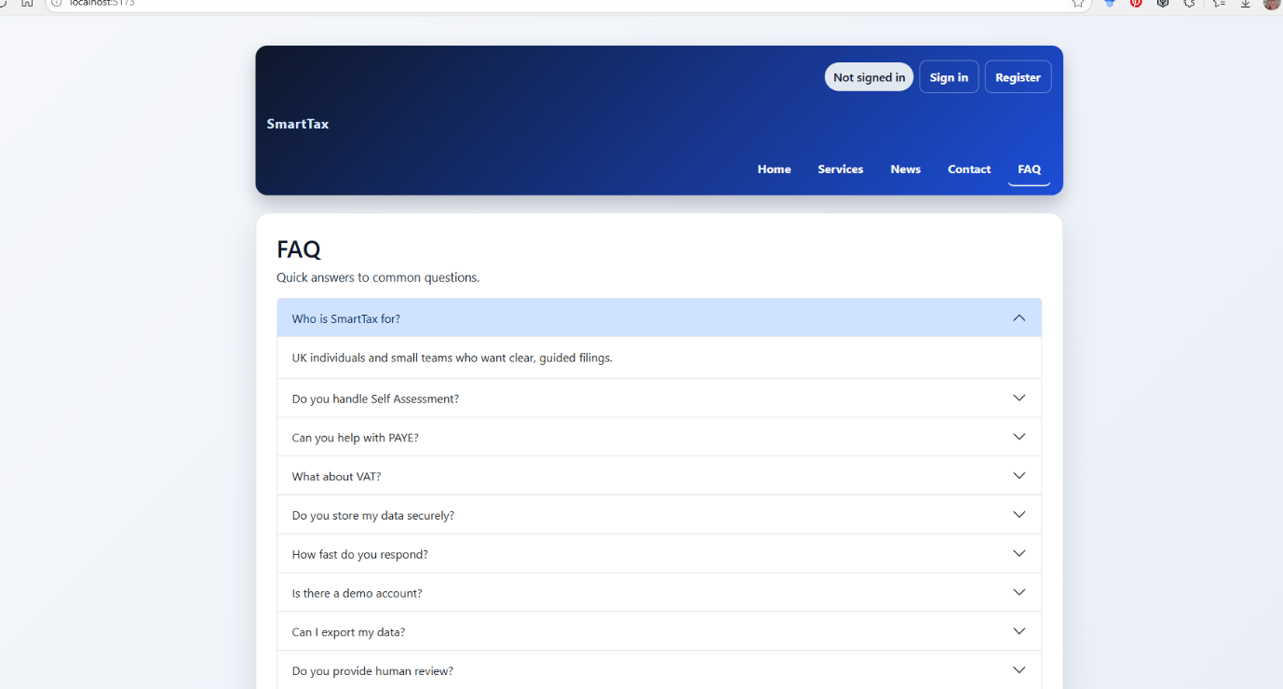

Pic 19. FAQ Page V2

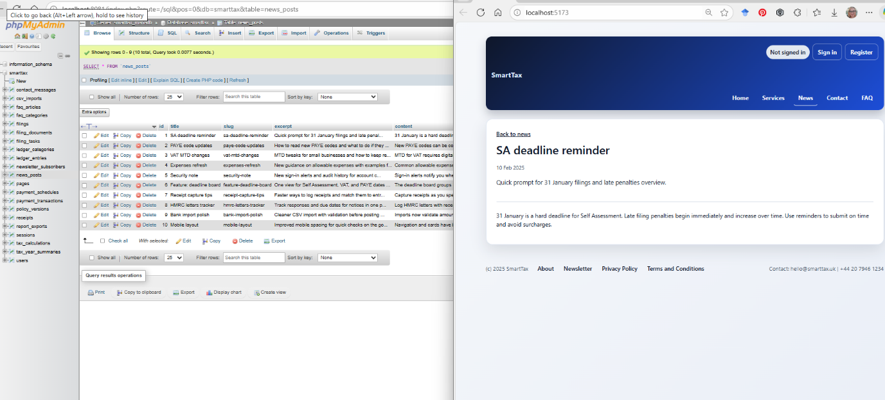

Pic 20 Newsletter

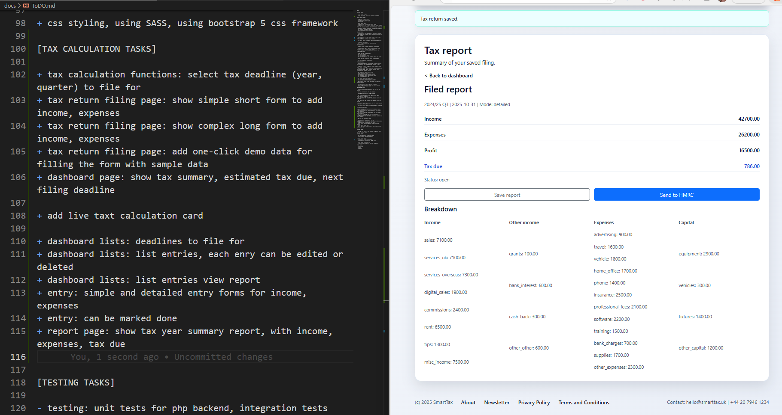
Pic 21 News page

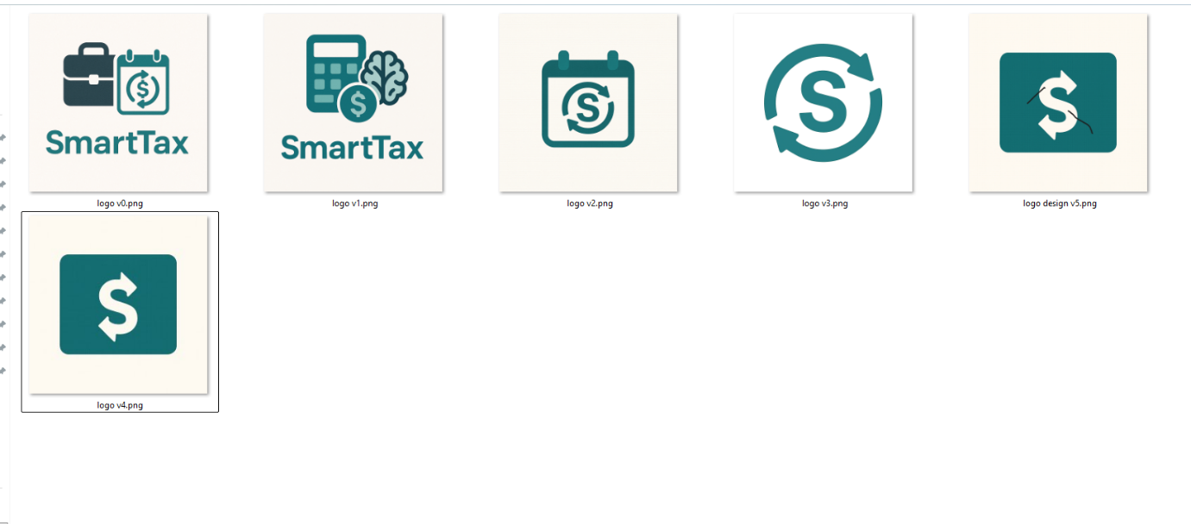

Pic 22 Logo created.

Pic 23 terms and conditions

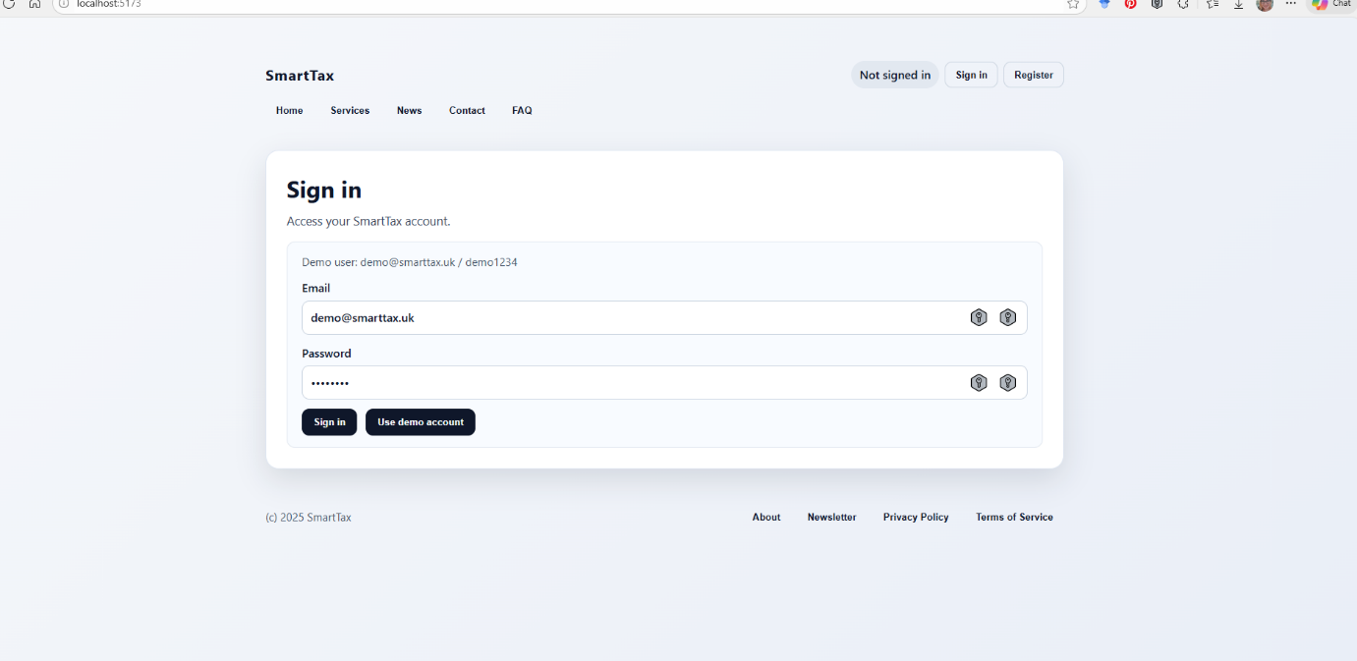
Pic 24 Sign In Page

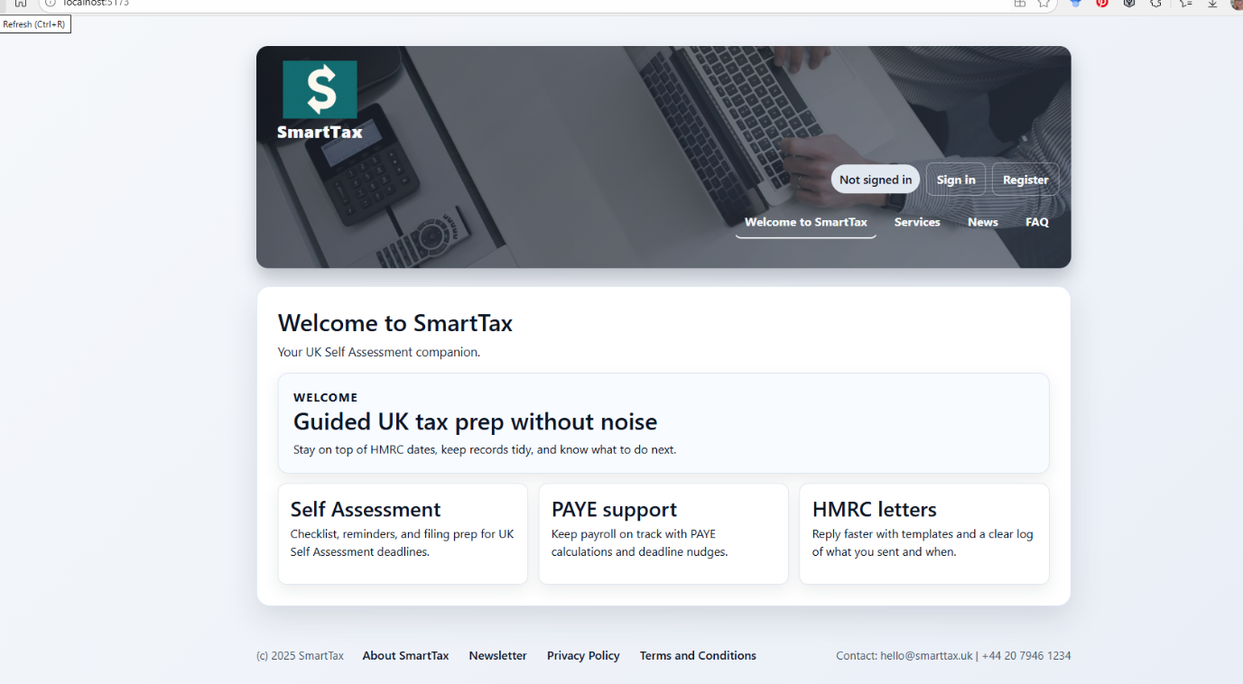

Pic 25 Final Design

Pic 26 Mobile final Dashboard | Pic 27 Hamburger button

Errors

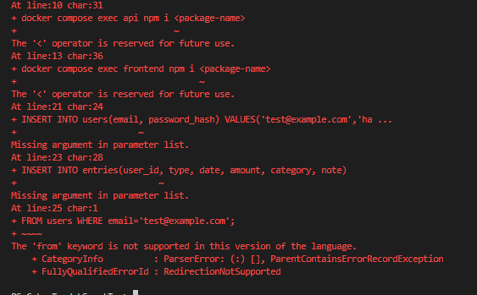
Pic1 (Docker Failure)

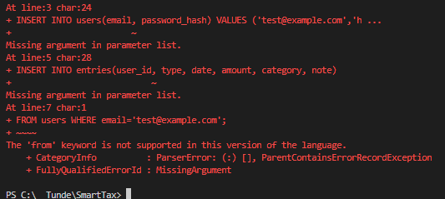
Pic 2 (Dashboard)

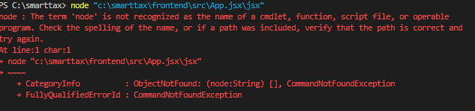
Pic 3 (Nodejs not recognised)

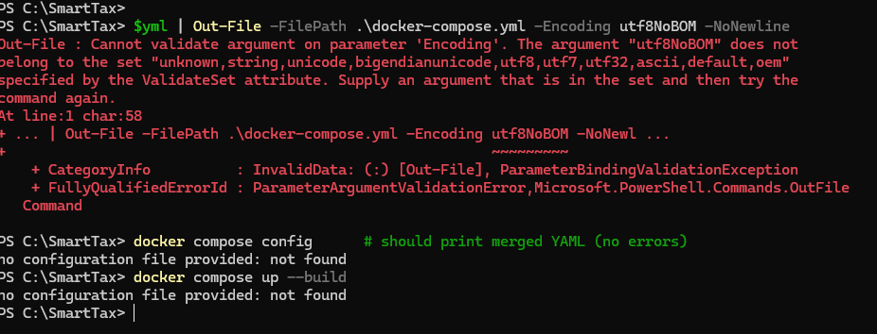
Pic 3 (Docker connection failed)
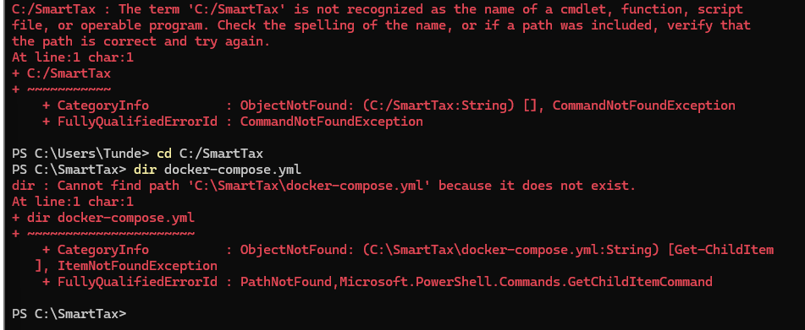

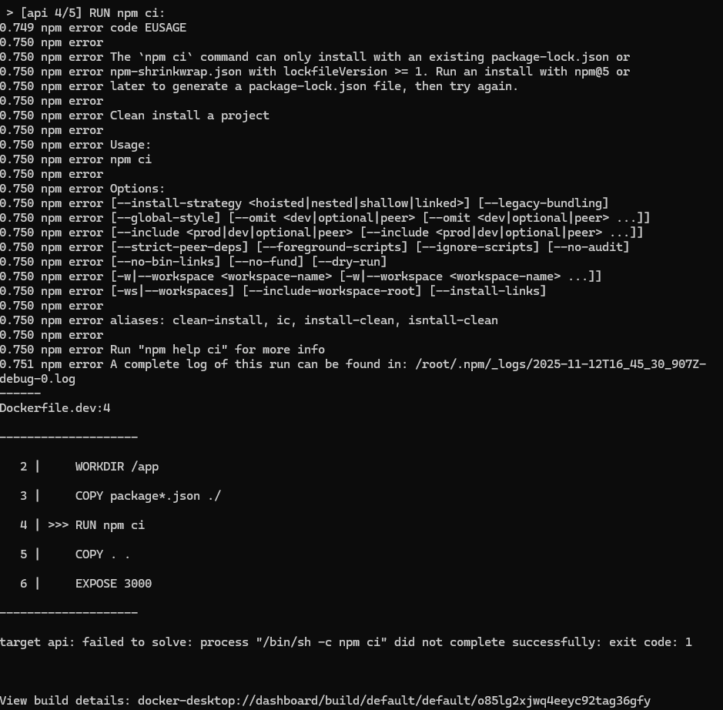
Pic 4 (API failure)
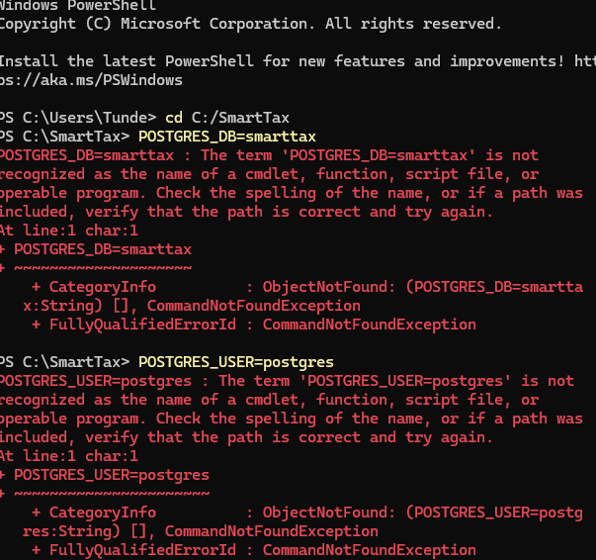
Pic 5 (database not recognised)

