

Construction Management
Assignment 1
Programme Control

By Benjamin Davies (2012775)
Submitted on 20/01/23

Table of Contents Page Number

Introduction 3

Task A 4

A1 5-6

A2 7-11

A3 12

Task B 13

B3 13

Introduction
Construction Management is a role in the construction industry that is vital for a project to succeed, Construction management is a service that involves providing a project owner with management of all aspects of a construction project, from planning to scheduling to budgeting to execution. Without a construction manager you run great risks of going over-budget, running in to major delays, leaving the company vulnerable to break building regulations and health & safety laws, and finally you can experience major communication issues from one job to another. One way that construction managers are able to effectively organise and run a project is through the use of Gantt charts, A Gantt chart is a horizontal bar chart used to illustrate a project’s schedule and related tasks or events during the project lifecycle, these charts give construction managers and teams an overview of what work needs to get done, who’s doing it, and when. In this report we have been assigned with building a Gantt chart of our own and using it for a pre-assigned project, this will show how useful gantt charts can be for construction management.

Task A
You are to assume that UWTSD has received planning consent for a new start up innovation company hub in SA1. [See attached plan and elevation].
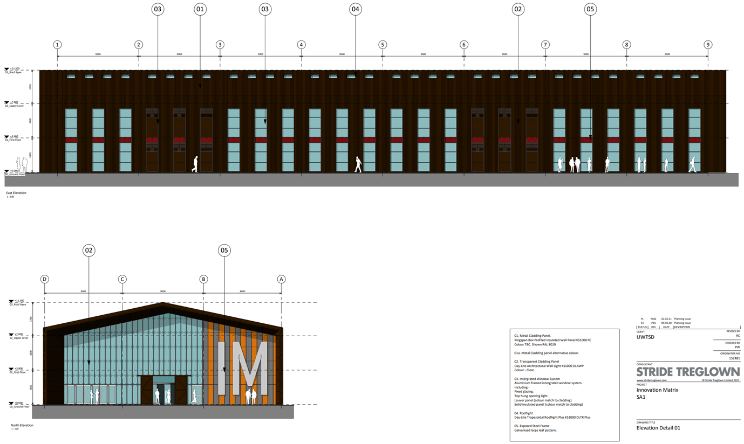
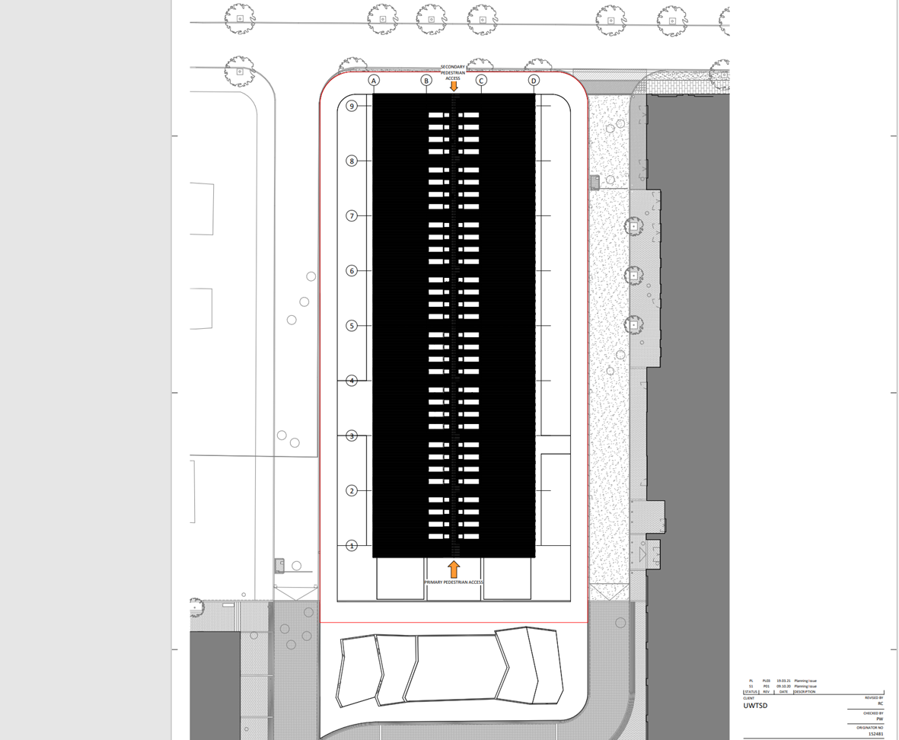

A1
Produce a Gannt chart utilising suitable software showing the critical path. Show a programme from concept design through to handover with detailed programming for the construction phase of a specific element of your choice (25%)
The element I specifically chose was the general construction of the building from planning to completion and I went through each stage in the use of a Gannt chart I constructed on Microsoft Project starting with the Planning phase and ending with material delivery which eludes to the start of construction
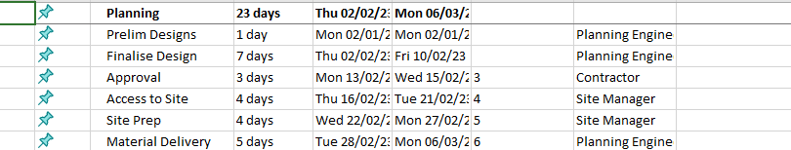

I assigned these roles to different operators like the planning engineer which will be the primary role in the execution of the project, while also accounting for the contractor which is UWTSD itself, and the Site manager who will run the construction site, it spans over 23 days which is a good time scope for this stage.
The first phase is the prelim designs by the planning engineer which is a few drawings that then get cut down to one final design. This then goes to approval from the main contractor, After that the site can be set out by the site manager. Then after the prep is done the materials will then get delivered ready to start the construction.

These Tasks also will show a critical path, a critical path is the longest sequence of tasks that must be completed to complete a project. The tasks on the critical path are called critical activities because if they’re delayed, the whole project completion will be delayed.
The Critical Path is for the planning stage is shown below
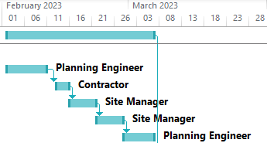

A2
Develop, evaluate and produce site specific reports for time, cost and resources of the work activities. Costs should be relevant to the element of your choice (25%)

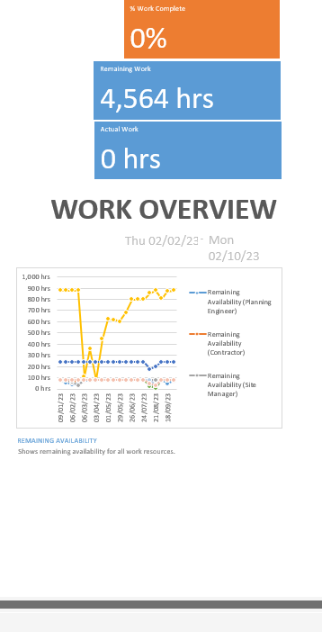
This Graph shows us that the work I have proposed runs from 02/02/23 – 02/10/23 which is 242 days and requires 4,564 hours of work from the construction workers. It also shows the availability of each worker in the graph which is very useful to us because it must be accounted for during construction.
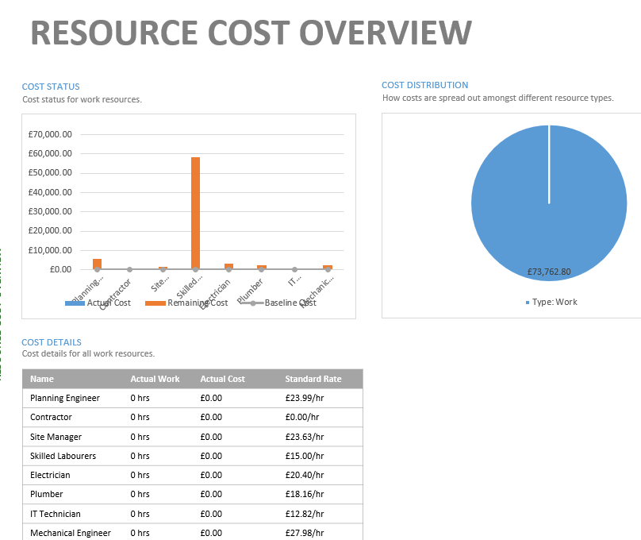

The resource cost is the hourly rate of each worker, this will help calculate the final cost of the whole project, I used the spons guide to calculate each hourly rate per worker.

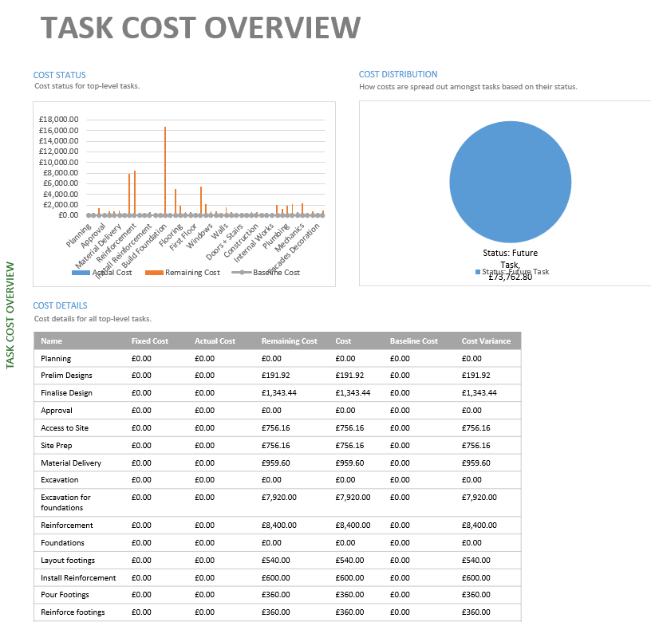
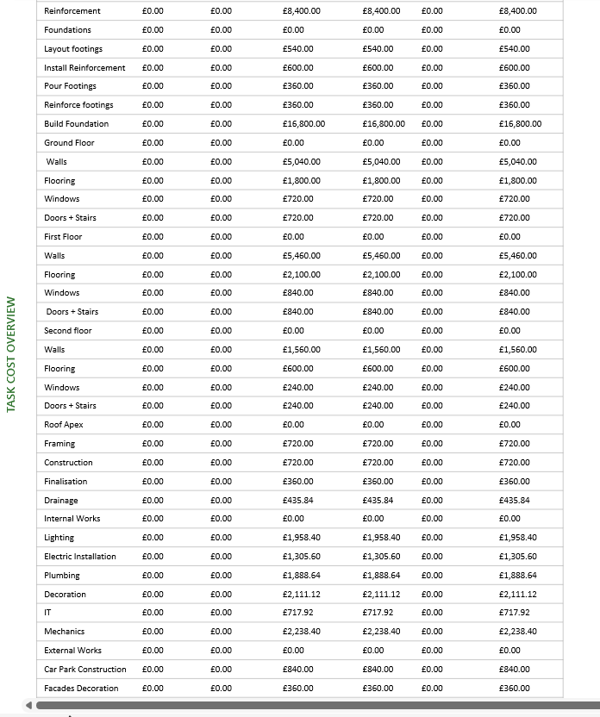

This table shows the cost per each task and as we can see excavation sector costing the most with it altogether costing £16,320 altogether this is due to the high number of skilled labourers needed to excavate the area and use reinforcement. Knowing these costs is important because when designing and constructing a building, successful projects require accurate cost estimates. Cost estimations forecast the resources and associated costs needed to execute a project, which helps ensure you achieve project objectives within the approved timeline and budget.

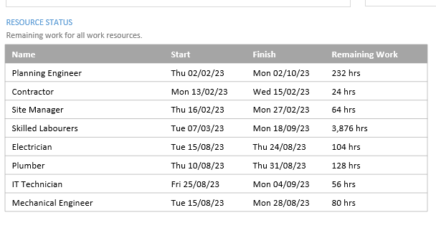
This table shows the working hours of each profession involved in planning and construction. This helps us calculate the overall cost as we can go through each one and calculate their hours against their hourly rate.

A3
You need to explain possible ways of addressing performance issues in terms of productivity and incentivisation to the client specific to the scenario (25%).
Performance and incentivisation is often a difficult and nuanced discussion but empowering the workforce through incentivisation is important for any business. Rewarding employees can help to attract and retain the best talent and develop committed and incentivised staff. Incentivisation is incorporating incentives into an arrangement in order to motivate the workers to perform. Incentives can be either financial or non-financial. In our case we could implement some friendly competition towards cash prizes between the workers to increase productivity or run on site competitions to increase well being and morale. Doing this will improve the productivity of the workers which will in turn better their performances to get tasks done efficiently. Also, we must listen to the views and opinions of the workers so they feel like their opinions matter which will make them feel like they want to be in the construction project, and it will help them feel more involved with the project. Performance measurements are a good incentive tool for the workers, especially when rewards are attached to them, if we set clear performance measurements and consider attaching a small financial bonus for each one, they achieve, It will help with the communication between our team, making the workers more effective in terms of improving efficiency. There are a variety of performance incentives we can set, including: being on time at the construction site, helpfulness toward colleagues, completing construction work on time, taking initiative to solve problems and issues that arise, and the overall quality of the build.

Task B
B3
There is a delay in the manufacture of the bespoke windows. The delay is due to be 5 weeks. Show how this affects the project within the report addressed to the client and how is it generally dealt with from a contractual point of view (Gantt chart). (25%).

Generally, in most construction contracts you are provided with additional time for delays which are attributable to the owner. However, if the delay is because of the contractor, then, the owner is entitled to receive liquidated damages stipulated under the contract, the contractor is entitled to receive time extension without any additional compensation. Generally, construction contracts do not cover all kinds of delays. However, most of the construction contracts generally contain a clause regarding timely completion of the works under the contract, it is also regarded that time is of the essence, which indicates that the contractor is under an obligation to ensure timely completion of the contract.
In this case we have been told there is a delay with the manufacturing of windows, to ensure that we are able to get everything done in time we worked around it and got other projects complete first so we ended up doing the framing before fitting and waited until mid July for the windows to come as seen in the gaant chart below


