Organisational Report

Syeda Shabna Begum
2126655

Lecturer: Maggie Lan Zang
Submission date: 31 May 2024

Management & Organisational Behaviour
BMIH5004

Word Count: 2,177

Executive Summary:
The report on Hilton delves into the organisation’s recent changes initiatives, strategic direction, and impact on operations. Hilton’s focus on enhancing guest experiences, sustainability efforts, and community involvement aligns with its commitment to excellence and differentiation in the competitive hospitality market. By incorporating sustainability into its operations and emphasising guest satisfaction, employee development, and community engagement, Hilton aims to maintain a competitive edge in the industry. the report also analyses Hilton’s organisational structure, culture, and goals, highlighting its efforts to drive innovation and strategic partnerships to address competitive forces and stay ahead in the market.

Contents Table:

Cover page…………………………………………………………………….…………….1
Executive summary…………………………………………………………………….….2
Introduction....………………………………………………………………………………4
Hiltons Organisational Structure.………………………………………………….…4-5
Hilton’s culture and goals………………………………….…………………………….6
Hilton’s goals……………………………………………………………………….……6-7
Progress of Hilton: 2030 Goal Tracking……………………………….……………7-8
Hilton’s recent change initiatives, their impact and how well these were managed…………………………………………………………………………….………9
Hiltons strategic direction……………………………………………....………….10-12
Recommendations……………………………………………………………………….13
Conclusion…………………………………………………………………………………13
References…………………………………………………………………………….14-17

Introduction:
Hilton hotel group is a renowned hospitality company known for its luxury hotels and resorts worldwide. Offering a wide range of services and amenities to cater the needs of various travellers, ensuring a comfortable and memorable stay for their guests. Hilton is committed to providing exceptional hospitality experiences and is a popular choice. Hilton is recognised first as the World's Best Workplace by Great Place to Work and Fortune (Hilton, 2024). This report will explore the organisational structure, culture, and goals of Hilton, analyse recent change initiatives and their impacts, assess the management of these changes, and evaluate the strategic direction of the organisation at both the corporate and individual unit levels.

Hilton’s organisational structure:
Organisational structure refers to how it is organised in terms of divisions, departments, and roles. It outlines how different parts of the organisation are connected and how tasks are divided among employees. This structure helps define the hierarchy, communication channels, and decision-making processes within the organisation (Jain, 2024). Hilton's organisational structure is hierarchical, allowing for effective administration and decision-making throughout the corporation. The Board of Directors is at the top of their organisational hierarchy, followed by the CEO and Executive Team, the Corporate Support Team, and finally the Hotel Operations Team. Each department plays a crucial role in maintaining the high standards and quality service that Hilton is known for (Helm, 2024). Hilton’s organisational structure can also be described as divisional, the C-suite at Hilton oversees several functional and regional divisions: Ownership, Management and Franchise, timeshare (Organimi, 2024).
The roles each departments play:
Board of Director’s: Hilton's Board of Directors oversees the company's overall direction and performance. They advise and support the Executive Team, ensuring that the company acts in the best interests of its shareholders and stakeholders.
CEO and Executive Team: The CEO and Executive Team are responsible for the company's strategic direction and vision. They make critical decisions and guarantee that the organisation achieves its goals and objectives. They also lead and guide the Corporate Support and Hotel Operations Teams.
Corporate Support Team at Hilton: The Corporate Support Team supports the entire organisation, including human resources, finance, marketing, and technology. They collaborate closely with the Executive Team to implement plans and activities that propel the company's growth and success.
Hotel Operation’s Team: The Hotel Operations Team oversees managing Hilton's global hotels daily. They ensure that each hotel operates smoothly and provides excellent service to customers. They also collaborate closely with the Corporate Support Team to establish best practices and standards across all locations (Helm, 2024). 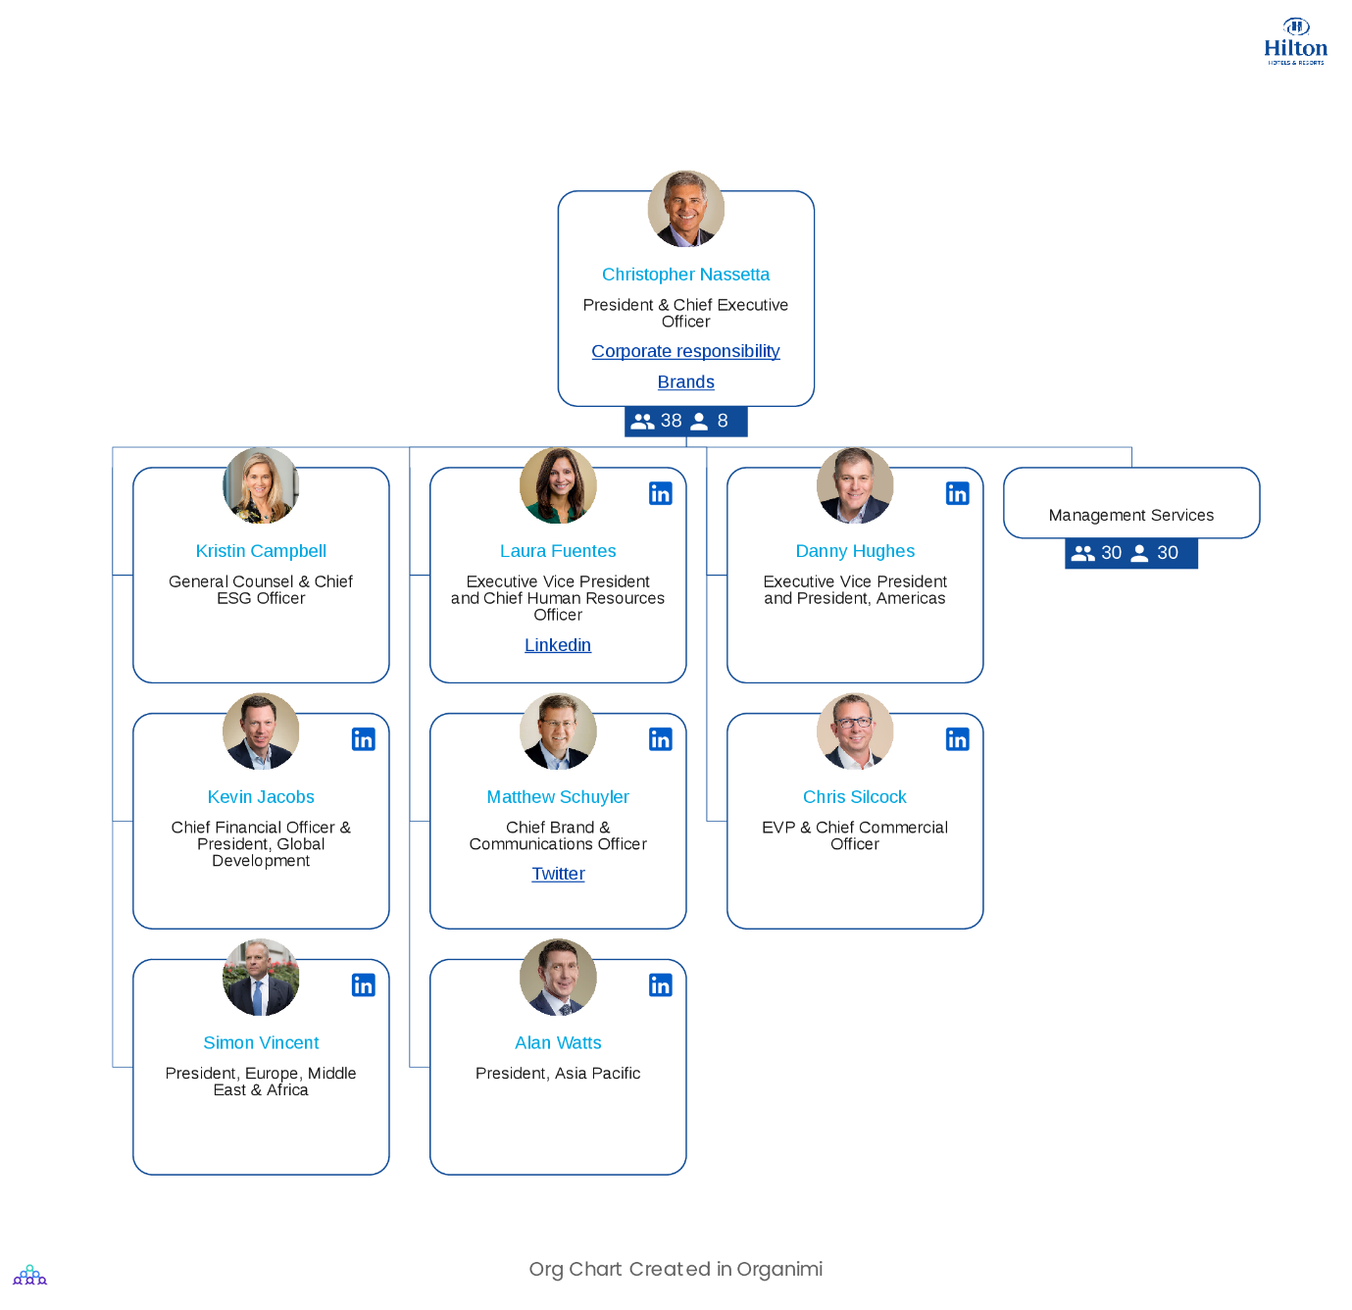
(Organimi, 2024).
Hilton’s Organisation culture and goals:
Hilton’s people-first employee-oriented company culture that harmonises with their corporate vision and strategy, grants them a unique competitive advantage in the hospitality industry. Hilton’s organisational culture is known for its focus on guest satisfaction, employee development, and community engagement. They strive to create a welcoming and inclusive environment for both guests and employees, emphasising high-quality service and continuous Improvement. Hilton’s goals include providing exceptional hospitality experiences, promoting sustainability practices, and contributing to the communities they operate in through various initiatives. Their culture and goals reflect a commitment to excellence and making a positive impact in the hospitality industry (Lambrano, 2020). Hilton was just named No. 1 on Fortune's Best Workplaces for Women 2023 list, for the fifth consecutive year. Maintaining this prestigious distinction is no easy achievement, given Hilton's operations in 124 countries and territories and a workforce of nearly 460,000 employees. Hilton uses four pillars to follow Conrad Hilton's vision. Hilton stays faithful to Conrad Hilton's original vision, combining a customer-centric strategy with a strong dedication to hospitality and its employees. The organisation helps employees throughout their entire employment path, from day one to retirement, with a variety of wellness, lifestyle, and professional development programmes (Cawley, 2023).

Hiltons goals:
Hilton’s goal is to be the leading worldwide hospitality provider, the first choice for owners, team members, and visitors alike. Their mission is to provide unique experiences to every hotel, every visitor, every time, to spread the love and light of hospitality throughout the world (Hospitality ON, 2024). Hilton, one of the biggest hospitality organisations in the world, is dedicated to promoting responsible travel and tourism around the globe. Through their ESG strategy, Travel with Purpose 2030 goals to redefine sustainable travel. Hilton is dedicated to promoting ethical travel and tourism throughout the world while also advancing good environmental and social impact and sound governance throughout their operations and communities. In accordance with the goals and schedule of the Sustainable Development Goals (Hilton, 2023).
Aside from enhanced environmental targets, Hilton has reinforced its commitment to supporting the areas where it works by releasing three updated social impact goals.
- Create 5 million learning and career development opportunities for team members and communities, with a focus on underrepresented populations, by 2030.
- By 2030, Hilton will have a significant impact on 20 million community members through local support, disaster relief, economic opportunities, and other initiatives.
- Promote responsible, inclusive conduct throughout their entire value chain operations.
Hilton's social impact strategy will be supported by the Hilton Global Foundation, which has provided over $5 million to over 70 non-governmental and community-based organisations that make a positive effect in the communities it serves since 2019. The Foundation has announced 14 additional awards to NGOs that help people disproportionately affected by COVID-19 and climate change. The subsidies include of employment assistance for asylum seekers, medical supplies for local health systems, and urban community farms (Travel with Purpose, 2022).

Progress of Hilton: 2030 Goal Tracking:

Hilton have been monitoring every target since the inception of their Travel with Purpose 2030 Goals in May 2018 to ensure they meet their objectives. Below is the progress report:

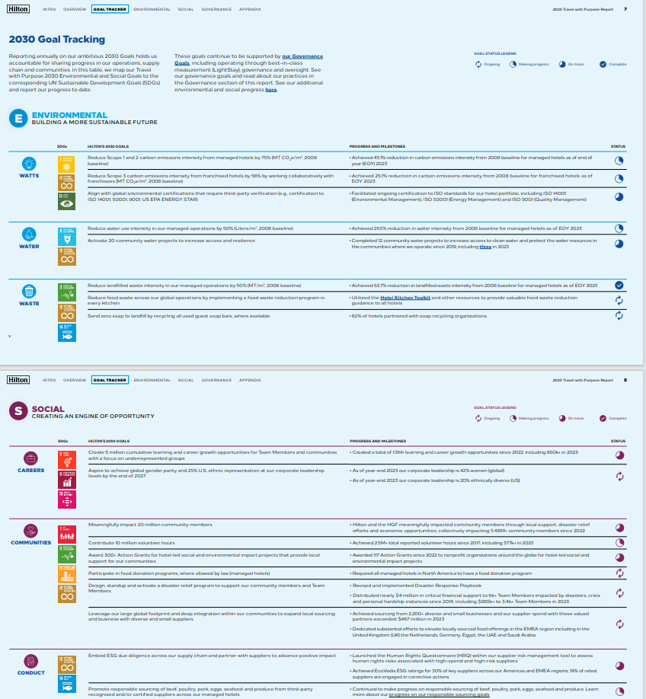
(Hilton, 2023).

Hilton’s recent change initiatives, their impacts and how well these were managed:
The most direct strategy to reduce food waste is to prevent it in the first place. The hotel industry may help reduce its carbon footprint by being careful of the food it discards (Truong, 2022). In line with Hiltons 2030 Travel with Purpose ESG goals, Hilton has pledged to cut waste in all areas of their international operations by 50% by the year 2030. In addition, Hilton is attempting to implement these solutions throughout their estate while collaborating with several technology partners to advance a forensic understanding of their waste (thesra.org, 2024).
Launching the Hilton Green Ramadan Initiative last year alongside UNEP West Asian and Winnow across three hotels in the Middle East, which led to a 61% decrease in food waste during the Holy Month, is one particularly proud moment. Hilton with great pleasure announced that this initiative has already expanded to 32 hotels in seven countries this year. Hilton anticipates working with UNEP to promote the development pf an industry toolkit in the future (Food tank, 2024).
Building on the success of that initiative in conjunction with the United Nations Environment Programme, Hilton established the Green Breakfast Pilot Programme across 13 hotels in the UAE which began in August 2023. In addition to introducing behavioural nudges and interventions, all 13 hotels integrated Winnow AI technologies for production and plate waste management. By using gastronomy, local sourcing, composting, and food donations, Hilton closed the loop throughout the food value chain. Hilton noticed a 62% decrease in food waste throughout the 13 hotels in just four months and helped reach their COP28 (Ayache, 2023).
Outstanding illustration of the financial and moral impact, last year’s Green Ramadan results were astounding. With the use of and engaging and informative approach, the campaign, which served 27,000 visitors, was able to overcome the obstacles to food waste awareness. Over 8,600 meals were provided, resulting in a 61% reduction in waste, as well as the avoidance of about 4.8 tonnes of garbage and over 14 tonnes of CO2 emissions. Additionally, it saved about $40,000 (thesra.org, 2024)

Hilton’s Strategic direction:
A hotel strategy is a comprehensive plan that describes how an organisation intends to go about achieving its targets. Addressing several important operational and managerial topics, such as: Market positioning, management of revenue, customer support and experience (SiteMinder, 2024).
Service distinction can be described as the cornerstone of Hilton Hotel’s business strategy. By focusing on maintaining a strong competitive edge through innovative guest experiences, effective customer relationship management, strategic partnerships with suppliers, continuous market analysis to anticipate new entrants, and differentiate through unique offerings to minimise the threats of substitutes. This strategic approach helps Hilton stay ahead in the dynamic hospitality industry landscape (Talbot, 2019).
When applying Porter’s Five Forces analysis to Hilton Hotel Group, the strategic direction is influenced by various factors. The competitive rivalry within the hospitality industry, the bargaining power of customers, the threat of new entrants the bargaining power of suppliers, and the threat of substitute products or services all play a role in shaping Hilton’s strategic directions. By carefully considering these forces, Hilton can adapt its strategy to maintain a competitive edge in the market and continue to provide exceptional hospitality experiences while addressing challenges effectively (Strategic Analysis Hub, 2024).
Competitive rivalry:
In the hospitality industry Hilton faces significant competitive rivalry from other major hotel chains like Marriott, Hyatt, and InterContinental Hotels Group. These competitors constantly strive to attract guests, offer unique experiences, and expand their global presence, which creates a dynamic environment where Hilton must continuously innovate and differentiate itself to maintain its competitive edge. Hilton differentiates itself from competitors by focusing on guest satisfaction, employee development, and community engagement.
Bargaining power:
Hiltons bargaining power is influences by various factors, including its strong brand reputation, global presence, and customer loyalty. These elements give Hilton a significant advantage in negotiations with suppliers, partners, and even customers, allowing them to secure favourable deals and maintain a competitive position in the market.
Threat of substitute:
In the hospitality industry, Hilton faces a moderate threat of substitute products or services. While there are alternative accommodation options like Airbnb or boutique hotels, Hiltons strong brand, service quality, and loyalty programs helps differentiate it from substitutes, making it a preferred choice for many travellers seeking a reliable and high-quality hospitality experience (Dudovskiy, 2016).

One example of how disruptive technologies can be successfully used into marketing tactics is the Hilton case. Hilton’s strategy, which is distinguished by the creative use of social media for consumer interaction and advertising, has significantly increased revenue, customer retention, and brand recognition (Eze, 2022).
Hilton has a 100-year history and operates over 5,700 locations throughout the world. However, many investors may be unaware that Hilton’s business has continues to grow rapidly, resulting in outstanding returns for stockholders.
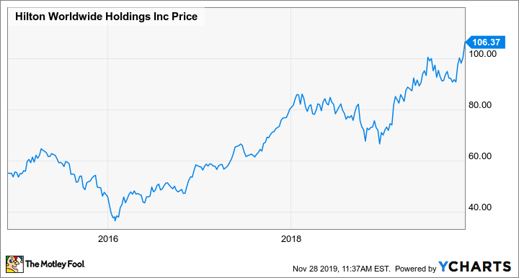
To encourage visitors to book directly with Hilton, the business has advertised its loyalty programme and promised to match the best price available on any website, providing travellers with both the best price and loyalty reward points.
The reaction has been positive. The number of participants in Hilton's reward programme increased to 94 million this year from 36 million in 2012. Since loyalty programme members made up over 60% of the hotel chain's occupancy in the second quarter of 2019, the endeavour’s growth is particularly encouraging.
Hilton's marketing campaign and reward scheme have generated substantial consumer demand, outpacing the whole hotel industry and consistently resulting in occupancy levels above 75%. Because the parent company is no longer investing in real estate, this strong performance has encouraged franchisees to open additional hotels, which is essential for expansion. Additionally, the company's financial model guarantees that the growth will be profitable (Sanchez, 2019).
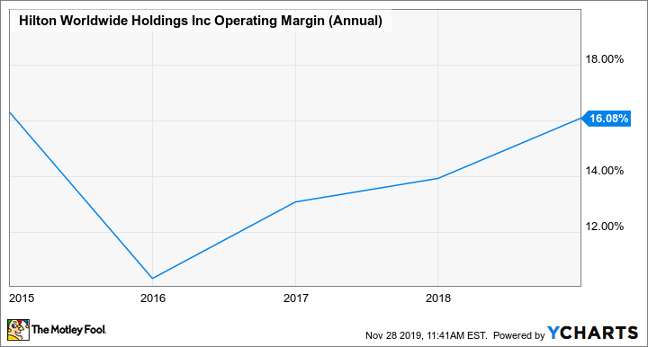
Hilton wats to reinvent and progress sustainable travel through Travel with Purpose. To do this the company will leverage the strength of its people, who are the core of this endeavour, together with a wide range of projects (Hilton, 2023). Hilton’s mission statement “To fill the earth with the light and warmth of hospitality by delivering exceptional experiences-every hotel, every guest, every time” (JobSage, 2024).
Numerous prestigious measuring groups have acknowledged Hilton’s commitment and teamwork for their social and environmental initiatives (Hospitalitynet, 2023). Hilton is well-positioned for further expansion in 2024 after a strong 2023 that saw the firm reach its greatest development pipeline in history and open a record 24,000 rooms across 132 properties in the last quarter of the year (Stories from Hilton, 2024).

Recommendations:
Based on the analysis conducted, some recommendations for Hilton hotel group include further enhancing employee training and development programs to ensure consistent service quality, expanding sustainability initiatives to align with evolving consumer preferences, and strengthening community engagement efforts to foster positive relationships in the areas they operate (EcoCart, 2023). Additionally, Hilton could consider leveraging technology to streamline operations and enhance guest experiences further (Gold, 2024). These recommendations can help Hilton stay at the forefront of the industry and continue to excel in the competitive hospitality market.

Conclusion:
In conclusion, Hilton hotel group’s strong organisational structure, culture emphasising guest satisfaction and community engagement and strategic goals centred on excellence and sustainability positions the organisation as a leader in the hospitality industry. By aligning its goals with industry dynamics and competitive forces, Hilton continues to differentiate itself and drive excellence in the market. The report highlights Hilton’s proactive approach to addressing challenges and leveraging opportunities to maintain its competitive edge and uphold its reputation for excellence. Hilton continues to deliver exceptional hospitality experiences while upholding its commitment and positive impact.

References.

Ayache, A. (2023) Savouring Sustainability: Hilton’s Green Breakfast Project Slashes Food Waste. Available at: Savouring Sustainability: Hilton's Green Breakfast Project Slashes Food Waste - The Ethicalist (Accessed: 28 May 2024).

Cawley, C. (2023) How Hilton Upholds Its Legacy Through Employee-Centric Practices. Available at: The Four Pillars Behind Hilton’s Positive Workplace Culture | U.S. Chamber of Commerce Foundation (uschamberfoundation.org) (Accessed: 24 May 2024).

Dudovskiy, J. (2024). Hilton Porter’s Five Forces Analysis. Available at: Hilton Porter’s Five Forces Analysis - Research-Methodology (Accessed: 30 May 2024).

EcoCart (2023) 50 Sustainability Initiatives That Help You Meet Emissions Goals. Available at: 50 Sustainability Initiatives That Help You Meet Emissions Goals - EcoCart (Accessed 29 May 2024).

Eze, M. (2022) DIGITAL MARKETING STRATGEY OF HILTON. Available at: (PDF) DIGITAL MARKETING STRATEGY OF HILTON (researchgate.net) (30 May 2024).

FOOD TANK (2024) Hilton Reduces Food Waste by 61 Percent During Green Ramadan Campaign. Available at: Hilton Reduces Food Waste by 61 Percent During Green Ramadan Campaign – Food Tank (Accessed: 28 May 2024).

Gold, C. (2024) 5 Ways to Improve Hotel Guests Experience with Technology. Available at: Improve Guest Experience: Tech Solutions | HotelMinder (Accessed: 29 May 2024).

Helm, P. (2024) What is Hilton’s Organisational structure? Available at: What is Hilton's organizational structure? - Travel FAQ (2024 Edition) (ncesc.com) (Accessed: 14 May 2024).

Hilton (2023) Our Approach. Available at: Our Approach to ESG | Travel with Purpose | Hilton ESG (Accessed: 26 May 2024).

Hilton (2023) Our Progress. Available at: Our Progress | Travel with Purpose | Hilton ESG. (Accessed: 26 May 2024).

Hilton (2024) A leading global, hospitality company. Available at: Hilton Brands | Global Hospitality Company (Accessed: 24 May 2024).

Hospitalitynet (2023) Hilton 2022 Environmental, Social and Governance Report. Available at: Hilton 2022 Environmental, Social and Governance Report (hospitalitynet.org) (Accessed: 30 May 2024).

HospitalityON (2024) Worldwide Hospitality Awards. Available at: Hilton - English | Hospitality ON (hospitality-on.com) (Accessed: 25 May 2024).

JobSage (2024) Hilton Mission & Bio. Available at: About Hilton - Benefits, Mission Statement, & Photos | JobSage (Accessed: 30 May 2024).

Lambrano, L. (2020) A Brief History of the Corporate Culture Transformation at Hilton. Available at: A Brief History of the Corporate Culture Transformation at Hilton (linkedin.com) (Accessed: 25 May 2024).

Nick, J. (2024) ‘What is Organisational Structure?’ IDEASCALE, 12 April. Available at: What is Organizational Structure? Definition, Types, Hierarchy, and Examples (ideascale.com) (Accessed: 13 May 2024).

Organimi (2024) Hilton’s Organizational Structure. Available at: Hilton's Organizational Structure [Interactive Chart] | Organimi (Accessed: 14 May 2024).

Sanchez, L. (2019) How Hilton’s Growth Strategy Is Delivering Strong Results. Available at: How Hilton's Growth Strategy Is Delivering Strong Results | The Motley Fool (Accessed: 30 May 2024).

SiteMinder (2024) Hotel strategy: Examples to boost your business. Available at: Hotel strategy: Examples to boost your business - SiteMinder (Accessed: 30 May 2024).

Stories from Hilton (2024) Hilton Expands Its Global Footprint with Plans to Enter 5 New Markets in 2024. Available at: Hilton Expands Its Global Footprint with Plans to Enter 5 New Markets in 2024 | Stories From Hilton (Accessed: 30 May 2024).

Strategic Analysis Hub (2024) Porter’s Five Forces Analysis of Hilton Hotels. Available at: Porter’s Five Forces Analysis of Hilton Hotels - Strategic Analysis Hub (Accessed: 30 May 2024).

Talbot, P. (2019) Inside Hilton’s Marketing Strategy. Available at: Inside Hilton's Marketing Strategy (forbes.com) (Accessed: 30 May 2024).

thesra.org (2024) HOW HILTON SPARKED ITS ‘PARADIGM SHIFT’ ON FOOD WASTE. Available at: How Hilton Sparked Its 'Paradigm Shift' On Food Waste (thesra.org) (Accessed: 28 May 2024).

Travel with purpose (2022) Hilton enhances ESG Targets to Drive Climate Action and Social Impact. Available at: Hilton Enhances ESG Targets to Drive Climate Action and Social Impact (Accessed: 25 May 2024).

Truong, B. (2022) Food Wast: The Hospitality Industry’s Role. Available at: Food Waste: The Hospitality Industry's Role (greenhospitality.io) (Accessed: 28 May 2024).

