Ban the American 2nd amendment – The Right to Bare Arms

On 13th March 1996 Thomas Hamilton entered Dunblane primary school and shot dead 16 children and 1 teacher, the then prime minister John Major ordered an inquiry into the shootings and within 18 months an amendment to the firearms act was introduced which effectively outlawed private ownership of most handguns. (source BBC news) Since then death and murder caused by a firearm in the UK are incredibly rare.

In the year ending March 2017, 709 people were murdered in England and Wales, of those 8 were victims of shootings, which equates to only 3% of the murder rate. This is in stark difference to the USA where in 2017, 73% of murders were by guns. Of that less than 1% were as a result of terrorism (source Office of National Stats UK, and FBI USA)

Mass shootings in the USA happen on all to regular occasions. On 2nd December 2015 In San Bernardino, California USA, 14 people were shot dead in a terrorist attack, the number of people killed in terrorist attacks in the USA incredibly the response by the President of the USA Donald Trump was to put out a statement as below:

“Donald J. Trump is calling for a total and complete shutdown of Muslims entering the United States until our country's representatives can figure out what the hell is going on,” (extract from The Washington Post 8.12.15)

In this statement he appears to blame a whole race and culture for terrorist actions in the USA, instead of looking at the real problem of easy access to firearms in the states where an 18 year old cannot purchase alcohol until the age of 21 but can walk into a supermarket and purchase rifles or shotguns!

The American government are heavily influenced by the National Rifle Association NRA who are staunchly against any restrictions to the 2nd amendment and the right to bare arms, they spend millions supporting election campaigns of those who are against gun control and they believe being allowed to carry guns makes the country safer, I believe the stats alone tell a very different story.
It is clear from the UK’s and other countries approach following a mass shooting in the past, restrict access to weapons, reduces and almost eradicates mass killings. Trumps statement in relation to banning Muslims from entering the USA have done nothing but invoke fear, in reality they should be more afraid of their partners / children / neighbors / colleagues who are the cause of more deaths by guns than any terrorist.

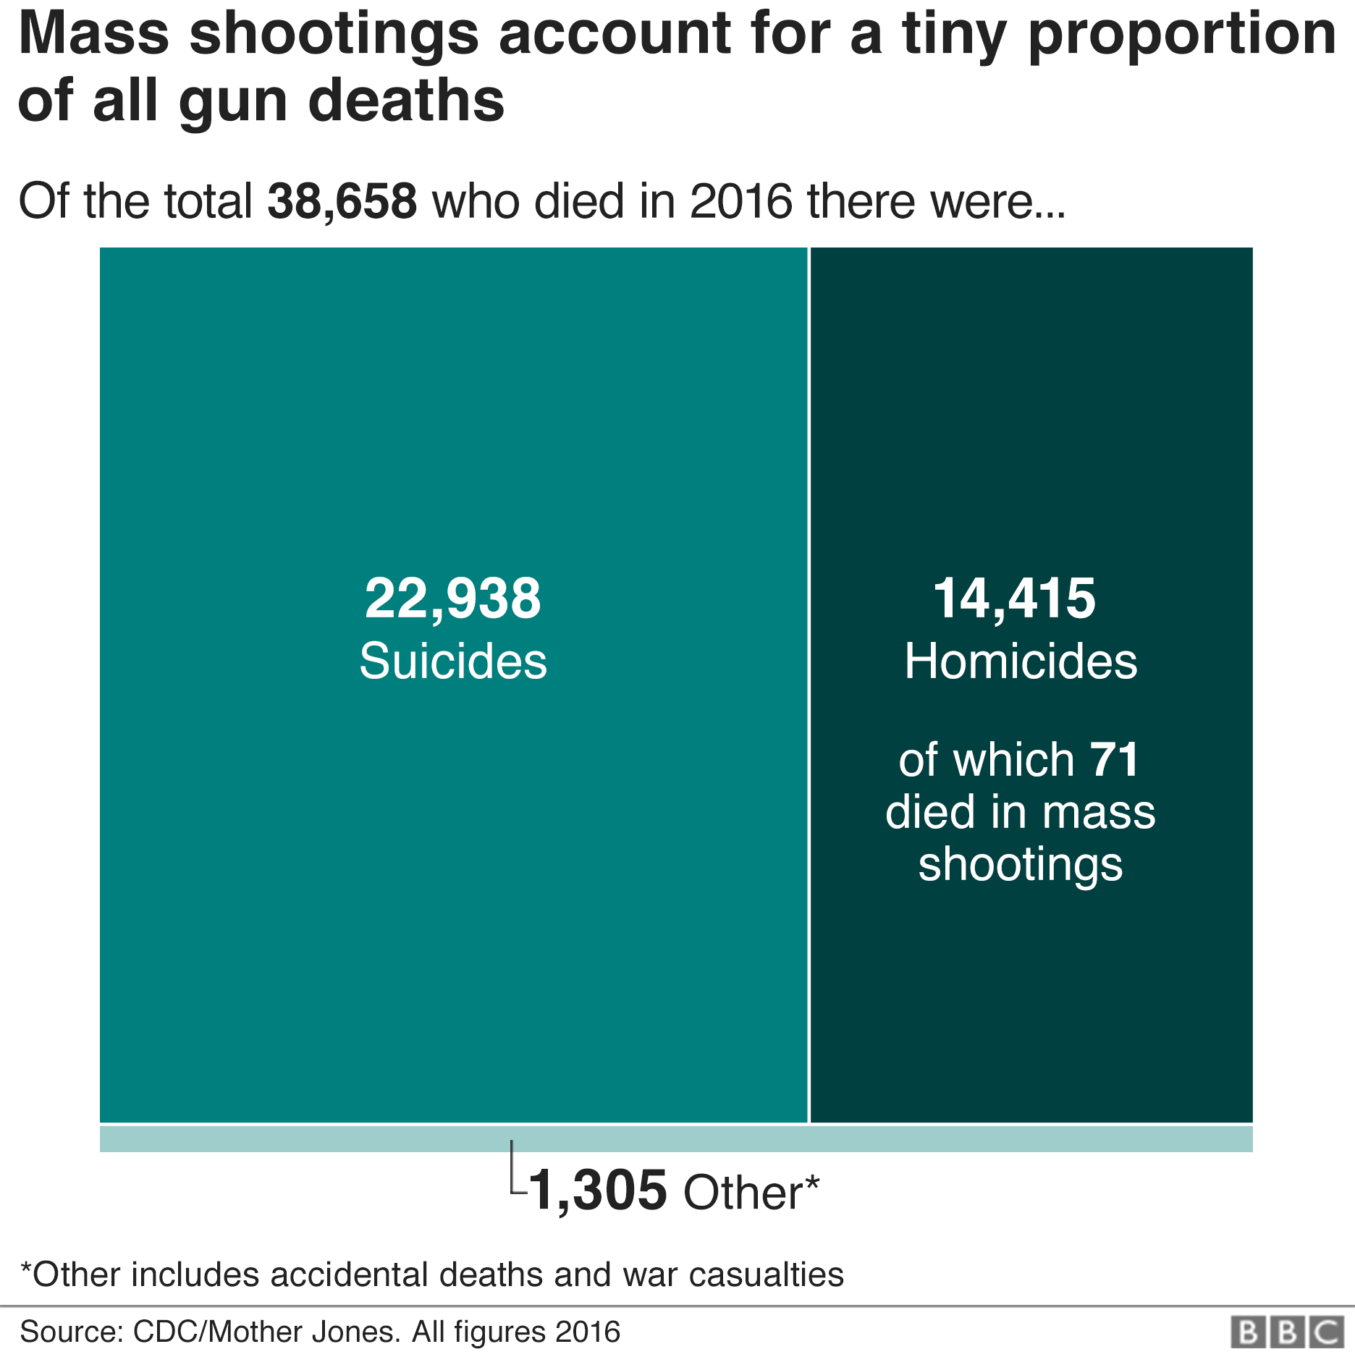

Some images I had considered using in the poster, but in the end I opted for a comparison of the type of gun used at the time of the 2nd amendment, compared to the semi-automatic weapons used in mass shootings today, Guns have changed significantly sadly political attitudes to owning and carrying them have not.


