MIHAI CIOCAN
1919225
ACADEMIC AND EMPLOYABILITY SKILLS
BMSW4001
Reflect on your learning in this module
Dr TOYIN ADISA

Abstract the following report should reflect my journey in the last academic year at UWTSD, and specially the learnings that I have on this specific module, Academic and Employability Skills. For me this was a new experience and a difficult one as I am a parent and a full time employed on night shifts so managing time was the biggest challenge. This is one of the topics we have discussed in the module, Time Managing, I find it useful and interesting. Also, we talked about how to write a CV and why it is important to have a Cover letter with the CV, things that I did not known before. One other aspect was about Writing a Report and how is this different from an essay. So even if it was demanding and a bit stressful, at the end of the road I am glad that I have chosen to sign up for this course as I did learn a lot of useful new things.
Time Management. I always thought that I do not have enough time to do what I would like to do, that I am to bussy for some new activities or to meet more with friends and have some relaxing moments. We had this topic about time management,
and it made me realize that not time was the issue but my lack of organization and planning that make me think I do not have enough time.
“Time management is the process of organizing and planning how to divide your time between specific activities.” (“What Is Time Management? - Time Management Skills From ...”) (mindtools.com, Working Smarter to Enhance Productivity)
An appropriate time management helps you work smarter and get things done efficiently in less time. For me, doing a daily time management reduces the time wasted, helps me focus on the important tasks and keeps me going. I like the idea of setting SMART goals, which means your goals need to be specific, measurable, achievable, realistic and time related. Everyone has a specific time of the day when they are more alert and they can focus better, it is called a natural body clock; mine is usually at midday, when I am waking up after the night shift. I find really interesting this quote of Eisenhower: “I have two kinds of problems: the urgent and the important. The urgent are not important, and the important are never
urgent."(“Eisenhower's Urgent/Important Principle - Time Management ...”) According to Eisenhower the way you prioritize your tasks and goals it is especially important as it will help you focus on the most urgent goals and at the same time you work your way towards important, longer term goals.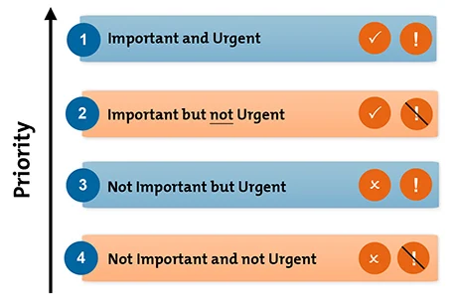
He categorized the tasks and activities as follows:
- Important and urgent
- Important but not urgent
- Not important but urgent
- Not important and not urgent.
By using what I have learned on this topic, I can now say that I am a more organized person, and I am using my time at the best.
Writing a CV We have discussed on this term about how to write a proper CV and the importance of a cover letter.
“A CV is a document aimed at convincing an employer that who you are, your qualifications, work experience and your skills makes it worthwhile for them to offer you either work experience or a chance to move forward in a formal selection process.” (Morgan,1997:339)
A CV should contain your personal contact details and a personal statement. The personal statement should be brief, clear, and concise and have evidence to support your statements. Further in the CV you must include your education and qualifications with the recent qualifications listed first; your work experience with the most recent first, dates, job title and 2-3 points explaining what you did and the achievements; then state any additional responsibilities and any relevant skills and knowledge gained from these activities. You should end with your hobbies and interests, this will tell employers more about your abilities, about what motivates you and what you enjoy doing.
I can say that until we had this lesson my CV was a total mess; I was not aware that is a certain order in putting your details, or how long or short a CV must be, or haw to list your previous jobs and experience, or why is important to add hobbies and other personal activities you like. I also learned that in a CV everything matters, not just the words that you are putting in but also the presentation and the format of the CV like:
- Using bold, italics to make the key words stand out
- Bullet points to provide key information
- The consistency: fonts, font sizes
- Clutter: make it look tidy
- Power words (Morgan,2017:356)
In order to stand out a CV should be aesthetical and easy to read.
Cover Letter An aspect that I did not considered important before is the cover letter, and I personally never used one with my CV.
“A covering letter is a professional business letter which provides an employer with an introduction to an accompanying CV” (Morgan,2017:339)
The main purpose of a cover letter is to interest the employer in reding your resume.
Read cover letter > Read resume > Call for interview (careeronestop.org)

When writing a cover letter, you should introduce yourself and explain why you are writing and how did you heard about the job. Then describe how your skills, qualifications and previous job experiences will benefit the employer needs and help the company grow. In the end you suggest a plan of action, inform them that you would love to get interviewed to discuss more, and thank them for their time.
Now I understand the importance of a cover letter, it is the first thing an employer reads, and a proper cover letter can increase the chances of your CV being read and to be called for an interview. Now I can say that my CV looks like a professional one, I did add a cover letter to, and I personally will call me to arrange an interview now, something I cannot say if I was reading my original CV, the one I had before taking part in these classes.
Reflective report Another topic that I did not know anything about before is writing a report, and in this case, a reflective report, in which I need to talk about my journey this year at UWTSD and what I did take with me from studying on the ACE module.
I was not sure what a report is, it has been a long time since I have finished my studies, and it was a lot more different the way we were learning back then.
“Essentially, a report is a short, sharp, concise document which is written for a particular purpose and audience.” (“ReportWriting | SkillsYouNeed”) (skillsyouneed.com, how to write a report)
In my case, the report is about what I have learned in the past year, how useful did I find it and how did I benefit from it, and it is addressed to be reviewed by the lecturers of UWTSD.
“It is not sufficient simply to have an experience in order to learn. Without reflecting upon this experience, it may quickly be forgotten, or its learning potential lost. It is from the feelings and thoughts emerging from this reflection that generalizations or concepts can be generated.” (“The Gibbs ' Model of Reflection Essay - 2060 Words | Bartleby”) (Gibbs,1988) (“Applying the Gibbs Reflective Model”)

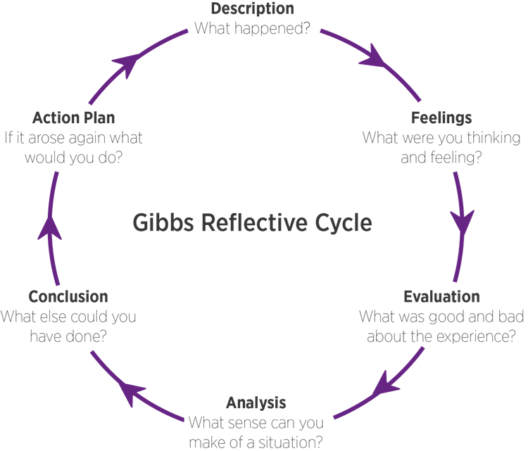

Thinking now why I have enrolled to this university and if I achieved what I have proposed, I can say that yes, I was looking for a way to improve my knowledge about employability, about what you need to do better so you can stand out when applying for a job, what are the employers looking now, what they want from a candidate, which skills are more demanded, which areas do I need to work more to improve. This course makes me realize that it is not enough to be a hard worker and have experience in a certain domain,
nowadays you need to continuously seek for more knowledge, for upgrading yourself and try to excel in more than one domain, because this what today is all about, being multifunctional, the ability to adapt to any work position, be perseverant and absorb all the knowledge you can, to be able to grow and finally achieve your dream job position.
For me, this course was a wakeup call, I did learn allot during this year, and had motivated me to never give up pursuing my dreams.

References
- Mindtools.com, Working Smarter to Enhance Productivity
- Eisenhower’s Urgent\Important Principle-Time Management
- Morgan, 1997:339
- Morgan, 2017:356
- Morgan, 2017:339
- Careeronestop.org
- Report Writing\SkillsYouNeed skillsyouneed.com, how to write a report
- Applying the Gibbs Reflective Model Gibbs,1988

