

An Investigation on the Digital World Tools to Learn and Teach Users on Digital Applications

By
Garin Llewelyn Rees

Supervisor: Jeanette Adams
Second Marker: John Williams

Project submitted as part of the requirements for the award of
BSc (Hons) Applied Computing

May 2019

Declaration and Consent Form (see Appendix 1)

Abstract

This report is an investigation into the digital world tools that are used to help the user to learn how to use digital applications and this would help to find out assumptions of their use and how it is provided. The overall aim is to produce a digital environment to allow users to use digital applications without having to go online and would have to meet the requirements of the specification, be done on schedule and within the set budget too. The research found out that the most used applications, the age range of the audience that the digital world could be done for and the safety awareness of these tools.

The methods that are used to help research and develop the project was using a research onion that focuses on a small one-time audience which leans towards more on the thoughts and feelings of the user of the application. The development method that was used a timebox so that the schedule of each part of the project development could be kept on time and error check against the project too. The main findings of the project were that the use of a PC interface was not the first interface that the user would have wanted to practice on since the most used technology was the mobile phone and should have been tailored to that sort of interface. Not to mention that

The conclusion of the project showed that the literature review was right about the use of activities to be on the application but not the right technology because everyone uses mobile more than anything else. The project was able to meet the requirements for the project on a working digital environment using the online tasks associated with the digital world. The use of timeboxing restricted the developer in the programming of the project and would have been useful to have given more freedom to their development.

It was recommended that a different development methodology could be used for this project in the future without the use of timebox letting the developer have more freedom in their programming and make use of the design to be as a mobile for further development. Not to mention that the interfaces could be worked a bit more to look more like a desktop interface with a website looking functions too.
Contents

Declaration and Consent Form (see Appendix 1) 2
Abstract 2
1. Introduction 4
2. Research & Review of Literature 4
2.1. Every Day Literacy 4
2.2. Being Digital Literate 5
2.3. Learning Methods 6
2.4. Safety in the Digital World 7
2.5. Current Tools Available 8
2.6. Potential Technologies 14
2.7. Conclusion 15
3. Research & Development Methodologies 16
3.1. Research Methodology 16
3.1.1. Philosophy: Phenomenology 16
3.1.2. Approach: Inductive 17
3.1.3. Strategy: Case Study 18
3.1.4. Time Horizon: Cross-Sectional 18
3.1.5. Data Collection: Questionnaire 18
3.2. Development Methodology 19
3.2.1. Timeboxing 19
3.2.2. Software and Hardware 19
3.2.3. Materials and Tools 19
4. Design & Implementation 20
4.1. Design 20
4.2. Implementation 23
4.2.1. Development 23
5. Evaluation 32
6. Conclusion & Recommendations 33
6.1. Conclusion 33
6.2. Recommendations 33
7. Reflection 34
8. Bibliography 35
9. Appendices 40
9.1. Appendix 1 - Declaration and Consent Form 40

Introduction
Digital literacy tools are a widely used method to learn and teach aspects of the digital world and has become integrated with many organisations. Although there are users around that still do not know how to use applications and with the rising risks with using digital applications, it is becoming hard for them to learn in safety.

The reasoning to investigate digital world tools is to look at the various studies about the ways to learn and teach users on digital applications that are out there today. This would help with getting a summarised and detailed assumptions of their use and methods on how they're providing them.

Research & Review of Literature

Every Day Literacy
The use of everyday applications on digital technologies out there today are mostly done on mobile and personal computers, since they both do the same function just as well as each other than convenience being between them as a difference the usual task done every day would be taking pictures, checking social media, checking emails, watching videos, self-organisation and navigation. This is discussed in “Mobile practices in everyday life” [1], which listed the everyday practices on a mobile included capturing objects and events, checking web-information, casual entertainment, maintaining lightweight contact, arranging meetings, navigation and micro-coordination.

The most used application online on the Internet is mainly emails because usage of the digital world is being able to talk to each other consistently and reliably with certainty that messages will be delivered to the recipient which was covered by Barry in “The Internet in Everyday Life: An Introduction” [2], saying users ranked the email feature online as the number one reason for being online. The Internet is not just about technology or information but communication.

There are also other forms of activities that support that email is used as well other forms of tasks within a digital world on the Internet that users execute in their daily lives which is covered by “Digital Literacy and the ‘Digital Society’” [3], explains that there are digital tools out there that allow for users to be able to represent themselves online with blogs and their own websites which can be created, not to mention the use of emailing, texting, showing CV’s or even multi-media content that is on social media sites. It also says that other digital actions are done online as well by using a search engine or even buying things like clothes, tickets or booking hotels.

Other forms of activities that would be performed online with a computer every day would be to not only use emails and social media but also users would surf the Internet with search engines like Google, not to mention buying or selling product on online shopping sites too, this was found out in “Search Engine Use 2012” [4], which gathered data that on Internet users on how they use their search engines by gathering these findings through a survey over time that said 91% of online adults use search engines for their online activities. Not to mention other high results of online activities following emailing with 92% are buying products online of 71% as well as using social media too with 66%.

Even though email is one of the most used tasks that are performed on the Internet, but technology has progressed enough that there are faster ways to message people instantly now like for instance, Facebook Messenger and WhatsApp. Not to mention non-communicative methods are used like online shopping for booking, buying and selling of products or services.

Being Digital Literate
The digital literacy skill levels of the population are needed at present for applications and how to use them are more important at present with the rise for jobs in the IT industry as well as the need to implement into education, so that there are skilled students in these areas of expertise. This is supported with the fast development and integration of information and technology in the way of living as well as working which leads the youth to be educated in these new careers for this industry [5].

It would seem that the digitally illiterate have a grasp on the use of digital applications and the Internet, but it does not have any influence that they are proficient in using it, even in the survey taken in “Survey Measures of Web-Oriented Digital Literacy” [6], which says that most adults in the survey did convey the knowledge as bad but their own opinion showed that they took a more critical view of the skill as non-existent whereas the performance test showed that they were a bit capable.

Another factor which also supports the inclination that an older generation is more likely to have a lower literacy level in digital application than any other generation is a survey discussed in “Digital Literacies—Concepts, Policies and Practices” [7], that half of the sample of adults had only an entry-level skill in the use of digital applications and even then they found it hard to use the search engine. The younger generation have a better working understanding of the using digital application because they are the age range which has grown up in the age of technology this is covered in “Digital tools and challenges to institutional traditions of learning: technologies, social memory and the performative nature of learning” [8], but it would seem that the younger generation may have a lack of risk awareness when it comes to the digital world and would need some education in the dangers of the Internet [7].

In the category of the youth but mainly with students would consider themselves as greater expertise in their task on their digital literacy than other except for professionals but would have only a small level below that of what they can do, this was researched in “Can we teach digital natives digital literacy?” [9] which took a group of university students that were undergraduates and had a post-questionnaire that showed that they thought that they have improved in their digital literacy when they were on a course with an average rating of 6.2 out of 10 at the start of it as well as the end of the course with a rating of 8. This supports the opinion that the young adult generation is more adept at using technology on the spot than most others.

The younger generations would have split in their skills based on their social or economic standing and would show that the ones with a low standing in it would have a harder time with understanding the capabilities of using computers whereas people with high standing in these areas would not have these issues. Not to mention the same would be said of their ages too that young children would have a difficult time with their own abilities to have any sort of digital literacy to us computers to its fullest capabilities whereas the older teens have more of a grasp on the Internet. This was explained in “Digital literacy and safety skills” [10], which showed the opinions of children of 11 to 16 years of age of their skills on using computers and it showed that people with low socio-economic level have the least amount of confidence in their abilities to be able to use them as well as showed the opposite effect for children with higher socio-economic standings. Not to mention that the results of their study showed that an average rationing showed that older teens between the ages of 14 and 16 have rating of 5.2 more assurance in themselves that they have the knowledge to use computer whereas the younger ages have a lower average rating of 3.4 of the tasks that were addressed in the document.

It would seem, most of the digitally literate users in the digital world consist of the younger generations because they grew up with it as well as the young adults mainly student have the best adaptability towards any technologies use when it comes to digital literacy and the generations that need most help with using digital applications are the older generation like the elderly or adults. Even the younger generation have some difficulties with their skills based on how young they are and there low social as well as economic standing whereas the opposite has more confidence in themselves.

Learning Methods
The learning methods that help with training and educating the populace in the digital world have only come up in small amounts, but it does not make up a representation of all aspects of it. The best methods out there would involve demonstrations, instructions or activities but all would come to the same conclusion is that the user would take actions on all the aspects of the training and learning of the features of applications through practice. This is supported in “Literacy in the Digital University: Critical perspectives on learning, scholarship and technology” [11], which declares that an attribute of e-learning is agility and it contributes to users being able to be the learner as well as the teacher to communicating from community to community working from a central role to manage, engaging in the digital world.

Other uses of learning methods that would also be helpful to use within a practising in digital literacy which are photo-visual literacy, reproduction literacy, lateral literacy and information literacy. A more effective method depended on the age range of the user this is investigated in “Digital Literacy: A New Terminology Framework and Its Application to the Design of Meaningful Technology-Based Learning Environments” [12], saying the younger participants were effective in learning through photo-visual learning, lateral literacy and reproduction literacy whereas the older participants had more use learning with information literacy.

The basic breakdown of the different learning methods for digital literacy focuses on the technical method that covers the processing of operational or technical data, cognitive method which covers the ability to learn through thinking to gather as well as evaluate data and social-emotional that involves the processing data to learn from using social applications like social media or communication on the Internet. The most used form of method that would be preferred would be through using the cognitive dimension because people learn better when they are thinking about it on their own. This is supported by “Can we teach digital natives digital literacy?” [9], which concluded that the focus of the development for eLearning would require the students of the study to have the use of tools and cognitive abilities so that technological advances in society as well as to adapt to the growth of existing technology or adopting new technology.

An in-depth look at the learning methods based on the preferred way of learning through either using with support or not support of IT systems would vary between different people with those without the use of any technology would prove difficult to learn more advanced techniques for digital literacy whereas with IT support would show more promise to achieving the higher levels, this was studied in “Exploring Students’ use of ICT and Expectations of Learning Methods” [13], which showed research on university students preferred methods to learn digital literacy with either the use of ICT support or not and gather their opinions on their own skills with the use of their preferred method. The results showed that there was a substantial positive view between the participant’s response using technology in their social time and their reported advanced IT skills meaning that those that preferred the use of IT in their learning had a better rating of using advanced IT than there were for students that did not use IT support.

Although even though the older participants were more capable of pedagogical tasks, but it can only go so far in age and may have trouble with the terminology when it comes to learning about the digital world.

Safety in the Digital World
The safety of the digital world has been an evolving subject for the digital world since new viruses and ways to do harm on the Internet get bigger as time progresses, the same going for consistent solutions to those problems, but the main solution to the safe use of the digital world is awareness and not many people are aware or have knowledge against these threats. The youth of today are susceptible to deception since they are learning as they are going, only just getting a grasp of the risk of the Internet. This is supported in “Digital Literacies—Concepts, Policies and Practices” [7], which explains the Internet safety which gained attention in the past that lead Internet literacy to be important to learn about the dangers online for children like filters and educating them of the danger as well as how to avoid them too.

There are other safety risks which occur in the digital world other than just online safety like the dangers of digital media, which is discussed in “Digital Literacies—Concepts, Policies and Practices” [7], explaining that there are other topics with safety in the digital world other than Internet safety including digital media needs to be discussed to get a broader look on the Internet along with Internet literacy.

Safety is a concern to users with low literacy in the digital world, even the concern of the use of digital applications are from usually older generations but they have common sense whereas younger generations are naïve to the digital world and the dangers they hold, the documents that support the children safety over any other are in “Digital Literacies—Concepts, Policies and Practices” [7], which covered that in the past years that made Internet literacy becoming important to learn online dangers for children and also in “How can parents support children’s internet safety?” [14], which did a survey against children that had parental mediation, the results showed that no mediation from a parent is affecting the risks that come up.

Although the younger generation would have mixed opinion on their capabilities needed for safety online and would have a split in the age ranges that the younger ages of below 14 having next to no knowledge on being aware as well as reacting to their safety on the Internet. Older teens, on the other hand, would have more confidence in their skills to keep them safe online. This was explained in “Digital literacy and safety skills” [15], which studied skills on their literacy and their safety skills, it showed that only on the average the children would have half the skills needed to keep them safe but the split of the bets averages doing the safety tasks show that 14 to 16-year-olds have more confidence in their abilities to be safe on the Internet whereas 11 to 13-year-olds are not so confident.

Current Tools Available
The current tools that are available that has a digital world to teach and test the users on the applications of that world which are:

Hoonuit (Atomic Learning) [16]
Hoonuit is a website that gives skills and support tools needed to transform the user’s education system by providing material for learning as well as testing too.

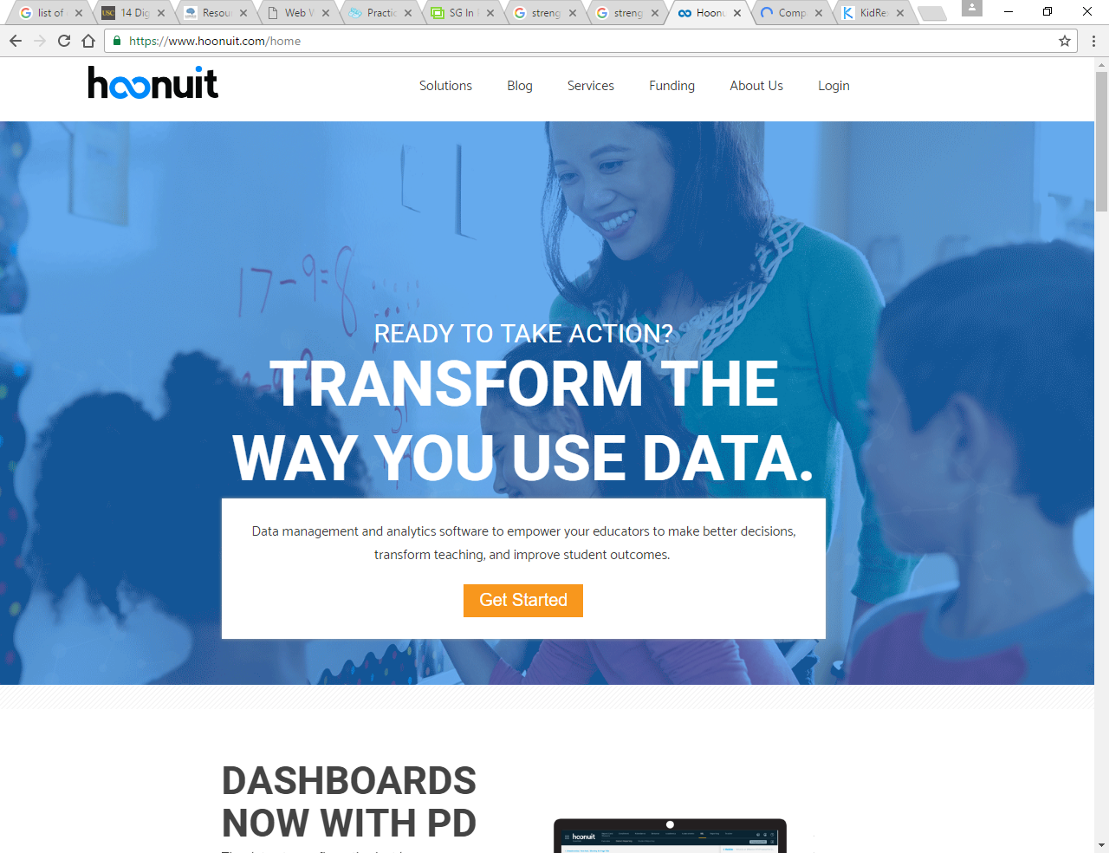
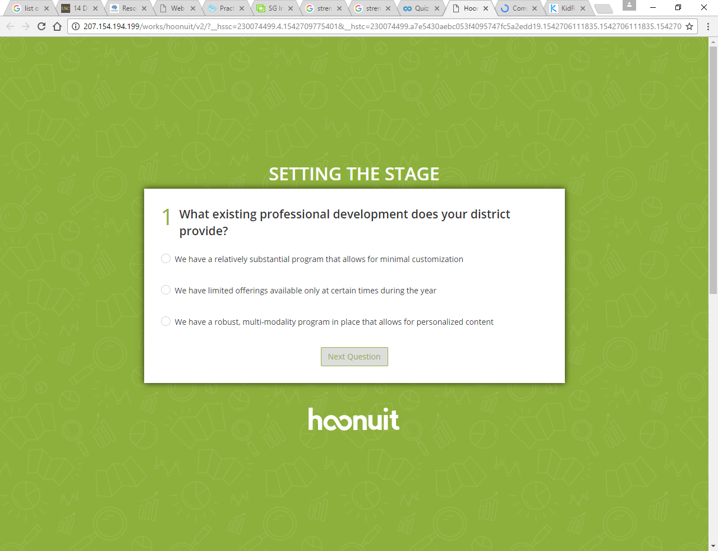
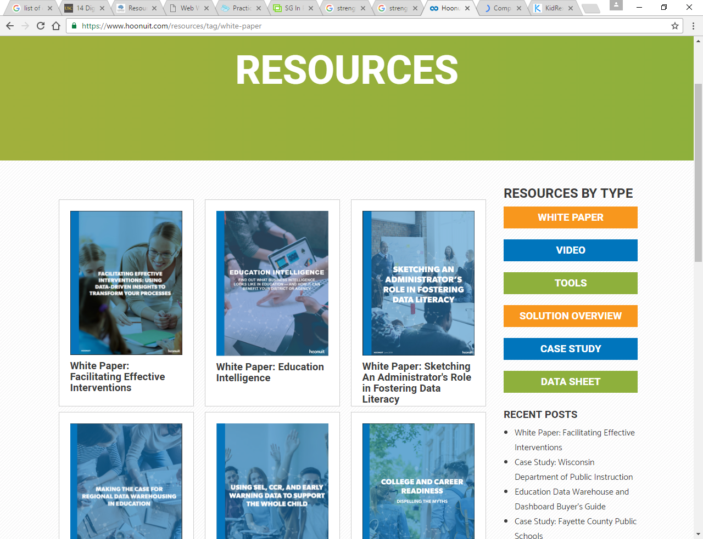
Strengths
The strengths of this tool for learning and teaching digital literacy are that it uses videos with its platform of giving a better illustration and demonstration of the material that it conveys to the user. It also shows numerous varieties of courses that are available with it displaying it overviews and its feedback of it in terms of results or user review of it. You could also be able to search for the items on the online website across the tool’s platform. Not to mention that it makes use of authentication with the tool because it is online allowing for a secure platform to use the tool for the user [18].

Weaknesses
Although the weaknesses that would come with this tool, as well as the platform that it is using, is that there are little obstructions in the view of the captions which would prevent the users from understanding some of the functions and instructions provided by the tool. There are also no transcriptions that are used with the tool which could prevent further understanding using the tool by reiterating the videos or even for users that have a hearing impairment and would require text to follow the videos. The site has not convenient to be able to use it like allowing for alteration of the background dimming, the usage of pop-up videos, to use playback speed or rewinding on the videos and unable to take bot on the videos either. The tool is not able to give feedback on the level of abilities based on the user’s performance on the course and because it is an online website this tool cannot be accessed without the connection to the Internet. It also cannot be used properly on any mobile device because of its extensive screen size needed to interpret the information on the tool too [17].

KidRex [18]
KidRex is a safe search engine that does not show inappropriate content that usually would come up for other search engines by filtering as well as blocking elements of the World Wide Web from kids.
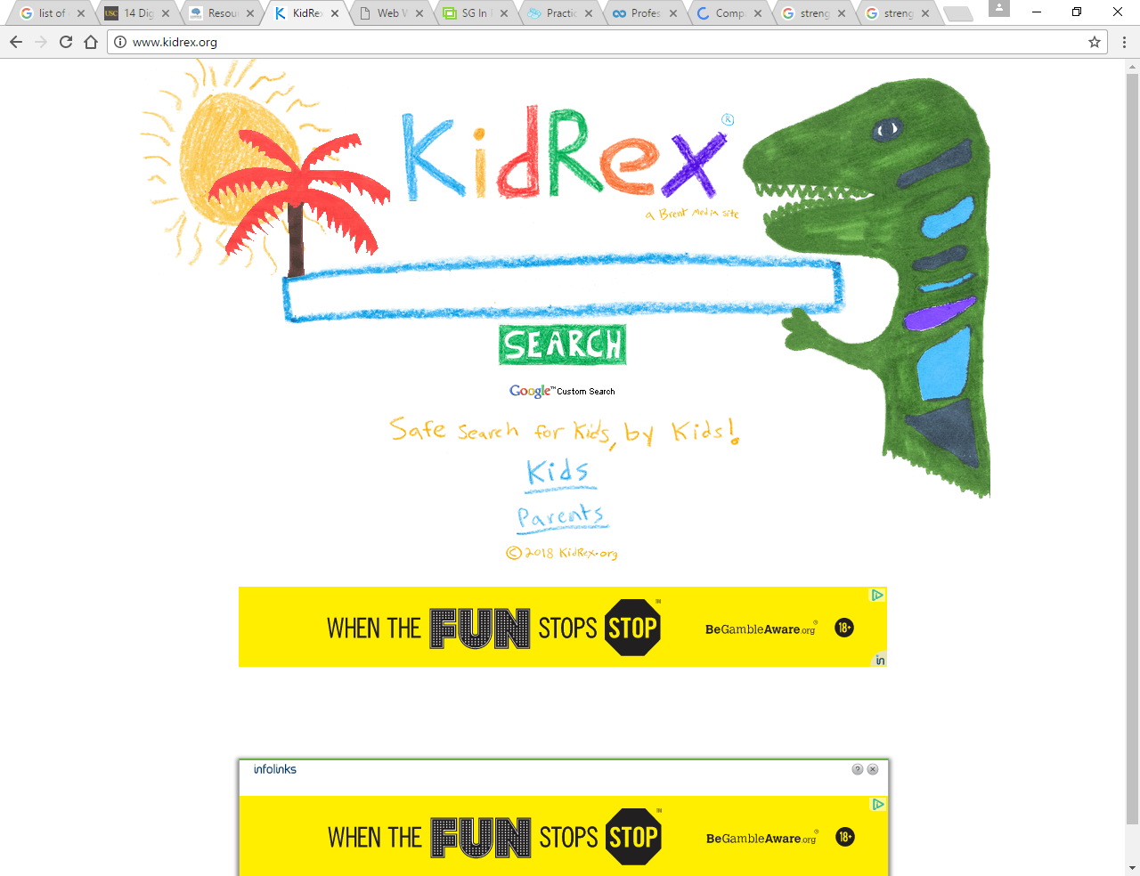
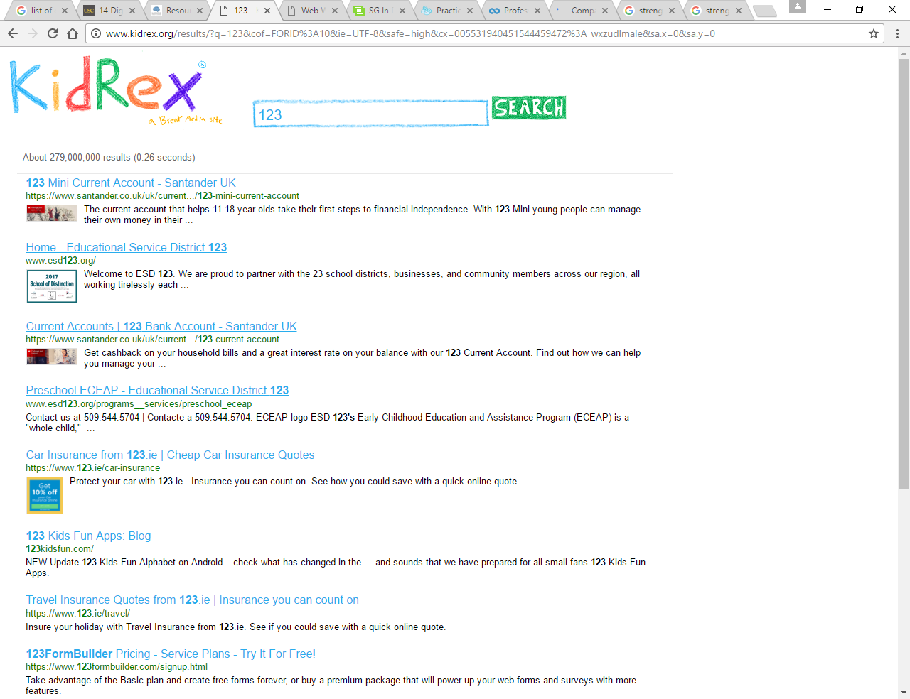
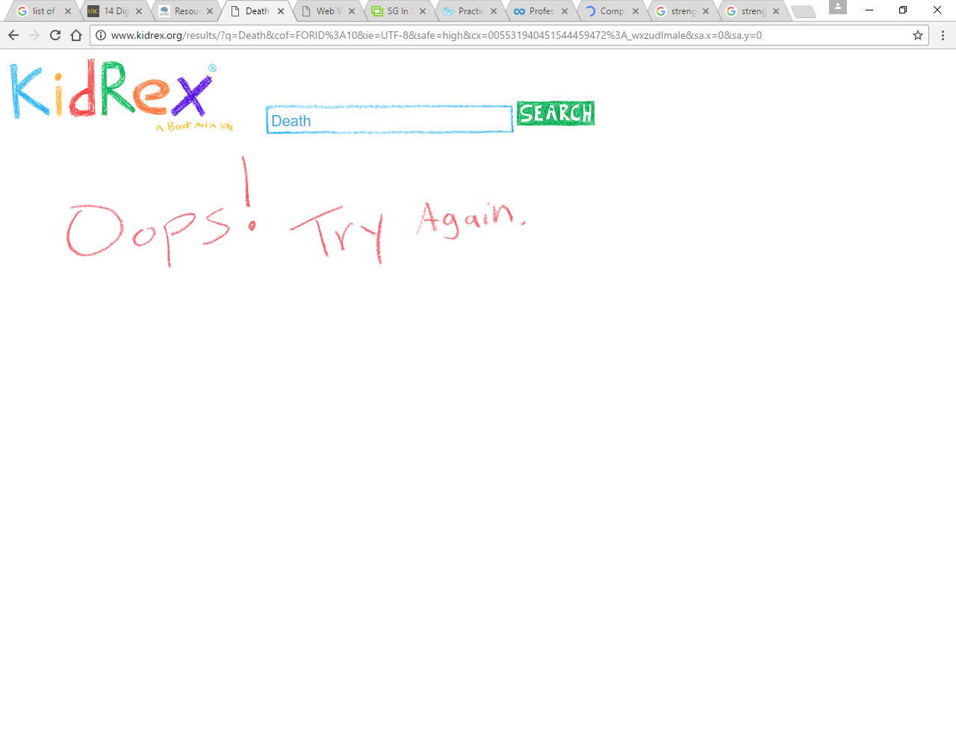
Strengths
The strengths of this tool are that it can prevent any harmful contents to be forced on to the user that could be dangerous to an audience of children. It can also help the parent or guardians of the children users to learn about how to search safely online too. Not to mention that the materials that are available with this tool so that the children can be educated on online safety as well. There is also the advantage that it is a website search engine which allows for the users to be able to access this tool from anywhere that has access to the Internet.

Weaknesses
The weaknesses that this tool has is that because it is accessible online that means that if the user cannot access the Internet then the tool would not be available to them. It also does not have much teaching involved in all aspects of digital literacy only to the safety precautions that need to be taken online. The tool also seems to be only used to the younger ages to make them safe when using a computer to surf the Internet and the tool is only suitable to the more immature audiences in terms of aesthetic appeal to the users.

Microsoft Digital Literacy [19]
Digital Literacy is a Microsoft course that teaches and assesses the concept and skills needed to use a computer when a computer helps everyday life to access new social and economic changes for users.
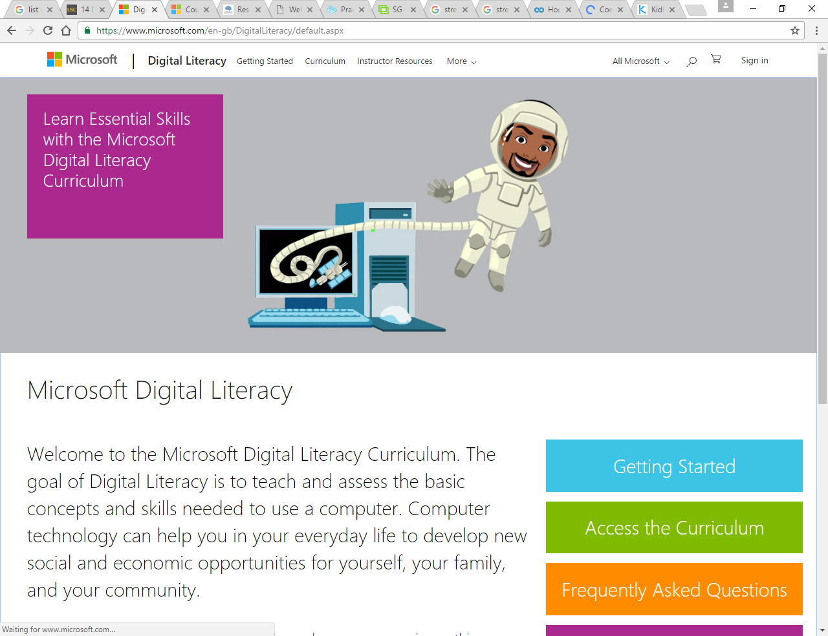
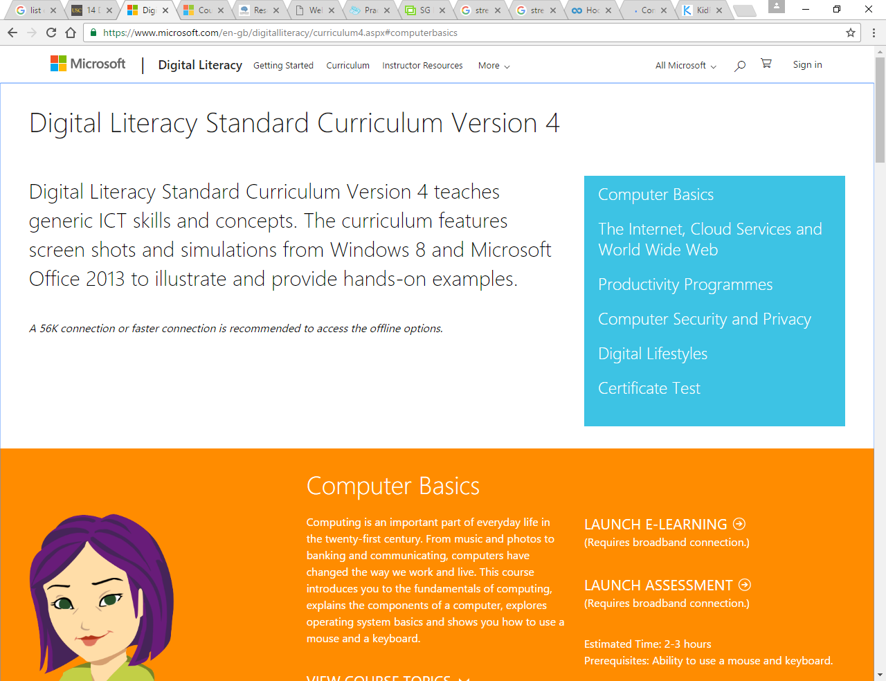
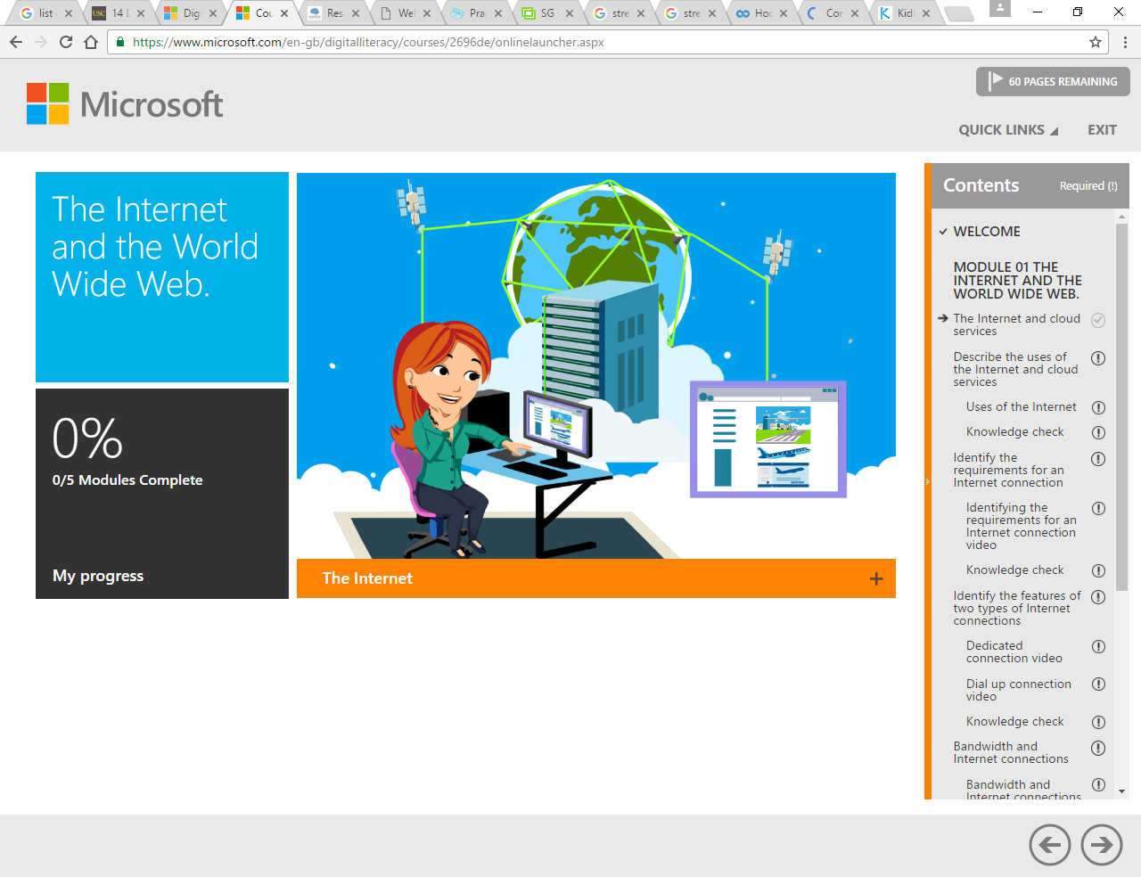
Strengths
The strengths that this tool has is that it can measure the progress that has been achieved by the user on the applications teaching and learning material. It also has availability to different courses that cover the use of the Internet as well as any other subject involved with digital literacy too. The tool can assess the ability level of the user based on their performance using the teaching and learning aspects of the tool. Not to mention that because it is a web-based tool it can be accessed from anywhere if there is access to the Internet.

Weaknesses
The weakness that comes with this tool is that because it is a web-based tool which is online without any access to the Internet the tool cannot be used by anyone that wants to make full use of its features and functions. It also does not have the availability of any audio descriptions or videos with some of the content that could be used for the visually impaired users to learn digital literacy. Not to mention that the tool does not focus on the safety for the user online as much as the other subjects that are available with the tool.

Potential Technologies
The potential technologies that could be used to be able to learn the digital literacies of a digital world so that applications can be used properly would be the use of:
Web Application
A web application is a form of an interactive way to do a task and uses features that can only be accessed with a broadband connection as well as it stays working as long as the server that it is on is working too.

The strengths of the web application technology to be used for a product has the convenience to be accessed from anywhere because of the availability of the Internet with any PC with a big enough screen to see the content for the application on a website. It also has the use of a responsive design which is an application that is designed and developed to respond to the users' interaction with the interface that usually deals with the screen sizing, the platform it uses as well as the orientation of the screen to match what the users require. It has available storage space with a large capacity by using the cloud to store it to be accessed or downloaded from any location from different computers.

The weaknesses of using a web application technology for a product is that because it is online that would mean that if the device that the user has cannot have access to the Internet then it would not be able to use any application that is on a website. The data that is stored online would not be a secure place to have it because it comes under threat from many sources that aim to obtain user’s data to use for their own needs. It also would be slower to use a web-based application than any other form of platform to use for the product and there is an issue when it comes to the compatibility of other browsers for an application and would not be usable on every one of the browsers.

Desktop Application
A desktop application is an interactive user interface that can allow you to do tasks and use features that are accessible to the computer that it is on but also can be put on the network as well.

The strengths of a desktop application technology are that it can be used without any access to the Internet and wouldn’t have the risks associated with the Internet as well. It also has better security on a computer than it is online when it comes to the data that makes it harder for external threats to access but that would have to depend on the personal security measures that the user has on it. Not to mention that it runs faster than a web-based application would because there is no guarantee on them connection speed whereas there is a guarantee with the processing speed of a desktop application.

The weakness of the desktop application for a product is that the user can only access the application on the PC that it has been put on and would require the application to be installed on it to use it as well. Another weakness that a desktop application has is that it would need to be manually updated to get the new content and features to have a better experience with the application or fix any bugs with it.

Mobile application
A mobile application allows users to complete tasks and use features on a mobile device in a portable, convenient and small piece of hardware.

The strengths that a mobile application technology has for a product is that because of its portability with its small size it can be used from anywhere in the world and because of its small size it becomes more convenient to use with quick action and interaction with the screen. It also can be used at any time as well depending on the user but that would be based on the battery life of the mobile device that the application is on.

The weaknesses of mobile application technology for a product is that because of its smaller screen it makes it difficult for users to work from the application environment and it is easy to lose the device with its small size as well. It also has less advanced features and functionality that can be done on the mobile device because it must be understandable and that means only using minimal actions to be taken on each area of the application.

Conclusion
In conclusion, everyday tasks that are done by users in the digital world are used mainly for emails along with communication, social media, entertainment, capturing images and organising themselves on mobile devices. There also statistics that support this with an emailing being used 91% of the time, 71% for online shopping and 66% for social media. The age range of digital literacy in the population, which covers adult or elderly age range, and a survey for web literacy showed adults were more illiterate but also had a low opinion on their skills. The younger generations having higher levels, making the older generation the focus for teaching digital literacy. The current learning methods available to teach people in digital literacy would mainly use demonstration, instruction and task-based learning. Age groups have different methods of learning that younger users preferred using photo-visual learning and older users preferred information literacy. The digital world safety evolves as it develops, requiring knowledge to prevent any scams or attacks from the Internet. A survey on protection for children against dangers online, the results showed even if filters or blocks are implemented would not make the youth aware of the risks.
The current tools that were gathered mainly came from online applications that cover on how to be safe online and how to use certain features but not covering the actual use of different applications online that everyone uses daily.
Based off the strengths and weaknesses with different technologies to use for learning digital literacy, the recommended platform would be a desktop application because it has a big application view showing features and be able to deduct a desktop view than a mobile. Not to mention that it is available without needing a broadband connection.
The unique selling point for this project to develop is that there is no desktop application that creates a digital world allowing for users to be able to practice the most used aspects of the digital world like how online banking works, social media messaging or emailing in a safe environment.

Research & Development Methodologies

Research Methodology
The research methodology that will be used for this project will be a diagram model called a research onion which was developed to show the stages which have to be covered when making a strategy for the research. It provides progression effectively when going through designing a research methodology and it makes up 5 stages in this structure [20].

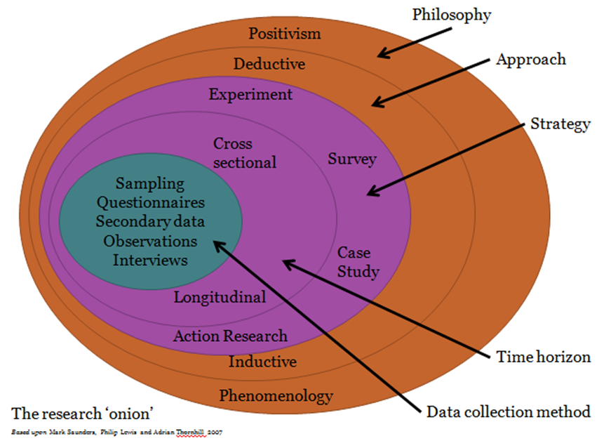

Philosophy: Phenomenology
Phenomenology is a structured study that focuses on the opinions of experience from a person’s perspective and the study follows the experience is centralised on an intended target or goal. This is a discipline that has been used to the study of phenomena which is the appearance of things or how individual see those things in their experience [21].

It was chosen to use as the philosophy because it is focused on the opinions of the target audience that participate in the study and when it comes to design descriptive words are more valuable than the factual numbers of it all and because this sort of study uses 10 or fewer people which is the aim of the project to have [22].

The advantages of using phenomenology in research are that it allows you to be able to find the general experience as well as provide a deep understanding of the subject that it is focused on. It also can gather the data of the experiences from themes and meanings, the use of qualitative data with this research can have the researcher identify the data in form of trends as well as patterns which look at the whole thing. It can be used to be able to understand a physical experience of someone else and have it brought a result from it, this would help with adding to the development of any new discoveries or improvements on based on the data found.
The disadvantages of using phenomenology in research are that participants must express their own thoughts and feelings clear about the experiences, this would make it difficult for them to show how they are feeling through barriers like age, language, mental ability or even by embarrassment. It will be done so that it will not become a problem by allowing for data to be gathered through observation of the subject, having non-embarrassing content to research and having a questionnaire that can be done in their own time on their own or with help with the questions.
Another disadvantage that this has is that it is hard to be able to find out if the researcher is being biased in the study and this can be fixed by just allowing for external sources of feedback to prevent this from happening the analyse the data that has no biased towards the research.
It can be unreliable when it comes to the use of statistics in the research to gather the data and that includes even large amount of data for a sample because it won’t provide generalised data in the end. This can be ensured that it won’t be a problem for the research by allowing for some formulae to use grouped opinions like positive and negative to make statistical values out of them.
It could be hard to be able to get people to participate in the research because it relies on their own thoughts and views on things that people are not willing to share about but this can also be circumnavigated by having a non-disclosure agreement agreeing that their feedback will be kept confidential and will not be used for any other purpose than for the research.

It is time-consuming to use this in research and hard to work on for researchers, but this can be offset by organising the team to be as efficient as possible by allocating time for the task to be done and redistributing the jobs when needed in the research [23].

Approach: Inductive
The inductive approach to research is a stage in research that starts by collecting the data which is relevant to the topic and when there is a large enough amount collected to create a hypothesis based on the data. This way the analysis will show the patterns that arise from the research that has been collected and plan for it accordingly.

It was chosen for the approach to research because it allows for the understanding of a subject of the project in a complete way and focuses on more on the people side of data which is qualitative data [24].

The advantages that inductive reasoning has is that it works with probabilities even though some might not be true or that it is possible when using it for research, but it allows for varying options that are produced from it which can be used to get the judgement of the project software development. Not to mention that it is used to allow the investigation of a subject’s context and its subject area to be able to attempt or test the different scenarios for it. This kind of research approach not only just does this but also the researcher to understand how accurate or not from the first assessments and findings.

The disadvantages for using the inductive research approach is that it is extensively limited because it uses single observations for specific situations making hard for the researcher to make a fair assessment and even trying to generalise the data gathered will not have any use for any other situation but that one. To avoid this from happening in the project it would be required to outsource the evaluations made to a un-bias researcher and also to only see that a professional can generalise the data gathered to be used by others in the future but if at all possible to avoid this issue by having the project only be used for the specific situation only for the client [25].

Strategy: Case Study
This was the chosen method because it is often used with projects established with the social sciences but this approach to research helps appraise researchers of the situation with what went well, what has been achieved and what are the problems [26].

This strategy is appropriate for the research because it gives a detailed situation to work from rather than blindly working through other strategies and it provides detailed information which can be rich with qualitative data. It can also provide insight into further research needed when improvements are made to it.

The advantages will be used to be able to get a full layout of the objectives as well as the requirements and non-requirements to get a specific application design and function. The insight of this research will be used to make a future improvement for the project so that it can be better than before.

To avoid the problems that this case study has with it not being suited for a generalised method of researching it would be best to have this only be used for one organisation or individual. To solve the problem with it being subjective when it is used by having outside colleagues of the project to get an un-objective review [27].

Time Horizon: Cross-Sectional
A cross-sectional time horizon is a research study stage that like longitudinal which gathers information in a time-period but the difference between them is that whereas longitudinal gather data within several points in time and cross-sectional just takes it from one point in time. It also uses different samples of data studying different points of view within the research allowing for a variety of opinions [28].

It was chosen to use cross-sectional research study as the time horizon because the time given to this project is limited so there will only be a one-time evaluation and testing of the subject. Not to mention that allows for new samples of participants being studied with their all unique points of view on the research subject to have a varied structure to get the results [29].

Data Collection: Questionnaire
A questionnaire is a form of gathering data from a participant that allow for an open-ended question for more detailed answers or closed questions that allow for more statistical function.

This data collection method was used because it allows for multiple users to take part in and if done correctly will a more descriptive analysis of their opinions from their perspective, but it could lead to a misunderstanding if it is not done correctly [30].

The advantages of using a question for data collection for researching in this project will allow for easy analysis to be made of the data collected as well as familiar thing to use today like with online surveys and it can reach a large amount of the population if need be with relatively lower costs than any other method. Not to mention that it is easy to administer to the targeted audience, it is a quicker method for data collection and lastly the questionnaire can be a good method to use when handling sensitive topics to the users like the literate levels when using computers.

The disadvantages for using a questionnaire for data collection is that if there is a question missing in the final draft then you wouldn’t be able to get that question answered by the user in the end for evaluation. This mostly could be avoided by having a researcher be in place in case there are further questions that need to be asked after the user is done with the questionnaire. Another downside to using this data collection method is that posting the questionnaires will not allow for adequate responses needed to make an evaluation, but this can be avoided by having on seen questionnaires from a focus group obtained for testing the software application. There is also the problem that the questionnaire is that the respondents might not answer all the questions, and this could be avoided by enforcing the issue that all question must be answered in full before evaluations can begin.
[31]

Development Methodology

Timeboxing
The development method that will be used for this project is a timeboxing development which is an agreed schedule that a person or group works on to complete a goal rather than working until it is finished [32]. It was a chosen development method because it sets up tasks in order and on a timescale to be done. The limitation that some tasks may need more time than others could be overcome by allowing for gaps in the schedule between tasks for leeway in case some tasks need it more than others. Taking advantage of the scheduling of tasks so that no objectives will be half done or slightly worked on, making sure that all tasks will be completed.

Software and Hardware
Software
The software that will be needed to develop the software application for the client is as follows:
- Visual Studio 2017
Visual Studio 2017 is a software platform that will be used to develop the project application of a digital world and this is an appropriate platform to use for the development of this application because this is a familiar technology that has been used for the most amount of time and can be used nearly all the tools that are available with this as well. Not to mention there is a lot of helpful material that relates to the use of this platform for engineering software applications making it easy to look up any problems that may occur during the development.

Hardware
The hardware that will be required to be able to develop the project application is as follows:
- PC
A PC is required to be able to use any digital activity that is based online or even on the computer itself and this is because the software only will work on a computer but also that the capabilities that can be done on it are much easier to handle with full control over the system. To be a full PC it would need all the necessary extra hardware for it with the use of a monitor, keyboard and mouse to be able to interact with the machine.

Materials and Tools

- C# Programming Language
A programming language that will be used with Visual Studio application will be C# because it is the most used language for programmers in large organisations or even any organisations too. Not to mention that there is extensive experience in using this language before but would like more experience with it to improve the skills too.

Design & Implementation

Design
Timebox
This is the design that will be implemented for the time box of each task in the development of the project software.

Database Design
This is the database design of all the data that will be used in the digital world application and are connected through identical fields so that more than 1 table could be used when calling data. Then there are the data definitions going into detail on what each table would be designed to as well.
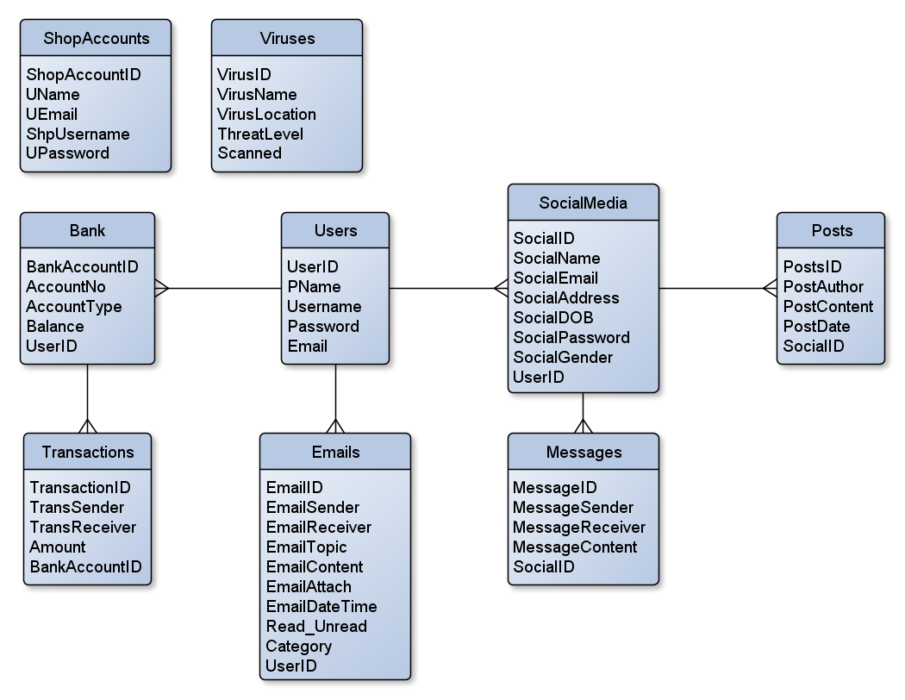
The database was designed this way because most of the details can be connected to each other so that they could be obtained through SQL commands if they were needed in the application.

Interface Design
Problem with identifying the user was a problem when programming the function but this was overcome using an object to keep the login details of a user by adding a label to the design and this was contributed to the completion of the online shopping function on the application with the login feature for it as well as the social media interface too.

Another problem that was encountered in the design of the function in the application was the use of multiple views and the crowding of objects to show them as separate pages, but this was overcome through allowing them to be grouped together so there was no mix up in the design. It was fixed using a group box which separated all the other object from each other which was taken from the toolbox on visual studio. This has led to having a cleaner interface to look at when working on the application which worked for all the functions on it.

Most of the designs were changed so that they look more like the actual online tasks that are performed online with the online back making use of the better design of navigation like on a website. This keeps the environment of an online experience. An example of the change is shown in the 2 images below:
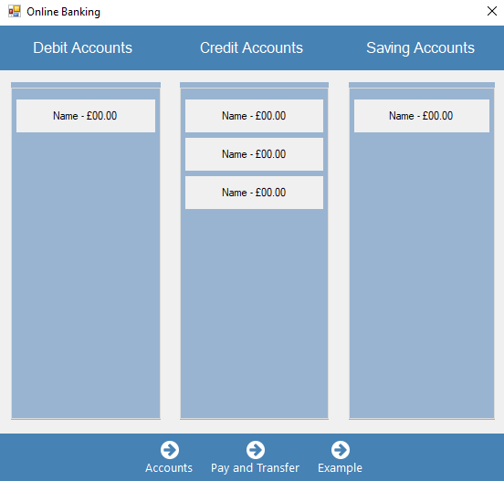
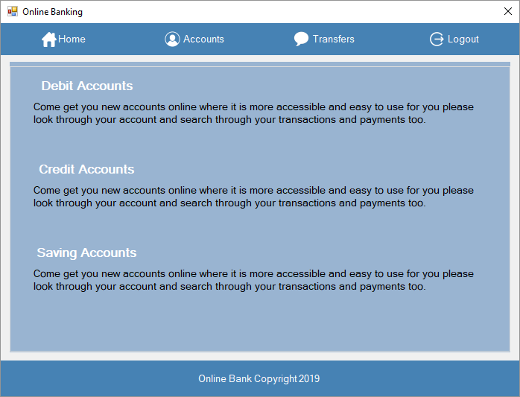

Implementation

The difficulties that were encountered in implementing the designs and developing the application were as follows:
- Software Incompatibility with accessing the database
- Code Syntax Errors

These problems that occurred during the implementation of the application were overcome by:
- Installed MS Access Package online to allow access to the database
- Debugging

Development

The requirements that were covered for the project application in a condition to be used for the audience is:

- Have a design that resembles a desktop interface.
- Allow for the user to use emails.
- Allow for the user to shop.
- Allow for the user to use the social media platform.
- Allow for the user to scan the application for viruses.
- Be able to remove viruses from the application.
- Be able to login into the online shop and social media in the application.
- Have all functions resemble the interfaces in their respected areas.

These requirements were discovered through the design and development of the project application, but the most influence came from the research in the literature review that found the functions that will be used on the application from what tasks are done every day on the Internet as well as the technology that it will be used on with the PC being the first technology that users start out with.

The models that were used that helped develop the project application was an entity relationship diagram which was a method to help give a visualisation of the tables that are going to be used and how they would be related to each other. This made it so that when the application was developed made it easy to use SQL statements to get data on different tables.

The interfaces that were used in the application are:
- Desktop Interface - This interface held the links to all the other functions on the application that would match a real desktop interface.


- Online Bank - This is a function that imitates the online activity of banking with accounts, transactions and transfers.

- Online Shop - This is a function that imitates the activity of online shopping for a user using baskets and purchasing products.
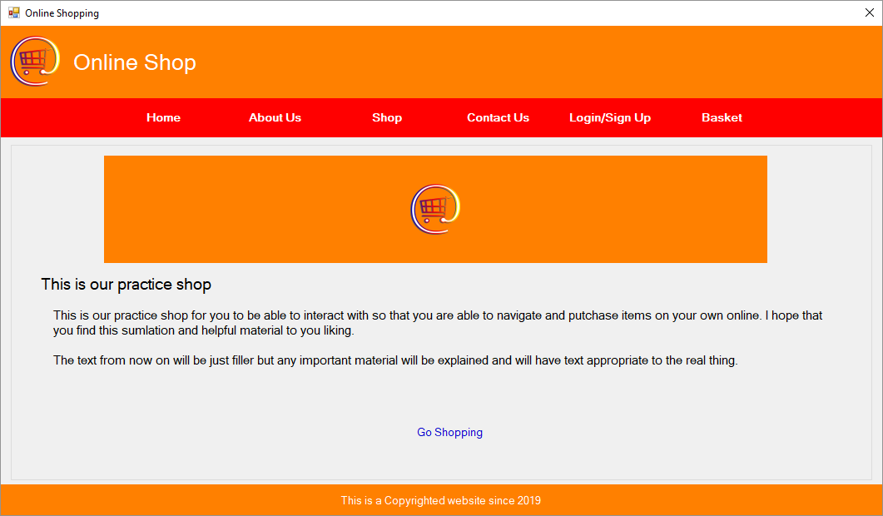

- Anti-Virus - This is a function that imitates the use of anti-virus software that is found on most computer and allows the user to scan and purge any viruses.
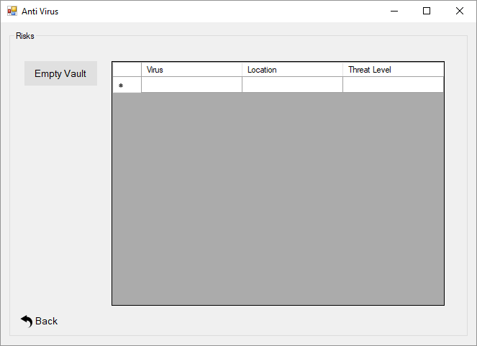

- Email Account - This is a function that displays the emails that the user has made and allows for them to alter the list by inserting, moving or deleting them.
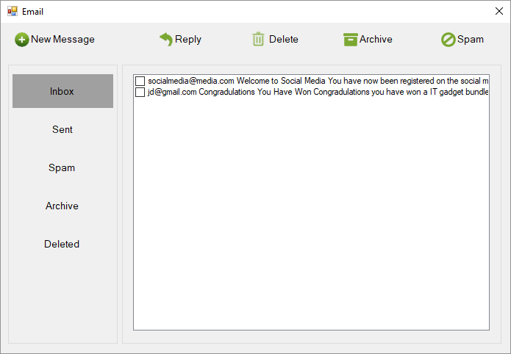

- Social Media - This is a function that acts like a social platform that the user can chat, post and edits their profile on.
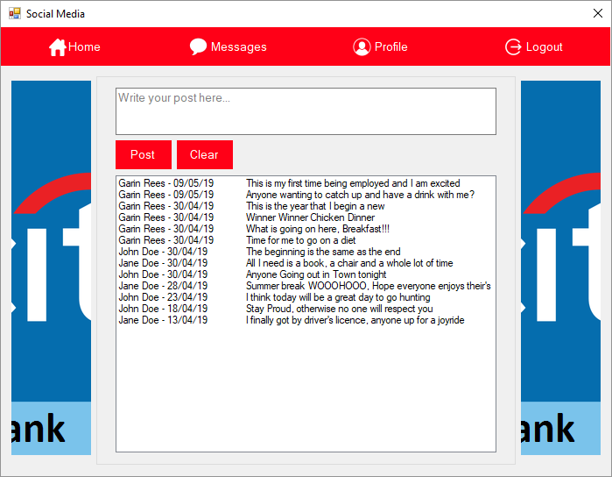
The problems that were apparent in the development of the application was the errors in the syntax of the code be it the SQL commands or the C# coding, but these problems were fixed through the debugging process of trial and error.

The successes that were made on the application was linking the databases together within the code and was able to set the code so that the database could be accessed from the program using a static connection.

Snippets of Example Code
Update Email
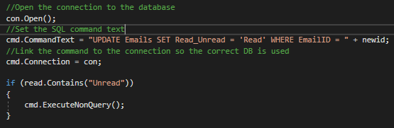
Delete Email
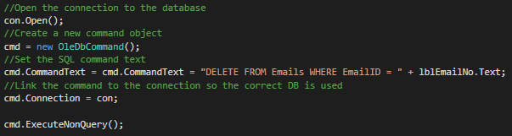

Select Emails
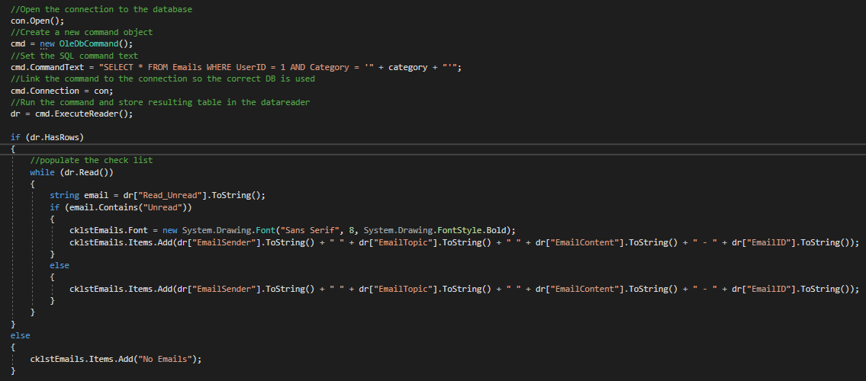
Insert Email
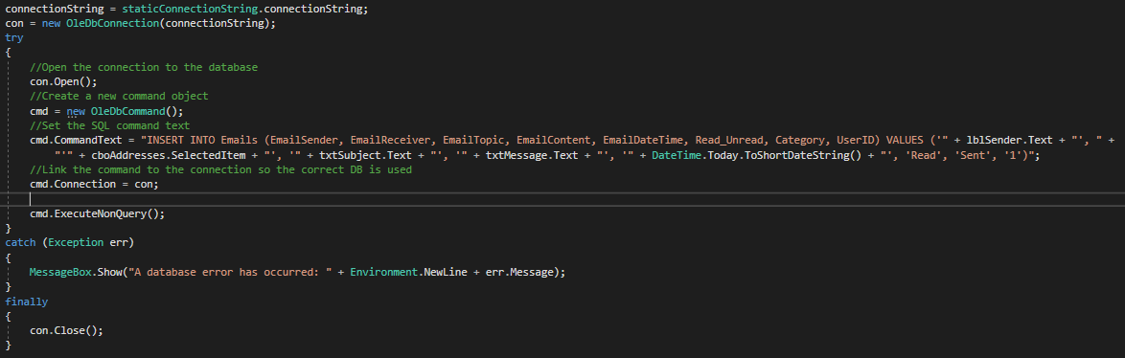
Function Testing
This is the testing that was performed to make sure that all the functions worked as they were intended after each of the functions was finished with.
Test Plan
Test | Expect Results | Actual Results
Real-Time Date and Time | To show the current time after every minute that has passed on the computer's clock | Not as Expected  A timer was used to refresh the time and date after every second
Create Email | To be able to create a new message on the interface | As Expected
Send Email | To be able to send an email to another email account and show in the sent category | As Expected
Reply to Email | To be able to reply to an email and reuse the title and editing to use “RE:” | As Expected
Move Email | To be able to move the emails into different folders on the interface | As Expected
Delete Email | To be able to delete an email from the application | As Expected
Navigate Online Shop | To be able to go to each of the pages in the online shop | As Expected
Sign Up for a New Online Shop Account | To be able to sign up as a new user on the online shop | As Expected
Login on the Online Shop Account | To be able to log in as a user on the online shop | As Expected
Add Item to Basket | To be able to add an item to the basket page of the interface | As Expected
Purchase Item | To be able to purchase an item listed in the basket from the shop | As Expected
Navigate Social Media | To be able to go through all the pages of the social media platform | As Expected
Create a Post and View Posts | To be able to create a post on the platform and have it show up in the timeline | As Expected
Views Conversations | To be able to see all the conversations that are active in the platform | Not as Expected  An SQL statement was used to group all the accounts that have messaged the user or have been messaged by the user
View Messages in a Conversation | To be able to click on a conversation and see all the message associated with it | As Expected
View Profile | To be able to view the user profile on the platform | As Expected
Edit Profile | To be able to edit the details of the profile for the user on the platform | As Expected
Save Profile | To be able to save the details that have been changed on the profile | As Expected
Create a New Social Media Account | To be able to register as a new user on the platform | As Expected
Login into the Social Media Account | To be able to log on to the social media platform to view their contents | As Expected
Anti-Virus Scan | To be able to scan the application for any viruses that have inhabited it | As Expected
View Viruses Scanned | To be able to see the scanned viruses in a list on the interface | As Expected
Empty Viruses from Vault | To be able to purge the viruses from the application | As Expected
Navigate Online Bank | To be able to move around the online bank pages | As Expected
View Bank Accounts | To view all the accounts for the user on the interface | As Expected
View Bank Account Transactions | To view all the transactions based on what account was clicked | As Expected
Transfer Money to Another Account | To be able to transfer money from 1 account to another | Not as Expected  An SQL statement was used to show the transaction based on the account and then an if statement to put the deposits into one list box and withdrawals into another

Based on the testing that has been performed on each action of the application came up with a few errors that were easily fixed and making it reusable for the other parts of the application allowing for easy fixes to be done on them. There are some parts that are unfinished and would require to be worked on more to get them to work but it doesn’t impact the whole application with is non-functionality.

User Acceptance Questionnaire
Acceptance Test
Questions | Answer
Is the design consistent for every function on the application? | The designs seem to be consistent through each of the windows that I have navigated through but there was hardly any design for the anti-virus window.
Is the navigation through the application smooth? | The navigations seem to be easy to use on the windows and would just act like any website although it is not a realistic speed.
Did the interface feel realistic for all the functions on the application? | I did seem a bit real when you first look at it, the desktop was a good similarity to an actual desktop, but others were less so with just generalisation used for any website and window.
What did not work for you on the application? | The things that found on the program which were a bit difficult to comprehend or even the use of the colours used for the other windows since they just annoyed me more than anything else.
Any Suggestions for Improvement? | The improvements that I would make to this program is that it would have been more useful to have it on mobile because it is the device that I use more than anything.
The user questionnaire feedback on what they thought about the application is that even though they found the design consistent barring the anti-virus function the there was no satisfaction with the preferred platform it was on. They would have gathered on using this sort of application on a mobile phone. Not to mention that the design was real for the desktop but not the other functions which apparently were a bit of poor imitation.

Evaluation
The literature review found out that the everyday tasks consisted of using social media, emails, online shopping and the most digital literate individuals are the younger generations that grew up with it and the adult to elderly age ranges have the most difficulty with it. It showed that the teaching method for the audience preferred instructional tasks and information but could get lost in the terminology. The safety online was getting riskier and low information is being conveyed to users, is that the kids are too naïve to notice these risks. The current tools are used online and still have risks to them. The technologies available that are the best to use is a PC to teach digital learning and there is none that exists that simulates an online environment.

The research and development methodologies that were chosen was the use of phenomenology as a philosophy, inductive as the approach, case study for the strategy, cross-sectional for the time-horizon and questionnaire for data collection. These made up the research methodology which allowed for a quick and small method of gathering information with feedback from users. The development methodology was the use of timeboxing which scheduled all tasks to be completed for the project which led to functions being redone when they were late.

The software and hardware that was chosen to be used for this project allowed for the easy use of code and environment to work in as it allows for the work to be portable to any computer with the required packages. The software that was required for the project was the use of Visual Studio which can be downloaded on almost any computer and it was a platform that most are familiar with especially the use of C# language code too. The Hardware that was required for the project application was a fully working PC with use to a keyboard and mouse, this was able to meet the requirement for the digital illiterate users to have if they wanted to practice the online tasks.

The design and implementation methods that were used to help develop the project application was the design of the database using an entity relationship database which showed how the database that table connected to each other to help with its development. New tables were created during the development process when they were needed for the functions in the application. Data Definitions were also used in designing the database too to help layout what each table has and what field is what. The interface designs went through the design changes that were made to allow for functions to be able to work smoothly on the application, leading to changes of adding group boxes that allowed the separation of objects into their own function area and label to hold Login details for some function too. A technique that helped with the implementation was testing the application for any flaws or errors to be working as well as get feedback from the user of their own opinions of the application too for any improvements that could be made in the future.

Overall, the data that was gathered from the feedback and testing from what was accomplished in the project showed that most activities done online are mainly used on mobiles which reaches a wider audience than on a PC desktop and the activities on the application did reach some realism of the actual online environment but could not match all online tasks.

The project was able to meet the aim and requirement to make an environment to simulate the use of online activities with some errors in functions but overall worked as it was intended too. If this project could have been done again better research and development methods could have been used to allow programmer freedom rather than going through the same time limit for all the functions.

Conclusion & Recommendations

Conclusion
In conclusion, the literature review was able to find the everyday tasks that were used in it and it also prompted the development of the application through the results showed that the current learning tools out there don’t make use of an offline digital environment to teach users to use the Internet as well as their computers too. The research and development methodologies that were used showed that it was not the best one to use for the project since it was quite large and required a lot of testing to do it. This has allowed for a better strategy to made in place of this that could be used in the future if a similar project was assigned. The software and hardware were chosen from the knowledge of the researcher had of the system that they were developing. Making use of resources that were available for their workspace. This gave better understanding situations of the users that might have access to mobiles rather than PC’s which is most likely and that can be used a future project when it comes to digital literacy environments. The design and implementation stages showed that the testing methods that were used and designing reflected that they were not dynamic enough to be used. This allowed the realisation that better data collection could have been used more in the development allowing for the user in the project rather than as a one-time participant to the testing of the application.

The evaluation showed that even though that the project application met all the requirements for a learning environment to perform online tasks the development could have been done differently that would have allowed better time and given better freedom for the developer. The further avenues of research that would be required are the technologies that could be used for this sort of program for other than PC like mobile for a wider audience to reach. There is also the

Recommendations
The recommendation that would improve the project application was to work on the design of the interfaces more so that they look exactly like an online task like a shop, social media platform as well as email workspace so that. Login credential for all the functions in the application would also be recommended since it will further increase the awareness of keeping all aspect online secure.

Suggestions for Further Work
The further work can be done to the application by making it so that this application can be used also as a mobile interface to help users practice in a digital environment since it reaches a larger number of users to help keep them aware of the risks on the Internet.

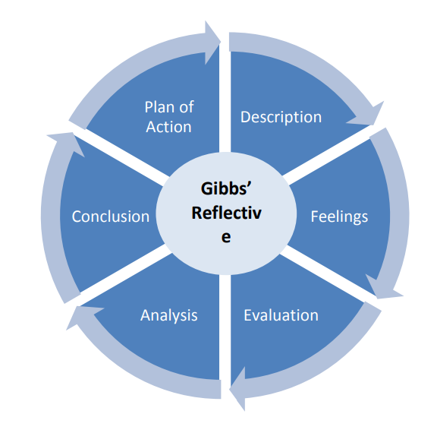
Reflection
In this reflection section of the project the evaluation method that will be used is Gibbs’ Reflective Cycle which is a model used by individuals as a framework to perform reflective writing on the user and follows 6 stages, each having to inform the next stage allowing for the user to challenge their assumptions, explore their thinking and promote their own improvement [33].

The programming knowledge that was used for programming was an unfamiliar code to develop the program in, but this allowed for more experience to be gained throughout the project development increasing the knowledge of C#. Once there were errors in the code it gave a drive that allowed for intuitive problem solving to be involved. It gave a sense of achievement when every error was fixed in the development but there were at times that the experience was overwhelming during the end of the project. It brought on stress with it, but this allowed for a motivation to finish putting everything on the table to get to the deadline with no problems. The coding with C# allowed for a lot of success but there were times when there was a chain reaction in the code that lead to disruption on another function on the project and this ended with only small functions in the program being a problem without impacting the bigger functions with it meeting the requirements of the project.
There was an incident that leads to the program breaking after changing small parts of the code which required time to fix them, but this was near the end of the project deadline and it became a race to fix what was needed testing everything one more time. This could have been avoided if I had used a better testing method of performing them after every function was created. What leads to this happening in the project was that there was less time spent on finishing the program rather than testing it.
The scheduling of the tasks that had to be completed before their intended deadline for each of them lead to a bit of a mess when it came to doing them on time which kept the schedules of the other functions back a bit making it difficult to finish. The thought was that keeping to their intent time limits will be more effective, but it created an unease from the start and later became more apparent when everything was breaking after they were gone through before. This leads to a rush in the work piling on the stress that it gave since it was close to the project deadline too. After all of it was done there was a sense of relief but dreading to think that this inefficiency was the cause of inadequate responsibility to keep to the schedule and checking the program consistently.
The event that occurred that lead to thing going badly for the scheduling was the extra circular events outside of the project interfered with the development of the project and lead to a confusion of the re-designing of the schedule with no knowledge on how much time was spent off the work. The ended schedule being somewhat having a rough schedule that happened on the work and a very un-detailed explanation on it as well.
These things could have been done differently if adequate time was given to some functions in the program to allow for them to be done properly. The reason that did not happen was that there were other duties that occurred during the project development leading to less time spent on the functions. The knowledge that was gained from the experience is that scheduling was not one of the strengths and could be improved in the future so that it wouldn’t happen again.

Bibliography

- Author(s): Guy Merchant
Title: Mobile practices in everyday life
URL: http://docshare01.docshare.tips/files/17220/172206144.pdf
Page(s): 8
Access Date: 20/11/2018
Publish Date: 2012

- Author(s): Caroline Haythornthwaite & Barry Wellman
Title: The Internet in Everyday Life: An Introduction
URL: http://groups.chass.utoronto.ca/netlab/wp-content/uploads/2012/05/Introduction-to-The-Internet-in-Everyday-Life.pdf
Page(s): 20 & 21
Access Date: 20/11/2018
Publish Date: 2002

- Author(s): Allan Martin
Title: Digital Literacy and the “Digital Society”
URL: http://digitalfuturesoer3.pbworks.com/w/file/fetch/55536345/DigitalLiteracies-Lankshear%26Knobel2008.pdf#page=153
Page(s): 157
Access Date: 15/01/2019
Publish Date: 2008

- Author(s): Kristen Purcell, Joanna Brenner, Lee Rainie
Title: Search Engine Use 2012
URL: http://www.pewinternet.org/wp-content/uploads/sites/9/media/Files/Reports/2012/PIP_Search_Engine_Use_2012.pdf
Page(s): 5
Access Date: 24/01/2019
Publish Date: 2012

- Author(s): J. Voogt, O. Erstad, C. Dede & P. Mishra
Title: Challenges to learning and schooling in the digital networked world of the 21st century
URL: http://www.punyamishra.com/wp-content/uploads/2013/09/jcal2013-Voogt-Orstad-Dede-Mishra.pdf
Page(s): 1, 2, 4, 5, 7 & 8
Access Date: 13/11/2018
Publish Date: 2013

- Author(s): Eszter Hargittai
Title: Survey Measures of Web-Oriented Digital Literacy
URL: http://www.webuse.org/pdf/Hargittai-SurveyMeasures2005.pdf
Page(s): 1, 2, 5 & 6
Access Date: 13/11/2018
Publish Date: 2005

- Author(s): Colin Lankshear & Michele Knobel / David Buckingham
Title: Digital Literacies—Concepts, Policies and Practices
URL: http://pages.ucsd.edu/~bgoldfarb/comt109w10/reading/Lankshear-Knobel_et_al-DigitalLiteracies.pdf#page=19
Page(s): 78 – 80
Access Date: 13/11/2018
Publish Date: 2008

- Author(s): R. Säljö
Title: Digital tools and challenges to institutional traditions of learning: technologies, social memory and the performative nature of learning
URL: https://pdfs.semanticscholar.org/60dd/89d8a8298d273858a22bedb0f18fbce743b7.pdf
Page(s): 1, 2, 4 & 10
Access Date: 18/11/2018
Publish Date: 2010

- Author(s): Wan Ng
Title: Can we teach digital natives digital literacy?
URL: https://scholar.google.co.uk/scholar?q=Can+we+teach+digital+natives+digital+literacy&hl=en&as_sdt=0&as_vis=1&oi=scholart
Page(s): 1067, 1068, 1077 & 1078
Access Date: 20/01/2019
Publish Date: 2012
- Author(s): N. Sonck, Sonia Livingstone, E. Kuiper and J. de Haan
Title: Digital literacy and safety skills
URL: http://eprints.lse.ac.uk/33733/1/Digital%20literacy%20and%20safety%20skills%20(lsero).pdf
Page(s): 2
Access Date: 24/01/2019
Publish Date: 2011

- Author(s): Robin Goodfellow & Mary R. Lea
Title: Literacy in the Digital University: Critical perspectives on learning, scholarship and technology
URL: https://books.google.co.uk/books?hl=en&lr=&id=WVpHAQAAQBAJ&oi=fnd&pg=PP1&dq=learning+methods+for+digital+literacy&ots=rDxUBhD3YH&sig=JgVrD5jMacEeTQW-hyUt-T1OHGU#v=onepage&q&f=false
Pages: 64 & 65
Access Date: 19/11/2018
Publish Date: 2013

- Author(s): Yoram Eshet
Title: Digital Literacy: A New Terminology Framework and Its Application to the Design of Meaningful Technology-Based Learning Environments
URL: https://files.eric.ed.gov/fulltext/ED477005.pdf
Pages: 5 & 6
Access Date: 20/11/2018
Publish Date: 2002

- Author(s): Allison Littlejohn, Anoush Margaryan and Gabriele Vojt
Title: Exploring Students’ use of ICT and Expectations of Learning Methods
URL: https://files.eric.ed.gov/fulltext/EJ880095.pdf
Pages: 17
Access Date: 21/01/2019
Publish Date: 2010
- Author(s): Andrea Duerager & Sonia Livingstone
Title: How can parents support children’s internet safety?
URL: http://eprints.lse.ac.uk/42872/1/How%20can%20parents%20support%20children%E2%80%99s%20internet%20safety%28lsero%29.pdf
Pages: 3
Access Date: 19/11/2018
Publish Date: 2012

- Author(s): N. Sonck, Sonia Livingstone, E. Kuiper and J. de Haan
Title: Digital literacy and safety skills
URL: http://eprints.lse.ac.uk/33733/1/Digital%20literacy%20and%20safety%20skills%20(lsero).pdf
Pages: 2
Access Date: 21/01/2019
Publish Date: 2011

- URL: https://www.hoonuit.com/home
Access Date: 17/12/2018

- Author(s): Andy Benoit
Title: Comparative Evaluation of Lynda dot com and Atomic Learning
URL: https://er.educause.edu/articles/2016/6/comparative-evaluation-of-lynda-dot-com-and-atomic-learning
Access Date: 20/11/2018
Updated: 2016

- URL: http://www.kidrex.org
Access Date: 17/12/2018

- URL: https://www.microsoft.com/en-gb/DigitalLiteracy/default.aspx
Access Date: 17/12/2018

- Author(s): UKEssays
Title: Research Onion – Explanation of the Concept
URL: https://www.ukessays.com/essays/psychology/explanation-of-the-concept-of-research-onion-psychology-essay.php
Access Date: 19/03/2019
Updated: 2018
- Author(s): David Woodruff Smith
Title: Phenomenology
URL: https://plato.stanford.edu/entries/phenomenology/#WhatPhen
Access Date: 17/12/2018
Updated: 2013

- Author(s): Grand Canyon University, Center for Innovation in Research and Teaching
Title: Phenomenology Research Overview
URL: https://cirt.gcu.edu/research/developmentresources/research_ready/phenomenology/phen_overview
Access Date: 17/12/2018
Updated: 2018

- Author(s): Center for Innovation in Research and Teaching
Title: Strengths & Limitations of Phenomenology
URL: https://cirt.gcu.edu/research/developmentresources/research_ready/phenomenology/strengths_limits
Access Date: 19/02/2019
Updated: 2019
- Author(s): Andy Schmitz
Title: Inductive or Deductive? Two Different Approaches
URL: https://2012books.lardbucket.org/books/sociological-inquiry-principles-qualitative-and-quantitative-methods/s05-03-inductive-or-deductive-two-dif.html
Access Date: 17/12/2018
Updated: 2012

- Author(s): Crystal Ayres
Title: 3 Advantages and Disadvantages of Inductive Reasoning
URL: https://connectusfund.org/3-advantages-and-disadvantages-of-inductive-reasoning
Access Date: 12/03/2019
Updated: 2016

- Author(s): University of Nottingham
Title: Case study methodology
URL: https://www.nottingham.ac.uk/artsandhealth/methodology.aspx
Access Date: 13/12/2018
Updated: 2018

- Author(s): Saul McLeod
Title: Case Study Method
URL: https://www.simplypsychology.org/case-study.html
Access Date: 13/12/2018
Updated: 2008

- Author(s): CLOSER Learning Hub
Title: Cross-sectional
URL: https://learning.closer.ac.uk/glossary/cross-sectional
Access Date: 02/04/2019
Updated: 2019
- Author(s): CLOSER Learning Hub
Title: Longitudinal vs cross-sectional studies
URL: https://learning.closer.ac.uk/introduction/types-of-longitudinal-research/longitudinal-versus-cross-sectional-studies
Access Date: 02/04/2019
Updated: 2019
- Author(s): The University of Sheffield
Title: Questionnaires
URL: https://www.sheffield.ac.uk/lets/strategy/resources/evaluate/general/methods-collection/questionnaire
Access Date: 17/12/2018
Updated: 2018

- Author(s): eVALUEd
Title: Questionnaires
URL: http://www.evalued.bcu.ac.uk/tutorial/4a.htm
Access Date: 12/03/2019
Updated: 2006

- Author(s): Agile Alliance
Title: Timebox
URL: https://www.agilealliance.org/glossary/timebox/#q=~(infinite~false~filters~(postType~(~'page~'post~'aa_book~'aa_event_session~'aa_experience_report~'aa_glossary~'aa_research_paper~'aa_video)~tags~(~'timebox))~searchTerm~'~sort~false~sortDirection~'asc~page~1)
Access Date: 13/12/2018
Updated: 2018
- Author(s): The University of Edinburgh
Title: Gibbs' reflective cycle
URL: https://www.ed.ac.uk/reflection/reflectors-toolkit/reflecting-on-experience/gibbs-reflective-cycle
Access Date: 09/07/2019
Updated: 2019

Appendices

Appendix 1 - Declaration and Consent Form
Ethics Approval Form

Before you complete this form, please take time to carefully consider the following questions:

Have you considered yet whether there are any problematic ethical issues in your proposed research project? If you have not you should talk to your Course Tutor or Supervisor.

Have you already completed an Ethics Approval Form? Yes – then you do not need to complete this form

No – please complete this form in as much detail as you can

Name: | Garin Llewelyn Rees
Project/Research Title: | An Investigation on the Digital World Tools to Learn and Teach Users on Digital Applications
Name of Supervisor: | Jeanette Adams
School/Dept. | NPTC Group
Faculty: | Computing
Proposed Start Date: | 23/10/2018 | End Date: | 09/05/2019

1. Summary of planned research (please indicate below the purpose of your planned project/research, together with your aims, main research questions and research design – you should continue onto a separate sheet if necessary)
The purpose of the proposal is to investigate that teach or test digital literacy that improve it that prepares users for the digital world and the questions include:
- Every Day Literacy
- Being Digital Literate
- Learning Methods
- Safety in the Digital World
- Current Tools Available
- Potential Technologies

2. Methodology (You need to be clear about the methodology you intend to use in your study; this could include any number of methods, so either tick those shown below (where appropriate) or put the details in the box marked *)

 | Interviews |  | Participant Observation | ✓ | Use of personal data
✓ | Focus groups | ✓ | Questionnaire | ✓ | Literature Review
 | Performance | ✓ | Presentation |  | Other (state below)*

3. Participants - Does your proposed project/research involve human participants?

✓ | 1. Yes, as a primary source* |  | 2. Yes, as a secondary source* |  | No- go to section 4

*If you have ticked yes, it is likely you will need an Advanced CRB check before undertaking your study

If yes, indicate who your participants are:

 | Early years/Pre-School children |  | Adults - give details below
 | School age children |  | Vulnerable people - give details below
✓ | Young People aged 17-18
 | Unknown at this stage

4. Ethical issues - you should tick all that apply

 | Administration of drugs incl. alcohol |  | Deprivation
 | Unpleasant stimuli in any manner or form |  | Active deception or withholding information
 | Collection of highly personal information |  | Payment

5. Are there any ethical concerns other than those listed above? (Continue onto a separate sheet if necessary)

6. If there are any ethical concerns, please state how you intend to minimise any risk of harm or distress that could be caused (continue onto a separate sheet if necessary)

You should enclose any materials (e.g. questionnaire, interview schedule), plus the Consent Form, and the Debriefing Sheet when submitting the Ethics Approval Form to your supervisor.

Student Signature _G. L. Rees_____________________________Date: _09/05/2019___

***************************************************************************
 | Advanced CRB check required |  | CRB confirmation received -  Date:_______________
 | Recommendation of approval given at Faculty Level
 | Approval not given at Faculty level – forwarded for discussion at the next meeting of the University Ethics Committee
Comments:

Signature: (Assistant Dean/Head of School) _______________ __ Date: ________________

Faculty recommendation endorsed by the Ethics Committee | Chair’s Initials |  | Date

