Iftimoae Laurentiu Gelu
2206170

Event Strategic Planning and Delivery Considerations for a International Meeting - Romanian Winter Wonderland

International Meetings Management BMIH6007
Tutor Name: Kathryn Flynn

I confirm that I have not used any AI tools in the research and creation of this assignment. I confirm that I have not presented any AI generated materials as my own work. I confirm I have copies of my drafts, notes, and other resources I used, which I may be asked to provide in evidence.

Executive Summary
Romanian Winter Wonderland is a three-day cultural festival in Coventry acknowledging Romanian traditions and practices during winter holidays. This traditional Romanian event will be organized and include Romanian music, folk dances, arts and crafts and Romanian foods such as sarmale and cozonac. Featuring several stages, workshops and food stalls located within the centrally based Families for all hub, the location provides a welcoming atmosphere perfect for large shows.
Strategic success factors are low ticket prices, expectation of the local support and Romanians, business sponsorships and an expected net income of £3000. The concluding statement will reflect that there exists a need to increase the profile using digital marketing and provide online ticket selling as an option. Adherence to health and safety concerns, environmentally conscious decisions and meaningful cultural content also guarantee success in an event more so.
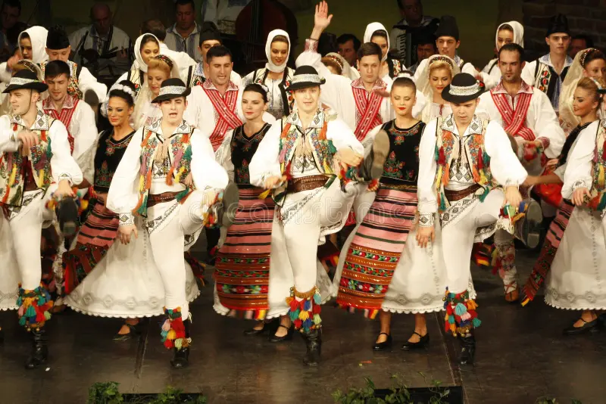
(Image highlighting the traditional Romanian dances and its traditions)

Table of Contents
Executive Summary 2
Introduction 4
Rationale for the Event 4
Background to the Theme and Location or Key Business 4
Industry Trends or Cultural Considerations that were considered. 5
Analysis of the Issues and Key Concepts 6
Event Cycle and how it has been used. 6
Theories and Concepts 7
Key Elements of Feasibility 7
Research Results 8
Proposed Event 8
Budget and any other Financial Projections 8
Operational Details 9
Marketing Plans 13
Conclusion 14
References 15
Appendices 17
Appendix 1: Detailed Insights of the Event Project Summary 17

Introduction
The “Romania Winter Wonderland” is a cultural holiday event where Romanian traditions and culture with an emphasis especially on the gourmet offered to the broader public during the winter season. It includes concerts of Romanian traditional Christmas(Capra, Calusarii, Steaua) music and dances, the exhibition of arts and crafts, and the preparation of meals, including the well-known dish sarmale (cabbage rolls) and cozonac (sweet bread) (ADRIAN et al., 2023). It is a plan to organise an event which would represent what guests can hear, feel, taste, touch and engage with when it comes to Romanian culture with the aim of bridging the cultural divides.

Rationale for the Event
This event has been selected due to the increasing concern towards the ethnic experience, especially in multicultural regions. There is strong connectedness of Romanians in the UK especially in parts like Coventry (Dachin et al., 2024). It makes them show interest in the event as those in the region desire to contact their tradition as well as get the locals and tourists acquainted with Romanian tradition.
Economic Uncertainty: Cultural events depend on the expendable income of people, and given that there is an economic contraction, there may be a decline in the number of people attending such occasions (Nechita et al., 2023). To overcome this, the strategy of keeping the ticket price cheap will be considered and will also look for sponsorship opportunities.
Health & Safety Regulations: In post COVID-19 era, there is a need for better measures in managing crowds and food hygiene. The event will make sure that it operates within compliance with local health regulations to keep the attendees safe.

Background to the Theme and Location or Key Business
It was held in Families for All Hub in Coventry at Foleshill Road, near Edgwick Park. It is a public venue with great accessibility and proximity to the densely populated central business district. The audacious undertaking requires a venue that can accommodate large crowds and activities both indoors and under the open skies simultaneously. The venue is friendly for the community and capable of accommodating large cultural events which makes it perfect for reaching out to kids and families expecting a friendly atmosphere as well as culture audiences interested in Romanian Winter Wonderland events.

Industry Trends or Cultural Considerations that were considered.
The events industry is dynamic because different trends, challenges and societal changes shape it. These trends are as follows and will affect the planning and execution of "Romanian Winter Wonderland":
Industry Trends
- Experiential Events: There is an increasing tendency to have mostly touch events. This trend will receive special attention in Romania Winter Wonderland where guests will be offered to try real Romanian life with the help of traditional carols, dances, hand-made crafts, and products from our restaurants.

- Sustainability: Increasing environmental consciousness makes more events incorporate waste management, efficient use of environmentally friendly materials, and questions about green catering (Herman et al., 2023). This will ensure best practices particularly in the areas of food preparation and waste disposal.
- Digital Integration: The use of digital tools in event marketing, as well as ticket selling and live streaming, is also influencing the industry moderately. To increase attendance and ensure that more people are aware of Romanian Winter Wonderland, the event will use social media, online ads and online ticket selling.
Cultural Considerations | SWOT Framework
SWOT Analysis
Strengths
- Concern with Romanian culture and heritage gives a specific, genuine experience to the consumer.
- Hired Romanians to maintain standards of authentic Romanian cuisine, music, and many other aspects in the restaurant.
Weaknesses
- Lesser-known brand of the event in the local UK market, thus the problem of how to create awareness of the event at first instance.
- In the case that the organisation relies too much on local businesses to give a more native touch, it inhibits a variety of products.
Opportunities
- Higher attendance and participation may result from developing cultural tourism and exotic parties.
- Local cultural organisations or sponsors can increase the event's coverage and sponsorship. However, this idea needs to be brainstormed with members and shareholders.
Threats
- Unfavourable economic conditions were able to decrease the entertainment budget which in turn reduced ticket sales or attendance.
- Threats posed by other winter events or holiday festivals may also be likely to affect the uniqueness or the number of people attending.

Analysis of the Issues and Key Concepts

Event Cycle and how it has been used.
The Event Cycle refers to the different phases of an event, from the time it is conceived right up to the end of the event or program then until it is assessed (Allen et al., 2022). It is typically broken down into six main phases: Initiation, Planning, Implementation, Event, Closure, and Evaluation (Bladen et al., 2022). Every phase of them presupposes various activities and important choices concerning the organisation of the event (Coman et al., 2023).
1. Initiation: In this phase, formation of the concept for the event is made. The theme for Romania Winter Wonderland was developed with the intention of promoting Romania's winter holiday occasion. The rationale for this occasion resulted from the increasing demand for cultural tourism, and there is a large Romanian population residing in the given area, especially in Coventry.
2. Planning: It encompasses most of the planning process in which most of the undertakings that will be involved in the event are arranged (Hancock, 2023). All decision were made with the alignment of the event success that includes selecting the location, financials, people, equipment, and promotion of the event. The Families for All Hub in Coventry was selected because has a vast performance space for the actors and singers, as well as space for food stalls and other workshops. The essential suppliers were determined, and the budget of the event was evaluated, which included catering services, staffing, marketing, and renting of the venue.
3. Implementation: This is backstage, where the preparation of the event location takes place, human resources are recruited, and other resources, such as materials and technology, among others, are sourced and arranged. This will involve finalising schedules for all parts of the play, getting confirmation from the performers/stars for the performances/activities and ensuring that relevant technical aids like sound systems for music and carols, among others, are in place.
4. Event: The event "Romania Winter Wonderland" will occur on the weekend. People will be treated to the performance of Romanian folk dances, as well as flavours of Romania, through food sampling.
5. Closure: While the event ends, the physical environment will be left tidy, whereby vendors who had erected stalls will close them. The event conditions will also solve any problems before leaving the venue, and the venue should be cleared on time.
6. Evaluation: Assessing the event after the successful completion of this event will, therefore, play a significant role in the success of the event (Abdulan et al., 2023). For this event, the event organiser will study attendee feedback, and financial results to identify lessons for future events as well as the general effectiveness of event implementation. This assessment will therefore aid in putting into consideration several factors and inform the planning which will go into other consecutive phases of "Romanian Winter Wonderland."

Theories and Concepts
As a theoretical framework that supports planning for Romania's Winter Wonderland, the Event Lifecycle Theory has been used. This theory focuses on different phases that an event passes through, from its inception to the assessment of the event (Mohanty and Choudhury, 2022). Under the planning phase, the key strategies range from understanding the goals and objectives of the event, finances and making the reservations for the event venue. During the event operational management has great responsibility for maintaining operational order through logistical support and staffing. After the event, the level of satisfaction among the attendees will be ascertained, and general suggestions obtained.

Key Elements of Feasibility
The probabilities of success of the “Romania Winter Wonderland” event can be considered good in terms of the prospective demand for culture and local non-trivialities, involving target-clients from the UK and specifically Coventry. The selected site is Families for All Hub, which is not only convenient but also spacious, thus improving the navigation and differentiate the zones. Further, ensuring that ticket prices remain low, and the team can attract potential sponsors contributes to making the team financially viable, certain economic risks can also be eliminated easily. Based on the plan of the event cycle, concerning health regulations and eco-friendliness, the event is ready to provide safe, genuine, and powerful representation of cultural event.

Research Results
According to the research, people’s interest in multicultural experiences has become more prominent, especially in the multicultural environment (Cornwell, 2020). Coventry is a city with a considerable Romanian community and the people insist on their desire to get back to their roots and share the stories with others. Also, the trends reveal that people prefer experiential as well as sustainable events (Elhosiny et al., 2023). Thus, “Romanian Winter Wonderland” is in line with the trends. First, a survey of stakeholders highlighted their high level of engagement in cultural events and potential sponsors are willing to support local cultural programs.

Proposed Event

Budget and any other Financial Projections
Estimated Costs (£)
- Venue Rental: £2,000
- Catering: £5,000 (local Romanian food vendors)
- Staffing: £3,000 (event staff, volunteers, performers)
- Marketing & Promotion: £1,500 (advertising, digital campaigns)
- Decorations & Lighting: £1,500 (stage lighting, festive decorations)
- Entertainment: £2,000 (music, dance performances, workshops)
- Permits & Insurance: £500 (required event permits and event insurance)
- Miscellaneous: £500 (unexpected expenses)
Total Costs: £16,000
Projected Revenue (£)
- Ticket Sales: £10,000 (based on attendance and ticket prices)
- Sponsorships: £4,000 (support from local businesses)
- Vendor Fees: £2,000 (from food and merchandise vendors)
- Merchandise Sales: £3,000 (sale of event-related items)
Total Revenue: £19,000
Net Profit: £3,000

Operational Details
Proposed Locations
The Families for All Hub will be the main central for the event. The event will engage the corresponding authorities of the management of the venue to ensure that it meets operation necessities for performances, workshops, food stalls and rotation seating arrangements among gatherings.
Venue Availability
The Families for All Hub in Coventry is available on the proposed weekend dates for the “Romania Winter Wonderland.” It also covers the necessary date to host a large-scale community event, which makes the selection possible. As for ticket booking, the event strategy has worked closely with the management of the venue to adequately book time in for setup as well as event activities.
Venue Suitability
This cultural event is only appropriate to hold at the Families for All Hub, since it will provide the open space that is needed for the large crowd. Its accessibility to patrons by being central in Coventry contributes to this while the facilities allow for several VIP actions such as performance, skills development sessions, and even food stations, to make it a befitting social-cultural event.
Staffing Requirements
The event will need volunteers who will be hired from the Romanian community and other persons who will be involved in issues that include officers, guides, booth managers and crowd controllers, among others. There will be a local Romanian supply for all catering teams and local and traditional foods like sarmale and cozonac will be provided. Technical assistance will guarantee that all performances, including music for Romanian carols and cultural dance, will include sound and lighting systems.
Catering, Lighting, Parking Facilities and Seating
Food and beverages will be supplied by Romanian providers for the themed event “Romanian Winter Wonderland,” distinct traditional dishes to be served include sarmale and cozonac. The buffet style will incorporate food stations so that guests will not be confused when moving from one zone to another while offering them a great taste of food. For lighting, festive, and proper decoration that will fit the performances will improve performances and produce a warm feeling at night. Presently, the Families for All Hub provide an impressive parking lot, which means they can host many guests, and they can easily find a place to park. There will be seating for openness of workshops, area with assigned seating for the major events, and lounge seating next to food vendors so families and large parties will be able to easily accommodate.
Event Itinerary
Day 1 – Friday
- 5:00 PM -Opening Ceremony: It will start with the event manager the event welcoming the guests After that, there will be some formal introduction regarding the cultures associated with the event. There will be Romanian Traditional carols to be sung by local people with the assistance of a choir.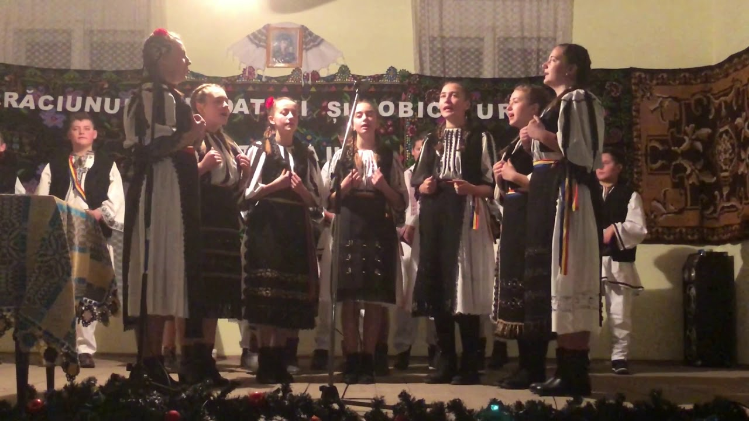
- 6:00 PM – Theatrical Folk Show: A live folk show with the best performances of Romanian traditional dances at the castle.
- 7:00 PM – Food Tasting: The guests taste true Romanian delights like sarmale, cozonac and tochitura de porc – pork’s mince casserole.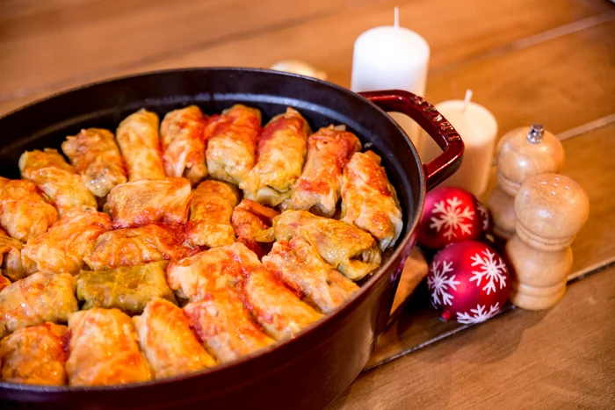
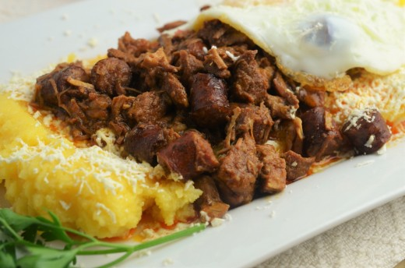
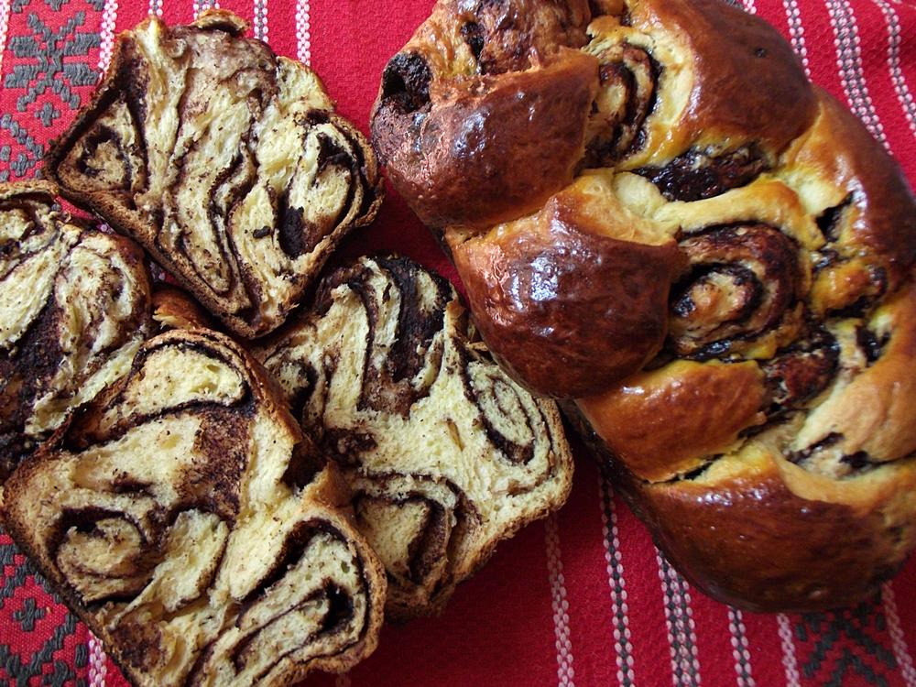
- 8.00 PM – Sarmale and mămăligă (polenta) demonstration/ workshop where the participants will be able to follow the process.

Day 2 – Saturday
- 11:00 – Crafting Workshop: Participants will be able to make traditional Romanian ornaments.
- 1:00 PM – Any given Friday – Music Session: Romanian bands will be singing Christmas carols and will present Romanian traditional Christmas dances ( Capra -the goat dance, Calusari, Steaua)
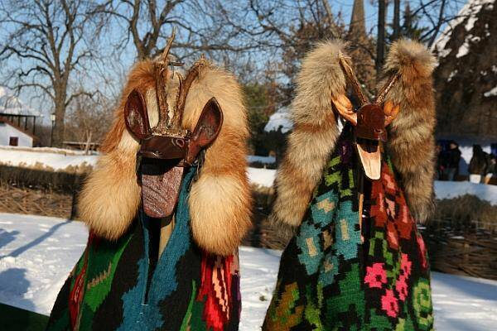

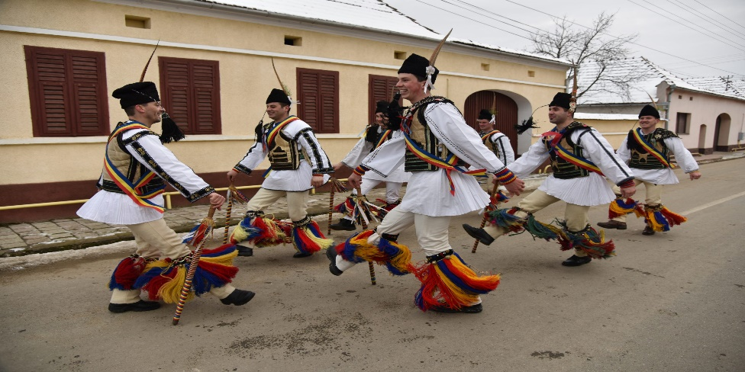

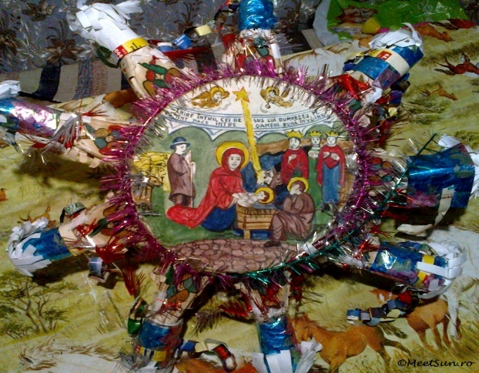
- 3:00 PM – New presentation: Romanian chefs will prepare other dishes including Alba ca zapada– a snow-white cake or cornulete cu Rahat – mini croissant with Turkish delight.
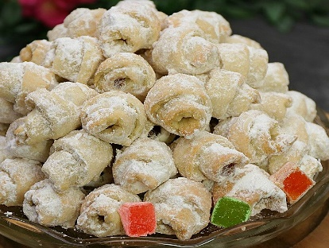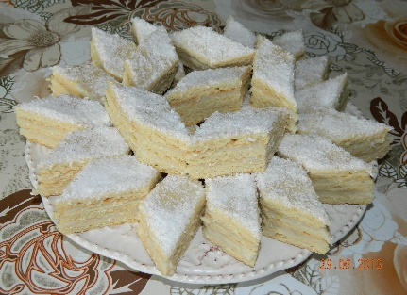
- 5:00 PM – Lecture: A special guest will discuss the importance of the Romanian and its representatives’ Traditions in winter.
- 7:00 PM – Romanian Christmas: Showcasing, cultural Romanian folk dancing, singing and a delicious dinner.
Day 3 – Sunday
- 11:00 AM – 45 minutes Family Physical Fitness: This will involve an exercise that will require the involvement of all the family members.
- 1:00 PM Last Performance: The programme ends with a magnificent show, the performance of the Romanian Folk Music and Dance Team, as well as a Vote of Thanks.

Marketing Plans
Target Market
The target market for “Romania Winter Wonderland is made of Romanian citizens in the UK especially in Coventry and other residents with interest in multiculture. The event is also cultural tourism, families, and single people looking for real performances of local people, interesting holiday activities, and local cuisine. Marketing will also target the Romanian community and other people in Coventry reaching multicultural communities interested in multicultural activities.
Demand
Existing literature suggests high consumer interest in experiencing cultural tourism and ethnic entertainment in the UK particularly Coventry city (Rogers and Wynn-Moylan, 2022). Romanians in the area are eager to relate to their roots, whilst those living in local community are in search of new experiences in holidays. The demand of this event is justified by the trending experiential events and evolving interest in multiculturalism, which makes this event relevant.
Supply
The event will meet this demand by offering such Romanian cultural tastes, moves, and touches in food, music, dance, and artefacts. The existence of Romanian vendors and performers ensures that there really is a cultural event going on. Furthermore, available venue and accessible infrastructures, and expert event team make the events enjoyable to the crowds in a way that attendees who are searching for quality and real event experience will have their needs met.
Competition
Threats that could affect “Romania Winter Wonderland” include competition comes from other holiday markets and other winter festivals prevalent in Coventry and the surrounding regions. However, it is specific to Romanian culture and is a novelty, which most Trump male clients cannot experience daily. To achieve this, the event will ensure that the festival’s adverts give a clear distinction of the cultural aspects, traditional foods, and Romanian acrobatics to set it apart from other festive events.

Conclusion
Therefore, "Romania Winter Wonderland" is a perfect chance to explore Romanian culture and traditions, as the major focus will be on the participants' belongings, as well as specialities, music, and performances. Consequently, the theoretical perspectives will assist the event in the planning and evaluation using the event lifecycle approach, analysing organisational strengths, weaknesses, opportunities, and threats in the Event Appraisal and Selection matrix (SWOT). Both cultural exposure and high engagement in community activities will make this a remarkable affair for all stakeholders.

References
Abdulan, I.M., Popescu, G., Maștaleru, A., Oancea, A., Costache, A.D., Cojocaru, D.C., Cumpăt, C.M., Ciuntu, B.M., Rusu, B. and Leon, M.M. (2023) Winter holidays and their impact on eating behaviour—A systematic review. Nutrients, 15(19), p.4201.
ADRIAN, B., MIROSLAV, R., ANDREA, F. and NICOLETA, M.S. (2023) TOURISM INDUSTRY IN EUROPE AND ROMANIA OVER THE LAST FEW YEARS-TRENDS, CHALLENGES, AND OPPORTUNITIES. Agricultural Management/Lucrari Stiintifice Seria I, Management Agricol, 25(1).
Allen, J., Harris, R. and Jago, L. (2022) Festival & special event management. John Wiley & Sons.
Bladen, C., Kennell, J., Abson, E. and Wilde, N. (2022) Events management: An introduction. Routledge.
Coman, A., Grigore, A.M. and Ardelean, A. (2023) July. Management of Cultural Institutions. Case Study: Management of Performing Arts in Romania. In International Conference on Human-Computer Interaction (pp. 183-199).
Cornwell, T.B. (2020) Sponsorship in marketing: Effective partnerships in sports, arts, and events. Routledge.
Dachin, D., Dawed, R. and DACHIN, D.A. (2024) Impact of globalisation and climate change on tourist destinations. A case study in Romania. Romanian Journal of Regional Science, 18(1), pp.87-107.
Elhosiny, S.M., Hassan, T.H., Josan, I., Salem, A.E., Abdelmoaty, M.A., Herman, G.V., Wendt, J.A., Janzakov, B., Mahmoud, H.M.E. and Abuelnasr, M.S. (2023) Oradea’s Cultural Event Management: The Impact of the ‘Night of the Museums’ on Tourist Perception and Destination Brand Identity. Sustainability, 15(21), p.15330.
Fox, D. et al. (2014) Doing events research: from theory to practice. Routledge: Oxford.
Getz, D. and Page, S. (2019) Event studies: theory, research, and policy for planned events. 3rd Edition. Routledge: Oxford.
Hancock, P. (2023) Organizing Christmas. Routledge.
Herman, G.V., Caciora, T., Grama, V., Baias, S., Beatón, M.O.R., Green, I., Hassan, T.H., Bulz, G.C., Andriamampianina, H.S. and Gozner, M. (2023) Tourist Perception of the „Night of the Museums” Event. Case Study in Oradea Municipality, Romania. GeoJournal of Tourism and Geosites, 47(2), pp.486-492.
Lehtovuori, I. (2023) Building an event-planning start-up: business plan for a small event planning start-up company.
Miller, D.L., 2023. An introductory guide to event study models. Journal of Economic Perspectives, 37(2), pp.203-230.
Mohanty, P. and Choudhury, R. (2022) Events tourism in the eye of the COVID-19 storm: Impacts and implications. In Event Tourism in Romanian Countries (pp. 97-114). Apple Academic Press.
Nechita, F., Rățulea, G.G., Borcoman, M., Sorea, D. and Leluțiu, L.M. (2023) Hybrid events as a sustainable Educational Approach for Higher Education. Trends in Higher Education, 2(1), pp.29-44.
O’Toole, W. (2011) Events feasibility and development: from strategy to operations. Elsevier: Oxford.
Parent, M.M. and Ruetsch, A., 2020. Managing major sports events: Theory and practice. Routledge.
Rogers, T. and Wynn-Moylan, P. (2022) Conferences and conventions: A global industry. Routledge.
Walker, J.R., 2021. Introduction to hospitality. Pearson.
Watanabe, A.T., Sebem, R., Leal, A.B. and Hounsell, M.D.S., 2021. Fault prognosis of discrete event systems: An overview. Annual Reviews in Control, 51, pp.100-110.
Wideman, R.M., 2022. Project and program risk management a guide to managing project risks and opportunities. Project Management Institute, Inc.

Appendices

Appendix 1: Detailed Insights of the Event Project Summary


