Legal Risks for the Hotel Industry
Module Code: M4X01017_BIRM
Student Name: Theodor- Andrei Bidoianu
Student Number:1816338
Lecturer: Dale Clarke

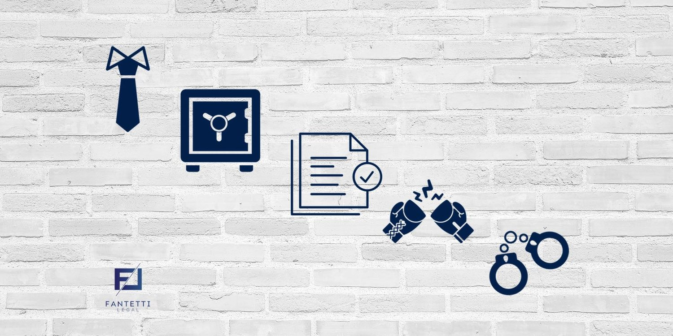

Table of contents
Introduction……………………………………...………………. Page 3
Liability…………………………………………………………… Page 3
Licensing ……………………………………………………….…Page 3
Food Hygiene……………………………………………………. Page 4
Data Protection …………………………………………………. Page 4
Risk Management ………………………………………………. Page 4
Health and safety………………………………………………… Page 5
The Hotel Proprietors Act 1956 …………………………………Page 5
Conclusion ………………………………………………………… Page 6
References ………………………………………………………… Page 7

Introduction
In this report I will be presenting the learnt aspects that people working in the hotel industry have to cope with these things being such as; liability, data protection, health and safety, food hygiene, risk management, licensing, and I will be talking about the key provisions which have been introduced in 1956 in the Hotel Proprietors Act. Hotels and Inns have a huge impact in the economy because of the services they offer and the products they are selling. They tend to make lots of money and to increase the prices once with the number of guests, so the economic level is increasing as well constantly. Holding a business such as a hotel might be tricky because there are many specific things that need to be under control every time. For example, the food safety which is a side of the health and safety needs to be checked before giving it for sale. The food in a hotel is usually given to the people requesting and paying it so the owner needs to be aware of any allergies or contaminations and let the consumer know before buying it as well. Theoretically health and safety in a hotel industry means much more as it has to be perfectly checked so the people coming will not be having accidents because they cost time and money also, the building safety needs to be perfect because if not then most of the money from their budget will be spent on the material to build up the destroyed thing again.
Liability

In the Hotel Industry you will always have responsibilities that contours the wat that the Hotel is going, and it could be better every time, worse or variable. Hotel’s liabilities are based on the aspects I am about to describe within the following paragraphs, those being: Health and safety, data protection, food hygiene, licensing… If those responsibilities are not well structured so everything is fine many accidents may happen and then the amount of guest will decrease, the economy will decrease as well, and it would be very hard for the hotel to build its reputation again. Therefore, liability is important in a business especially in a hotel because there are hundreds of people coming because they trust in your services and your capability to maintain a good and safe atmosphere while they are staying in. There are many things that The Hotel’s Staff could be liable for such as the transport from the station to the hotel or the valet service which yes, could improve the hotel’s economy, but it also, makes the staff take a bigger risk.
Licensing

As “The hospitality industry is one of the biggest industries and thus is regulated by a huge variety of rules and regulations” (Barth and Hayes 2006) the licenses are very important and they will allow you to open the Hotel and then it will allow you to build up services and sells. For example, the applicable location-based license will be needed on your way to build up food services and this because you need to protect various location-based permits, this license will allow you to build relevant building permits and signs to let the people know the way to your local hotel and a summary about what they can find at yours. Another necessary license is the Relevant Tax Registration which will give you the opportunity to pay your federal taxes which then will allow you to register your hotel for a general business licence and your state, county or city authority tax. Also, in my opinion the most important license in a hotel that own a restaurant as well is the Food service (Safety license) which is only approved only after the licensor considers that the storage, preparation, handling and sanitation are well protecting the health and safety for the people coming at the hotel. I feel like this is the most important license because if the food is contaminated the guests will be having illnesses.

Food Hygiene

It includes the food safety, toxic substances related to food and its risks, which are at a higher and higher level because of the number of issues the guests had because of the contaminated food. The hazard which is linked to food and its risks will be minimized by a systematic and continued training and education with changes in behaviour. In 1995, Schmidt which took part of the World Health Organisation (WHO) said that “The food and water borne illness as regardless of the presenting symptoms and includes any disease of an infectious r toxic nature caused by or thought to be cause by the consumption of food or water”. The organisation clearly proved that even the water which is not filtered can be a negative factor that drives guests to bad illnesses, because of the high number of microbiological and chemical or physical hazards.
.
Data protection

“There are risks in collecting and using personal information (to individuals, society and organizations), and they must be recognised and addressed.”(Carey 2008) The mentioned quote makes us understand that it is very important how you, as a member of staff decide to protect important information such as credit cards details, dates when people booked in, passport reference numbers, passwords and booking/ enquiry systems. It will have a huge negative impact if the Data Protection in not well protected and it will influence many departments and it goes beyond any border within an organisation, so the level of importance for accountability must be at director level. The idea of well protected private information will allow the business to stay compliant with the Data Protection and this will entail constant monitoring of systems and processes against the regulations to avoid data breaches and manage the risks. If the Hotel someone owns is popular and has a huge number of guests, it will be more likely to create privacy committees to improve link data privacy objectives to directors’ performance management. Another important aspect is linked with the persons that are coming to work for the higher positions so therefore the employee must be careful at what people could offer for the specific role.

Risk management

Risk is defined as the potential loss or harm and this has been said by the Canadian Tourism Commission, but when it comes about the risk management it refers to the practices, polices and procedures specialised to reduce the injuries within the guests and employers. Keeping the customers and staff safe is a moral and necessary responsibility of operators and this is based on avoiding the emotional and physical accidents. Also, the risk that must be taken by the operators is the protection against damage to property, damage to reputation and any financial impacts linked with the litigation.
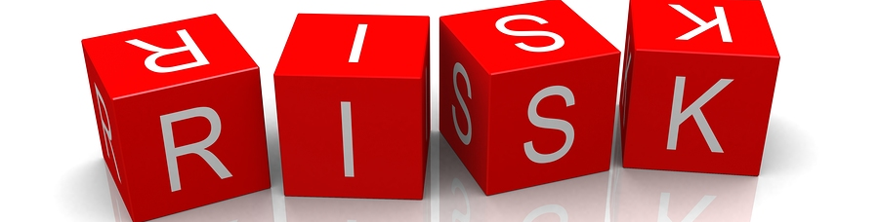

Health and safety

Health and safety is considered very important for any type of business, but when it comes about tourism and hospitality industry the responsibility is a lot bigger than the others because there are many people you need to be responsible for and this will costs more than the standard price for all the checks. The risks that needs to be considered about Health and Safety are; slips, trips and falls; the lifting and the manual handling; the contact with hot surfaces and harmful substances, the cuts; upper limb disorders and many, many others. Most of the accidents an be prevented if the management and supervision with an effective training behind.
What employers need to do is based on providing and maintaining a safe equipment, ensure health and safe working environment, provide useful information, instruction and training for the new workers, prevent and frequently exposure to hazardous substances and loud noise. Next to the listed aspects, “health and safety measure included in the hygiene signs, emergency exit areas, emergency signs and lightings, fire exits, fire signs, hazard and warming signs placed throughout the place, radiation signs, safe condition signs and several other signs that show that the safety is kept in mind when planning the organisation.” (Guillet and Mattila, 2010)

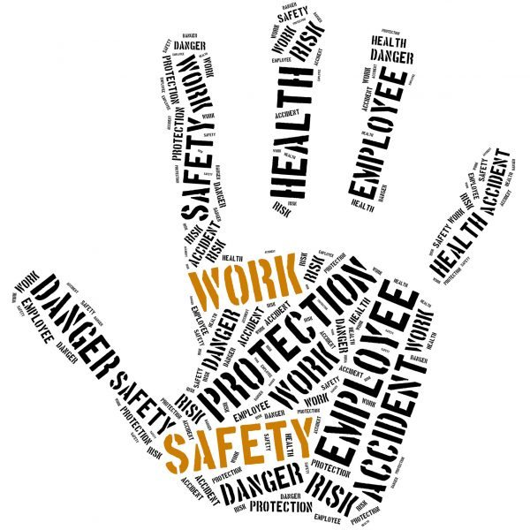

The Hotel Proprietors Act 1956

Is an act which amend the law relating to inns and innkeepers describing the new rules linked with the liabilities in terms of guest’s and staff’s goods. It is said that “The proprietor of an hotel shall, as an innkeeper, be under the like liability, if any, to make good to any guest of his any damage to property brought to the hotel as he would be under to make good the loss thereof” (The hotel proprietors act, 1956). This quote showing that each person needs to be liable for their objects and how they keep those within them, this being very necessary to know as if not the hotel will get negative feedback which will not be looking good when people will be looking at its reviews.

Conclusion

In the final lines I am just about to say that it is very important how much effort and research you put in before opening a business in the hospitality industry. As the legal risks are very necessary in a business you need to fully aware of their role and what are the disadvantages if you do not respect the specific conditions.

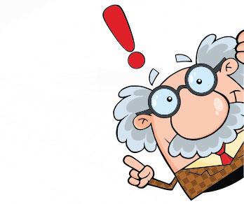

References

Barth, S. C., & Hayes, D. K. (2006). Hospitality law: Managing legal issues in the hospitality industry. John Wiley & Sons.
Carey, P. (2008). Data Protection. 3rd ed. Oxford: OUP Oxford
Canadian Tourism Commission
Guillet, B. D., & Mattila, A. S. (2010). A descriptive examination of corporate governance in the hospitality industry. International Journal of Hospitality Management, 29(4), 677-684.
The hotel proprietors act

