

Quantity Surveying BSc

Assignment title: Water Supply and Waste Drainage

Assignment 1.

Name: Cody Colarusso
Student number: 1703000

Word count Part 1: 1430
Word count Part 2: 566

Table of Contents

PART 1
Introduction 3
History of London’s Sewerage 3
Sir Joseph Bazalgette’s Impact 3
London’s Current Sewerage system 4
The Thames Tideway Tunnel 5
References 6

PART 2
Direct Hot and Cold Water Systems 7
Indirect Hot and Cold Water Systems 8

Introduction

London is currently undergoing its biggest infrastructure change since the last millennium. The old and outdated sewerage system that was designed back in 1858 is beginning to crack under the ever growing population of London. That and the heavy rainfall of climate change is proving too strong and pushing the system to its limits. This paper reads into London’s modern day sewerage epidemic.

History of London’s Sewerage

During the 1800’s, London’s population was dramatically increasing, with numbers almost doubling from the beginning to the end of the century. It was becoming evident that the increased population was proving too much for an overused and underdeveloped sewage system and it was steering London into disastrous public health concerns.

By the 1850s London was inhabiting more than 2.5 million people, all of which contributing to the non existent sewerage system. Stephen Halliday (2001) described the sewage design at the time to be an open sewer, which flowed into the River Thames. The result of such poor provisions of sanitation resulted in cross contamination in nearby springs, wells and sources of drinking water with diseases such as cholera and typhoid being formed. This epidemic had already been envisioned during the 1700s but advancements on the issue were deterred as the cost of constructing the new sewerage system was substantial. However, this current system was far from hygienic, with fumes being generated from the contamination also polluting the local air. There was no cure or treatment for cholera at the time, and the disease was responsible for almost 40,000 deaths.

During 1858, the foul smelling air which seeped from the River Thames grew so pungent it forced Houses of Parliament to issue a bill for construction of works, it was dubbed The Great Stink of London. The bill illustrated protection over the capitals water supply from sewage and waste and a £3 million bill was allotted to the Metropolitan Board of Works. At the time Sir Joseph Bazalgette was Chief Engineer of the Board of Works and provided authority to design and construct a system.

Sir Joseph Bazalgette’s Impact

Seven Wonders of the Industrial World (2003), spoke about Sir Joseph Bazalgette, explaining he proposed a bold scheme that would provide London with over 1100 miles of sewerage, linking the sanitation provisions for high streets through underground intercepting pipework, that divert London’s waste downstream and away from the population.

Bazalgette provided an ingenious solutions to aid the drainage by implementing pumping stations to help raise the flow of low level sewage higher in order to drain and building two major water treatment works. The work began during 1859, with Bazalgette using around 318 million bricks, 2.5 million cubic metres of earth and adoption of the newly manufactured Portland Cement. The project ended only 9 years later during 1868, with a total cost of finishing at around £4.2 million. With his standard of work being coped all over the word, it was obvious that Bazalgette held a significant impact which revolutionised engineering at the time.

London’s Current Sewerage system

Sir Joseph Bazalgette’s London sewage system still exists today but has been expanded on numerous times, so that it can keep up with the population growth. The initial design was assumed to support 2.5 million people, but with London’s population now increasing to over 9 million people, the current system simply cannot be expanded anymore and is showing signs of breaking point.

In the previous couple of years, many reports have been publicised addressing the major problem London is having with its sewers, with some have even dubbing it “Our Generations ‘Great Stink’”. BBC News reported during September 2017, that a “fatberg” weighing 130 tonnes was found to be blocking London’s sewers. The fatberg consisted of various sanitary items which had been flushed into the sewers and built up beneath Whitechapel. It required two months of engineer’s time, in order to be removed.

Another report in February 2018 from the BBC, stated that wet wipes were one of the main culprits donating to London’s sewage problem. Those and sanitary towels were responsible for over 30 tonnes congealed fat that were clogging up the system, with Londoners being encouraged to “bin it, not block it”.

However, during 2010, attempts were made to help alleviate the pressure currently on Bazalgette’s system with a £635 million project called the Lee Tunnel. Construction commenced in late 2010, with the aim to prevent 16 million tonnes of overflow from the Abbey Mills pumping station from entering the River Lee, in an effort to ease overflow from rolling into the River Thames. Morgan Sindall (2019) explained that the project was taken on, in an attempt to improve the quality of London’s rivers and reduce tension on the CSO’s. Though despite the Lee Tunnel’s efforts, London’s sewage was still under pressure.

The Thames Tideway Tunnel Strategy (2015), summarised that on average over 39 million tonnes of untreated waste water is overflowing the CSOs (Combined Sewer Overflows - Were designed to release any excess untreated water into the River Thames to prevent the hydraulic treatment works from being surpassed) around 50-60 times a year. Nonetheless, the network is still currently operating at around 80% during dry weather, with any light rainfall that comes, quickly fill the system to its capacity and causing overflow to enter the River Thames.

The Thames Tideway Tunnel

After exhausting all options, a super sewer project is currently under development in order to help answer London’s sewage problem. The chosen solution detailed in The Thames Tideway Tunnel Strategy (2015) explains - The Thames Tideway Tunnel will be 7.2 m in diameter, up to 67 m deep, and up to 25 km (16 miles) long. A tunnel of this size is necessary to provide sufficient storage capacity within it and the depth is necessary to avoid other tunnels and to allow the sewage to flow through the tunnel by gravity.

With The Thames Tideway Tunnel Strategy (2015) going on to state that the UK is legally bound to oblige the Water Framework Directive (WFD) and the Urban Waste Water Treatment Directive (UWWTD). Both legislations ensure possession of satisfactory systems for the protection of water quality and the management and treatment of waste water, to protect the environment.

This new system is aimed to capture the polluting overflow and divert it through the newly designed tunnel which is around 65 metres below ground. It aims to intercept at least 94% of the volume produced in a year. The tunnel will avoid previous underground tunnels and transport the untreated sewage into the plant at Beckton, thus preventing millions of tonnes of waste from entering the Thames and ensuring a clean river for future generations. The operation is proposed to come into effect during 2023.

However, the project has been critiqued and with many questions being raised regarding the overall cost, the disruption the project will cause, how long the project will take and if the project is even the correct solution. Supported by the National Audit Office, their report found that construction of the £4.2bn project could overrun by more than £2bn in a worst case scenario.

But there are some benefits with the project, with estimates saying that the project will return between 1.8 and 3.1 it’s costs. The National Audit Office’s Report, states “The Department forecasts that the benefits of the project will be between 1.8 and 3.1 times its costs, however these estimates are uncertain. Approximately 60 per cent of the estimated annual benefits accrue to households outside of Thames Water’s service area, although only Thames Water customers will pay towards the Tunnel’s costs.” Thames Water also state that plenty of economic advantages will come with the project. Around 4000 jobs will be produced and several thousand other jobs within the wider economy, whilst the tunnel is under construction.

References

Institution of Civil Engineers (ICE). (2019). London sewer system. [online] Available at: https://www.ice.org.uk/what-is-civil-engineering/what-do-civil-engineers-do/london-sewer-system [Accessed 18 Jan. 2019].

2 Halliday, S. (2001). The Great Stink of London. Sutton Publishing Ltd.

3 Bbc.co.uk. (2019). BBC - Seven Wonders. [online] Available at: http://www.bbc.co.uk/england/sevenwonders/london/sewers_mm/index.shtml [Accessed 20 Jan. 2019].

4 Citymetric.com. (2019). Victorian London’s ‘Great Stink’ sewer crisis offers lessons about solving climate change | CityMetric. [online] Available at: https://www.citymetric.com/horizons/victorian-london-s-great-stink-sewer-crisis-offers-lessons-about-solving-climate-change [Accessed 20 Jan. 2019].

5 Evening Standard. (2019). London's monster fatberg FINALLY defeated after two months. [online] Available at: https://www.standard.co.uk/news/london/londons-monster-fatberg-finally-defeated-after-two-months-of-gutwrenching-work-a3675866.html [Accessed 20 Jan. 2019].

6 BBC News. (2019). Wet wipes clogging up London sewers. [online] Available at: https://www.bbc.co.uk/news/av/uk-england-london-43066688/wet-wipes-clogging-up-london-sewers [Accessed 20 Jan. 2019].

7 Ingenia.org.uk. (2019). [online] Available at: https://www.ingenia.org.uk/getattachment/Ingenia/Issue-63/Londons-deepest-tunnel-and-shafts/richard-sutherden.pdf [Accessed 20 Jan. 2019].

8 Nao.org.uk. (2019). Review of the Thames Tideway Tunnel. [online] Available at: https://www.nao.org.uk/wp-content/uploads/2017/03/Review-of-the-Thames-Tideway-Tunnel.pdf [Accessed 20 Jan. 2019].

PART 2

Direct Hot and Cold Water Systems

A direct cold water supply is a system that is supplied water through rising mains and is directly fed to each of the cold water taps and WC in the building. The storage cistern is then filled and a branch off pipe connects to the hot water cylinder. The hot water cylinder then uses heat convection or immersion heaters and feeds water to the boiler (gas fired) which recirculates back into the cylinder. The cylinder then supplies hot water directly to the taps.

Advantages of using a direct water system:

- Simpler and cheaper system to install.
- Water quality is generally better as it comes directly after treatment.
- Drinkable water can be obtained from each cold water outlet.
- Mains pressure throughout building.
- Hot water can be heated quickly.
However, if there is damage to the mains, the entire water supply to building is stopped until repaired. The direct supply also increases pressure on all fittings which can cause leaks or noises.

Type of Building Use

The direct water system was primarily used in domestic housing up until 1970s. This was done by using a water filled cylinder and directly heating it by a back boiler over a coal fire. The method of heat convection did not require the use of any pumps or electrical controls as it heated the water through gravity circulation.

See figure 1 for illustration.

Indirect Hot and Cold Water Systems

An indirect cold water supply is a system where water is supplied from the mains pressure and is fed directly into the ground floors kitchen tap and cold water storage cistern. The cistern is then branched out into each cold water tap or faucet in the building and into the hot water storage cylinder. The indirect hot water cylinder works differently to a direct system, as it separates both the central heating and the hot water and uses a heat exchanger or coil. The heat exchanger or coil is connected to the boiler flow and return pipes. This coil in the cylinder holds a separate flow of water to that which is in the boiler, creating the need for a feed and expansion cistern, to supply the boiler circuit.

The advantages from this system:

- Larger storage capacity, if the mains water is cut off, there is a reserve.
- Reduced water pressure on taps and fittings.
- Less noises and wear on fittings.
An overflow pipe connects from the cistern and travels through the exterior wall, so if the cistern gets too full, it can discharge the water. This is to prevent overflow and flooding to the building. The minimum size must 22mm and one size larger than the supply pipe.

Type of Building Use

The indirect hot water system is the preferred method for hard water areas and combined hot water and central heating. Due to the indirect system incorporating a
dual system, which uses two water routes. One is for the cold water storage which travels through the cylinder and the other is for the boiler, which feeds the F&E tank.
When the water inside the boiler is heated past 49 degrees Celsius, it causes the lime scale to come out of suspension.

This type of system is typically found in larger buildings, as the storage size will be estimated from the number of fittings and the amount of users.

See figure 2 for illustration.

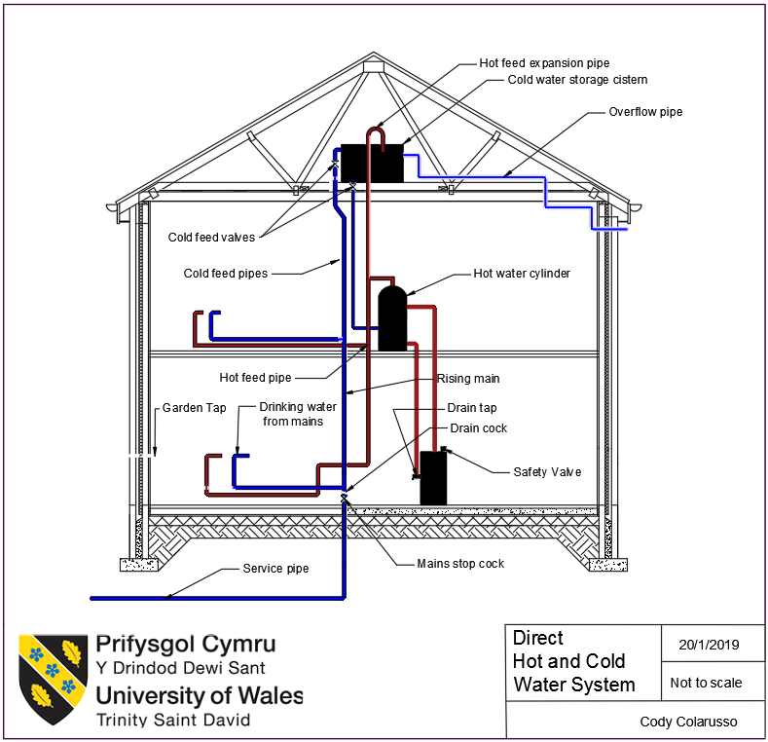
Figure 1.

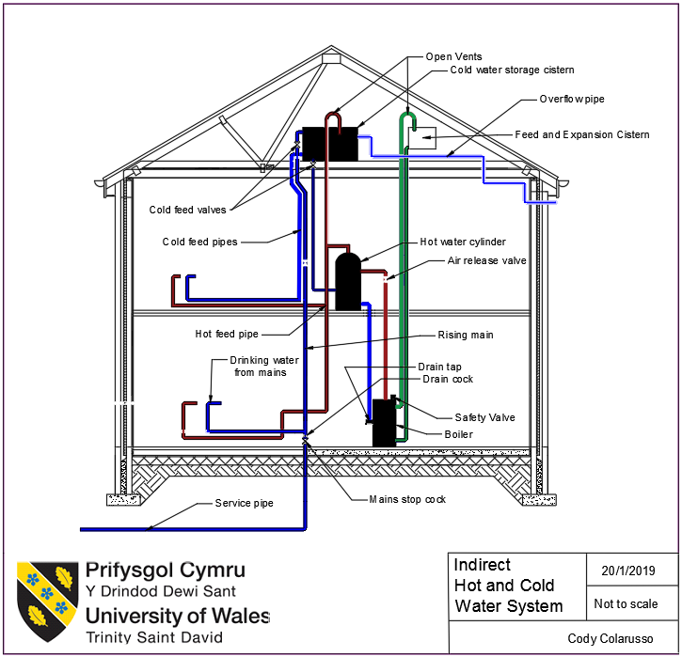
Figure 2.

Institution of Civil Engineers (ICE). (2019). London sewer system. [online] Available at: https://www.ice.org.uk/what-is-civil-engineering/what-do-civil-engineers-do/london-sewer-system [Accessed 18 Jan. 2019].
Halliday, S. (2001). The Great Stink of London. Sutton Publishing Ltd.
Bbc.co.uk. (2019). BBC - Seven Wonders. [online] Available at: http://www.bbc.co.uk/england/sevenwonders/london/sewers_mm/index.shtml [Accessed 20 Jan. 2019].
Citymetric.com. (2019). Victorian London’s ‘Great Stink’ sewer crisis offers lessons about solving climate change | CityMetric. [online] Available at: https://www.citymetric.com/horizons/victorian-london-s-great-stink-sewer-crisis-offers-lessons-about-solving-climate-change [Accessed 20 Jan. 2019].
Evening Standard. (2019). London's monster fatberg FINALLY defeated after two months. [online] Available at: https://www.standard.co.uk/news/london/londons-monster-fatberg-finally-defeated-after-two-months-of-gutwrenching-work-a3675866.html [Accessed 20 Jan. 2019].
BBC News. (2019). Wet wipes clogging up London sewers. [online] Available at: https://www.bbc.co.uk/news/av/uk-england-london-43066688/wet-wipes-clogging-up-london-sewers [Accessed 20 Jan. 2019].
Ingenia.org.uk. (2019). [online] Available at: https://www.ingenia.org.uk/getattachment/Ingenia/Issue-63/Londons-deepest-tunnel-and-shafts/richard-sutherden.pdf [Accessed 20 Jan. 2019].
Nao.org.uk. (2019). Review of the Thames Tideway Tunnel. [online] Available at: https://www.nao.org.uk/wp-content/uploads/2017/03/Review-of-the-Thames-Tideway-Tunnel.pdf [Accessed 20 Jan. 2019].

