

NAME : MUDIREDDY KOTESHWAR REDDY
STUDENT ID : 2216776

MODULE :
HUMAN RESOURCE MANAGEMENT (LCMB7000)

Table of Contents
Introduction 4
The recent state of the labour market in the UK 4
Evolution of the UK labour market 4
Regulations regarding labours in the UK 5
The recent situation in the labour market 7
Challenges faced by the labours due to external factors 8
Challenges due to Brexit: 8
Challenges due to covid-19: 8
The challenges faced by human resource management due to Covid 8
Implementation of remote work environment 9
Retaining employees 9
The recent changes in HRM Strategies in the post-Covid situation 9
Flex working and the Emergence of the Post Covid Workforces 9
Supervising employees working from home 10
Use of different technologies to automate processes 10
The challenges faced by human resource management due to Brexit 11
Understand the new UK immigration system 11
Assist employees to achieve settled and pre-settled status 12
Change within employment policies 12
The recent changes in human resourcing Strategies in the post-Brexit situation 13
Workforce Planning – Improve Employee Retention 13
Taking Different Approach to Attract EU Workers 13
Conclusion 14
References 15

Executive summary
The following report highlights the current situation of the labour market in the UK, the recent progress in human resource strategies in the post covid situation and Brexit. The issues faced by human resource management due to Covid and Brexit are also discussed in this report. Moreover, the report highlights the evolution of the UK labour market, regulations related to labours in the UK and the current challenges faced by labours due to external factors such as Covid and Brexit are discussed in this report. The entire report focuses on human resource management and the challenges faced by human resource managers due to Brexit and Covid-19.

Introduction
Human resource management is the method of hiring and training people for developing policies related to the business. Over the last 20 years, the human resource management field has dealt with many changes. In today's business world, human resource management plays an important role by processing payroll and managing people in the workplace. The managers in organisations play an important role in achieving business success and growth.
The following report covers the recent condition of the labour market in the UK, the recent changes in human resource strategies in the post covid situation and Brexit. The challenges faced by human resource management due to Covid and Brexit are also discussed in this report. Moreover, the report highlights the evolution of the UK labour market, regulations related to labours in the UK and the current challenges faced by labours due to external factors such as Covid and Brexit are discussed in this report.

Figure 1: Human resource management
(Source: Chams and García-Blandón, 2019)

The recent state of the labour market in the UK

Evolution of the UK labour market

Every organisation has policies, which help them to ensure continuity and fairness within the organisation. Human resource management helps to develop these organisational policies. The labour market in the UK has been increasing day by day. Job vacancies across the UK economy have continued to progress and it is nearly 1.3 million (Chams and García-Blandón, 2019). With unemployment, the bridge of workers is filling the job vacancies, which has grown in recent days in the UK. Employers in the UK are facing challenges in fulfilling vacancies, which can increase the value of work. The average weekly wage is developing by up to 5.4% over the year 2022. Unemployment in the UK is low due to the growth in those economically inactive environments. In 2022, the employment rate in the UK was 75.6% (Boon et al., 2018). It is important for people to get a job and then it is essential for them to improve the workplace circumstances by maintaining organisational policies. The changes in the labour market can affect the nature of work with a focus on growth regarding self-employment and progress in the insecure form of workplaces. By evaluating the current impact of the economic crisis on the UK, labour market companies can retain employees.
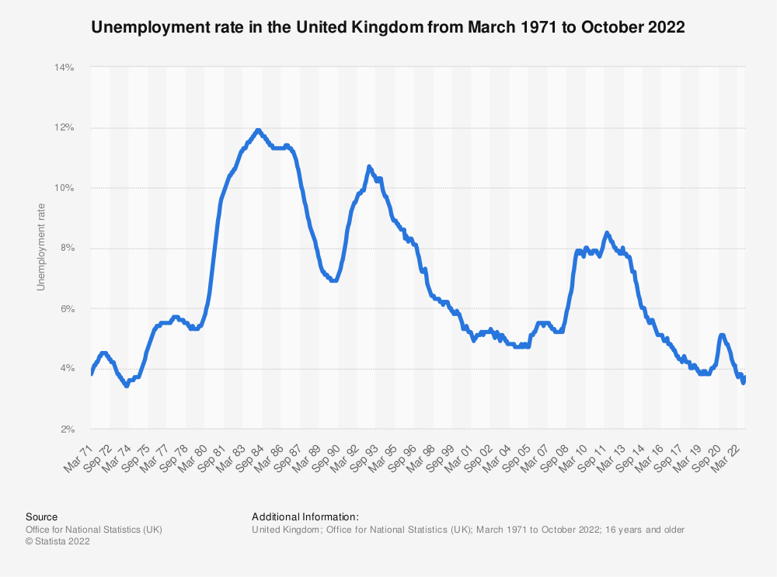
Figure 2: The unemployment rate in the UK
(Source: Boon et al., 2018)

Regulations regarding labours in the UK

Organisations in the UK can depend on a minimum charter of employment rights such as regulations, the Act of Parliament and common equity and law. The main source of employment law in the UK is legislation. Most of the employment law in the UK has derived from European law. Due to Brexit, most European employment laws were transformed into domestic law. Employment rights have changed and changed (Tambe et al., 2019). However, there will be greater scope to enhance EU-derived law in the future. The employment law in the UK ensures the protection of both employees and employers. The contracts of employment help to ensure the backbone of the relationship, the employment that protects both the employees and employers. In order to ensure the policies workers are needed to be clear on the procedures and contractual rights. All aspects of employment law deal with poor performance in managing a flexible work environment (Boxall and Purcell, 2022). Employment laws distinguish among the self-employed, employees and employers in the UK. Employees have most of the extensive rights in the workplace according to employment law.

Figure 3: The Equality Act 2010
(Source: Kaufman, 2019)
The employment law in the UK represents terms and conditions regarding employment including discrimination, industrial relations, employee representation, maternity rights, termination of employment, data protection in employee privacy and many more. With the help of UK employment laws employees are protected from hiring practices to conduct tasks in the workplace including fair wages (Greer, 2021). Businesses in the UK follow the National Minimum Wage, which focuses on the age of the workers, and all workers over the age of 23 are entitled to the law. The employees are protected from the first day of their job in the organisation with the help of the Equality Act 2010. By this law, the organisations prevent discrimination against employees based on their protected characteristics including disability, race and gender (Cooke, 2018). With the help of Health and Safety laws, the organisations in the UK ensure all workers have the right to a safe work environment.

The recent situation in the labour market

The current scenario of the labour market existing in the United Kingdom has exhibited a monthly increase in the numbers of pay rolled employees by a large margin up to an approximate figure of 71000 by the end of august 2022. It helped the number of existing employees in the labour market of the UK to reach a record figure of 29.7 million (Tang et al., 2018). The rate of unemployment also decreased from the month of May to July 2002 to buy a percentage of 0.2 on the water to 3.6%. The economic inactivity has increased by 0.4 percentage points in the quarter to 21.7% by the end of July 2022.
The job vacancies in the United Kingdom have decreased by a large number of 34000 from the previous quarter in the last of August 2022. The estimated job vacancy after this duration was 1266000 and it showed an increase in employment and high competition in the labour market of the United Kingdom. Statistics have also shown that the growth in average total pay of the employees was estimated at a figure of 5.5% and the growth in regular pay was evaluated at a figure of 5.2% after the end of July 2022 on an average (Papa et al., 2018). In the private sector organisations, the growth in the payment of the employees was evaluated at a figure of 6% at the end of July 2022 whereas this figure was approximately 2% for the public sector. This huge difference in pay raise is a result of the covid-19 and its impact on the economy of the United Kingdom.

Challenges faced by the labours due to external factors

Challenges due to Brexit: Brexit has created an overall shortage of labours existing in the markets of the United Kingdom. The working permits of foreign workers were not properly sanctioned and it created major problems for them in order to work in the UK. After the exit of the UK from the EU, the European Nations did not want to send the workers to the UK and vice versa (Reiche et al., 2018). The early retirement of the existing workers at the age of 50 has created troubles in the entire labour market of the United Kingdom amidst the political scenario caused due to Brexit.
Challenges due to covid-19: The global pandemic has influenced the workforce existing in the United Kingdom in multiple dimensions including health concerns and economic disruptions. Approximately 2.9 million working people in the UK had covid in the initial stages and it has affected their working capabilities. Approximately 80000 people lost their jobs during this pandemic and it created a gap in organisational performances (Kaufman, 2019). The shortage in the working-age population of the UK is constantly fluid by the economic inactivity due to the outbreak of the covid-19 pandemic. The rate of labour force participation has dropped by 0.7% then the pre-pandemic peak of approximately 84% and the changing nature of the jobs requires a huge amount of human capital to fill the employee shortage.

The challenges faced by human resource management due to Covid
The ongoing impact of Covid-19 has created challenges for human resource management in different organisations throughout the world. Businesses in the world are struggling to manage their work and keep their employees safe due to the lack of productivity and security measures (Collings et al., 2018). The managers of the HR department have faced different challenges.

Implementation of remote work environment

Human resource managers face challenges due to the implementation of remote work environments. It is difficult for HR managers to maintain employees' engagement and performance while they are working remotely (Kavanagh and Johnson, 2020). Due to the remote working system, the employees and the management face gaps in communication.

Retaining employees

One of the biggest challenges that human resource management faces due to the ongoing impact of Covid-19 is the difficulty in retaining employees in the workplace. Most of the employees leave the job due to unsatisfied job opportunities and low wages (Snell and Morris, 2018). Due to the lack of safety and wellness, a number of employees leave work, which creates a shortage of workforce in the organisation.

The recent changes in HRM Strategies in the post-Covid situation
The HR strategies probably have been most critical in adopting changes within the transition towards a new Paradigm developing a new normal work environment in the post-Covid situation. The Global organizations reflected on ensuring that the people were adopting the new normal thereby ensuring the business operations continuity with efficiencies and effectiveness (Werner, 2021). The recent changes have been noticed in the HRM strategies right after the Covid period for the recovery from the crisis and better management of people. The changes are as follows,

Flex working and the Emergence of the Post Covid Workforces

The post-Covid situation introduced the likelihood of Teleworking and Flex Working experiences wherein the HR through video conference. The HR managers instead of hiring people randomly for full-time employment utilize hiring on demand for project purposes. Later the demands of skills and knowledge from the managers of the organization have formed strategies of workforce management based on the situation (Swanson, 2022). The HR managers reflected on improving the training and development of the employees with the setting of a virtual video call or virtual group conference.

Supervising employees working from home

Maintaining business continuity, the HR managers of the organizations reflected on supervising and monitoring the performance of the employees from their homes instead of coming to the office. Following the government rules of social distancing, the HR managers shifted the workplace towards a Hybrid Working System that helped employee monitoring and performance management easier to handle the activities of employee engagement (Chams and García-Blandón, 2019). Communication became easier and better connectivity improved in the HRM strategies specifically in the post-Covid situation.

Use of different technologies to automate processes

Employee engagement and managing employee retention became easier with the adoption of different technology in the automation of the process. The HRM strategies already adopted different Technologies to automate the process of hiring and managing employees like cloud technology, Talent management software, Talent Acquisition Software, Gamification Techniques and many more (Boon et al., 2018). The use of the technologies in HRM strategy development after Covid improved the strategies of performance management and benefited the administrations for better workforce analysis, improving the employee compensation, talent acquisition and payroll process.

Figure 4: Talent Acquisition Software
(Source: Tambe et al., 2019)

The challenges faced by human resource management due to Brexit
The UK-left European Union is currently in a transitional period that has created various challenges in Human Resource Management specifically in the UK. Due to Brexit, HRM strategies change dramatically focusing on the areas of HRM like Recruitment, legislation, and maintaining standards of HR policies and practices. The challenge is as follows,

Understand the new UK immigration system

Human resource management in the UK faced challenges specifically understanding the new immigration system and applying the regulations in the human resource management practices in their organizations. Coming to work in the UK in 2021 and working from other countries of the world will require the immigration roots that have been utilized by the new rules of the labor market (Kaufman, 2019). The change in implementation and understanding of the rules in the immigration system created various negative consequences for hiring people in the organization.

Assist employees to achieve settled and pre-settled status

The EEA national employees and the people who are leaving the UK by the end of the year 2020 can be able to apply for the settlement of the status or can apply for the present status that has created challenges to understanding the new rules and regulations by the employees. The HRM practices faced various challenges to make the employees understand the new working rules in the UK due to a lack of regular communication to achieve their status (Tambe et al., 2019). The deadline for the applications created challenges for most of the applicants that have affected the job opportunities offered by the HRM in the UK.

Change within employment policies

The HR managers faced huge challenges regarding carrying out the immigration audit including the review and restructuration of the policies ensuring that the organizations are compliant with the change in the immigration system. That has created various challenges due to the diversified policies that needed to be considered during the process of recruitment (Swanson, 2022). The HR managers lost various talented candidates and, in some cases, they were forced in paying higher salaries for the applicants to meet the requirements for a specific job role.

Figure 5: Impact of Brexit on human resource management
(Source: Swanson, 2022)

The recent changes in human resourcing Strategies in the post-Brexit situation
Identification of the challenges faced by the HRM practices it is important to highlight the practices and the recent changes in HRM in the post-Brexit situation. The changes are as follows,

Workforce Planning – Improve Employee Retention

Around 12% of EU workers make up the UK workforce according to the Recruitment and Employment Confederation records. The employers and HR managers have reflected on giving excellent benefits and packages attracting new people in the organization, making the existing employees motivated, involved, and valued in their work. Improving employee retention became one of the greatest changes in Human Resource Management and strategies to develop written loyalty among employees (Kavanagh and Johnson, 2020). Autonomy and Freedom allowed the employees to overcome the impact of Brexit solving their issues with innovative ideas and making themselves efficient in better future planning within the organization.

Taking Different Approach to Attract EU Workers

The Brexit introduced a transition period for the people in the UK including the EU citizens who have the right to continue their working in the UK. The UK Government has taken the initiative of introducing the new immigration system and implementing changes in the HRM practices from January 2021 that has improved the rights of EU citizens with better benefits and opportunities (Reiche et al., 2018). The changes offered the employees to improve their career opportunities with clear guidance through the scheme of EU settlement associated with their working rights and leaving rights in the UK that will help the HRM in securing their workplace.

Conclusion
Global Human Resource Management reflected on improving the hiring and retention process with the development of policies and practices managing the workforce effectively for improving productivity and efficiency. The organizations in the Global platform reflected on dealing with various changes due to the Global Incident for the improvement of Human Resource Management, which plays an efficient role in hiring and managing people in the organizations. The impact of Covid and Brexit threatened the overall HRM Strategies and practices to achieve business success because it has created huge changes in people management in the organization. The labor market constantly changed due to the impact of the pandemic and Brexit event and specifically, in the UK the labor market witnessed strategic changes that have forced human resource management to adopt changes in their managerial functionalities. The report has successfully reflected on identifying the challenges that are associated with human resource management during the impact of Covid-19 and Brexit. It has also evaluated the changes in HRM practices right after Covid 19 pandemic situation. The highlighted regulations related to laborer’s in the UK and the current challenges faced by laborer’s due to external factors such as Covid and Brexit have been thoroughly discussed here.

References
Boon, C., Eckardt, R., Lepak, D.P. and Boselie, P., (2018). Integrating strategic human capital and strategic human resource management. The International Journal of Human Resource Management, 29(1), pp.34-67.
Boxall, P. and Purcell, J., (2022). Strategy and human resource management. Bloomsbury Publishing.
Chams, N. and García-Blandón, J., (2019). On the importance of sustainable human resource management for the adoption of sustainable development goals. Resources, Conservation and Recycling, 141, pp.109-122.
Collings, D.G., Wood, G.T. and Szamosi, L.T., (2018). Human resource management: A critical approach. In Human resource management (pp. 1-23). Routledge.
Cooke, F.L., (2018). Concepts, contexts, and mindsets: Putting human resource management research in perspectives. Human Resource Management Journal, 28(1), pp.1-13.
Greer, C.R., (2021). Strategic human resource management. Pearson Custom Publishing.
Kaufman, B.E., (2019). Managing the human factor. In Managing the Human Factor. Cornell University Press.
Kavanagh, M.J. and Johnson, R.D. eds., (2020). Human resource information systems. SAGE Publications, Incorporated.
Papa, A., Dezi, L., Gregori, G.L., Mueller, J. and Miglietta, N., (2018). Improving innovation performance through knowledge acquisition: the moderating role of employee retention and human resource management practices. Journal of Knowledge Management.
Reiche, B.S., Tenzer, H. and Harzing, A.W., (2018). International human resource management. International Human Resource Management, pp.1-640.
Snell, S. and Morris, S., (2018). Managing human resources. Cengage Learning.
Swanson, R.A., (2022). Foundations of human resource development. Berrett-Koehler Publishers.
Tambe, P., Cappelli, P. and Yakubovich, V., (2019). Artificial intelligence in human resources management: Challenges and a path forward. California Management Review, 61(4), pp.15-42.
Tang, G., Chen, Y., Jiang, Y., Paillé, P. and Jia, J., (2018). Green human resource management practices: scale development and validity. Asia Pacific Journal of Human Resources, 56(1), pp.31-55.
Werner, J.M., (2021). Human resource development: talent development. Cengage Learning.

