Student Name: Mirela Margareta Lazar
Student Number:1921853
Lecturers Name: Diola Bijlhout
Module Code: BMHP6009_LON
Title: Living with Care: The Older Person

Executive summary
The report has addressed the concepts of loneliness and separation among the elder population of the United Kingdom and Switzerland. There are several impacts of isolation and the health and wellbeing of elder people that have been addressed in the report. Moreover, the report has focused on different policies and initiatives developed by the two countries in terms of care provision to elder people.

Table of Contents
Introduction 4
a) What it means to be an elderly person in the UK and another country of the choice 5
b) Statistics on the ageing population and how these have changed in recent years 6
c) Relevant theories of loneliness and isolation and explore the concepts associated with loneliness 7
d) The impact of loneliness and isolation on an older person living within a care setting 8
e) Critically examination of current legislation and policies that deal with or aim to raise awareness or reduce loneliness and isolation in the elderly population 9
f) Critically evaluate and compare local, national, and global provision of services for the older person in line with current initiatives and policy 10
g) Examine the prospective future of the care of the older person, what changes could be made to the programmes and how technology could be applied in care provision to lonely older persons 13
h) Recommendations 14
Conclusion 15
References 16

Introduction
The report will be developed by focusing on the elderly people of the UK and Switzerland. The consequences of social isolation and loneliness on older people in these two countries will be the main topic of the report. Different policies and strategies developed in the UK and Switzerland to reduce loneliness among elders will be evaluated. A comparison between the local, nationwide, and worldwide facilities of care services for lonely older people will be provided in the report.

a) What it means to be an elderly person in the UK and another country of the choice
Elderly in the UK:
In the UK, generally, an individual more than the age of 65 years is considered an elder person. In the country, 65 years of age is conventionally taken as the sign of the beginning of elder age and it is most likely as it was the authorised retirement age for people and it was an age at which people could draw State Pension. In the UK, ageing refers to an inevitable process which is mainly measured by consecutive age and an individual aged 65 years or more than that is mainly defined as elderly (nhs, nd). The elder persons in the UK are provided special care in the UK in terms of care services. There are many nursing homes, residential homes, and hospices that provide adequate health and care services to elder people. In the UK, care service for elders is highly structured and controlled and the care providers are strictly inspected to make sure that elder people are safe, comfortable, and healthy. In the country, the elderly moreover means obtaining sufficient care services, care home facilities, and equipment to make life easier. A person can get help for the elderly from the UK government, such as security systems, wheelchairs, walking aids, home adaptations, household gadgets, and others (Lazell, 2022).
Elderly in Switzerland:
In Switzerland, the age of 65 years is considered elderly as, in this country, the legal and official age for retirement is 65 years. However, in the case of women, the retirement age is 64. Therefore, a woman at the age of 64 years is considered an elder person in Switzerland. The country has a healthcare system along with a social insurance system and worldwide insurance coverage that ensure a sufficient financial state for 96% of the elder inhabitants. As the median age of the population is increasing gradually, the Swiss government has been thinking to involve the older workforce in economic productive activity. Moreover, the government has planned to step-by-step increase the age of retirement for women to 65 whereas providing encouragements for all elder persons to work extendedly (swissinfo, 2019).

b) Statistics on the ageing population and how these have changed in recent years
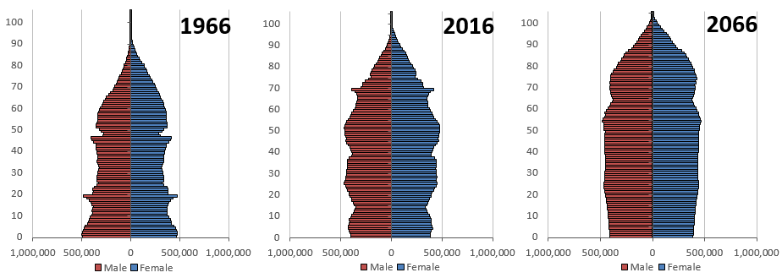
Population pyramids in the UK
Source: (gov.uk, 2018)
According to the graph, the population of the UK has been gradually getting older and it has tended to continue in the future as well. In 2016, there were over 11.8 million people in the UK who were 65 or older, or 18% of the total population. However, there were only 9.1 million elderly individuals 25 years ago. In the UK, there will be 8.6 million more elderly over 65 in 2066. (gov.uk, 2018)
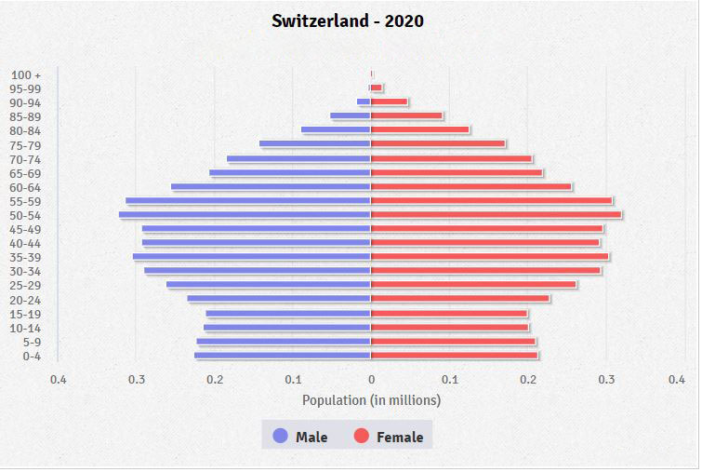
Population pyramid in Switzerland
Source: (indexmundi, 2021)
According to the pyramid graph, it is shown that in Switzerland, there was almost 18.73% of the elder people aged 65 years and over in 2020. The number of the elder population was higher than the age groups of 0-14, 15-24, and 55-64.

c) Relevant theories of loneliness and isolation and explore the concepts associated with loneliness
Concepts of loneliness:
According to Hawkley and Cacioppo (2013), the realisation that one's social requirements are not being met by the quality or number of their social connections is accompanied by the uncomfortable feeling of loneliness. Chronic loneliness develops when the feelings of painful social isolation and loneliness last for a long period. The loneliness is mainly characterised by unrelenting and constant feelings of being separated or alone from others as well as an incapability to connect on a profound level. Along with that, loneliness refers to an unwelcome and subjective feeling of loss or lack of friendship that arises when there are disparities between the quality and quantity of the social and healthy relations that people have. Loneliness and isolation are mainly experienced by people under the age of 18 years and adults more than 65 years. The level of loneliness and isolation gradually increases in elder age, especially in the age group of 65-70 years.
As stated by Brown (2022), there are mainly three different kinds of loneliness that people experience, such as emotional or intimate, social or relational, and collective. Emotional/intimate refers to the need for having a partner to share personal feelings with. The concept of social/relational refers to the need for quality support and companionships. The concept of collective loneliness refers to the need for a group or network that shares a purpose. In their elder age, people mainly experience emotional/intimate loneliness as they expect family members or friends with whom they can share a close and deep connection.
As older adults slow down, they gradually withdraw from society.
Because of their declining health, limited mobility, and other life changes, many elderly people have a tendency to withdraw from society – spending most of their time looking back – reflecting on what they have made out of their lives. (Brown ,2022)
Theories of loneliness-
Attachment theory: This theory was developed by Robert S. Weiss as a persuasive psychological theory regarding loneliness. The theory has addressed six kinds of social needs which if unfulfilled, feelings of loneliness to occur. Those needs refer to attachment, nurturance, social integration, the proper direction in complex situations, a sense of consistent alliance, and encouragement of worth. As per the theory, friendship can complement; however, intimate relationships can stave off loneliness and isolation (Akdogan, 2017).
Behavioural approach: According to this theoretical viewpoint, personality traits that are linked to unfavourable types of social connection and may even facilitate them are primarily responsible for loneliness. For example, loneliness is associated with hostility, sadness, distraction, anxiety and embarrassment, and others. A lonely person has been observed to struggle to develop and maintain social and healthy relationships. (Akdogan, 2017).
Theories of isolation-
Social isolation theory: As per the theory, social isolation refers to the nonappearance of social contact, relationships, and interactions with family members and friends at an distinct level and with wider society on a broad level. Social isolation signifies a lens through which to examine these hormonal, neutral, genetic, cellular, and behavioural mechanisms. Isolation intensifies compassion for social threats and encourages the regeneration of social connections. (Akdogan, 2017).

d) The impact of loneliness and isolation on an older person living within a care setting
The feelings of loneliness and isolation gradually increase in older persons, especially who live without families and friends in a care setting. Older people are at augmented risk for social isolation and loneliness as they are more probable to experience different factors, like living alone, hearing loss, chronic illness, unstable physical condition, and others. At this time of life, older people start feeling isolated and alone as they gradually become unable to maintain social contacts and relationships. The low quality or lack of relationships creates anxiety among older persons, and they start feeling lonely in a care setting.(nhs,2018). As older people are specifically susceptible to social isolation and loneliness, it can have a major influence on their physical and mental health.
In the UK, many older people are separated from community and society and lonely, especially, people over the age of 75. Therefore, people in this age group have serious effects of loneliness and isolation (nhs, 2018). Though Switzerland has a significant rank among the world's happiest countries, the older people in the early setting start experiencing more isolation and loneliness during the pandemic when they were isolated from their close ones. (nhs, 2018)
There are several adverse impacts of isolation and loneliness among older people which are as follows.
i) Reduced stability of physical and mental health: Loneliness and social isolation have a direct effect on the mental and physical health of older people. Seniors who feel lonely in a care setting are reported to have high blood pressure, poor immune system, obesity, heart disease, and high sugar level. Moreover, it develops serious mental health issues, like depression, anxiety, stress, dementia, cognitive decline, and others (nih, 2019).
ii) High risk of mortality: The chronic feeling of loneliness and isolation in older people in a care setting can increase the risk of mortality. In a care setting, often older people have to live alone without their close ones and social contacts and due to that, they start having mental and physical issues which can slowly lead them to death.
iii) Certain behavioural changes: Older people living in a care setting, often reported behavioural changes due to mental issues caused by isolation and loneliness. They start behaving strangely and their actions towards others change. Such behavioural symptoms in older people in a care setting are apathy, moodiness, unsocial behaviours, personality changes, and language difficulties.

e) Critically examination of current legislation and policies that deal with or aim to raise awareness or reduce loneliness and isolation in the elderly population
UK legislation and policies:
The UK government has developed several policies to increase awareness and reduce the problem of isolation and loneliness among the elderly population.
i) The UK government imposed the Care Act 2014 in order to set out a legal framework for providing support and care services to the elder population. This framework helps to offer proper care to elder people who are suffering from isolation and loneliness as well. This act moreover established some well-being principles to promote social wellbeing and personal and social relationships.
ii) The UK government has the National Strategy on Loneliness, and a commission has moreover developed to provide some suggestions to the government on establishing suitable actions and strategies to address loneliness among the elder along with all age groups people. In 2018, the UK government declared £20 million for funds for several schemes addressing loneliness and isolation (ageuk, 2019).
iii) In 2020, the UK government introduced a policy to tackle the loneliness that developed among adults and elder people during the pandemic. This policy involves the introduction of the 'Let's Talk Loneliness' campaign on how people can support themselves as well as others if they feel lonely or isolated.
iv) In 2020, the government of the UK moreover declared a grand fund worth £5 million for loneliness charity. These funds involve targeted relief for people who are at a major risk of isolation and loneliness.
v) The government of the UK moreover developed a strategy called ‘A connected society’ to tackle loneliness among the elder population and people of all age groups. The strategy has developed on the work of numerous individuals and organisations and promotes the significance of social connections (gov.uk, 2018).
Legislation and policies of Switzerland:
i) In Switzerland, a range of community-based involvements have developed called ‘Neighbourhoods in Solidarity’ aimed at rising social connectedness and decreasing loneliness and isolation in elder people. (slhs, 2022).
ii) Swiss government applies the National Policy on Older Person to support elder people and make sure that the mental and physical needs of elder people are fulfilled properly. This policy moreover helps to raise awareness of loneliness and isolation along with protecting them from any abuse and exploitation. (slhs, 2022).
iii) A policy has been developed in Switzerland in order to define current strategies to enable the outreach to elder people who are most in need. As per the policy on addressing socially isolated and solitary elders, several awareness campaigns are launched to reduce stigma and increase awareness (slhs, 2022).
iv) The Swiss government has introduced a new scheme called ‘Time Bank’ for elder people dealing with isolation and loneliness. Most of the elder people have to live lonely in their homes or care settings as their children stay away from them for their jobs or higher studies. As per the scheme by providing proper care to an elderly person who feels lonely, the individual can save that time in the TimeBank so that in future they can get some help to alleviate isolation and loneliness.

f) Critically evaluate and compare local, national, and global provision of services for the older person in line with current initiatives and policy
Local: Switzerland has a healthcare system with worldwide insurance coverage along with a social insurance system for elderly people. This way, Switzerland has made sure that there is a sufficient financial situation for around 96% of the 1.1 million elderly inhabitants (WHO, 2017). The services that are available in Switzerland for the elderly person include Caregiver programs, financial assistance, long-term care programs, home health services, legal assistance, home modification or repair, adult care day, elder abuse prevention programs (WHO, 2017)
National: The national policy on older persons (NPOP), 1999 extends the state support to make sure that there is food security and financial security, shelter, healthcare, as well as other needs for the elder person, protecting against any exploitation and abuse, equitable share in terms of development and ensure to improve and enhance their quality of lives by ensuring availability of services (Chang et al., 2020).
As per the United Nations Department of Economic and Social Affairs, the Swiss population would grow from around 8.30 million in the year 2015 up to 9.22 million in 2030 and around 10.02 million in 2050. The population of Switzerland is aging at a rapid rate and therefore it has among the highest proportions of elderly people in the globe.
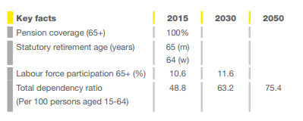
Figure: Pension Coverage
Source: (WHO, 2017)
Policies include a pension system. The statutory current retirement age in Switzerland is 64 years for men and 64 years for women. The pension system in Swiss is three-fold based. Moreover, the country credits with a bonus if anyone takes care of an elderly person.
National policies related to healthy ageing
Since the year 2016, Switzerland has been ranking first in the Global AgeWatch Index, and with that, it has achieved high ratings in several domains such as income security, environment, capability, health status, and so on. However, there were still certain challenges in the areas of increase in the relative higher poverty rate among the elderly person (WHO, 2017).
The Swiss Government came up with the "Health 2020 strategy" in order to foster health which became one of the key objectives of the Federal Council of Swiss. This strategy covers a broader array of measures across the health care industry with a main to maintain the quality of elderly life, reduce inequalities, raise the care quality and thereby improve transparency.
Global: In the global and European policy agendas, healthy ageing is always prioritised. The global and European strategic priority areas which the UK has also agreed upon include "healthy ageing over the life course" wherein mental capacity maintenance is emphasised along with the overall wellbeing of the elderly population (Lewis & Ollivaud, 2020). Secondly, the strategy includes supporting an environment where WHO has promised to develop a network within the communities and cities.

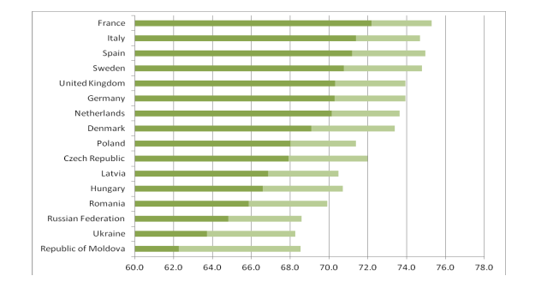
Figure: Age at which remaining life expectancy is 15 years (2010-2050)
Source: (Lewis & Ollivaud, 2020)
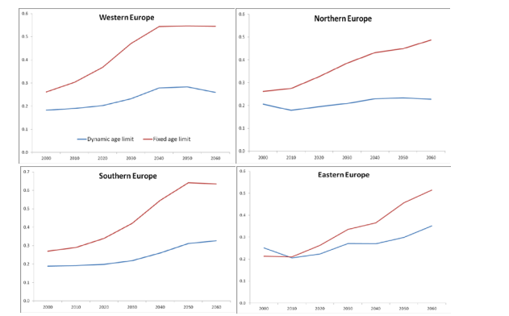
Figure: Projected dependency ratio with fixed and dynamic age limits
Source: (Chang et al., 2020)
Along with that, in the European countries including the UK as well as in other countries, WHO regional office has envisaged working with different countries at different levels of government to design and thereby implement five of the interventions that need to be prioritised:
1. Preventing falls.
2. Promoting physical activities (Chang et al., 2020).
3. Vaccination for influenza of the elderly population and thereby prevent infectious disease in the setting of healthcare.
4. Provide public support in the context of informal caregiving with an emphasis on self-care and home care.
5. Gerontological and geriatric capacity building among the social and healthcare workforces.

g) Examine the prospective future of the care of the older person, what changes could be made to the programmes and how technology could be applied in care provision to lonely older persons
The potential future of care for older people:
Older people need different care support from in-home support, such as cleaning, laundry, gardening, and others to mental support to fight against loneliness and social isolation. Moreover, there is a significant requirement for community support, such as volunteering support, mutual aid, and local social activities. The UK government is shifting their focus on providing all kinds of care support to older people to make them feel socially connected and valued. The further interest of the NHS in tackling isolation and loneliness through social prescribing so that older people can leave happily without the support of family and friends (Abrahams, 2020).
In Switzerland, there is moreover a prospective future for elderly care as the Swiss government has been trying to launch different plans and policies to address the physical and social needs of the elderly and trying to meet their needs with proper actions and strategies. The government has determined that further insurance will be a potential solution to provide funds for elderly care provision (swissre, 2017).
Some changes are required to make to the programmes for addressing the isolation and loneliness among elders, such as:
i) These types of programs required involve elder people directly to address their issues from the core. In this case, face-to-face conversations, interviews, and surveys are required to be conducted among elders to understand their problems.
ii) These programmes moreover involve health and fitness activities along with empathetic conversations with elder people to improve their mental health condition and involve them in different activities so that they do not feel isolated.

h) Recommendations
The care provider is recommended to apply different strategies to tackle the loneliness of elder people. They can introduce different technologies to elders, like social media platforms, VR, robotics, and others so that they can spend their time enjoying and forgetting about loneliness. Moreover, it is recommended to involve elders in different voluntary programs, healthcare activities, and social work so that they can feel socially connected.

Conclusion
It is concluded that the loneliness among the elderly population is gradually increasing in the UK and Switzerland as they often have to spend their time alone in care settings without family and friends. The constant feelings of being isolated have been adversely impacting the physical and mental health of elders. Both countries have developed different policies and legislation to mitigate loneliness in the elder population. The report moreover has provided some recommendations to improve the care provided for lonely elder people.

References
Abrahams, C., (2020). The future of care for older people. [Online]
Available at: https://www.ageuk.org.uk/discover/2020/06/the-future-of-care-for-older-people/
[Accessed 2022].
ageuk, (2019). Loneliness. [Online]
Available at: https://www.ageuk.org.uk/globalassets/age-uk/documents/policy-positions/health-and-wellbeing/ppp_loneliness_and_isolation_uk.pdf
[Accessed 2022].
Akdogan, R., (2017). A model proposal on the relationships between loneliness, insecure attachment, and inferiority feelings. Personality and Individual Differences, 111, pp.19-24.
Brown, D., (2022). Dealing With Loneliness in the Age of Social DistancingThe three types of loneliness and how to combat them.. [Online]
Available at: https://www.inc.com/damon-brown/3-types-of-loneliness-how-to-combat-them.html
[Accessed 2022].
Chang, E-Shien., Kannoth, S., Levy, S., Wang, S.-Y., Lee, J.E. & Levy, B.R. (2020). The global reach of ageism on older persons’ health: A systematic review. PLOS ONE, [online] 15(1), p.e0220857. doi:10.1371/journal.pone.0220857.
Centre for Ageing Better, (2018) Transforming Later Lives. Available at:https://www.ageing-better.org.uk/sites/default/files/2018-07/Ageing-Better-Transforming-Later-Lives.pdf (Accessed 2022).
gov.uk, (2018). A connected society: a strategy for tackling loneliness. [Online]
Available at: https://www.gov.uk/government/publications/a-connected-society-a-strategy-for-tackling-loneliness
[Accessed 2022].
gov.uk, (2018). Living longer: how our population is changing and why it matters. [Online]
Available at: https://www.ons.gov.uk/peoplepopulationandcommunity/birthsdeathsandmarriages/ageing/articles/livinglongerhowourpopulationischangingandwhyitmatters/2018-08-13
[Accessed 2022].
Hawkley, L. C. & Cacioppo, . J. . T., (2013). Loneliness Matters: A Theoretical and Empirical Review of Consequences and Mechanisms. National Library of Medicine, Issue 10.1007/s12160-010-9210-8.
HSE, (2016) Person-Centred Principles and Person-Centred Practice Framework Available at: https://www.hse.ie/eng/staff/resources/changeguide/resources/person-centred-principles-and-person-centred-practice-framework.pdf (Accessed 2022).
JRF, (2015) The costs and benefits of paying all the lowest-paid care home workers in the UK the Living Wage Available at: https://www.jrf.org.uk/report/costs-and-benefits-paying-all-lowest-paid-care-home-workers-uk-living-wage (Accessed 2022).
indexmundi, (2021). Switzerland Age structure. [Online]
Available at: https://www.indexmundi.com/switzerland/age_structure.html
[Accessed 2022].
Lazell, M., (2022). Care at home and nursing homes: elderly care in the United Kingdom. [Online]
Available at: https://www.expatica.com/uk/living/family/elder-care-in-the-uk-249260/
[Accessed 2022].
Lewis, C. & Ollivaud, P. (2020). Policies for Switzerland’s ageing society. www.oecd-ilibrary.org. [online] doi:10.1787/3f8a12c6-en.
nhs, (2018). Loneliness in older people. [Online]
Available at: https://www.nhs.uk/mental-health/feelings-symptoms-behaviours/feelings-and-symptoms/loneliness-in-older-people/
[Accessed 2022].
McCormack, B. and McCance, T. (2017) People’s Needs Defining Change – Health Services Change Guide Available at: https://www.hse.ie/eng/staff/resources/changeguide/resources/person-centred-principles-and-person-centred-practice-framework.pdf (Accessed: 15 August 2022).
nhs, (nd). Improving care for older people. [Online]
Available at: https://www.england.nhs.uk/ourwork/clinical-policy/older-people/improving-care-for-older-people/#:~:text=Generally%2C%20someone%20over%20the%20age,healthier%20than%20someone%20aged%2060.
[Accessed 2022].
nih, (2019). Social isolation, loneliness in older people pose health risks. [Online]
Available at: https://www.nia.nih.gov/news/social-isolation-loneliness-older-people-pose-health-risks#:~:text=Research%20has%20linked%20social%20isolation,Alzheimer's%20disease%2C%20and%20even%20death.
[Accessed 2022].
slhs, (2022). Socially Isolated and Lonely Older Adults in Switzerland. [Online]
Available at: https://www.slhs.ch/en/policy-briefs-stakeholder-dialogues/our-topics/socially-isolated-and-lonely-older-adults-in-switzerland/
[Accessed 2022].
swissinfo, (2019). Ageing population threatens Swiss prosperity, study warns. [Online]
Available at: https://www.swissinfo.ch/eng/worker-shortfall_ageing-population-threatens-swiss-prosperity--study-warns/45371408
[Accessed 2022].
swissre, (2017). Solutions for an ageing society. [Online]
Available at: https://www.swissre.com/institute/research/topics-and-risk-dialogues/society-and-politics/next-generation-insurance-customer-2017-summary.html
[Accessed 2022].
WHO (2017). Global consultation on integrated care for older people (ICOPE) -the path to universal health coverage. [online] Available at: https://apps.who.int/iris/bitstream/handle/10665/272863/WHO-FWC-ALC-18.3-eng.pdf [Accessed 28 Jul. 2022].

