

Name: Iram Jamal
Student ID: 2525239
Module Code: LCHS4001
Module: Academic and Employability skills
Lecturer: Markus Klingelfuss (Module Lead- Birmingham)
Submitted on: Friday, 24th July 2026, 10 am

Table of Contents
1.1 Introduction ......................................................................................................................................... 3
2 Care Worker in the Health and Social Care Sector ............................................................................. 3
2.1 Description of Care Worker in the Health and Social Care Sector ................................................. 3
2.2 Explanation of the Most Significant Skills Needed for a Care Worker in the Health and Social Care Sector ................................................................................................................................................ 4
3 Strategies for Skill Improvement for a Care Worker in the Health and Social Care Sector ..................................................................................................................................................................... 5
3.1 Three Strategies to Improve the Skills for a Care Worker in the Health and Social Care Sector ..................................................................................................................................................................... 5
4 Conclusion ............................................................................................................................................. 7
5 Reference List ........................................................................................................................................ 8

1.1 Introduction
Care Workers play a fundamental role in the UK health and social care sector by supporting individuals who require assistance with daily living because of age, illness, disability or long-term health conditions. They promote independence, dignity and wellbeing while delivering person-centred care that meets individuals' physical, emotional and social needs (Skills for Care, 2024). This report examines the role of a Care Worker in the Health and Social Care Sector. It describes the responsibilities of the role, explains three essential skills required for effective practice, evaluates strategies for developing these skills and highlights their importance in providing safe, high-quality and person-centred care (NHS England, 2024).


(WHO, 2022)

2.1 Description of Care Worker in the Health and Social Care Sector
A Care Worker in the Health and Social Care Sector supports individuals who need help with daily living because of age, disability, illness or long-term health conditions. The role is essential because it promotes independence, dignity and wellbeing while enabling people to remain as active and independent as possible. Care Workers provide person-centred support in care homes, supported living services and individuals' own homes, helping people meet their physical, emotional and social needs (Skills for Care, 2024; Manthorpe, Moriarty and Harris, 2022).
The responsibilities of a Care Worker include assisting with personal care, supporting mobility, preparing meals, monitoring wellbeing, maintaining care records and reporting changes in an individual's condition to healthcare professionals. They also work closely with nurses, social workers, occupational therapists and families to deliver coordinated care while following safeguarding and infection prevention procedures (NHS England, 2024; Kelly et al., 2023). For example, when supporting an older adult with arthritis, a Care Worker may use safe moving and handling techniques, encourage the person to complete tasks independently where possible and report reduced mobility to the supervising nurse so that appropriate support can be arranged. This helps maintain safety, independence and quality of care.

2.2 Explanation of the Most Significant Skills Needed for a Care Worker in the Health and Social Care Sector

2.2.1 Communication Skills
Communication is a fundamental skill for a Care Worker because clear information sharing promotes safe, person-centred care. Care Workers communicate with service users, relatives and healthcare professionals to understand needs, explain care and report changes in health. Good communication also includes active listening and accurate record-keeping. For example, if an older person with mild dementia becomes confused about medication times, the Care Worker should use simple language, remain patient and inform the supervising nurse if concerns continue. Effective communication improves safety, builds trust and supports continuity of care (Kelly et al., 2023; Skills for Care, 2024).

2.2.2 Empathy
Empathy enables a Care Worker to understand how individuals feel and respond with kindness, respect and compassion. Many people receiving care experience loneliness, anxiety or reduced independence because of illness or disability. Showing empathy helps develop trusting relationships and encourages individuals to participate in their own care. For example, when a new resident feels anxious after moving into a care home, a Care Worker who listens carefully, offers reassurance and involves the person in daily activities can help reduce distress and improve emotional wellbeing. Empathetic care contributes to better experiences and person-centred support (Manthorpe, Moriarty and Harris, 2022; Kelly et al., 2023).

2.2.3 Teamwork
Teamwork is essential because Care Workers rarely work alone and must collaborate with nurses, social workers, occupational therapists and family members to provide coordinated care. Sharing accurate information allows professionals to make informed decisions and respond quickly when needs change. For example, if a Care Worker notices that a service user has reduced appetite and increasing weakness, reporting these observations during handover enables the multidisciplinary team to review the person's care plan promptly. Effective teamwork improves continuity, safety and quality of care (NHS England, 2024; Kelly et al., 2023).

2.2.4 Impact of Poor Communication, Empathy and Teamwork
When communication, empathy and teamwork are lacking, the quality of care may decline significantly. Poor communication can lead to misunderstandings and inaccurate reporting, while limited empathy may reduce trust and discourage individuals from expressing their concerns. Weak teamwork can result in inconsistent care, delayed interventions and poor coordination between professionals. Consequently, service users may experience reduced wellbeing, increased safeguarding risks and lower quality of care. These skills are therefore essential for delivering safe, compassionate and effective health and social care services (Skills for Care, 2024; NHS England, 2024).

3.1 Three Strategies to Improve the Skills for a Care Worker in the Health and Social Care Sector

3.1.1 Strategy to Improve Communication Skills: SBAR Communication Training
SBAR (Situation, Background, Assessment and Recommendation) communication training is an effective strategy for improving communication because it provides a structured method for sharing important information accurately and consistently. This strategy was chosen because research shows that structured communication reduces misunderstandings, improves patient safety and strengthens teamwork across health and social care settings (Muller et al., 2021; NHS England, 2024). Through SBAR training, Care Workers learn to report concerns clearly and confidently during handovers or when speaking to healthcare professionals. For example, if an older adult suddenly becomes confused and refuses food, the Care Worker can use SBAR to communicate the situation to the supervising nurse, enabling prompt assessment and appropriate intervention. This also improves the accuracy of information shared between staff.

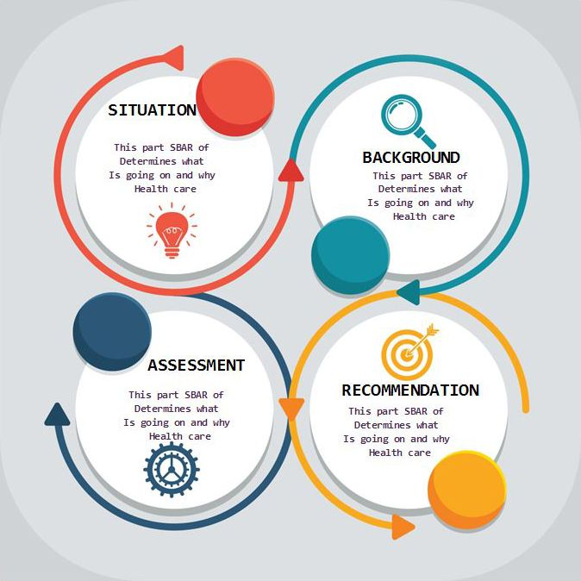

(Muller et al., 2021)

3.1.2 Strategy to Improve Empathy: Reflective Practice
Reflective practice is an effective strategy for developing empathy because it encourages Care Workers to evaluate their interactions with service users and consider how their behaviour influences care experiences. This strategy was selected because evidence suggests that reflection improves emotional awareness, compassion and person-centred practice (Kelly et al., 2023; Manthorpe, Moriarty and Harris, 2022). By regularly reflecting on experiences and discussing them during supervision, Care Workers can identify strengths and areas for improvement. For example, reflecting on how reassurance reduced the anxiety of a newly admitted care home resident can help the worker develop more compassionate approaches in future situations. Regular reflection also improves professional judgement and confidence when supporting people with different emotional and care needs.

3.1.3 Strategy to Improve Teamwork: Interprofessional Education (IPE) 
Interprofessional Education (IPE) is an effective strategy for strengthening teamwork because it enables professionals from different disciplines to learn and work together. This strategy was chosen because research demonstrates that collaborative learning improves communication, understanding of professional roles and coordinated care planning (Reeves et al., 2022; World Health Organization, 2023). During IPE activities, Care Workers develop the confidence to contribute effectively within multidisciplinary teams and share information appropriately. For example, participating in joint training with nurses, occupational therapists and social workers helps a Care Worker understand each professional's responsibilities, improving collaboration when planning support for an older person recovering after a fall.

4. Conclusion
Care Workers play a vital role in the UK health and social care sector by supporting individuals to maintain their independence, dignity and overall wellbeing. This report has demonstrated that effective communication, empathy and teamwork are fundamental skills for delivering safe, compassionate and person-centred care. It has also highlighted that strategies such as SBAR communication training, reflective practice and Interprofessional Education (IPE) can strengthen these skills and improve the quality of professional practice. Developing these competencies enables Care Workers to work collaboratively, respond effectively to individuals' changing needs and provide high-quality care that promotes positive health outcomes and enhances quality of life.

REFERENCES
Kelly, F., Waring, J., Bardsley, M. and Fisher, R. (2023) ‘Workforce challenges and care quality in adult social care: a qualitative study’, Health & Social Care in the Community, 2023, Article ID 8865214.
Manthorpe, J., Moriarty, J. and Harris, J. (2022) ‘Adult social care workforce: current challenges and future priorities’, Journal of Long-Term Care, 2022, pp. 164–173.
Muller, M., Jurgens, J., Redaelli, M., Klingberg, K., Hautz, W.E. and Stock, S. (2021) ‘Impact of the SBAR communication tool on patient safety: a systematic review’, BMJ Open, 11(8), e045565.
NHS England (2024) The NHS Long Term Workforce Plan. London: NHS England.
Reeves, S., Fletcher, S., Barr, H., Birch, I., Boet, S., Davies, N., McFadyen, A., Rivera, J. and Kitto, S. (2022) ‘A BEME systematic review of the effects of interprofessional education’, Medical Teacher, 44(7), pp. 750–760.
Skills for Care (2024) The state of the adult social care sector and workforce in England 2024. Leeds: Skills for Care.
World Health Organization (2023) Framework for Action on Interprofessional Education and Collaborative Practice. Geneva: World Health Organization.

