Effective Team work and Communication skill
Component 2



Project by

Usha Krishna Raj
Student no - 2022598

Executive Summary:

Considering myself as a Business consultant for Andrea Jones’ Retail store,
in this report I have



- proposed a new team structure for the newly expanded work force,
- applied Belbin’s & Tuckman’s theory to improve team work in Andrea’s Retails store,
- applied Shannon-Weaver’s model, Berlo’s Model & Schramm’s model to emphasize the importance of Two – way communication in Andrea’s store.
- explained the importance of Virtual communication and Team Working.
- explained the importance of Effective communication for the continued success of an Organisation, applying to Andrea’s Retail Store.
- listed out the effective communication channels appropriate to Andrea’s Retail store.
- finally recommended ideas for the development of Andrea’s Stores with its rapidly expanding workforce.

Terms of Reference:

This report was requested by Tutor Ms Melanie Squire for Component 2 of Effective Team work & Communication. The Report is compiled by Usha Krishna Raj.
Areas addressed & investigated: Effective-communication, Team-working, effective channels of communication, Virtual communication.

Procedure:



Journals - Butterworth Heineman, APA PsycNet, Prospects, Channel 4 News.
Website – Bits & Pieces, Chron, Career Addict.

Introduction:

Andrea Jones, the owner of a medium sized retail store in Swansea has developed her business over the years from a team of 5 to 27 due to online presence. As the workforce is rapidly expanding, now the business is need of a powerful team structure and formal processes to ensure it runs smoothly.



This can be accomplished by
- Applying appropriate team-working theories & communication theories to promote team-work & effective communication into the business, &
- Promoting effective channels of communication.
Let us discuss how can this be implemented in Andrea’s business;

Findings:

New Team structure I propose:

Applying Belbin’s theory to improve team work in Andrea’s Retail store:

Belbin (1996) describes a team role as a tendency to behave, contribute and interrelate with others in a particular way. He classifies team roles into;

- Cerebral Oriented Roles
- People Oriented Roles &
- Action Oriented Roles
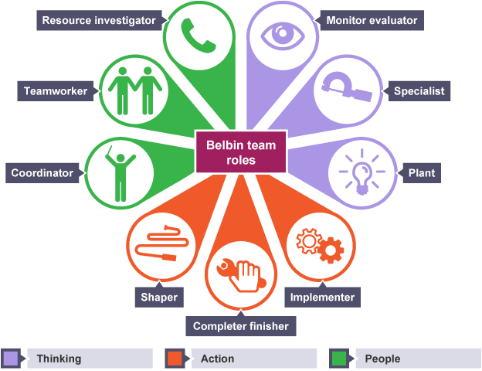

Let us apply this into Andrea’s Retail store to improve their team work;

Cerebral Oriented role:

I would place the Managers & Stock-room staffs under Cerebral Oriented role because;

- Managers will need to play as a Plant that brings growth & progress to the Company by using creative techniques in achieving the objective. Their creative ideas can be shared among the staffs by conducting regular group meetings.
- Managers also need to play as a Monitor evaluator that are rational thinkers best suited in analysing problems or conflicts among staffs and finding a best solution.
- Stock-room staffs will need to play as Specialists as they need to have an in-depth knowledge of how the massive stocks need to be segregated and arranged in the Stock room and how they need to be distributed to the delivery drivers according to the locations.

People Oriented Role:

I would place the Sales-assistants and Managers under People Oriented role because

- Managers will need to function as Resource Investigators as they need to be skilled at networking and developing contacts with clients & external stake-holders to expand the business and achieve their goal.
- Managers also need to take the role of a Co-ordinator by being mature & confident in delegating work to the teams under them and recognize the value each staff brings to the team by offering rewards.
- Sales-assistants will need to be Team players as they are expected to be flexible with shifts, diplomatic with customers and make sure their team members are working together to build a strong team & focus on their sales objective.

Action Oriented Role:

I would place the Managers, Delivery drivers, Cleaner and Security guards under People Oriented role because

- Managers will need to act as Shapers as they should challenge the employees to improve in performance and push them to action in sales by motivating them continuously.
- Delivery drivers will need to play as Implementers as they need to be disciplined & reliable for this job and get their deliveries done with a well-organized personality. Cleaners & Security guards will also need to function as Implementers by being disciplined, reliable and getting their job done efficiently.
- Delivery drivers will also need to play as Complete - Finishers as they need to make sure there are no errors or omissions with their deliveries and be concerned with deadlines, sticking to the delivery time.

Applying Tuckman’s theory to improve team work in Andrea’s Retail store:

In order to improve team work and help Andrea’s retail store become more efficient, Tuckman’s model can be applied within the business.

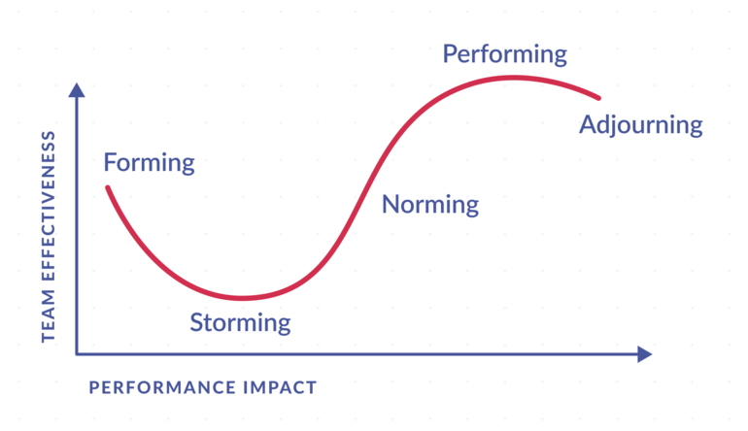

Bruce Tuckman (1965) initially proposed “Forming-Storming-Norming-Performing” model of group development. Later he added the fifth stage, “Adjourning” to mark the end of the team’s journey.

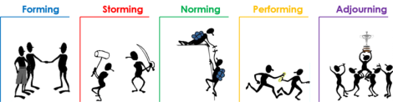

Forming:

New staffs were hired in Andrea’s store and they might be curious, nervous and unsure of the team’s purpose though the on-duty manager trained them.

I would advise the team needs clarity and connection more than anything at this stage. Therefore, before any physical training is provided new-starters can be allowed to do Work-shadowing.

Author Smith, (2021) states work-shadowing helps new-starters gain an understanding of the workplace and how the role they’re interested in fits in with them.

Storming:

This is the stage where conflicts arise among staffs due to clashing work styles between them.

I would advise the conflicts need to be acknowledged then and there by the Managers.

It is stated on CIPD that conflicts are a part of Organizational life and to ensure smooth running of its business, conflicts need to be recognized and nipped in the bud and complaints need to be responded quickly and sensitively.

Norming:

At this stage, the team begins to recognize and value the strength of their team mates. They bond well and familiarize with the team processes; respect the management.

I advise at this stage, the Management should start having regular meeting with the employees to keep them in track from getting deviated from the job, by setting performance targets.

Performing:

At this stage, the employees are self-reliant and confident enough on what they are doing with the process.

I advise, though this stage makes the Management happy with the out-standing performance of the employees, they need to keep up the business development by introducing perks, incentives, bonuses and employees rewards for the performers.
Adjourning:

At this stage, the team dissolves after their task is achieved, either to form a new team with new project or other reasons. This is also a mourning phase for employees as they experience a feeling of loss when the team is disbanded.

At this stage, the Management can arrange a success party or meet outside of work for a small treat arranged by the management as a gesture of thanking them.

Applying Shannon - Weaver’s Model into Andrea Jones’ Retail store to emphasize the importance of Two-way communication:

Shannon –Weaver (1949), proposed a two-way communication model to develop communication within any Organization. According to him, the sender encodes the message and sends it to the receiver through a channel. The receiver decodes the message, interprets it and sends feedback to the Sender.

In Andrea Jones’ retail store, no formal meetings/regular meetings were organised within the workforce. When an in-person meeting occurred only staffs worked at the shift attended. This lead to information not being shared equally among employees.

My solution for this issue would be, as I’ve explained in the picture above,

Managers can share the information related to the business via MS TEAM meetings using their Laptop which encodes the info using internet as channel and the information is decoded in work computers, home computers, phone and is received equally by all the employees; –
- those at work,
- working from home &
- Field- workers (Delivery drivers).

Applying Berlo’s model into Andrea Jones’ Retail store to emphasize the importance of Two – way communication:

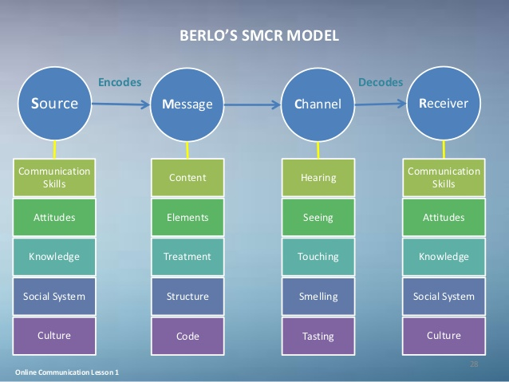

As there was a rapid growth & expansion in the store due to online presence, there was a need of more formal processes to ensure business runs smoothly like;
- Setting Priorities & Targets
- Restructuring job roles
- New regulations
- Audits, etc.

This information can be shared by the Senior Manager of the store by doing a presentation with all statistical data, with all the employees sat in a room listening to his presentation.

Firstly, the Senior Manager as a Source of message is expected to possess;

- Excellent communication skill
- Right attitude
- Knowledge about the new functions of the business
- Focus on the social set up where presentation happens &
- Awareness of the cultural background of the listeners.

Then the Message/information is encoded with the following factors;

- Contents – Data on new structure & functions of the company
- Elements – Hand movements pointing at the slides to grab attention
- Treatment – Conveying message with a friendly smile
- Structure – Expressing the message via pictures, graphs etc.
- Code – Explaining with politeness

Now the message is communicated through the Channel of Hearing (the company data) & Seeing (Pictorial Representations).

Finally, the message is decoded & received by the employees who responds through applauds, smiles, nodding head etc.

The receiver which is employees in our case, are expected to be on the same level of communication as the speaker (Sr Manager) to get a better understanding of the message.

Applying Shramm’s communication model into Andrea Jones’ Retail store to emphasize the importance of Two – way communication:

Wilber Shramm’s model (1954) proposed his two-way circular communication theory involving a Sender and a Receiver.

In the Store, there was a Sales-assistant that has been on a long-term leave due to sickness.

I would recommend Shramm’s model for this situation;

As depicted in the picture above,
- Manager can phone the long-term sick Sales-assistant, encoding the message
- Manager’s Message can be:
- How are you feeling?
- When will you be able to return to work?
- Sales-assistant answers the phone call; decodes the message & understands.
- Now responds by encoding the reply
- The Reply can be:
- Partially recovered.
- I can return to work in 2 weeks.
- Manager decodes the reply message and understands it.

Why Effective Virtual Communication is important:

Author Maclachlan (2009), states Virtual communication has numerous advantages like rise in productivity, less business costs and a better work/life balance of the workforce.

Author Soni (2020), quotes Palmer Freeman, a famous American Entrepreneur, “in today’s world the best way to communicate with someone is face to face”.



Effective Virtual-Communication is important as it has numerous advantages like;

- Saves resources
- More Convenient
- Time saving
- Cut costs/saves money
- Promotes flexibility
- Increases productivity
- Enhanced customer experience
- Allows for a more flexible work culture

Importance of Team working:



Andrew Carnegie says “Teamwork is the ability to work together towards a common vision”.
Author Zimmer (2019) also quotes Andrew Carnegie in his article “team work is the fuel that allows common people to attain uncommon results”

The Author emphasizes the importance of team working saying;
- It maximizes output by supporting each team member’s strength
- Acts as an aid-tool to employees
- Provides opportunities for individual growth

Effective Communication leads to continued success:
Applied in the case study for Andrea’s store:

Author Zambas (2021) states Effective Communication in the workplace is an essential factor of a business’ success. Author also says, it strengthens relationships within the company and with clients; it also enhances employee engagement and the overall potency of the team.



Effective Communication is conveying the message clearly, making the other person understood and listening to other’s message effectively to understand it clearly.

Let us discuss here;
- the reasons why effective communication is important in Andrea’s store,
- how these reasons can be handled with the effective communication skill and
- what are the effective communication channels recommended

- Not all employees were working in the same shift.

Effective communication by the Management via emails ensures employees working in other shifts does not miss any updates regarding the business & process that are being shared.

- Stockroom staffs process Online orders.

Effective communication by the Stockroom staffs to the customers via email or phone call, during unavailability of stock or missed delivery or wrong delivery protects the company from losing its name and customers.

- Stockroom staffs do night shift with no managers on duty

Effective communication by the night shift staffs to the Managers via email report or via Company’s software, clarifies any doubts or questions Managers might have with the job completed with no supervision.

- Few staffs work from home

Effective communication by work-from-home staffs to Managers via phone calls in the case of any errors occurred with the sale or other processes will lead Managers to sort out the errors immediately.

- New staffs were hired

Effective Communication by the On-duty Manager to the new-staffs via in-person training/Work-Shadowing will enable the new-staffs understand the process easily and quickly.

- Business expanded rapidly – Need of formal processes

Effective Communication by myself as a Business consultant to the Business Owner, Management and Employees via PPT Presentation explaining new formal processes will lead them to understand my ideas easily.

Recommendations:



To sum up my ideas I’ve discussed above, my recommendations for Andrea’s business are;
- Building up an effective team structure suitable to the expansion of business.
- New formal processes developed are to be shared among all the employees equally via MS Team virtual meetings or In-person PPT Presentations.
- Regular virtual meetings are to be organised to ensure all employees receive the information equally from wherever they are working.
- Training all employees on effective communication skill in order to express their thoughts clearly to colleagues to work together as a team and contribute to the growth of business.

Conclusion:

I therefore conclude saying Andrea Jones’s Retail store, with its newly expanding workforce, upon following effective team working and effective communication along with the new formal processes introduced into the business and strongly interpersonal-skilled employees, will develop into a strong & successful organization.

References

- Belbin, M. (1996). Team Roles at work, Butterworth Heinemann, Oxford.
- Berlo, David K. (1960). The Process of Communication; an introduction to theory and practice. New York
- CIPD, (2020). Managing Conflict in the modern workplace, Broadway London.
- Maclachlan, M, (2009). The importance of Effective virtual communication, Communicaid in the News: Lack of languages damaging economy, Channel 4 News
- Schramm, W. (1954). The Process & Effects of mass communication. University of Illinois.
- Shannon, C.E., and Weaver, W. (1949). The Mathematical theory of Communication.
- Smith, J. (2021). Work shadowing, Prospects.
- Tuckman, B. (1965). Developmental sequence in small groups, APA PsycNet.
- Soni, D. (2020). Top 3 benefits of Virtual Communication for businesses, Bits and Pieces
- Zambas J. (2021). The Importance of Effective Communication in the Workplace. Career Addict
- Zimmer, T. (2019). Importance of Teamwork at Work, Chron (News letter).

