
\

Student name: Dayna Denny
Student ID: 2408900
Module name: Changemakers: Building your Personal Brand for Sustainable Employment.
Module code:BMHP5015
Lecturer name: Caroline Salami

Assignment Guidance Template
Introduction (Approx 150-200 Words) | This portfolio will reflect on the knowledge, skills, and experiences I have gained in the module of Changemakers: Building Your Brand for Sustainable Employment module. It explores the four key units studied during the course and considers how each has contributed to my personal and professional development within the health and social care sector.  The portfolio will examine how developing a personal brand has increased my awareness of professionalism, communication, and employability. It will also reflect on the importance of understanding global connections and the changing nature of health and social care, recognising how these influence career opportunities and professional practice. In addition, the portfolio will consider how identifying learning and employment opportunities has strengthened my ability to plan for continuous professional development. Finally, it will discuss the importance of wellbeing and resilience in maintaining personal effectiveness and delivering high-quality, compassionate care.  Overall, this portfolio demonstrates how the module has enhanced my confidence, employability, and readiness for a sustainable career in health and social care by encouraging reflective practice, lifelong learning, and the development of a strong professional identity.
Reflection on Unit 1: Brand You (Approx. 400 Words) | Unit 1 introduced the concept of personal branding and highlighted its importance in developing a successful and sustainable career within health and social care. Before studying this unit, I viewed personal branding primarily as how an individual presents themselves professionally. However, through the lectures, online activities and class discussions, I developed a deeper understanding that a personal brand reflects an individual's values, behaviours, skills, professional identity and reputation. I realised that every interaction with colleagues, service users and other professionals contributes to how I am perceived as a future practitioner.  One of the most valuable aspects of this unit was developing greater self-awareness. Through reflective activities, I identified both my strengths and areas for improvement. I recognised that empathy, effective communication and compassion are among my strongest qualities, which are essential for delivering person-centred care. At the same time, I identified leadership confidence and networking as areas I would like to strengthen as I progress towards my career goal of becoming a registered manager or owning a residential care home.  My learning can be linked to Johari's Window (Luft & Ingham, 1955), which demonstrates how self-awareness develops through personal reflection and feedback from others. Completing the self-assessment activities encouraged me to consider how I view myself compared with how others may perceive me. This reflection highlighted the importance of seeking constructive feedback from colleagues and managers to support continuous professional development.  The unit also reinforced the principles of personal branding discussed by Montoya and Vandehey (2008), who suggest that a strong personal brand is built through authenticity, consistency and demonstrating professional values. Within health and social care, this means consistently demonstrating compassion, integrity, accountability and respect while maintaining high professional standards. I reflected on how these qualities will help establish trust with service users, families, colleagues and external professionals.  Overall, Unit 1 has strengthened my understanding of the importance of self-awareness, reflective practice and professional identity. I now appreciate that building a personal brand is an ongoing process that requires continuous learning, reflection and professional development. These insights have increased my confidence and will support my long-term ambition of becoming a leader who promotes high-quality, person-centred care.  Evidence of Moodle Activities  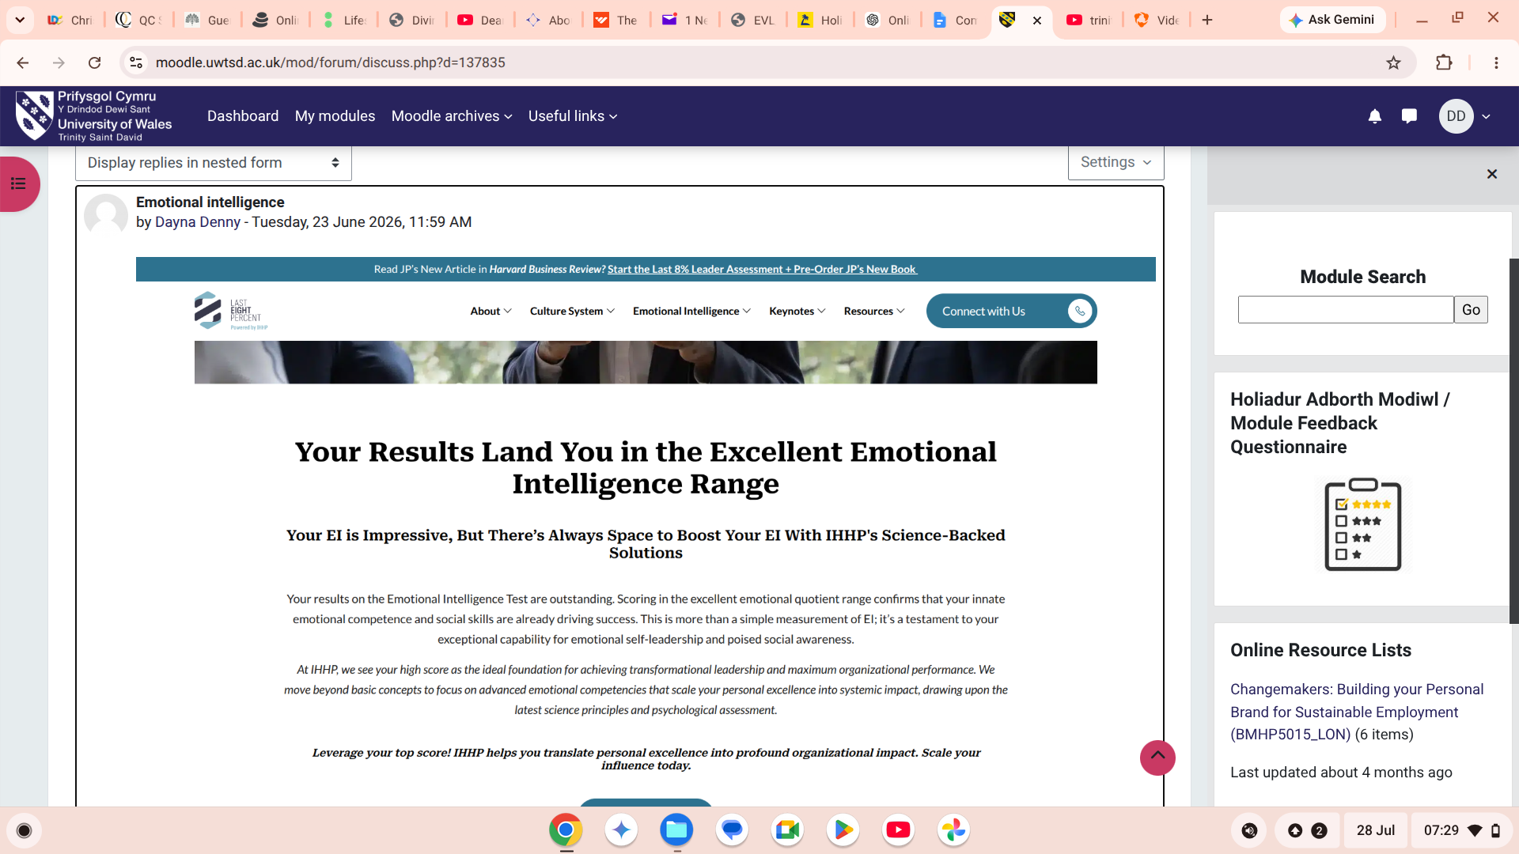  This activity encouraged me to evaluate my personal strengths, values and areas for development. Completing the exercise helped me identify qualities such as empathy, resilience and communication while recognising the importance of developing my leadership and networking skills.  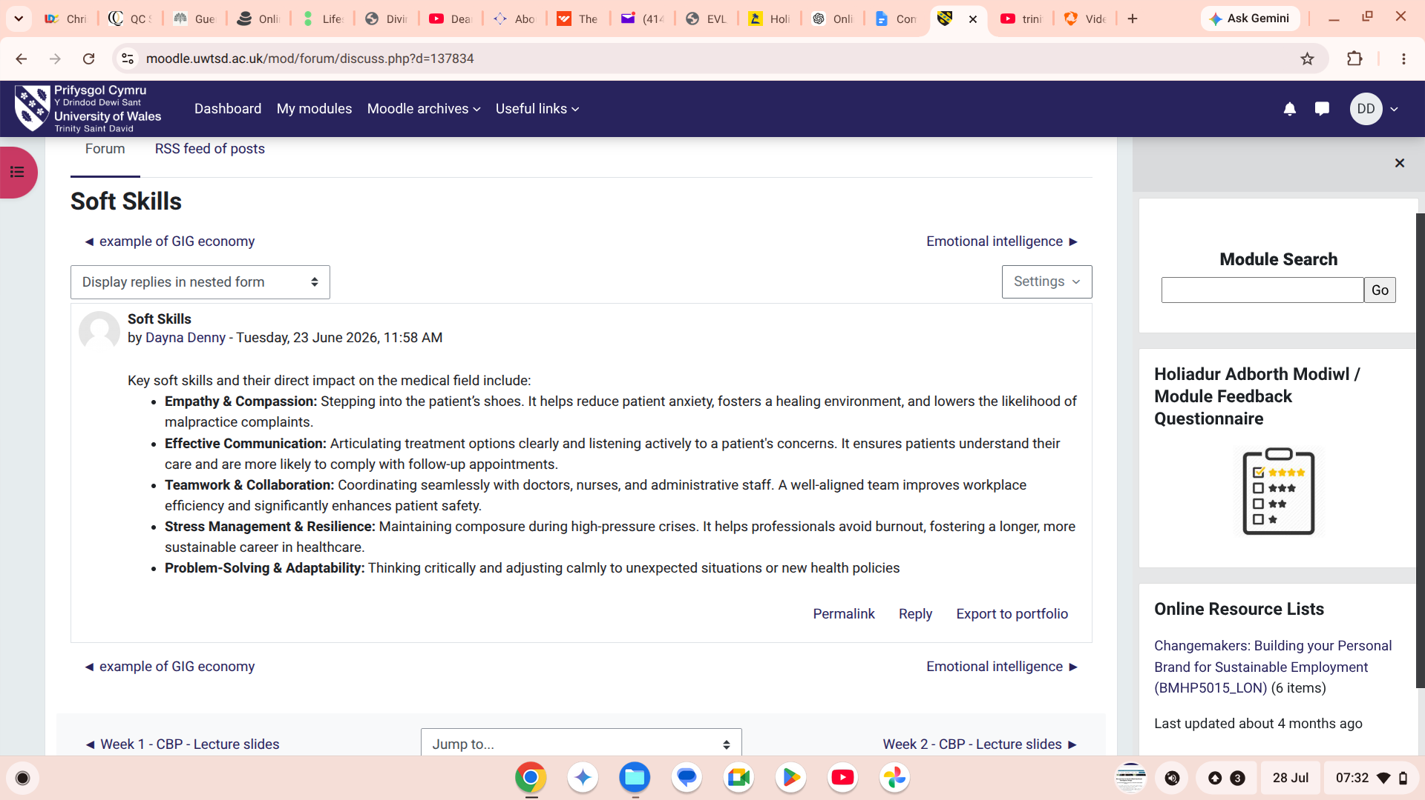  This activity explored how professional behaviours, communication and online presence contribute to building a positive personal brand. It reinforced the importance of maintaining professionalism and acting consistently with the values expected within health and social care.  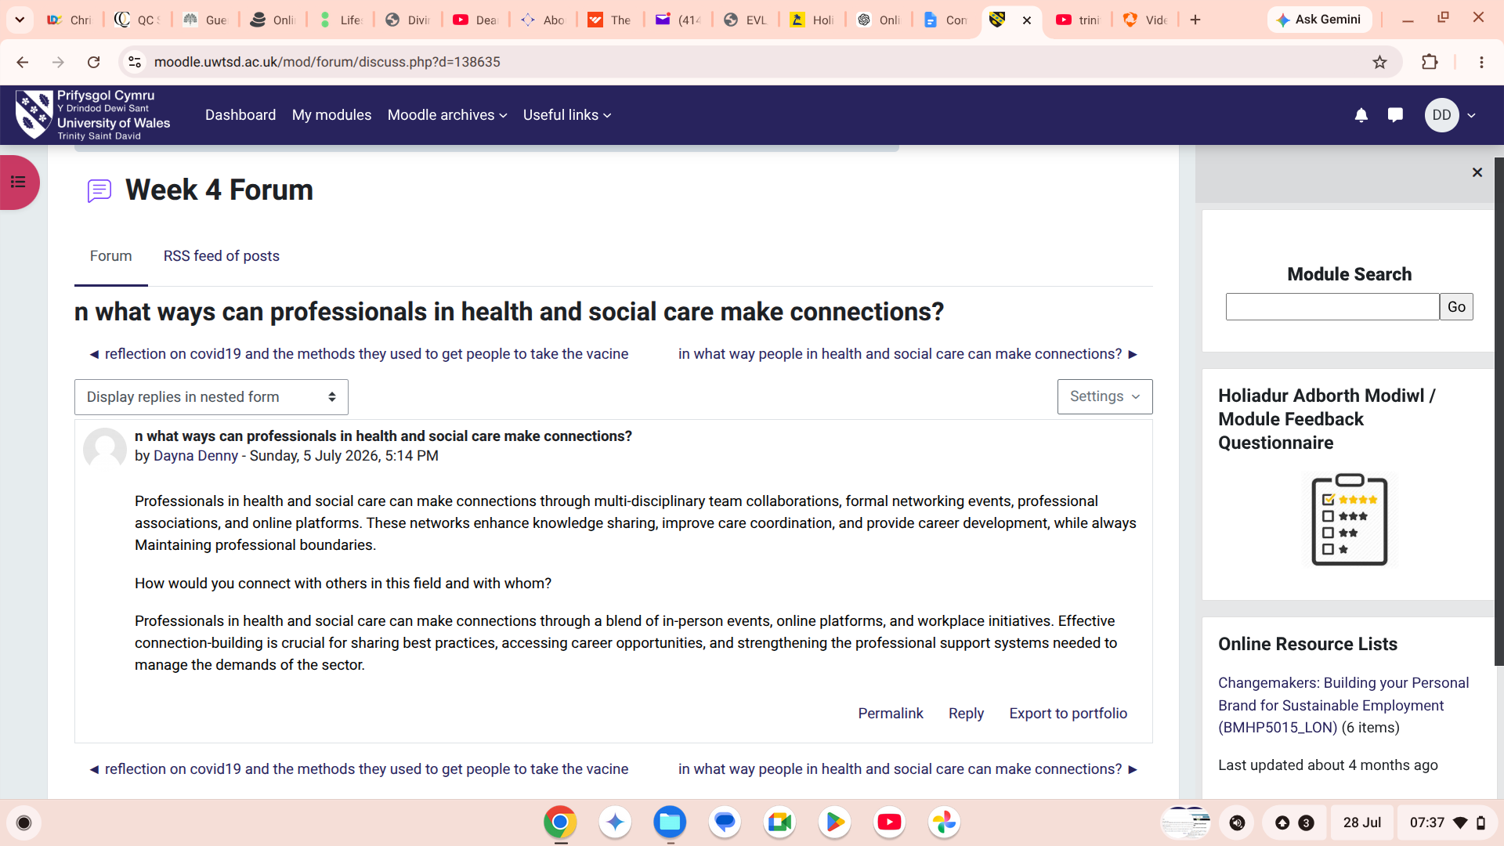  Participating in the online discussion enabled me to compare my views with those of other students. Reading different perspectives enhanced my understanding of personal branding and highlighted the value of collaboration, constructive feedback and reflective learning in professional practice.
Reflection on Unit 2: It’s a Small World (Approx. 400 Words) | Unit 2: Global Connections, Cultural Competence and Diversity  Reflection on Learning  Unit 2 broadened my understanding of how globalisation influences health and social care and highlighted the importance of delivering culturally competent, person-centred services. Before completing this unit, I understood that people have different cultural backgrounds and beliefs, but I had not fully considered how global migration, health inequalities, international policies and cultural diversity affect the planning and delivery of care. Through the lectures, Moodle activities and online forum discussions, I developed a greater appreciation of the need to provide care that is respectful, inclusive and responsive to the diverse needs of individuals and communities.  One of the most significant lessons I learned was the importance of cultural competence. I realised that effective practitioners must recognise and respect differences in culture, religion, language, values and beliefs to build trusting relationships with service users and their families. Reflecting on this has reinforced my commitment to treating every individual with dignity and respect while adapting my communication and approach to meet their unique needs. As someone who hopes to become a residential care home manager or owner, I recognise that promoting an inclusive culture is essential for delivering high-quality care and ensuring positive outcomes for residents and staff.  My learning can be linked to Hofstede's Cultural Dimensions Theory (Hofstede, 2011), which explains how cultural values influence behaviours, communication and decision-making. The theory helped me understand that individuals from different cultural backgrounds may have different expectations of healthcare, family involvement and authority. This insight has encouraged me to avoid making assumptions and instead adopt a person-centred approach that values each individual's preferences and experiences.  The unit also strengthened my understanding of equality, diversity and inclusion within health and social care. I reflected on how discrimination and health inequalities can create barriers to accessing services and achieving positive health outcomes. This has increased my awareness of my professional responsibility to challenge discrimination, promote equality and advocate for individuals whose voices may not always be heard. I now appreciate that culturally competent practice not only improves the quality of care but also promotes trust, safety and wellbeing.  Overall, Unit 2 has enhanced my understanding of global health issues and the importance of inclusive practice. It has reinforced that effective health and social care professionals must continuously develop their cultural awareness, remain open to different perspectives and work collaboratively to provide equitable, compassionate and person-centred care in an increasingly diverse society.  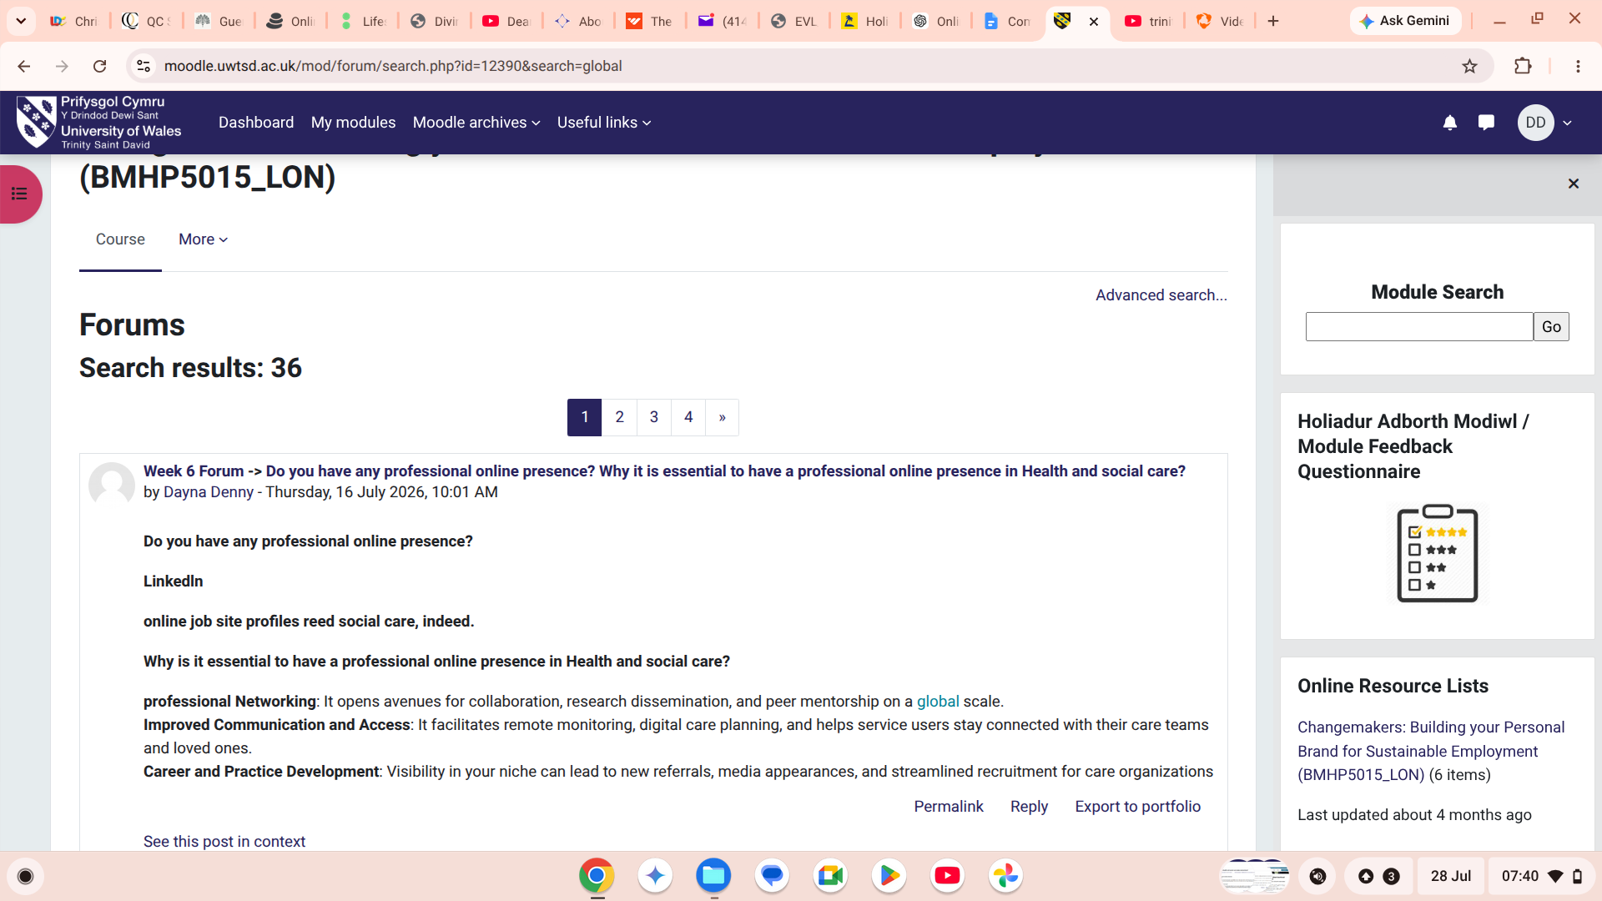  This discussion enabled me to explore how global health challenges, including migration and health inequalities, influence health and social care practice. Contributing to the discussion encouraged me to consider different viewpoints and reflect on the importance of equitable access to care.  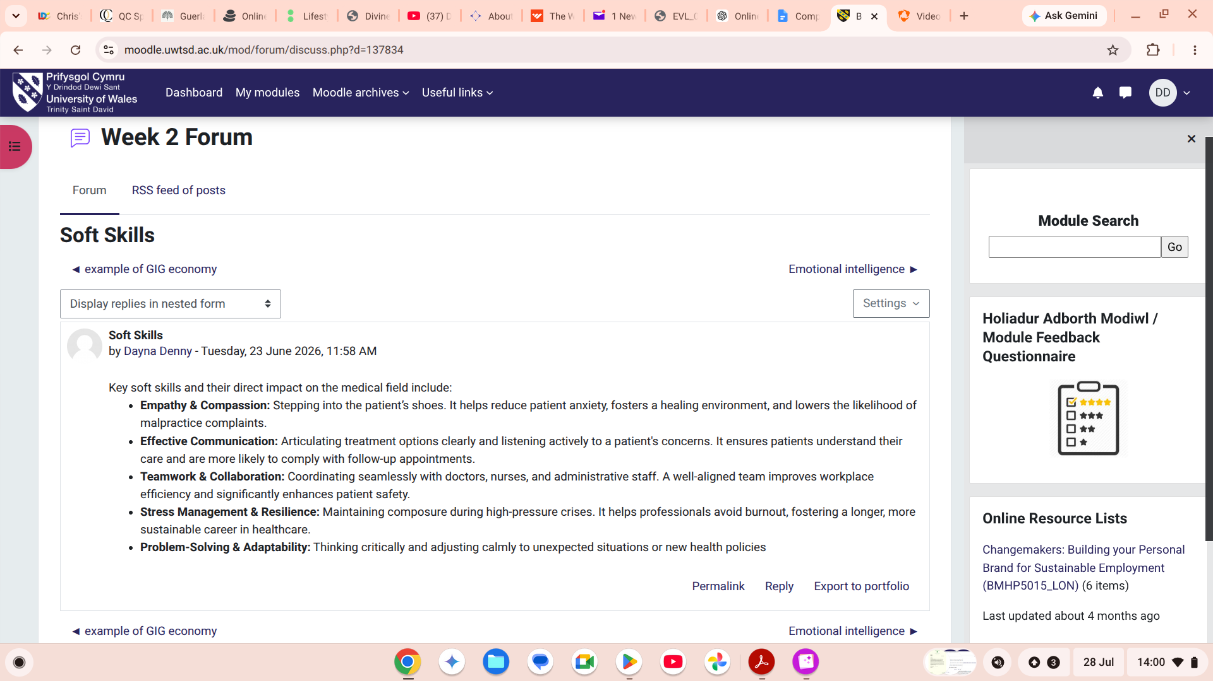  This activity encouraged me to reflect on the importance of respecting cultural diversity and adapting communication to meet the needs of people from different backgrounds. Reading other students' contributions broadened my understanding of inclusive practice.  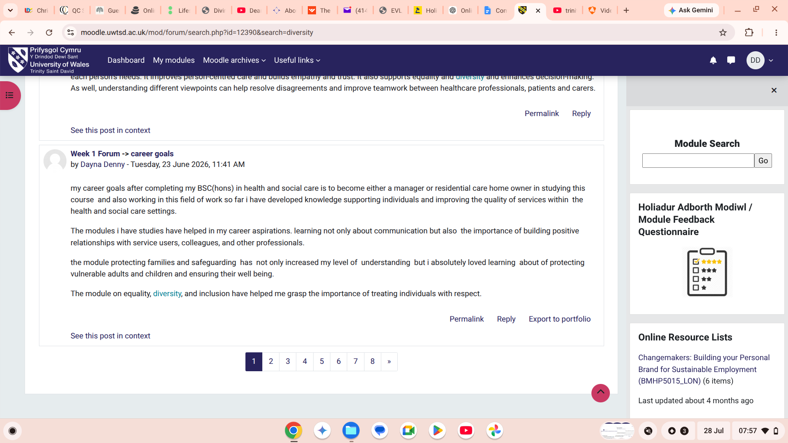  Participating in this discussion strengthened my understanding of how equality, diversity and inclusion contribute to person-centred care. It reinforced my responsibility to challenge discrimination and promote an environment where every individual is treated with dignity, respect and fairness.
Reflection on Unit 3: Opportunity Knocks (Approx. 400 Words) | Unit 3: Identifying and Using Opportunities  Reflection on Learning  Unit 3 enhanced my understanding of how recognising and making use of opportunities can support both personal and professional development within health and social care. Through the lectures, Moodle activities and online discussions, I learned that career progression requires proactive planning, continuous learning and the willingness to embrace new experiences. This unit encouraged me to reflect on my long-term career aspirations of becoming either a registered manager or owning a residential care home, and to consider the practical steps needed to achieve these goals.  One of the key lessons I gained was the importance of setting realistic and achievable goals. I found that having a clear personal development plan enables me to monitor my progress, identify areas for improvement and remain focused on my career ambitions. I also recognised that engaging in continuous professional development (CPD), seeking constructive feedback and taking advantage of training opportunities are essential for maintaining professional competence and delivering high-quality care.  My learning can be linked to the SMART Goals Framework (Doran, 1981), which emphasises that goals should be Specific, Measurable, Achievable, Relevant and Time-bound. Applying this framework helped me transform my career ambitions into clear objectives. For example, after completing my BSc (Hons) in Health and Social Care, I intend to gain leadership experience within a residential care setting, complete further management training and continue developing my knowledge of legislation, safeguarding and quality assurance before progressing into a management position or establishing my own residential care home.  I also reflected on my learning using Gibbs' Reflective Cycle (Gibbs, 1988). This encouraged me to evaluate what I had learned, identify my strengths and areas for improvement, and develop an action plan for future professional development. Reflective practice has increased my confidence in identifying opportunities for growth and reinforced the importance of lifelong learning within the health and social care profession.  Overall, Unit 3 has strengthened my confidence in planning my future career. It has shown me that success depends not only on academic achievement but also on taking initiative, developing leadership skills, building professional networks and continuously reflecting on my practice. These experiences have prepared me to become a proactive, reflective and effective leader who can contribute to improving the quality of health and social care services.  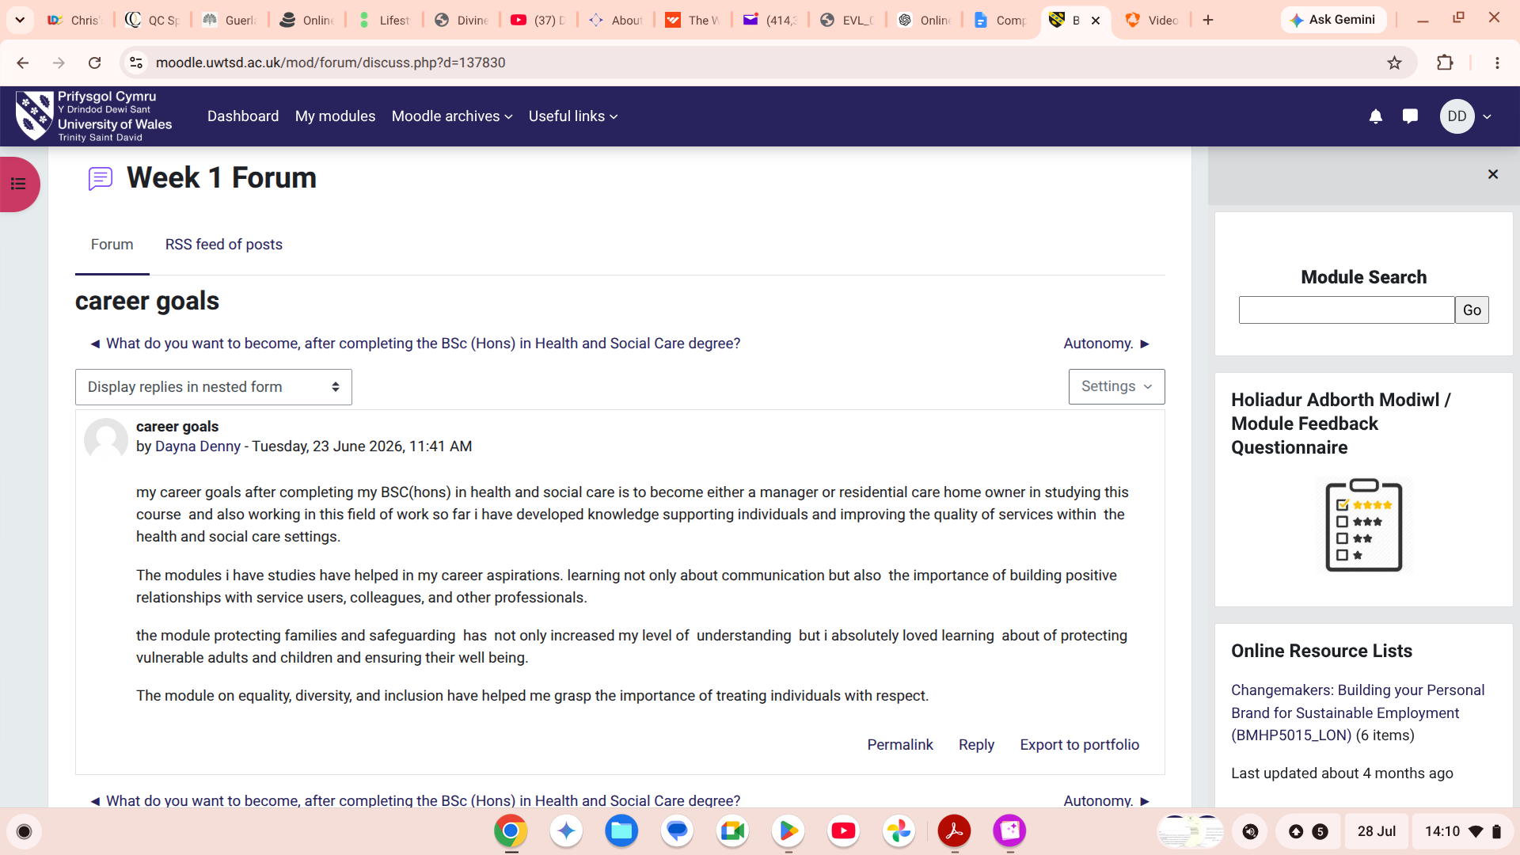  This activity focused on identifying my short-term and long-term career goals. It helped me create a structured plan for achieving my ambition of becoming a registered manager or residential care home owner by identifying the knowledge, skills and experience I need to develop.  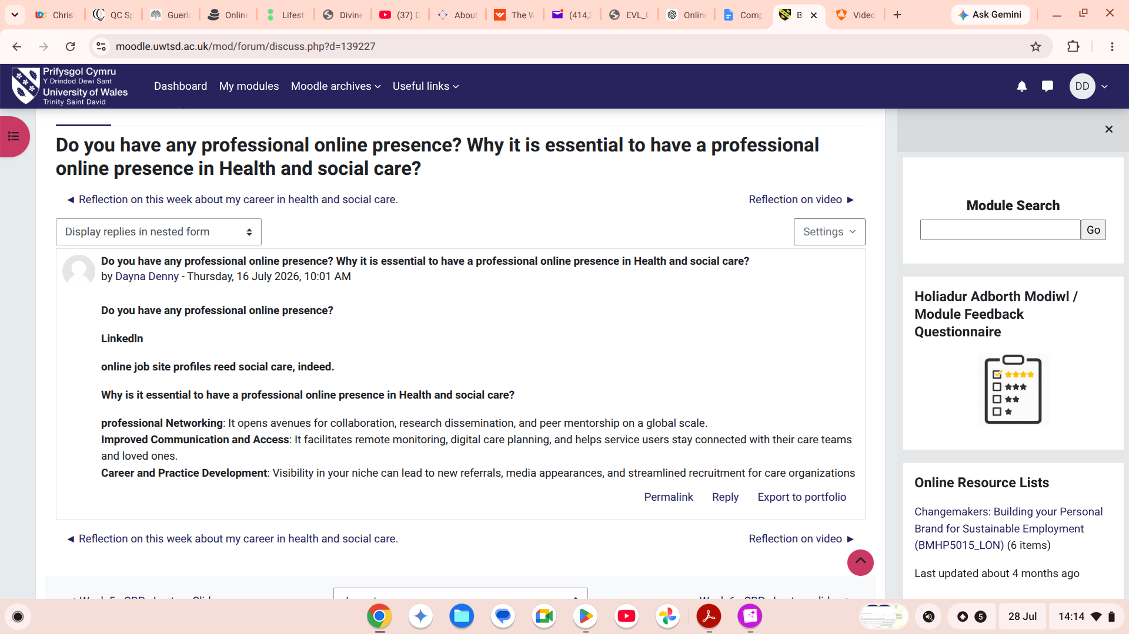  This forum discussion encouraged me to reflect on the importance of continuous professional development and lifelong learning. Reading other students' experiences helped me recognise different pathways into leadership roles within health and social care.
Reflection on Unit 4: The Pursuit of Happiness (Approx. 400 Words) | Unit 4: Wellbeing, Resilience and Work-Life Balance  Reflection on Learning  Unit 4 deepened my understanding of the importance of wellbeing, resilience and maintaining a healthy work-life balance within health and social care. Throughout the lectures, Moodle activities and online discussions, I recognised that providing high-quality care requires practitioners to look after their own physical, emotional and mental wellbeing, as well as that of the individuals they support. I developed an appreciation that resilience is not an innate quality but a skill that can be strengthened through reflection, self-awareness and positive coping strategies.  One of the most valuable lessons I learned was that maintaining personal wellbeing is essential for delivering safe, compassionate and person-centred care. I reflected on the emotional demands of working in health and social care and realised that stress, burnout and compassion fatigue can negatively affect both practitioners and service users if they are not managed effectively. This unit encouraged me to develop practical strategies such as effective time management, seeking support from colleagues, engaging in reflective practice and maintaining a healthy work-life balance. These strategies will be particularly important as I work towards my career goal of becoming a registered manager or owning a residential care home, where I will have responsibility for supporting both staff and residents.  My learning can be linked to Seligman's PERMA model of wellbeing (Seligman, 2011), which identifies five elements that contribute to flourishing: Positive Emotion, Engagement, Relationships, Meaning and Accomplishment. Reflecting on this model helped me recognise that professional success is closely connected to personal wellbeing. Developing positive relationships with colleagues, finding meaning in supporting vulnerable individuals and celebrating professional achievements will contribute to my resilience and long-term career satisfaction.  The concept of resilience also reinforced the importance of reflective practice and continuous professional development. I now understand that resilient practitioners are better equipped to adapt to change, overcome challenges and maintain high standards of care in demanding environments. This learning has strengthened my confidence and reinforced my commitment to creating a supportive workplace culture where staff wellbeing is valued alongside the delivery of excellent care.  Overall, Unit 4 has enhanced my understanding of the relationship between wellbeing, resilience and effective leadership. It has encouraged me to prioritise self-care, remain adaptable and continue developing professionally throughout my career. I believe these qualities will enable me to become a compassionate and effective leader who promotes a positive working environment and delivers high-quality, person-centred care.  Evidence of Online Activities  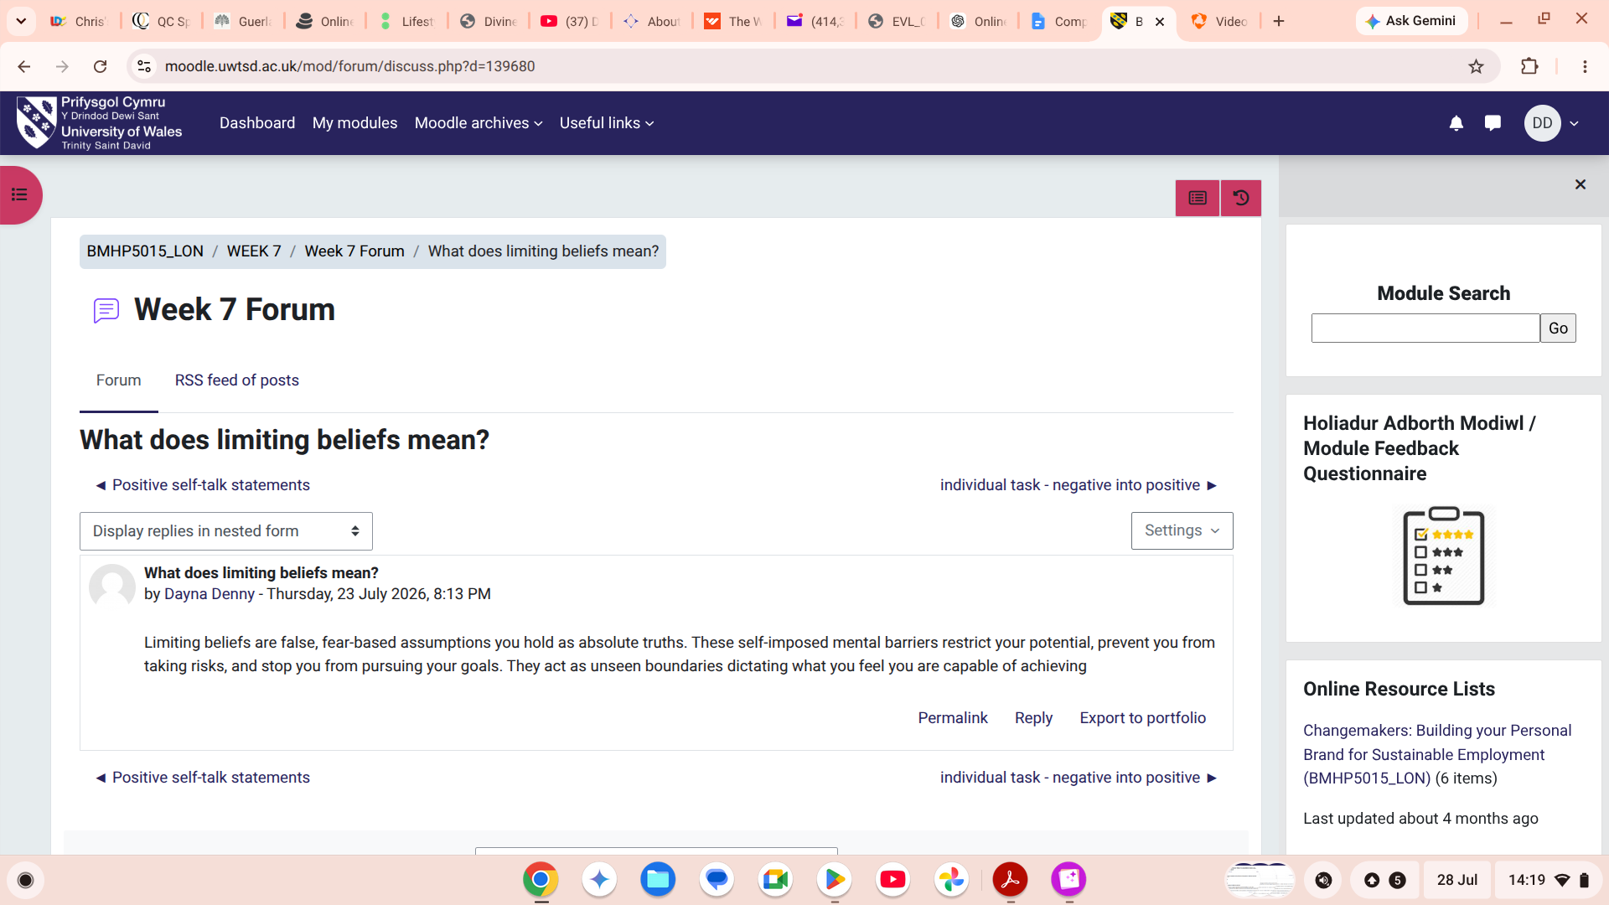  This activity encouraged me to reflect on my own wellbeing and identify practical strategies for managing stress and maintaining a healthy work-life balance. It helped me appreciate the importance of self-care in supporting effective professional practice.  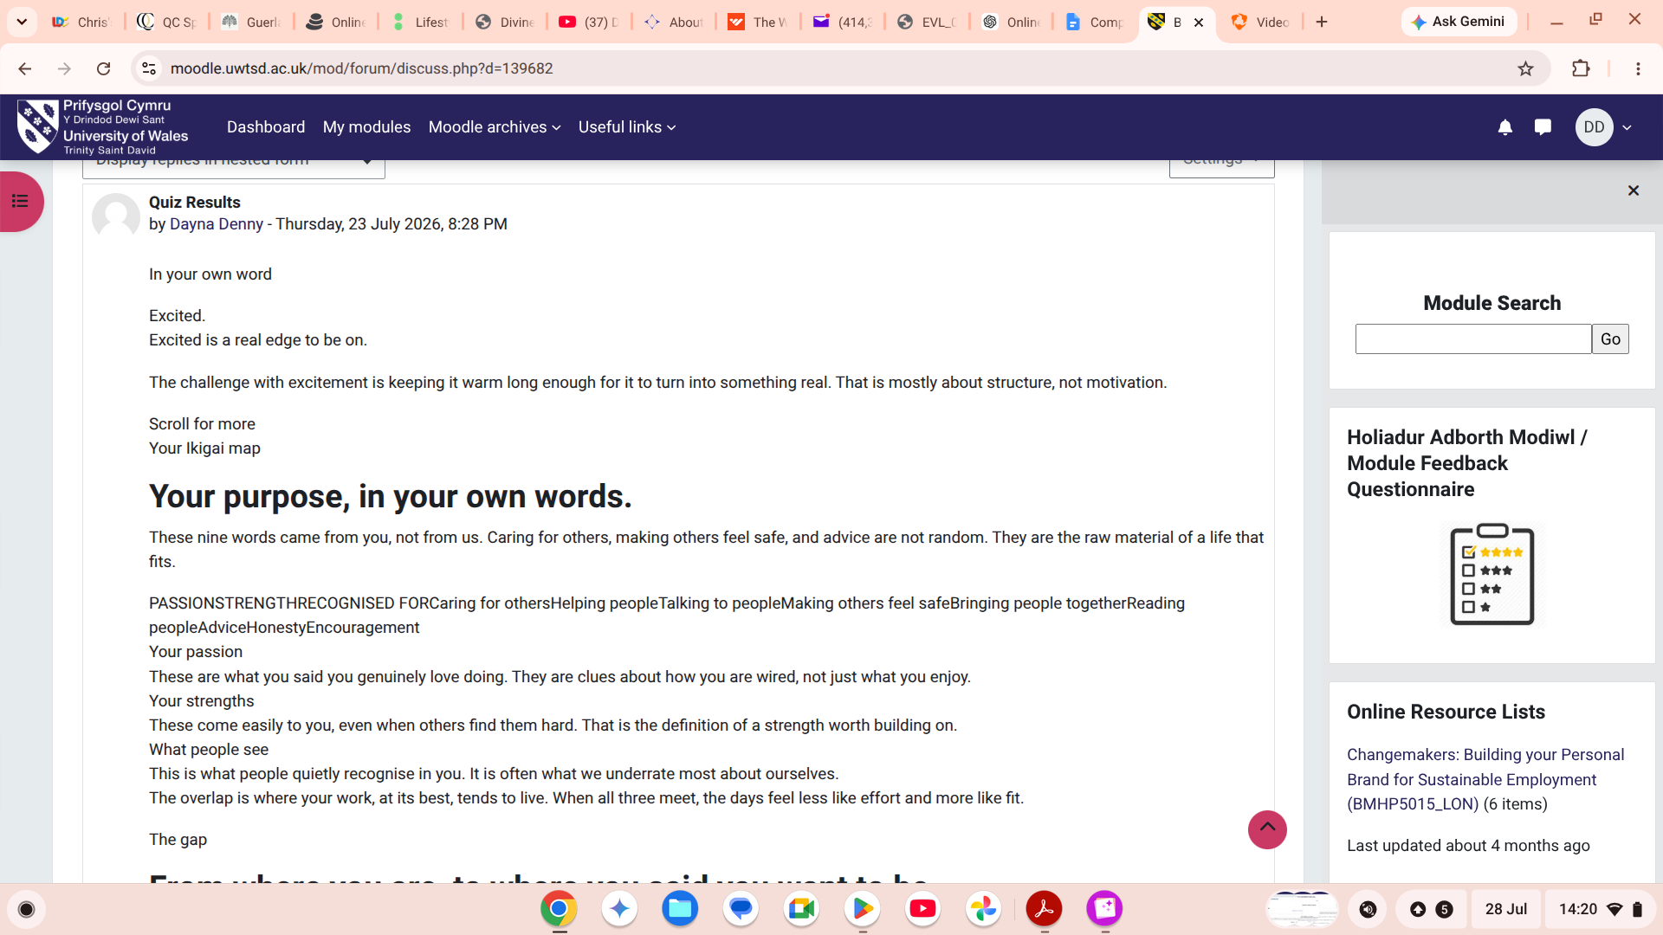  This online discussion explored how resilience can be developed in health and social care. Reading and responding to other students' experiences broadened my understanding of different coping strategies and reinforced the value of teamwork and reflective practice.  This activity focused on maintaining a balance between professional responsibilities and personal wellbeing. It highlighted the importance of time management, setting boundaries and accessing support when needed to prevent burnout and maintain high-quality care.
Conclusion (Approx. 150-200 Words) | Conclusion  This portfolio has enabled me to critically reflect on the knowledge, skills and professional values I have developed throughout the Changemakers: Building Your Brand for Sustainable Employment module. Reflecting on the four units has strengthened my understanding of personal branding, cultural competence, career development, wellbeing and resilience, and highlighted how these concepts are interconnected within health and social care practice.  The module has increased my self-awareness and reinforced the importance of effective communication, reflective practice, continuous professional development and person-centred care. It has also strengthened my confidence in setting realistic career goals and recognising opportunities to enhance my professional knowledge and leadership skills. Furthermore, I have gained a greater appreciation of the importance of equality, diversity and inclusion, as well as maintaining my own wellbeing to provide safe, compassionate and high-quality care.  Overall, this learning has prepared me for my future career as a manager or residential care home owner. I am confident that the knowledge and skills gained throughout this module will enable me to lead effectively, support others with professionalism and compassion, and contribute to the continuous improvement of health and social care services.
References | Luft, J. and Ingham, H. (1955) The Johari Window: A graphic model of interpersonal awareness. Proceedings of the Western Training Laboratory in Group Development.  Montoya, P. and Vandehey, T. (2008) The Brand Called You. New York: McGraw-Hill.  Health and Care Professions Council (HCPC) (2024) Standards of conduct, performance and ethics (or use the professional regulator relevant to your field).  Hofstede, G. (2011) 'Dimensionalizing cultures: The Hofstede model in context', Online Readings in Psychology and Culture, 2(1).  World Health Organization (2021) Global competency and health equity (or another relevant WHO publication).  Nursing and Midwifery Council (2018) The Code: Professional standards of practice and behaviour for nurses, midwives and nursing associates. (If your practice aligns with another regulator, use the relevant professional code instead.)  Doran, G.T. (1981) ‘There’s a S.M.A.R.T. way to write management’s goals and objectives’, Management Review, 70(11), pp. 35–36.  Gibbs, G. (1988) Learning by Doing: A Guide to Teaching and Learning Methods. Oxford: Oxford Polytechnic.  Skills for Care (2024) Continuing Professional Development.  Gibbs, G. (1988) Learning by Doing: A Guide to Teaching and Learning Methods. Oxford: Oxford Polytechnic.  Seligman, M.E.P. (2011) Flourish: A Visionary New Understanding of Happiness and Well-being. New York: Free Press.  World Health Organization (2022) Mental health at work (or another relevant WHO publication on wellbeing and workplace health).

