Grand Hyatt
Module code: BMIH4005
Module Title: Marketing Essentials
Student Name: Sarda Anu Stefania Kumar
Student ID: 2230813
Word count: 1322

Introduction
Regarding this report, a market opportunity will be developed to explore marketing tactics for the hotel. This report uses the SOSTAC model, and Grand Hyatt is the hotel of choice. The main goals of this marketing plan are to attract new clients, to sustain customer loyalty, and to be present online in order to attract the target audience.

Situation Analysis

SWOT analysis (Microanalysis)
I have provided an overview of the key Strengths, Weaknesses, Opportunities and Threats in the following section, a more in-depth overview can be found in Appendix.
Strengths
- Grand Hyatt has more than 58 hotels in multiple countries (Kopycki, 2019).
- It offers the greatest amenities, including living rooms, gyms, in-room laundry, and spas.
Weaknesses
- It is an expensive hotel.
- It experiences significant labour outflows (Jha, 2018).
Opportunities
- It can attract more clients by offering bundles.
- It might also concentrate on opening in exotic locations.
Threats
- There are a lot of competitors in the industry.
- The hotel's reputation is damaged by dishonest online businesses.

Customers: Segmentation and Targeting / Customer profile’s (SimilarWeb)
Marketing Segmentation: Target Market
Geographic: Individuals from all over the world.
Demographic: High income, age over 25, any ethnicity or religion, and all genders.
Psychographic: Individuals who enjoy traveling, leisure pursuits, and travel as a hobby.
Behavioural: Clients that love to travel.

Competitors: Perceptual positioning map, Bowman's strategy clock
Hence, Grand Hyatt is mostly considered to provide high-quality services at expensive costs.
Perceptual Positioning Map
The vertical axis of a perceptual positioning map is often used to represent the perceived value of a service, while the horizontal axis is employed to represent its cost. The Grand Hyatt Hotels brand positions itself as offering opulent lodgings at extremely high prices. Based on the provided coordinates, it is possible to locate them in the geographical region corresponding to the top right corner of the Earth's surface. This suggests that Grand Hyatt positions itself as a competitor in the premium market segment via the provision of luxurious facilities and services. The organisation aims to provide a superior level of service and is willing to implement a higher pricing structure accordingly.
Bowman's Strategy Clock
In order to enhance comprehension of a company's price and value propositions in relation to its competitors, Bowman devised a tool known as the Strategy Clock. The positioning of Grand Hyatt Hotels may be classified as "Hybrid" on the Strategy Clock, showing the company's commitment to provide superior services. These products exhibit a correlation between their elevated cost and the perception of their substantial worth. This aligns with their spatial positioning on the cognitive map of perceptual experiences.
Grand Hyatt is mostly concentrated on differentiation with high prices and services (refer to appendix).

Collaborators: Demonstrate an awareness of Grand Hyatt B2B Relationships, Partnerships, and Franchises.
Through their partnership, Grand Hyatt and SLH are able to offer customers exclusive benefits at any participating SLH hotel when they earn and redeem points. (SLH, 2023).
Grand Hyatt and Traveller Made cooperated in order to encourage luxury travel designers in offering luxurious travel experiences for wealthy clients. (Traveler Made, 2023).

Climate: PESTLE (Macro analysis)
I have provided an overview of the key elements in the following section, a more in-depth version can be found in Appendix.
Political
- The UK has political stability (Sri Kustono et al., 2023).
- Brexit had a significant negative impact on the hospitality industry (Sri Kustono et al., 2023).
Economic
- The UK's economic output in 2019 was £59.3 billion, indicating stability and high GDP (UK Parliament, 2022).
- A third to five percent of the UK economy comes from the hospitality sector (UK Parliament, 2022).
Social
- Spending has decreased from £117 billion to £77.45 as a result of the pandemic.
- The rate of employee turnover is high (George, 2021).
Technological
- Chatbots and mobile apps are used.
- Online payments and booking are done for the convenience of the customer (George, 2021).
Legal
- Gas Safety Regulations 1998 were created in order to ensure the welfare of the guests (Chen et al., 2023).
- To keep employees safe, the Health and Safety at Work Act of 1974 was created (Chen et al., 2023).
Environmental
- Renewable energy is used.
- Hotels are pursuing sustainability (George, 2021).

Marketing Mix

Price
The hotel has opted for a premium pricing strategy, maintaining higher prices for its products (Grand Hyatt, 2023).

Place
With 58 hotels spread across the UK, India, Australia, and other nations, the hotel chain is primarily distributed, with its headquarters in the UK (Grand Hyatt Hotel, 2023).

Product
Being a prominent premium hotel chain, which provides top-tier hospitality services, the main product is the hotel itself (Hurdawaty and Pratama, 2019).

Promotion
For its promotion and marketing strategy Grand Hyatt uses social media platforms (Grand Hyatt, 2023).
A more in-depth overview can be found in Appendix.

Objectives
- To achieve and maintain 90% positive brand recognition.
- To enhance and raise brand awareness by 70%.
- To create and track leads with potential new clients by 75%.

Strategy
Market penetration can be focused with the help of Ansoff Matrix.
Sustainable margins should be a greater priority for Grand Hyatt Hotels worldwide. Moreover, boosting market penetration should be the primary goal of marketing and advertising campaigns. Hence, technology is another way that new channels with enhanced supply chains and distribution systems can determine innovation. It should offer premium pricing while offering a lower price when compared to its rivals. (Clarissia, 2020).
The marketing mix, often referred to as the "4Ps," delineates the fundamental constituents of Grand Hyatt marketing strategy (attached in appendix).

Tactics
The main marketing strategy is to highlight the hotel plan across all social media channels using various techniques. Twitter, Facebook, Instagram, TikTok, and email will be prioritized. Therefore, in order to attract people, posts and articles will be used on the platforms, and more films, pictures and stories are to be uploaded.

Race Model

Reach
To attract a larger audience, various marketing strategies are being applied on social media platforms. Facebook, TikTok, and Instagram will be used in order to engage people. Posting various ideas in the form of images, media, blogs, and videos will help increase brand awareness of the company's unique products and services, like the exotic location and discounts. (Vrontis et al., 2021).

Act
In the act phase, Grand Hyatt will be highlited in order to promote interactions on different websites and platforms. The hotel will make sure that the website is easy to use and customer- responsive.

Convey
In the convey phase, the hotel is primarily considering emails and various other marketing methods to reach target audiences. Hence, packages, personalized rooms and, customized tours will be ensured for the customers (Morgan et al., 2019).

Engage
Finally, the engagement phase is to consider the customer feedback, email engagement, and social media platforms. Therefore, with this marketing tactics customers will be gained.

Action
A Gannt Chart is used as a timeline to determine when and how each task should be completed. Therefore, in order to market this hotel, direct messaging, sales promotion, public relations, and television will be considered. Hence, the entire year should be considered in relation to this chart, with a focus on marketing tactics.

Control
The main KPIs used for this plan are views, web traffic, shares, and likes. Therefore, the principal selling point is customer retention. Sales-qualified and marketing-qualified leads are to be considered for online and direct contact done by both new and existing customers. Hence, it is important to focus on customer loyalty. (Farrison, 2016). Moreover, Gannt Chart is attached in the appendix below.

Conclusion
In regard to this report, the primary marketing tactic involved aligning with objectives and evaluating the hotel using various models and frameworks. The principal marketing challenge is that the concept is flexible and can be adjusted within the plan by addition or subtraction. Therefore, the entire plan's timeframe can be extended as needed.

References
Chen, M., Wang, X., Law, R. and Zhang, M., 2023. Research on the frontier and prospect of service robots in the tourism and hospitality industry based on international core journals: A review. Behavioral Sciences, 13(7), p.560.
Clarissia, S.M.S., 2020. A study on Ansoff Matrix Technique: As a growth strategy and an adaptive learning technique adopted in the leading brand of products. BIMS Journal of Management, 18.
George, R., 2021. The Tourism and Hospitality Marketing Environment. In Marketing Tourism and Hospitality: Concepts and Cases (pp. 183-219). Cham: Springer International Publishing.
Kopycki, W., 2019. MELA Business Meeting November 14, 2018 Grand Hyatt Hotel San Antonio, TX. MELA Notes, (92), pp.34-44.
Grand Hyatt Hotel. 2023. about Hyatt. [Online]. Available at: https://www.hyatt.com/brands/grand-hyatt [Accessed on October 12, 2023].
Jha, S.K., 2018. An Analysis on Unique Selling Point of Multinational Hotels in Kathmandu. Editorial Board, p.124.
Morgan, N.A., Whitler, K.A., Feng, H. and Chari, S., 2019. Research in marketing strategy. Journal of the Academy of Marketing Science, 47, pp.4-29.
SLH. 2023. SMALL LUXURY HOTELS OF THE WORLD CONNECTS WITH THE WORLD OF HYATT. [Online]. Available at: https://slh.com/hyatt [Accessed on October 12 2023].
Sri Kustono, A., Effendi, R. and Pratiwi, A.D., 2023. Political costs, monitoring mechanisms, and tax avoidance: case of the hospitality industry. Management & Accounting Review (MAR), 22(2), pp.183-203.
Statista. 2023a. Gross domestic product of the United Kingdom from 1948 to 2022. [Online]. Available at: https://www.statista.com/statistics/281744/gdp-of-the-united-kingdom/ [Accessed on October 12, 2023].
Statista. 2023b. Inflation rate for the Consumer Price Index (CPI) in the United Kingdom from January 1989 to August 2023. [Online]. Available at: https://www.statista.com/statistics/306648/inflation-rate-consumer-price-index-cpi-united-kingdom- [Accessed on October 12, 2023].
Traveler made. 2023. TRAVELLER MADE® WELCOMES GRAND HYATT HOTELS AND RESORTS AS A PREFERRED HOTEL GROUP. [Online]. Available at: https://travellermade.com/traveller-made-welcomes-hyatt-hotels-and-resorts-as-preferred-hotel-group/ [Accessed on October 12 2023].
UK Parliament. 2023. Hospitality industry and Covid-19. [Online]. Available at: https://commonslibrary.parliament.uk/research-briefings/cbp-9111/ [Accessed on October 12, 2023].
Hurdawaty, R. and Pratama, A., 2019. Marketing mix strategy to attract customers: case study of salsa verde restaurant in grand Hyatt Bali. In International conference on cultural studies Bali.
Vrontis, D., Makrides, A., Christofi, M. and Thrassou, A., 2021. Social media influencer marketing: A systematic review, integrative framework and future research agenda. International Journal of Consumer Studies, 45(4), pp.617-644.

Appendix

Report

SWOT Analysis
Strength
The hotel's exceptional service reputation, particularly in relation to the Hyatt brand, stands out as a prominent factor contributing to its appeal. Establishing a strong customer base and cultivating a favorable reputation may be achieved via the demonstration of great customer service and attentiveness to consumer needs. The hotel has a network of over 58 locations spanning over 16 distinct countries, showcasing its substantial international presence. This strategy is highly effective in attracting a diverse spectrum of tourists and elevating the hotel's reputation. The hotel is characterised by a multitude of exceptional amenities, including a spa, several dining establishments, well-appointed accommodations, fully equipped kitchens, workout facilities, and convenient laundry services, all complemented by its advantageous geographical location. These attributes augment the duration of tourists' sojourns and distinguish the hotel from its rivals.
Weakness
A notable limitation of this hotel is to its exorbitant pricing. Despite the establishment's provision of exceptional amenities and top-notch service, its excessive pricing structure may restrict its clientele to those capable of affording a lavish accommodation experience. For those with financial constraints, this might prove to be too expensive. One further disadvantage of the hotel is its high vulnerability to fluctuations in the tourist sector. The susceptibility of the region to variations in tourist arrivals, economic circumstances, and unforeseen occurrences such as pandemics is attributed to its heavy dependence on tourism. In summary, a higher frequency of employee attrition within the organisation indicates difficulties in maintaining a stable and proficient labour force, potentially leading to varying levels of service quality and augmented expenses associated with recruitment and orientation of fresh personnel.
Opportunity
There exist several strategies that might be used to enhance the efficacy and attractiveness of the hotel. To start, the provision of tailored packages that cater to individual requirements and inclinations has the potential to attract a more diverse clientele. By consolidating its facilities and services, the hotel has the potential to enhance convenience and cost-effectiveness for its guests. Additionally, the hotel has the potential to improve its operational processes and increase efficiency via the integration of technology throughout its many divisions. This may include computerised check-in procedures, individualised customer care, or automated amenities inside the guest's accommodation. Finally, the establishment of a hotel in an unconventional site has the potential to attract a more affluent and distinctive clientele. An astute strategic choice for a corporation might include venturing into unexplored areas with the aim of expanding its client base and augmenting its market presence.
Threat
The competitive advantage of a hotel is contingent upon its ability to efficiently mitigate the many hazards it encounters. The intense competition within the hotel business is the first noteworthy obstacle. Other hotels may engage in competitive strategies to attract customers by providing comparable services and facilities, perhaps resulting in price competition and a loss in market share. Consequently, the hotel is compelled to devise novel techniques to establish a distinctive edge over its competitors. Furthermore, the proliferation of unscrupulous web enterprises and the prevalence of unfavourable reviews have the potential to detrimentally impact the reputation of the hotel. In the contemporary era of digitalization, effective management of a hotel's online reputation has paramount importance to deter clients from patronising competitors with superior ratings. Finally, it is possible that there might be adverse consequences resulting from worries over hotel safety. Tourist injuries, legal complications, and reputational harm may arise because of safety concerns and incidents. Maintaining a consistently high standard of safety and security is crucial in order to mitigate the impact of potential hazards and ensure the continued confidence and satisfaction of visitors.

Customer Segmentation
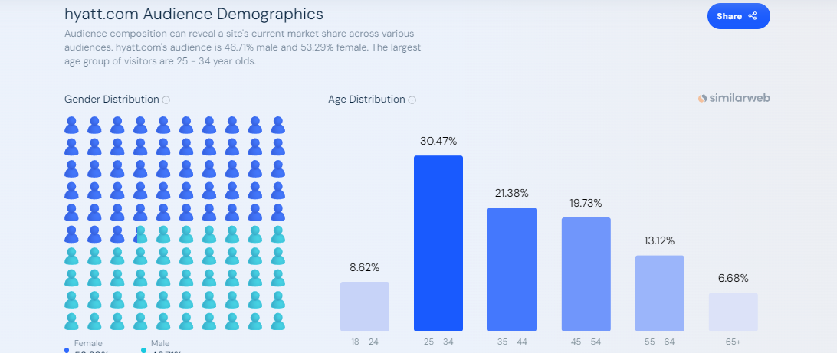
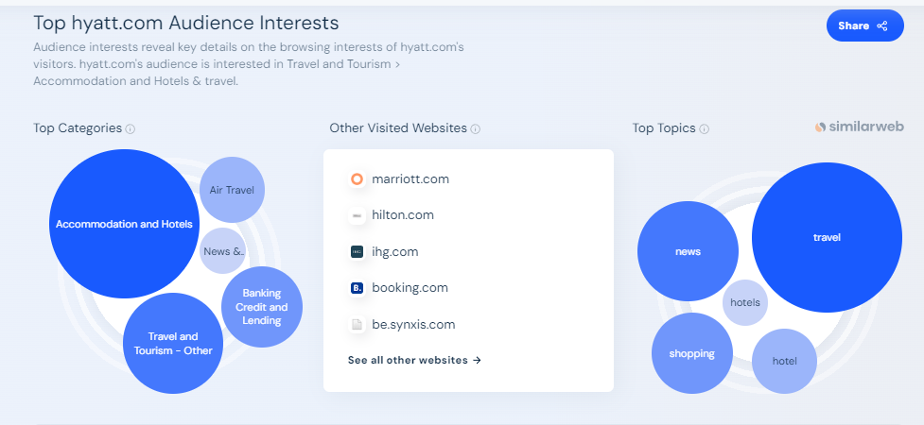

Competitors
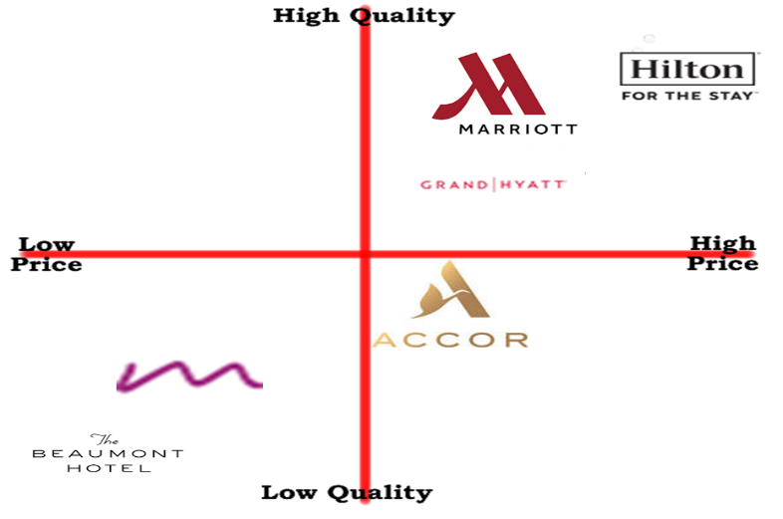
Figure 1: Perceptual mapping
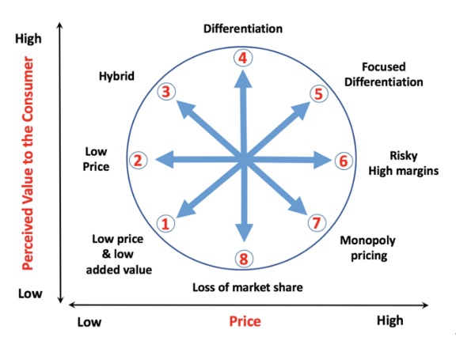

Figure 2: Bowman's Strategy

PESTLE analysis
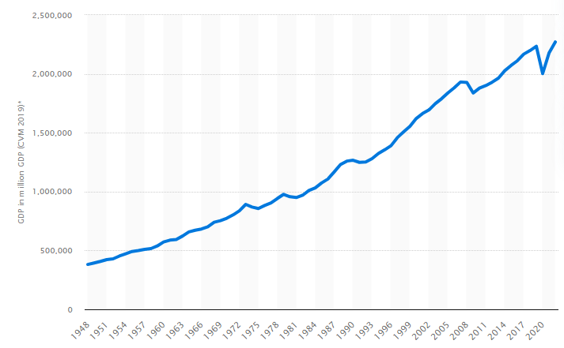
Figure 3: UK's GDP
Source: Statista, 2023a

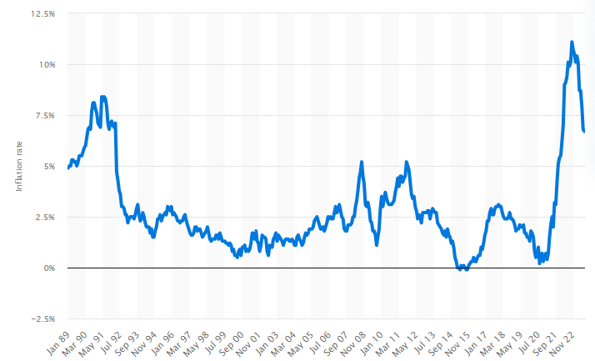
Figure 4: Inflation rate for the Consumer Price Index (CPI) in the United Kingdom from January 1989 to August 2023
Source: Statista, 2023b
Political
The multiplicity of policies in the UK allows businesses to adjust to a broad range of laws. Another benefit of political stability is that it fosters an environment that is conducive to business. Brexit, however, had a serious toll on the hotel industry, and this might lead to challenges with laws, employment, and commerce.
Economic
The UK's strong and stable GDP is a major factor in the growth of the hotel business there. The industry contributed significantly to the nation's economy in 2019 with £59.3 billion in economic output. Nonetheless, if the pandemic continues, the £117 billion in missed consumer spending might have a big impact on the business's bottom line.
Social
One way the pandemic has impacted society is via decreased consumer spending. The hotel industry may be impacted financially and operationally by this shift in customer behaviour. Moreover, a high turnover rate raises concerns for society since it may result in increased costs for hiring and training new employees.
Technological
Analysis of technological advancements, innovation, and digital trends impacting the hotel industry, like online booking systems, online money transactions, mobile apps and chatbots is required to enhance guest experiences and operational efficiency.
Legal
Ensuring a pleasant and conflict-free workplace in the UK requires robust labour laws that safeguard workers' rights. Laws like the Health and Safety at Work Act of 1974 and the Gas Safety Regulations of 1998 protect the health and safety of both patrons and employees in the hospitality sector.
Environmental
Environmental sustainability is becoming more and more important to the hotel industry. Hotels are increasingly emphasising environmental responsibility and using renewable energy. This is consistent with the global movement for environmental conservation and might provide companies who serve eco-conscious clients an advantage.

Marketing Mix
Product
Grand Hyatt Hotels provide a wide range of opulent facilities and services. The establishment encompasses a range of upscale facilities, including accommodations such as rooms and suites, dining establishments, wellness centres, conference spaces, and attentive hospitality services.
Price
The pricing of Grand Hyatt reflects its positioning as a luxury brand. The elevated price associated with a lodging reservation is indicative of the superior level of service that customers might anticipate receiving. In order to broaden their consumer base, it is possible for businesses to provide a variety of bundled products or services as well as implement membership reward programmes.

Place
The Grand Hyatt Hotels are strategically positioned in highly sought-after positions inside the world's most popular cities and iconic monuments. The hotels often occupy strategically located central regions, making them very suitable for both business and leisure tourists.
Promotion
Advertising for the Grand Hyatt may be seen both online and in traditional media. The organisation uses social media platforms efficiently to increase brand recognition and broaden the scope of their audience in addition to more conventional promotional approaches like strategic alliances and attendance at conferences and trade events. In order to solidify its status as an industry leader, the corporation uses a mix of influencer marketing and public relations tactics.
The Grand Hyatt has the right to review prices periodically and make changes in response to market and economic conditions. Marketing strategies including seasonal discounts, limited-time specials, and dynamic pricing might help them attract new customers without diluting their premium image.

Ansoff matrix

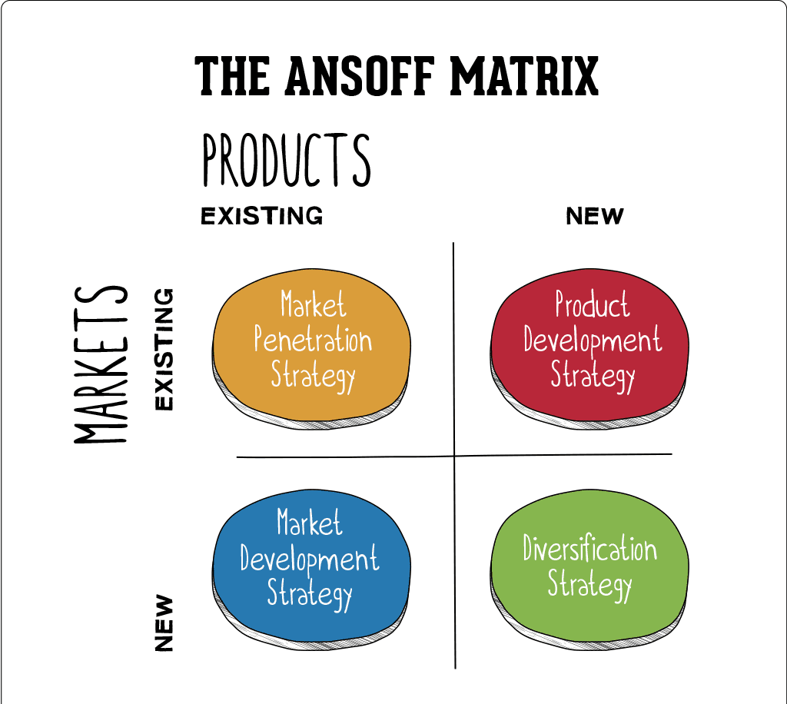
Figure 5: Ansoff Matrix

Gannt chart
Figure 6: Gannt Chart

Presentation


