12/5/2025
Walter Ernesto Melendez Dominguez (2413597)
UWTSD
Research, build, and deploy a Virtualized Enterprise network.
Network Operating Systems and Services ACCA5023

Contents

Introduction 2
Report research (Task 1) 3
Research on Hypervisor: 3
Research on IP Addressing 4
Research on Routing 7
Research on Network Services 8
Evidence of download and installation. (Task 2 Report: Technical Documentation) 9
Download/ Installation 9
Windows (Server and Enterprise) 10
Linux Debian 12
Deploy your network as per the given topology 13
NAT network for Windows 13
NAT network for Debian 15
Server Network 17
IP addressing 19
Test and Troubleshoot 23
WAN Routing and Connectivity Configuration 25
Tracert 26
Reflection (Task 3) 27
References 28

Introduction

The purpose of this assignment is to design and implement the network topology for SWANSEA.ACCA, following the requirements for NOSS 2026 Inc. The work is divided into two main parts: research and practical implementation.
First, I conducted research on key networking concepts, including Hypervisors, IP Addressing, Routing protocols, and Network Services. This research helped me understand the theory behind the tools and configurations required for the project.
For the practical implementation, I used Oracle VirtualBox to set up the environment with four virtual machines:
A Windows Server 2019 and a Windows 11 Client.
A Debian 13 Server and a Debian Client.
I configured the IP addresses manually and set up Static Routing to connect the two local networks through a central WAN link. During the process, I solved connectivity challenges related to IP conflicts and firewalls.

Report research (Task 1)

Research on Hypervisor:

- Summarize your understanding of hypervisor types (Type 1 and Type 2) and their architectures
- Reflect on which hypervisor type is suitable for this topology (e.g., hosting the Windows Server 2022 and Debian Server) based on features, hardware requirements, advantages, scalability, security, and compatibility. Consider Enhanced Topology as well!!!
- Justify your choice by considering the domain environment (SWANSEA.ACCA) and the need to support both Windows and Debian clients, including specific hardware constraints or security needs in the topology.

Hypervisors enable virtualization by abstracting software from physical hardware. There are two primary architectures: Type 1 (Bare-Metal) installs directly on the hardware (e.g., VMware ESXi, Microsoft Hyper-V), providing direct access to resources. Type 2 (Hosted) runs as an application atop a Host Operating System (e.g., VirtualBox), which introduces latency but offers ease of use. [1]
For the SWANSEA.ACCA topology, a Type 1 Hypervisor is the most suitable choice for production deployment. Hosting resource-intensive operating systems like Windows Server 2022 (S-DC) and managing routing via Debian (L-CD) requires the efficiency, stability, and scalability that bare-metal architecture provides. Performance comparisons indicate that Type 1 hypervisors significantly outperform Type 2 in networking throughput and CPU efficiency. [3]
Regarding the domain environment, Type 1 offers superior security isolation, which is critical for protecting the Domain Controller and sensitive user data within NOSS 2026 Inc. Security studies emphasize that the additional layer of a Host OS in Type 2 creates a larger attack surface. Therefore, to support simultaneous Windows and Debian clients reliably, a Bare-Metal solution is mandated. [2]

Research on IP Addressing

- Explore how IP Addressing contributes to the functionality and effectiveness of the network.
- You need to address the structure, format, and representation of IPv4, IPv6 addressing, concept of subnetting, efficient utilization of IP addresses.
- Include diagrams and examples of IP Addressing concepts and their practical applications.

Data transmission over the internet relies on packet switching, where IP addresses act as unique logical identifiers for the source and destination, ensuring accurate delivery. IP addresses are like digital house addresses. In this infrastructure, switches operate at the data link layer to facilitate local data flow using MAC addresses (like within a room), while routers operate at the network layer, using IP addresses to forward data between different networks and determine optimal routes across the internet. [4].
Addressing is fundamental to network functionality. IPv4 uses a 32-bit structure represented in dotted-decimal notation (e.g., 192.168.1.1), divided into network and host portions. Due to IPv4 exhaustion, IPv6 was introduced, utilizing a 128-bit hexadecimal format (e.g., 2001:db8::1) to provide a vastly larger address space and improved security features [5].
To optimize effectiveness, subnetting is employed. This process borrows bits from the host portion to create smaller sub-networks. Subnetting contributes to network efficiency by reducing broadcast domains, enhancing security, and ensuring the efficient utilization of limited IP address ranges within an organization [6].
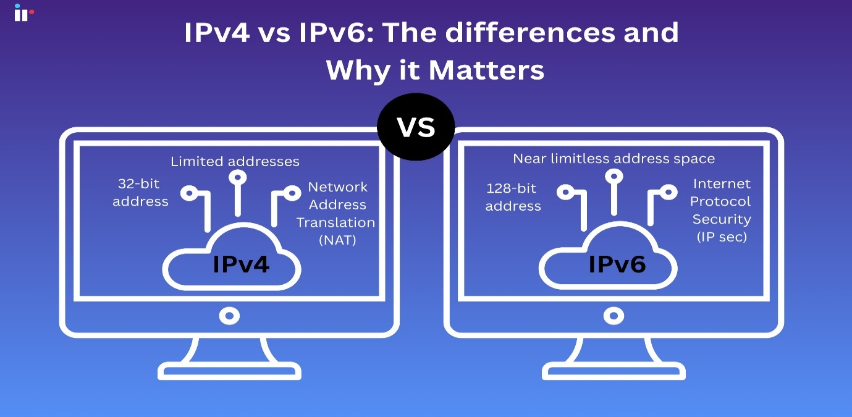
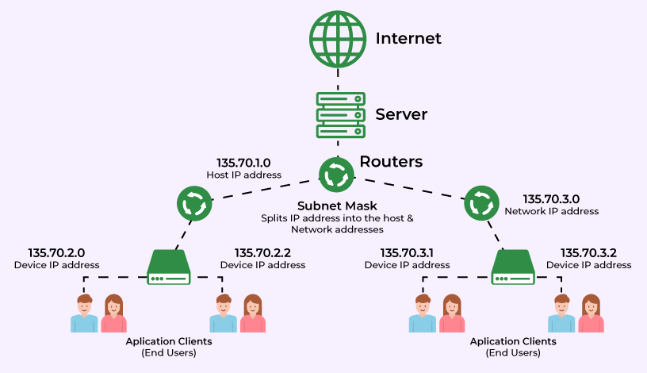

Research on Routing

- Summarize your understanding of routing protocols, focusing on their purpose, how they operate, and the differences between static and dynamic routing.
- Reflect on which routing approach suits the topology’s setup, considering the Debian Server’s role as a DHCP Relay and the Windows Server’s connectivity

Routing protocols act like a GPS for data, determining the best path for packets to travel across networks. There are two main approaches: Static and Dynamic. In Static Routing, a network administrator manually configures the specific paths. It is secure and uses few resources but does not adapt automatically to changes. In contrast, Dynamic Routing (using protocols like OSPF or RIP) allows routers to "talk" to each other and update paths automatically, which is ideal for large, changing networks but uses more processing power [7].
Reflecting on the SWANSEA.ACCA topology, Static Routing is the most suitable approach. Since the network is small, consisting only of two servers acting as routers and a stable WAN link, there is no need for the complexity or overhead of dynamic protocols [7].
Furthermore, Static Routing provides the stability required for the Debian Server’s role as a DHCP Relay. For a DHCP request to successfully travel from a client in one network to a server in another, the path must be predictable and reliable. Static routes ensure that the Windows Server and Debian Server maintain permanent connectivity, guaranteeing that services run smoothly without interruption.

Research on Network Services

- Summarize your understanding of VPNs, DHCP, Active Directory Domain Services (AD DS), and Certificate Authorities, focusing on their key features and best practices.

Network services form the backbone of enterprise infrastructure. Virtual Private Networks (VPNs) provide secure remote access by creating encrypted tunnels over public networks, ensuring data confidentiality. Dynamic Host Configuration Protocol (DHCP) automates the assignment of IP addresses, preventing conflicts and reducing administrative overhead by centrally managing scope configurations [9].

In the realm of identity and security, Active Directory Domain Services (AD DS) acts as a centralized database for managing users, computers, and policies. Its key feature, Group Policy, allows administrators to enforce security configurations across the entire network. Complementing this, Certificate Authorities (CAs) are critical for Public Key Infrastructure (PKI); they issue and verify digital certificates to encrypt traffic (like HTTPS) and authenticate devices [10].

Best practices are vital for maintaining integrity. For VPNs, implementing Multi-Factor Authentication (MFA) is mandatory to prevent unauthorized access. DHCP security requires DHCP Snooping to block rogue servers. In AD DS, the principle of Least Privilege should be strictly enforced to limit admin rights. Finally, for CAs, it is essential to keep the Root CA offline to prevent catastrophic compromise of the trust chain.

Evidence of download and installation. (Task 2 Report: Technical Documentation)

Download/ Installation
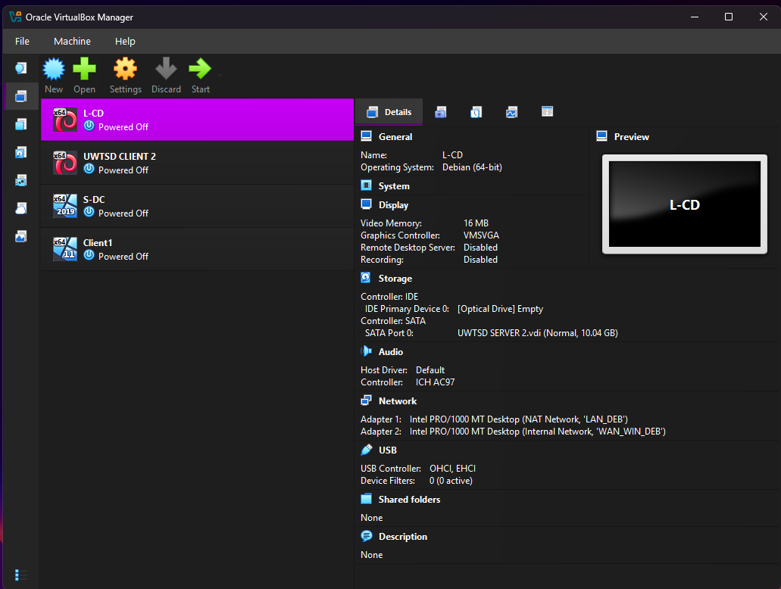

The deployment of the network topology began with the setup of the virtualization environment. Oracle VirtualBox was selected as the Type 2 Hypervisor due to its compatibility with the host hardware and support for diverse guest operating systems.
Windows: ISO images for Windows Server 2019 and Windows 11 Enterprise were obtained from the official Microsoft Evaluation Center.
Linux: The Debian 13 (Bookworm) ISO installer was downloaded from the official Debian repository.
Virtual Machine Provisioning: Four virtual machines were created to replicate the required nodes. Resource allocation was configured to ensure stability during simultaneous operation:
Servers (S-DC & L-CD): Configured with 2 vCPUs and 4GB of RAM to handle routing and future directory services.
Clients (ClientS1 & ClientL1): Configured with 1 vCPU and 4GB of RAM.
The installation process followed standard deployment procedures, including virtual hard disk partitioning and the creation of administrative accounts (Administrator for Windows and admin for Debian).

Windows (Server and Enterprise)
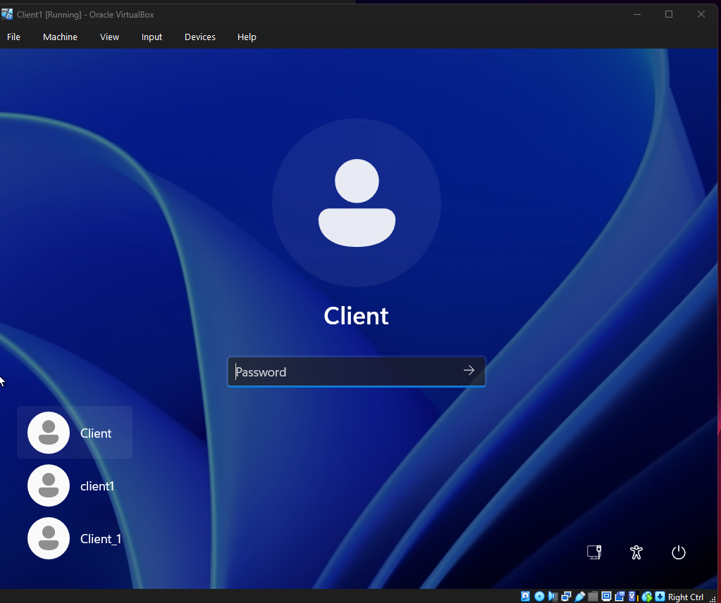

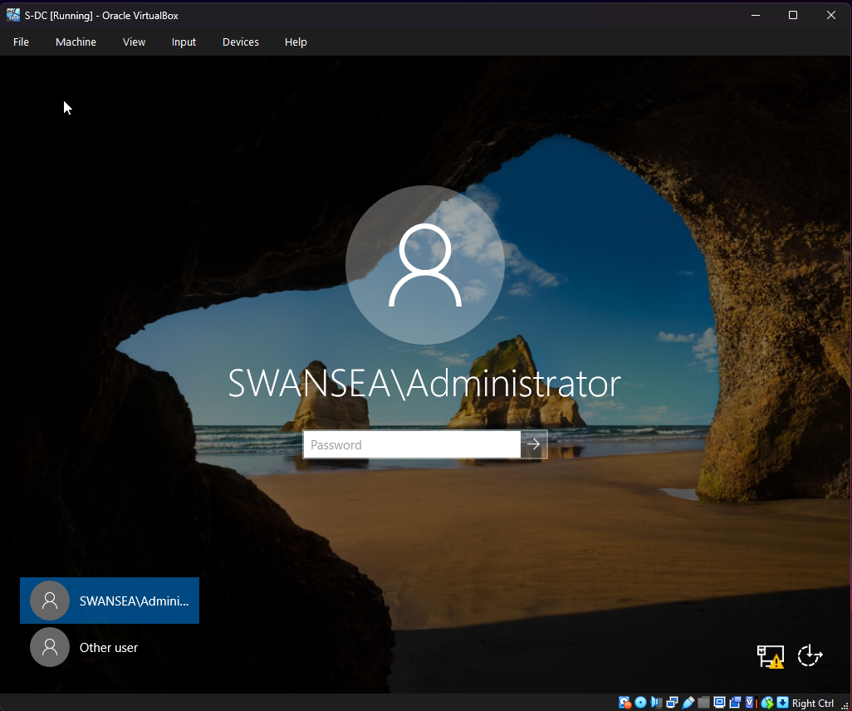

Linux Debian
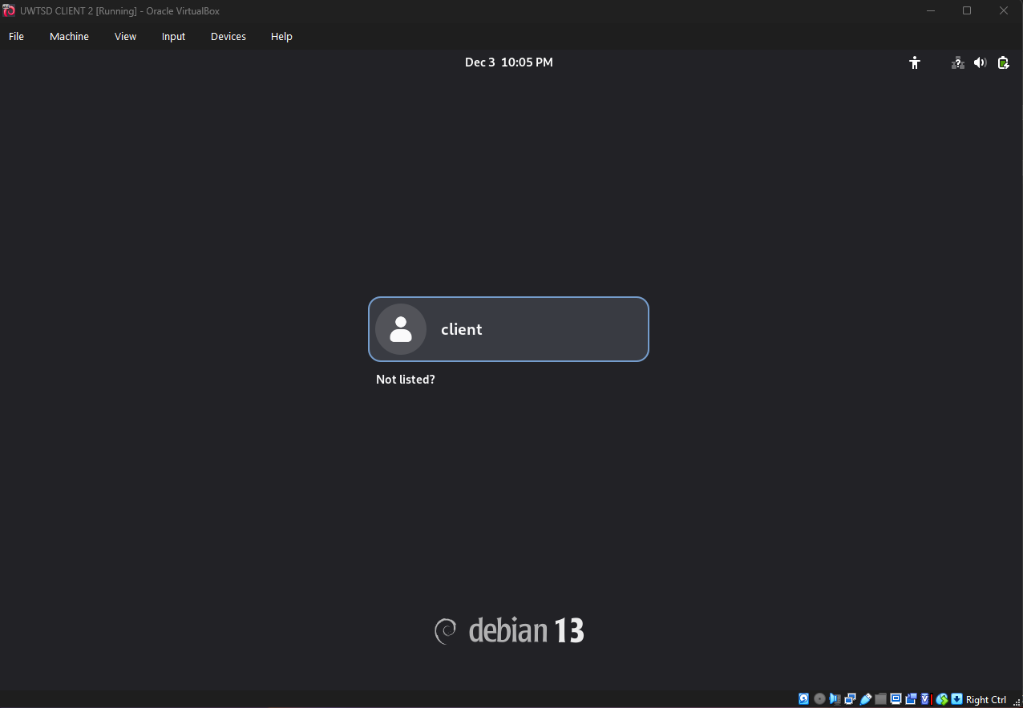
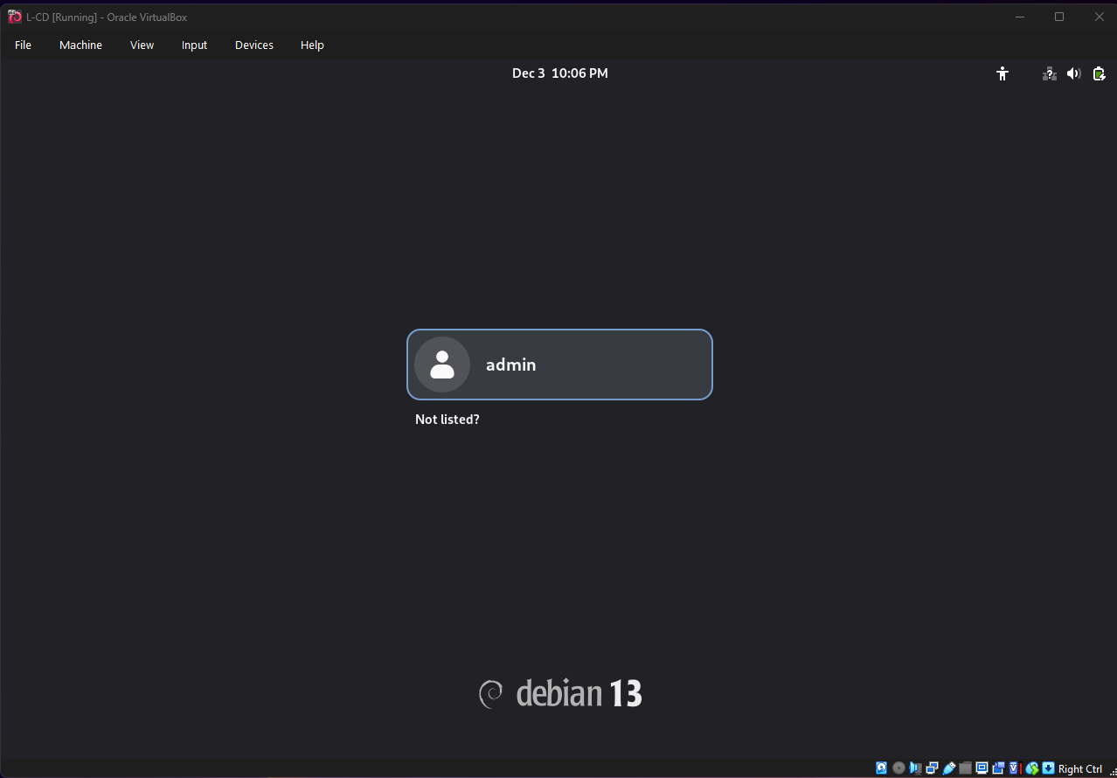

Deploy your network as per the given topology

NAT network for Windows
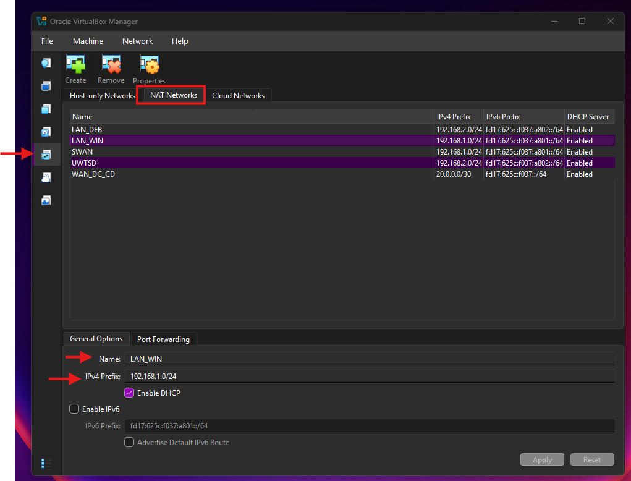

In accordance with the network topology requirements, the virtualization environment was segmented into three distinct logical networks using the NAT Network feature in Oracle VirtualBox.
LAN_WIN (192.168.1.0/24): A dedicated subnet created to host the Windows infrastructure, connecting the Windows Server (S-DC) and the Windows Client (Client1).

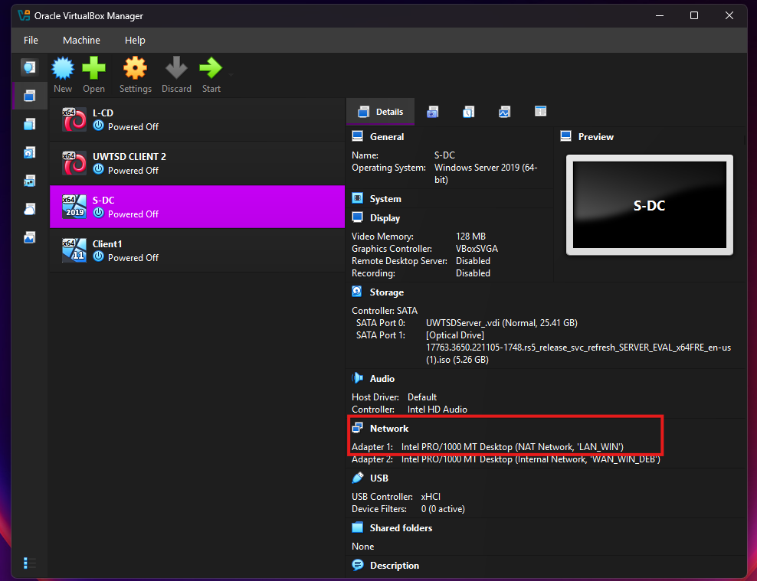

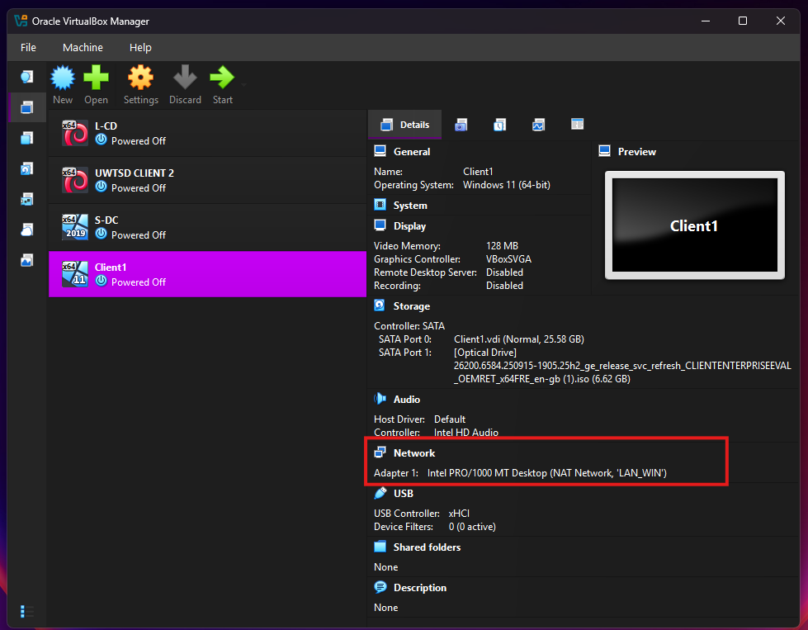

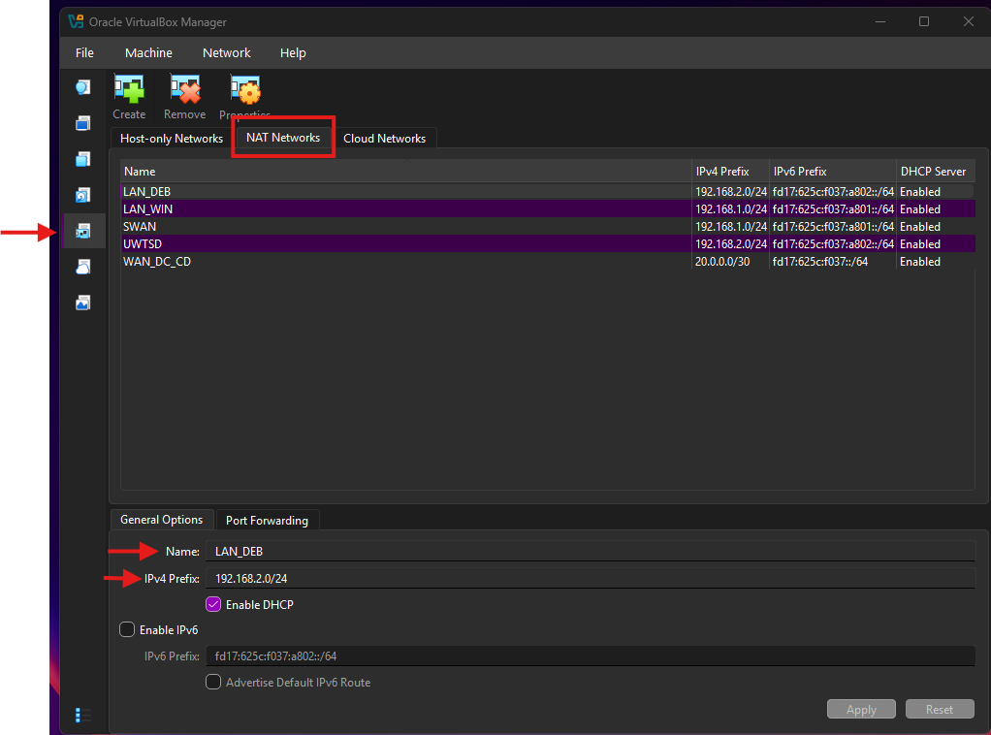
NAT network for Debian

LAN_DEB (192.168.2.0/24): A separate subnet for the Linux environment, hosting the Debian Server (L-CD) and Debian Client (ClientL2).

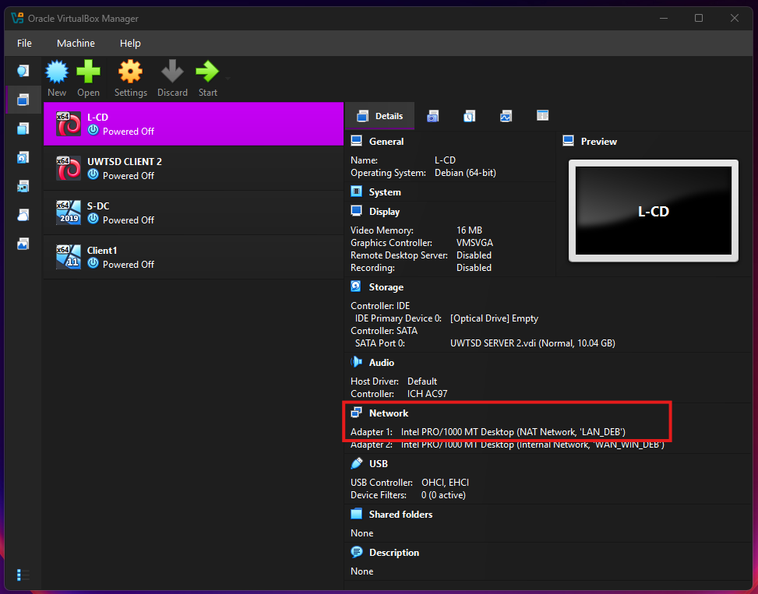

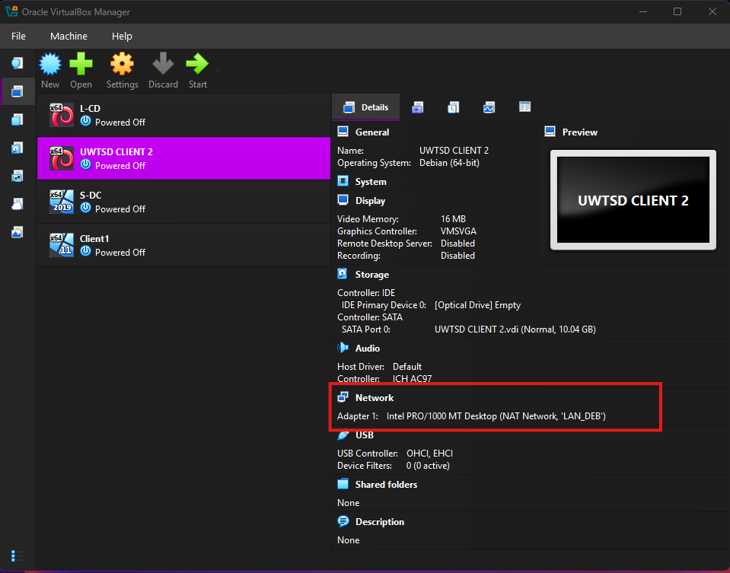

Server Network
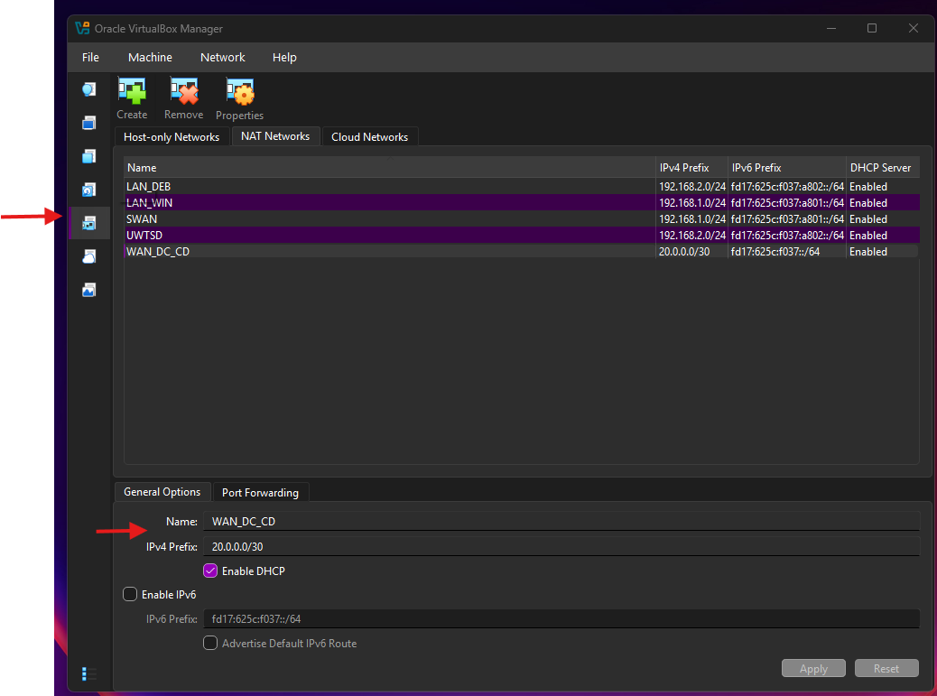

WAN_DC_CD (20.0.0.0/30): A specific point-to-point network configured as an Internal Network to simulate the Wide Area Network link between the two servers.
The network adapters of all virtual machines were manually mapped to their respective segments, ensuring traffic isolation between the departments while establishing a physical path for inter-router communication via the WAN link.

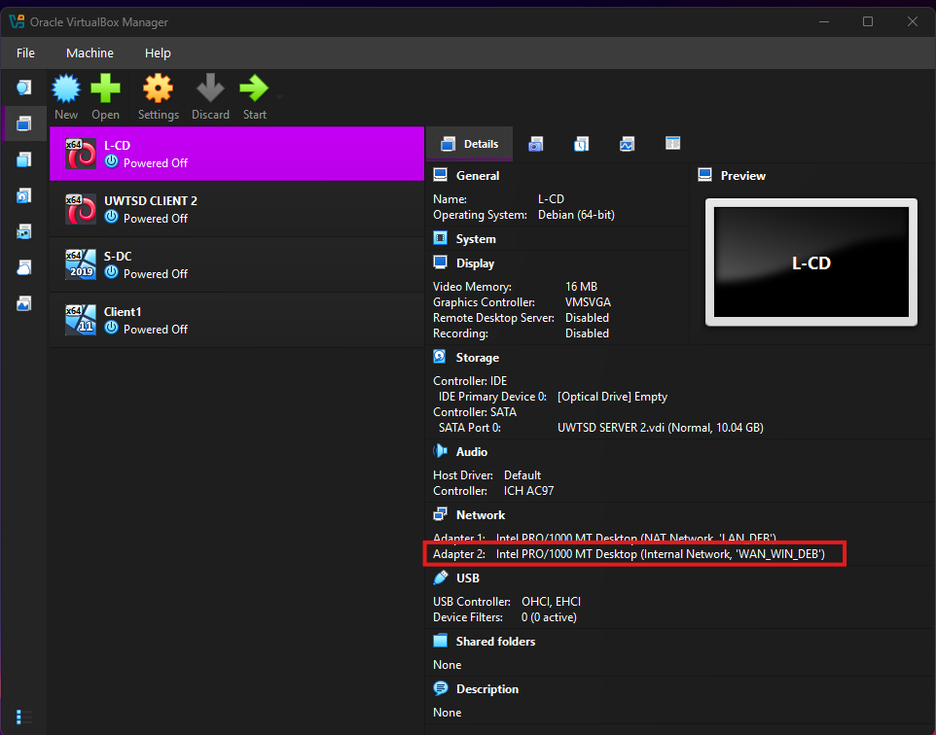

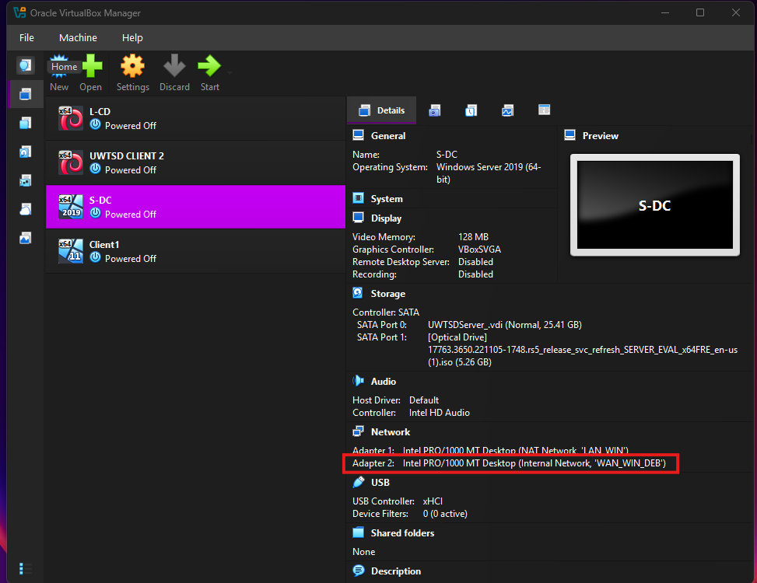

IP addressing
Windows server
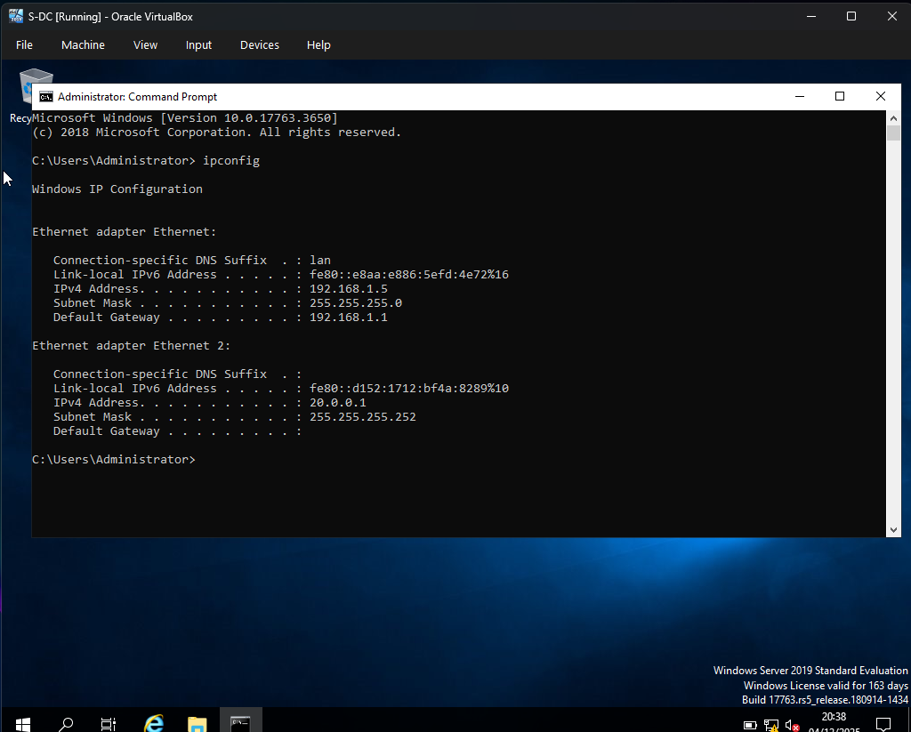
The IP addressing scheme was implemented to ensure connectivity while adhering to the constraints of the hypervisor environment.

Windows Server (S-DC): The WAN interface was statically configured with 20.0.0.1/30. For the LAN interface, a DHCP configuration was adopted (resulting in IP 192.168.1.5) to resolve an IP conflict with the default VirtualBox NAT gateway (192.168.1.1).

Windows Client
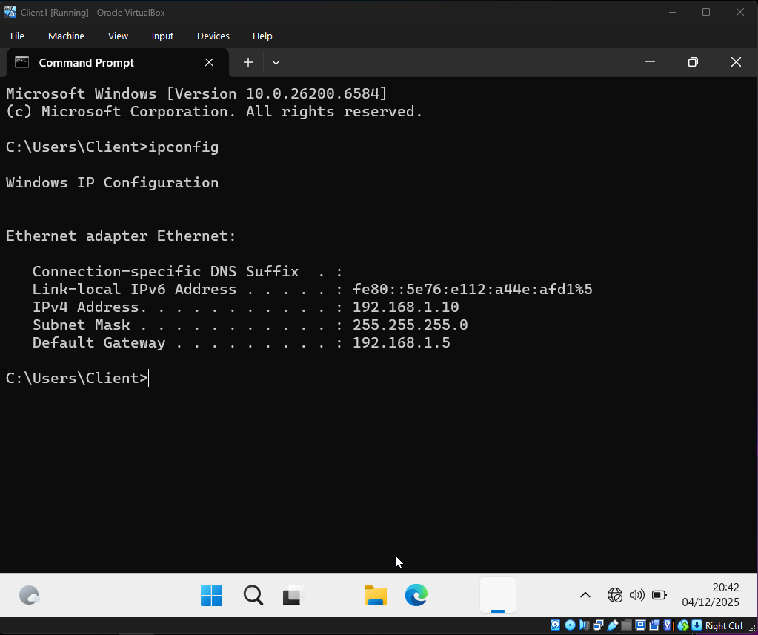

Windows Client (ClientS1): Assigned a static IP of 192.168.1.10. The Default Gateway was manually set to 192.168.1.5 to direct traffic through the local server.

Debian Server L-CD
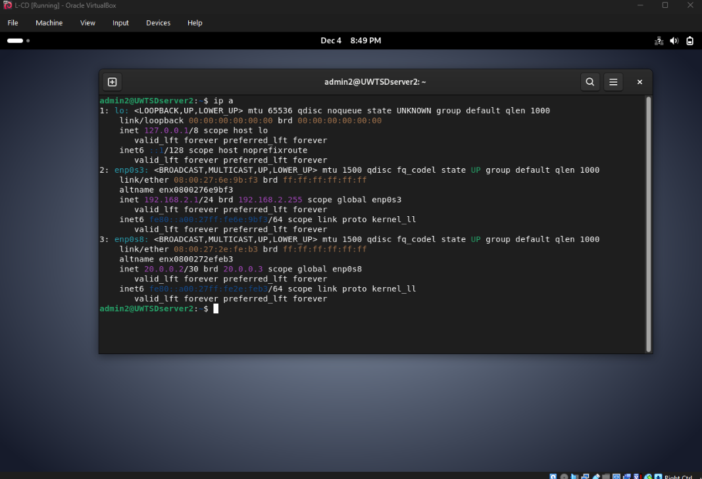

Debian Server (L-CD): Statically configured with 192.168.2.1/24 for the LAN interface and 20.0.0.2/30 for the WAN interface.

Debian Client
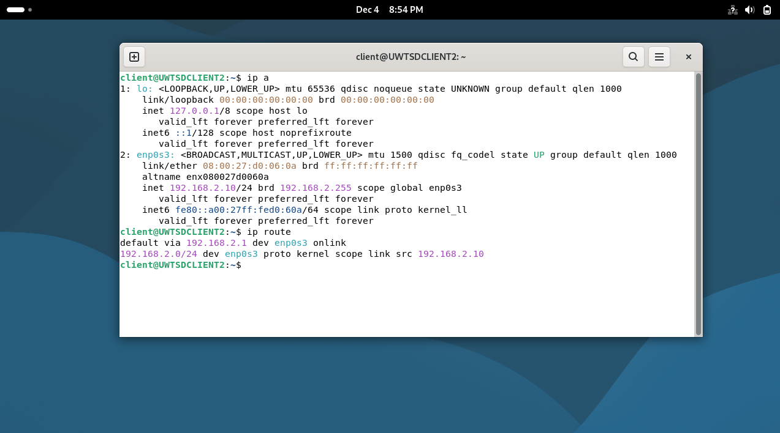

Debian Client (ClientL1): Assigned a static IP of 192.168.2.10/24, with the Default Gateway pointing to the Debian Server (192.168.2.1)
This configuration ensures that all clients correctly route non-local traffic to their respective servers.

Test and Troubleshoot
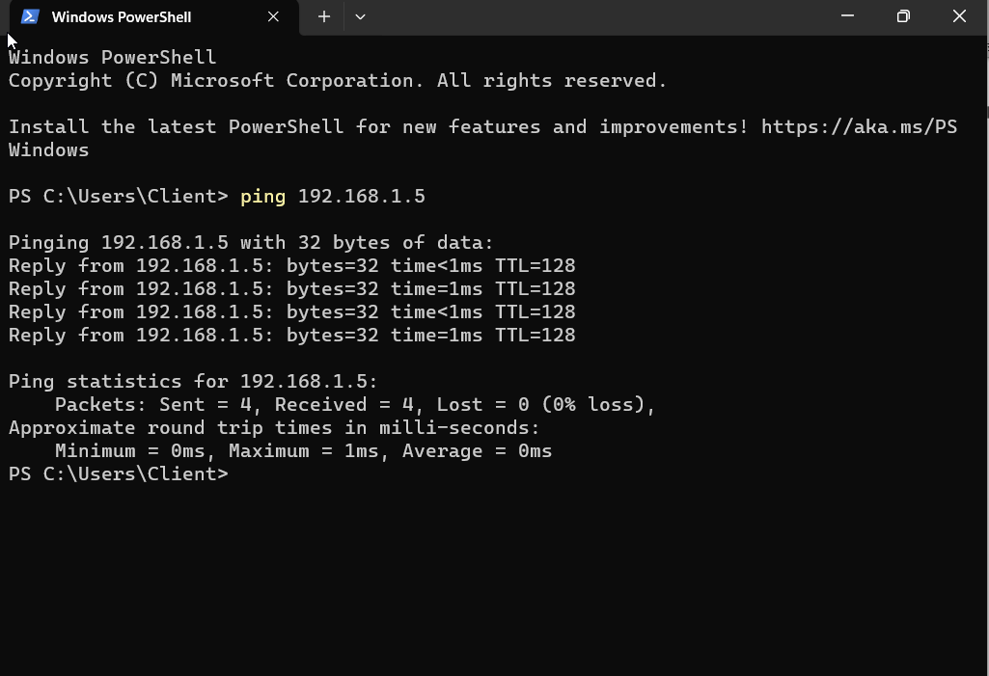

Windows Network: A ping request from ClientS1 (192.168.1.10) to the local server gateway (192.168.1.5) returned a successful reply with 0% packet loss, confirming internal LAN stability.
Successful ping from Windows Client to local Windows Server.

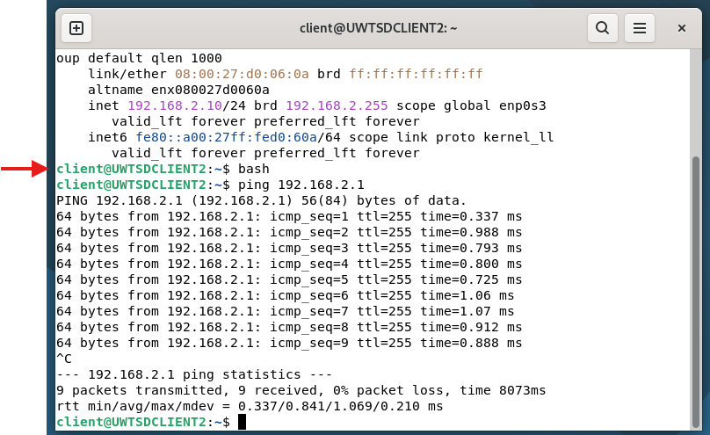

Debian Network: Similarly, the Debian Client (192.168.2.10) successfully reached the Debian Server (192.168.2.1), verifying the integrity of the Linux subnet configuration”
Successful ping from Debian Client to local Debian Server.
These tests confirm that the TCP/IP stack is correctly configured on all nodes and that clients can reach their default gateways.

WAN Routing and Connectivity Configuration

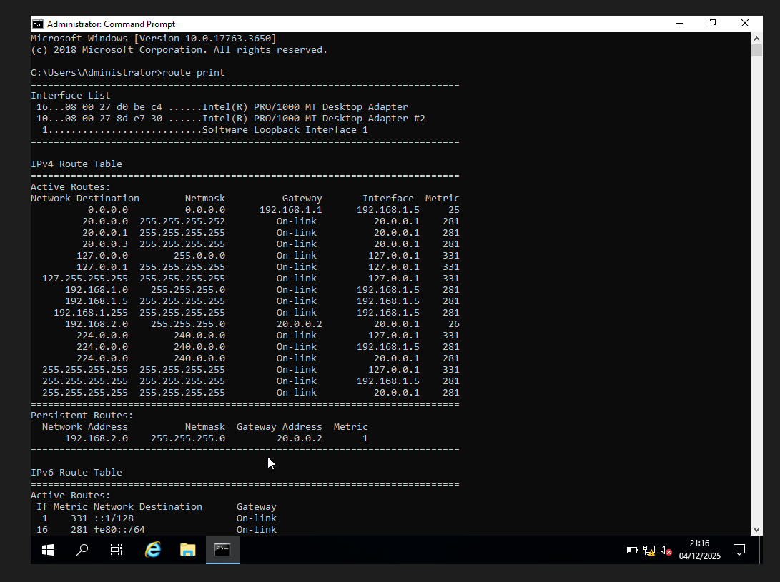

Static routing was configured on both servers to enable communication between the isolated subnets.
(Windows Routing Table): The route print command confirms a persistent static route for the destination network 192.168.2.0/24, directing traffic to the next-hop gateway 20.0.0.2 (Debian Server WAN interface).

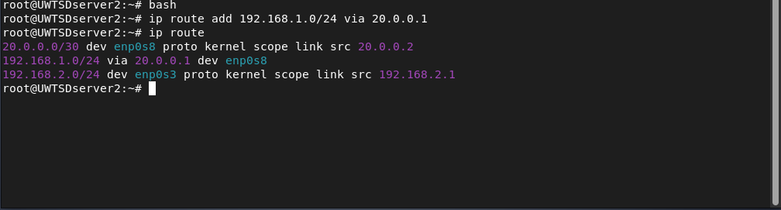

(Debian Routing Table): The routing configuration was verified using ip route. A corresponding static route was added to forward traffic destined for 192.168.1.0/24 via the gateway 20.0.0.1 (Windows Server WAN interface), ensuring bidirectional traffic flow across the WAN link.

Tracert

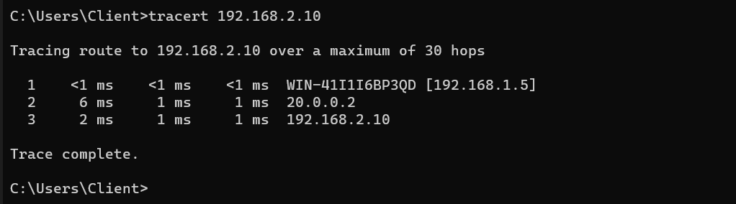
End-to-end connectivity test showing traffic routing from Windows Client to Debian Client through the WAN link.
To enable communication between the two isolated networks, static routing was configured on both servers. IP forwarding was enabled, and specific routes were added to the routing tables to direct traffic between networks across the WAN link (20.0.0.0/30).
The final end-to-end connectivity test was performed using the tracert command from the Windows client to the Debian client (192.168.2.10). The trace result shows that the packet successfully traversed three hops:
- The local gateway (Windows server).
- The remote gateway (Debian server via WAN).
- The destination host (Debian client).
This confirms that the routing logic is working correctly and that the network topology has been implemented correctly.

Reflection (Task 3)

The IP conflict encountered with the Windows Server highlighted a critical lesson in network virtualization: the importance of understanding the environment before deployment.
Initially, I attempted to force the static IP 192.168.1.1 as per the diagram, but this caused connectivity failure because the hypervisor (VirtualBox) had already reserved that address for its internal routing. This taught me that in real-world scenarios, network diagrams are logical guides, but implementation requires adapting to the physical (or virtual) constraints of the hardware.
By switching to a DHCP strategy for the LAN interface, I learned that flexibility is key to troubleshooting. Instead of fighting the system limitation, I adapted the configuration (updating the Client's Gateway to 192.168.1.5) to achieve the goal: end to end connectivity. This experience reinforced my understanding of how Gateways work it doesn't matter if the IP is .1 or .5, if the clients know exactly where to send their traffic.

References

[1] A. S. Tanenbaum, "MODERN OPERATING SYSTEMS FOURTH EDITION," 2015,
[2] M. Pearce, S. Zeadally and R. Hunt, "Virtualization: Issues, security threats, and solutions," vol. 45, no. 2, pp.1–39, 2013,
[3] J. Hwang, et al., 2013 IFIP/IEEE International Symposium on Integrated Network Management (IM 2013), pp. 269–276
[4] B. A. Forouzan, Data Communications and Networking Global Edition 5e, McGraw Hill, 2012.
[5] W. Stallings, Data and Computer Communications, 10th ed. Upper Saddle River, NJ: Pearson, 2013
[6] D. E. Comer, Internetworking with tcp/ip, Addison-Wesley Professional, 2013.
[7] J. F. Kurose and K. W. Ross, Computer Networking: A Top-Down Approach, 7th ed. Hoboken, NJ: Pearson, 2017.
[8] W. Stallings, Effective cybersecurity: a guide to using best practices and standards, Addison-Wesley Professional, 2018.
[9] B. Shin, Security enhancement in defense information system by active directory, University of Delaware, 2019.
[10] W. R. Stanek, Windows Server 2019: The Personal Trainer, Stanek & Associates, 2019.

